# DWBI Assignemt -01 – IT21303616- Shangeeth A

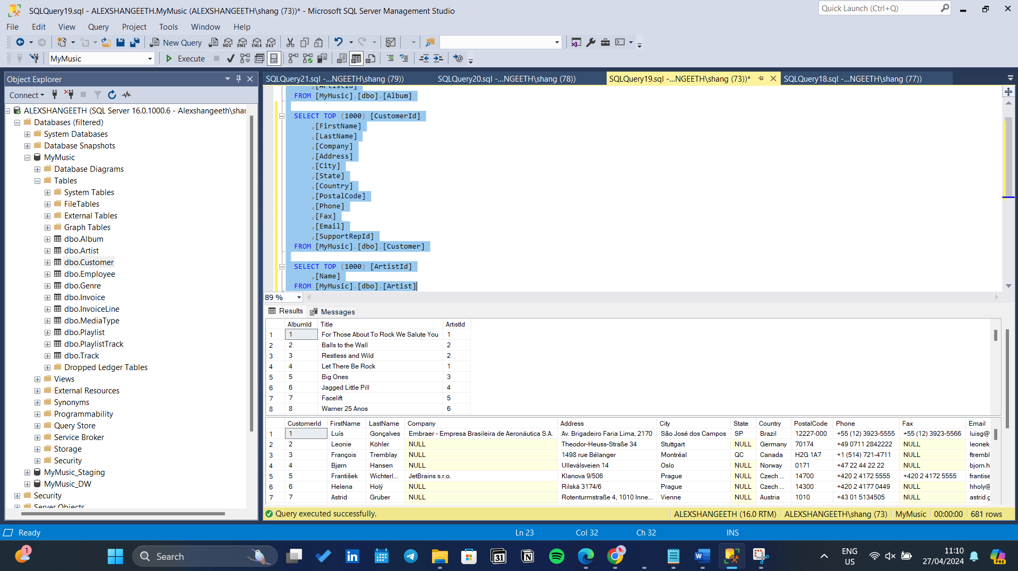

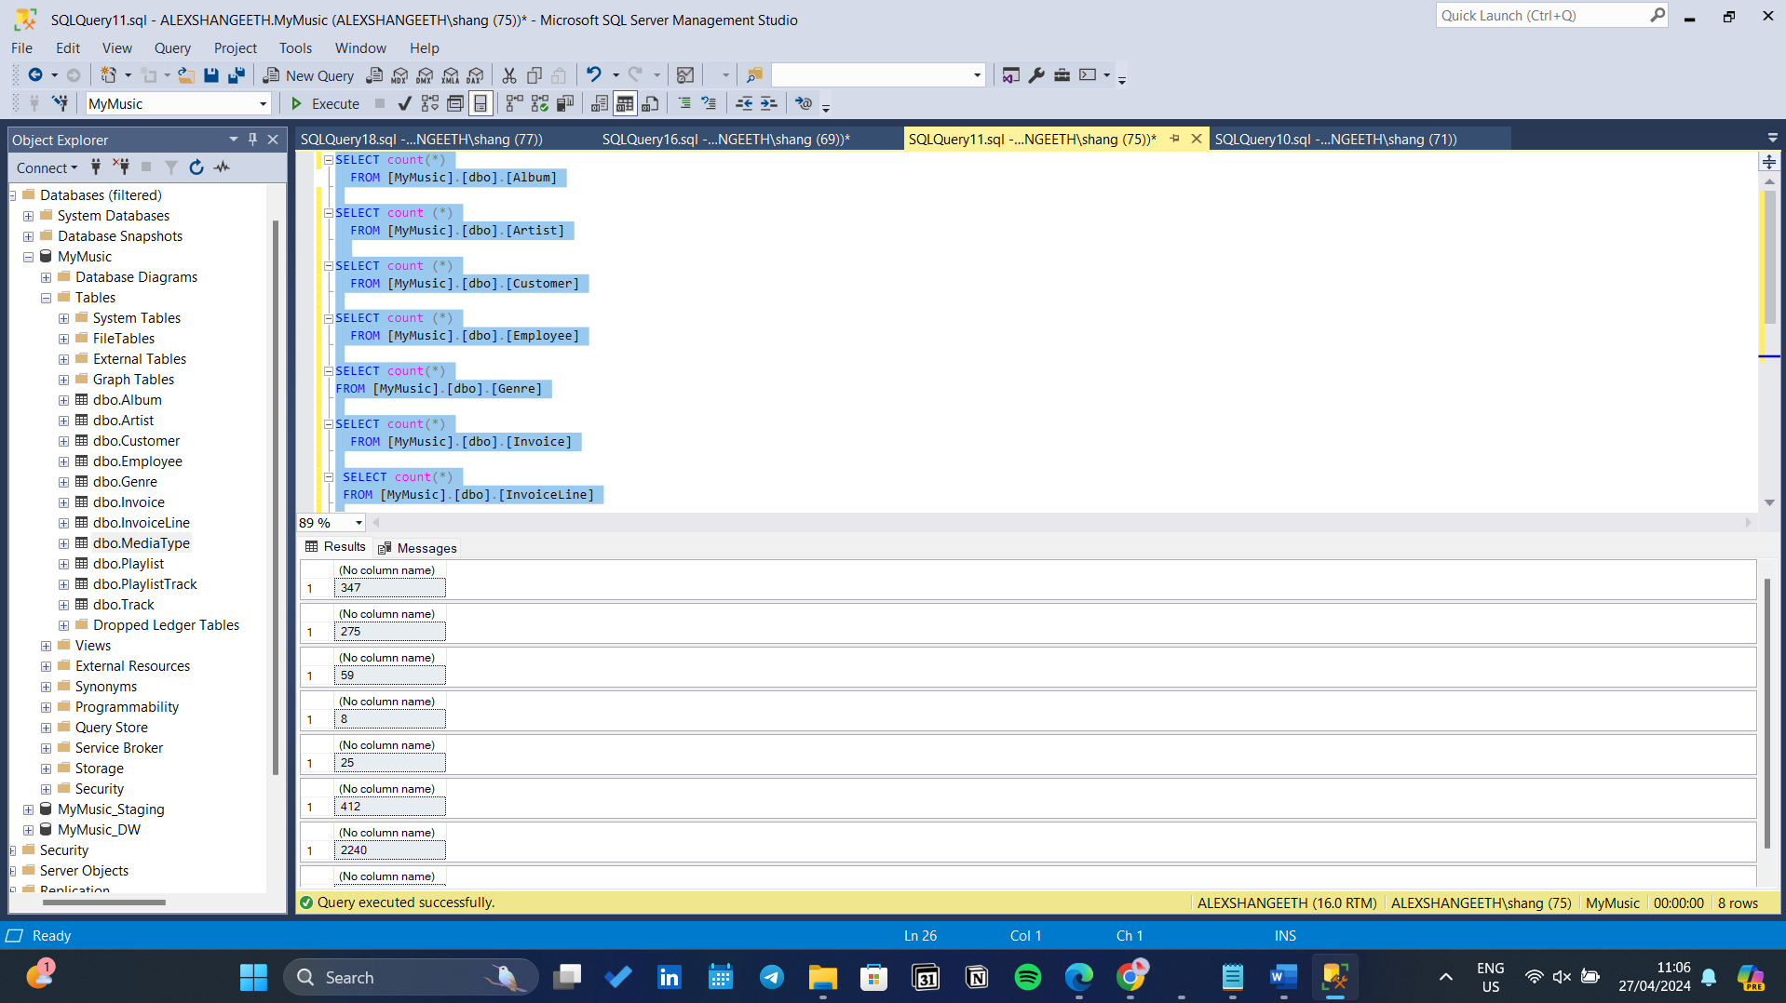

Er diagram

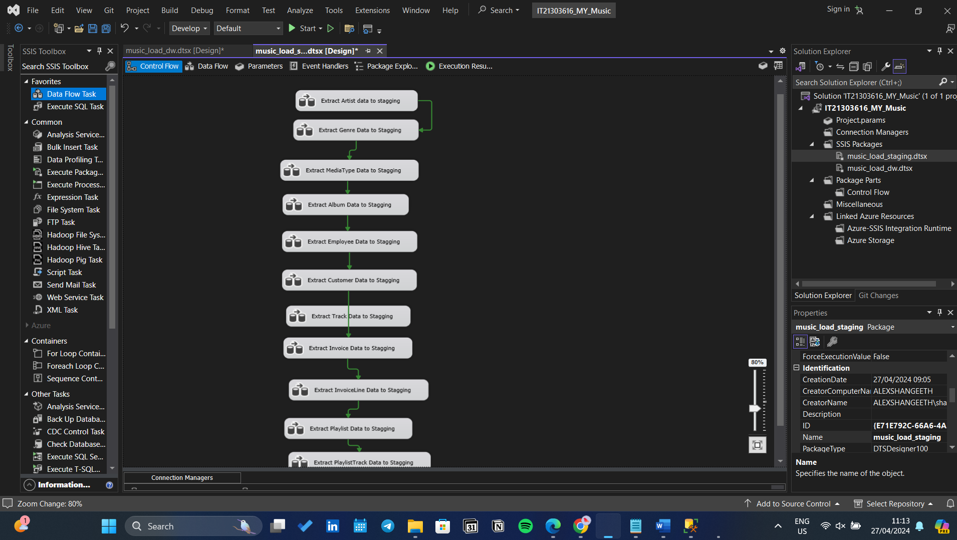

1. What are the table(s) that cannot be used in the main model is there is any?

* Artist table
* Album table
* Playlist table
* playlistTrack Table
* MediaType table
* Genere table
* Employee table

1. If there are any tables, why they can’t be taken into the model?

* These tables cannot be directly incorporated into the main star schema model

1. If this needed to be taken in what is the data element needed in which table it should be?

* If any of these tables need to be incorporated into the model, they could be used as dimension tables rather than being part of the fact table. For example:
* **Artist table:** Can be a dimension table related to the Track dimension, linking artists to tracks.

Star schema

