**Video Games Analysis – Case Study**

In this project, I will solely be dealing with exploratory analysis, which has the goal of understanding how data is distributed and generating insight for future decision-making. This analysis seeks to examine the data as much as possible in a straightforward, intuitive, and instructive manner.The data contains the Sales of the various Videos Games in United States, European Union, Japan, Others and overall across the years from 1980 to 2016. The games are also categorised across different Genres, Publishers and Platforms as well in which they are played by the buyers.

This dataset contains a list of video games with sales greater than 100,000 copies. It was generated by a scrape of vgchartz.com.

* Rank - Ranking of overall sales
* Name - The games name
* Platform - Platform of the games release (i.e. PC, PS4, etc.)
* Year - Year of the game's release
* Genre - Genre of the game
* Publisher - Publisher of the game
* EU_Sales - Sales in Europe (in millions)
* JP_Sales - Sales in Japan (in millions)
* Other_Sales - Sales in the rest of the world (in millions)
* Global_Sales - Total worldwide sales.

To enter into a Video Games Production company or becoming a large scale Distributor or Retailer of Video Games, we should know all the pros and cons of the business which we will identify in this business problem.

The main objective of this study is to find the following answers-

* Is the sales trend of Video Games increasing or decreasing? What are some interesting takeaways from the Sales across the various regions which can help us more in this new business venture?
* Which Publishers have made the highest revenues and in which regions?
* Which genre is liked the most by the buyers across the different regions?
* Which Platform is most popularly used by the Buyers across the different regions?
* If we find the answers to above questions, we can know the answer to the following question.

If we want to be a Distributor of the Video Games or start a Video Games production Company, which Genres can maximize our profits, in which regions we should start at first.

We used CRSIP DM methodology to mine the data and discover insights using exploratory data analysis and used PowerBI to produce high level visualizations to extract the insights from each variable using univariate and bivariate analysis. We looked into the Sales of all the Video Games by Genres firstly, it was found that Action, Sports and Shooter are the top 3 games based on Sales and Revenue across the World except Japan, where roleplaying is number 1 game in terms of Sales. It is quite obvious that Action video games are liked the most by the Player and hence sold the most world-wide. They are full of actions and story and also could have a beneficial effect on the brain according to a study. New international research has found that playing action video games could have a beneficial effect on the brain by expanding its cognitive abilities including perception, attention and reaction time. So, Action Games are proven to be the highest selling game of all the genres.

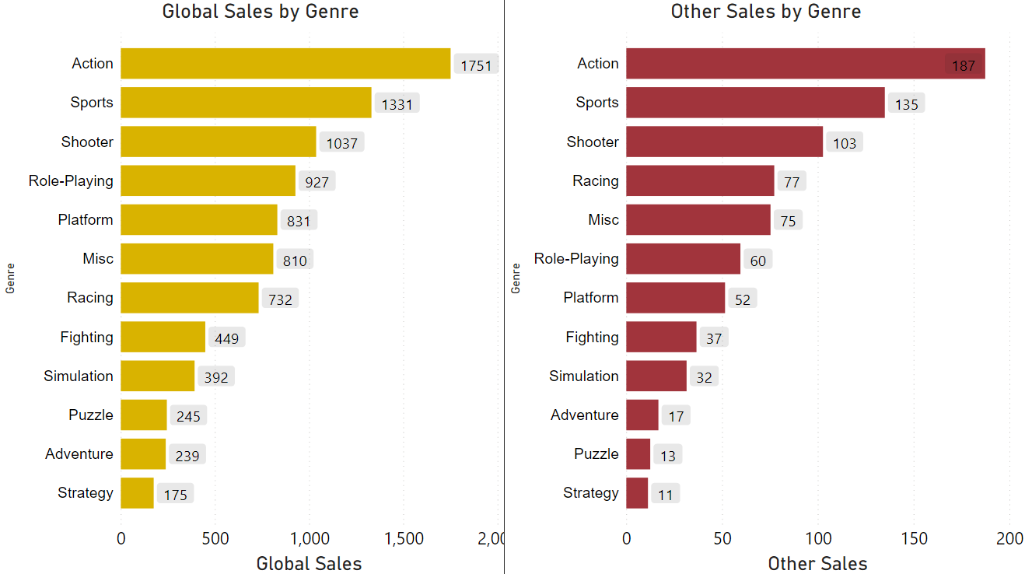

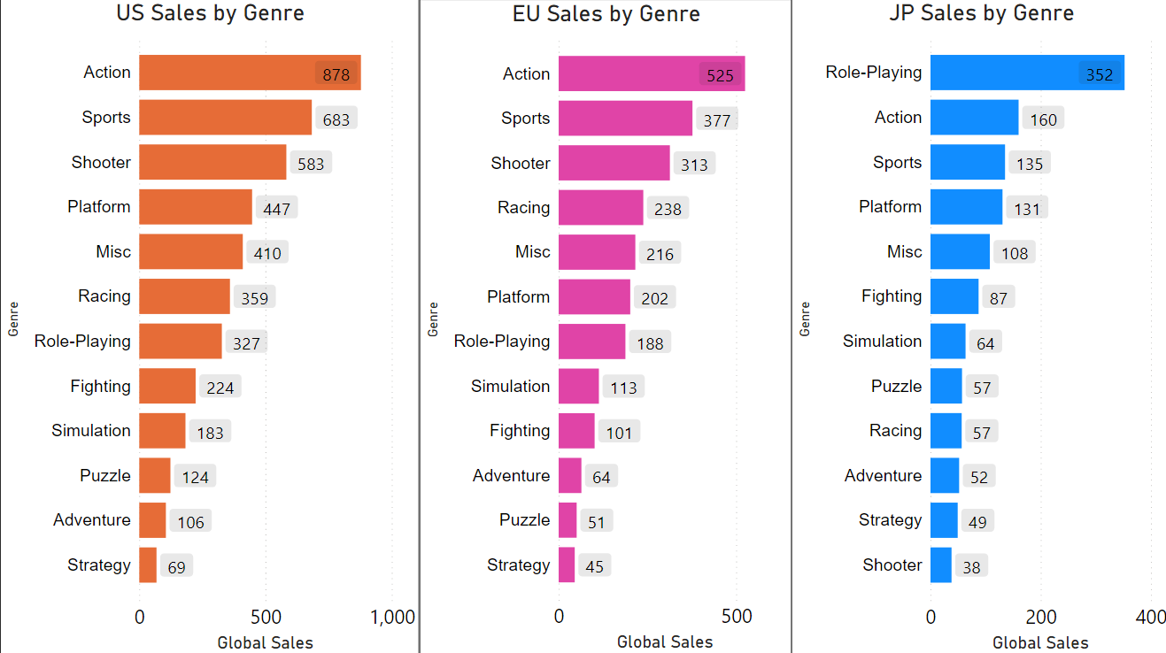

- As demonstrated by the amount of sales, Americans love gaming.

- In Japan, it appears that there is less action and greater desire for puzzles and role-playing games.

- In America, there appears to be a significant demand for action and shooter games. In the action category, the United States accounted for about half of all sales.

If we look into the Global Sales by Name of the game, we can conclude that Wii Sports is number 1 game of all time followed by Grand Theft Auto 5 and followed by Super Mario Brothers. It caught my attention that a game like Grand Theft Auto V is not the number 1 game. Following this, I discovered that the Grand Theft Auto V game was launched at various times for different systems, and that sales for each platform were tracked independently. GTA sales are segmented per platform, with various release dates. This is true for many games; collecting them all would be extremely intricate and difficult... Even if we collect them all, GTA V will only come in second, so Wii Sports will once again be the most popular game. Wii Sports is currently in first place, especially in terms of sales in America. Nintendo's Wii Sports is a sports video game for the Wii video game platform that was developed and released by Nintendo. On November 19, 2006, the game was launched in North America alongside the Wii, and the following month in Japan, Australia, and Europe. The game is a compilation of five sports simulations meant to show off the Wii Remote's motion-sensing capabilities. Tennis, baseball, bowling, golf, and boxing are among the five sports represented. (resource:Wikipedia)

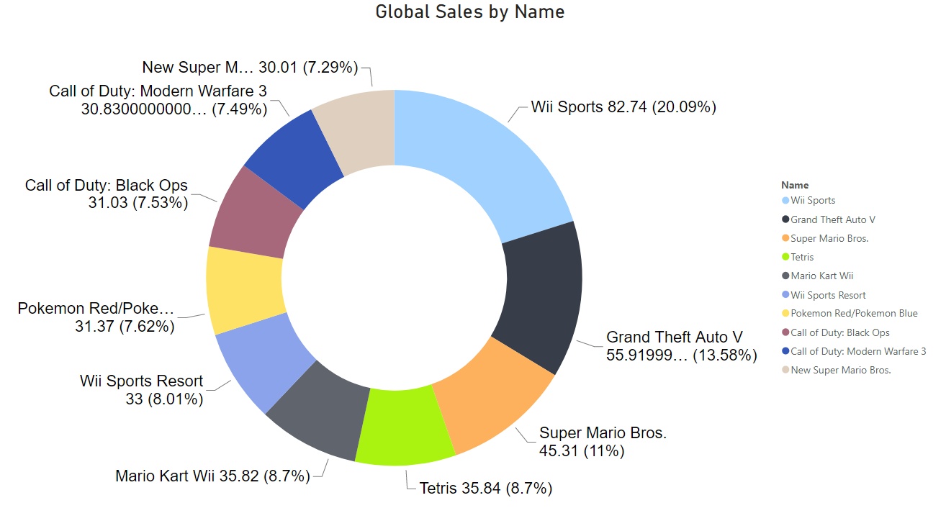

In terms of Platforms, Wii is number 1 followed by GB, then PS3, NES and Xbox 360 of all time.

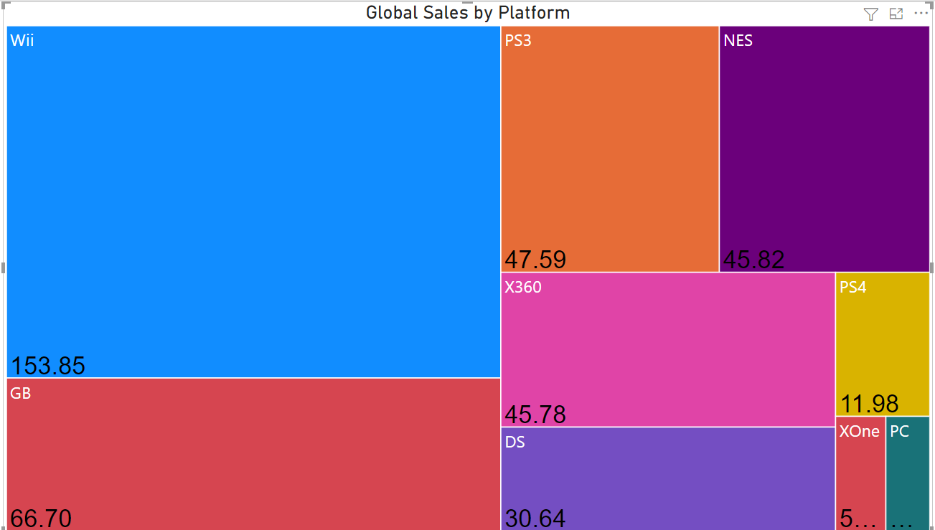

If we look into the Global Sales by Publishers, Nintendo is the Publisher with highest and with no comparison.

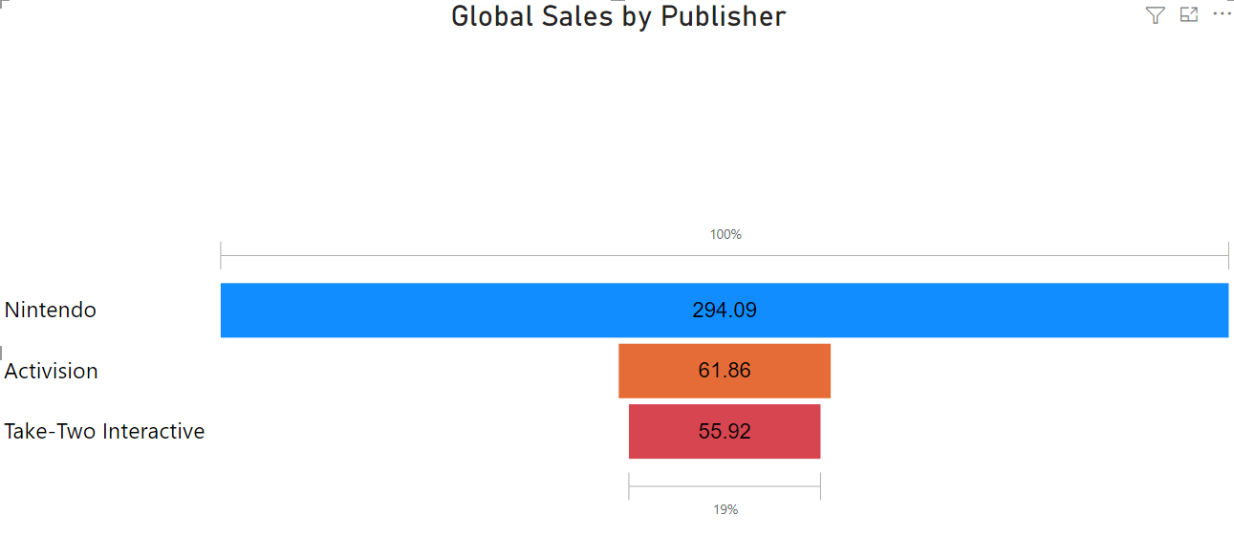

So, finally we can propose that if we want to get involve in the business Action, Shooting games are a big bet and USA is the region where the video games are bought and loved the most. When we look at the game genres in various companies. Nintendo features games in every genre, and no other company has as many genres in its games as Nintendo. Finally, we may infer the causes behind Nintendo's market dominance. Also, we can see that the firms on the top list put a lot of effort into action games since consumers enjoy them. Puzzle and Strategy are the least popular genres in the top ten. When individuals play games, they typically want to calm and relax a little bit, so this is not unusual. It's clear that some genres aren't appropriate for every platform. Shooter games, for example, are more popular than racing games, but they are available on fewer platforms. We also noticed that strategy and puzzle games are not widely distributed. This might be due to two factors. For beginners, not many people were interested in these genres before they were made available on many platforms, so why bother? That would be too expensive for the corporation. The second reason is that, because of the nature of the games maybe it was not possible to develop them in many different platforms.