*
install or download related software or package

Visual Studio Code

Postman

npm install aws-serverless-express

npm install body-parser

npm install express

*
Setting Up DynamoDB Local (Downloadable Version)
https://docs.aws.amazon.com/amazondynamodb/latest/developerguide/DynamoDBLocal.html

download dynamodb_local_latest.tar.gz from
https://docs.aws.amazon.com/amazondynamodb/latest/developerguide/DynamoDBLocal.DownloadingAndRunning.html

*
After you download the archive, extract the contents and copy the extracted directory to a location of your choice.

*
To start DynamoDB on your computer, open a command prompt window, navigate to the directory where you extracted DynamoDBLocal.jar, and enter the following command.

java -Djava.library.path=./DynamoDBLocal_lib -jar DynamoDBLocal.jar -sharedDb

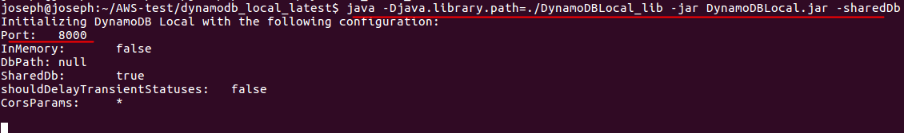

*
https://docs.aws.amazon.com/amazondynamodb/latest/developerguide/DynamoDBLocal.DownloadingAndRunning.html

Before you can access DynamoDB programmatically or through the AWS Command Line Interface (AWS CLI), you must configure your credentials to enable authorization for your applications. Downloadable DynamoDB requires any credentials to work, as shown in the following example.

AWS Access Key ID: "fakeMyKeyId"
AWS Secret Access Key: "fakeSecretAccessKey"
You can use the aws configure command of the AWS CLI to set up credentials

*
Start writing applications. To access DynamoDB running locally with the AWS CLI, use the --endpoint-url parameter. For example, use the following command to list DynamoDB tables.

aws dynamodb list-tables --endpoint-url http://localhost:8000
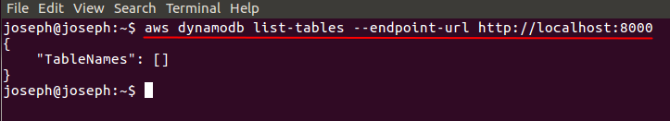

*
create local dynamodb table by aws dynamodb create-table command or GUI dynamodb-admin app

aws dynamodb create-table cmd

aws dynamodb create-table \
--table-name otalogging-local-test \
--attribute-definitions \
AttributeName=device_id,AttributeType=S \
AttributeName=sw_ver,AttributeType=S \
--key-schema AttributeName=device_id,KeyType=HASH AttributeName=sw_ver,KeyType=RANGE \
--provisioned-throughput ReadCapacityUnits=1,WriteCapacityUnits=1 \
--endpoint-url http://localhost:8000

joseph@joseph:~$ aws dynamodb list-tables --endpoint-url http://localhost:8000
{
"TableNames": [
"otalogging-local-test"
]
}

dynamodb-admin app

https://github.com/aaronshaf/dynamodb-admin

npm install -g dynamodb-admin

# For Windows:
set DYNAMO_ENDPOINT=http://localhost:8000
dynamodb-admin

# For Mac/Linux:
DYNAMO_ENDPOINT=http://localhost:8000 dynamodb-admin

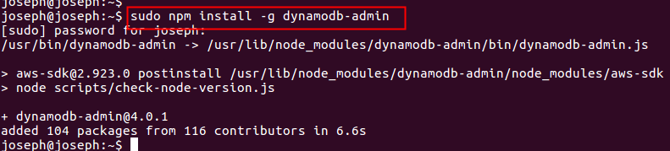

//
open any amplify folder that pulled backend environment test from the cloud.

offline test

DYNAMO_ENDPOINT=http://localhost:8000 dynamodb-admin
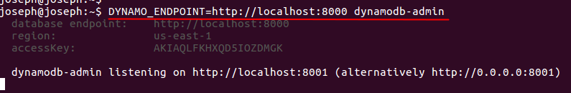

open browser to access http://localhost:8001/ to create related test table and item
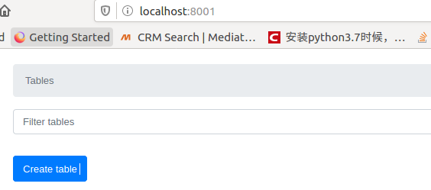

create otaupdatedb-local-test table and primary key is swver
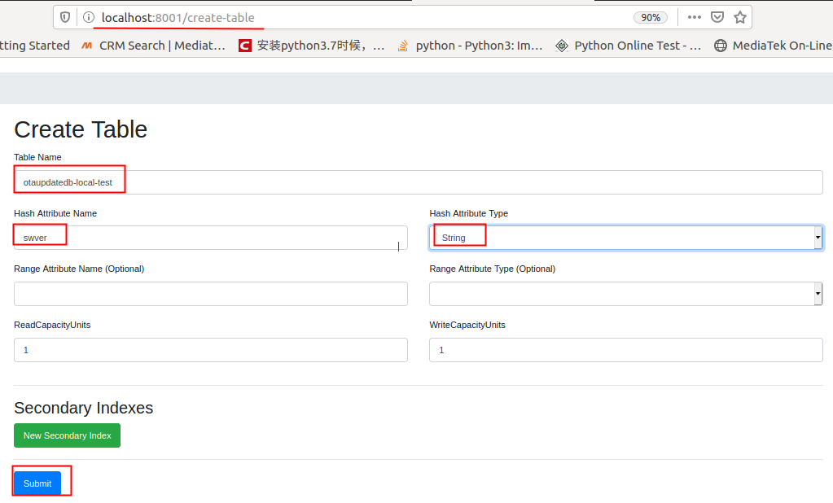

create otalogging-local-test table and primary key is device_id and sw_ver
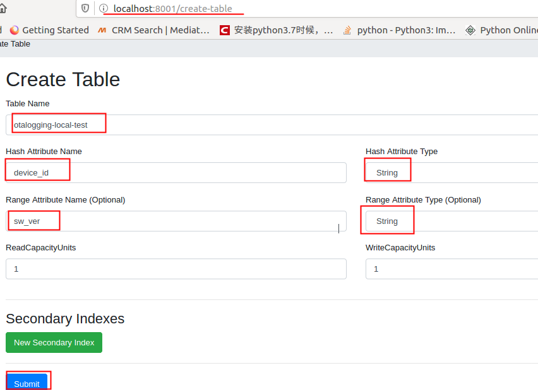

create test item in otaupdatedb-local-test table

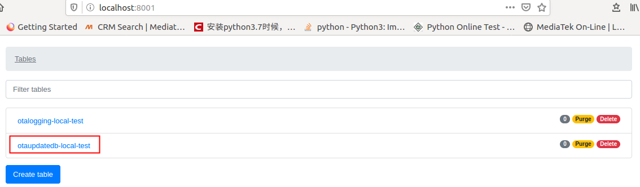

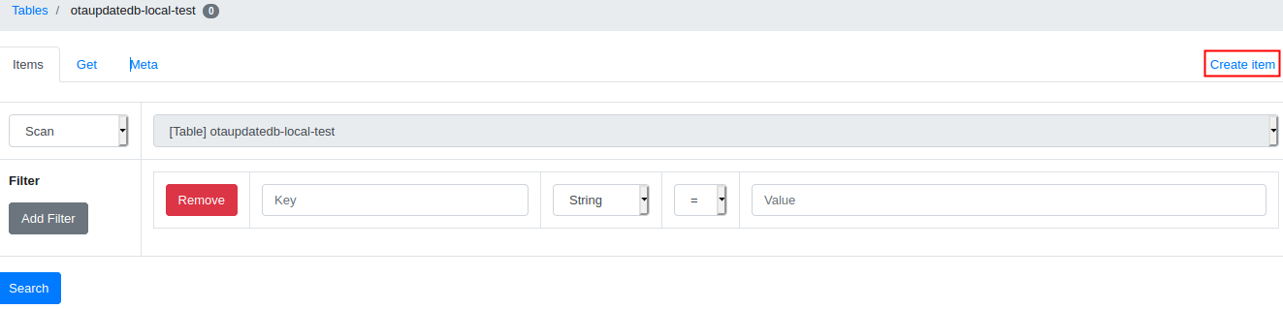

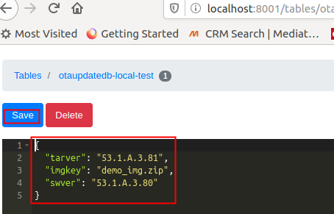

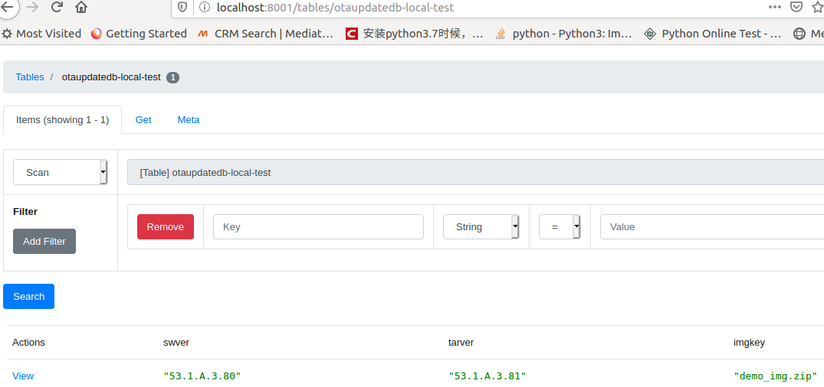

*
open the amplify folder
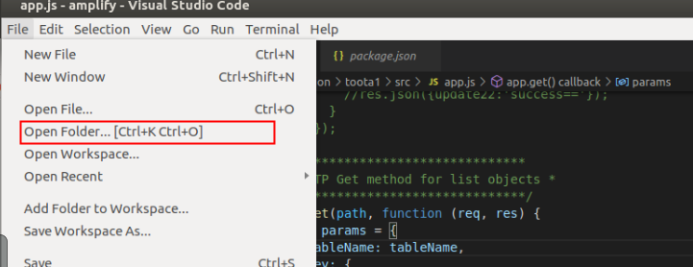

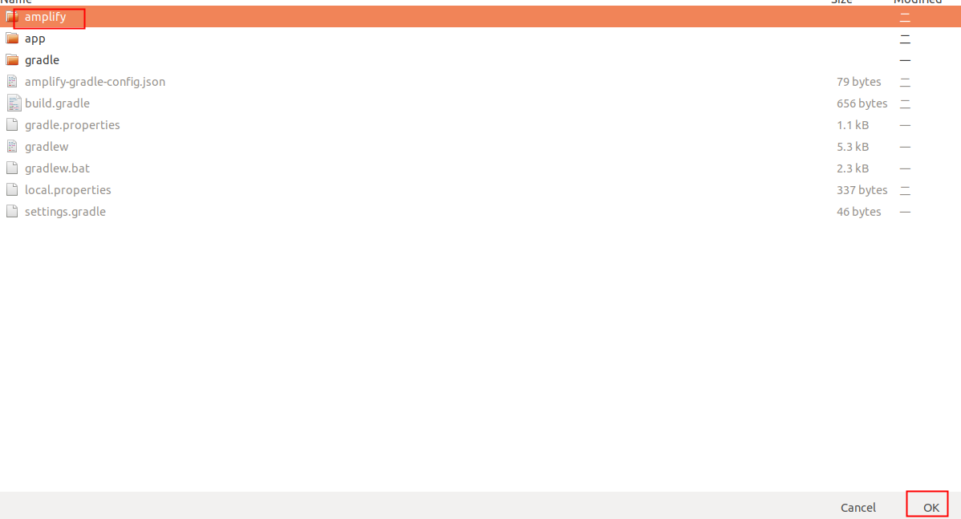

*
open app.js file
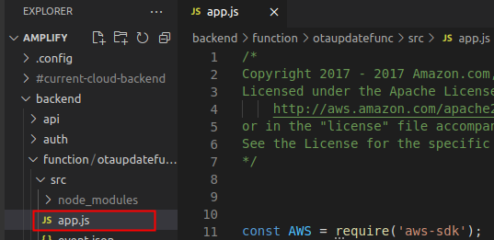

*
modify app.js file for Postman tool test

const AWS = require('aws-sdk');
AWS.config.update({
region: "us-east-1",
endpoint: "http://localhost:8000"
});
var awsServerlessExpressMiddleware = require('aws-serverless-express/middleware')
var bodyParser = require('body-parser')
var express = require('express')

//AWS.config.update({ region: process.env.TABLE_REGION });

const dynamodb = new AWS.DynamoDB.DocumentClient();

let tableName = "otaupdatedb-local-test";
let loggingTable = "otalogging-local-test";
// let tableName = "otaupdatedb";
// if(process.env.ENV && process.env.ENV !== "NONE") {
// tableName = tableName + '-' + process.env.ENV;
// }

// let loggingTable = "otalogging";
// if(process.env.ENV && process.env.ENV !== "NONE") {
// loggingTable = loggingTable + '-' + process.env.ENV;
// }
..
..
function requestlogging(req, res, otaupdatedbData) {
var params = {
TableName: loggingTable,
Key: {
device_id: req.body.uuid,
sw_ver: req.body.swver
}
};

dynamodb.get(params,(err, data) => {
if (data.Item) {
//record column req_count +1 if log record existed
var updateParams = {
TableName: loggingTable,
Key: {
"device_id": req.body.uuid,
"sw_ver": req.body.swver
},
UpdateExpression: "SET req_count = req_count + :incr, date_time = :date_time, tar_ver = :tar_ver",
ExpressionAttributeValues: {
":incr": 1,
":date_time": new Date().toISOString().slice(0, 10),
":tar_ver": otaupdatedbData.tarver
},
ReturnValues: "UPDATED_NEW"
};
dynamodb.update(updateParams, (err, data) => {
if (err) {
console.log("otalogging update failed!")
} else {
console.log("otalogging update succeed!")
}
//update otalogging req_count column success and
//return swver,tarver,imgkey if info in otaupdatedb
//res.json(otaupdatedbData);
res.status(200).send(otaupdatedbData);
});
} else {
//put a new record if log record not existed
var putParams = {
"device_id": req.body.uuid,
"sw_ver": req.body.swver,
"req_count": 1,
"tar_ver": otaupdatedbData.tarver,
"upgrade_status": "",
"date_time": new Date().toISOString().slice(0, 10)
};
let putItemParams = {
TableName: loggingTable,
Item: putParams
}
dynamodb.put(putItemParams, (err, data) => {
if (err) {
console.log("otalogging update failed!")
} else {
console.log("otalogging update succeed!")
}
//insert a new record to otalogging success and
//return swver,tarver,imgkey if info in otaupdatedb
//res.json(otaupdatedbData);
res.status(200).send(otaupdatedbData);
});
}
});
}
..
..
app.get(path, function(req, res) {
var params = {
TableName: tableName,
Key: {
swver: req.body.swver
}
};

dynamodb.get(params,(err, data) => {
if (err) {
res.statusCode = 500;
res.json({error: 'Could not load items: ' + err.message});
} else {
if (data.Item) {
requestlogging(req, res, data.Item);
} else {
requestlogging(req, res, data);
}
}
});
});

..
app.put(path + updateStatusPath, function (req, res) {
var updateItemParams = {
TableName: loggingTable,
Key: {
"device_id": req.body.uuid,
"sw_ver": req.body.swver
},
UpdateExpression: "set upgrade_status = :status, date_time = :date_time",
ExpressionAttributeValues: {
":status": req.body.status,
":date_time": new Date().toISOString().slice(0, 10)
},
ReturnValues: "UPDATED_NEW"
};

dynamodb.update(updateItemParams, (err, data) => {
if (err) {
res.statusCode = 500;
//res.json({ error: 'report upgrade status error: ' + err.message });
res.status(500).send('report upgrade status error: '+ err.message);
} else {
//res.json({ success: 'report upgrade status succeed!', data: data });
res.status(200).send(data);
}
});
});

*
Do the node app.js to get the app running on local host
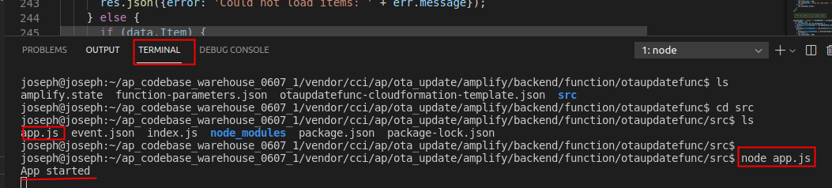
*
unzip Postman-linux-x64-8.5.1.tar.gz and open Postman
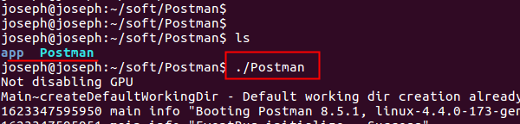

*
make sure the Postman in sign out state
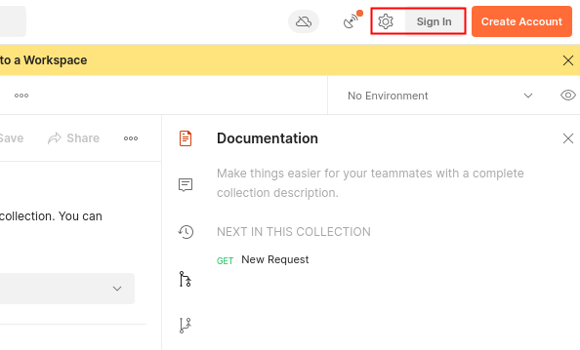

*
Tap the New Request
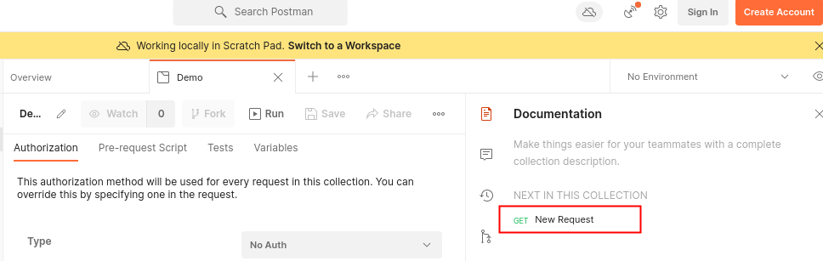

*
fill in http://localhost:3000/upgraderequest for GET request test

select Content-Type and application/json in Headers tab

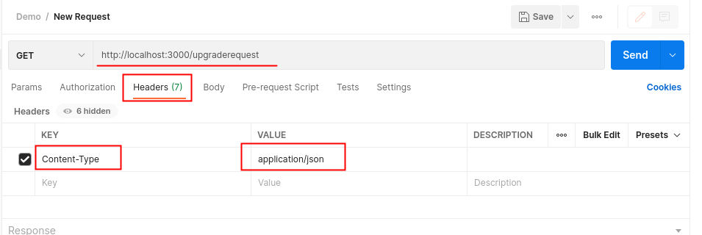

*
select raw item in Body tab and fill in test json data

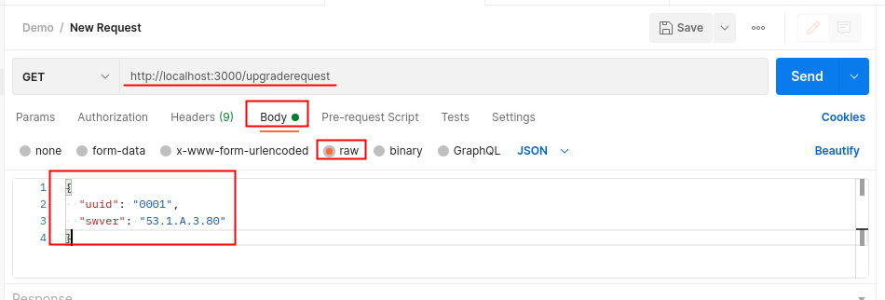

*
tap Send button and get test result in Raw or Preview window
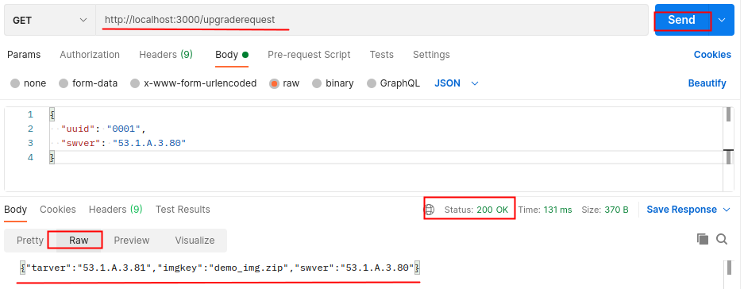

*
make sure the GET test result in dynamodb-admin

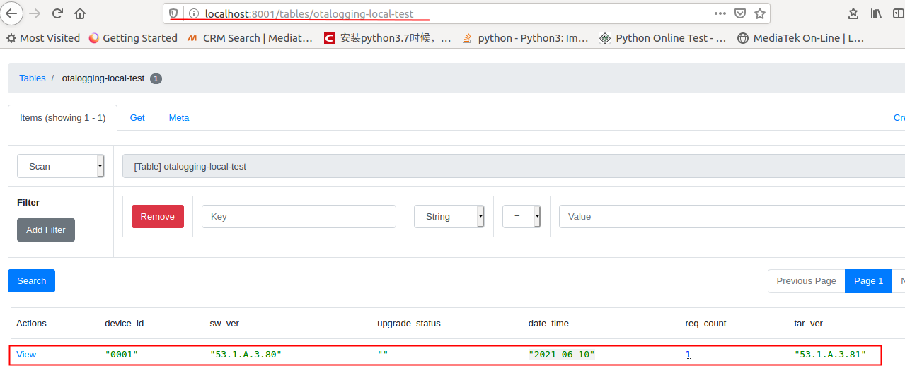

*
fill in http://localhost:3000/upgraderequest/updatestatus for PUT request test

select Content-Type and application/json in Headers tab

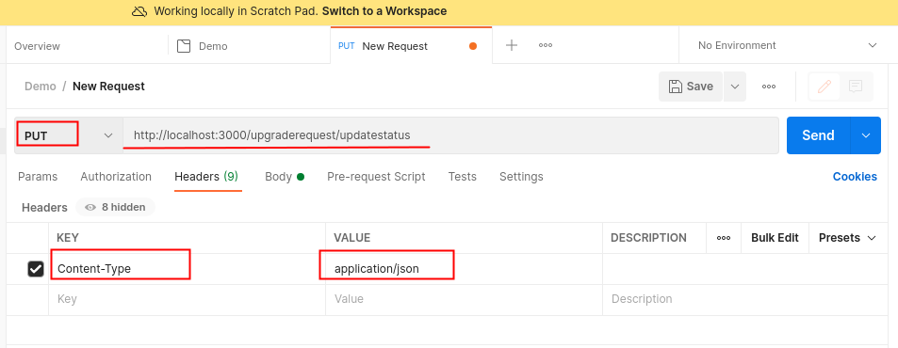

*
select raw item in Body tab and fill in test json data
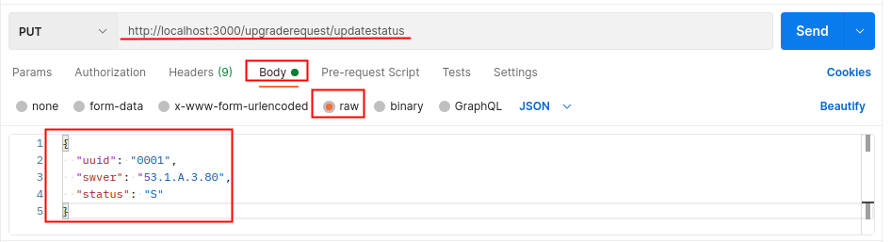

*
tap Send button and get test result in Raw or Preview window

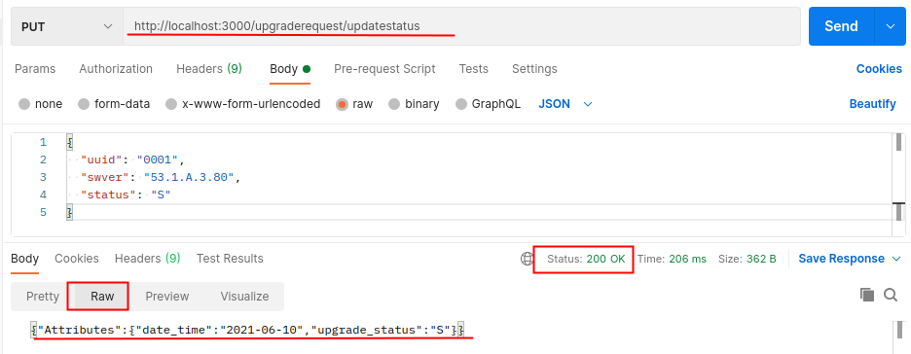

*
make sure the PUT test result in dynamodb-admin

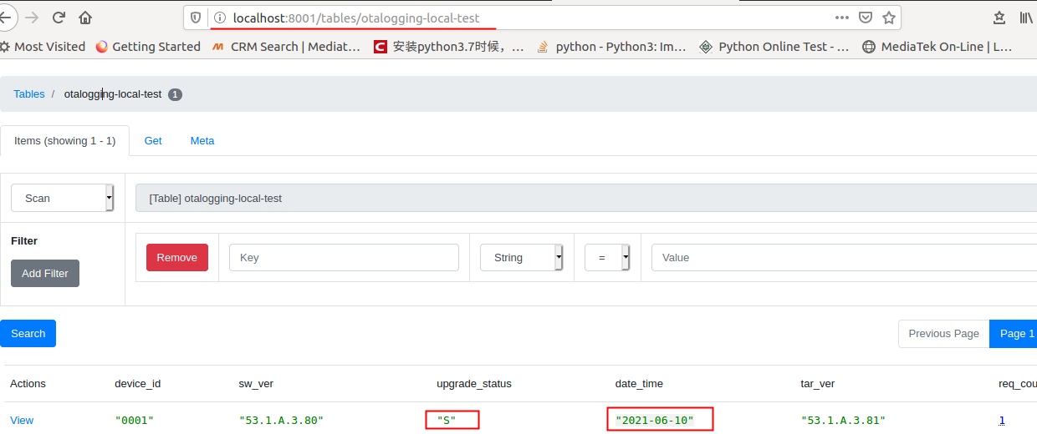

*
The console.log in app.js will be appeared in the Visual Studio Code terminal console

EX:
