HOME (Why We Exist)

Why do smart people get into debt?
What does money mean to you?
How do you make your money decisions?
Why do many couples fight over money matters?
How can you change your relationship with money?

Money – to some, it is only a medium of exchange. Yet to others, it is a symbol of power, pleasure or even as a tool to enhance relationships. Some people fuss over it, others avoid thinking too hard about it or planning for their future with it.

Our relationship with money really tells us a lot of about how we look at life. Therefore, understanding how we think and feel about money can be the start of an exciting journey of self-discovery and even personal transformation. This is why we built MoneyLiFE™.


Designed with you in mind, MoneyLiFE™ also is a tool that will help individuals, practitioners (e.g. counsellors, financial coaches & planners) and even organisations (like human resource, family life, educational or religious institutions etc) add value to people they serve and create meaningful conversations.

Whether you are an individual, a practitioner or even representing an organisation or movement, you can begin an exciting journey with us today! Just click here to find out more!

ABOUT US (Who We Are)

MoneyLiFE™ Personality Profiling is the brainchild of a winning partnership between two industry experts in the fields of psychology and financial services – Dr Danny Ng and Bernard Lim. With a combined expertise of more than 50 years in psychological & financial counselling, planning and coaching, they discovered that not many people understand enough about the way they think and feel about money. Moreover, many practitioners in the fields of counselling, coaching and planning (especially financial) were making recommendations overlooking the psychological make-up (thoughts and feelings) of their clients.

The missing link was a tool that would help put the ‘cart before the horse’ – getting to know a client’s thoughts and feelings before anything else. Hence after many months of discussion, development and testing, the MoneyLiFE™ Personality Profile was born. Here is more about the co-developers:


Dr Danny Ng is a clinical psychologist in private practice and is the Clinical Director of Renovaré Pte Ltd; an organization that serves to provide holistic care and counselling to the community by promoting authentic growth in people and relationships. In his clinical work, he is also involved in the research in the impact and effects of technology on the individual, family system and society. He is a published researcher and sits on several advisory boards relating to counselling.

Apart from his clinical practice for more than 30 years, he is actively involved in promoting holistic counselling since 1993; where the practice of counselling must go beyond clinically competency. He is the founder of Family Connexion, a non-profit organisation whose focus lies in promoting a greater bonding and deepening of relationships between people, especially within the family.

Dr Ng speaks at many seminars, conferences, and chairs the WCCA (Wholistic Christian Counselling in Asia – since 2004) conference, organised by Family Connexion. He is also a clinical supervisor to several agencies and institutions and acts as a resource person to the media and extends member care support to mission organisations.


Bernard Lim CFP® CSFE® AFCouns® is Chief Executive of Wealth College (division of Wealth Hub Pte Ltd). With about 30 years of experience in the financial services industry, he has extensive experience in training and coaching practitioners in counselling and financial planning all over the world. To date, more than 10,000 practitioners have been trained through his highly practical and engaging sessions.

He has designed and delivered highly-rated courses ranging from broad-based financial education & counselling to specialized subjects like estate planning. His L.i.F.E. - Living in Financial Excellence® Program have received rave reviews from attendees around the world including the well-respected Personal Finance Employee Education Foundation (US). His financial counselling programs have been extremely well-received by the civil service while his Estate & Legacy planning training has reached financial service professionals through banks, insurers and independent financial advisers consistently achieving more than 90% rating in attendee feedback.

Bernard is also in constant demand for speaking engagements through private & public organisations and professional bodies around the world – from Jakarta, Taipei, Dubai to Vancouver. He is adjunct of the Singapore Management University’s Financial Training Institute and a certified transformational life coach. He has also been interviewed on the Business Times, the Straits Times, 93.8 Live and Channel 5’s Common Cents. He is a member of the Association for Financial Counselling & Planning Education (US) and the founder & president of the FinCARE® (Financial Counselling, Aid & Resilience Education) – a community services initiative of the financial services industry.

PRODUCTS & SERVICES (What We Do and How It Works)

Why MoneyLiFE™ ?
The subject of money has often been one shrouded with some mystery. While much effort has been invested in bringing about financial ‘literacy’ to the masses (and rightly so), it has often marginal impact on lasting changes in financial habits that can bring about financial wellness. One explanation is that little is known about the psychology of how people think and feel about money (otherwise known as financial psychology) in the first place.

Moreover, many people do not seem to make clear connections between their money and the rest of the life. The fact is that there is an inseparable connection between the way a person thinks and feels about money and how he/she ultimately uses it (through savings, investments, giving etc).

This creates a gap between what they want to achieve financially and where they are today. The basis for creating a financial wellness journey is not about just knowing WHERE YOU ARE (Current Position) and WHERE YOU WANT TO BE (Goal-Setting) or even HOW YOU ARE GOING TO GET THERE (Planning) but starts with knowing WHO YOU ARE (Self-Knowledge).

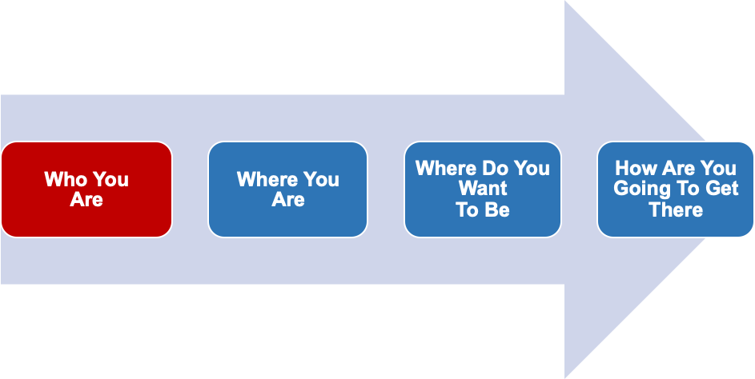
Self-Knowledge
Current Position
Goal Setting
Planning
Having engaged thousands of people over the years of practice (counselling and financial planning), we are fully convinced that awareness comes before change. MoneyLiFE™ was developed to serve this purpose – helping people understand their ‘financial psychology’.

How does MoneyLiFE™ work?

MoneyLiFE™ is a proprietary web-based profiling system based on many years of expertise in psychological assessments and financial life coaching. Through a unique algorithm, that helps to identify 5 main personality ‘types’ based on a series of psychologically based way of questioning. In a nutshell, the ‘types’ are:

Adventurers - those who have the propensity to take risks


Nesters - those who have the propensity to save



Managers - those who have the propensity to manage



Influencers - those who have the propensity to give



Hunters - those who have the propensity to spend
There is no one ‘type’ of personality which is superior or preferred to the other. Each one has it own potential strengths and pitfalls. Neither is any person 100% of a specific personality ‘type’.

To explain the specific diversities of ‘financial psychology’, each of these ‘types’ in turn refined by 6 ‘dimensions’ of a person’s thoughts and feelings towards money. These are:

- Attitude
- Lifestyle
- Relationships
- Social Responsibility
- Security
- Identity

Therefore, the permutations of profiles can be significant which is far better than ‘pigeon-holing’ people into broad categories. When ‘self-knowledge’ of individual financial psychology is available, the journey towards financial wellness becomes more meaningful. Whether MoneyLiFE™ is used in a personal or inter-personal setting (like financial counselling, coaching or planning), there is value in understanding what goes on the in the minds and hearts of people concerning money.

Who should use MoneyLiFE™?

For Practitioners
According to the Edelman Trust Barometer 2018, financial services are ranked the lowest among all other industries in terms of public trust. Unfortunately, financial services practitioners have a ‘reputation’ of only wanting to ‘sell’ financial products and often miss the opportunity to engage prospects and clients in a more meaningful way.

Many financial services practitioners are trained to conduct ‘Know Your Client’ (KYC) only as filling a Fact-Finder. Fact-finding often delves into the realm of ‘Where Are You’ now but the ‘Who Are You’ is left to either a lot of guesswork or through numerous interactions. As a result, a lot of time is wasted speaking the ‘wrong’ psychological language of the prospective client (or client). Moreover, the interaction strategy can become ‘cookie-cutter’. Prospective clients (or clients) are then left with the feeling of being ‘sold’ rather than being ‘understood’. This creates unnecessary suspicion of the practitioner.

MoneyLiFE™ was designed to help bridge the ‘Trust Gap’ between the prospective client (or client) and a practitioner (financial counsellor, coach or planner). By putting relevant and valuable psychological insights into the hands of competent, credible and caring practitioners, it becomes a powerful tool in creating meaningful conversations and more focused interactions. In understanding how a person thinks and feels, his or her attitudes and motivations towards money, the foundation of a trust-based relationship can be developed.
In a nutshell, MoneyLiFE™ can practitioners:
- Shorten the getting-to-know you process
- Create connections more quickly
- Assist in speaking the ‘psychological’ language of a client
- Focus on key issues
- Become better and more complete in the KYC process
- Bridges the ‘Trust Gap’ and builds trust

For Organisations
The potential benefits of the MoneyLiFE™ to organisations are numerous. Depending on the purpose of deploying psychological assessments, MoneyLiFE™ can be an extremely useful tool in a variety of situation including:

Human resource (recruitment, selection or employee benefits)
- Amidst the battery of psychological assessments often administered by companies in recruitment and selection, there is hardly a tool available that can help assess the motivations of a staff concerning money. Yet, concerns about money often determine the level of productivity among employees. Moreover, in the war for talent, companies are having to find innovative ways to recruit and retain staff. MoneyLiFE™ can be a useful tool in the hands of HR for recruitment, selection and/or employee benefits.

Social service (counselling and coaching)
- Social service professionals will often admit that a large percentage of people they counsel (often have issues with money). Yet, conversations surrounding money are never easy to approach. As people often express the way they think and feel about life through how they use money, knowledge of a client’s financial psychology through MoneyLiFE™ and even simple ideas and strategies available present an opportunity to get beyond superficial change to more lasting transformation.

Education (financial literacy, wellness and work-life readiness)
- While educational institutions often prepare students to be work-ready, it often lacks in preparing them to be life-ready. Moreover, financial literacy programs (if available) often delve into the mechanics of money management bypassing an all-important aspect self-knowledge – how people think and feel about money in the first place. MoneyLiFE™ does not replace financial literacy programs, it enhances these programs by helping students understand their money motivations and preferences.

Family (pre-marriage preparation and marriage enrichment)
- Statistics have often suggested that money matters can become big issues in marriages – sometimes even ending in divorce when disagreements escalate beyond redemption. It is not easy for two people who hold different views towards money try to live together and make it work. Even when psychological tools are used for pre-marriage (or marriage) programs, the money issue is often glazed through. MoneyLiFE™ become a valuable tool to promote understanding in a couple’s relationship thus avoiding unnecessary marital conflict.

Religious institutions (teaching and discipleship)
- There are well-known sayings like ‘the love of money is a root to all kinds of evil’ and ‘where your treasure is, there your heart will be also’. These are religious teachings which can go a long way in shaping a person’s ‘worldview’ towards money. But what worldview a person hold in the very place can be the key to transforming his or her way of thinking. MoneyLiFE™ offers an amoral assessment of a person’s worldview – his or her thoughts and feelings – towards money and suggests strategies for transformation.

NEWS (Articles & Media Releases)

Changing Your Mindset To Adopt Better Money Habits
https://www.areyouready.sg/YourInfoHub/Pages/News-Changing-your-mindset-to-adopt-better-money-habits-SUT20180826.aspx

What is Financial Psychology?
https://www.health24.com/Lifestyle/Health-and-your-money/Retirement/What-is-financial-psychology-20120721

The Psychology of Money
https://www.collaborativefund.com/blog/the-psychology-of-money/

The Big Lie About Personal Finance
https://www.psychologytoday.com/intl/blog/mind-over-money/201001/the-big-lie-about-personal-finance

3 Ways Your Money Psychology Is Hurting You Financially
https://www.forbes.com/sites/jaimecatmull/2018/09/28/3-ways-your-money-psychology-is-hurting-you-financially/#7483b39b52a1

Willpower, Finance and Spending
https://www.apa.org/helpcenter/willpower-finances

How Psychology of Money Affects Your Wealth
https://www.todayonline.com/business/how-psychology-money-affects-your-wealth

The Psychology Of Unethical Behaviour In The Finance Industry
https://ink.library.smu.edu.sg/cgi/viewcontent.cgi?article=6029&context=lkcsb_research

CONTACT US (How to Partner Us)

If you wish to know more about how MoneyLiFE™ can add value to your professional practice, your organisation or movement, please complete the form below and tell us more about yourself. We will get back to you in a jiffy!

Name :
Organisation :
Email :
Contact Number :
Comments :

EMAIL CAMPAIGN

Ravi Menon speech
http://heshenchow.blogspot.com/2011/11/how-singapore-uses-behavioural.html

How to improve ‘clickability’ (bridging the curiosity gap)
https://www.wordstream.com/blog/ws/2017/04/10/curiosity-gap

how much info should you give for good email conversion

