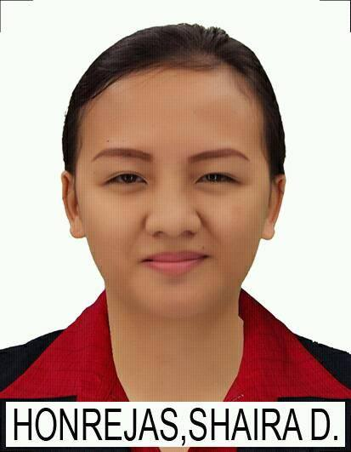**HONREJAS, SHAIRA DE LEON**

BLK 5 LOT 50 Phase A, the Istana Subd., Malagasang 1-F, Imus Cavite

09983669930

[honrejasshaira@gmail.com](mailto:honrejasshaira@gmail.com)

**To be able to work, enhance my skills and my experience.**

**PERSONAL DATA:**

**Age:** 24 **Gender:** Female

**Birth date:** September 5, 1998 **Marital Status:** Single

**Birth place:** Mapuyo, Kawayan, Biliran

**EDUCATIONAL ATTAINMENT:**

**Year Name of Institution**

2016-2018 GenRev Institute of Science and Technology

(Vocational Degree)

Information Technology

Magna Cum Laude

**INTERESTS AND SKILLS:**

* Knowledgeable in basic Microsoft applications
* Computer Literate
* Leadership skills
* Knowledgeable in C++, VB 6.0 and HTML, PHP, MySQL, VB .Net
* Knowledgeable in Javascript, Bootstrap5, Laravel, NodeJs, ReactJs, Git
* Knowledgeable in Photoshop and Troubleshooting
* Can type 35 wpm
* Time Management
* Answering Phone Calls
* Data Entry
* Multi-Tasking
* Great in debugging

**TRAINING:**

* Office Staff (OJT) - GenRev Institute of Science and Technology
* Contact Center Services NC II (passer)
* Computer System Servicing NC II (passer)
* Call Center Training (passer)
* KODEGO Bootcamp – Full Stack Web developer (May 9, 2023)
* Awarded as a best website in mini project 1 and one of the top 5 students in class

**WORK EXPERIENCES:**

* Student Assistant University of Baguio October 2015- May 2016
* School Secretary GenRev Institute of February 2018 – July 2018

Science and Technology

* Call Center Representative IQOR SM Dasma February 11 2019 - January 2021
* Call Center Representative Teletech MOA February 2021 - June 2021
* Call Center Representative IQOR SM Dasma March 2022 - October 2022

**CHARACTER REFERENCES:**

* **Mr. Brix Panilagao**

Customer Service Supervisor

IQOR Dasma

09357177973

* **Ms. Nomilee Myrah S. Bruel**

School Treasurer

GenRev Institute of Science and Technology

09104550088

09356251260

* **Ms. Cielito Palacio**

Instructor

KODEGO

09205625085

*I hereby certify that all the information that was entered above are true and correct to the best of my knowledge and below.*

**SHAIRA D. HONREJAS**

Applicant