Development, Validation, and Deployment of Prediction Models for Hospital Mortality, Intensive Care Unit Mortality, and Duration of Mechanical Ventilation for 37 Intensive Care Units across 14 Hospitals in the UPMC Health System

Contents
Additional Supplemental Tables 3
Supplement Abstract 17
Background and Motivation for Developing Models 18
Supplemental Model Methods 19
Overview 19
Data Curation 19
eGOSSIS Validation and Deployment 20
Mortality Model Benchmark Comparison 20
UPMC Mortality Model Development, Validation, and Deployment 21
UPMC Duration of Mechanical Ventilation Model Development, Validation, and Deployment 21
Predicted Duration of Mechanical Ventilation Models using a Multiple Classification Approach 22
Bias Assessment and Cluster Analysis 23
Software Colophon 23
Model Performance Results 24
Cohort Ascertainment for Mortality Models 24
Predictors in Development (Train) and Test Cohorts for the UPMC Mortality Model 28
Predictors in the Pre-Implementation (Baseline) and Post-Implementation Cohorts for the 14-day Duration of Mechanical Ventilation Models 38
Predictors in the Pre-Implementation (Baseline) and Post-Implementation Cohorts for the 6-day, Multiple Classifier Duration of Mechanical Ventilation Models 42
eGOSSIS Performance and Benchmark Comparison 47
eGOSSIS Performance 47
Comparison of eGOSSIS with the Vizient Hospital Mortality Model 50
UPMC Mortality Model Performance 54
UPMC Duration of Mechanical Ventilation Models Performance 57
Actual versus Predicted Duration of Mechanical Ventilation Results 65
Bias Assessment and Cluster Analysis 65
Results Synthesis and Deployment Readiness Assessment 66
Deployment 67
UPMC ICU Service Center Structure 69
References 70
Collaborators 72
Realyze Intelligence 72
University of Pittsburgh Department of Critical Care Medicine Quality Improvement Committee 72
UPMC Clinical Analytics Team 72
UPMC Clinical Documentation Capture Team 72
UPMC eRecord Team 72
UPMC Wolff Center 72
Vizient Incorporated 72
Others 72

Additional Supplemental Tables
Supplemental Table 1. SQUIRE 2.0 checklist
SQUIRE 2.0 Checklist
Item Name | Description | Page
Title and Abstract
Title | Indicate that the manuscript concerns an initiative to improve healthcare (broadly defined to include the quality, safety, effectiveness, patient-centeredness, timeliness, cost, efficiency, and equity of healthcare) | 1
Abstract | a. Provide adequate information to aid in searching and indexing  b. Summarize all key information from various sections of the text using the abstract format of the intended publication or a structured summary such as: background, local problem, methods, interventions,  results, conclusions | 2
Introduction – Why did you start?
Problem description | Nature and significance of local problem | 3
Available knowledge | Summary of what is currently known about the problem, including relevant previous studies | 3
Rationale | Informal or formal frameworks, models, concepts, and/or theories used to explain the problem, any reasons or assumptions that were used to develop the intervention(s), and reasons why the intervention(s) was  expected to work | 3
Specific aims | Purpose of the project and of this report | 3
Methods – What did you do?
Context | Contextual elements considered important at the outset of introducing the intervention(s) | 4, Supplement
Intervention(s) | a. Description of the intervention(s) in sufficient detail that others could  reproduce it  b. Specifics of the team involved in the work | 4, Supplement
Study of the  Intervention(s) | a. Approach chosen for assessing the impact of the intervention(s)  b. Approach used to establish whether the observed outcomes were due to the intervention(s) | 4, Supplement
Measures | a. Measures chosen for studying processes and outcomes of the intervention(s), including rationale for choosing them, their operational definitions, and their validity and reliability  b. Description of the approach to the ongoing assessment of contextual elements that contributed to the success, failure, efficiency, and cost  c. Methods employed for assessing completeness and accuracy of data | 4, 5, Supplement
Analysis | a. Qualitative and quantitative methods used to draw inferences from the data  b. Methods for understanding variation within the data, including the effects of time as a variable | 5, 6, Supplement
Ethical considerations | Ethical aspects of implementing and studying the intervention(s) and how they were addressed, including, but not limited to, formal ethics review and potential conflict(s) of interest | 3, 4
Results – What did you find?
Results | a. Initial steps of the intervention(s) and their evolution over time (e.g., time-line diagram, flow chart, or table), including modifications made  to the intervention during the project  b. Details of the process measures and outcome  c. Contextual elements that interacted with the intervention(s)  d. Observed associations between outcomes, interventions, and relevant contextual elements  e. Unintended consequences such as unexpected benefits, problems, failures, or costs associated with the intervention(s).  f. Details about missing data | 6, 7, Supplement
Discussion – What does it mean?
Summary | a. Key findings, including relevance to the rationale and specific aims  b. Particular strengths of the project | 7, 8, Supplement
Interpretation | a. Nature of the association between the intervention(s) and the outcomes  b. Comparison of results with findings from other publications  c. Impact of the project on people and systems  d. Reasons for any differences between observed and anticipated outcomes, including the influence of context  e. Costs and strategic trade-offs, including opportunity costs | 8, Supplement
Limitations | a. Limits to the generalizability of the work  b. Factors that might have limited internal validity such as confounding, bias, or imprecision in the design, methods, measurement, or analysis  c. Efforts made to minimize and adjust for limitations | 8, Supplement
Conclusions | a. Usefulness of the work  b. Sustainability  c. Potential for spread to other contexts  d. Implications for practice and for further study in the field  e. Suggested next steps | 8, Supplement
Funding
Funding | Sources of funding that supported this work. Role, if any, of the funding organization in the design, implementation, interpretation, and reporting | N/A

Supplemental Table 2. Digital quality measures, the associated definition, and a detailed explanation of the related programming logic.
Metric | Definition | Logic
Spontaneous Breathing Trial (SBT) | $$\frac{\begin{aligned}Number of days a spontaneous \\ breathing trial completed\end{aligned}}{Number of days eligible for a breathing trial}$$ | Eligible days included day 2 or greater of mechanical ventilation.  SBTs were considered contraindicated (and therefore the patient-day was ineligible) if any of the following criteria were met and documented in association with SBT documentation:  - PEEP > 8 cmH₂O to maintain S_{p}O₂ >90%  - F_{i}O₂ >0.5 to maintain S_{p}O₂ >90%  - Chronic ventilator dependent respiratory failure  - Norepinephrine dose >0.2 mcg/kg/min  - Continuous sedative infusion  - Receiving neuromuscular blockade  - Intracranial pressure >20 mmHg  - Cardiac assist device  - Clinician order
Spontaneous Awakening Trial (SAT) | $$\frac{\begin{aligned}Number of days a spontaneous \\ awakening trial completed\end{aligned}}{Number of days eligible for an awakening trial}$$ | Eligible days included both day 2 or greater of mechanical ventilation and day 2 or greater of receiving a continuous infusion of one of the following sedatives:  - propofol  - ketamine  - midazolam  - lorazepam  - dexmedetomidine  SATs were considered contraindicated (and therefore the patient-day was ineligible) if any of the following criteria were met and documented in association with SAT documentation:  - Intracranial pressure >20 mmHg for > 5 min  - Receiving neuromuscular blocks  - Open chest  - Clinician order
Low-Tidal Volume Ventilation (LTVV) | $$\frac{\begin{aligned}Number of days the average patient-day \\ tidal volume was under 8 ml/kg\end{aligned}}{\begin{aligned}Number of patient-days of \\ mechanical ventilation\end{aligned}}$$ | Set tidal volume was included in the calculation of average patient-day tidal volume for the following ventilator modes:  - Pressure regulated volume control  - Volume control  - Volume support  Exhaled tidal volume was included in the calculation of average patient-day tidal volume for pressure control modes.

Supplemental Table 3. The collective results of post-implementation reviews of previous quality improvement work at UPMC focusing on improving adherence to ventilator management best practices.
Lesson Learned | Subsequent Implementation Practice
Close partnerships with clinical leadership from multiple disciplines is necessary to ensure a successful launch and ongoing success of a quality improvement program. | Leadership representatives from medicine, nursing, and respiratory therapy are present at biannual meetings with individual intensive care units and serve as accountable points of contact for program related workflows.
Clinical decision support embedded in electronic health record systems is an effective tool for directing clinical practice in a desired direction. | Quality improvement workflows are closely coupled with ordersets and required documentation that can be iteratively audited for feedback purposes.
Clinical stakeholders are responsive to timely, accurate, and readily accessible data. | A dashboard hosting key quality metrics is available to clinical leadership on demand; data refresh monthly.
Metrics need to be broadly applicable to varied environments and workflows. | Widely applicable metrics supported by a strong evidence base were chosen and the related workflows, including electronic documentation and related data capture, were harmonized across sites.
Simple and interpretable summary data presented alongside peers’ data are important to convey meaningful information about performance. | The dashboard presents a site’s data alongside all other sites’ identifiable data. Metrics are presented with simple color-coding representing performance (red = poor performance, yellow = marginal performance, green = acceptable performance).
Providing access to patient-level data behind the metrics is necessary to allow clinical leaders to drill-down into their data and identify improvement opportunities in their sites’ workflows. | Select clinical leaders have access in the dashboard to the curated table of patient-level data that are used to calculate summary metrics. The table contains necessary identifiers to allow patient chart review to hone in on potential opportunities for improvement.
Manual data collection and presentation is both time and resource intensive. | Informatics best practices were adopted to automate data extraction, transformation, and loading into the dashboard, allowing the quality improvement program to scale across the entire UPMC system.
Accounting for patient illness severity is necessary in order to accurately benchmark efforts and improve clinician buy-in. | Robust risk-adjustment models were developed, validated, and deployed using informatics best practices to support data interpretation.

Supplemental Table 4. Summaries and related references for previous A-F bundle quality improvement initiatives across the UPMC ICUs.
Bundle Component | Previous Quality Improvement Program at UPMC ICUs
Assess, prevent, and manage pain | A dedicated mechanical ventilation sedation-analgesia order set (Cerner PowerPlan) was released in 2017 and updated in 2021, single analgesia orders, and nursing documentation of Critical Care Pain Observation Tool scores in adherence to Joint Commission standards were detailed in education provided to all ICUs in 2017 and again in 2021, along with an official UPMC policy on the organization’s intranet.¹  EHR displays the 5 most recent pain scores, active pain medications ordered, and any pain medications administered in the previous 24 hours.
Perform Both spontaneous awakening trials and spontaneous breathing trials | See the main manuscript text for implementation details.  EHR displays sedation interruptions and breathing trials for the present and preceding 3 days.
Choose the right analgesia and sedation regimens | The dedicated sedation-analgesia orderset (see component A above), single sedation orders, and nursing documentation of Riker Sedation Agitation scores in adherence to Joint Commission standards were detailed in education provided to all ICUs in 2017 and again in 2021, along with an official UPMC policy on the organization’s intranet.²  EHR displays Riker scores for the past 24 hours and active sedation medication orders.
Delirium assessment, management, and prevention | Delirium is assessed twice per calendar day using the Intensive Care Delirium Screening Checklist (ICDSC) which accounts for a patient’s level of sedation as measured by the Riker score.³  EHR displays delirium scores for the present and preceding 3 days, active antipsychotic medication orders, and antipsychotic medication administrations within the past 24 hours.
Early mobility and exercise | Early mobility is documented daily using the Johns Hopkins Highest Level of Mobility (JH-HLM) Scale.⁴  EHR displays the JH-HLM scores for the present and preceding 3 days.
Family engagement and empowerment | Family engagement and empowerment efforts in the UPMC ICU Service Center have been reported previously in detail.⁵  The EHR displays the date and time of the 5 most recent family meetings.
Abbreviations: EHR, electronic health record; ICU, intensive care unit.

Supplemental Table 5. Transparent reporting of multivariable prediction models developed or validated using clustered data (TRIPOD Cluster) checklist.
TRIPOD Cluster Checklist
Item # | Description | Page
Title and abstract
1 | Identify the study as developing and/or validating a multivariable prediction model, the target population, and the outcome to be predicted | Supplement
2 | Provide a summary of research objectives, setting, participants, data source, sample size, predictors, outcome, statistical analysis, results, and conclusions. | Supplement
Introduction
3a | Explain the medical context (including whether diagnostic or prognostic) and rationale for developing or validating the prediction model, including references to existing models, and the advantages of the study design. | Supplement
3b | Specify the objectives, including whether the study describes the development or validation of the model. | Supplement
Methods
4a | Describe eligibility criteria for participants and datasets. | Supplement
4b | Describe the origin of the data, and how the data were identified, requested, and collected | Supplement
5 | Explain how the sample size was arrived at. | Supplement
6a | Define the outcome that is predicted by the model, including how and when assessed. | 5
6b | Define all predictors used in developing or validating the model, including how and when measured. | Supplement
7a | Describe how the data were prepared for analysis, including any cleaning, harmonization, linkage, and quality checks. | Supplement
7b | Describe the method for assessing risk of bias and applicability in the individual clusters (e.g., using PROBAST). | 7, Supplement
7c | For validation, identify any differences in definition and measurement from the development data (e.g., setting, eligibility criteria, outcome, predictors). | Supplement
7d | Describe how missing data were handled. | Supplement
8a | Describe how predictors were handled in the analyses. | Supplement
8b | Specify the type of model, all model-building procedures (e.g., any predictor selection and penalization), and method for validation. | Supplement
8c | Describe how any heterogeneity across clusters (e.g., studies or settings) in model parameter values was handled. | Supplement
8d | For validation, describe how the predictions were calculated. | Supplement
8e | Specify all measures used to assess model performance (e.g., calibration, discrimination, and decision curve analysis) and, if relevant, to compare multiple models. | 5, 6, Supplement
8f | Describe how any heterogeneity across clusters (e.g., studies or settings) in model performance was handled and quantified. | Supplement
8g | Describe any model updating (e.g., recalibration) arising from the validation, either overall or for particular populations or settings. | N/A
9 | Describe any planned subgroup or sensitivity analysis, (e.g., assessing performance according to sources of bias, participant characteristics, setting). | 5, Supplement
Results
10a | Describe the number of clusters and participants from data identified through to data analyzed. A flow chart may be helpful. | Supplement
10b | Report the characteristics overall and where applicable for each data source or setting, including the key dates, predictors, treatments received, sample size, number of outcome events, follow-up time, and amount of missing data. | Supplement
10c | For validation, show a comparison with the development data of the distribution of important variables (demographics, predictors, and outcome). | Table 3, Supplement
11 | Report the results of the risk of bias assessment in the individual clusters. | Table 3, Supplement
12a | Report the results of any across-cluster heterogeneity assessments that led to subsequent actions during the model’s development (e.g., inclusion or exclusion of particular predictors or clusters). | Not performed
12b | Present the final prediction model (i.e., all regression coefficients, and model intercept or baseline estimate of the outcome at a given time point) and explain how to use it for predictions in new individuals. | Not applicable
13a | Report performance measures (with uncertainty intervals) for the prediction model, overall and for each cluster. | Table 3, Supplement
13b | Report results of any heterogeneity across clusters in model performance. | Table 3, Supplement
14 | Report the results from any model updating (including the updated model equation and subsequent performance), overall and for each cluster. | Not performed
15 | Report results from any subgroup or sensitivity analysis. | 8, Supplement
Discussion
16a | Give an overall interpretation of the main results, including heterogeneity across clusters in model performance, in the context of the objectives and previous studies. | 8, Supplement
16b | For validation, discuss the results with reference to the model performance in the development data, and in any previous validations. | 8, Supplement
16c | Discuss the strengths of the study and any limitations (e.g., missing or incomplete data, non-representativeness, data harmonization problems). | 8, Supplement
17 | Discuss the potential use of the model and implications for future research, with specific view to generalizability and applicability of the model across different settings or (sub)populations. | 8, Supplement
Other information
18 | Provide information about the availability of supplementary resources (e.g., study protocol, analysis code, datasets). | Supplement
19 | Give the source of funding and the role of the funders for the present study. | Not applicable

Supplemental Table 6. Prediction model Risk of Bias Assessment (PROBAST) tool checklist.
PROBAST Tool Checklist
Item and # | Description | Answer
Step 1 | Specify your systematic review question | Specified
Step 2 | Classify the type of prediction model evaluation | Specified
Step 3 | Assess risk of bias and applicability
Participants
1.1 | Were appropriate data sources used? | Yes
1.2 | Were all inclusions and exclusions appropriate? | Yes
Predictors
2.1 | Were predictors defined and assessed in a similar way for all participants? | Yes
2.2 | Were predictor assessments made without knowledge of outcome data? | Yes
2.3 | Are all predictors available at the time the model is intended to be used? | Yes
Outcomes
3.1 | Was the outcome determined appropriately? | Yes
3.2 | Was a prespecified or standard outcome definition used? | Yes
3.3 | Were predictors excluded from the outcome definition? | Yes
3.4 | Was the outcome defined and determined in a similar way for all participants? | Yes
3.5 | Was the outcome determined without knowledge of predictor information? | Yes
3.6 | Was the time interval between predictor assessment and outcome determination appropriate? | Yes
Analysis
4.1 | Were there a reasonable number of participants with the outcome? | Yes
4.2 | Were continuous and categorical predictors handled appropriately? | Yes
4.3 | Were all enrolled participants included in the analysis? | Yes
4.4 | Were participants with missing data handled appropriately? | Yes
4.5 | Was selection of predictors based on univariable analysis avoided? | Yes
4.6 | Were complexities in the data accounted for appropriately? | Yes
4.7 | Were relevant model performance measures evaluated appropriately? | Yes
4.8 | Were model overfitting, underfitting, and optimism in model performance accounted for? | Yes
4.9 | Do predictors and their assigned weights in the final model correspond to the results from the reported multivariable analysis? | Partially
Step 4 | Overall judgement | Low, though feature importance partially obscured

Supplemental Table 7. Interoperability crosswalk for the prediction models.
Variable Name | Vocabulary | Standard Vocabulary Term(s)
Acute renal failure | ICD-10 | Determined according to the presence of certain ICD-10 codes
Age | LOINC | 30525-0
Aids | ICD-10 | Determined according to the presence of certain ICD-10 codes
Albumin | LOINC | 1751-7
APACHE morbidities | ICD-10 | Determined according to the presence of certain ICD-10 codes
Arterial partial pressure of carbon dioxide | LOINC | 2019-8
Arterial partial pressure of oxygen | LOINC | 2703-7
Arterial pH | LOINC | 2744-1
Bicarbonate | LOINC | 1960-4, 2026-3, 2027-1, 2028-9, 14627-4, 16551-4, 20565-8
Bilirubin | LOINC | 1971-1, 1975-2
Blood urea nitrogen | LOINC | 3094-0, 6299-2
BMI | LOINC | 39156-5
Calcium | LOINC | 17861-6, 49765-1
Cirrhosis | ICD-10 | Determined according to the presence of certain ICD-10 codes
COVID-19 boosted | SNOMED CT | 840534001
COVID-19 positive | SNOMED CT | 840539006
COVID-19 vaccination | SNOMED CT | 840534001, 1156257007
Creatinine | LOINC | 2160-0, 21232-4, 38483-4
Diabetes Mellitus | ICD-10 | Determined according to the presence of certain ICD-10 codes
Diastolic blood pressure | LOINC | 8462-4
Elective surgery | SNOMED CT | 387713003
Fraction of inspired oxygen | LOINC | 3150-0
Gender | LOINC | 54131-8
Glasgow coma scale - eyes | LOINC | 9267-6
Glasgow coma scale - motor | LOINC | 9268-4
Glasgow coma scale - verbal | LOINC | 9270-0
Glucose | LOINC | 2345-7, 2339-0
Heart rate | LOINC | 8867-4
Height | LOINC | 8302-2
Hemoglobin | LOINC | 718-7
Hematocrit | LOINC | 4544-3
Hepatic Failure | ICD-10 | Determined according to the presence of certain ICD-10 codes
Hospital admission date and time | LOINC | 52455-3, 75522-3
Hospital discharge date and time | LOINC | 52525-3, 75523-1
Hospital length of stay | LOINC | 78033-8
ICU admission date and time | LOINC | 95367-9
ICU discharge date and time | LOINC | 95368-7
ICU length of stay | LOINC | 74200-7
Immunosuppression | SNOMED CT | 234532001, 414029004, 370388006, 370391006
INR | LOINC | 34714-6
Intubated | SNOMED CT | 40617009, 26412008
Lactate | LOINC | 2524-7
Length of stay prior to ICU admission | LOINC | 52455-3, 75522-3, 81273-1
Leukemia | ICD-10 | Determined according to the presence of certain ICD-10 codes
Lymphoma | ICD-10 | Determined according to the presence of certain ICD-10 codes
Mean blood pressure | LOINC | 8478-0
PaO2 / FiO2 | LOINC | 50984-4 (Calculated PaO2/FiO2 ratio)
Platelets | LOINC | 26515-7
Potassium | LOINC | 2823-3
Respiratory rate | LOINC | 9279-1
Saturation by pulse oximetry | LOINC | 59408-5
Sequential organ failure assessment score | LOINC | 96789-3
Sodium | LOINC | 2951-2
Systolic blood pressure | LOINC | 8480-6
Temperature | LOINC | 8310-5 (Body temperature)
Urine output | LOINC | 9187-6
Weight | LOINC | 29463-7
White blood cell | LOINC | 6690-2, 6743-9
Supplemental Table 8. Model data curation logic for continuous measurements.
Variable | Definition* | Units of Measurement | Data Type | Unit limits
Albumin | The albumin concentration of the patient in their serum during the first 24 hours of their unit stay | g/dL | Numeric | min:0.5|max:6.5
Arterial PCO2 | The arterial partial pressure of carbon dioxide for the patient during the first 24 hours of their unit stay | mmHg | Numeric | min:5|max:250
Arterial pH | The arterial pH for the patient during the first 24 hours of their unit stay |  | Numeric | min:6.5|max:8.0
Arterial PO2 | The arterial partial pressure of oxygen for the patient during the first 24 hours of their unit stay | mmHg | Numeric | min:15|max:720
Bilirubin | The bilirubin concentration of the patient in their serum or plasma during the first 24 hours of their unit stay | mg/dL | Numeric | min:0.2|max:65
Blood urea nitrogen | The blood urea nitrogen concentration of the patient in their serum or plasma during the first 24 hours of their unit stay | mg/dL | Numeric | min:1|max:300
Calcium | The calcium concentration of the patient in their serum during the first 24 hours of their unit stay | mmol/L | Numeric | min:0|max:150
Creatinine | The creatinine concentration of the patient in their serum or plasma during the first 24 hours of their unit stay | mg/dL | Numeric | min:0.1|max:25.0
Diastolic blood pressure | The patient’s diastolic blood pressure during the first 24 hours of their unit stay, either non-invasively or invasively measured | mmHg | Numeric | min:0|max:300
Glucose | The glucose concentration of the patient in their serum or plasma during the first 24 hours of their unit stay | mg/dL | Numeric | min:0|max:2000
HCO3 | The bicarbonate concentration of the patient in their serum or plasma during the first 24 hours of their unit stay | mMol/L | Numeric | min:0|max:80
Heart rate | The patient’s heart rate during the first 24 hours of their unit stay | Beats per minute | Numeric | min:0|max:350
Hemoglobin | The hemoglobin concentration of the patient during the first 24 hours of their unit stay | g/dL | Numeric | min:0.0|max:100.0
Hematocrit | The volume proportion of red blood cells in a patient’s blood during the first 24 hours of their unit stay, expressed as a fraction | Fraction | Numeric | min:5.0|max:75.0
INR | The international normalized ratio for the patient during the first 24 hours of their unit stay | micromol/L | Numeric | min:0|max:25
Lactate | The lactate concentration of the patient in their serum or plasma during the first 24 hours of their unit stay | mmol/L | Numeric | min:0|max:30.0
Mean blood pressure | The patient’s mean blood pressure during the first 24 hours of their unit stay, either non-invasively or invasively measured | mmHg | Numeric | min:0|max:300
P/F ratio | The ratio of paO2 to fiO2 values where paO2 and fiO2 values are taken in the same time window (within 4 hours of each other) | Fraction | Numeric | min:15|max:3000
Platelets | The lowest platelet count for the patient during the first 24 hours of their unit stay | 10^9/L | Numeric | min:0|max:2000
Potassium | The potassium concentration of the patient in their serum or plasma during the first 24 hours of their unit stay | mmol/L | Numeric | min:0|max:12
Respiratory rate | The patient’s respiratory rate during the first 24 hours of their unit stay | Breaths per minute | Numeric | min:0|max:150
Sodium | The sodium concentration of the patient in their serum or plasma during the first 24 hours of their unit stay | mMol/L | Numeric | min:90|max:215
Pulse oximetry | The patient’s peripheral oxygen saturation during the first 24 hours of their unit stay | Percentage | Numeric | min:0|max:100
Systolic blood pressure | The patient’s systolic blood pressure during the first 24 hours of their unit stay, either non-invasively or invasively measured | mmHg | Numeric | min:0|max:400
Temperature | The patient’s core temperature during the first 24 hours of their unit stay, invasively measured | Degrees Celsius | Numeric | min: 25|max:46
White blood cells | The white blood cell count for the patient during the first 24 hours of their unit stay | 10^9/L | Numeric | min:0|max:300
Fraction of inspired oxygen | The fraction of inspired oxygen for the patient during the first 24 hours of their unit stay | Fraction |  | min:0|max:1.0
* Variables include both a minimum and maximum measurement in the model

Supplement Abstract
This document describes the deployment of the electronic global, open-source, severity of illness score (eGOSSIS) and the development and deployment of the UPMC Mortality Model and predicted duration of mechanical ventilation models in a business intelligence environment utilizing data from 37 intensive care units (ICUs) across 14 hospitals in the UPMC health system. GOSSIS is a multivariable, extreme gradient boosting (XGBoost) prediction model that is used to calculate a probability of death during hospitalization for patients who are cared for in an ICU during an inpatient encounter. The eGOSSIS is an electronic version of the GOSSIS, which was previously developed by researchers in the Lab for Computational Physiology at the Massachusetts Institute of Technology. The eGOSSIS is calculated using patient demographics, vital signs, laboratory values, characteristics of hospitalization, and diagnoses. A local ICU mortality model was developed at UPMC by retraining an XGBoost model using eGOSSIS predictors plus additional, salient variables, with the outcome of interest being ICU mortality. This approach was then adapted to develop a heterogenous stacked ensemble model for predicting duration of mechanical ventilation up to 14 days and 3 multiple classification models for predicting mechanical ventilation between 1 and 6 days for patients who received mechanical ventilation during an ICU admission. Each model demonstrated robust statistical performance characteristics which are detailed in this document. As the UPMC health system consists of community, tertiary, and quaternary hospital designations, performance characteristics were evaluated by hospital type in the locally developed models. Statistical performance characteristics were evaluated within hospital type clusters to evaluate for sources of bias.

Background and Motivation for Developing Models
Intensive care units (ICUs) admit patients with a variety of diseases and an associated range of acuities. Several multivariable, risk-adjustment models have been previously developed to help account for patient illness severity in observational studies, clinical trials, and quasi-experimental quality improvement (QI) reports. Commonly used models include the Simplified Acute Physiology Score (SAPS),⁶ the Acute Physiology and Chronic Health Evaluation (APACHE) score,⁷ the Mortality Probability Model (MPM),⁸ and the iterations of these scores.^{9–11} These models generate predicted probabilities of mortality, and all include some combination of vital signs, laboratory results, patient assessments, or diagnoses. These models were also originally designed in an era in which data abstraction was performed manually and, accordingly, were constructed with an emphasis on simplicity and interpretability.
Modern machine learning operations (MLOps) supported by contemporary information technologies (IT) provide an opportunity for automated calculation of multivariable, risk-adjustment models. Through automation, more sophisticated models can be developed and deployed than what would be feasible with manual data abstraction. Programmed automation supports the use of more model variables and obviates the need to convert data into interpretable point-based tabulations that risk discarding meaningful information (e.g., assigning 2 points for a Glasgow coma scale (GCS) score <8 versus incorporating the continuous information provided by the GCS into a model). Automation also makes nonlinear modeling approaches, such as extreme gradient boosting (XGBoost) and random forest, easier to incorporate into workflows, particularly when using MLOps best practices. Accomplishing automation with MLOps requires first curating and cleansing data for incorporation into IT ‘pipelines’ that feed reliable, validated data into advanced models. Data curation and cleansing commonly require 80-90% of person-hours or effort in data science projects.¹² Accordingly, repurposing pipelines when possible is a strategy for promoting efficiency in MLOps.
In this supplement, we describe the MLOps for deploying a previously developed, machine learning, hospital mortality prediction model using data from across our large health system. We then describe how the MLOps pipeline was repurposed to develop, validate, and deploy an ICU mortality model using our health system’s data, as well as several models for predicting duration of mechanical ventilation. Our approach for model deployment was benchmarked to a commercial solution as a demonstration of performance compared to a more widely used model. Bias assessment was undertaken with public input on interrogation strategies to simultaneously promote awareness of these advanced analytics strategies while also obtaining input on potential pitfalls of the models from unbiased perspectives. This suite of severity of illness models was developed and deployed for incorporation into QI workflows focused on promoting adherence to best practices for ventilator management across our health system.

Supplemental Model Methods

Overview
The development and validation of the global, open-source, severity of illness score (GOSSIS) by the Lab for Computational Physiology (LCP) at the Massachusetts Institute of Technology (MIT) was previously reported.¹³ Incorporating an electronic GOSSIS (eGOSSIS) into an extract, transform, and load (ETL) pipeline in the local data warehouse environment at UPMC required curating local data sources to align the necessary variables in a schema that worked with the open-source code. Local reference codes for individual data elements were identified using a United States core data for interoperability (USCDI) crosswalk from the Cerner Ignite application programming interface¹⁴ and additional mappings were added based on manual validation as needed (Supplemental Table 7).
Recalibration is commonly required for externally developed prediction models.^{15,16} Additionally, the COVID-19 pandemic occurred following the creation of the original GOSSIS and introduced new patient factors thought to be consequential in risk prediction. Accordingly, once the eGOSSIS performance had been verified, the implementation pipeline was repurposed to train and calibrate a new extreme gradient boosted mortality prediction model using the same eGOSSIS variables plus the addition of additional, clinically salient variables. Finally, the methods of Pollack et al. served as a guide to develop an ensemble machine learning model, trained using data from January 2018 to September 2020 (the start of the QI initiative) for predicting duration of mechanical ventilation.¹⁷ For the purposes of peer performance comparison within QI initiatives at UPMC, hospitals are categorized as community, tertiary, or quaternary centers. Model development is reported according to the Transparent Reporting of a multivariable prediction model for Individual Prognosis Or Diagnosis for cluster analyses guideline (Supplemental Table 5).¹⁸ The cross-industry standard process for data modeling (CRISP-DM) framework was followed for model development and deployment. CRISP-DM outlines six steps for data science projects that include 1) understanding the use case; 2) understanding the data; 3) data curation; 4) model development; 5) model evaluation; and 6) model deployment.¹⁹ Importantly, iteration is built into the framework between steps 1 and 2, 3 and 4, and 5 and 1.

Data Curation
The GOSSIS was developed using the Australia-New Zealand Intensive Care registry data and the eICU Collaborative Research Database, a large, multicenter, critical care database maintained by the LCP.^{20,21} Data element units were reviewed, and conversions applied as needed to harmonize UPMC data with the expectations of the GOSSIS model (e.g., converting creatinine from micromole per liter to milligram per deciliter). A subset of Cerner Millennium EHR (Oracle Cerner, Kansas City, MO) database tables, selected for their relevance to operations analytics, are delivered via an ETL pipeline into an Oracle data warehouse (Oracle, Austin, TX) every 15 minutes. Data were queried by an individual with read-only access to the warehouse (Klug) using Oracle SQL Workbench version 21.4.1.349 (Oracle Corp., Austin, TX). The data included patient locations, demographics, laboratory results, and vital signs. Additionally, medical billing data, including patient demographics, diagnoses, and procedure codes, are stored primarily in a Mediac billing database (Allscripts, Honolulu, HI). Data from different source databases are linked using a common account number unique to each encounter. As GOSSIS was originally developed using data elements captured for risk adjustment with the Acute Physiology and Chronic Health Evaluation IV (APACHE IV) system, international classification of diagnoses version 10 (ICD-10) code stems were mapped to APACHE IV diagnoses categories using Realyze natural language processing software (Realyze Intelligence, Pittsburgh, PA) followed by manual check, correction, and mapping of the unmapped categories.¹⁰ For monthly data refreshes to support the visualization dashboard, data are queried at least 90 days after the last patient in a cohort was admitted to the hospital, to ensure complete data are available for nearly all patients in the cohort while also providing a recent view of quality measures pertinent to performance improvement initiatives.
Data boundaries developed for the original GOSSIS data curation were reviewed and boundaries adjusted to accommodate ranges that excluded physiologically impossible values (e.g., a heart rate of 400). Acceptable boundaries for data collection are detailed in Supplemental Table 8. Several quality assurance checks were incorporated into the curation process, including checking for missingness of data elements, and generating summary statistics including mean, median, and standard deviations. Summary statistics were compared to summary data for the ANZICS and eICU databases and potential discrepancies were adjudicated by an ICU Service Center physician. For the eGOSSIS, imputation was performed using the imputation algorithm developed for the original GOSSIS algorithm.¹³ Statistical analyses were performed in RStudio version 2023.09.1+494 ‘Desert Sunflower’ (Posit, Boston, MA), R version 4.2.2 (R Foundation, Vienna, Austria), and Python version 3.9.13 (Python Software Foundation, Wilmington, DE).

eGOSSIS Validation and Deployment
Convention in the ICU Service Center is to track hospital mortality as death during hospitalization or within 3 days of discharge. Statistical performance of the GOSSIS was assessed by curating data for the first ICU encounter for all patients admitted to one of the 37 ICUs across the 14 hospitals in the UPMC using the Cerner EHR from January 1, 2018 to August 31, 2020. Encounters were eligible if they were at least 18 years old at the time of hospitalization, were in the ICU at least 6 hours, and did not have a previous ICU stay during the same encounter. Area under the receiver operating characteristics curve (AUROC) was calculated to assess discrimination, Brier scores were calculated and calibration belts generated to assess reliability, and area under the precision recall curve (AUPRC) was also calculated as an alternative measure of discrimination for the outcome of ICU Service Center hospital mortality. Acceptable performance for deployment was defined a priori as an AUROC ≥ 0.8.
Once verified, the model was deployed to support performance improvement efforts via a dedicated Qlik visualization dashboard that is refreshed monthly (QliK, King of Prussia, PA). The dashboard displays unit-level standardized mortality ratios (unadjusted mortality expressed as a proportion divided by the mean of the eGOSSIS predictions) for user-selected periods of time as line plots and bar plots that allow for performance comparisons between ICUs across UPMC. The dashboard also includes a ‘patient detail’ tab that hosts an exportable table that includes quality metrics and model predictions alongside encounter identifiers for linkage to the EHR, allowing for detailed chart review. Access to the dashboard is limited to clinical and QI team leadership. A summary definition of the eGOSSIS is visible on the dashboard and a link to a PDF document containing a summary of model development and statistical performance characteristics is accessible to dashboard users.

Mortality Model Benchmark Comparison
The eGOSSIS was compared to a commercial mortality risk model provided by Vizient (Vizient Inc, Irving, TX) that predicts hospital mortality and is used in the UPMC system for performance assessments. Vizient models are used at 2 flagship hospitals in the UPMC system to support performance improvement initiatives and are familiar to system leadership. This comparison was performed to benchmark statistical performance in a common group of patients. The Vizient hospital mortality model is a proprietary algorithm that generates a probability of hospital mortality using administrative data, including patient demographics, diagnoses codes, and procedure codes. The predictors for the Vizient model are derived from the entire hospitalization, not just the ICU encounter. A random cross-sectional cohort of 500 patients admitted between February 1 and March 31, 2023, whose hospitalization included an ICU admission and who had both Vizient and eGOSSIS predictions available were identified. AUROC, calibration, and AUPRC were compared between the 2 prediction methods.

UPMC Mortality Model Development, Validation, and Deployment
The UPMC Mortality Model was developed using data curated for the eGOSSIS with the addition of COVID-19 vaccination status (fully vaccinated and boosted denoted separately), and ICU length of stay. ICU length of stay was incorporated into the model as it serves as a proxy for the complexity and resource intensity of patient care, reflecting variations in illness severity that may not be fully captured by early clinical variables alone and helps to account for the cumulative effects of prolonged or complicated hospitalizations. Accordingly, the UPMC ICU Mortality Model was intended as complementary to the information provided by the eGOSSIS. Instead of imputation, missingness was handled with 2 approaches depending on the data type: 1) for categorical data, each category was one-hot-encoded; 2) for continuous numerical data, each data element was normalized to a mean of 0 and unit variance, missing values were imputed with 0, then a separate missingness variable was created dichotomizing whether a value was present (1) or missing (0) and this data element was then concatenated to the standardized data element vector, yielding a vector twice the size for each data element compared to the element’s original vector. This approach both standardizes the scale of each data element to avoid the magnitude of a specific type of measurement from influencing the important of the element in prediction (e.g., heart rates expressed as beats per minute are much higher than creatinine values expressed as milligram per deciliter) and also makes potentially useful information determined from the absence of a data element value available for model training. Data from the first ICU encounter for all qualifying patients from January 1, 2018 to February 28, 2023 were split into training and testing datasets 70%/30%, respectively. The outcome for the UPMC Mortality Model was ICU mortality, defined as death during an ICU admission or within 3 days of leaving the ICU. Model performance was assessed in the validation dataset with AUROC, AUPRC, Brier score, and visualization of a calibration belt. Once verified, the model was deployed on the UPMC ICU Service Center dashboard and within QI processes in the same manner as the eGOSSIS.

UPMC Duration of Mechanical Ventilation Model Development, Validation, and Deployment
The methods of Pollack et al., who designed and retrospectively validated a multivariable, linear regression model for predicting pediatric ICU length of stay, provided an outline for data preparation and model development for the present work.¹⁷ However, instead of classic linear regression, we opted to train a heterogeneous, stacked ensemble model with a linear regression meta model using the same set of predictors as the UPMC Mortality Model. This decision was premised on the expectedly heterogenous nature of both the patient population and the complex relationship between patient characteristics and the duration of mechanical ventilation. Eight base models were trained for eventual consideration in the meta regressor: 1) elastic net, which is good for managing different scales of data and helps to prevent overfitting; 2) support vector regression, which can be useful for high dimensional models; 3) decision tree regressor, which is good for modeling nonlinear relationships but can be prone to overfitting; 4) K-nearest neighbor regressor, a nonparametric method that works well with fewer observations; 5) adaptive boosting regressor, which can handle difficult to model cases by iteratively adjusting weights; 6) bagging, or bootstrap aggregating, regressor which uses bootstrapping to reduce variance and mitigate overfitting; 7) random forest regressor, which also helps to mitigate overfitting; and 8) extra trees regressor, which is similar to random forest but incorporates more randomness to tree construction.
The first episode of mechanical ventilation for patients in any of the 37 ICUs between January 1, 2018 and August 31, 2020 were included for model development. Days of mechanical ventilation were tabulated using current procedure terminology codes 94002 (initial day of mechanical ventilation) and 94003 (subsequent day of mechanical ventilation), which is the standard method for tracking invasive mechanical ventilator days for QI purposes across our health system. Missing data were imputed using the same strategy as described for the UPMC Mortality Model. As billing codes are reliable for calendar day but not time, the first calendar day of mechanical ventilation and 1 subsequent calendar day were set as the time windows for curation of the vital sign and laboratory value predictors for model development. Ventilator days were organized into 1 through 14, with 14 representing 14 or more days of mechanical ventilation.
Model performance was assessed using 5-fold internal cross-validation and assessing the mean squared error (MSE), root mean squared error (RMSE), the coefficient of determination (R²), mean absolute error (MAE), and the concordance correlation coefficient (CCC). Internal cross-validation was used instead of a test-train split as the purpose of developing the models was to calculate reliable predictions in the training cohort and assess for divergence from model predictions following implementation of a QI initiative. Accordingly, all available data from the pre-implementation period were used for training. MSE provides a measurement how much predictions deviate from truth but gives more weight to larger errors by squaring the errors. RMSE is similar to MSE but can be more readily interpreted as the units are the same as the predictions, in this case days of mechanical ventilation. R² is a measure of how well predictions fit actual data ranging from 0 to 1, with 1 indicating a perfect fit and 0 indicating predictions do not explain any of the variability in the actual data. MAE is a measure of the average difference between predicted and actual values using units that are the same as the predictions. CCC is a measure of how predictions match actual values, ranging from -1 to 1, that accounts for both precision (how close predictions are to each other) and accuracy (how close predictions are to actual values). A higher CCC indicates better agreement.

Predicted Duration of Mechanical Ventilation Models using a Multiple Classification Approach
Predicting continuous duration outcomes for critically ill patients using data curated from early in the hospitalization is increasingly challenging for longer outcome durations, as the interceding evolution of a patient’s situation has a naturally decreasing association with presenting illness characteristics as time accrues. The 14-day DMV model incorporated ICU length of stay because attempts to train the model without it resulted in unacceptable calibration, particularly beyond approximately 5 days of mechanical ventilation; however, this decision introduced a potential source of bias, as length of stay might reflect outcomes influenced by the evolving clinical trajectory or health system factors influence patient throughput rather than just baseline illness severity. Accordingly, we opted to train 3 additional models offering varied vantages of patient hospitalization characteristics as they relate to time using a multiple classification approach. These models were developed for patients receiving 6 days or less of mechanical ventilation. A stacked ensemble multiple classifier approach was undertaken to predict 4 classes of DMV: 1 day (class 1), 2 days (class 2), 3 days (class 3), and 4-6 days (class 4). Three approaches for predictor selection were undertaken: 1) A model based on predictors that included data from early during an episode of mechanical ventilation, diagnoses, ICU length of stay, and mortality. In this model, as with the 14-day DMV model, length of stay served as a surrogate for the evolution of a patient’s condition over the course of hospitalization; 2) A model containing data from early in a patient’s hospitalization and diagnoses but not including length of stay or mortality; 3) A model based on data from early in a patient’s hospitalization, diagnoses, and other surrogates of illness severity that may not be evident early in an intensive care encounter or course of mechanical ventilation but that may influence the duration of mechanical ventilation. These surrogates of illness severity included receipt of extracorporeal life support, renal replacement therapy, intravenous corticosteroids, intravenous antibiotics, or neuromuscular blockade. The purpose of this model was to better represent the evolution of a patient’s condition without subjecting the model to the potential biases associated with using length of stay or mortality as a predictor. Five-fold internal cross validation was performed in the training (pre-implementation) cohort for all models.

Bias Assessment and Cluster Analysis
The GOSSIS was previously assessed for sources of bias and findings were previously reported. Once implemented, the eGOSSIS was submitted to bias interrogation as part of a joint datathon coordinated between UPMC Graduate Medical Education, the University of Pittsburgh (Pitt) Department of Biomedical Informatics, Pitt Health Information Management, and LCP at MIT that is reported in detail separately.²² In brief, 5 teams consisting of a blend of students, trainees, and junior medical faculty were given a synthetic derivative of curated eGOSSIS data with the GOSSIS model, along with guidance for bias assessments based on the structure of the Prediction model Risk Of Bias Assessment Tool (Supplemental Table 6).²³ Teams worked together virtually over approximately 30 hours to evaluate the dataset according to independently generated hypotheses.
As data were derived from an EHR spanning 21 hospitals, cluster assessments of models’ performance were performed evaluating model statistical performance across quaternary, tertiary, or community hospital type. The eGOSSIS performance was also assessed across hospital types to examine whether differential performance was evident.

Software Colophon
Software used included Oracle SQL Workbench version 21.4.1.349 (Oracle Corp., Austin, TX), RStudio version 2023.09.1+494 ‘Desert Sunflower’ (Posit, Boston, MA), R version 4.2.2 (R Foundation, Vienna, Austria), and Python version 3.9.13 (Python Software Foundation, Wilmington, DE). The following Python libraries were used: rGOSSIS1 version 1, scikit learn version 1.4.2, numpy version 1.26.4, and XGBoost version 2.0.3. CeCiL CCL Power Tools (beta version) was used to assist with converting historic Cerner CCL Discern logic reports to SQL. GPT-3, 3.5, 4, and 4-turbo (‘4o’) (OpenAI, San Francisco, CA) were used to assist with code conversion (e.g., Microsoft SQL to Oracle SQL), code debugging, and manuscript formatting. No GPT software was used for manuscript writing or editing.

Model Performance Results

Cohort Ascertainment for Mortality Models
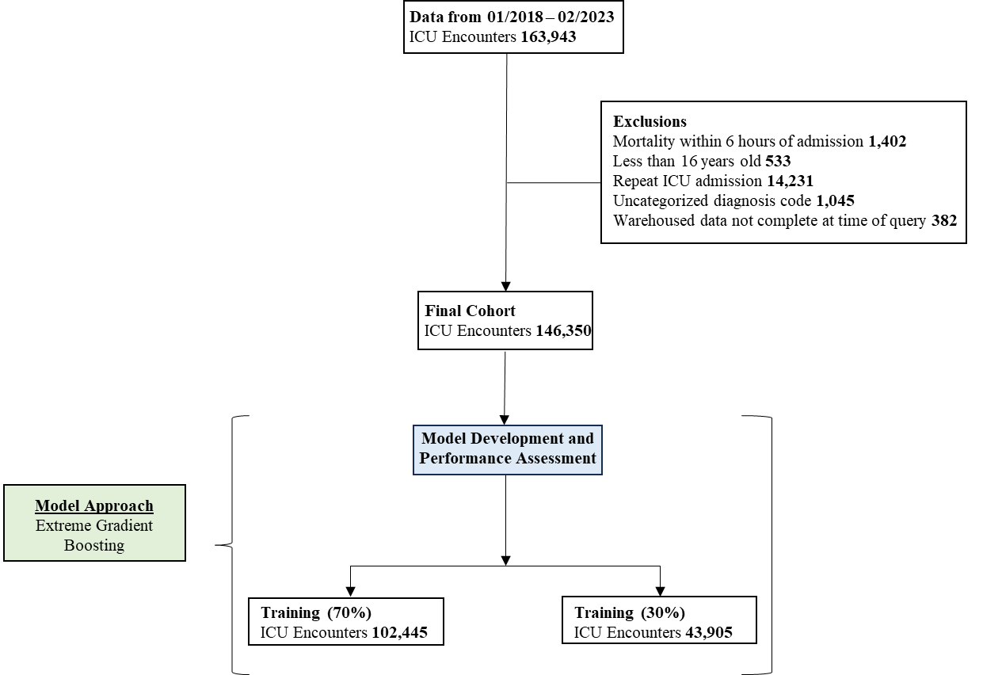
Supplemental Figure 1. Cohort ascertainment for the UPMC ICU Mortality Model.

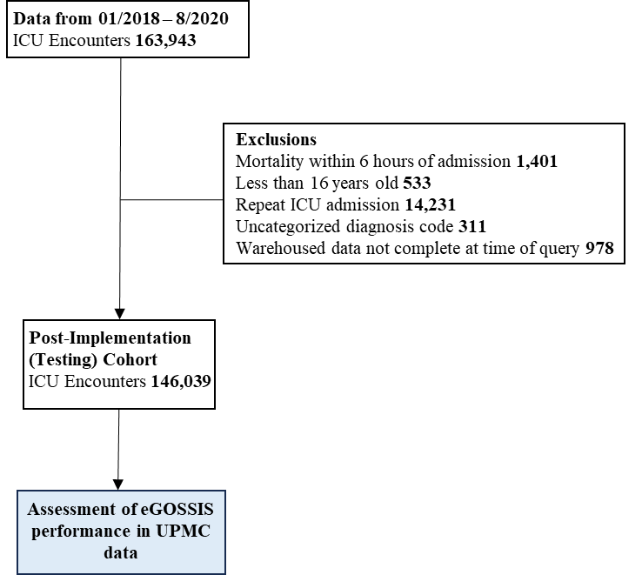
Supplemental Figure 2. Cohort ascertainment for the assessment of the electronic, global, open-source, severity of illness score (eGOSSIS) using UPMC data.

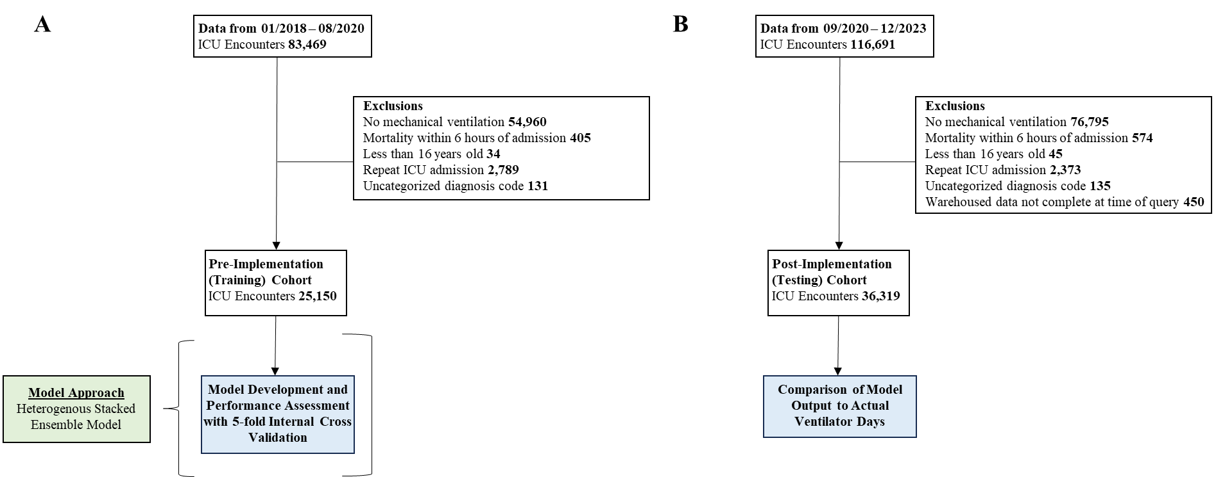
Supplemental Figure 3. Initial cohort Ascertainment for the mechanical ventilation models.



Predictors in Development (Train) and Test Cohorts for the UPMC Mortality Model
Supplemental Table 9. Cohort characteristics and associated predictors for the dataset used to train and test the UPMC Mortality Model
Characteristicsª | Entire Cohort^{b} | Train^{c} | Test^{d}
DMV | 0.00 (0.00, 1.00) | 0.00 (0.00, 1.00) | 0.00 (0.00, 1.00)
SOFA | 3.00 (1.00, 7.00) | 3.00 (1.00, 7.00) | 3.00 (1.00, 7.00)
age | 65.00 (54.00, 75.00) | 65.00 (54.00, 75.00) | 65.00 (54.00, 75.00)
albumin_apache | 2.90 (2.40, 3.40) | 2.90 (2.40, 3.40) | 2.90 (2.40, 3.40)
bilirubin_apache | 0.70 (0.50, 1.27) | 0.70 (0.50, 1.20) | 0.70 (0.50, 1.30)
bmi | 28.64 (24.22, 34.47) | 28.63 (24.21, 34.48) | 28.66 (24.23, 34.43)
bun_apache | 20.00 (13.00, 33.00) | 20.00 (13.00, 33.00) | 20.00 (13.00, 33.00)
creatinine_apache | 1.01 (0.79, 1.61) | 1.01 (0.79, 1.61) | 1.01 (0.79, 1.60)
d1_albumin_avg | 2.90 (2.40, 3.30) | 2.90 (2.40, 3.30) | 2.90 (2.40, 3.30)
d1_albumin_diff | 0.00 (0.00, 0.00) | 0.00 (0.00, 0.00) | 0.00 (0.00, 0.00)
d1_arterial_pco2_avg | 41.00 (35.50, 47.00) | 41.00 (35.50, 47.00) | 41.00 (35.50, 47.00)
d1_arterial_pco2_diff | 4.00 (0.00, 11.00) | 4.00 (0.00, 11.00) | 4.00 (0.00, 11.00)
d1_arterial_ph_avg | 7.36 (7.31, 7.41) | 7.36 (7.31, 7.41) | 7.36 (7.31, 7.41)
d1_arterial_ph_diff | 0.04 (0.00, 0.12) | 0.04 (0.00, 0.11) | 0.04 (0.00, 0.12)
d1_arterial_po2_avg | 123.50 (90.00, 179.00) | 123.50 (89.51, 178.50) | 124.00 (90.00, 180.00)
d1_arterial_po2_diff | 28.00 (0.00, 107.00) | 28.00 (0.00, 107.00) | 29.00 (0.00, 108.00)
d1_bilirubin_avg | 0.60 (0.40, 1.10) | 0.60 (0.40, 1.10) | 0.60 (0.40, 1.10)
d1_bun_avg | 19.00 (12.50, 32.00) | 19.00 (12.50, 32.00) | 19.00 (12.50, 32.00)
d1_calcium_avg | 8.40 (7.90, 8.80) | 8.40 (7.90, 8.80) | 8.40 (7.90, 8.80)
d1_calcium_diff | 0.00 (0.00, 0.40) | 0.00 (0.00, 0.40) | 0.00 (0.00, 0.40)
d1_creatinine_avg | 1.00 (0.75, 1.55) | 1.00 (0.75, 1.55) | 1.00 (0.75, 1.55)
d1_creatinine_diff | 0.00 (0.00, 0.13) | 0.00 (0.00, 0.13) | 0.00 (0.00, 0.13)
d1_diasbp_avg | 69.50 (60.50, 80.00) | 70.00 (60.50, 80.00) | 69.50 (60.50, 80.00)
d1_diasbp_diff | 42.00 (29.00, 62.00) | 42.00 (29.00, 62.00) | 42.00 (29.00, 62.00)
d1_glucose_avg | 136.00 (110.00, 172.00) | 136.00 (110.00, 172.00) | 136.00 (110.00, 172.00)
d1_glucose_diff | 34.00 (0.00, 85.00) | 34.00 (0.00, 85.00) | 34.00 (0.00, 85.00)
d1_hco3_avg | 24.00 (21.30, 26.50) | 24.00 (21.30, 26.50) | 24.00 (21.35, 26.50)
d1_hco3_diff | 1.40 (0.00, 4.00) | 1.40 (0.00, 4.00) | 1.50 (0.00, 4.00)
d1_heartrate_avg | 86.00 (75.00, 98.50) | 86.00 (75.00, 98.50) | 86.00 (75.00, 98.50)
d1_heartrate_diff | 32.00 (23.00, 47.00) | 32.00 (23.00, 47.00) | 32.00 (23.00, 47.00)
d1_hemaglobin_avg | 11.05 (9.30, 12.70) | 11.05 (9.25, 12.70) | 11.05 (9.30, 12.75)
d1_hemaglobin_diff | 0.30 (0.00, 1.20) | 0.30 (0.00, 1.20) | 0.30 (0.00, 1.20)
d1_hematocrit_avg | 33.10 (27.95, 37.90) | 33.05 (27.90, 37.90) | 33.10 (28.00, 38.00)
d1_hematocrit_diff | 0.50 (0.00, 3.40) | 0.50 (0.00, 3.40) | 0.50 (0.00, 3.40)
d1_inr_avg | 1.30 (1.20, 1.60) | 1.30 (1.20, 1.60) | 1.30 (1.15, 1.60)
d1_inr_diff | 0.00 (0.00, 0.10) | 0.00 (0.00, 0.10) | 0.00 (0.00, 0.10)
d1_lactate_avg | 1.75 (1.15, 2.75) | 1.75 (1.15, 2.75) | 1.75 (1.20, 2.75)
d1_lactate_diff | 0.30 (0.00, 1.40) | 0.30 (0.00, 1.40) | 0.30 (0.00, 1.40)
d1_mbp_avg | 88.00 (79.00, 99.00) | 88.00 (79.00, 99.00) | 88.00 (79.00, 99.00)
d1_mbp_diff | 43.00 (31.00, 61.00) | 43.00 (31.00, 61.00) | 43.00 (31.00, 61.00)
d1_pao2fio2ratio_avg | 257.50 (164.00, 391.67) | 256.67 (163.75, 390.00) | 260.00 (165.00, 395.00)
d1_pao2fio2ratio_diff | 0.00 (0.00, 25.58) | 0.00 (0.00, 26.00) | 0.00 (0.00, 24.37)
d1_platelets_avg | 197.00 (145.00, 258.00) | 197.00 (145.00, 258.50) | 197.00 (146.00, 258.00)
d1_platelets_diff | 0.00 (0.00, 16.00) | 0.00 (0.00, 16.00) | 0.00 (0.00, 16.00)
d1_potassium_avg | 4.00 (3.70, 4.40) | 4.00 (3.70, 4.40) | 4.00 (3.70, 4.40)
d1_potassium_diff | 0.10 (0.00, 0.60) | 0.10 (0.00, 0.60) | 0.10 (0.00, 0.60)
d1_resprate_avg | 20.50 (17.00, 24.50) | 20.50 (17.00, 24.50) | 20.50 (17.00, 24.50)
d1_resprate_diff | 18.00 (12.00, 26.00) | 18.00 (12.00, 26.00) | 18.00 (12.00, 26.00)
d1_sodium_avg | 138.00 (136.00, 141.00) | 138.00 (136.00, 141.00) | 138.00 (136.00, 141.00)
d1_sodium_diff | 1.00 (0.00, 3.00) | 1.00 (0.00, 3.00) | 1.00 (0.00, 3.00)
d1_spo2_avg | 95.50 (93.50, 97.00) | 95.50 (93.50, 97.00) | 95.50 (93.50, 97.00)
d1_spo2_diff | 8.00 (5.00, 11.00) | 8.00 (5.00, 11.00) | 8.00 (5.00, 11.00)
d1_sysbp_avg | 123.50 (110.50, 137.50) | 123.50 (110.50, 137.50) | 123.00 (110.50, 137.50)
d1_sysbp_diff | 60.00 (43.00, 83.00) | 60.00 (43.00, 83.00) | 60.00 (43.00, 84.00)
d1_temp_avg | 36.67 (36.28, 36.97) | 36.67 (36.28, 36.97) | 36.67 (36.27, 36.97)
d1_temp_diff | 0.66 (0.29, 1.20) | 0.66 (0.29, 1.20) | 0.67 (0.29, 1.20)
d1_wbc_avg | 10.60 (7.70, 14.60) | 10.60 (7.70, 14.60) | 10.65 (7.75, 14.60)
d1_wbc_diff | 0.00 (0.00, 1.70) | 0.00 (0.00, 1.70) | 0.00 (0.00, 1.70)
fio2_apache | 60.00 (40.00, 100.00) | 60.00 (40.00, 100.00) | 60.00 (40.00, 100.00)
gcs_eyes_apache | 4.00 (3.00, 4.00) | 4.00 (3.00, 4.00) | 4.00 (3.00, 4.00)
gcs_motor_apache | 6.00 (5.00, 6.00) | 6.00 (5.00, 6.00) | 6.00 (5.00, 6.00)
gcs_verbal_apache | 4.00 (1.00, 5.00) | 4.00 (1.00, 5.00) | 4.00 (1.00, 5.00)
glucose_apache | 155.00 (118.00, 212.00) | 155.00 (118.00, 212.00) | 155.00 (119.00, 213.00)
heart_rate_apache | 103.00 (88.00, 120.00) | 103.00 (88.00, 120.00) | 103.00 (88.00, 120.00)
height | 170.00 (160.00, 178.00) | 170.00 (160.00, 178.00) | 170.00 (160.00, 178.00)
hematocrit_apache | 34.00 (29.00, 38.20) | 34.00 (29.00, 38.20) | 34.00 (29.10, 38.20)
icu_los_days | 2.05 (1.09, 4.06) | 2.05 (1.09, 4.06) | 2.05 (1.09, 4.05)
map_apache | 80.00 (55.00, 116.00) | 80.00 (55.00, 116.00) | 79.00 (55.00, 115.00)
paco2_apache | 37.70 (32.00, 43.90) | 37.80 (32.00, 44.00) | 37.60 (32.00, 43.52)
paco2_for_ph_apache | 37.70 (7.44, 49.00) | 37.70 (7.44, 49.20) | 37.50 (7.44, 49.00)
pao2_apache | 109.00 (71.00, 193.00) | 108.00 (71.00, 192.00) | 111.00 (71.00, 194.00)
ph_apache | 7.35 (7.27, 7.43) | 7.35 (7.27, 7.43) | 7.35 (7.27, 7.43)
resprate_apache | 13.00 (10.00, 34.00) | 13.00 (10.00, 34.00) | 13.00 (9.00, 34.00)
sodium_apache | 139.00 (135.00, 142.00) | 139.00 (135.00, 142.00) | 139.00 (135.00, 141.00)
temp_apache | 36.89 (35.70, 37.22) | 36.89 (35.72, 37.22) | 36.89 (35.70, 37.22)
urineoutput_apache | 1390.00 (800.00, 2195.00) | 1382.00 (800.00, 2180.00) | 1400.00 (800.00, 2200.00)
wbc_apache | 11.10 (8.00, 15.50) | 11.10 (7.90, 15.50) | 11.10 (8.00, 15.50)
weight | 82.30 (68.00, 99.63) | 82.28 (68.00, 99.64) | 82.35 (68.08, 99.62)

Characteristicsª | Entire Cohort^{b} |  | Train^{c} |  | Test^{d}
BOOSTED | 1 | 8100 / 146350 (5.53%) | 1 | 5594 / 102445 (5.46%) | 1 | 2506 / 43905 (5.71%)
 | 0 | 138250 / 146350 (94.47%) | 0 | 96851 / 102445 (94.54%) | 0 | 41399 / 43905 (94.29%)
FULLYVAX | 1 | 23077 / 146350 (15.77%) | 1 | 16005 / 102445 (15.62%) | 1 | 7072 / 43905 (16.11%)
 | 0 | 123273 / 146350 (84.23%) | 0 | 86440 / 102445 (84.38%) | 0 | 36833 / 43905 (83.89%)
diabetes_mellitus | 1 | 52977 / 146350 (36.20%) | 1 | 37235 / 102445 (36.35%) | 1 | 15742 / 43905 (35.85%)
 | 0 | 93373 / 146350 (63.80%) | 0 | 65210 / 102445 (63.65%) | 0 | 28163 / 43905 (64.15%)
elective_surgery | 1 | 23517 / 146350 (16.07%) | 1 | 16400 / 102445 (16.01%) | 1 | 7117 / 43905 (16.21%)
 | 0 | 122833 / 146350 (83.93%) | 0 | 86045 / 102445 (83.99%) | 0 | 36788 / 43905 (83.79%)
hepatic_failure | 1 | 7954 / 146350 (5.43%) | 1 | 5539 / 102445 (5.41%) | 1 | 2415 / 43905 (5.50%)
 | 0 | 138396 / 146350 (94.57%) | 0 | 96906 / 102445 (94.59%) | 0 | 41490 / 43905 (94.50%)
icu_death* | 1 | 16860 / 146350 (11.52%) | 1 | 11802 / 102445 (11.52%) | 1 | 5058 / 43905 (11.52%)
 | 0 | 129490 / 146350 (88.48%) | 0 | 90643 / 102445 (88.48%) | 0 | 38847 / 43905 (88.48%)
intubated_apache | 1 | 49524 / 146350 (33.84%) | 1 | 34566 / 102445 (33.74%) | 1 | 14958 / 43905 (34.07%)
 | 0 | 96826 / 146350 (66.16%) | 0 | 67879 / 102445 (66.26%) | 0 | 28947 / 43905 (65.93%)
readmission_status | 1 | 10243 / 146350 (7.00%) | 1 | 7243 / 102445 (7.07%) | 1 | 3000 / 43905 (6.83%)
 | 0 | 136107 / 146350 (93.00%) | 0 | 95202 / 102445 (92.93%) | 0 | 40905 / 43905 (93.17%)
ventilated_apache | 1 | 49457 / 146350 (33.79%) | 1 | 34562 / 102445 (33.74%) | 1 | 14895 / 43905 (33.93%)
 | 0 | 96893 / 146350 (66.21%) | 0 | 67883 / 102445 (66.26%) | 0 | 29010 / 43905 (66.07%)
admit_source_Accident & Emergency | 0 | 62719 / 146350 (42.86%) | 0 | 43802 / 102445 (42.76%) | 0 | 18917 / 43905 (43.09%)
 | 1 | 83631 / 146350 (57.14%) | 1 | 58643 / 102445 (57.24%) | 1 | 24988 / 43905 (56.91%)
admit_source_Other Hospital | 0 | 105081 / 146350 (71.80%) | 0 | 73562 / 102445 (71.81%) | 0 | 31519 / 43905 (71.79%)
 | 1 | 41269 / 146350 (28.20%) | 1 | 28883 / 102445 (28.19%) | 1 | 12386 / 43905 (28.21%)
admit_source_Operating Room / Recovery | 0 | 125400 / 146350 (85.69%) | 0 | 87862 / 102445 (85.77%) | 0 | 37538 / 43905 (85.50%)
 | 1 | 20950 / 146350 (14.31%) | 1 | 14583 / 102445 (14.23%) | 1 | 6367 / 43905 (14.50%)
bodysystem_Cardiovascular | 0 | 113184 / 146350 (77.34%) | 0 | 79298 / 102445 (77.41%) | 0 | 33886 / 43905 (77.18%)
 | 1 | 33166 / 146350 (22.66%) | 1 | 23147 / 102445 (22.59%) | 1 | 10019 / 43905 (22.82%)
bodysystem_Sepsis | 0 | 122086 / 146350 (83.42%) | 0 | 85528 / 102445 (83.49%) | 0 | 36558 / 43905 (83.27%)
 | 1 | 24264 / 146350 (16.58%) | 1 | 16917 / 102445 (16.51%) | 1 | 7347 / 43905 (16.73%)
bodysystem_Neurological | 0 | 124714 / 146350 (85.22%) | 0 | 87280 / 102445 (85.20%) | 0 | 37434 / 43905 (85.26%)
 | 1 | 21636 / 146350 (14.78%) | 1 | 15165 / 102445 (14.80%) | 1 | 6471 / 43905 (14.74%)
bodysystem_Respiratory | 0 | 127752 / 146350 (87.29%) | 0 | 89347 / 102445 (87.21%) | 0 | 38405 / 43905 (87.47%)
 | 1 | 18598 / 146350 (12.71%) | 1 | 13098 / 102445 (12.79%) | 1 | 5500 / 43905 (12.53%)
bodysystem_Gastrointestinal | 0 | 130159 / 146350 (88.94%) | 0 | 91074 / 102445 (88.90%) | 0 | 39085 / 43905 (89.02%)
 | 1 | 16191 / 146350 (11.06%) | 1 | 11371 / 102445 (11.10%) | 1 | 4820 / 43905 (10.98%)
bodysystem_Trauma | 0 | 136905 / 146350 (93.55%) | 0 | 95814 / 102445 (93.53%) | 0 | 41091 / 43905 (93.59%)
 | 1 | 9445 / 146350 (6.45%) | 1 | 6631 / 102445 (6.47%) | 1 | 2814 / 43905 (6.41%)
bodysystem_Metabolic | 0 | 138478 / 146350 (94.62%) | 0 | 96923 / 102445 (94.61%) | 0 | 41555 / 43905 (94.65%)
 | 1 | 7872 / 146350 (5.38%) | 1 | 5522 / 102445 (5.39%) | 1 | 2350 / 43905 (5.35%)
diagnosis_501.06 | 0 | 127903 / 146350 (87.40%) | 0 | 89602 / 102445 (87.46%) | 0 | 38301 / 43905 (87.24%)
 | 1 | 18447 / 146350 (12.60%) | 1 | 12843 / 102445 (12.54%) | 1 | 5604 / 43905 (12.76%)
diagnosis_107.01 | 0 | 137275 / 146350 (93.80%) | 0 | 96140 / 102445 (93.85%) | 0 | 41135 / 43905 (93.69%)
 | 1 | 9075 / 146350 (6.20%) | 1 | 6305 / 102445 (6.15%) | 1 | 2770 / 43905 (6.31%)
SOFA_missing | 1 | 71496 / 146350 (48.85%) | 1 | 50097 / 102445 (48.90%) | 1 | 21399 / 43905 (48.74%)
 | 0 | 74854 / 146350 (51.15%) | 0 | 52348 / 102445 (51.10%) | 0 | 22506 / 43905 (51.26%)
albumin_apache_missing | 1 | 78133 / 146350 (53.39%) | 1 | 54636 / 102445 (53.33%) | 1 | 23497 / 43905 (53.52%)
 | 0 | 68217 / 146350 (46.61%) | 0 | 47809 / 102445 (46.67%) | 0 | 20408 / 43905 (46.48%)
bilirubin_apache_missing | 1 | 78598 / 146350 (53.71%) | 1 | 54957 / 102445 (53.65%) | 1 | 23641 / 43905 (53.85%)
 | 0 | 67752 / 146350 (46.29%) | 0 | 47488 / 102445 (46.35%) | 0 | 20264 / 43905 (46.15%)
bun_apache_missing | 1 | 9927 / 146350 (6.78%) | 1 | 6917 / 102445 (6.75%) | 1 | 3010 / 43905 (6.86%)
 | 0 | 136423 / 146350 (93.22%) | 0 | 95528 / 102445 (93.25%) | 0 | 40895 / 43905 (93.14%)
creatinine_apache_missing | 1 | 9793 / 146350 (6.69%) | 1 | 6823 / 102445 (6.66%) | 1 | 2970 / 43905 (6.76%)
 | 0 | 136557 / 146350 (93.31%) | 0 | 95622 / 102445 (93.34%) | 0 | 40935 / 43905 (93.24%)
d1_albumin_avg_missing | 1 | 78133 / 146350 (53.39%) | 1 | 54636 / 102445 (53.33%) | 1 | 23497 / 43905 (53.52%)
 | 0 | 68217 / 146350 (46.61%) | 0 | 47809 / 102445 (46.67%) | 0 | 20408 / 43905 (46.48%)
d1_albumin_diff_missing | 1 | 78133 / 146350 (53.39%) | 1 | 54636 / 102445 (53.33%) | 1 | 23497 / 43905 (53.52%)
 | 0 | 68217 / 146350 (46.61%) | 0 | 47809 / 102445 (46.67%) | 0 | 20408 / 43905 (46.48%)
d1_arterial_pco2_avg_missing | 1 | 96808 / 146350 (66.15%) | 1 | 67783 / 102445 (66.17%) | 1 | 29025 / 43905 (66.11%)
 | 0 | 49542 / 146350 (33.85%) | 0 | 34662 / 102445 (33.83%) | 0 | 14880 / 43905 (33.89%)
d1_arterial_pco2_diff_missing | 1 | 96808 / 146350 (66.15%) | 1 | 67783 / 102445 (66.17%) | 1 | 29025 / 43905 (66.11%)
 | 0 | 49542 / 146350 (33.85%) | 0 | 34662 / 102445 (33.83%) | 0 | 14880 / 43905 (33.89%)
d1_arterial_ph_avg_missing | 1 | 96832 / 146350 (66.16%) | 1 | 67800 / 102445 (66.18%) | 1 | 29032 / 43905 (66.12%)
 | 0 | 49518 / 146350 (33.84%) | 0 | 34645 / 102445 (33.82%) | 0 | 14873 / 43905 (33.88%)
d1_arterial_ph_diff_missing | 1 | 96832 / 146350 (66.16%) | 1 | 67800 / 102445 (66.18%) | 1 | 29032 / 43905 (66.12%)
 | 0 | 49518 / 146350 (33.84%) | 0 | 34645 / 102445 (33.82%) | 0 | 14873 / 43905 (33.88%)
d1_arterial_po2_avg_missing | 1 | 96816 / 146350 (66.15%) | 1 | 67787 / 102445 (66.17%) | 1 | 29029 / 43905 (66.12%)
 | 0 | 49534 / 146350 (33.85%) | 0 | 34658 / 102445 (33.83%) | 0 | 14876 / 43905 (33.88%)
d1_arterial_po2_diff_missing | 1 | 96816 / 146350 (66.15%) | 1 | 67787 / 102445 (66.17%) | 1 | 29029 / 43905 (66.12%)
 | 0 | 49534 / 146350 (33.85%) | 0 | 34658 / 102445 (33.83%) | 0 | 14876 / 43905 (33.88%)
d1_bilirubin_avg_missing | 1 | 78598 / 146350 (53.71%) | 1 | 54957 / 102445 (53.65%) | 1 | 23641 / 43905 (53.85%)
 | 0 | 67752 / 146350 (46.29%) | 0 | 47488 / 102445 (46.35%) | 0 | 20264 / 43905 (46.15%)
d1_bilirubin_diff_missing | 1 | 78598 / 146350 (53.71%) | 1 | 54957 / 102445 (53.65%) | 1 | 23641 / 43905 (53.85%)
 | 0 | 67752 / 146350 (46.29%) | 0 | 47488 / 102445 (46.35%) | 0 | 20264 / 43905 (46.15%)
d1_bun_avg_missing | 1 | 9927 / 146350 (6.78%) | 1 | 6917 / 102445 (6.75%) | 1 | 3010 / 43905 (6.86%)
 | 0 | 136423 / 146350 (93.22%) | 0 | 95528 / 102445 (93.25%) | 0 | 40895 / 43905 (93.14%)
d1_bun_diff_missing | 1 | 9927 / 146350 (6.78%) | 1 | 6917 / 102445 (6.75%) | 1 | 3010 / 43905 (6.86%)
 | 0 | 136423 / 146350 (93.22%) | 0 | 95528 / 102445 (93.25%) | 0 | 40895 / 43905 (93.14%)
d1_calcium_avg_missing | 1 | 13679 / 146350 (9.35%) | 1 | 9517 / 102445 (9.29%) | 1 | 4162 / 43905 (9.48%)
 | 0 | 132671 / 146350 (90.65%) | 0 | 92928 / 102445 (90.71%) | 0 | 39743 / 43905 (90.52%)
*Outcome, not a predictor

Characteristicsª | Entire Cohort^{b} |  | Train^{c} |  | Test^{d}
d1_calcium_diff_missing | 1 | 13679 / 146350 (9.35%) | 1 | 9517 / 102445 (9.29%) | 1 | 4162 / 43905 (9.48%)
 | 0 | 132671 / 146350 (90.65%) | 0 | 92928 / 102445 (90.71%) | 0 | 39743 / 43905 (90.52%)
d1_creatinine_avg_missing | 1 | 9793 / 146350 (6.69%) | 1 | 6823 / 102445 (6.66%) | 1 | 2970 / 43905 (6.76%)
 | 0 | 136557 / 146350 (93.31%) | 0 | 95622 / 102445 (93.34%) | 0 | 40935 / 43905 (93.24%)
d1_creatinine_diff_missing | 1 | 9793 / 146350 (6.69%) | 1 | 6823 / 102445 (6.66%) | 1 | 2970 / 43905 (6.76%)
 | 0 | 136557 / 146350 (93.31%) | 0 | 95622 / 102445 (93.34%) | 0 | 40935 / 43905 (93.24%)
d1_glucose_avg_missing | 1 | 7720 / 146350 (5.28%) | 1 | 5357 / 102445 (5.23%) | 1 | 2363 / 43905 (5.38%)
 | 0 | 138630 / 146350 (94.72%) | 0 | 97088 / 102445 (94.77%) | 0 | 41542 / 43905 (94.62%)
d1_glucose_diff_missing | 1 | 7720 / 146350 (5.28%) | 1 | 5357 / 102445 (5.23%) | 1 | 2363 / 43905 (5.38%)
 | 0 | 138630 / 146350 (94.72%) | 0 | 97088 / 102445 (94.77%) | 0 | 41542 / 43905 (94.62%)
d1_hco3_avg_missing | 1 | 8046 / 146350 (5.50%) | 1 | 5576 / 102445 (5.44%) | 1 | 2470 / 43905 (5.63%)
 | 0 | 138304 / 146350 (94.50%) | 0 | 96869 / 102445 (94.56%) | 0 | 41435 / 43905 (94.37%)
d1_hco3_diff_missing | 1 | 8046 / 146350 (5.50%) | 1 | 5576 / 102445 (5.44%) | 1 | 2470 / 43905 (5.63%)
 | 0 | 138304 / 146350 (94.50%) | 0 | 96869 / 102445 (94.56%) | 0 | 41435 / 43905 (94.37%)
d1_hemaglobin_avg_missing | 1 | 10127 / 146350 (6.92%) | 1 | 7007 / 102445 (6.84%) | 1 | 3120 / 43905 (7.11%)
 | 0 | 136223 / 146350 (93.08%) | 0 | 95438 / 102445 (93.16%) | 0 | 40785 / 43905 (92.89%)
d1_hemaglobin_diff_missing | 1 | 10127 / 146350 (6.92%) | 1 | 7007 / 102445 (6.84%) | 1 | 3120 / 43905 (7.11%)
 | 0 | 136223 / 146350 (93.08%) | 0 | 95438 / 102445 (93.16%) | 0 | 40785 / 43905 (92.89%)
d1_hematocrit_avg_missing | 1 | 10683 / 146350 (7.30%) | 1 | 7402 / 102445 (7.23%) | 1 | 3281 / 43905 (7.47%)
 | 0 | 135667 / 146350 (92.70%) | 0 | 95043 / 102445 (92.77%) | 0 | 40624 / 43905 (92.53%)
d1_hematocrit_diff_missing | 1 | 10683 / 146350 (7.30%) | 1 | 7402 / 102445 (7.23%) | 1 | 3281 / 43905 (7.47%)
 | 0 | 135667 / 146350 (92.70%) | 0 | 95043 / 102445 (92.77%) | 0 | 40624 / 43905 (92.53%)
d1_inr_avg_missing | 1 | 85937 / 146350 (58.72%) | 1 | 60249 / 102445 (58.81%) | 1 | 25688 / 43905 (58.51%)
 | 0 | 60413 / 146350 (41.28%) | 0 | 42196 / 102445 (41.19%) | 0 | 18217 / 43905 (41.49%)
d1_inr_diff_missing | 1 | 85937 / 146350 (58.72%) | 1 | 60249 / 102445 (58.81%) | 1 | 25688 / 43905 (58.51%)
 | 0 | 60413 / 146350 (41.28%) | 0 | 42196 / 102445 (41.19%) | 0 | 18217 / 43905 (41.49%)
d1_lactate_avg_missing | 1 | 71334 / 146350 (48.74%) | 1 | 49922 / 102445 (48.73%) | 1 | 21412 / 43905 (48.77%)
 | 0 | 75016 / 146350 (51.26%) | 0 | 52523 / 102445 (51.27%) | 0 | 22493 / 43905 (51.23%)
d1_lactate_diff_missing | 1 | 71334 / 146350 (48.74%) | 1 | 49922 / 102445 (48.73%) | 1 | 21412 / 43905 (48.77%)
 | 0 | 75016 / 146350 (51.26%) | 0 | 52523 / 102445 (51.27%) | 0 | 22493 / 43905 (51.23%)
d1_pao2fio2ratio_avg_missing | 1 | 104334 / 146350 (71.29%) | 1 | 72992 / 102445 (71.25%) | 1 | 31342 / 43905 (71.39%)
 | 0 | 42016 / 146350 (28.71%) | 0 | 29453 / 102445 (28.75%) | 0 | 12563 / 43905 (28.61%)
d1_pao2fio2ratio_diff_missing | 1 | 104334 / 146350 (71.29%) | 1 | 72992 / 102445 (71.25%) | 1 | 31342 / 43905 (71.39%)
 | 0 | 42016 / 146350 (28.71%) | 0 | 29453 / 102445 (28.75%) | 0 | 12563 / 43905 (28.61%)
d1_platelets_avg_missing | 1 | 12502 / 146350 (8.54%) | 1 | 8713 / 102445 (8.51%) | 1 | 3789 / 43905 (8.63%)
 | 0 | 133848 / 146350 (91.46%) | 0 | 93732 / 102445 (91.49%) | 0 | 40116 / 43905 (91.37%)
d1_platelets_diff_missing | 1 | 12502 / 146350 (8.54%) | 1 | 8713 / 102445 (8.51%) | 1 | 3789 / 43905 (8.63%)
 | 0 | 133848 / 146350 (91.46%) | 0 | 93732 / 102445 (91.49%) | 0 | 40116 / 43905 (91.37%)
d1_potassium_avg_missing | 1 | 8629 / 146350 (5.90%) | 1 | 5983 / 102445 (5.84%) | 1 | 2646 / 43905 (6.03%)
 | 0 | 137721 / 146350 (94.10%) | 0 | 96462 / 102445 (94.16%) | 0 | 41259 / 43905 (93.97%)
d1_potassium_diff_missing | 1 | 8629 / 146350 (5.90%) | 1 | 5983 / 102445 (5.84%) | 1 | 2646 / 43905 (6.03%)
 | 0 | 137721 / 146350 (94.10%) | 0 | 96462 / 102445 (94.16%) | 0 | 41259 / 43905 (93.97%)
d1_sodium_avg_missing | 1 | 8720 / 146350 (5.96%) | 1 | 6048 / 102445 (5.90%) | 1 | 2672 / 43905 (6.09%)
 | 0 | 137630 / 146350 (94.04%) | 0 | 96397 / 102445 (94.10%) | 0 | 41233 / 43905 (93.91%)
d1_sodium_diff_missing | 1 | 8720 / 146350 (5.96%) | 1 | 6048 / 102445 (5.90%) | 1 | 2672 / 43905 (6.09%)
 | 0 | 137630 / 146350 (94.04%) | 0 | 96397 / 102445 (94.10%) | 0 | 41233 / 43905 (93.91%)
d1_wbc_avg_missing | 1 | 12432 / 146350 (8.49%) | 1 | 8665 / 102445 (8.46%) | 1 | 3767 / 43905 (8.58%)
 | 0 | 133918 / 146350 (91.51%) | 0 | 93780 / 102445 (91.54%) | 0 | 40138 / 43905 (91.42%)
d1_wbc_diff_missing | 1 | 12432 / 146350 (8.49%) | 1 | 8665 / 102445 (8.46%) | 1 | 3767 / 43905 (8.58%)
 | 0 | 133918 / 146350 (91.51%) | 0 | 93780 / 102445 (91.54%) | 0 | 40138 / 43905 (91.42%)
fio2_apache_missing | 1 | 76799 / 146350 (52.48%) | 1 | 53720 / 102445 (52.44%) | 1 | 23079 / 43905 (52.57%)
 | 0 | 69551 / 146350 (47.52%) | 0 | 48725 / 102445 (47.56%) | 0 | 20826 / 43905 (47.43%)
gcs_eyes_apache_missing | 1 | 15359 / 146350 (10.49%) | 1 | 10724 / 102445 (10.47%) | 1 | 4635 / 43905 (10.56%)
 | 0 | 130991 / 146350 (89.51%) | 0 | 91721 / 102445 (89.53%) | 0 | 39270 / 43905 (89.44%)
gcs_motor_apache_missing | 1 | 15368 / 146350 (10.50%) | 1 | 10731 / 102445 (10.47%) | 1 | 4637 / 43905 (10.56%)
 | 0 | 130982 / 146350 (89.50%) | 0 | 91714 / 102445 (89.53%) | 0 | 39268 / 43905 (89.44%)
gcs_verbal_apache_missing | 1 | 15362 / 146350 (10.50%) | 1 | 10725 / 102445 (10.47%) | 1 | 4637 / 43905 (10.56%)
 | 0 | 130988 / 146350 (89.50%) | 0 | 91720 / 102445 (89.53%) | 0 | 39268 / 43905 (89.44%)
glucose_apache_missing | 1 | 7720 / 146350 (5.28%) | 1 | 5357 / 102445 (5.23%) | 1 | 2363 / 43905 (5.38%)
 | 0 | 138630 / 146350 (94.72%) | 0 | 97088 / 102445 (94.77%) | 0 | 41542 / 43905 (94.62%)
hematocrit_apache_missing | 1 | 10683 / 146350 (7.30%) | 1 | 7402 / 102445 (7.23%) | 1 | 3281 / 43905 (7.47%)
 | 0 | 135667 / 146350 (92.70%) | 0 | 95043 / 102445 (92.77%) | 0 | 40624 / 43905 (92.53%)
paco2_apache_missing | 1 | 96808 / 146350 (66.15%) | 1 | 67783 / 102445 (66.17%) | 1 | 29025 / 43905 (66.11%)
 | 0 | 49542 / 146350 (33.85%) | 0 | 34662 / 102445 (33.83%) | 0 | 14880 / 43905 (33.89%)
paco2_for_ph_apache_missing | 1 | 96834 / 146350 (66.17%) | 1 | 67801 / 102445 (66.18%) | 1 | 29033 / 43905 (66.13%)
 | 0 | 49516 / 146350 (33.83%) | 0 | 34644 / 102445 (33.82%) | 0 | 14872 / 43905 (33.87%)
pao2_apache_missing | 1 | 96816 / 146350 (66.15%) | 1 | 67787 / 102445 (66.17%) | 1 | 29029 / 43905 (66.12%)
 | 0 | 49534 / 146350 (33.85%) | 0 | 34658 / 102445 (33.83%) | 0 | 14876 / 43905 (33.88%)
ph_apache_missing | 1 | 96832 / 146350 (66.16%) | 1 | 67800 / 102445 (66.18%) | 1 | 29032 / 43905 (66.12%)
 | 0 | 49518 / 146350 (33.84%) | 0 | 34645 / 102445 (33.82%) | 0 | 14873 / 43905 (33.88%)
sodium_apache_missing | 1 | 8720 / 146350 (5.96%) | 1 | 6048 / 102445 (5.90%) | 1 | 2672 / 43905 (6.09%)
 | 0 | 137630 / 146350 (94.04%) | 0 | 96397 / 102445 (94.10%) | 0 | 41233 / 43905 (93.91%)
urineoutput_apache_missing | 1 | 11734 / 146350 (8.02%) | 1 | 8163 / 102445 (7.97%) | 1 | 3571 / 43905 (8.13%)
 | 0 | 134616 / 146350 (91.98%) | 0 | 94282 / 102445 (92.03%) | 0 | 40334 / 43905 (91.87%)
wbc_apache_missing | 1 | 12432 / 146350 (8.49%) | 1 | 8665 / 102445 (8.46%) | 1 | 3767 / 43905 (8.58%)
 | 0 | 133918 / 146350 (91.51%) | 0 | 93780 / 102445 (91.54%) | 0 | 40138 / 43905 (91.42%)
ªData are expressed as median (25th percentile, 75th percentile) for continuous data, n/N (%) for categorical data.
^{b,c,d}The eGOSSIS was validated in the entire cohort. The UPMC Mortality Model was developed in the train cohort and performance was assessed in the test cohort.
Abbreviations: eGOSSIS, electronic global, open-source, severity of illness score

Predictors in the Pre-Implementation (Baseline) and Post-Implementation Cohorts for the 14-day Duration of Mechanical Ventilation Models

Supplemental Table 10. Cohort characteristics and associated predictors for the pre- and post-implementation cohorts for the 14-day duration of mechanical ventilation models
Characteristicsª | Baseline^{b} | Post-Implementation^{c}
DMV | 2.00 (1.00, 5.00) | 3.00 (1.00, 6.00)
age | 64.00 (53.00, 73.00) | 64.00 (53.00, 73.00)
albumin_apache | 3.00 (2.40, 3.50) | 2.90 (2.30, 3.40)
bmi | 29.30 (24.69, 35.27) | 29.44 (24.80, 35.59)
bun_apache | 21.00 (14.00, 35.00) | 21.00 (14.00, 36.00)
creatinine_apache | 1.10 (0.80, 1.71) | 1.10 (0.80, 1.80)
d1_albumin_avg | 3.00 (2.45, 3.50) | 2.90 (2.40, 3.40)
d1_arterial_ph_avg | 7.35 (7.29, 7.39) | 7.35 (7.29, 7.40)
d1_arterial_po2_diff | 89.00 (0.00, 239.20) | 65.20 (0.00, 217.00)
d1_bun_avg | 20.00 (13.00, 33.00) | 20.50 (13.50, 35.00)
d1_calcium_avg | 8.40 (7.90, 8.95) | 8.40 (7.90, 8.90)
d1_calcium_diff | 0.00 (0.00, 0.40) | 0.00 (0.00, 0.50)
d1_creatinine_avg | 1.05 (0.80, 1.65) | 1.08 (0.80, 1.69)
d1_diasbp_diff | 62.00 (41.00, 99.00) | 61.00 (40.00, 95.00)
d1_glucose_avg | 146.50 (120.50, 178.50) | 146.00 (119.50, 181.00)
d1_hco3_diff | 3.50 (1.48, 6.00) | 4.00 (2.00, 6.00)
d1_heartrate_avg | 88.00 (72.50, 102.50) | 89.00 (74.50, 104.00)
d1_heartrate_diff | 53.00 (32.00, 99.00) | 51.00 (32.00, 92.00)
d1_hemaglobin_avg | 10.80 (9.15, 12.60) | 11.05 (9.30, 12.90)
d1_hemaglobin_diff | 1.20 (0.10, 2.90) | 1.10 (0.10, 2.50)
d1_hematocrit_avg | 32.80 (27.80, 38.05) | 33.40 (28.27, 38.70)
d1_hematocrit_diff | 3.30 (0.00, 8.20) | 2.90 (0.00, 7.30)
d1_lactate_avg | 1.95 (1.25, 3.35) | 2.00 (1.25, 3.60)
d1_mbp_diff | 67.00 (42.00, 112.00) | 65.00 (42.00, 105.00)
d1_platelets_diff | 0.00 (0.00, 30.00) | 0.00 (0.00, 29.00)
d1_potassium_diff | 0.50 (0.00, 1.10) | 0.50 (0.00, 1.10)
d1_resprate_avg | 20.00 (16.50, 24.00) | 20.00 (15.50, 24.50)
d1_resprate_diff | 21.00 (14.00, 29.00) | 23.00 (15.00, 30.00)
d1_sodium_avg | 138.00 (135.50, 141.00) | 138.50 (136.00, 141.50)
d1_sodium_diff | 3.00 (0.00, 6.00) | 3.00 (0.00, 5.00)
d1_spo2_diff | 9.00 (5.00, 16.00) | 9.00 (5.00, 17.00)
d1_sysbp_diff | 97.00 (64.00, 147.00) | 95.00 (64.00, 144.00)
d1_temp_diff | 1.03 (0.29, 2.24) | 1.02 (0.33, 2.20)
d1_wbc_avg | 12.00 (8.55, 16.45) | 12.20 (8.70, 16.90)
d1_wbc_diff | 0.00 (0.00, 2.80) | 0.00 (0.00, 2.60)
fio2_apache | 80.00 (50.00, 100.00) | 90.00 (50.00, 100.00)
gcs_eyes_apache | 2.00 (1.00, 3.00) | 2.00 (1.00, 3.00)
gcs_motor_apache | 5.00 (1.00, 6.00) | 4.00 (1.00, 6.00)
gcs_verbal_apache | 1.00 (1.00, 1.00) | 1.00 (1.00, 1.00)
glucose_apache | 177.00 (136.00, 226.00) | 175.00 (136.00, 229.00)
gossis_pred | 0.26 (0.10, 0.56) | 0.28 (0.11, 0.58)
heart_rate_apache | 112.00 (84.00, 137.00) | 114.00 (88.00, 139.00)
height | 170.00 (162.00, 178.00) | 170.00 (162.00, 178.00)
hematocrit_apache | 34.00 (29.40, 38.50) | 34.70 (29.70, 39.00)
icu_los_days^{d} | 3.27 (1.64, 6.92) | 4.20 (2.03, 8.42)
map_apache | 55.00 (40.00, 101.00) | 56.00 (43.00, 106.00)
resprate_apache | 12.00 (0.00, 33.00) | 12.00 (0.00, 34.00)
sodium_apache | 139.00 (134.00, 142.00) | 140.00 (134.00, 143.00)
temp_apache | 35.90 (34.70, 37.28) | 36.11 (34.70, 37.28)
wbc_apache | 12.90 (9.00, 17.90) | 13.00 (9.20, 18.40)
weight | 84.70 (70.20, 102.23) | 85.23 (70.49, 102.85)

Characteristicsª | Baseline^{b} |  | Post-Implementation^{c}
cirrhosis | 1 | 1504 / 25150 (5.98%) | 1 | 2304 / 36319 (6.34%)
 | 0 | 23646 / 25150 (94.02%) | 0 | 34015 / 36319 (93.66%)
diabetes_mellitus | 1 | 9109 / 25150 (36.22%) | 1 | 13052 / 36319 (35.94%)
 | 0 | 16041 / 25150 (63.78%) | 0 | 23267 / 36319 (64.06%)
elective_surgery | 1 | 6707 / 25150 (26.67%) | 1 | 6943 / 36319 (19.12%)
 | 0 | 18443 / 25150 (73.33%) | 0 | 29376 / 36319 (80.88%)
hepatic_failure | 1 | 2323 / 25150 (9.24%) | 1 | 3606 / 36319 (9.93%)
 | 0 | 22827 / 25150 (90.76%) | 0 | 32713 / 36319 (90.07%)
icu_death | 1 | 4852 / 25150 (19.29%) | 1 | 9594 / 36319 (26.42%)
 | 0 | 20298 / 25150 (80.71%) | 0 | 26725 / 36319 (73.58%)
readmission_status | 1 | 2384 / 25150 (9.48%) | 1 | 2369 / 36319 (6.52%)
 | 0 | 22766 / 25150 (90.52%) | 0 | 33950 / 36319 (93.48%)
admit_source_Accident & Emergency | 0 | 13433 / 25150 (53.41%) | 0 | 17070 / 36319 (47.00%)
 | 1 | 11717 / 25150 (46.59%) | 1 | 19249 / 36319 (53.00%)
admit_source_Other Hospital | 0 | 16024 / 25150 (63.71%) | 0 | 24080 / 36319 (66.30%)
 | 1 | 9126 / 25150 (36.29%) | 1 | 12239 / 36319 (33.70%)
admit_source_Operating Room / Recovery | 0 | 20843 / 25150 (82.87%) | 0 | 31579 / 36319 (86.95%)
 | 1 | 4307 / 25150 (17.13%) | 1 | 4740 / 36319 (13.05%)
bodysystem_Cardiovascular | 0 | 18157 / 25150 (72.19%) | 0 | 27876 / 36319 (76.75%)
 | 1 | 6993 / 25150 (27.81%) | 1 | 8443 / 36319 (23.25%)
bodysystem_Sepsis | 0 | 20859 / 25150 (82.94%) | 0 | 27583 / 36319 (75.95%)
 | 1 | 4291 / 25150 (17.06%) | 1 | 8736 / 36319 (24.05%)
bodysystem_Respiratory | 0 | 20943 / 25150 (83.27%) | 0 | 31325 / 36319 (86.25%)
 | 1 | 4207 / 25150 (16.73%) | 1 | 4994 / 36319 (13.75%)
bodysystem_Gastrointestinal | 0 | 22070 / 25150 (87.75%) | 0 | 32794 / 36319 (90.29%)
 | 1 | 3080 / 25150 (12.25%) | 1 | 3525 / 36319 (9.71%)
bodysystem_Neurological | 0 | 22482 / 25150 (89.39%) | 0 | 31508 / 36319 (86.75%)
 | 1 | 2668 / 25150 (10.61%) | 1 | 4811 / 36319 (13.25%)
bodysystem_Trauma | 0 | 23690 / 25150 (94.19%) | 0 | 34167 / 36319 (94.07%)
 | 1 | 1460 / 25150 (5.81%) | 1 | 2152 / 36319 (5.93%)
diagnosis_501.06 | 0 | 21294 / 25150 (84.67%) | 0 | 30061 / 36319 (82.77%)
 | 1 | 3856 / 25150 (15.33%) | 1 | 6258 / 36319 (17.23%)
diagnosis_107.01 | 0 | 22714 / 25150 (90.31%) | 0 | 34777 / 36319 (95.75%)
 | 1 | 2436 / 25150 (9.69%) | 1 | 1542 / 36319 (4.25%)
diagnosis_203.01 | 0 | 23471 / 25150 (93.32%) | 0 | 34280 / 36319 (94.39%)
 | 1 | 1679 / 25150 (6.68%) | 1 | 2039 / 36319 (5.61%)
albumin_apache_missing | 1 | 11083 / 25150 (44.07%) | 1 | 11692 / 36319 (32.19%)
 | 0 | 14067 / 25150 (55.93%) | 0 | 24627 / 36319 (67.81%)
bilirubin_apache_missing | 1 | 11012 / 25150 (43.79%) | 1 | 11927 / 36319 (32.84%)
 | 0 | 14138 / 25150 (56.21%) | 0 | 24392 / 36319 (67.16%)
d1_albumin_avg_missing | 1 | 11083 / 25150 (44.07%) | 1 | 11692 / 36319 (32.19%)
 | 0 | 14067 / 25150 (55.93%) | 0 | 24627 / 36319 (67.81%)
d1_albumin_diff_missing | 1 | 11083 / 25150 (44.07%) | 1 | 11692 / 36319 (32.19%)
 | 0 | 14067 / 25150 (55.93%) | 0 | 24627 / 36319 (67.81%)
d1_arterial_pco2_avg_missing | 1 | 6263 / 25150 (24.90%) | 1 | 8295 / 36319 (22.84%)
 | 0 | 18887 / 25150 (75.10%) | 0 | 28024 / 36319 (77.16%)
d1_arterial_pco2_diff_missing | 1 | 6263 / 25150 (24.90%) | 1 | 8295 / 36319 (22.84%)
 | 0 | 18887 / 25150 (75.10%) | 0 | 28024 / 36319 (77.16%)
d1_arterial_ph_avg_missing | 1 | 6263 / 25150 (24.90%) | 1 | 8307 / 36319 (22.87%)
 | 0 | 18887 / 25150 (75.10%) | 0 | 28012 / 36319 (77.13%)
d1_arterial_ph_diff_missing | 1 | 6263 / 25150 (24.90%) | 1 | 8307 / 36319 (22.87%)
 | 0 | 18887 / 25150 (75.10%) | 0 | 28012 / 36319 (77.13%)
d1_arterial_po2_avg_missing | 1 | 6265 / 25150 (24.91%) | 1 | 8300 / 36319 (22.85%)
 | 0 | 18885 / 25150 (75.09%) | 0 | 28019 / 36319 (77.15%)
d1_arterial_po2_diff_missing | 1 | 6265 / 25150 (24.91%) | 1 | 8300 / 36319 (22.85%)
 | 0 | 18885 / 25150 (75.09%) | 0 | 28019 / 36319 (77.15%)

ªData are expressed as median (25th percentile, 75th percentile) for continuous data, n/N (%) for categorical data.
^{b}The duration of mechanical ventilation model was developed in a pre-implementation cohort ascertained from January 1, 2018 to July 31st, 2020.
^{c}Patient characteristics and related predictors for the duration of mechanical ventilation model for the post-implementation period, August 1, 2020 to December 31, 2023, are displayed.
^{d,e}Original model (Model 1) does not include FLAG characteristics^{e}, Model 2 does not include icu length of stay, death indicator^{d}, and FLAG characteristics^{e}, Model 3 does not include icu length of stay and death indicator^{d}, but includes FLAG characteristics^{e}.

Predictors in the Pre-Implementation (Baseline) and Post-Implementation Cohorts for the 6-day, Multiple Classifier Duration of Mechanical Ventilation Models
Supplemental Table 11. Cohort characteristics and associated predictors for the pre- and post-implementation cohorts for the 6-day duration of mechanical ventilation models
Characteristicsª | Baseline^{b} | Post-Implementation^{c}
DMV | 2.00 (1.00, 3.00) | 2.00 (1.00, 3.00)
age | 64.00 (54.00, 73.00) | 65.00 (54.00, 73.00)
albumin_apache | 3.00 (2.40, 3.60) | 2.90 (2.40, 3.50)
bmi | 29.13 (24.61, 34.95) | 29.18 (24.62, 35.03)
bun_apache | 20.00 (13.00, 33.00) | 20.00 (14.00, 35.00)
creatinine_apache | 1.10 (0.80, 1.70) | 1.10 (0.80, 1.74)
d1_albumin_avg | 3.00 (2.50, 3.50) | 2.90 (2.40, 3.40)
d1_arterial_ph_avg | 7.35 (7.30, 7.39) | 7.35 (7.29, 7.40)
d1_arterial_po2_diff | 101.00 (2.00, 250.20) | 77.00 (0.00, 240.00)
d1_bun_avg | 19.00 (13.00, 32.00) | 19.50 (13.00, 33.00)
d1_calcium_avg | 8.40 (7.90, 8.95) | 8.40 (7.90, 8.90)
d1_calcium_diff | 0.00 (0.00, 0.40) | 0.00 (0.00, 0.50)
d1_creatinine_avg | 1.05 (0.80, 1.60) | 1.06 (0.80, 1.65)
d1_diasbp_diff | 65.00 (42.00, 103.00) | 63.00 (41.00, 99.00)
d1_glucose_avg | 146.00 (121.00, 177.50) | 145.00 (119.00, 179.00)
d1_hco3_diff | 3.70 (1.60, 6.00) | 4.00 (2.00, 6.30)
d1_heartrate_avg | 87.00 (71.50, 101.50) | 88.00 (73.00, 103.00)
d1_heartrate_diff | 56.00 (33.25, 103.00) | 54.00 (33.00, 98.00)
d1_hemaglobin_avg | 10.85 (9.20, 12.60) | 11.05 (9.40, 12.85)
d1_hemaglobin_diff | 1.30 (0.20, 3.00) | 1.10 (0.10, 2.70)
d1_hematocrit_avg | 33.00 (28.00, 38.10) | 33.45 (28.45, 38.70)
d1_hematocrit_diff | 3.70 (0.00, 8.90) | 3.20 (0.00, 8.00)
d1_lactate_avg | 1.95 (1.25, 3.35) | 2.00 (1.25, 3.65)
d1_mbp_diff | 69.00 (44.00, 117.00) | 67.00 (43.00, 111.00)
d1_platelets_diff | 0.00 (0.00, 31.00) | 0.00 (0.00, 31.00)
d1_potassium_diff | 0.50 (0.00, 1.20) | 0.50 (0.10, 1.20)
d1_resprate_avg | 19.50 (16.00, 23.50) | 19.50 (15.00, 24.00)
d1_resprate_diff | 21.00 (14.00, 29.00) | 23.00 (15.00, 30.00)
d1_sodium_avg | 138.00 (135.50, 140.50) | 138.50 (136.00, 141.00)
d1_sodium_diff | 3.00 (0.00, 6.00) | 3.00 (0.00, 6.00)
d1_spo2_diff | 9.00 (5.00, 15.00) | 9.00 (5.00, 16.00)
d1_sysbp_diff | 101.00 (66.00, 152.00) | 98.00 (65.00, 151.00)
d1_temp_diff | 1.10 (0.33, 2.39) | 1.10 (0.37, 2.31)
d1_wbc_avg | 11.90 (8.60, 16.30) | 12.10 (8.70, 16.80)
d1_wbc_diff | 0.00 (0.00, 2.90) | 0.00 (0.00, 2.80)
fio2_apache | 70.00 (50.00, 100.00) | 80.00 (50.00, 100.00)
gcs_eyes_apache | 2.00 (1.00, 3.00) | 2.00 (1.00, 3.00)
gcs_motor_apache | 5.00 (1.00, 6.00) | 4.00 (1.00, 6.00)
gcs_verbal_apache | 1.00 (1.00, 1.00) | 1.00 (1.00, 1.00)
glucose_apache | 177.00 (137.00, 225.00) | 175.00 (136.00, 228.00)
gossis_pred | 0.24 (0.09, 0.55) | 0.26 (0.10, 0.57)
heart_rate_apache | 111.00 (80.00, 137.00) | 113.00 (85.00, 140.00)
height | 170.00 (162.50, 178.00) | 170.00 (162.00, 178.00)
hematocrit_apache | 34.30 (29.80, 38.50) | 34.90 (30.00, 39.00)
icu_los_days^{d} | 2.65 (1.31, 4.65) | 3.14 (1.71, 5.29)
map_apache | 54.00 (39.00, 100.00) | 55.00 (41.00, 106.00)
resprate_apache | 12.00 (0.00, 32.00) | 12.00 (0.00, 32.00)
sodium_apache | 139.00 (133.00, 142.00) | 139.00 (134.00, 143.00)
temp_apache | 35.80 (34.50, 37.22) | 35.90 (34.50, 37.22)
wbc_apache | 12.90 (9.10, 17.80) | 13.00 (9.20, 18.30)
weight | 84.30 (70.00, 101.69) | 84.50 (70.00, 101.50)

Characteristicsª |  | Baseline^{b} |  |  |  | Post-Implementation^{c}
cirrhosis |  | 1 |  | 1194 / 20763 (5.75%) |  | 1 |  | 1750 / 28418 (6.16%)
 |  | 0 |  | 19569 / 20763 (94.25%) |  | 0 |  | 26668 / 28418 (93.84%)
diabetes_mellitus |  | 1 |  | 7396 / 20763 (35.62%) |  | 1 |  | 9965 / 28418 (35.07%)
 |  | 0 |  | 13367 / 20763 (64.38%) |  | 0 |  | 18453 / 28418 (64.93%)
elective_surgery |  | 1 |  | 5028 / 20763 (24.22%) |  | 1 |  | 4846 / 28418 (17.05%)
 |  | 0 |  | 15735 / 20763 (75.78%) |  | 0 |  | 23572 / 28418 (82.95%)
hepatic_failure |  | 1 |  | 1721 / 20763 (8.29%) |  | 1 |  | 2613 / 28418 (9.19%)
 |  | 0 |  | 19042 / 20763 (91.71%) |  | 0 |  | 25805 / 28418 (90.81%)
icu_death^{d} |  | 1 |  | 3607 / 20763 (17.37%) |  | 1 |  | 6624 / 28418 (23.31%)
 |  | 0 |  | 17156 / 20763 (82.63%) |  | 0 |  | 21794 / 28418 (76.69%)
readmission_status |  | 1 |  | 2055 / 20763 (9.90%) |  | 1 |  | 1796 / 28418 (6.32%)
 |  | 0 |  | 18708 / 20763 (90.10%) |  | 0 |  | 26622 / 28418 (93.68%)
admit_source_Accident & Emergency |  | 0 |  | 11276 / 20763 (54.31%) |  | 0 |  | 13663 / 28418 (48.08%)
 |  | 1 |  | 9487 / 20763 (45.69%) |  | 1 |  | 14755 / 28418 (51.92%)
admit_source_Other Hospital |  | 0 |  | 13534 / 20763 (65.18%) |  | 0 |  | 19207 / 28418 (67.59%)
 |  | 1 |  | 7229 / 20763 (34.82%) |  | 1 |  | 9211 / 28418 (32.41%)
admit_source_Operating Room / Recovery |  | 0 |  | 16716 / 20763 (80.51%) |  | 0 |  | 24033 / 28418 (84.57%)
 |  | 1 |  | 4047 / 20763 (19.49%) |  | 1 |  | 4385 / 28418 (15.43%)
bodysystem_Cardiovascular |  | 0 |  | 14374 / 20763 (69.23%) |  | 0 |  | 20862 / 28418 (73.41%)
 |  | 1 |  | 6389 / 20763 (30.77%) |  | 1 |  | 7556 / 28418 (26.59%)
bodysystem_Sepsis |  | 0 |  | 17716 / 20763 (85.32%) |  | 0 |  | 22831 / 28418 (80.34%)
 |  | 1 |  | 3047 / 20763 (14.68%) |  | 1 |  | 5587 / 28418 (19.66%)
bodysystem_Respiratory |  | 0 |  | 17481 / 20763 (84.19%) |  | 0 |  | 24560 / 28418 (86.42%)
 |  | 1 |  | 3282 / 20763 (15.81%) |  | 1 |  | 3858 / 28418 (13.58%)
bodysystem_Gastrointestinal |  | 0 |  | 18099 / 20763 (87.17%) |  | 0 |  | 25438 / 28418 (89.51%)
 |  | 1 |  | 2664 / 20763 (12.83%) |  | 1 |  | 2980 / 28418 (10.49%)
bodysystem_Neurological |  | 0 |  | 18670 / 20763 (89.92%) |  | 0 |  | 24731 / 28418 (87.03%)
 |  | 1 |  | 2093 / 20763 (10.08%) |  | 1 |  | 3687 / 28418 (12.97%)
bodysystem_Trauma |  | 0 |  | 19560 / 20763 (94.21%) |  | 0 |  | 26676 / 28418 (93.87%)
 |  | 1 |  | 1203 / 20763 (5.79%) |  | 1 |  | 1742 / 28418 (6.13%)
diagnosis_501.06 |  | 0 |  | 17972 / 20763 (86.56%) |  | 0 |  | 24056 / 28418 (84.65%)
 |  | 1 |  | 2791 / 20763 (13.44%) |  | 1 |  | 4362 / 28418 (15.35%)
diagnosis_107.01 |  | 0 |  | 18461 / 20763 (88.91%) |  | 0 |  | 27001 / 28418 (95.01%)
 |  | 1 |  | 2302 / 20763 (11.09%) |  | 1 |  | 1417 / 28418 (4.99%)
diagnosis_203.01 |  | 0 |  | 19464 / 20763 (93.74%) |  | 0 |  | 26831 / 28418 (94.42%)
 |  | 1 |  | 1299 / 20763 (6.26%) |  | 1 |  | 1587 / 28418 (5.58%)
albumin_apache_missing |  | 1 |  | 9560 / 20763 (46.04%) |  | 1 |  | 9338 / 28418 (32.86%)
 |  | 0 |  | 11203 / 20763 (53.96%) |  | 0 |  | 19080 / 28418 (67.14%)
bilirubin_apache_missing |  | 1 |  | 9487 / 20763 (45.69%) |  | 1 |  | 9479 / 28418 (33.36%)
 |  | 0 |  | 11276 / 20763 (54.31%) |  | 0 |  | 18939 / 28418 (66.64%)
d1_albumin_avg_missing |  | 1 |  | 9560 / 20763 (46.04%) |  | 1 |  | 9338 / 28418 (32.86%)
 |  | 0 |  | 11203 / 20763 (53.96%) |  | 0 |  | 19080 / 28418 (67.14%)
d1_albumin_diff_missing |  | 1 |  | 9560 / 20763 (46.04%) |  | 1 |  | 9338 / 28418 (32.86%)
 |  | 0 |  | 11203 / 20763 (53.96%) |  | 0 |  | 19080 / 28418 (67.14%)
d1_arterial_pco2_avg_missing |  | 1 |  | 5157 / 20763 (24.84%) |  | 1 |  | 6641 / 28418 (23.37%)
 |  | 0 |  | 15606 / 20763 (75.16%) |  | 0 |  | 21777 / 28418 (76.63%)
d1_arterial_pco2_diff_missing |  | 1 |  | 5157 / 20763 (24.84%) |  | 1 |  | 6641 / 28418 (23.37%)
 |  | 0 |  | 15606 / 20763 (75.16%) |  | 0 |  | 21777 / 28418 (76.63%)
d1_arterial_ph_avg_missing |  | 1 |  | 5158 / 20763 (24.84%) |  | 1 |  | 6651 / 28418 (23.40%)
 |  | 0 |  | 15605 / 20763 (75.16%) |  | 0 |  | 21767 / 28418 (76.60%)
d1_arterial_ph_diff_missing |  | 1 |  | 5158 / 20763 (24.84%) |  | 1 |  | 6651 / 28418 (23.40%)
 |  | 0 |  | 15605 / 20763 (75.16%) |  | 0 |  | 21767 / 28418 (76.60%)
d1_arterial_po2_avg_missing |  | 1 |  | 5159 / 20763 (24.85%) |  | 1 |  | 6645 / 28418 (23.38%)
 |  | 0 |  | 15604 / 20763 (75.15%) |  | 0 |  | 21773 / 28418 (76.62%)
d1_arterial_po2_diff_missing |  | 1 |  | 5159 / 20763 (24.85%) |  | 1 |  | 6645 / 28418 (23.38%)
 |  | 0 |  | 15604 / 20763 (75.15%) |  | 0 |  | 21773 / 28418 (76.62%)
d1_bilirubin_avg_missing | 1 |  | 9487 / 20763 (45.69%) |  | 1 |  | 9479 / 28418 (33.36%)
 | 0 |  | 11276 / 20763 (54.31%) |  | 0 |  | 18939 / 28418 (66.64%)
d1_bilirubin_diff_missing | 1 |  | 9487 / 20763 (45.69%) |  | 1 |  | 9479 / 28418 (33.36%)
 | 0 |  | 11276 / 20763 (54.31%) |  | 0 |  | 18939 / 28418 (66.64%)
d1_calcium_avg_missing | 1 |  | 2759 / 20763 (13.29%) |  | 1 |  | 1327 / 28418 (4.67%)
 | 0 |  | 18004 / 20763 (86.71%) |  | 0 |  | 27091 / 28418 (95.33%)
d1_calcium_diff_missing | 1 |  | 2759 / 20763 (13.29%) |  | 1 |  | 1327 / 28418 (4.67%)
 | 0 |  | 18004 / 20763 (86.71%) |  | 0 |  | 27091 / 28418 (95.33%)
d1_inr_avg_missing | 1 |  | 6348 / 20763 (30.57%) |  | 1 |  | 9933 / 28418 (34.95%)
 | 0 |  | 14415 / 20763 (69.43%) |  | 0 |  | 18485 / 28418 (65.05%)
d1_inr_diff_missing | 1 |  | 6348 / 20763 (30.57%) |  | 1 |  | 9933 / 28418 (34.95%)
 | 0 |  | 14415 / 20763 (69.43%) |  | 0 |  | 18485 / 28418 (65.05%)
d1_lactate_avg_missing | 1 |  | 3771 / 20763 (18.16%) |  | 1 |  | 4541 / 28418 (15.98%)
 | 0 |  | 16992 / 20763 (81.84%) |  | 0 |  | 23877 / 28418 (84.02%)
d1_lactate_diff_missing | 1 |  | 3771 / 20763 (18.16%) |  | 1 |  | 4541 / 28418 (15.98%)
 | 0 |  | 16992 / 20763 (81.84%) |  | 0 |  | 23877 / 28418 (84.02%)
d1_pao2fio2ratio_avg_missing | 1 |  | 5407 / 20763 (26.04%) |  | 1 |  | 6892 / 28418 (24.25%)
 | 0 |  | 15356 / 20763 (73.96%) |  | 0 |  | 21526 / 28418 (75.75%)
d1_pao2fio2ratio_diff_missing | 1 |  | 5407 / 20763 (26.04%) |  | 1 |  | 6892 / 28418 (24.25%)
 | 0 |  | 15356 / 20763 (73.96%) |  | 0 |  | 21526 / 28418 (75.75%)
d1_platelets_avg_missing | 1 |  | 1065 / 20763 (5.13%) |  | 1 |  | 1423 / 28418 (5.01%)
 | 0 |  | 19698 / 20763 (94.87%) |  | 0 |  | 26995 / 28418 (94.99%)
d1_platelets_diff_missing | 1 |  | 1065 / 20763 (5.13%) |  | 1 |  | 1423 / 28418 (5.01%)
 | 0 |  | 19698 / 20763 (94.87%) |  | 0 |  | 26995 / 28418 (94.99%)
d1_wbc_avg_missing | 1 |  | 1124 / 20763 (5.41%) |  | 1 |  | 1428 / 28418 (5.02%)
 | 0 |  | 19639 / 20763 (94.59%) |  | 0 |  | 26990 / 28418 (94.98%)
d1_wbc_diff_missing | 1 |  | 1124 / 20763 (5.41%) |  | 1 |  | 1428 / 28418 (5.02%)
 | 0 |  | 19639 / 20763 (94.59%) |  | 0 |  | 26990 / 28418 (94.98%)
gcs_eyes_apache_missing | 1 |  | 1922 / 20763 (9.26%) |  | 1 |  | 2227 / 28418 (7.84%)
 | 0 |  | 18841 / 20763 (90.74%) |  | 0 |  | 26191 / 28418 (92.16%)
gcs_motor_apache_missing | 1 |  | 1926 / 20763 (9.28%) |  | 1 |  | 2234 / 28418 (7.86%)
 | 0 |  | 18837 / 20763 (90.72%) |  | 0 |  | 26184 / 28418 (92.14%)
gcs_verbal_apache_missing | 1 |  | 1925 / 20763 (9.27%) |  | 1 |  | 2231 / 28418 (7.85%)
 | 0 |  | 18838 / 20763 (90.73%) |  | 0 |  | 26187 / 28418 (92.15%)
paco2_apache_missing | 1 |  | 5157 / 20763 (24.84%) |  | 1 |  | 6641 / 28418 (23.37%)
 | 0 |  | 15606 / 20763 (75.16%) |  | 0 |  | 21777 / 28418 (76.63%)
paco2_for_ph_apache_missing | 1 |  | 5158 / 20763 (24.84%) |  | 1 |  | 6651 / 28418 (23.40%)
 | 0 |  | 15605 / 20763 (75.16%) |  | 0 |  | 21767 / 28418 (76.60%)
pao2_apache_missing | 1 |  | 5159 / 20763 (24.85%) |  | 1 |  | 6645 / 28418 (23.38%)
 | 0 |  | 15604 / 20763 (75.15%) |  | 0 |  | 21773 / 28418 (76.62%)
ph_apache_missing | 1 |  | 5158 / 20763 (24.84%) |  | 1 |  | 6651 / 28418 (23.40%)
 | 0 |  | 15605 / 20763 (75.16%) |  | 0 |  | 21767 / 28418 (76.60%)
urineoutput_apache_missing | 1 |  | 1338 / 20763 (6.44%) |  | 1 |  | 2281 / 28418 (8.03%)
 | 0 |  | 19425 / 20763 (93.56%) |  | 0 |  | 26137 / 28418 (91.97%)
wbc_apache_missing | 1 |  | 1124 / 20763 (5.41%) |  | 1 |  | 1428 / 28418 (5.02%)
 | 0 |  | 19639 / 20763 (94.59%) |  | 0 |  | 26990 / 28418 (94.98%)
ANTIBIOTICS_FLAG^{e} | 1 |  | 12825 / 20763 (61.77%) |  | 1 |  | 18126 / 28418 (63.78%)
 | 0 |  | 7938 / 20763 (38.23%) |  | 0 |  | 10292 / 28418 (36.22%)
NEURO_BLOCKER_FLAG^{e} | 1 |  | 1340 / 20763 (6.45%) |  | 1 |  | 1830 / 28418 (6.44%)
 | 0 |  | 19423 / 20763 (93.55%) |  | 0 |  | 26588 / 28418 (93.56%)
STEROIDS_FLAG^{e} | 1 |  | 4452 / 20763 (21.44%) |  | 1 |  | 6216 / 28418 (21.87%)
 | 0 |  | 16311 / 20763 (78.56%) |  | 0 |  | 22202 / 28418 (78.13%)
VASOACTIVE_FLAG^{e} | 1 |  | 11226 / 20763 (54.07%) |  | 1 |  | 17104 / 28418 (60.19%)
 | 0 |  | 9537 / 20763 (45.93%) |  | 0 |  | 11314 / 28418 (39.81%)

ªData are expressed as median (25th percentile, 75th percentile) for continuous data, n/N (%) for categorical data.
^{b}The duration of mechanical ventilation model was developed in a pre-implementation cohort ascertained from January 1, 2018 to July 31st, 2020.
^{c}Patient characteristics and related predictors for the duration of mechanical ventilation model for the post-implementation period, August 1, 2020 to December 31, 2023, are displayed.
^{d,e}Original model (Model 1) does not include FLAG characteristicse, Model 2 does not include icu length of stay, death indicator, and FLAG characteristics, Model 3 does not include icu length of stay and death indicator, but includes FLAG characteristics.

eGOSSIS Performance and Benchmark Comparison

eGOSSIS Performance
Supplemental Table 12. Performance characteristics of the eGOSSIS overall and by hospital type.
Hospital Type | N/n | Mortality (%) | Predicted Mortality (%) | AUROC (95% CI) | AUPRC (95% CI) | Standardized Mortality Ratio  (95% CI) | Brier Score
All Hospital Types | 146039 | 15% | 20% | 0.85  (0.84, 0.85) | 0.55  (0.55, 0.56) | 0.76  (0.75, 0.77) | 0.1
Community | 17645 | 12.8% | 16.5% | 0.88  (0.87, 0.88) | 0.58  (0.56, 0.60) | 0.78  (0.74, 0.81) | 0.08
Tertiary | 49066 | 16.3% | 20.2% | 0.86  (0.86, 0.86) | 0.59  (0.58, 0.6) | 0.81  (0.79, 0.82) | 0.10
Quaternary | 79328 | 15% | 20.8% | 0.83  (0.83, 0.84) | 0.53  (0.52, 0.54) | 0.72  (0.71, 0.74) | 0.11

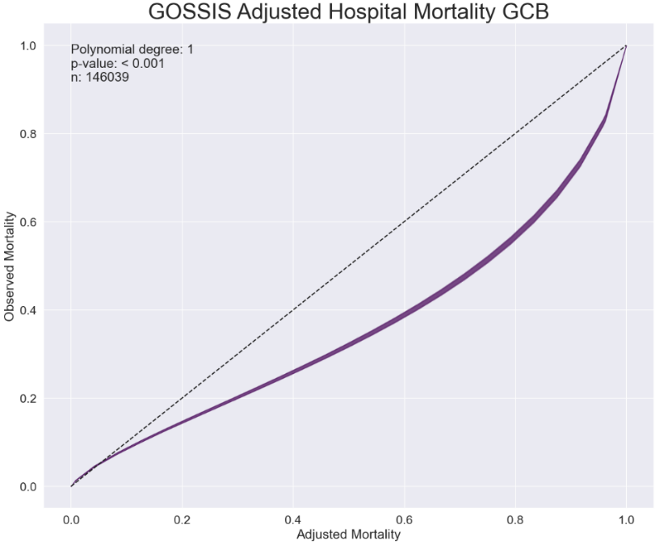
Supplemental Figure 4. eGOSSIS calibration belt.

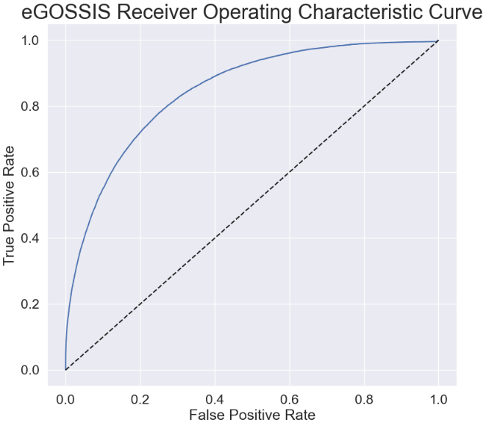
Supplemental Figure 5. eGOSSIS receiver operating characteristics curve.

Comparison of eGOSSIS with the Vizient Hospital Mortality Model
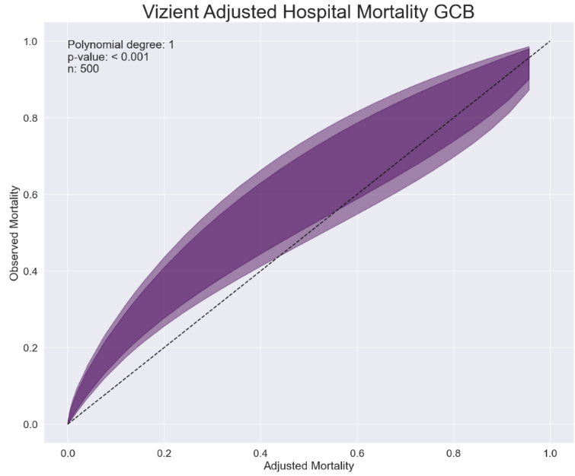
Supplemental Figure 6. Vizient model calibration belt in a subset of 500 patients.

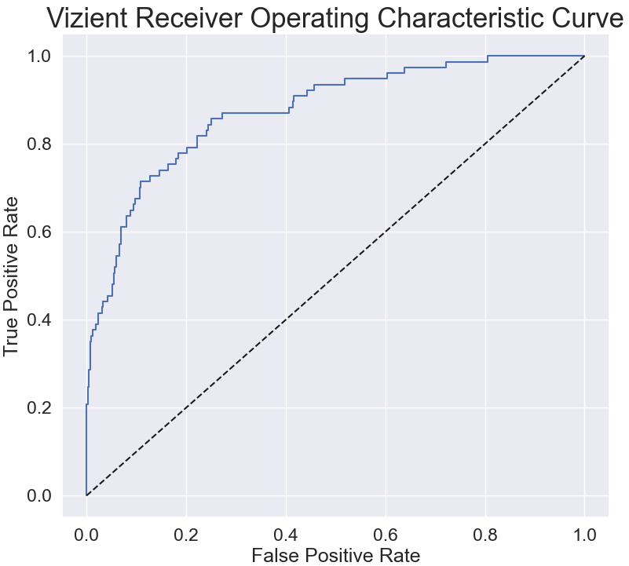
Supplemental Figure 7. Vizient receiver operating characteristics curve in a subset of 500 patients.

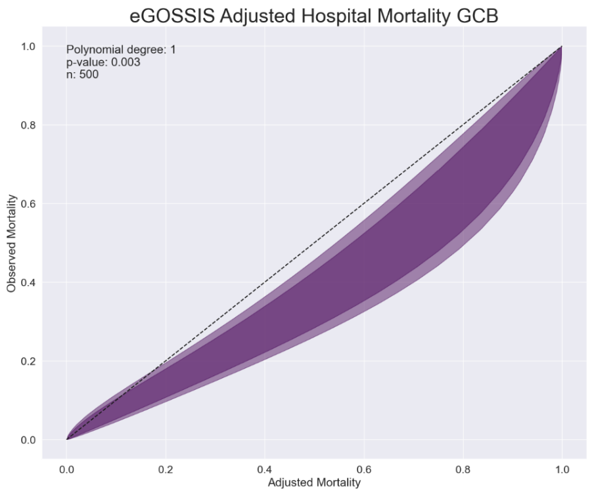
Supplemental Figure 8. eGOSSIS calibration belt in same subset of 500 patients as the Vizient model.

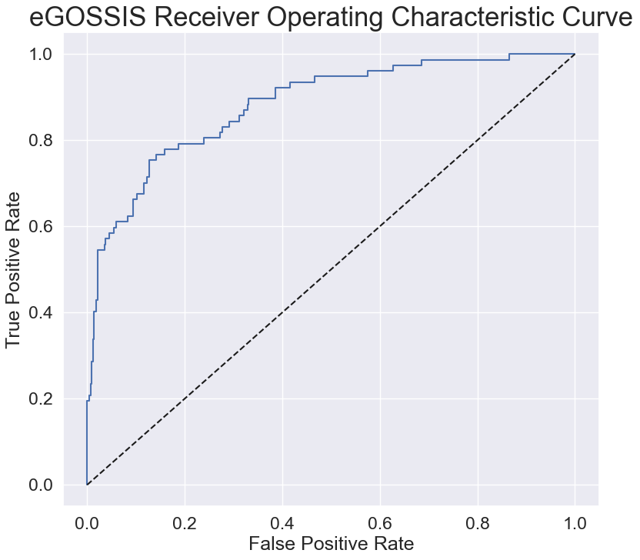
Supplemental Figure 9. eGOSSIS reiver operating characteristics in the subset of 500 patients.

UPMC Mortality Model Performance
Supplemental Figure 10. UPMC Mortality Model calibration belt in the validation cohort.
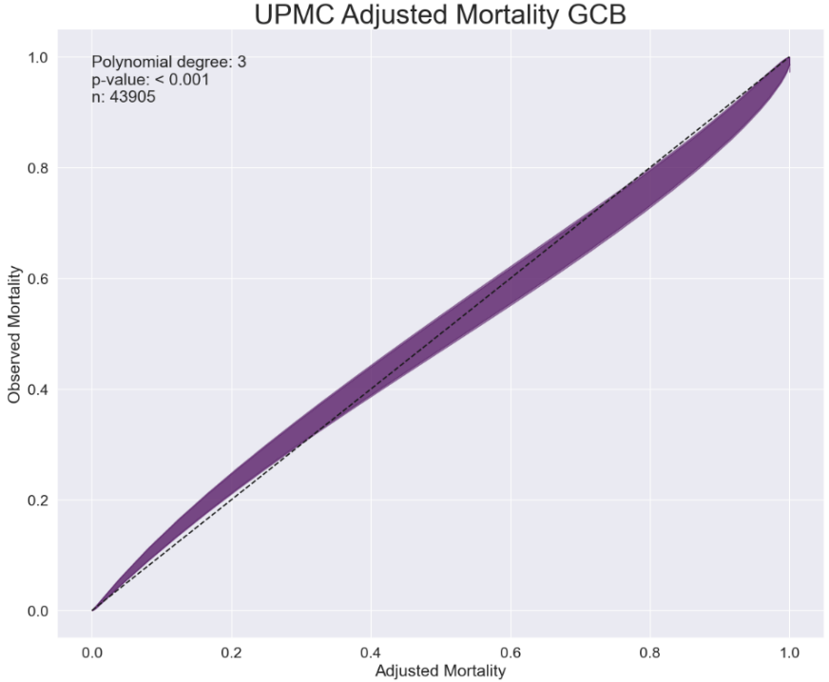
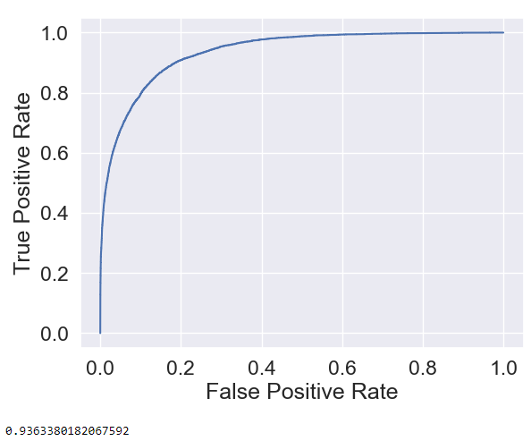
Supplemental Figure 11. UPMC Mortality Model receiver operating characteristics curve in the validation cohort.

Supplemental Table 13. Performance characteristics of the UPMC Mortality Model overall and by hospital type in train and test datasets.
Hospital Type | N/n | Mortality (%) | Predicted Mortality (%) | AUROC (95% CI) | AUPRC (95% CI) | Standardized Mortality Ratio  (95% CI) | Brier Score
Train
All Hospital Types | 102445 | 11.5% | 11.5% | 0.98  (0.98, 0.99) | 0.93  (0.92, 0.93) | 1.00  (0.98, 1.02) | 0.03
Community | 12363 | 10.4% | 10.8% | 0.98  (0.98, 0.98) | 0.90  (0.89, 0.91) | 0.96  (0.91, 1.01) | 0.03
Tertiary | 34468 | 12.8% | 12.7% | 0.98  (0.98, 0.99) | 0.93  (0.92, 0.94) | 1.01  (0.98, 1.04) | 0.03
Quaternary | 55614 | 11% | 11% | 0.99  (0.98, 0.99) | 0.93  (0.93, 0.94) | 1.00  (0.98, 1.03) | 0.03
Test
All Hospital Types | 43905 | 11.5% | 11% | 0.94  (0.93, 0.94) | 0.74  (0.73, 0.75) | 1.05  (1.02, 1.07) | 0.05
Community | 5288 | 10.1% | 10.6% | 0.92  (0.91, 0.93) | 0.64  (0.60, 0.68) | 0.95  (0.87, 1.03) | 0.06
Tertiary | 14870 | 13.3% | 12.2% | 0.94  (0.93, 0.94) | 0.76  (0.74, 0.77) | 1.09  (1.04, 1.13) | 0.06
Quaternary | 23747 | 10.7% | 10.4% | 0.94  (0.94, 0.94) | 0.75  (0.74, 0.76) | 1.04  (1.00, 1.07) | 0.05

UPMC Duration of Mechanical Ventilation Models Performance
Supplemental Table 14. 14-day DMV Model performance and cluster analysis.
Hospital Type | N/n | MSE | RMSE | MAE | R² | CCC
All Hospital Types | 25150 | 0.63 | 0.80 | 0.48 | 0.95 | 0.97
Community | 1708 | 0.60 | 0.77 | 0.46 | 0.96 | 0.98
Tertiary | 6981 | 0.62 | 0.78 | 0.47 | 0.96 | 0.98
Quaternary | 16461 | 0.62 | 0.79 | 0.47 | 0.96 | 0.98

Supplemental Table 15. 6-Day Multiple Classifier DMV Model performance and cluster analysis.
Hospital Type | N/n | Model 1ª |  |  | Model 2^{b} |  |  | Model 3^{c}
 |  | Precision^{d} | Recall^{d} | F1-score^{d} | Precision^{d} | Recall^{d} | F1-score^{d} | Precision^{d} | Recall^{d} | F1-score^{d}
All Hospital Types | 20,763 | 0.60 | 0.60 | 0.59 | 0.43 | 0.44 | 0.42 | 0.44 | 0.46 | 0.43
Community | 1,447 | 0.56 | 0.56 | 0.55 | 0.33 | 0.32 | 0.30 | 0.41 | 0.37 | 0.34
Tertiary | 13,468 | 0.61 | 0.60 | 0.59 | 0.46 | 0.46 | 0.44 | 0.47 | 0.49 | 0.45
Quaternary | 5,848 | 0.60 | 0.60 | 0.59 | 0.43 | 0.44 | 0.42 | 0.44 | 0.45 | 0.42
ªIncludes length of stay and mortality features
^{b}Does not include length of stay or mortality features
^{c}Does not include length of stay or mortality features, includes receipt of extracorporeal life support, renal replacement therapy, intravenous corticosteroids, intravenous antibiotics, and neuromuscular blockade features
^{d}For ‘All Hospital Types’ precision, recall, and F1-score are weighted averages

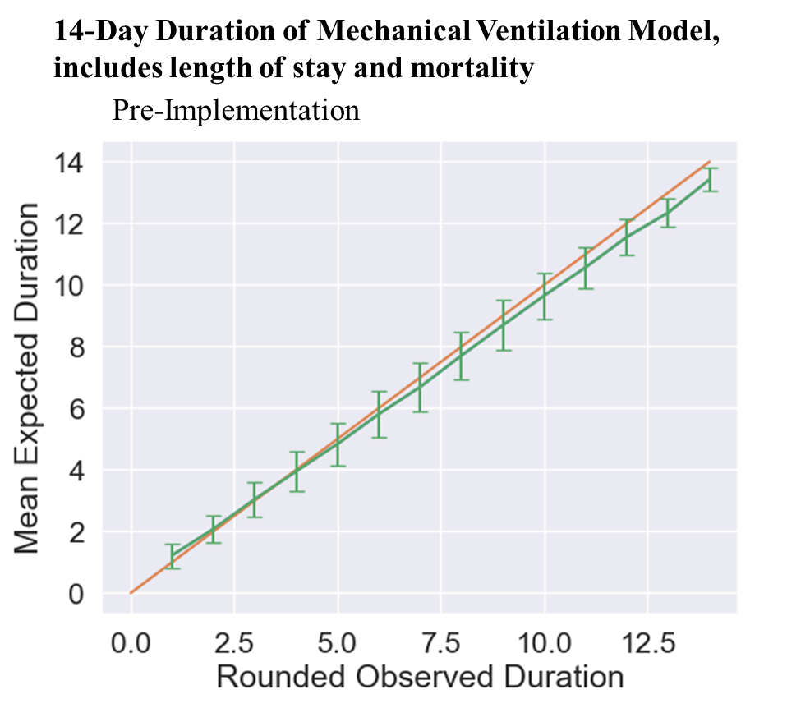
Supplemental Figure 12. 14-Day DMV Model reliability diagram

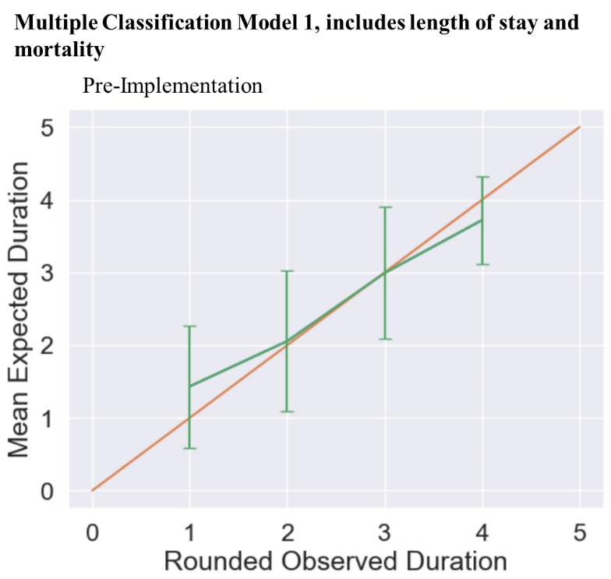
Supplemental Figure 13. DMV Multiple Classification Model 1, which includes length of stay and mortality as predictors.
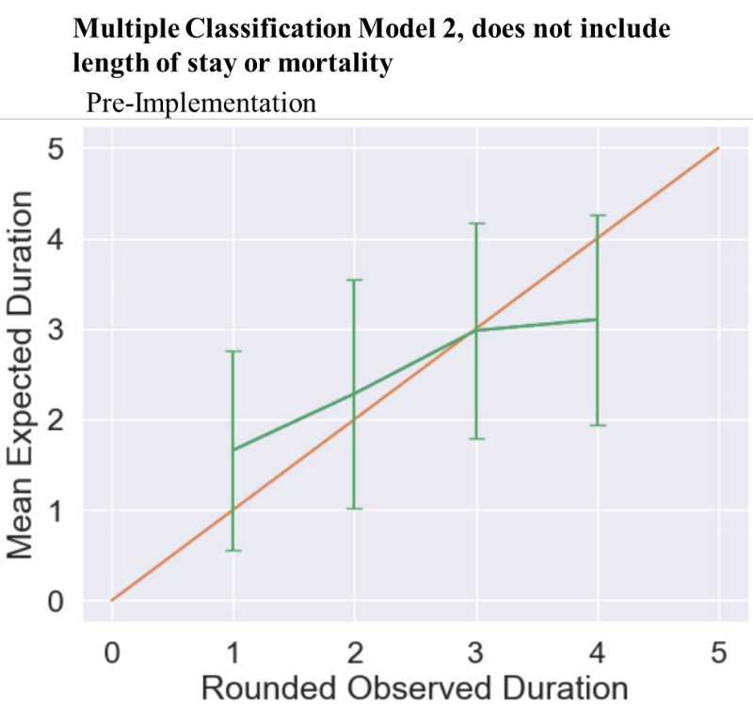
Supplemental Figure 14. DMV Multiple Classification Model 2, which does not include length of stay or mortality as predictors.

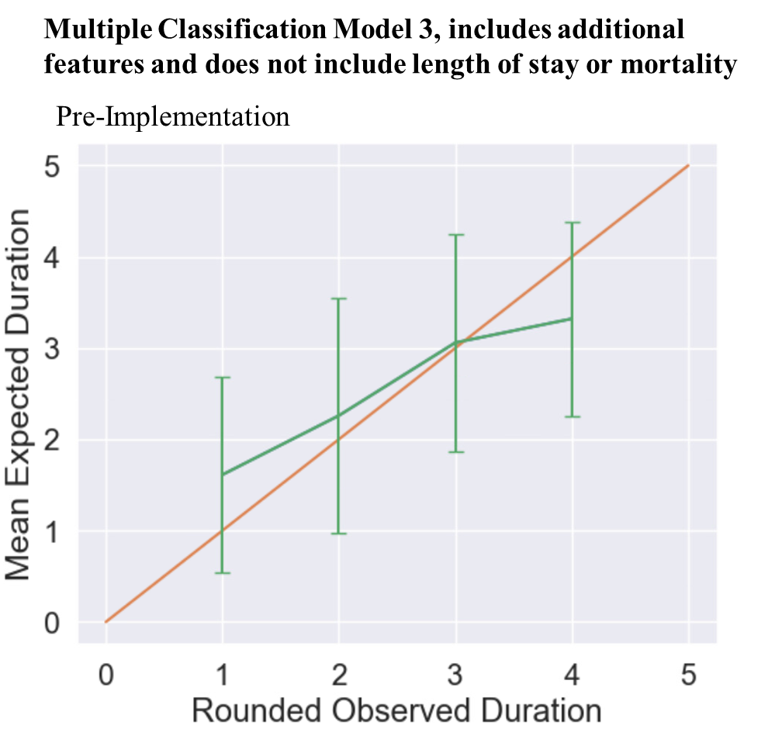
Supplemental Figure 15. DMV Multiple Classification Model 3, which does not include length of stay or mortality but does include additional hospitalization characteristics.

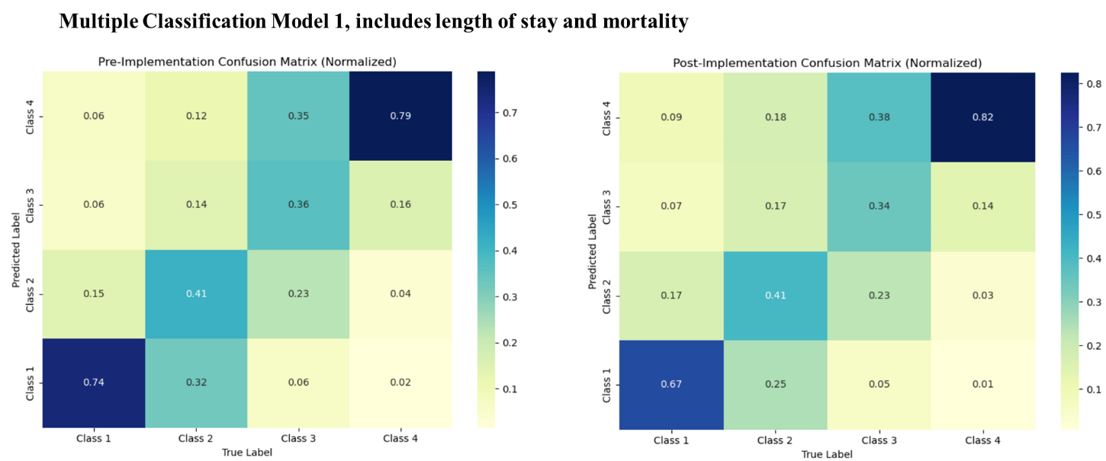
Supplemental Figure 16. Heat maps of Multiple Classifier DMV Model 1, in the pre- and post-implementation cohorts.


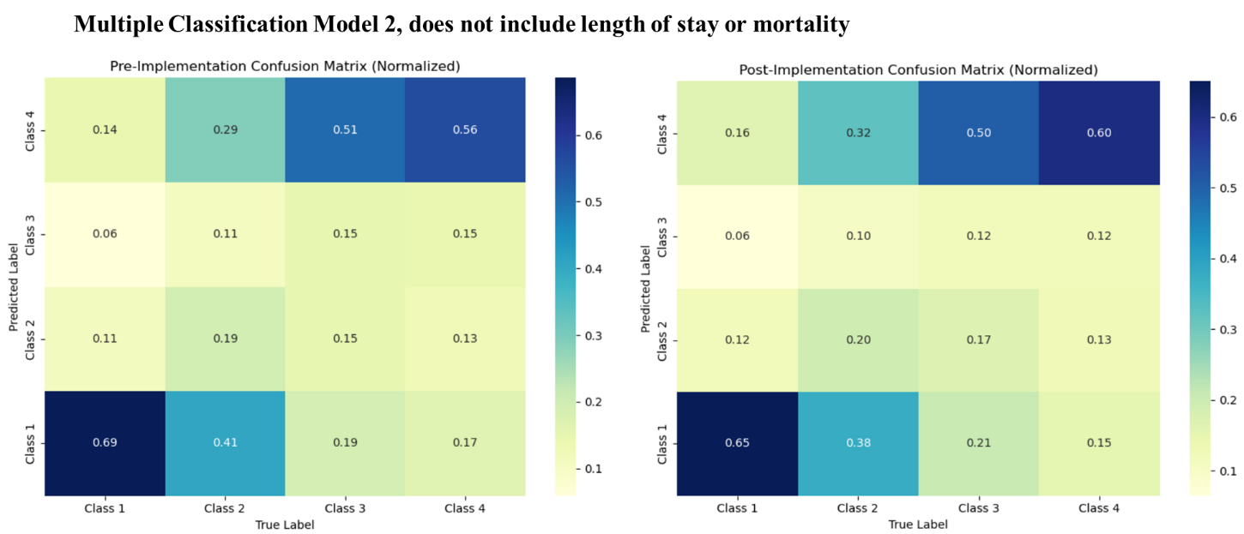
Supplemental Figure 17. Heat Maps of Multiple Classifier DMV Model 2, in the pre- and post-implementation cohorts.

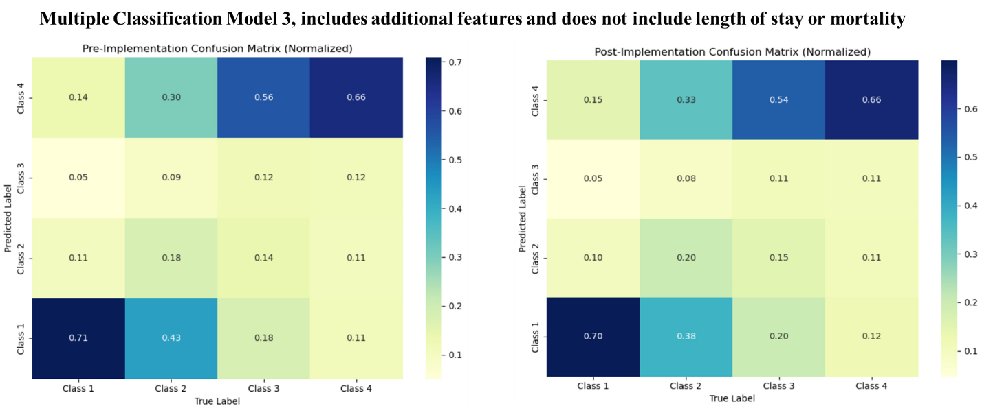
Supplemental Figure 18. Heat Maps of Multiple Classifier DMV Model 3, in the pre- and post-implementation cohorts.


Actual versus Predicted Duration of Mechanical Ventilation Results
Supplemental Table 16. Actual and predicted ventilator days with DMV multiple classifier models.
 | Training (Pre-Implementation) |  |  |  | Post-Implementation
Model | True Mean Class | Predicted Mean Class | Sum of Actual Classes | Sum of Predicted Classes | True Mean Class | Predicted Mean Class | Sum of Actual Classes | Sum of Predicted Classes
Model 1 | 2.1 ± 1.1 | 2.3 ± 1.2 | 44208 | 46847 | 2.3 ± 1.1 | 2.5 ± 1.2 | 64581 | 71207
Model 2 | 2.1 ± 1.1 | 2.3 ± 1.3 |  | 47692 | 2.3 ± 1.1 | 2.4 ± 1.3 |  | 69954
Model 3 | 2.1 ± 1.1 | 2.3 ± 1.3 |  | 48197 | 2.3 ± 1.1 | 2.4 ± 1.3 |  | 69294
Means are presented with ± standard deviation

Supplemental Figure 19. Average actual and predicted duration of mechanical ventilation using the 14-Day DMV Model.
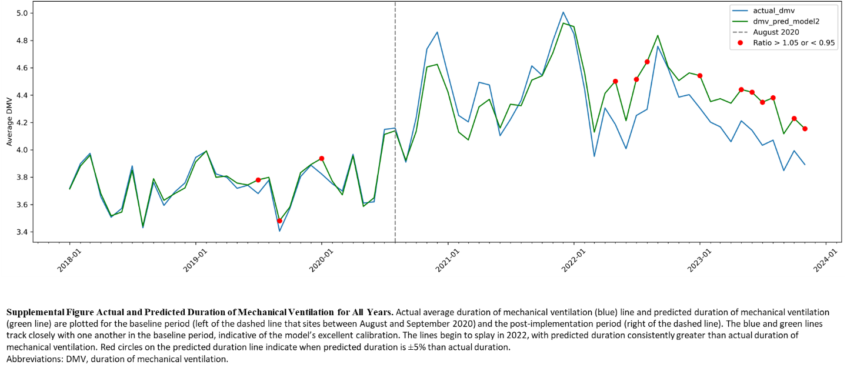
Actual average duration of mechanical ventilation (blue) line and predicted duration of mechanical ventilation (green line) are plotted for the baseline period (left of the dashed line that sites between August and September 2020) and the post-implementation period (right of the dashed line). The blue and green lines track closely with one another in the baseline period, indicative of the model’s excellent calibration. The lines begin to splay in 2022, with predicted duration consistently greater than actual duration of mechanical ventilation. Red circles on the predicted duration line indicate when predicted duration is ±5% than actual duration. Abbreviations: DMV, duration of mechanical ventilation.

Bias Assessment and Cluster Analysis
The eGOSSIS cluster analysis revealed comparable performance of the model across community, tertiary, and quaternary hospitals (Supplemental Table 12). For the UPMC Mortality Model, performance and calibration was comparable across all hospital types (Supplemental Table 13). The 14-day DMV model performed comparably across all hospital types (Supplemental Table 14). For the 6-day DMV multiple classifier models, precision, recall, and F1-score were highest in the tertiary hospitals and lowest in the community hospitals (Supplemental Table 15).

Results Synthesis and Deployment Readiness Assessment
We developed, validated, and deployed several well-performing risk-adjustment models for mortality and duration of mechanical ventilation, with the intent of facilitating multicenter QI work within our large health system. Model development and validation were performed in adherence to the established CRISP-DM framework, followed recent guidelines for prediction model development, and were informed by post-implementation review of previously published QI efforts within our ICU Service Center. Assessment of model performance within clusters of hospitals based on community, tertiary, and quaternary designations is both a necessary step to interrogate for sources of bias and to form an early understanding of how this work might generalize to other health systems. Public interrogation of mortality models informed an analysis of biases and provided awareness of potential limitations of the deployed mortality models. Our collective approach, rooted in informatics best practices and leveraging IT resources increasingly available in modern health systems is in alignment with the National Academy of Medicine’s (NAM’s) Learning Health Systems paradigm. By adhering to an established framework for model development and deployment, our team was able to systematically develop, assess, and ultimately deploy well-performing models to support continuous QI in our ICU Service Center.
The size of the UPMC Health System is representative of a trend in contemporary healthcare in the United States and other developed nations around the world. Consolidation of healthcare delivery into large or mega systems has administrative advantages that include economies of scale for healthcare fixed and variable costs. Integrated delivery and finance systems can also result in overall improved access as systems scale and an insurance product can be used more widely. However, ensuring best practices adherence within ICUs spanning such increasingly large health systems poses a challenge that begins to mirror adherence challenges experienced on the national scale. Continuous QI, bolstered by modern IT and informatics best practices, is a vision promoted by both NAM and the Center for Medicare and Medicaid Services. Accordingly, well-performing risk adjustment tools that demonstrate utility in efforts across ICUs in UPMC’s community, tertiary, and quaternary hospitals may speak to the developed models’ value in broader use.
Importantly, recent experience nationally with the sequential organ failure assessment score and other machine learning model deployments indicates the need for caution in deploying such strategies without appropriate interrogation. Recent work has also highlighted important deficits in medical education and other education curriculums related to machine learning and artificial intelligence. Our bias assessment, conducted in collaboration with varied perspectives in the form of a datathon, did not reveal substantial new avenues of bias compared to the initial assessment of the eGOSSIS reported with the original publication.¹³ Improving public awareness and competence related to the potential advantages and disadvantages of machine learning models can help to offset risk by promoting transparency, inviting varied perspectives, and encouraging both clinicians and the larger public to think critically about their existence with advanced analytics. In support of this perspective, our team opted to include details about each model’s statistical performance within the analytics dashboard, and provides an overview of model development, validation, and deployment during audit and feedback sessions.
Assessment of model performance indicated our team had developed and validated a suite of well-performing risk adjustment models that were ready for deployment as part of our team’s QI initiative. Strengths of the approach included the robust statistical performance of all models, adherence to best informatics practices, and inviting public perspectives on potential sources of bias. Potential limitations included our reliance on a single XGBoost approach for classification and a heterogeneous stacked ensemble with linear meta-regression for continuous outcome prediction. Other classification approaches, such as logistic regression, may be more readily interpretable. Moreover, approaches such as regression, random forest, or support vector machine, may have further bolstered performance. However, the comparable performance of the eGOSSIS and Vizient model, as well as surpassing an a priori AUROC performance expectation of 0.8, indicates that our mortality models are sufficiently robust for the needed purposes of providing QI balancing measures. Regarding our duration of mechanical ventilation models, the stacked ensemble method offers a theoretic advantage of multiple modeling strategies; however, this approach is less interpretable compared to traditional linear regression. Further development, validation, adjudication, and refinement of all models in collaboration with other health systems, through continued adherence to transparent and interoperable methods, would advance the generalizability of our approach.

Deployment
Results synthesis and deployment readiness assessment indicated that the models were suitable for deployment to support the ventilator QI initiative (step 6 of CRISP-DM). The deployment pipeline is detailed in Supplemental Figure 20. As part of deployment, a quality assurance pipeline was developed to track data drift, highlight outlier encounters (those with a low/high probability of mortality who did not/did survive or those with a low predicted duration of mechanical ventilation whose duration surpassed 7 days), and generate funnel plots of standardized mortality ratios to identify units that may need additional attention for performance improvement. A limitation of our deployment strategy is the lack of continuous implementation and continuous deployment technical stacks; such features would represent optimal practices for MLOps but are not yet widely available in healthcare environments. Minor technical issues such as brief data latency or EHR downtimes were occasionally encountered, but resolved rapidly without meaningful disruption. Instances when clinical judgment appropriately necessitated deviation from QI bundle recommendations were allowed recorded systematically via EHR documentation workflows. Overall clinician perception was favorable, with initial challenges mainly related to workflow adjustments at implementation onset.

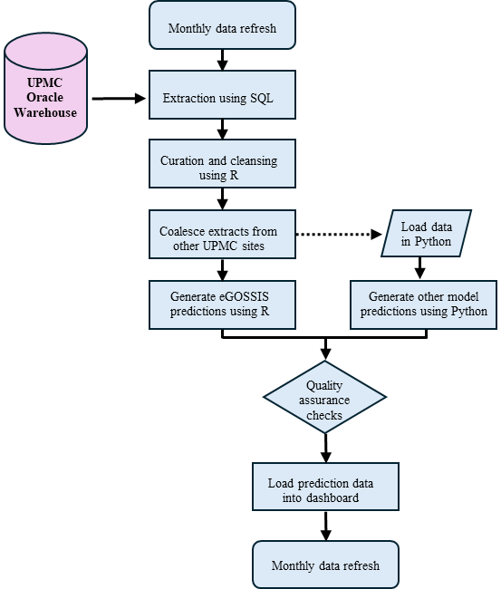
Supplemental Figure 20. Deployment pipeline for the risk adjustment models.

UPMC ICU Service Center Structure
An ICU Service Center operations team functions as a spoke of a UPMC central leadership hub that sets financial and operational goals for the health system. This operations team is responsible for implementation, change management, and ongoing maintenance of UPMC culture, policies, and procedures across the system’s ICUs. An ICU Service Center analytics team functions as a spoke of the central UPMC clinical analytics hub. The central hub is responsible for maintaining a data warehouse and related business intelligence solutions for the organization. The ICU Service Center analytics team focuses on harmonization of disparate data sources, metric development and validation, risk adjustment, data visualization, and ad hoc report generation to support the ICU operations team’s goals. Data in the present work are collected from 37 ICUs across 14 hospitals situated in Pennsylvania (20 hospitals) and New York (1 hospital) that use a single instance of the Cerner Millennium EHR (Oracle Cerner, Kansas City, MO). These hospitals were the initial setting of a QI initiative focusing on practices directly and indirectly related to mechanical ventilation.

References
1. Gélinas C, Fillion L, Puntillo KA, Viens C, Fortier M. Validation of the critical-care pain observation tool in adult patients. Am J Crit Care. 2006;15(4):420-427.
2. Sedation Agitation Scale - an overview | ScienceDirect Topics. Accessed April 28, 2024. https://www.sciencedirect.com/topics/medicine-and-dentistry/sedation-agitation-scale
3. Bergeron N, Dubois MJ, Dumont M, Dial S, Skrobik Y. Intensive Care Delirium Screening Checklist: evaluation of a new screening tool. Intensive Care Med. 2001;27(5):859-864. doi:10.1007/s001340100909
4. Hiser S, Chung CR, Toonstra A, et al. Inter-rater reliability of the Johns Hopkins Highest Level of Mobility Scale (JH-HLM) in the intensive care unit. Brazilian Journal of Physical Therapy. 2021;25(3):352. doi:10.1016/j.bjpt.2020.07.010
5. White DB, Angus DC, Shields AM, et al. A Randomized Trial of a Family-Support Intervention in Intensive Care Units. New England Journal of Medicine. 2018;378(25):2365-2375. doi:10.1056/NEJMoa1802637
6. Le Gall JR, Loirat P, Alperovitch A, et al. A simplified acute physiology score for ICU patients. Crit Care Med. 1984;12(11):975-977. doi:10.1097/00003246-198411000-00012
7. Knaus WA, Zimmerman JE, Wagner DP, Draper EA, Lawrence DE. APACHE—acute physiology and chronic health evaluation: a physiologically based classification system. Critical Care Medicine. 1981;9(8):591.
8. Lemeshow S, Teres D, Pastides H, Avrunin JS, Steingrub JS. A method for predicting survival and mortality of ICU patients using objectively derived weights. Crit Care Med. 1985;13(7):519-525. doi:10.1097/00003246-198507000-00001
9. Lemeshow S, Teres D, Klar J, Avrunin JS, Gehlbach SH, Rapoport J. Mortality Probability Models (MPM II) based on an international cohort of intensive care unit patients. JAMA. 1993;270(20):2478-2486.
10. Zimmerman JE, Kramer AA, McNair DS, Malila FM. Acute Physiology and Chronic Health Evaluation (APACHE) IV: Hospital mortality assessment for today’s critically ill patients*. Critical Care Medicine. 2006;34(5):1297. doi:10.1097/01.CCM.0000215112.84523.F0
11. Moreno RP, Metnitz PGH, Almeida E, et al. SAPS 3--From evaluation of the patient to evaluation of the intensive care unit. Part 2: Development of a prognostic model for hospital mortality at ICU admission. Intensive Care Med. 2005;31(10):1345-1355. doi:10.1007/s00134-005-2763-5
12. Press G. Cleaning Big Data: Most Time-Consuming, Least Enjoyable Data Science Task, Survey Says. Forbes. Accessed April 28, 2024. https://www.forbes.com/sites/gilpress/2016/03/23/data-preparation-most-time-consuming-least-enjoyable-data-science-task-survey-says/
13. Raffa JD, Johnson AEW, O’Brien Z, et al. The Global Open Source Severity of Illness Score (GOSSIS). Crit Care Med. 2022;50(7):1040-1050. doi:10.1097/CCM.0000000000005518
14. Cerner Ignite APIsSM | Home. Accessed April 27, 2024. https://fhir.cerner.com/
15. Harrison DA, Brady AR, Parry GJ, Carpenter JR, Rowan K. Recalibration of risk prediction models in a large multicenter cohort of admissions to adult, general critical care units in the United Kingdom. Crit Care Med. 2006;34(5):1378-1388. doi:10.1097/01.ccm.0000216702.94014.75
16. Mishra A, McClelland RL, Inoue LYT, Kerr KF. Recalibration Methods for Improved Clinical Utility of Risk Scores. Med Decis Making. 2022;42(4):500-512. doi:10.1177/0272989X211044697
17. Pollack MM, Holubkov R, Reeder R, et al. PICU Length of Stay: Factors Associated With Bed Utilization and Development of a Benchmarking Model. Pediatr Crit Care Med. 2018;19(3):196-203. doi:10.1097/PCC.0000000000001425
18. Debray TPA, Collins GS, Riley RD, et al. Transparent reporting of multivariable prediction models developed or validated using clustered data: TRIPOD-Cluster checklist. BMJ. 2023;380:e071018. doi:10.1136/bmj-2022-071018
19. Schröer C, Kruse F, Gómez JM. A Systematic Literature Review on Applying CRISP-DM Process Model. Procedia Computer Science. 2021;181:526-534. doi:10.1016/j.procs.2021.01.199
20. ANZICS CORE Registries. ANZICS. Accessed June 6, 2024. https://www.anzics.com.au/anzics-registries/
21. Pollard TJ, Johnson AEW, Raffa JD, Celi LA, Mark RG, Badawi O. The eICU Collaborative Research Database, a freely available multi-center database for critical care research. Sci Data. 2018;5(1):180178. doi:10.1038/sdata.2018.178
22. Hochheiser H, Klug J, Mathie T, et al. Raising awareness of potential biases in medical machine learning: Experience from a Datathon. medRxiv. Published online November 2, 2024:2024.10.21.24315543. doi:10.1101/2024.10.21.24315543
23. Moons KGM, Wolff RF, Riley RD, et al. PROBAST: A Tool to Assess Risk of Bias and Applicability of Prediction Model Studies: Explanation and Elaboration. Ann Intern Med. 2019;170(1):W1-W33. doi:10.7326/M18-1377

Collaborators

Realyze Intelligence
Aaron Brauser; Gilan Saadawi

University of Pittsburgh Department of Critical Care Medicine Quality Improvement Committee
Christina Thorngren

UPMC Clinical Analytics Team
Oscar Marroquin; Jeffrey McKibben; Suresh Mulukutla; Kevin Quinn

UPMC Clinical Documentation Capture Team
Alexandrea Bartow; Megan Cortazzo; Jamie Deangelis; Samuel Fleming II; Derek Jativa

UPMC eRecord Team
Richard Ambrosino; Robert Bart; Deborah Beer; Ashley Beyerl; Jason Burkey; Lillian Carpio; Sherry Casali; Jason Daugherty; Julie Dice; Cindy Ferringer; Jessica Fesz; Kristie Helfer; Sheryl Keeler; Sherbrina Keen; Maryalyce Lowery; Brent Massar; Rebecca Medva; Lynne Oncea; Reno Perri; Jason Roth; Chanthou Sevilla; Martha Stambaugh; Sue Della Toffalo; Kenneth Trimmer; Lisa Weber; Amy Woelke

UPMC Wolff Center
Linda Harvey; Tami Minnier

Vizient Incorporated
Michael Gerber; Heather Harris; Jaie Lavoie; Suzanne Rogers

Others
Peta Alexander; Ryan Barbaro; Nassima Bouhenni; Kyle Kalchthaler; Carlos Vallespi

