[1].明确要实现的功能
收发功能
[2].看电路图，研究硬件原理(找到所操作的硬件 与 CPU之间的引脚关联)
三根线:
Txd
Rxd
GND
串口数据的发送
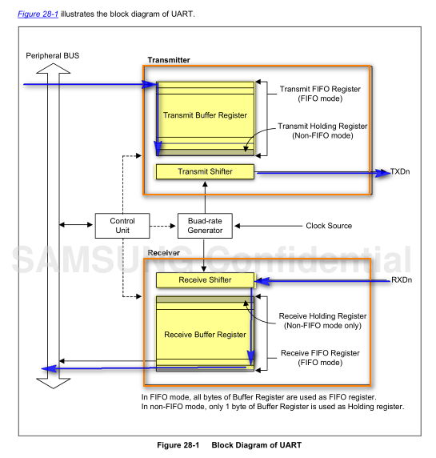
电路图:
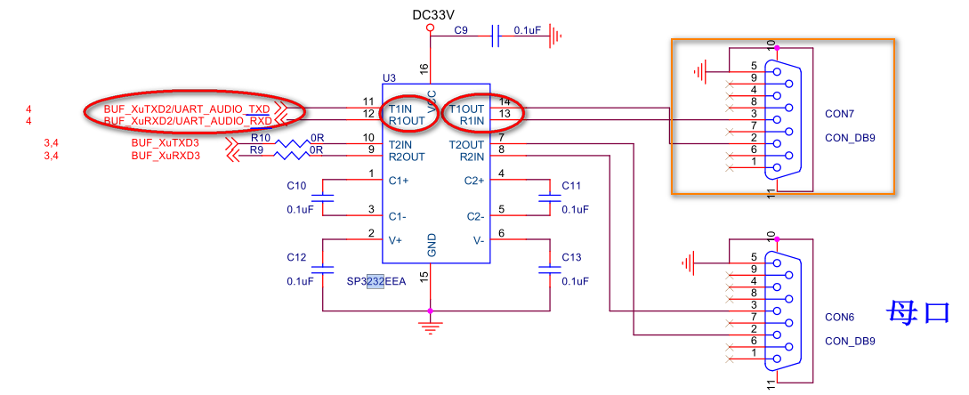

[3].查datasheet，找相关的寄存器(通过CPU的引脚 找关联的寄存器)
(a).寄存器 和 我们要实现的功能的 之间的关系
(b).寄存器的 地址
(c).寄存器的 值
6. General Purpose Input/Output (GPIO) Control 需要看 (GPIOd的引脚的寄存器)
28 Universal Asynchronous Receiverand Transmitter 需要看(UART的相关寄存器)

//GPIO
GPA1_0 --- Rxd
GPA1_1 --- Txd
• Base Address: 0x1140_0000
• Address = Base Address + 0x0020, Reset Value = 0x0000_0000
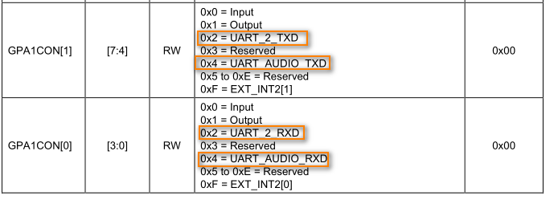
//UART ---串口属性
波特率 数据位 校验位 停止位

(ULCONn):
• A Start bit
• Five to eight data bits
• An optional parity bit
• One to two stop bits
UCON

SCLK UART –100Mhz (开发班上已经跑了一个程序,uboot -->已经完成了时钟的配置)

Base Address: 0x1380_0000, 0x1381_0000, 0x1382_0000, 0x1383_0000, 0x1384_0000
Register Offset Description Reset Value
ULCONn 0x0000 Specifies line control 0x0000_0000
UCONn 0x0004 Specifies control 0x0000_3000
UFCONn 0x0008 Specifies FIFO control 0x0000_0000
UMCONn 0x000C Specifies modem control 0x0000_0000
UTRSTATn 0x0010 Specifies Tx/Rx status 0x0000_0006
UERSTATn 0x0014 Specifies Rx error status 0x0000_0000
UFSTATn 0x0018 Specifies FIFO status 0x0000_0000
UMSTATn 0x001C Specifies modem status 0x0000_0000
UTXHn 0x0020 Specifies transmit buffer Undefined
URXHn 0x0024 Specifies receive buffer 0x0000_0000
UBRDIVn 0x0028 Specifies baud rate divisor 0x0000_0000
UFRACVALn 0x002C Specifies divisor fractional value 0x0000_0000
UINTPn 0x0030 Specifies interrupt pending 0x0000_0000
UINTSPn 0x0034 Specifies interrupt source pending 0x0000_0000
UINTMn 0x0038 Specifies interrupt mask 0x0000_0000

// ULCONn
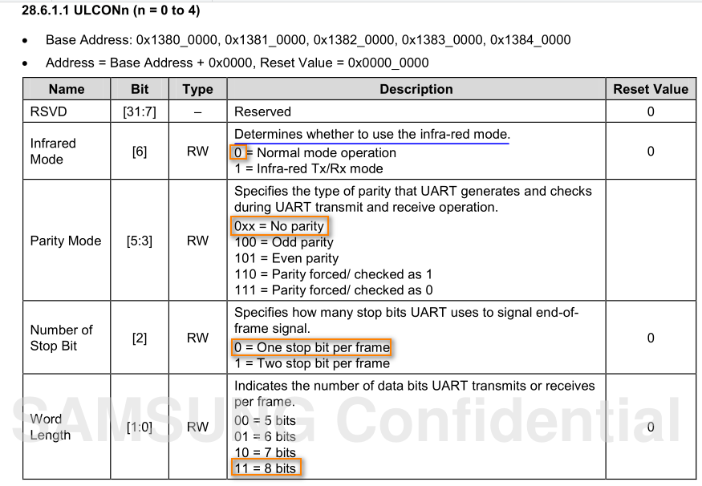

UCON
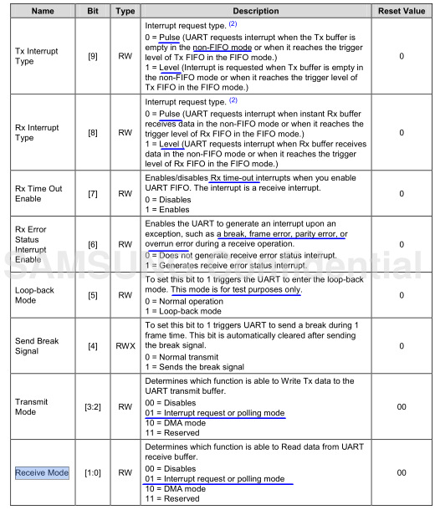
UFCONn
禁用FIFO
UMCONn
禁止
UTRSTATn
UTRSTATn 发送标志位 接收标志位
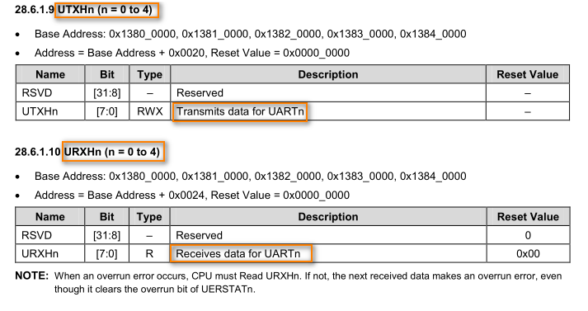

UART Baud-Rate Configuration
You can use the value stored in the Baud-rate divisor (UBRDIVn) and divisor fractional value (UFRACVALn)to determine the serial Tx/Rx clock rate (Baud rate) as:

DIV_VAL = UBRDIVn + UFRACVALn/16
or
DIV_VAL = (SCLK_UART/(bps  16))  1
Where, the divisor should be from 1 to (216 – 1).
By using UFRACVALn, you can generate the Baud rate more accurately.
For example, if the Baud rate is 115200 bps and SCLK_UART is 40 MHz, UBRDIVn and UFRACVALn are:
DIV_VAL = (40000000/(115200  16)) – 1
= 21.7 – 1
= 20.7
UBRDIVn = 20 (integer part of DIV_VAL)
UFRACVALn/16 = 0.7
Therefore, UFRACVALn = 11
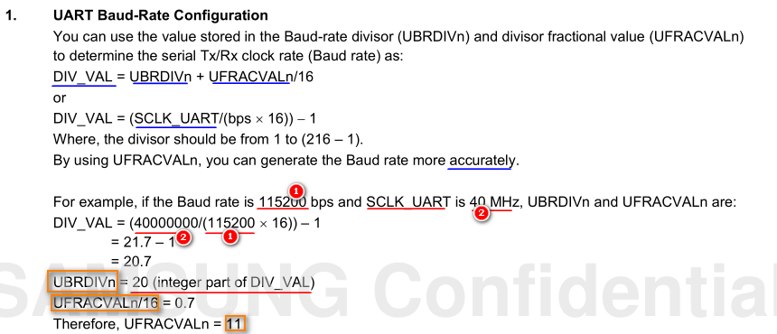

DIV_VAL = (100 000 000/(115200 X 16)) – 1
= 53.2
UBRDIVn = 53(integer part of DIV_VAL)
UFRACVALn/16 = 0.2
Therefore, UFRACVALn = 3

[4].编码(根据[3]整理编码思路，实现编码) {1.硬件的初始化，2.硬件的操作 3.退出操作}
//GPIO
GPA1_0 --- Rxd
GPA1_1 --- Txd

//uart
ULCONn //配置串口属性 --数据位 /校验位/校验位/红外模式
UCON //中断模式 或 polling模式
UFCON //禁用FIFO
UMCONn //禁止流控

//波特率
UBRDIVn = 53(integer part of DIV_VAL)
UFRACVALn = 3

//收发
UTRSTATn 发送标志位 接收标志位

if(UTRSTAT是否可发)
UTXH = val;
If(UTRSTAT是否可读)
Val = URXH;

//1.UART初始化
//2.uart_recv 接收
//3.uart_send 发送

[5].测试，找问题，(可能需要重复1-4)

