CATL (300750) In-Depth Research Report
Report Date: 2025-11-25 | Subject: CATL | Industry: New Energy and Advanced Manufacturing

1. Core Price Trend
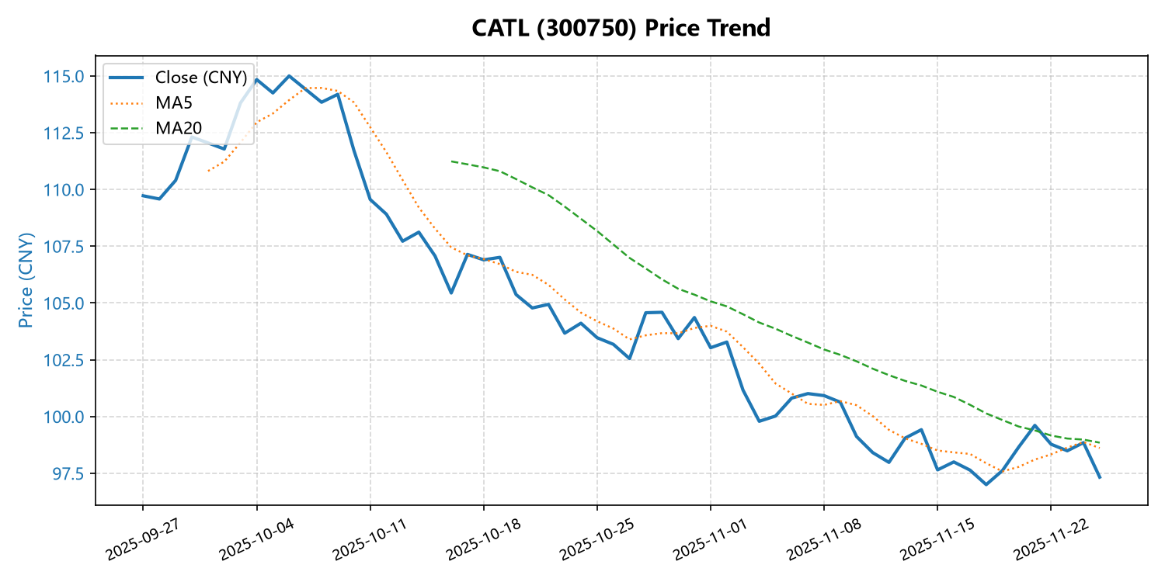
Trend Summary: Current price: CNY 97.33; 60-day change: -11.29%; period high: CNY 116.44; period low: CNY 95.4

Company Overview and Strategic Vision
The company currently trades at CNY 97.33, reflecting a 60-day decline of 11.29%, which indicates recent volatility and potential investor concerns. Despite this downturn, the stock remains near its 60-day low of CNY 95.4, suggesting a bearish trend in the short term. However, the price is still within a range that is not far from its recent peak of CNY 116.44, implying a degree of resilience and possible support at current levels. The strategic vision of the company likely centers on long-term growth, innovation, and market expansion, which may be influenced by macroeconomic conditions, industry dynamics, and internal operational efficiencies. Investors should consider the broader market context and the company's ability to adapt to evolving challenges in order to assess the sustainability of its strategic goals. The recent price movement may signal a consolidation phase or a response to sector-specific headwinds, but the company's fundamental positioning and future prospects remain critical in determining its long-term value.

Challenges and Future Outlook
The current price of CNY 97.33 reflects a notable decline of 11.29% over the past 60 days, indicating a bearish trend in the short term. This price movement has brought the asset close to its 60-day period low of CNY 95.4, suggesting increased selling pressure or market uncertainty. While the asset has not yet reached its period high of CNY 116.44, the recent underperformance raises concerns about liquidity and investor sentiment. The challenges include navigating potential macroeconomic headwinds and sector-specific risks that may continue to weigh on price appreciation. Looking ahead, the asset's future outlook depends on its ability to stabilize and regain momentum, which could be influenced by broader market conditions, policy changes, and sectoral recovery. Investors should remain cautious and monitor key indicators such as volume trends, technical levels, and fundamental performance to assess potential turning points.

Financial Performance and Market Position
The company's current stock price of CNY 97.33 reflects a 60-day decline of 11.29%, indicating a notable downward trend in recent performance. This decline places the stock slightly below its 60-day period low of CNY 95.4, while still remaining above the period high of CNY 116.44, suggesting volatility within a broader range. The stock has experienced a correction from its peak, which may be attributed to market sentiment, sector-specific challenges, or broader economic factors. Despite the recent pullback, the price remains relatively close to its recent high, signaling potential resilience or support at current levels. The company's market position appears to be under pressure, but the stock's ability to recover from the low implies underlying strength or investor confidence in its long-term prospects. Overall, the financial performance indicates a need for closer scrutiny of recent earnings, guidance, and macroeconomic influences to assess the sustainability of the current trajectory.

Appendix: Selected Recent Trading Data
Date | Close (CNY) | High (CNY) | Volume (lots)
2025-11-21 | 99.61 | 101.45 | 339,407
2025-11-22 | 98.78 | 100.59 | 337,251
2025-11-23 | 98.49 | 100.14 | 313,165
2025-11-24 | 98.85 | 100.30 | 320,806
2025-11-25 | 97.33 | 97.94 | 223,523

