# The Most Harmful Weather Events in US

## 1. Synopsis

In US, storm and other weather events cause a large loss for both population health and economy every year.In order to reduce the loss and damage from these disaster, it is important to find out which of them are the most harmful. History information including time and geography data for each weather event occurrence data were collected by U.S. National Oceanic and Atmospheric Administration's (NOAA) storm database. In this paper, the database was downloaded and analysed to answer two question:

1. Across the United States, which types of events (as indicated in the EVTYPE variable) are most harmful with respect to population health?
2. Across the United States, which types of events have the greatest economic consequences?

## 2. Getting the data

[NOAA storm database](http://d396qusza40orc.cloudfront.net/repdata/data/StormData.csv.bz2) is downloaded from coursera web page. Cache is used to avoid repetition of downloading.

Sys.setlocale('LC_ALL', 'English')

## [1] "LC_COLLATE=English_United States.1252;LC_CTYPE=English_United States.1252;LC_MONETARY=English_United States.1252;LC_NUMERIC=C;LC_TIME=English_United States.1252"

download.file("http://d396qusza40orc.cloudfront.net/repdata/data/StormData.csv.bz2",   
 "repdata-data-StormData.csv.bz2")  
stormData <- read.csv("repdata-data-StormData.csv.bz2", sep=",", header=TRUE,   
 stringsAsFactors=FALSE)

Take a look at the dataset, there are 4 columns are corresponding to health and economy loss:

1. FATALTIES ~ The number of fatalities caused by the events
2. INJURIES ~ The number of people injured by the events
3. PROPDMG ~ The amount of property loss by the events
4. CROPDMG ~ The amount of crop damage by the weather

str(stormData)

## 'data.frame': 902297 obs. of 37 variables:  
## $ STATE__ : num 1 1 1 1 1 1 1 1 1 1 ...  
## $ BGN_DATE : chr "4/18/1950 0:00:00" "4/18/1950 0:00:00" "2/20/1951 0:00:00" "6/8/1951 0:00:00" ...  
## $ BGN_TIME : chr "0130" "0145" "1600" "0900" ...  
## $ TIME_ZONE : chr "CST" "CST" "CST" "CST" ...  
## $ COUNTY : num 97 3 57 89 43 77 9 123 125 57 ...  
## $ COUNTYNAME: chr "MOBILE" "BALDWIN" "FAYETTE" "MADISON" ...  
## $ STATE : chr "AL" "AL" "AL" "AL" ...  
## $ EVTYPE : chr "TORNADO" "TORNADO" "TORNADO" "TORNADO" ...  
## $ BGN_RANGE : num 0 0 0 0 0 0 0 0 0 0 ...  
## $ BGN_AZI : chr "" "" "" "" ...  
## $ BGN_LOCATI: chr "" "" "" "" ...  
## $ END_DATE : chr "" "" "" "" ...  
## $ END_TIME : chr "" "" "" "" ...  
## $ COUNTY_END: num 0 0 0 0 0 0 0 0 0 0 ...  
## $ COUNTYENDN: logi NA NA NA NA NA NA ...  
## $ END_RANGE : num 0 0 0 0 0 0 0 0 0 0 ...  
## $ END_AZI : chr "" "" "" "" ...  
## $ END_LOCATI: chr "" "" "" "" ...  
## $ LENGTH : num 14 2 0.1 0 0 1.5 1.5 0 3.3 2.3 ...  
## $ WIDTH : num 100 150 123 100 150 177 33 33 100 100 ...  
## $ F : int 3 2 2 2 2 2 2 1 3 3 ...  
## $ MAG : num 0 0 0 0 0 0 0 0 0 0 ...  
## $ FATALITIES: num 0 0 0 0 0 0 0 0 1 0 ...  
## $ INJURIES : num 15 0 2 2 2 6 1 0 14 0 ...  
## $ PROPDMG : num 25 2.5 25 2.5 2.5 2.5 2.5 2.5 25 25 ...  
## $ PROPDMGEXP: chr "K" "K" "K" "K" ...  
## $ CROPDMG : num 0 0 0 0 0 0 0 0 0 0 ...  
## $ CROPDMGEXP: chr "" "" "" "" ...  
## $ WFO : chr "" "" "" "" ...  
## $ STATEOFFIC: chr "" "" "" "" ...  
## $ ZONENAMES : chr "" "" "" "" ...  
## $ LATITUDE : num 3040 3042 3340 3458 3412 ...  
## $ LONGITUDE : num 8812 8755 8742 8626 8642 ...  
## $ LATITUDE_E: num 3051 0 0 0 0 ...  
## $ LONGITUDE_: num 8806 0 0 0 0 ...  
## $ REMARKS : chr "" "" "" "" ...  
## $ REFNUM : num 1 2 3 4 5 6 7 8 9 10 ...

## 3. Data Processing

### 3.1 The most harmful events for public health

Top ten health threaten events ranked by total fataliteis and injuries.

fatalities <- aggregate(stormData$FATALITIES, list(stormData$EVTYPE), sum)  
injuries <- aggregate(stormData$INJURIES, list(stormData$EVTYPE), sum)  
health <- merge(fatalities, injuries, by="Group.1")  
health[,4] <- health[,2] + health[,3]  
colnames(health) <- c("type", "fatalities", "injuries", "total")  
healthtop <- health[order(health$total, decreasing=TRUE),][1:10,]

Plot the data

library(reshape2)  
healthtop_1 <- melt(healthtop, id.vars="type")  
  
library(ggplot2)  
ggplot(healthtop_1, aes(x = reorder(type, -value), y = value)) +   
 geom_bar(stat = "identity", aes(fill = variable), position = "dodge") +   
 scale_y_sqrt("Number of Cases") + xlab("Event Type") +  
 theme(axis.text.x = element_text(angle = 45, hjust=1)) +   
 ggtitle("Top 10 Health Threat Events")

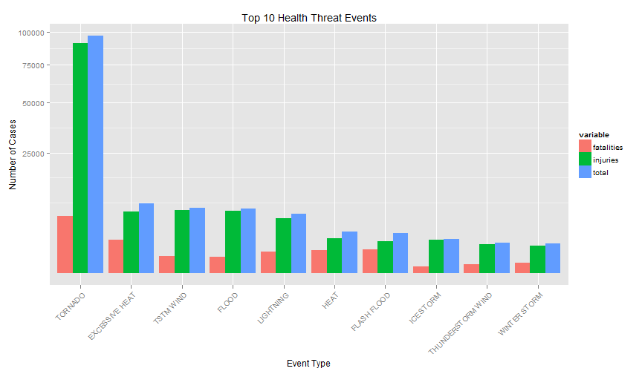

### 3.2 The most harmful events for economy

By examing the data, we find that the units for each row of property damage and corp damage are different, and there are huge gap between the range of property damage and corp damage. So it is more clear to demostrate them seperately. First, we need to make their units same.

unique(stormData$CROPDMGEXP)

## [1] "" "M" "K" "m" "B" "?" "0" "k" "2"

unique(stormData$PROPDMGEXP)

## [1] "K" "M" "" "B" "m" "+" "0" "5" "6" "?" "4" "2" "3" "h" "7" "H" "-"  
## [18] "1" "8"

According to the [National Weather Service Storm Data Documentation](https://d396qusza40orc.cloudfront.net/repdata%2Fpeer2_doc%2Fpd01016005curr.pdf):

* "K"/ "k" stand for thousand
* "M"/ "m" stand for million
* "B"/ "b" stand for billion

So, we creat a new data frame economy to use the same units.

economy <- stormData[,c("EVTYPE", "PROPDMG", "PROPDMGEXP", "CROPDMG",   
 "CROPDMGEXP")]  
index1 <- which(economy$PROPDMGEXP%in%c("K","k"))  
index2 <- which(economy$PROPDMGEXP%in%c("M","m"))  
index3 <- which(economy$PROPDMGEXP%in%c("B","b"))  
  
economy[,2][index1] <- economy[,2][index1]*(10^3)  
economy[,2][index2] <- economy[,2][index2]*(10^6)  
economy[,2][index3] <- economy[,2][index3]*(10^9)

Use the same method for crop damage

index4 <- which(economy$CROPDMGEXP%in%c("K","k"))  
index5 <- which(economy$CROPDMGEXP%in%c("M","m"))  
index6 <- which(economy$CROPDMGEXP%in%c("B","b"))  
  
economy[,4][index4] <- economy[,4][index4]*(10^3)  
economy[,4][index5] <- economy[,4][index5]*(10^6)  
economy[,4][index6] <- economy[,4][index6]*(10^9)

propertydmgs <- aggregate(economy$PROPDMG, list(economy$EVTYPE), sum)  
corpdmgs <- aggregate(economy$CROPDMG, list(economy$EVTYPE), sum)  
colnames(propertydmgs) <- c("type", "propertydmgs")  
colnames(corpdmgs) <- c("type", "corpdmgs")  
  
propertydmgstop <- propertydmgs[order(propertydmgs$propertydmgs,   
 decreasing=TRUE),][1:10,]  
corpdmgstop <- corpdmgs[order(corpdmgs$corpdmgs, decreasing=TRUE),][1:10,]

Plot the data

library(gridExtra)  
  
plot2 <- ggplot(propertydmgstop, aes(x=reorder(type, -propertydmgs),   
 y=propertydmgs)) +   
 geom_bar(stat = "identity", position = "dodge") +   
 scale_y_sqrt("Property Damage(US Dollar)") + xlab("Event Type") +  
 theme(axis.text.x = element_text(angle = 45, hjust=1)) +   
 ggtitle("Top 10 Property Threat Events")  
  
plot3 <- ggplot(corpdmgstop, aes(x=reorder(type, -corpdmgs), y=corpdmgs)) +   
 geom_bar(stat = "identity", position = "dodge") +   
 scale_y_sqrt("Corp Damage(US Dollar)") + xlab("Event Type") +  
 theme(axis.text.x = element_text(angle = 45, hjust=1)) +   
 ggtitle("Top 10 Corp Threat Events")  
  
grid.arrange(plot2, plot3, ncol = 2)

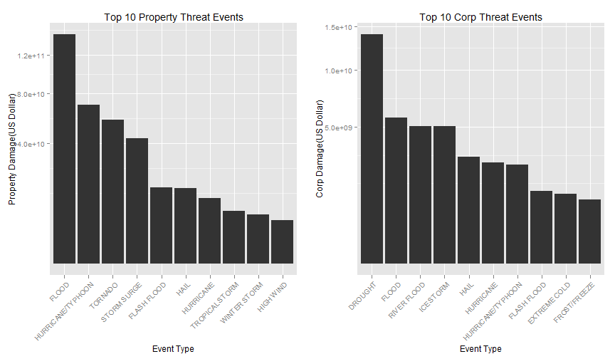

### 3.3 Which part of US suffer most from the weather disaster?

Creat a dataframe healthState demostrating number of health threaten cases by state.

healthState <- stormData[,c("STATE", "FATALITIES", "INJURIES")]  
healthState[,4] <- healthState[,2] + healthState[,3]  
colnames(healthState)[4] <- "TOTAL"

healthState_1 <- aggregate(healthState$TOTAL, list(healthState$STATE), sum)  
colnames(healthState_1) <- c("STATE", "VALUE")

Plot the data

ggplot(healthState_1, aes(x=reorder(STATE, -VALUE), y=VALUE)) +   
 geom_bar(stat = "identity", position = "dodge") +   
 ylab("Number of Health Cases") + xlab("State") +  
 theme(axis.text.x = element_text(angle = 45, hjust=1)) +   
 ggtitle("Number of Health Cases in State")

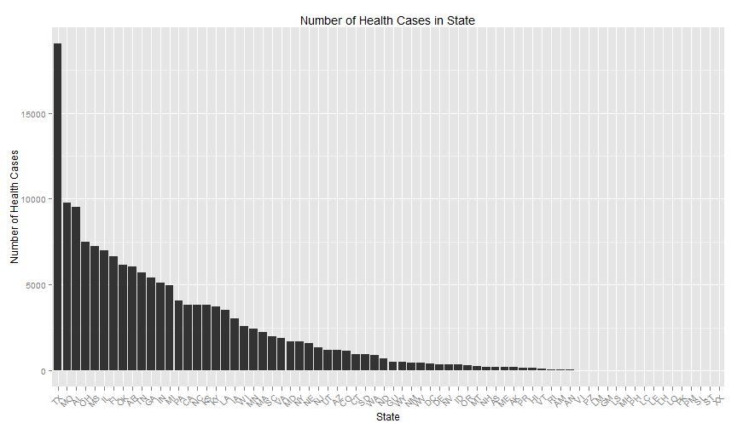

## 4. Result

According to the data demonstrated in first figure, among these types of weather disaster, **TORNADO**, **EXCESSIVE HEAT** and **TSTM WIND** are most dangerous for public health. As it showed in the second figure, **TORNADO**, **HURRICANE/TYPHOON** and **TORNADO** cause most property loss, while **DROUGHT**, **FLOOD** and **ICESTORM** bring most corp damage. In the aspect of geographic classification, Texas is the most vulnerable targets for bad weather events. But no obvious pattern can be discovered to show which part of US suffered more from the meteorological disaster.