**COCHIN UNIVERSITY OF SCIENCE AND TECHNOLOGY**



**MINI PROJECT REPORT**

**ON**

**CUSAT Reader**

***Submitted By:***

**SHANI KUMAR PATHAK (REG.NO 14160239)**

**SATISH KUMAR (REG.NO 14160236)**

**GAURAV SINGH HIMANSHU (REG.NO 14160221)**

**DHARAM BHUSAN SINGH (REG.NO 14160219)**

*In partial fulfillment of the award of degree of* ***Bachelor of Technology***

*in*

**INFORMATION TECHNOLOGY**

**COCHIN UNIVERSITY COLLEGE OF ENGINEERING KUTTANAD, PULINCUNNU**

**COCHIN UNIVERSITY OF SCIENCE AND TECHNOLOGY**

APRIL 2018



**Division of Information Technology CUCEK**

**Cochin University of Science &TechnologyKochi**

**CERTIFICATE**

*Certified that this is a bonafide record of the project work titled*

***CUSAT Reader***

*Done by*

**SHANI KUMAR PATHAK (REG.NO 14160239)**

**SATISH KUMAR (REG.NO 14160236)**

**GAURAV SINGH HIMANSHU (REG.NO 14160221)**

**DHARAM BHUSHAN SINGH (REG.NO 14160219)**

*of 6thsemester Information Technology in the year 2018 in*

*partial fulfillment of the requirements for the award of Degree of Bachelor of Technology in Information Technology of Cochin University of Science & Technology.*

*JABIR K V T* HARI KRISHNAN D  *Project Guide Head of the Division*

**ACKNOWLEDGEMENT**

Dreams never turn to reality unless a lot of effort and hard work is put into it. And no effort bears fruit in the absence of support and guidance. I would like to take this opportunity to thanks a few who were closely involved in the completion of this project. We are extremely grateful to our principal **Dr. SUNIL KUMAR** for his whole hearted cooperation for the successful completion of this project. We extend our sincere and heart full thanks to **Mr. HARI KRISHNAN D** Head of Department (Information Technology) for providing us the right ambience for carrying out the work on this project and for the facilities provided to us. I extend my sincere and heartfelt thanks to our esteemed guide Mr. **AGATH MARTIN** and **JABIR K V T** for providing me with the right guidance and advice at the crucial junctures and for showing me the right wayWe would also like to extend our gratitude to all the staffs and classmates of the IT department for the help and support rendered to us.

**ABSTRACT**

The aim of this project is to spark the student to initiate their study in an easy way. With the help of this project android app “CUSAT Reader” one can easily get their syllabus, subject related reference book and notes in pdf format for different branches all at single place according to the CUSAT syllabus 2015 scheme. The student can take benefit in their study with the help this android app.

**CONTENTS**

1. INTRODUCTION………………………………………………………………………..

2. SYSTEM ANALYSIS…………………………………………………………………...

2.1 Introduction…………………………………………………………………….

2.2 Analysis Model…………………………………………………………….…..

2.3 Study of System………………………………………………………………..

2.4 Proposed System……………………………………………………….………

3. FEASIBILITY STUDY……………………………………………………….…………

3.1 Technical Feasibility…………………………………..……………………….

3.2 Operational Feasibility………………………………..………………………..

3.3 Economical Feasibility…………………………………………………………

3.4 Schedule Feasibility…………………………………………………………….

4. SOFTWARE REQUIREMENT SPECIFICATION………………………………………

4.1 Introduction……………………………………………………………………..

4.2 Overview……………………………………………………………………….

4.3 Functional Requirements…………………………………………………….…

4.4 Non-Functional Requirements……………………………………………….…

4.5 Performance Requirements…………………………………………………….

4.6 Design Constraint………………………………………………………………

5. SYSTEM DESIGN………………………………………………………………………..

5.1 Languages Used…………………………………………..…………………….

5.2 System Specifications……………………………………..…………………....

5.3 Data Flow Diagrams………………………………………..…………………..

5.4 Design Table……………………………………………………………………

5.5 Entity Relationship Diagram…………………………….……………………..

6. SYSTEM IMPLEMENTATION………………………………..………………………..

7. TESTING……………………………………………………..…………………………..

8. SNAPSHOTS………………………………………………..……………………………

9. CONCLUSION………………………………………..…………………………………

10. FUTURE SCOPE……………………………………….……………………………….

11. BIBLIOGRAPHY………………………………….……………………………………

**CHAPTER-1**

**INTRODUCTION**

**INTRODUCTION TO THE PROJECT**

The aim of this project is to spark the student to initiatetheir study in an easy way. With the help of this project android app “CUSAT Reader” one can easily get their syllabus, subject related reference book and notes in pdf format for differentbranches all at single place according to the CUSAT syllabus 2015 scheme. The student can take benefit in their study with the help this android app.

**OBJECTIVE**

. The objectives of the projects as follows:

* Users can register on the App.
* User can login to the App where users can access full study material of their respective branch and admission year.
* Users can view, read, download and upload study materials.
* User can also get syllabus and new notifications.
* Admin can manage all the functionality and has full access to modify and add extra feature when required.

**SCOPE**

Any users can sign up and access all the functionality provided by Admin of App using their user ID and password used during sign up time. They can view, read, download and upload the study material related to their branch and scheme. Admin have full access to manage their users and uploaded contents by users. Admin can also take action against,s if he find any misbehaving activity by users.

**CHAPTER-2**

**SYSTEM ANALYSIS**

**INTRODUCTION**

After analyzing the requirements of the task to be performed, the next step is to analyze the problem and understand its context. The first activity in the phase is studying the existing system and the other is to understand the requirements and domain of the new system. Both the activities are equally important, but the first activity serves as the basis of giving the functional specifications and then successfully design the proposed system. Understanding the properties and the requirements of the new system is more difficult and requires creative thinking and understanding of existing running system is also difficult, improper understanding of the present system can lead diversion from solution.

**ANALYSIS MODEL**

SDLC METHODOLOGIES

This document play a vital role in the development of life cycle (SDLC) as it describes the complete requirement of the system. It means for use by developers and will be the basic during testing phase. Any changes made to the requirements in the future will have to go through formal change approval process.

Spiral model was defined by Barry Boehm in his 1988 article, “A spiral mode; of software development and enhancement”. This mode was not the first mode to discuss the iterative development, but it was the first model to describe why iteration n models are used.

Each phase starts with a design goal and ends with client reviewing the process. Analysis and engineering efforts are applied at each phase of the project, with an eye towards the end goal of the project.

**The steps for spiral model can be generalized as follows:**

The new system requirements are defined as much as possible. This usually involves interviewing a number of users representing all the external or internal users and other aspects of the existing system. A preliminary design s prepared for the system. A prototype of the new system is constructed from the preliminary design. This is an approximation of the final product. A second prototype is evolved by a fourfold procedure evaluating the first in terms of its strength, weakness, and risks. Define the requirements of the second prototype. Planning a design for second prototype. Constructing and testing the second prototype. At the customer option, the entire project can be aborted if the risk is large. Risk factors might be involved development cost overruns, operating cost miscalculation, or any other factor that could, in the

customer’s view, result in a less satisfactory product. The existing prototype is evaluated in the same manner as the previous prototype, and if necessary another prototype is developed from it according to the fourfold procedure outlined above.

The preceding steps are iterated until the customer is satisfied that the refined prototype represents the final product desired. The final system is constructed, based on the refined prototype. The final system is thoroughly evaluated and tested.

**STUDY OF THE SYSTEM**

In the flexibility of the uses the GUI’s at the top level have been categorized as the administrative user interface that concentrates on the consistent information that is practically part of the organizational activities and which needs proper authentication for the data collection. The interfaces help the administrations with all the transactional states like data insertion, deletion and updating along with the extensive data search capabilities.

**CHAPTER-3**

**FEASIBILITY ANALYSIS**

Preliminary investigation examine project feasibility, the likelihood the system will be useful to the organization. The main objective of the feasibility study is to test the technical, operational and economical, feasibility for adding new modules and debugging old system.

**3.1 Technical feasibility**

A study of resource availability that may affect the ability to achieve an acceptable system. This evaluation determines whether the technology needed for the proposed system is available or not.

• Can the work for the project be done with current equipment existing software technology & available personal?

• Can the system be upgraded if developed?

• If new technology is needed then what can be developed?

This is concerned with specifying equipment and software that will successfully satisfy the user requirement. The technical needs of the system may include:

Front- the benefits associated with the candidate system and if it suits the basic purpose of the organization i.e. profit making, the project is making to the analysis and design phase.

**3.2 Operational Feasibility**

It is mainly related to human organizations and political aspects. The points to be considered are:

• What changes will be brought with the system?

• What organization structures are disturbed?

• What new skills will be required? Do the existing staff members have these skills? If not, can they be trained in due course of time? The system is operationally feasible as it very easy for the End users to operate it. It only needs basic information about Windows platform.

**3.3 Economical Feasibility**

Economic justification is generally the “Bottom Line” consideration for most systems. Economic justification includes a broad range of concerns that includes cost benefit analysis. In this we weight the cost and the benefits associated with the candidate system and if it suits the basic purpose of the organization i.e. profit making, the project is making to the analysis and design phase.

The financial and the economic questions during the preliminary investigation are verified to estimate the following:

• The cost to conduct a full system investigation.

• The cost of hardware and software for the class of application being considered.

• The benefits in the form of reduced cost.

• The proposed system will give the minute information, as a result the performance is improved which in turn may be expected to provide increased profits.

The App CUSAT Reader does not require enormous amount of money to be developed. This can be done economically if planned judicially, so it is economically feasible. The cost of project depends upon the number of man-hours required.

**3.4 Schedule feasibility**

Time evaluation is the most important consideration in the development of project. The time schedule required for the developed of this project is very important since more development time effect machine time, cost and cause delay in the development of other systems. A reliable App **CUSAT Reader** can be developed in the considerable amount of time.

**SOFTWARE REQUIREMENT SPECIFICATION**

**4.1 INTRODUCTION**

**Purpose-** The purpose of the App **CUSAT Reader** is to upload, download ,view and read the study material and help to student to find materials easily to study so that they can score good in examination.

Developers should consult this document and its revisions as the only source of requirements for the project. They should not consider any requirements statements, written or verbal as valid until they appear in this document or its revision.

**Scope-**Admin have full access of App. He can upload, remove the study content and also remove users if he find any misbehaving activity. Users can manage all the activity from firebase. The main purpose of this App is:-

* View study materials
* Download study material
* Upload study material
* Read study material
* Get new notification
* Get updated time-table

**4.2 OVERVIEW**

This Software Requirements Specification (SRS) is the requirements work product that formally specifies CUSAR Reader. It includes the results of both business analysis and systems analysis efforts. Various techniques were used to elicit the requirements and we have identified your needs, analyzed and refined them. The objective of this document therefore is to formally describe the system’s high level requirements including functional requirements, non-functional requirements and business rules and constraints. The detail structure of this document is organized as follows:

* This document also provides an overview of the business domain that the proposed CUSAT Reader will support. These include a general description of the product, user characteristics, general constraints, and any assumptions for this system.
* This model demonstrates the development team's understanding of the business domain and serves to maximize the team's ability to build a system that truly does support the business.
* This also presents the detail requirements, which comprise the domain model.

**4.3 FUNCTIONAL REQUIREMENTS**

**Output Design-**

Outputs from computer systems are required primarily to communicate the results of processing to users. They are also used to provide a permanent copy of the results for later consultation. The various types of outputs in general are external outputs, whose destination is outside the organization. Internal outputs are those whose destination is within organization and they're the user's main interface with the computer. Operational outputs are those whose use is purely within the computer department. Interface outputs are which involves the user in communicating directly.

**Input Types-**

It is necessary to determine the various types of inputs. External inputs, which are prime inputs for the system. Internal inputs, which are user communication with the system. Operational, which are computer department's communication to the system. Interactive, which are inputs entered during dialogue. Here, the most of the inputs are of the form internal and interactive. As input data is to be directly typed in by the user, the keyboard can be considered to be the most suitable input device.

CUSAR Reader will support. These include a general description of the product, user characteristics, general constraints, and any assumptions for this system.

CUSAR Reader will support. These include a general description of the product, user characteristics, general constraints, and any assumptions for this system.

**Error Avoidance-**

At this stage, care is to be taken to ensure that input data remains accurate from the stage at which it is recorded up to the stage in which the data is accepted by the system. This can be achieved only by means of careful control, each time the data is handled.

**Error Detection-**

Even though every effort is made to avoid the occurrence of errors, still a small proportion of errors are always likely to occur. These types of errors can be discovered by using validations to check the input data

**Data Validation-**

Procedures are designed to detect errors in data at a lower level of detail. Data validations have been included in the system in almost every area where there is a possibility for the user to commit errors. The system will not accept invalid data. Whenever an invalid data is typed in, the system immediately prompts the user and the user has to again type the data and the system will accept the data only if it is correct. Validations have been included wherever necessary. The system is designed to be a user-friendly one.

**1. User Registration:** Users/student can sign up/register themselves by providing Reg. No. branch , semester, Scheme , email and mobile number.

**2. User Login:** Users/student can login to enjoy all the functionality provided by App by their registered email and password.

**3. View Content:** Student can view all the contents related to their branch and semester.

**4. Upload Content:** Student can upload the content related to their academic and important information, if they have any.

**5. Verify login:** Student can only login with registered Email and password.

**6. Download Contents:**Student can alsodownload the content from the app.

**R.4.1: SIGN UP**:

R.4.1.1: Form validation

R.4.1.2: Full Name

*Input:* "Enter name" option.

*Output*: user prompt to enter first, middle and last name.

R.4.2.3:User Name

Input: Enter the Email as "username".

Output: User prompt to enter his Email address.

R.4.2: Password

R.4.2.1: Create Password

Input : create a "password".

Output : prompt to enter password.

R.4.2.2:Re-enter Password

Input: Re enters the password.

Output: Prompt to enter the password again

Description: Check whether the reentered password is match with password.

R.4.3: Basic Information

R.4.3.1: Reg. Number

*Input:* "Reg. Number" option.

*Output:* User prompt to enter his Reg. Number.

R.4.3.2: Branch:

*Input:* "Select Branch" option: 1.IT, 2. CSE , 3.MECH,

4.CIVIL, 5.EC, 6.EEE

*Output* : user prompt to enter his/her Branch.

R.4.3.3: Semester

*Input:* "Select Semester" option.

*Output*: Prompt to select I.D CARD

Option: 1st & 2nd, 3rd, 4th, 5th, 6th ,7th, 8th.

**R.4.2: Login**

R.2.1: Form

R.2.1.1: Username

Input: Enter the username.

Output: Prompt enter valid username.

R.2.1.2: Password

Input: enter the password.

Output: prompt enter password

R.2.1.3: Submit

Input: button to enter submit.

Output: login to the account if user is valid

**R.4.3 : View Content**

R.4.3.1: Select Semester

*Input*: Enter the semester.

*Output*: Users prompt to enter semester.

R.4.3.2: Select Subject

*Input: "*Subject option" option.

*Output*: User prompts to choose subject.

R.4.3.3: View

*Input*: Get “View" option.

*Output*: User prompts to click on view button

*Description*: Just after clicking on "View". User will get the contents of the subject.

**R.4.4: Upload Content**

R.4.4.1: Semester

*Input*: "Enter semester" option.

*Output*: User prompt to enter semester.

R.4.4.2: Subject

*Input*: "Subject" option.

*Output*: User prompt to subject.

R.4.4.3: Content

*Input*: "select content" option.

*Output*: user prompt to select his/her content.

R.4.4.4: Upload

*Input* : "Click on Upload" button.

*Output*: Prompt to click on button.

**R.4.5: Download Content**

R.4.5.1: Semester

*Input*: "Enter semester“ option.

*Output*: Prompt to enter semester.

R.4.5.2: Subject

*Input*:"select Subject" option.

*Output*: Prompt to select subject.

R.4.5.1: Download

*Input*: "Enter content" option.

*Output*: Prompt to download subject.

**4.4 NON-FUNCTIONAL REQUIREMENTS**

**1. Interface Requirements:**

The interface requirements of CUSAT Reader include

* Easy to Navigate.
* Less Graphics .
* Display Error Messages and Relevant Dialogue Boxes.
* Providing high security such that not to be modified by irrelevant users.
* It must provide options such that to reduce the input actions by users.

**2. User Requirements:**

After a brief study of requirements of clients the requirements of this system is given as follows:

* Login information
* Content details
* Content upload
* Content view/read
* Content downloads

**3. Software Requirements:**

The software requirements of this are as follows:

* Windows OS
* Android Studio.

**4. Logical Database Requirements:**

The following information is to be stored in the firebase database

* Student details
* Content details

**Constrains:**

Integrity is an integral part of any system. Admin can upload, download , upload the content and also manage all the activity from the firebase .He can also take action against the student who upload irrelevant stuff.

*instructions for Security:*

Security through the login form. So, the system is secured, because of avoiding other people to update the content.

**CHAPTER-5**

**SYSTEM DESIGN**

**5.1 LANGUAGES USED**

* **JAVA**

**5.2 SYSTEM SPECIFICATION**

**5.2.1**  HARDWARE REQUIREMENT

|  |  |
| --- | --- |
| COMPONENT | SPECIFICATION |
| Computers & Processors | i5 |
| Main Memory | 8GB |
| Hard Disk | 1Tb |
| Display | LCD |

**5.2.2** SOFTWARE REQUIREMENT

|  |  |
| --- | --- |
| SOFTWARE | VERSION |
| Android Studio | 3.0.1 |
| Operating System | Windows 10 |
| Atom | 1.22.1 |

**5.3 DATA FLOW DIAGRAM (DFD)**

A Data Flow Diagram (DFD) is a structured analysis and design tool that can be used for flowcharting. A DFD is a network that describes the flow of data and the processes that change or transform the data throughout a system. This network is constructed by using a set of symbols that do not imply any physical implementation. It has the purpose of clarifying system requirements and identifying major transformations. So it is the starting point of the design phase that functionally decomposes the requirements specifications down to the lowest level of detail. DFD can be considered to an abstraction of the logic of an information-oriented or a process-oriented system flow- chart. For these reasons DFD’s are often referred to as logical data flow diagrams.

**EXTERNAL ENTITY**

An external entity is a source or destination of a data flow. Only those entities which originate or receive data are represented on a data flow diagram. The symbol used is a rectangular box.

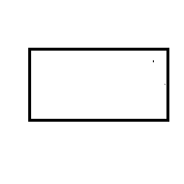

**PROCESS**

A process shows a transformation or manipulation of data flow within the system. The symbol used is an oval shape.

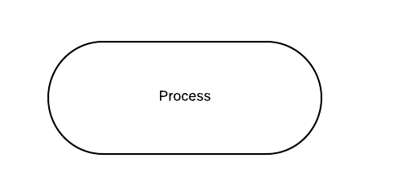

**DATA FLOW**

The data flow shows the flow of information from a source to its destination. Data flow is represented by a line, with arrowheads showing the direction of flow. Information always flows to or from a process and may be written, verbal or electronic. Each data flow may be referenced by the processes or data stores at its head and tail, or by a description of its contents.

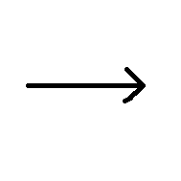

**DATA STORE**

A data store is a holding place for information within the system: It is represented by an open ended narrow rectangle. Data stores may be long-term files such as sales ledgers, or may be short-term accumulations: for example batches of documents that are waiting to be processed. Each data store should be given a reference followed by an arbitrarynumber

LEVEL-0 DFD

Storage

LEVEL-1 DFD

Input Output

Student/Users

Level-2 DFD

CUSAT Reader Storage

Read/upload Upload/Manage

Students

Download

Admin

Down Storage Up Storage

**Data Flow**

i/p pass,

username

Choose Subject

Loginn

Error

Error

Download/upload/read

Fail

Success

Display

Menu

Stop

**5.4 DESIGN TABLE**

**5.4.1 Sign Up**

|  |  |  |
| --- | --- | --- |
| Field Name | Data Type | Constraint |
| First name | char |  |
| Last name | Char |  |
| Password | Char |  |
| Email | Char | Primary Key |
| contact number | Int |  |
| Branch | Chat |  |
| Semester | int |  |

**5.4.2 Admin**

|  |  |  |
| --- | --- | --- |
| Field Name | Data Type | Constraint |
| Email | Char | Primary key |
| Password | Char |  |

**5.4.2 Student**

|  |  |  |
| --- | --- | --- |
| Field Name | Data Type | Constraint |
| Email | Char | Primary key |
| Password | Char |  |

**5.5 ENTITY RELATIONSHIP DIAGRAM**

Login

Sign Up

Student

Authentication

Fail

Pass

Branch

. . . . .

. . . . . . . …. .. .

Contribution

Read Book

**CHAPTER-6**

**SYSTEM IMPLEMENTATION**

This is a process of converting a new system into an operational one. It is a key stage on achieving a successful new system it involves a lot of upheaval in the user department. It must be therefore carefully planned, controlled and implemented.

**Documentation**

The whole system is documented carefully and is presented in a readable manner. Also the system manuals are prepared and handed over to the user operator system. This was to ensure that if any correction, manipulation, or updating is to be performed in the future, the user would face no problem in making these changes.

**Maintenance**

When the system is in maintenance phase, some people within the system are responsible for collecting maintenance requested for users and other interested parties. The purpose of maintenance system is returning to beginning of the system development phase until changes are implemented.

**CHAPTER-7**

**TESTING**

Testing is a process of evaluating a system or its components with the intent to find whether it satisfies the specified requirements or not. Testing is executing a system in order to identify errors, or missing requirements in contrarily to the actual requirement.

While testing the CUSAT Reader App, we tested every possible scenario that can be faced by the system. We tested all the forms one by one by providing real time values and the desired results were obtained.

After putting the system through rigorous testing, we assured that the system performs all the desired operations perfectly and hence we concluded that the system has successfully passed the testing phase and is ready to use.

**CHAPTER-8**

**SNAPSHOTS**

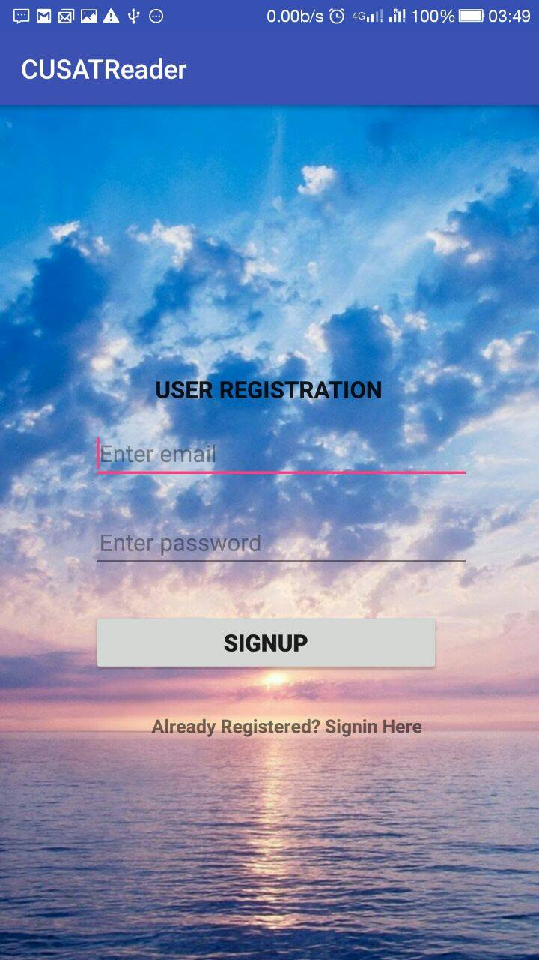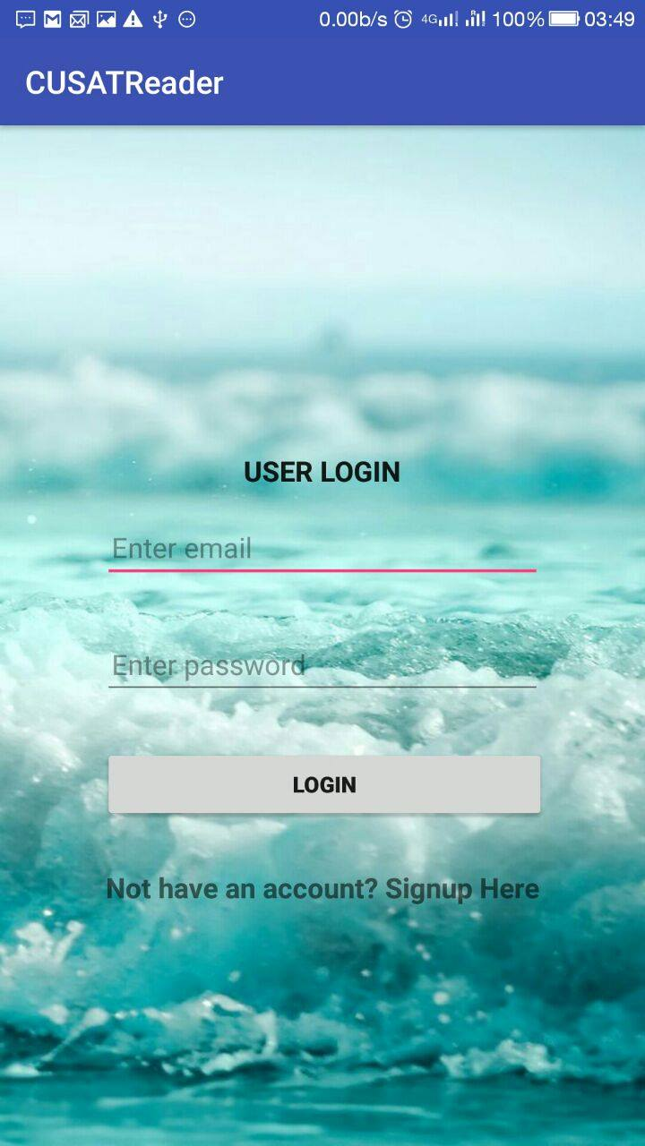

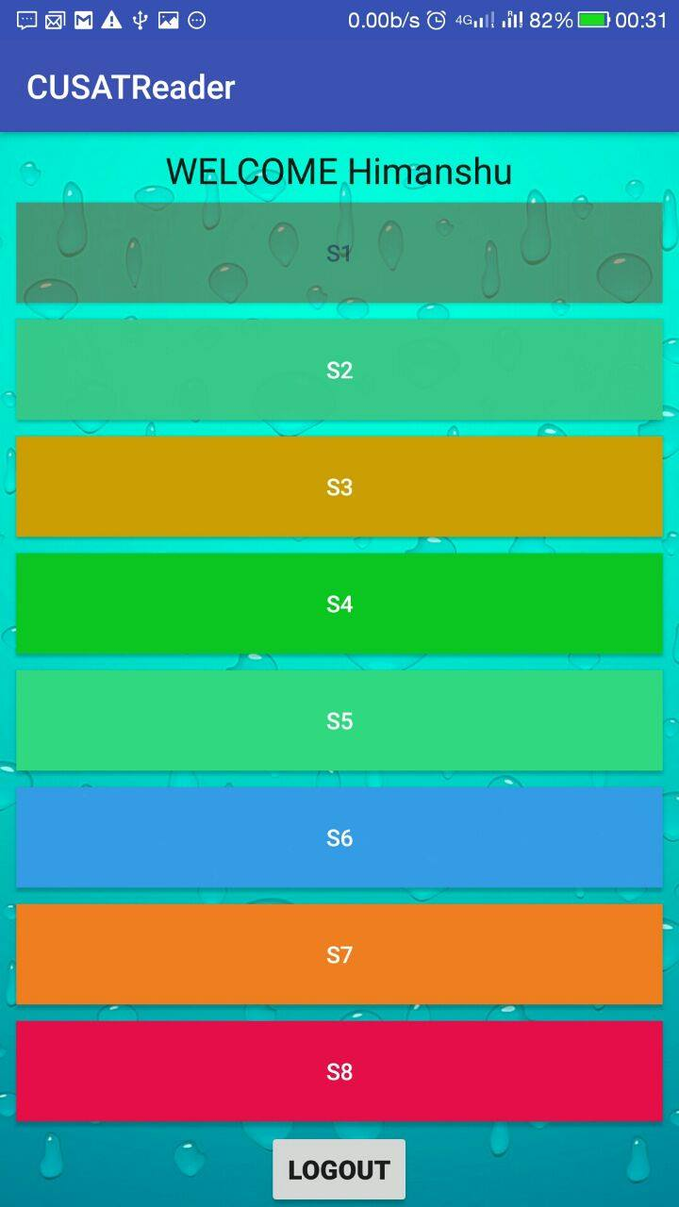

**CHAPTER-9**

**CONCLUSION**

The project entitled **CUSAT Reader** has completed successfully.The system has been developed with much care and free of errors and at the same time it is efficient and less time consuming. The purpose of this project was to develop a web application for CUSAR Reader .This project helped us in gaining valuable information and practical knowledge on several topics like designing web pages using JAVA, ANDROID STUDIO designing of android applications, and management of database using FIREBASE. The entire system is secured.Also the project helped us understanding about the development phases of a project and software development life cycle. We learned how to test different features of a project.This project has given us great satisfaction in having designed anapplication which can be implemented to any nearby shops or branded shops selling various kinds of products by simple modifications. There is a scope for further development in our project to a great extend. A number of features can be added to the system in future like watch me module, each admin having separate permissions.

Practical Training is a very important part of the curriculum as it strengthens the concepts and enhances knowledge about the practical implementation of all the theory concepts, we have learn so far in different subjects. Our project is CUSAT Reader. This project is used to keep study material for student. It helps managing the system very efficiently and conveniently. Although the project work has been done in a complete and detailed manner but due to the constraint of time, we could not include some more features we wanted to. We left these features as a part of the feature development. As soon as we’ll get time we’ll try to add them to my project

**CHAPTER-11**

**BIBLIOGRAPHY**

1. Programming: Java - The Complete Reference by Herbert Scheldt

2. Android: Hohensee, B., & Dharma, A. (2014).

Android for beginners: Developing apps using

Android Studio. Babelcube