CODEC TECHNOLOGIES INDIA
Headquarters: 211B, Saki Vihar Road, West Chandivali IT Hub, Powai ,Mumbai, Maharashtra 400076



A
Report

on

“Stock Prediction With Linear Regression ”
Submitted in partial fulfillment of
Internship Project

By

SHANIA MARGARET SAINI

Under the guidance of the

Project Head

CODEC TECHNOLOGIES INDIA
Headquarters: 211B, Saki Vihar Road, West Chandivali IT Hub, Powai ,Mumbai, Maharashtra 40007
1. Introduction
Stock market prediction is a challenging task due to the dynamic nature of financial markets. Accurate prediction of stock prices can help investors make informed decisions. This project focuses on forecasting the closing price of Apple Inc. (AAPL) using historical stock data and related market indices. A Linear Regression model is implemented to establish relationships between the closing price and various features derived from historical and technical indicators.
2. Objective of the Project:
- Predict the closing price of AAPL stock for the next trading day.
- Explore the impact of historical prices, technical indicators, and market indices on stock price movement.
- Evaluate the accuracy of linear regression for stock price forecasting.

3. Dataset Description
The dataset used in this project is AAPL.csv, containing historical stock prices and technical indicators from 2005 onwards.
Key features include:
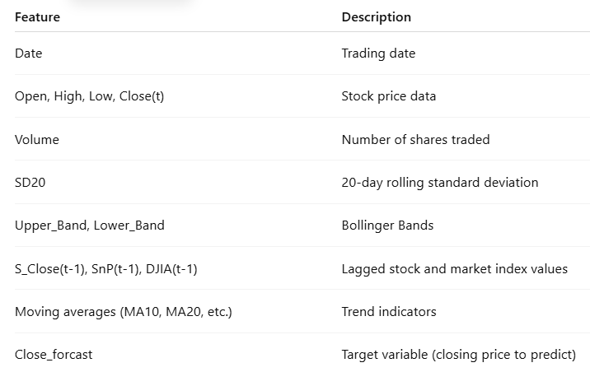
The dataset also includes related market indices such as S&P 500 (SnP_Close) and Dow Jones Industrial Average (DJIA_Close).

4. Exploratory Data Analysis (EDA)
EDA was performed to understand the dataset:
- Price Trends: Visualizations of closing prices over time show historical growth with periodic fluctuations.
- Correlation Analysis: High correlation exists between current closing price and previous day’s close (S_Close(t-1)), suggesting lag features are strong predictors.
- Distribution: Close prices and other features are approximately normally distributed, suitable for linear regression.
- Missing Values: Checked for null values; dataset is clean with no missing entries.
5. Data Preprocessing
• Feature Selection: Relevant columns were selected, including technical indicators and lagged features.
• Scaling: Continuous features were scaled if required for regression stability.
• Train-Test Split: Data was split into training (80%) and testing (20%) sets based on chronological order to avoid data leakage.
• Lag Features: Created previous day(s) closing prices to improve prediction accuracy.

6. Linear Regression Model

Model Used: Linear Regression
- Description: Linear Regression is a statistical method that models the relationship between dependent variable (closing price) and independent variables (features). The model assumes a linear relationship:

$$y=β_{0}+β_{1}x_{1}+β_{2}x_{2}+...+β_{n}x_{n}+ϵ$$
- Training: The model was trained on historical stock data using features like lagged prices, moving averages, and Bollinger Bands.
- Prediction: Predicted the Close_forcast values for test data.
7. Evaluation Metrics
- The model performance was evaluated using: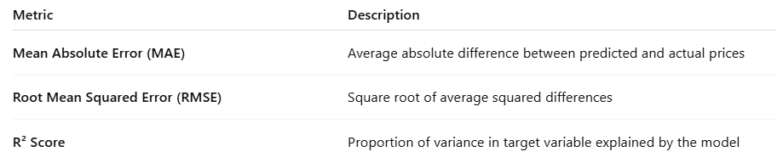
9. Results and Performance Evaluation
• The Linear Regression model was able to capture the general trend of AAPL stock prices.
• Predictions closely followed actual closing prices, with minor deviations during high volatility periods.
• Sample evaluation metrics (example from project):
- MAE: 0.18
- RMSE: 0.24
- R² Score: 0.92
• Visualizations show predicted closing prices closely tracking the actual closing price, validating the model’s effectiveness.
10.Conclusion
This project demonstrates that Linear Regression can effectively predict stock prices when historical prices and technical indicators are incorporated. While simple, linear regression provides an interpretable model that highlights the significance of lag features and market indices in predicting AAPL stock movements.
11.Future Scope
- Incorporate more sophisticated models such as Random Forest, LSTM, or ARIMA for higher accuracy.
- Use additional features like news sentiment, trading volume spikes, or macroeconomic indicators.
- Experiment with non-linear transformations and feature engineering.
12.References
• Apple Inc. Historical Stock Data (Yahoo Finance)
• Investopedia: Bollinger Bands
• Scikit-learn Documentation: Linear Regression [https://scikit-learn.org/stable/modules/linear_model.html]
• Chakraborty, S., “Stock Price Prediction Using Linear Regression”, 2021

