Shania Foster

COSC 412

06 30 2021

**Software Project Management Plan**

**(SPMP)**

**Preface**

**Purpose**

This project will help me have a platform to sell my product(s) of premade/customized salads as well as snacks and smoothies. The purpose is to have a convenient way to sell my salads, snacks, and smoothies. I want to create an easy to maneuver platform, so I have a way of selling, collecting, and presenting orders in an organized fashion.

**Table of Contents**

**Part 1: Introduction**…………………..………………….…………… 4

**Part 2: Project Organization**…..……………..……………………… 7

**Part 3: Managerial Process**…………………..……….……………… 8

**Part 4: Technical Process……………………..…**…………………...10

**Part 5: Description of Work Packages** …………….…..……….….. 12

**WBS**…………………………………………………….………. 12

**Gannt Chart**…………………………….……………………... 13

**Part 1 Introduction:**

* 1. **Project Overview**

This project is to be a very simple website design. People who want to order a salad (or customize their own) will be able to. There will be options to select a premade option as well. They will also be able to order a healthy snack option, water, Gatorade and/or smoothie if they chose. All ingredients will be provided due to food allergies. The customer will not be able to customize anything else, and there will be size options for both the salads and smoothies.

* 1. **Project Deliverables**

|  |  |
| --- | --- |
| **Deliverables** | **Deadline** |
| Topic Proposal | 04 June 2021 |
| Repository | 30 June 2021 |
| Design Review Meeting | 30 June 2021 |
| Tool Selection Review | 30 June 2021 |
| SPMP | 30 June 2021 |
| Milestone Review | 23 July 2021 |
| Final Presentation | 26 July 2021 |

This project will produce a running website that follows the below website requirements:

The website will allow users to select a premade salad or create their own.

Select a flavor of smoothie.

Select different sizing for orders of salads and smoothies.

Buy healthy snacks (along with or separate from a salad order).

**1.3 Evolution of SPMP**

This project will follow the schedule outlined in the Gantt chart. Any changes to the schedule will be displayed and adjusted the chart. However, none of the changes will not affect the overall delivery of the project.

* 1. **Reference Materials**

<https://www.freshgreensalads.com/menus/>

<https://www.panerabread.com/en-us/menu/categories/salads.html>

<https://www.ers.usda.gov/data-products/fruit-and-vegetable-prices/>

<https://wordpress.org/plugins/>

<https://learnwoo.com/setting-up-accounts-on-your-woocommerce-store/>

https://www.youtube.com/watch?v=nbez42Vtjfs

* 1. **Definitions and Acronyms**

**DreamHost**: a hosting platform, domain provider, and database curator.

**MAMP**: a local server used to download and work with WordPress. org

**WooCommerce**: an open-source e-commerce plugin for WordPress.

**WP Inventory Manager**: WP Inventory Manager is an easy-to-use plugin to manage inventory on your WordPress dashboard.

**WP Shopping Cart**: This shopping cart plugin lets you sell products and services directly from your own website.

**WP User Manager**: [WP User Manager](https://wpusermanager.com?utm_source=wordpress.org&utm_medium=free%20plugin%20listing&utm_campaign=WP%20User%20Manager) lets you create highly customizable user profiles together with custom user registration, login, password recovery and account customization forms to your WordPress website.

**SPMP**: a detailed document that shows an organized plan for a project

**Gantt Chart**: a chart that shows the work done and scheduling for work to be done on a specific project

**GitHub**: collaboration platform for software developers; for this project is mainly used for the repository

**Plug-in**: A software component that adds a specific feature to an existing computer program

**Waterfall Process**: The waterfall model is a breakdown of project activities into linear sequential phases, where each phase depends on the deliverables of the previous one and corresponds to a specialization of tasks.

**Part 2: Project Organization**

**2.1 Process Model**

This project was initiated on May 24th, 2021 and will be presented on July 26th, 2021. This project will follow a Gantt chart to stay on schedule. I will be using the Waterfall method as the process model for this project. Since this is not a complex project, the waterfall method will allow me to plan out details efficiently and move forward step by step.

**2.2 Organizational Structure**

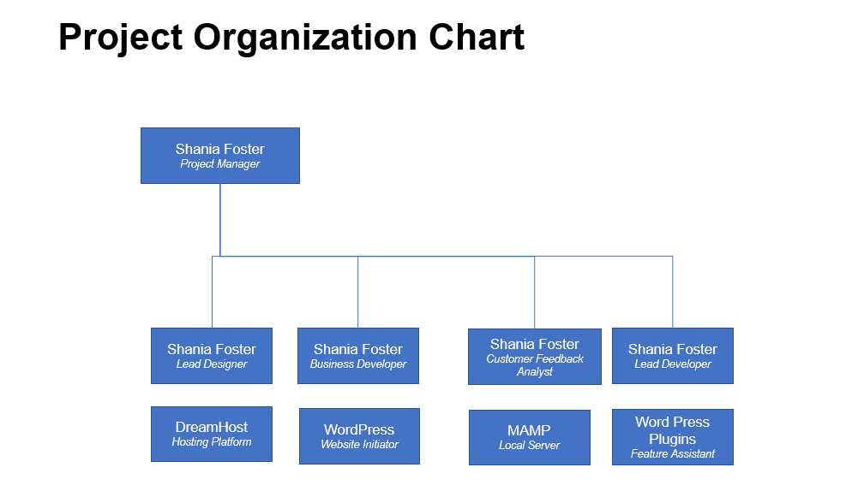**2.3 Organizational Interfaces**

The organizational interfaces include DreamHost as a hosting platform, WordPress.com as a starting platform, WordPress Plugins as a feature assistant, MAMP as a local server, and WooCommerce as the payment processor.

**2.4 Project Responsibilities**

|  |  |
| --- | --- |
| Project Phase | Description |
| System Concept Development Phase | Establish the vision for the project |
| Planning Phase | Develop a plan to manage the project, gather the requirements, and document the plan. |
| Requirements Analysis Phase | Analyze user needs and requirement specifications. |
| Design Phase | Transform requirements into software design documentation. |
| Integration and Testing | Demonstrate that the developed system meets all of the requirements. |
| Present | Present complete working project. |

**Part 3: Managerial Process**

* 1. **Management Objectives and Priorities**

The objective for this website is to be an effective but attractive start-up platform for a salad business. The priorities would include creating a shopping cart aspect for the website as well as an account creation aspect. There will also be various plug-ins used in the assistance for gathering and presenting data and orders to and from the website. Efficiency is the goal.

* 1. **Assumptions, Dependencies, and Constraints**

#### Assumptions

The project will be deployed and live by July 26th. Products, payment method, and the overall design of the website will be quick to implement due to prior layout. Plugins will come WordPress plug-ins inventory.

#### Dependencies

WP Inventory will handle all inventory of products and produce on website. WooCommerce will handle all payment transactions for this website. WP shopping cart will be in charge of collecting selected items on website. WP User Manger will assist in making the accounts for users. SSL Zen Word Press will be used to allow secure online payments.

#### Constraints

Transforming this website into a mobile app or UX friendly design (for mobiles) would be a big constraint. Also adding capabilities that are not accessible with WordPress Plugin would be another constraint.

**3.3 Risk Management**

*3.3.1 Too many minuscule features lead to a complicated design*

Probability: Medium

Impact: Medium

Prevention: Try to not be as detailed with certain aspects of the website.

Correction: By closely monitoring progress the decision to drop certain requirements can be made in time.

*3.3.2 Loss of critical information, documents or code*

Probability: Low

Impact: High

Prevention: DreamHost will save all of my documents in the database safely.

Correction: Use the latest backups to recover the most recent version.

*3.3.3 Lack of Experience with Relevant Technologies*

Probability: Medium

Impact: High

This is my first time working with web development and all of the sources I am using to build this website.

Prevention: Do in depth research on all functions/aspects of the project.

Correction: Ask for help in a timely manner.

* 1. **Monitoring and Controlling Mechanisms**

Every Thursday starting July 1st there will be weekly status updates on the progress of the website. This should align with the Gantt chart timeline as well.

**Part 4: Technical Process**

**4.1 Tools and Techniques**

* Web Hosting
  + WordPress
  + DreamHost
  + WooCommerce
  + WP Inventory
  + WP User Registration
  + WP Shopping Cart
  + SSL Zen WordPress Plugin
* GitHub for Repository

**4.2 Software Documentation**

Excel will be used for the Gantt chart. Microsoft Word will be used for the WBS. SPMP, Milestone Report, and all other deliverables. GitHub will be used for the repository. Documents will be uploaded to GitHub.

**4.3** **Project Support Functions**

#### 4.2.1 Quality Assurance

Quality assurance will be continuously assessed throughout implementation. For each added feature I will assess he functionality, reliability, usability, efficiency, and maintainability. Features will have to pass a specific criterion to determine overall development before proceeding.

#### 4.2.2 Configuration Management Plan

#### A document for specific changes will be made that will assess the type of change, time it will take, and impact on project. The Gantt chart will then be adjust to reflect if needed be. The system as a whole will be tested after each implementation.

**Part 5: Description of Work Packages**

**5.1Work Breakdown Structure (WBS)** 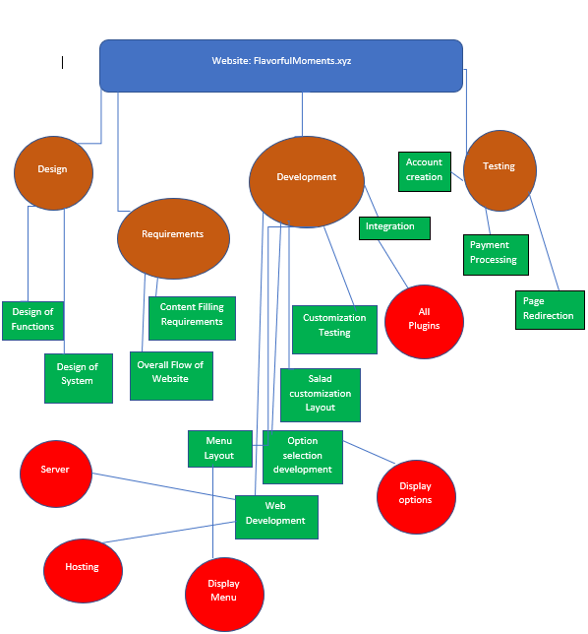

**5.2 Gantt Chart**

