NAME :SHANIB
ROLLNO:CSC/24/42
SUBJECT:INTRO TO WEB DEVELOPMENT

- Q1) Create a portfolio website to showcase your work, skills, and personal brand to companies/recruiters. The webpage will include:
- Professional highlights, projects, and achievements.
- Utilize HTML tables to organize content, and the layout will be clean with text alignments and a navigational header.

Html
<!DOCTYPE html>
<html>
<head>
<title>Shanib - Portfolio</title>
<link rel="stylesheet" href="style.css">
</head>

<body>

<header>
<h1>Hi, I'm Shanib</h1>
<p>Computer Science Student | Data Analyst | Machine Learning Enthusiast</p>

<nav>
<a href="#about">About</a>
<a href="#skills">Skills</a>
<a href="#projects">Projects</a>
<a href="#achievements">Achievements</a>
<a href="#contact">Contact</a>
</nav>
</header>

<section id="about" class="hero">
<h2>About Me</h2>
<p>
I am a Computer Science student interested in Data Analytics,
Machine Learning and building useful technology projects.
</p>

<p>
I enjoy working with data, developing machine learning models
and creating simple applications that solve real-world problems.
</p>
</section>

<section id="skills">
<h2>My Skills</h2>

<table>
<tr>
<th>Skill</th>
<th>Level</th>
<th>Area</th>
</tr>

<tr>
<td>Python</td>
<td>Advanced</td>
<td>Programming</td>
</tr>

<tr>
<td>C++</td>
<td>Intermediate</td>
<td>Programming</td>
</tr>

<tr>
<td>MySQL</td>
<td>Advanced</td>
<td>Database</td>
</tr>

<tr>
<td>Excel</td>
<td>Advanced</td>
<td>Data Analytics</td>
</tr>

<tr>
<td>Power BI</td>
<td>Intermediate</td>
<td>Data Visualization</td>
</tr>

<tr>
<td>Machine Learning</td>
<td>Intermediate</td>
<td>Artificial Intelligence</td>
</tr>
</table>
</section>

<section id="projects">
<h2>My Projects</h2>

<div class="projects">

<div class="project-card">
<h3>ResaleIQ</h3>
<p>
A used mobile phone resale price prediction project
using Machine Learning.
</p>
<button onclick="showProject('ResaleIQ')">
View Project
</button>
</div>

<div class="project-card">
<h3>Heart Risk Prediction</h3>
<p>
A machine learning project that predicts heart disease
risk from different health-related parameters.
</p>
<button onclick="showProject('Heart Risk Prediction')">
View Project
</button>
</div>

<div class="project-card">
<h3>Data Analysis Dashboard</h3>
<p>
A data analysis and visualization project using
Excel and Power BI.
</p>
<button onclick="showProject('Data Analysis Dashboard')">
View Project
</button>
</div>

</div>
</section>

<section id="achievements">
<h2>Achievements</h2>

<div class="achievement-box">
<h3>Computer Science Student</h3>
<p>
Pursuing BSc (Hons) Computer Science and continuously
developing programming and analytical skills.
</p>
</div>

<div class="achievement-box">
<h3>Machine Learning Projects</h3>
<p>
Developed practical machine learning projects using
Python and different ML algorithms.
</p>
</div>

<div class="achievement-box">
<h3>Data Analytics Skills</h3>
<p>
Experience with Python, SQL, Excel and Power BI for
analysing and visualizing data.
</p>
</div>
</section>

<section id="contact">
<h2>Contact Me</h2>

<p>Email: shanibkhan622@gmail.com</p>
<p>Let's connect and build something useful together.</p>
</section>

<footer>
<p>© 2026 Shanib | Personal Portfolio</p>
</footer>

<script src="script.js"></script>

</body>
</html>

Css)
* {
box-sizing: border-box;
scroll-behavior: smooth;
}

body {
margin: 0;
font-family: Arial, sans-serif;
background: #f4f6f8;
color: #222;
}

header {
min-height: 420px;
background: linear-gradient(135deg, #111827, #263b55);
color: white;
text-align: center;
padding: 100px 20px 40px;
}

header h1 {
font-size: 60px;
margin: 0;
animation: heading 2s ease-in-out infinite alternate;
}

header p {
font-size: 22px;
margin: 20px 0 40px;
}

nav {
margin-top: 30px;
}

nav a {
color: white;
text-decoration: none;
margin: 0 15px;
font-size: 18px;
padding: 10px;
transition: 0.3s;
}

nav a:hover {
color: #00d4ff;
border-bottom: 2px solid #00d4ff;
}

section {
width: 85%;
margin: 50px auto;
background: white;
padding: 40px;
border-radius: 15px;
box-shadow: 0 5px 20px rgba(0,0,0,0.08);
}

section h2 {
text-align: center;
font-size: 35px;
margin-bottom: 30px;
color: #182b49;
}

.hero {
text-align: center;
font-size: 18px;
line-height: 1.8;
}

table {
width: 100%;
border-collapse: collapse;
font-size: 17px;
}

th, td {
padding: 17px;
border: 1px solid #ddd;
text-align: center;
}

th {
background: #182b49;
color: white;
}

tr {
transition: 0.3s;
}

tr:hover {
background: #eef8ff;
transform: scale(1.01);
}

.projects {
display: flex;
gap: 25px;
justify-content: center;
}

.project-card {
width: 32%;
padding: 25px;
border-radius: 12px;
background: #f7f9fb;
text-align: center;
transition: 0.4s;
}

.project-card:hover {
transform: translateY(-10px);
box-shadow: 0 10px 25px rgba(0,0,0,0.15);
}

.project-card h3 {
font-size: 23px;
color: #182b49;
}

.project-card p {
line-height: 1.6;
}

button {
background: #182b49;
color: white;
border: none;
padding: 12px 20px;
border-radius: 6px;
cursor: pointer;
transition: 0.3s;
}

button:hover {
background: #00a8cc;
transform: scale(1.05);
}

.achievement-box {
padding: 20px;
margin: 15px 0;
border-left: 5px solid #182b49;
background: #f7f9fb;
transition: 0.3s;
}

.achievement-box:hover {
transform: translateX(10px);
background: #eef8ff;
}

.achievement-box h3 {
color: #182b49;
}

#contact {
text-align: center;
}

footer {
background: #111827;
color: white;
text-align: center;
padding: 25px;
margin-top: 60px;
}

@keyframes heading {
from {
transform: translateY(0);
}

to {
transform: translateY(-8px);
}
}

@media (max-width: 800px) {

header h1 {
font-size: 40px;
}

.projects {
flex-direction: column;
}

.project-card {
width: 100%;
}

section {
width: 92%;
}
}

Js
function showProject(projectName) {
alert("You selected: " + projectName);
}

document.querySelectorAll("nav a").forEach(function(link) {
link.addEventListener("click", function() {
console.log("Opening " + link.textContent + " section");
});
});

Output;
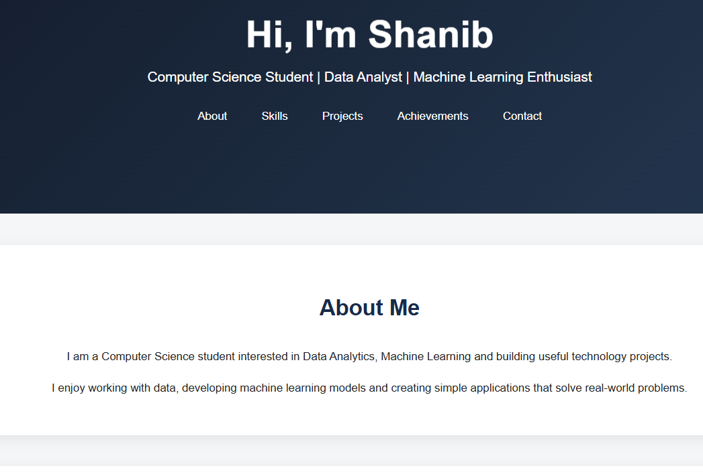
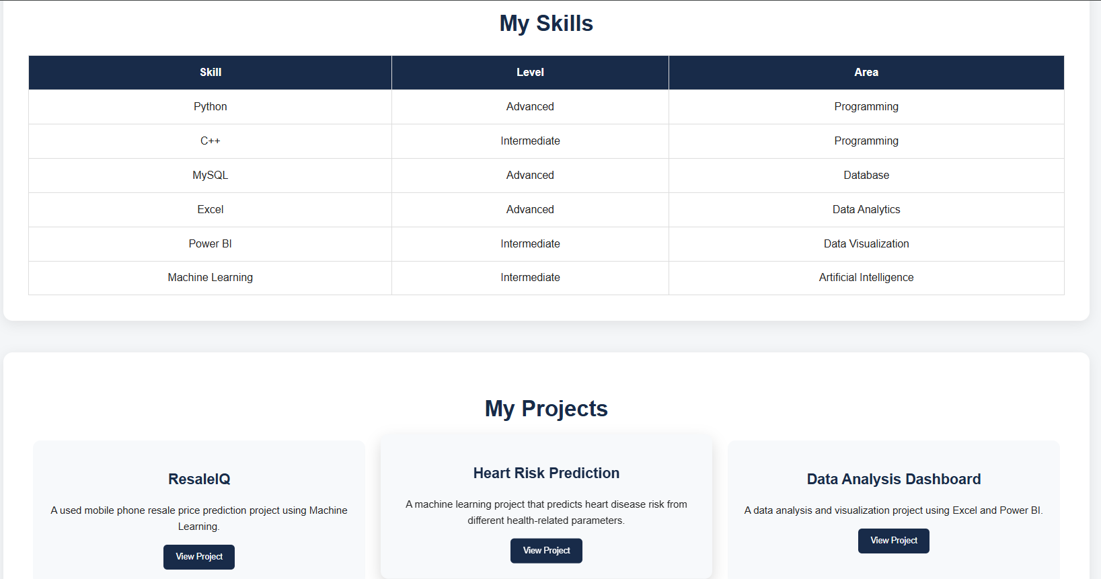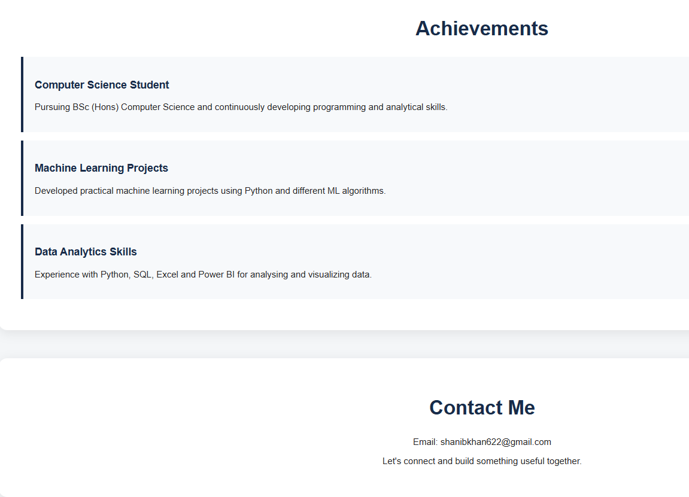

Ques2) Create a webpage for an Conference event called "International Conference on Artificial Intelligence and Machine Learning Technique 2027." This webpage will include:
- A header introducing the event.
- Navigation links for different sections (About, Schedule, Speakers, and Contact).
- A schedule table.
- A contact form
Html
<!DOCTYPE html>
<html>
<head>
<title>AI & ML Conference 2027</title>
<link rel="stylesheet" href="style.css">
</head>
<body>

<header>
<h1>International Conference on Artificial Intelligence and Machine Learning Technique 2027</h1>

<nav>
<a href="#about">About</a>
<a href="#schedule">Schedule</a>
<a href="#speakers">Speakers</a>
<a href="#contact">Contact</a>
</nav>
</header>

<section id="about">
<h2>About the Conference</h2>
<p>
Join us for an international conference focused on
Artificial Intelligence and Machine Learning techniques.
</p>
</section>

<section id="schedule">
<h2>Schedule</h2>

<table>
<tr>
<th>Time</th>
<th>Event</th>
<th>Speaker</th>
</tr>
<tr>
<td>10:00 AM</td>
<td>Opening Ceremony</td>
<td>Dr. Sharma</td>
</tr>
<tr>
<td>11:00 AM</td>
<td>Artificial Intelligence</td>
<td>Dr. Rahul</td>
</tr>
<tr>
<td>1:00 PM</td>
<td>Machine Learning Techniques</td>
<td>Dr. Priya</td>
</tr>
<tr>
<td>3:00 PM</td>
<td>Future of AI</td>
<td>Dr. Aman</td>
</tr>
</table>
</section>

<section id="speakers">
<h2>Speakers</h2>
<ul>
<li>Dr. Sharma - Artificial Intelligence</li>
<li>Dr. Rahul - Machine Learning</li>
<li>Dr. Priya - Deep Learning</li>
<li>Dr. Aman - Future Technologies</li>
</ul>
</section>

<section id="contact">
<h2>Contact Us</h2>

<form>
<label>Name:</label>
<input type="text" placeholder="Enter your name">

<label>Email:</label>
<input type="email" placeholder="Enter your email">

<label>Message:</label>
<textarea placeholder="Enter your message"></textarea>

<button type="submit">Submit</button>
</form>
</section>

<script src="script.js"></script>
</body>
</html>

Css
body {
font-family: Arial, sans-serif;
margin: 0;
background: #f4f4f4;
color: #333;
}

.border{
color: black;

}

header {
background: #222;
color: white;
text-align: center;
padding: 25px;
}

header h1 {
margin-bottom: 20px;
}

nav a {
color: white;
text-decoration: none;
margin: 15px;
}

nav a:hover {
color: #00bcd4;
}

section {
width: 80%;
margin: 25px auto;
padding: 20px;
background: white;
border-radius: 8px;
}

table {
width: 100%;
border-collapse: collapse;
border: #222;
border-radius: 3px;
border-width: 2px;

}

th, td {
border: 1px solid #ccc;
padding: 12px;
text-align: center;

}

th {
background: #222;
color: white;

}

form {
display: flex;
flex-direction: column;
}

input, textarea {
padding: 10px;
margin: 8px 0 15px;
border: 1px solid #ccc;
}

textarea {
height: 100px;
}

button {
width: 100px;
padding: 10px;
background: #222;
color: white;
border: none;
cursor: pointer;
}

button:hover {
background: #00bcd4;
}

Js
document.querySelector("form").addEventListener("submit", function(event) {
event.preventDefault();
alert("Thank you for contacting us!");
});

Output:
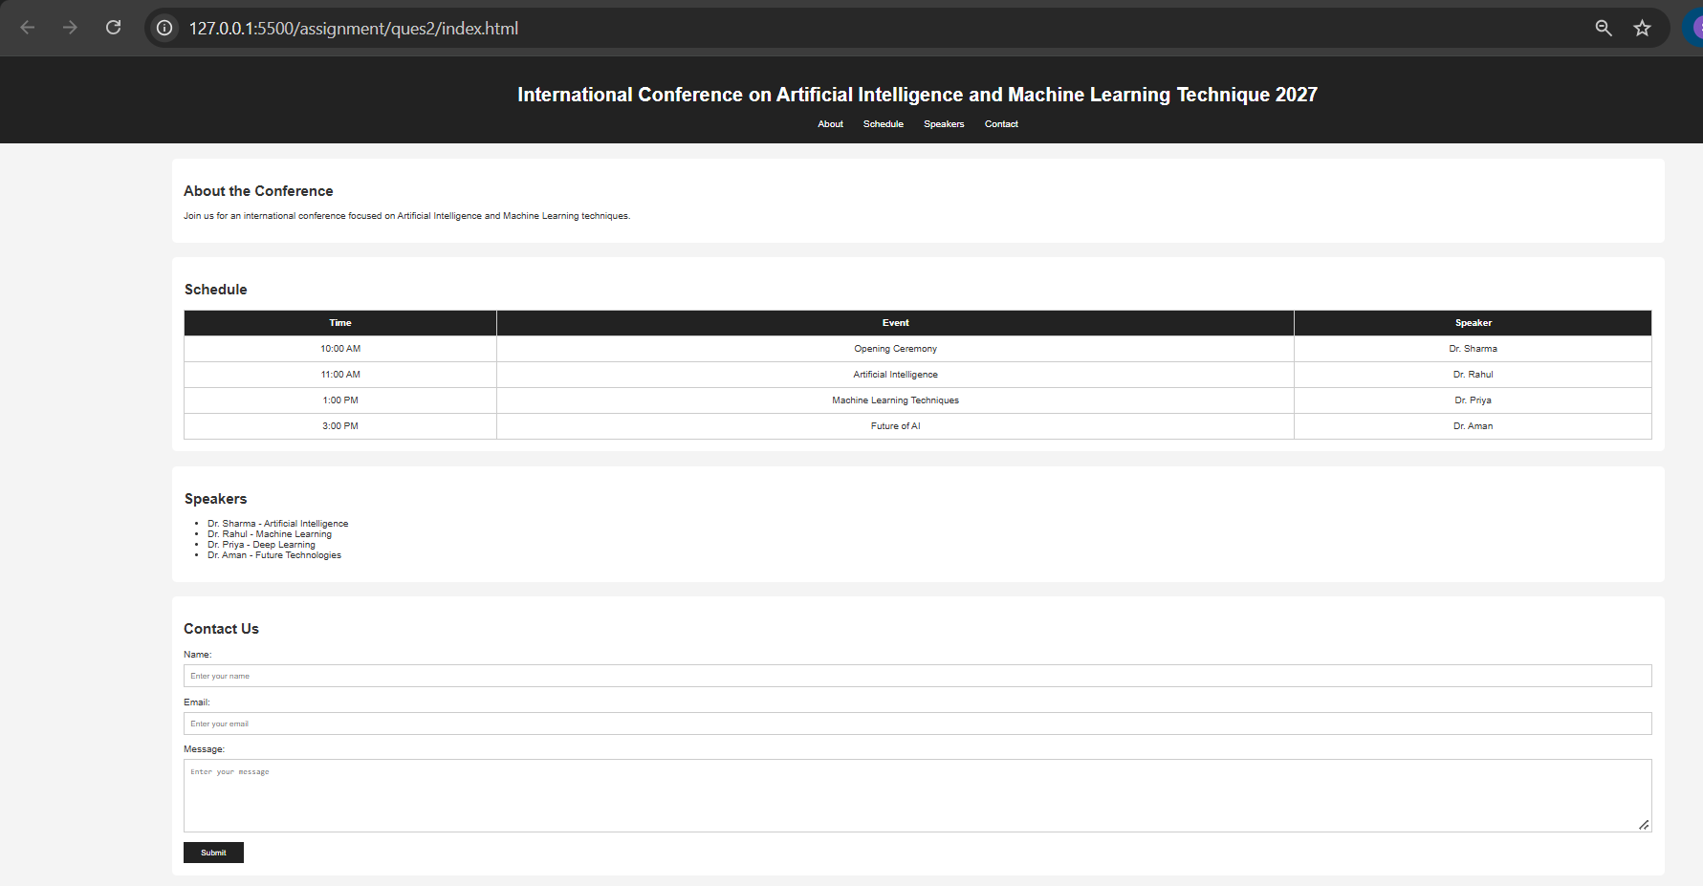

Ques3)
- Create a visually appealing Customer login page for a hotel website by layering a centered form over a background image and styling form elements and buttons for better user experience. Consider the following:
- Create a container with a background image using a <div> and set its class to "bg-img."
- Position the login form using another '<div>' with a class like "container." Adjust its 'left' and 'top' properties.

Html
<!DOCTYPE html>
<html>
<head>
<title>Hotel Login</title>
<link rel="stylesheet" href="style.css">
</head>

<body>

<div class="bg-img">

<div class="container">

<h1>Hotel Login</h1>

<form>
<label>Username</label>
<input type="text" placeholder="Enter Username">

<label>Password</label>
<input type="password" placeholder="Enter Password">

<button type="submit">Login</button>
</form>

</div>

</div>

<script src="script.js"></script>

</body>
</html>

Css
* {
box-sizing: border-box;
}

body {
margin: 0;
font-family: Arial, sans-serif;
}

.bg-img {
height: 100vh;
background-image: url("image.png");
background-size: cover;
background-position: center;
position: relative;
}

.container {
position: absolute;
left: 50%;
top: 50%;
transform: translate(-50%, -50%);

width: 900px;
height: 690px;
padding: 30px;

background: rgba(255, 255, 255, 0.9);
border-radius: 10px;
}

h1 {
text-align: center;
color: #222;
margin-bottom: 25px;

-webkit-text-stroke: 1px #555;
}

label {
display: block;
margin-bottom: 6px;
font-weight: bold;
}

input {
width: 100%;
padding: 12px;
margin-bottom: 18px;

border: 1px solid #aaa;
border-radius: 5px;
}

button {
width: 100%;
padding: 12px;

background-color: #222;
color: white;

border: none;
border-radius: 5px;
cursor: pointer;
font-size: 16px;
}

button:hover {
background-color: #555;
}
Js
document.querySelector("form").addEventListener("submit", function(event) {
event.preventDefault();

let username = document.querySelector("input[type='text']").value;
let password = document.querySelector("input[type='password']").value;

if (username === "" || password === "") {
alert("Please enter username and password");
} else {
alert("Login successful!");
}
});

Output:
