NAME: SHANIB
ROLL csc/24/42
DATA MINING PRACTICALS 3-5

3. Run Apriori algorithm to find frequent item sets and association rules on 2 real datasets and use
appropriate evaluation measures to compute correctness of obtained patterns
a) Use minimum support as 50% and minimum confidence as 75%
b) Use minimum support as 60% and minimum confidence as 60 %

CODE:

import pandas as pd
from mlxtend.frequent_patterns import apriori, association_rules
from mlxtend.preprocessing import TransactionEncoder

def load_groceries_data(filepath):
try:
df = pd.read_csv(filepath)
# Group items by Member and Date to define a 'transaction'
transactions = df.groupby(['Member_number', 'Date'])['itemDescription'].apply(list).tolist()

# Convert to One-Hot Encoded format
te = TransactionEncoder()
te_ary = te.fit(transactions).transform(transactions)
df_bool = pd.DataFrame(te_ary, columns=te.columns_)

print(f" Groceries Data Loaded. {len(df_bool)} transactions found.")
return df_bool
except Exception as e:
print(f"Error loading Groceries data: {e}")
return None

def load_market_basket_opt_data(filepath):
try:
# Read as list of lists directly since rows have varying lengths
# We use header=None because the first row contains data
df = pd.read_csv(filepath, header=None)

# Convert DataFrame rows to list of lists, removing None/NaN values
transactions = []
for i in range(len(df)):
# Drop NaN values and convert to string
row = df.iloc[i].dropna().tolist()
transactions.append(row)

# Convert to One-Hot Encoded format
te = TransactionEncoder()
te_ary = te.fit(transactions).transform(transactions)
df_bool = pd.DataFrame(te_ary, columns=te.columns_)

print(f" Market Basket Data Loaded. {len(df_bool)} transactions found.")
return df_bool
except Exception as e:
print(f"Error loading Market Basket data: {e}")
return None

def run_apriori_analysis(df, name, min_sup, min_conf):
print(f"\n--- Analysis for: {name} (Sup={min_sup*100}%, Conf={min_conf*100}%) ---")

if df is None or df.empty:
print(" Data not available.")
return

# 1. Frequent Itemsets
# low_memory=True helps with larger datasets like Groceries
frequent_itemsets = apriori(df, min_support=min_sup, use_colnames=True, low_memory=True)

if frequent_itemsets.empty:
print(" No frequent itemsets found with these parameters.")
return

print(f" Found {len(frequent_itemsets)} frequent itemsets.")

# 2. Association Rules
rules = association_rules(frequent_itemsets, metric="confidence", min_threshold=min_conf)
if rules.empty:
print(" No rules met the confidence threshold.")
else:
print(f" Found {len(rules)} Rules. Top 5 sorted by Lift:")
# Evaluation measures: Support, Confidence, Lift
cols = ['antecedents', 'consequents', 'support', 'confidence', 'lift']
print(rules[cols].sort_values(by='lift', ascending=False).head(5).to_string())

if __name__ == "__main__":
df_groceries = load_groceries_data("Groceries_dataset.csv")
# Dataset 2: Market Basket Optimisation
df_market = load_market_basket_opt_data("Market_Basket_Optimisation.csv")

# --- Task A: Sup=50%, Conf=75% ---
print("="*60)
print("TASK A: Minimum Support = 50%, Minimum Confidence = 75%")
print("="*60)
run_apriori_analysis(df_groceries, "Groceries Dataset", 0.5, 0.75)
run_apriori_analysis(df_market, "Market Basket Optimisation", 0.5, 0.75)
# --- Task B: Sup=60%, Conf=60% ---
print("\n" + "="*60)
print("TASK B: Minimum Support = 60%, Minimum Confidence = 60%")
print("="*60)
run_apriori_analysis(df_groceries, "Groceries Dataset", 0.6, 0.6)
run_apriori_analysis(df_market, "Market Basket Optimisation", 0.6, 0.6)

print("\nNOTE: If no rules are found, it is because 50-60% support is very high for retail data.")
print("Real-world market basket analysis typically uses support between 0.001 and 0.05.")

OUTPUT:

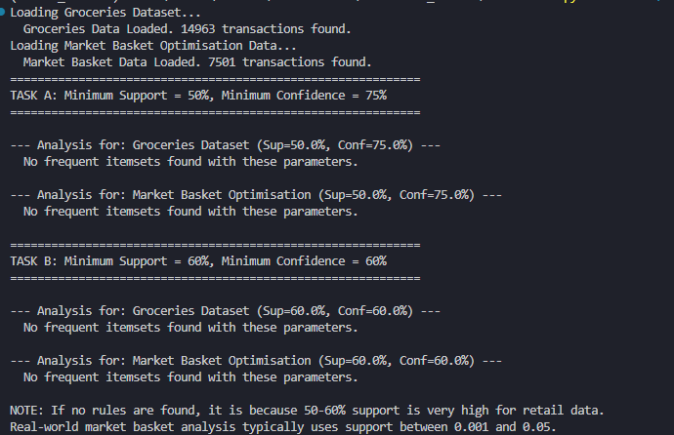

4. Use Naive bayes, K-nearest, and Decision tree classification algorithms and build classifiers on any two datasets. Divide the data set into training and test set. Compare the accuracy of the different classifiers under the following situations:
I. a) Training set = 75% Test set = 25% b) Training set = 66.6% (2/3rd of total), Test set = 33.3%
II. Training set is chosen by i) hold out method ii) Random subsampling iii) Cross-Validation.
Compare the accuracy of the classifiers obtained. Data needs to be scaled to standard format.

CODE:
import pandas as pd
import numpy as np
from sklearn.model_selection import train_test_split, ShuffleSplit, cross_val_score
from sklearn.preprocessing import StandardScaler
from sklearn.naive_bayes import GaussianNB
from sklearn.neighbors import KNeighborsClassifier
from sklearn.tree import DecisionTreeClassifier
from sklearn.metrics import accuracy_score
from sklearn.datasets import load_iris

def prepare_datasets():
datasets = {}

# 1. Delhi Crime Data
try:
df = pd.read_csv("Delhi crime records.csv")
df.set_index('CRIME HEAD', inplace=True)
df_t = df.transpose()
for col in df_t.columns:
df_t[col] = df_t[col].astype(str).str.replace(',', '').astype(float)
if 'Aug 2022' in df_t.index: df_t = df_t.drop('Aug 2022')
# Target: High Crime Year (1) vs Low Crime Year (0) based on median total
total_crime = df_t.sum(axis=1)
y_delhi = (total_crime > total_crime.median()).astype(int)
X_delhi = df_t
datasets["Delhi Crime"] = (X_delhi, y_delhi)
except Exception as e:
print(f"Could not load Delhi data: {e}")

# 2. Iris Data
iris = load_iris()
datasets["Iris"] = (pd.DataFrame(iris.data, columns=iris.feature_names), iris.target)

return datasets

def compare_classifiers(X, y, dataset_name):
print(f"\n>>> Evaluating on Dataset: {dataset_name} <<<")

# Scale features
scaler = StandardScaler()
X_scaled = scaler.fit_transform(X)

classifiers = {
'Naive Bayes': GaussianNB(),
'KNN': KNeighborsClassifier(n_neighbors=3),
'Decision Tree': DecisionTreeClassifier(random_state=42)
}

# --- Situation I: Fixed Splits ---
print("\n[Situation I] Fixed Train/Test Splits")
splits = [(0.25, "75% Train / 25% Test"), (0.333, "66.6% Train / 33.3% Test")]

for test_size, label in splits:
print(f" Split Strategy: {label}")
X_train, X_test, y_train, y_test = train_test_split(X_scaled, y, test_size=test_size, random_state=42)

for name, clf in classifiers.items():
clf.fit(X_train, y_train)
acc = accuracy_score(y_test, clf.predict(X_test))
print(f" {name}: {acc:.4f}")

# --- Situation II: Validation Methods ---
print("\n[Situation II] Validation Methods")

# i) Hold Out (Simple 70-30 split)
print(" i) Hold Out (70/30)")
X_train, X_test, y_train, y_test = train_test_split(X_scaled, y, test_size=0.3, random_state=42)
for name, clf in classifiers.items():
clf.fit(X_train, y_train)
acc = accuracy_score(y_test, clf.predict(X_test))
print(f" {name}: {acc:.4f}")

# ii) Random Subsampling
print(" ii) Random Subsampling (10 iterations)")
rs = ShuffleSplit(n_splits=10, test_size=0.25, random_state=42)
for name, clf in classifiers.items():
scores = cross_val_score(clf, X_scaled, y, cv=rs)
print(f" {name}: Mean Acc = {scores.mean():.4f}")

# iii) Cross Validation
print(" iii) Cross Validation (5-Fold)")
n_folds = min(5, len(X))
for name, clf in classifiers.items():
scores = cross_val_score(clf, X_scaled, y, cv=n_folds)
print(f" {name}: Mean Acc = {scores.mean():.4f}")

if __name__ == "__main__":
data_dict = prepare_datasets()
for name, (X, y) in data_dict.items():
compare_classifiers(X, y, name)

OUTPUT:
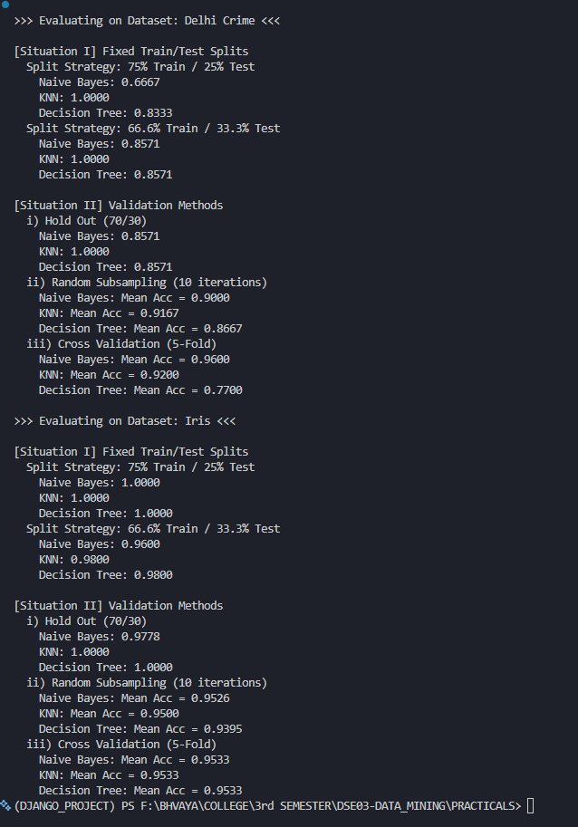
5. Use Simple K-means algorithm for clustering on any dataset. Compare the performance of
clusters by changing the parameters involved in the algorithm. Plot MSE computed after each
iteration using a line plot for any set of parameters.

CODE:
import pandas as pd
import matplotlib.pyplot as plt
from sklearn.cluster import KMeans
from sklearn.preprocessing import StandardScaler

def load_data():
try:
df = pd.read_csv("Delhi crime records.csv")
df.set_index('CRIME HEAD', inplace=True)
df_t = df.transpose()
for col in df_t.columns:
df_t[col] = df_t[col].astype(str).str.replace(',', '').astype(float)
if 'Aug 2022' in df_t.index: df_t = df_t.drop('Aug 2022')
return df_t
except Exception as e:
print(f"Error: {e}")
return None

def analyze_kmeans(df):
print("Running K-Means Analysis...")
scaler = StandardScaler()
X_scaled = scaler.fit_transform(df)

# 1. Compare Performance (Elbow Method) - Changing Parameter 'k'
mse_values = []
k_range = range(1, 10)

print("Calculating MSE for different k values...")
for k in k_range:
kmeans = KMeans(n_clusters=k, random_state=42, n_init=10)
kmeans.fit(X_scaled)
mse_values.append(kmeans.inertia_)
print(f" k={k}: MSE (Inertia) = {kmeans.inertia_:.2f}")

# 2. Plot MSE vs Iterations for a fixed set of parameters
# We manually simulate iteration history
print("\nTracking convergence (MSE per iteration)...")
fixed_k = 3
iterations = list(range(1, 16))
convergence_mse = []

# Initialize centers once to ensure continuity in the plot simulation
init_centers = KMeans(n_clusters=fixed_k, random_state=42, n_init=1).fit(X_scaled).cluster_centers_

for i in iterations:
# Run KMeans with increasing max_iter
km = KMeans(n_clusters=fixed_k, init=init_centers, max_iter=i, n_init=1, random_state=42)
km.fit(X_scaled)
convergence_mse.append(km.inertia_)

# --- Plotting ---
plt.figure(figsize=(12, 5))

# Plot 1: Elbow Curve
plt.subplot(1, 2, 1)
plt.plot(k_range, mse_values, 'bo-', linewidth=2)
plt.xlabel('Number of Clusters (k)')
plt.ylabel('MSE (Inertia)')
plt.title('Comparison of Clusters (Elbow Method)')
plt.grid(True)

# Plot 2: MSE Convergence
plt.subplot(1, 2, 2)
plt.plot(iterations, convergence_mse, 'r*-', linewidth=2)
plt.xlabel('Iteration Number')
plt.ylabel('MSE (Inertia)')
plt.title(f'Convergence over Iterations (k={fixed_k})')
plt.grid(True)

plt.tight_layout()
plt.savefig('kmeans_analysis_plots.png')
print("Plots saved as 'kmeans_analysis_plots.png'")
plt.show()

if __name__ == "__main__":
df = load_data()
if df is not None:
analyze_kmeans(df)

OUTPUT:

