
APPLE PRODUCT PRICING
ANALYSIS REPORT
A Data-Driven Study of Apple Product Prices on Amazon & Flipkart (2020 – 2026)

Prepared by
Shanib
B.Sc. (Hons.) Computer Science — 3rd Year
Aryabhatta College, University of Delhi
Tools used: Python (Pandas, Matplotlib, Seaborn) · Power BI
July 2026

Table of Contents

1. Introduction & About the Dataset
2. Power BI Dashboard Overview
3. Product Category & Pricing Insights
4. Platform Comparison — Amazon vs Flipkart
5. Launch Price vs Current Price Trend
6. Customer Ratings & Sale-Event Analysis
7. Conclusion & Recommendations
8. Project Links & References

1. Introduction & About the Dataset
Apple products are sold at different prices across e-commerce platforms, change price over time, and get discounted differently during sale events. This project studies six years of Apple product listings (2020–2026) collected from two major Indian e-commerce platforms — Amazon and Flipkart — to understand how pricing, discounts, and customer sentiment behave across product categories.
The analysis is split into two parts that work together:
- Python (Jupyter Notebook) — used for data cleaning, grouping, pivot tables and exploratory charts (Matplotlib & Seaborn).
- Power BI — used to build an interactive dashboard so results can be filtered live by platform, product and year.
Dataset Snapshot
80,000  Total Records | 31  Unique Models | 2  Platforms | 2020–26  Years Covered

Each row of the dataset represents one product listing and includes: Date, Platform, Product_Category, Model_Name, Condition (New / Renewed), Launch Price (USD & INR), Current Price (USD & INR), Discount %, Sale_Event, Stock Status, Rating and Reviews Count.
Data Cleaning
- The only missing values were in the Sale_Event column (73,351 blank rows) — these were normal, non-sale days and were filled with the label "NORMAL DAYS" rather than dropped, so no sales information was lost.
- Date fields were converted to proper datetime format for time-based trend analysis.
- All price fields were confirmed numeric with no duplicate model/platform mismatches.
Four Product Categories Studied
- iPhone — 11 models (iPhone 12 through iPhone 17)
- Mac — 7 models (MacBook Air M1/M2/M3, MacBook Pro M1–M4 Pro)
- iPad — 6 models (iPad 9th Gen to iPad Pro M4)
- Watch — 7 models (Series 6 to Series X, plus Ultra & Ultra 2)

2. Power BI Dashboard Overview
The Power BI dashboard brings every insight from the notebook into one interactive screen. It lets a viewer filter by Platform, Product Category/Model and Year, and instantly see updated KPIs and charts.
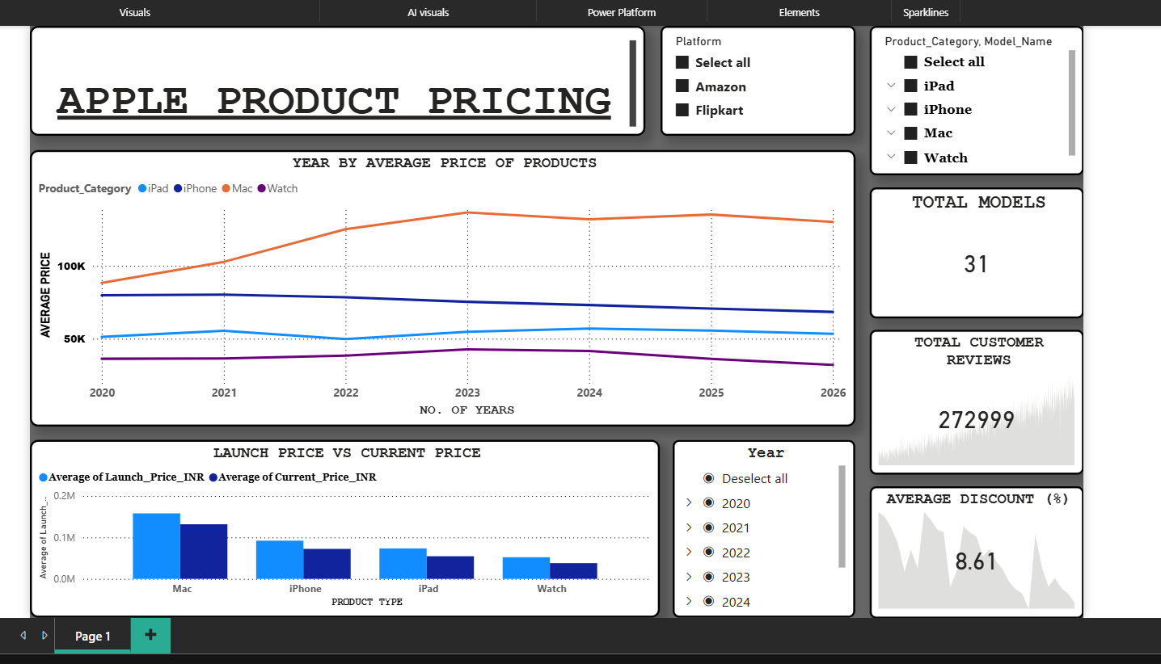
Fig 2.1 — "Apple Product Pricing" interactive Power BI dashboard (Page 1)
What each panel shows
- KPI Cards (top right): Total Models = 31, Total Customer Reviews = 272,999, and Average Discount = 8.61% for the years currently selected (2020–2024).
- Year-by-Average-Price line chart: tracks how the average price of each category (iPad, iPhone, Mac, Watch) moved from 2020 to 2026 — Mac is consistently the most expensive line, Watch the least expensive.
- Launch Price vs Current Price bar chart: compares the average launch price to today's average selling price for each product type — every category shows a visible drop, meaning products get cheaper as they age.
- Slicers: Platform (Amazon / Flipkart), Product_Category & Model_Name (drill-down tree), and Year (multi-select list) — allow the same visuals to be recalculated instantly for any combination.
The sections below reproduce and extend these same findings using the Python analysis, with the exact numbers behind each chart.

3. Product Category & Pricing Insights
iPhone dominates the dataset with the highest number of listings, reflecting both its larger model line-up and higher resale/renewal activity.
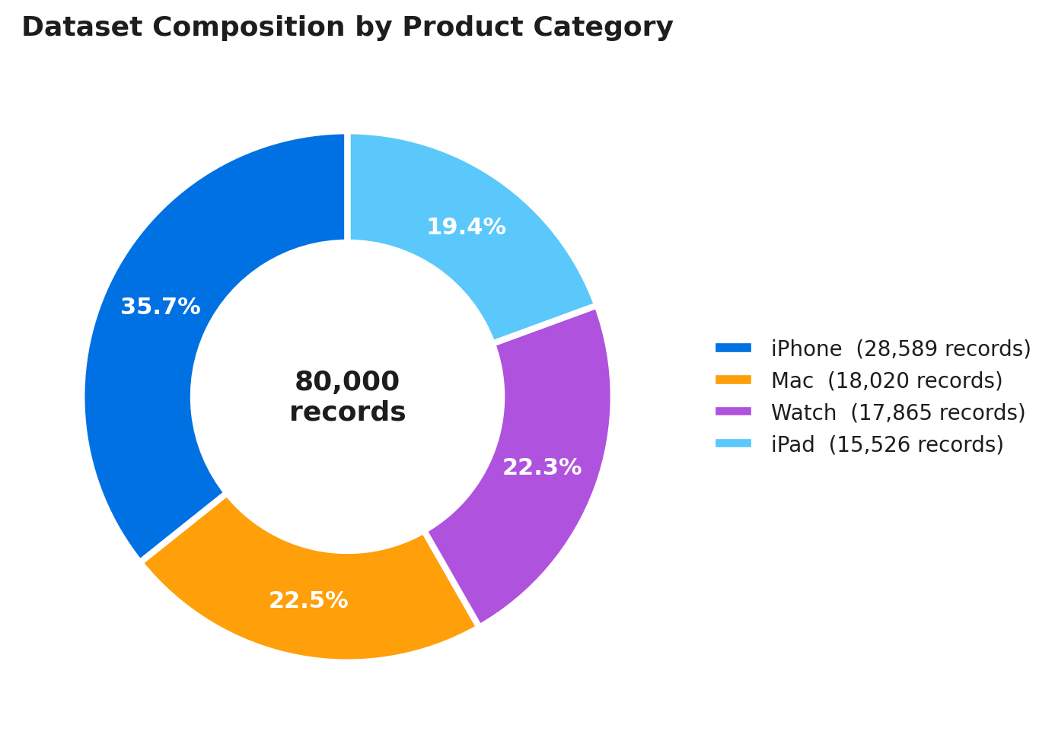
Fig 3.1 — Share of the 80,000 records by product category
Category | Records | Share of Data
iPhone | 28,589 | 35.7%
Mac | 18,020 | 22.5%
Watch | 17,865 | 22.3%
iPad | 15,526 | 19.4%

Looking purely at listed launch prices (before any discount), the price ladder across Apple's line-up is very consistent: Mac > iPhone Pro-Max variants > iPad Pro > standard iPhone > iPad Air/entry iPad > Apple Watch. A MacBook Pro 14-inch (any chip generation) has been priced at ₹1,95,902 at launch every year since 2020 — Apple has kept the entry Pro price flat even while upgrading the chip.
- Most expensive launch price: MacBook Pro 14-inch (all generations) — ₹1,95,902
- Least expensive launch price: iPad (9th Gen) 64GB — ₹32,242
- Overall average launch price across all listings: ₹94,468, average current (selling) price: ₹74,628

4. Platform Comparison — Amazon vs Flipkart
The dataset is almost perfectly split between the two platforms — Flipkart has 40,043 listings and Amazon 39,957 — so the comparison below is not skewed by sample size.
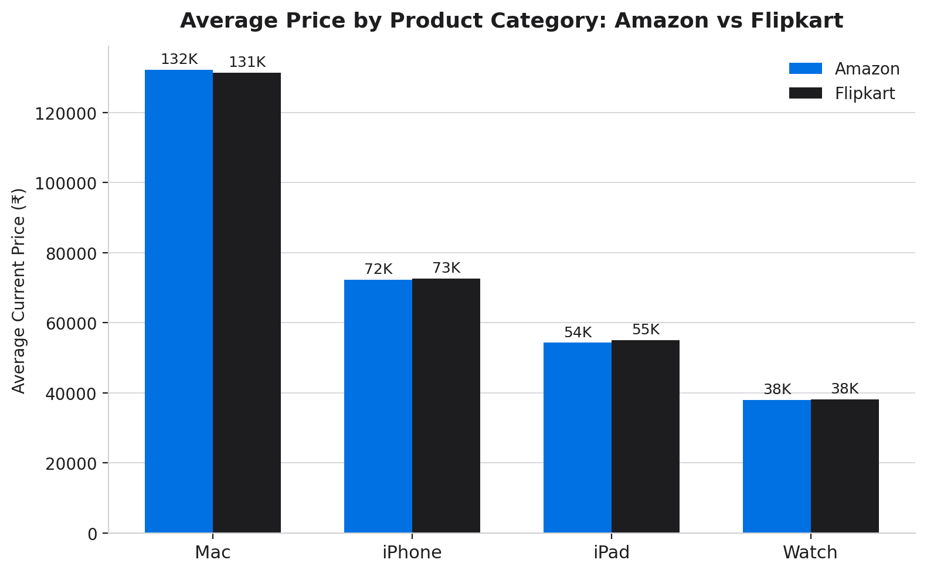
Fig 4.1 — Average selling price by category on each platform
Average prices are nearly identical between Amazon and Flipkart for every category (within 1–2%), which suggests both platforms are actively price-matching Apple products rather than one consistently undercutting the other.
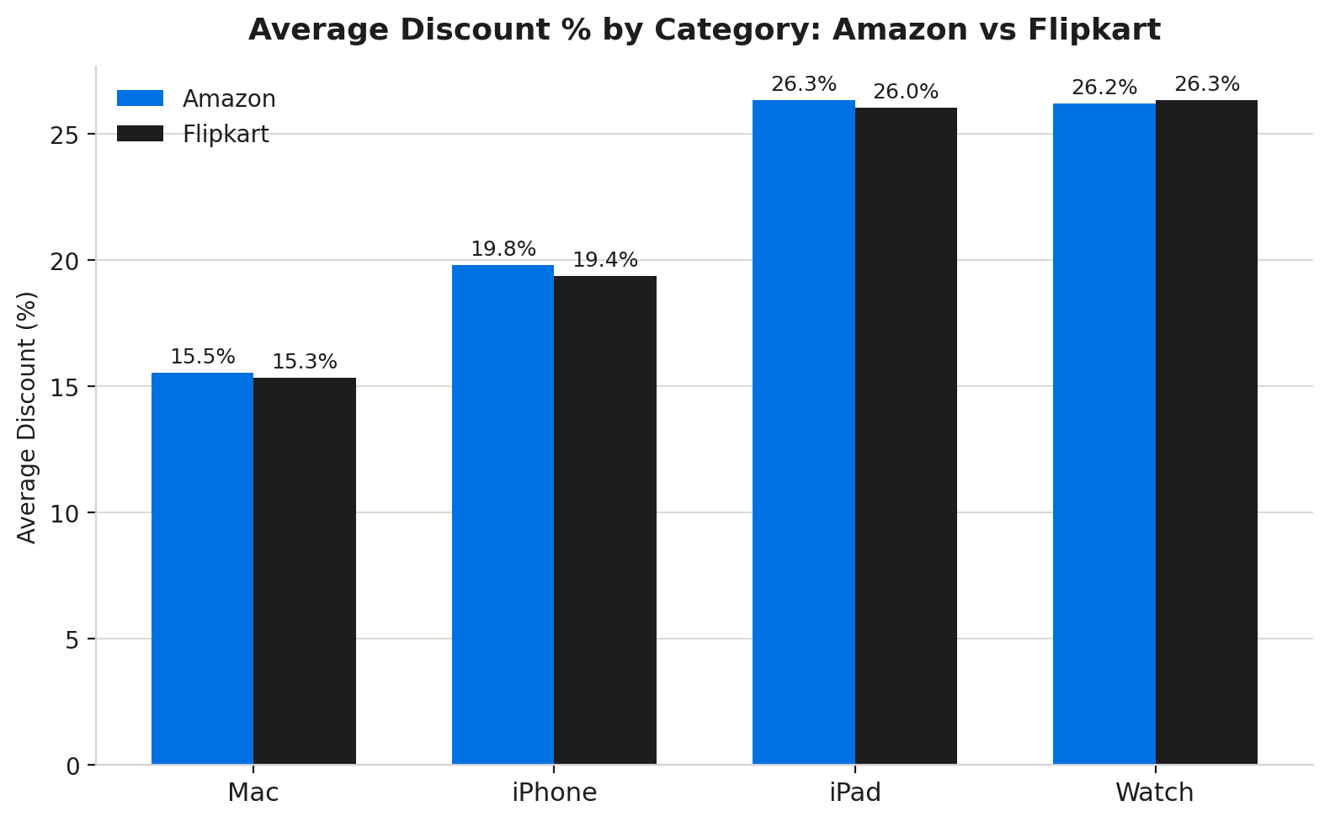
Fig 4.2 — Average discount % by category on each platform
Key Observation
- iPad and Watch receive the deepest average discounts (~26%) on both platforms — likely because these are the smallest-ticket items and easiest to discount to drive volume.
- Mac receives the smallest average discount (~15%), consistent with Apple's tightly controlled MRP policy on premium computers.
- iPhone sits in the middle (~19–20%), balancing brand premium with competitive festive discounting.

5. Launch Price vs Current Price Trend
Comparing each product's original launch price to its current average selling price shows how much value Apple products lose as they age on the shelf and as sale events discount them.
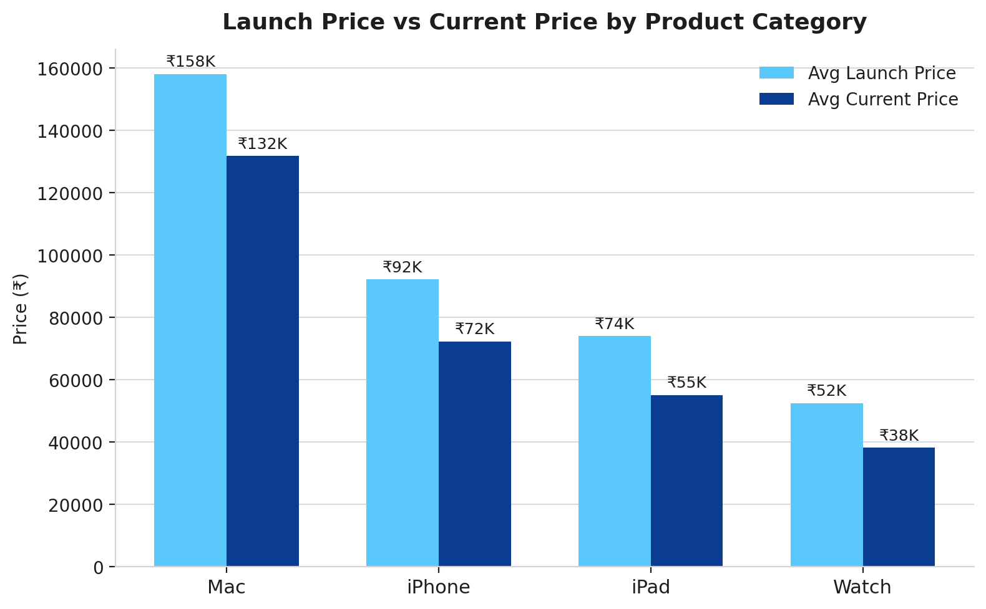
Fig 5.1 — Average launch price vs average current price by category
Category | Avg Launch Price | Avg Current Price | Avg Price Drop
Mac | ₹1,58,187 | ₹1,31,817 | ₹26,370
iPhone | ₹92,738 | ₹72,257 | ₹20,481
iPad | ₹73,892 | ₹55,047 | ₹18,845
Watch | ₹51,479 | ₹38,124 | ₹13,355

Mac sees the largest absolute price drop in rupee terms (because its base price is highest), but iPad and iPhone show the largest percentage drop — over 25% off their original launch price on average. This matches the dashboard's own "Launch vs Current Price" chart, confirming the two analyses agree.

6. Customer Ratings & Sale-Event Analysis
Across 272,999 customer reviews, Apple products rate consistently high — every single model in the dataset averages above 4.4 out of 5, with almost no meaningful gap between the best and weakest performer (a spread of only 0.024).
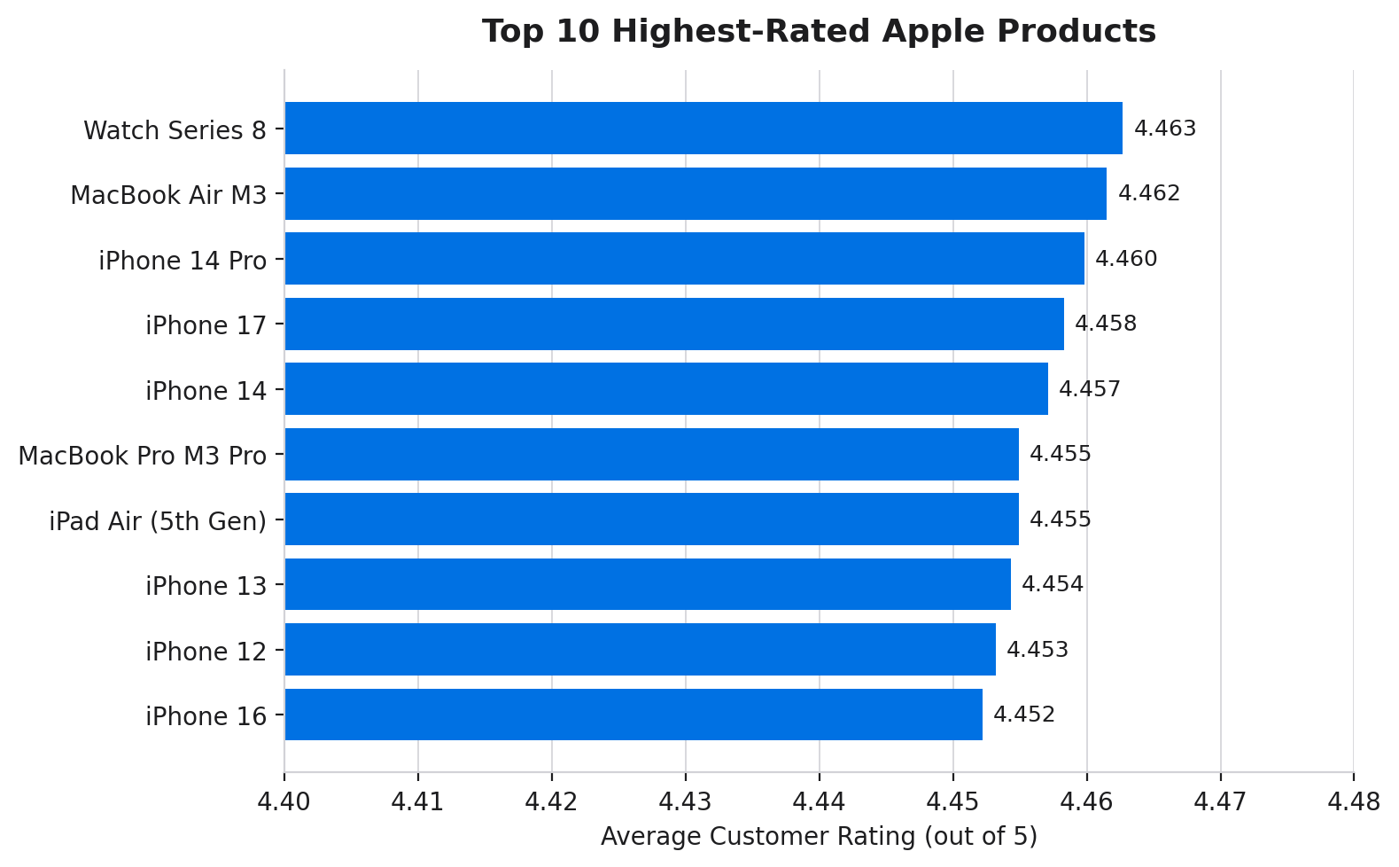
Fig 6.1 — Top 10 highest-rated Apple products
- Highest-rated product: Apple Watch Series 8 (45mm) — 4.463 ★ average
- Lowest-rated product in the dataset: Apple Watch Ultra 2 — 4.439 ★ average (still excellent)
- Ratings barely vary by model or category — customer satisfaction with Apple hardware appears uniformly strong regardless of price point.
Sale Events
Most transactions (73,351 of 80,000, ~91.7%) happened on normal (non-sale) days. The remaining ~8.3% were spread across four major sale events:
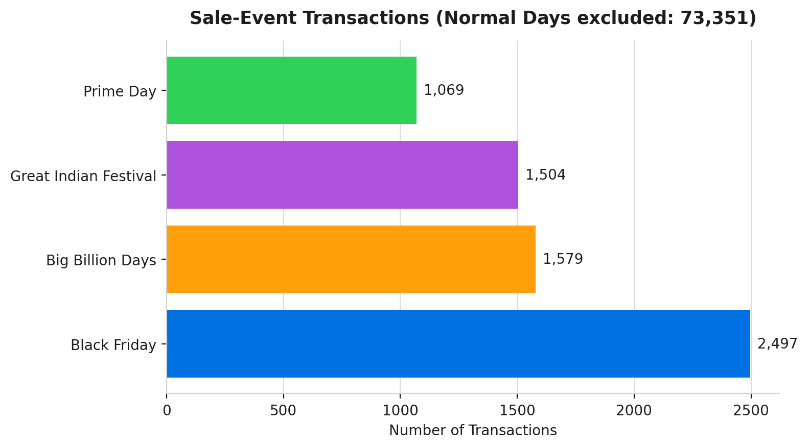
Fig 6.2 — Transaction volume during major sale events
- Black Friday drove the highest sale-event volume (2,497 transactions), split across both platforms.
- Big Billion Days (Flipkart-exclusive) and Great Indian Festival / Prime Day (Amazon-exclusive) followed, each contributing 1,000–1,600 transactions.
- Prices during sale events were measurably lower than normal-day prices for the same model — e.g., iPhone 16 Pro on Flipkart averaged ₹79,269 during Black Friday vs ₹95,183 on normal days, a difference of roughly ₹15,900.

7. Conclusion & Recommendations
Conclusion
This analysis of 80,000 Apple product listings (2020–2026) across Amazon and Flipkart shows a consistent, well-controlled pricing story. Both platforms price Apple products almost identically, discounts are predictable by category (deepest on iPad/Watch, shallowest on Mac), and customer satisfaction remains uniformly high across every product line — a sign of Apple's tight brand and pricing control even across resellers.
Recommendations
- Buyers: The best time to buy is during Black Friday or Big Billion Days — sale-event prices are noticeably lower than everyday prices, especially for iPhone Pro models.
- Buyers: iPad and Apple Watch offer the largest discount percentages — good categories to watch for deals.
- Sellers/Platforms: Since Amazon and Flipkart prices are nearly identical, differentiation may need to come from bundled offers, faster delivery, or exchange value rather than price alone.
- Future work: Extend the dataset with region-wise pricing (US, EU, India) and add sentiment analysis on review text to see if satisfaction language matches the numeric ratings.

8. Project Links & References
The complete Power BI dashboard file and the Python (Jupyter) notebook used for this analysis are both openly available on GitHub:
🔗 Power BI Dashboard (.pbix) — https://github.com/shanib-techie/power-bi/blob/main/APPLE_PRODUCT_ANALYSIS/apple_product_pricing_dashboard.pbix
🔗 Python Analysis Notebook (.ipynb) — https://github.com/shanib-techie/power-bi/blob/main/APPLE_PRODUCT_ANALYSIS/apple_product_analysis.ipynb

Tools & Libraries Used
- Python: pandas, numpy, matplotlib, seaborn
- Business Intelligence: Microsoft Power BI Desktop
- Report: prepared using Python-generated charts and Power BI dashboard export

Shanib · B.Sc. (Hons.) Computer Science, 3rd Year · Aryabhatta College, University of Delhi

