Week 1 – Design Thinking Lab

## Lab Answer Sheet

|  |  |
| --- | --- |
| Role | Student Full Name |
| Designer (you) | Shanielle Hall |
| Client (partner) | Juliya Varughese |
|  |  |
| Design Choice | Mask |

1. 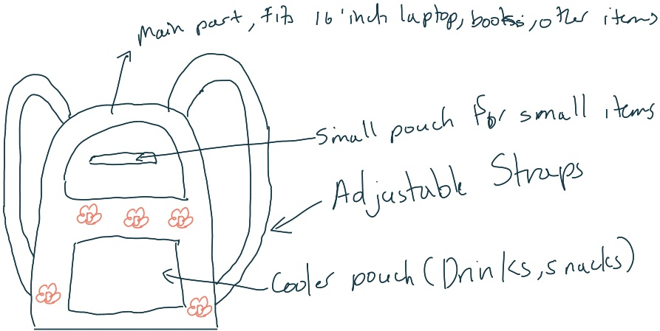Sketch your bag/mask in the space provided or sketch it on other paper and insert an image of your sketch. Be sure to annotate its most important features.
2. Take notes about your interview.  
   Prefers a bookbag over a tote bag for school, due to convenience. A lot of pockets, needs a pocket for laptop, water bottle and umbrella holders. Darker colors, something comfortable, good quality. Needs something convenient for train rides, and secure, so she doesn’t get robbed.

Going out, mini shoulder bag, adjustable cloth straps, space for phone, lip gloss, space for a bible, or books in general, outside pockets, zipper, a lot of space, wallet included.

2. What do they want to achieve with their bag/mask?

Convenience, muted colors, comfortability

1. What feelings or motivations do they have? Is there something you can infer about their design or use preferences based on what they told you that they maybe haven’t realized themselves?

They want comfort, convenience, and security. Needs pockets for umbrella and water bottle, as they travel on the train and don’t want a lot of stuff in their hands.

1. 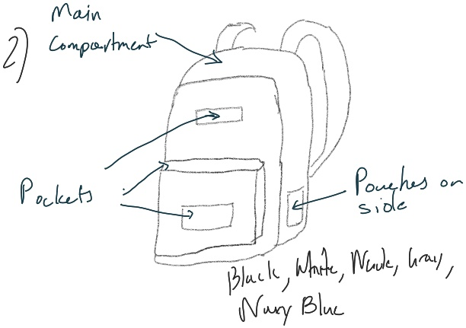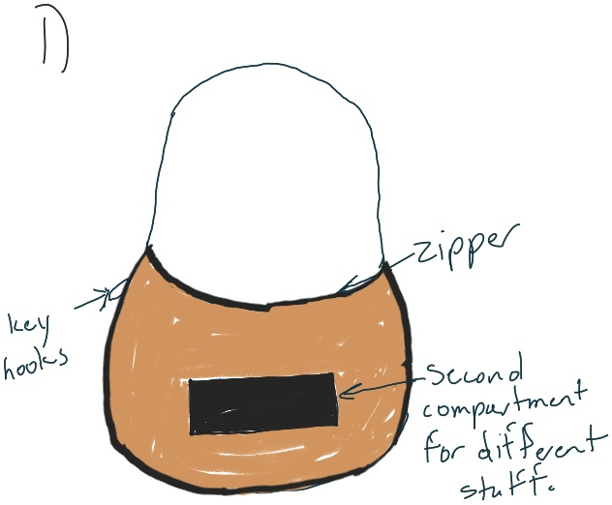At least 5 sketches.

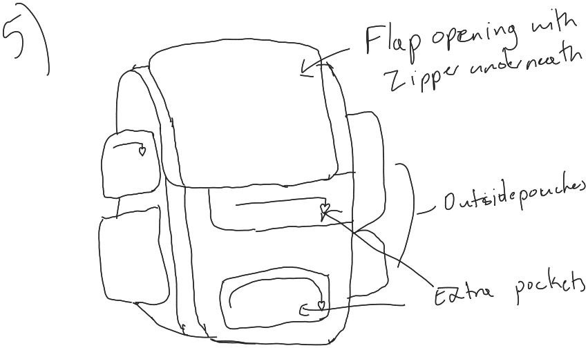

1. 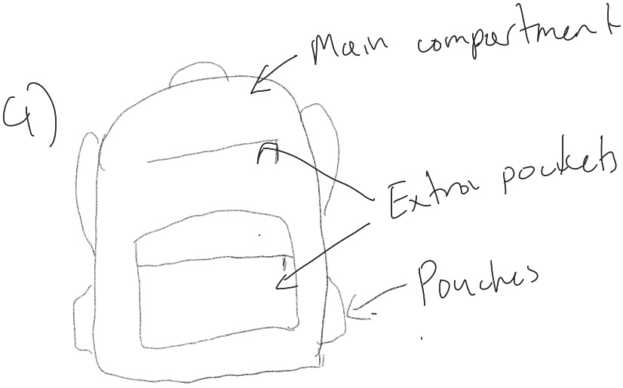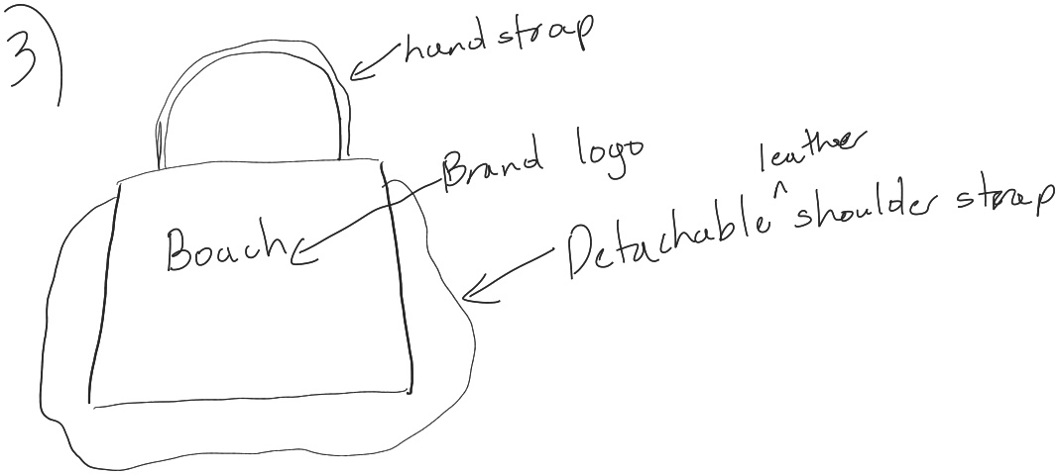Notes on user feedback.  
   [insert at least one paragraph or detailed bullet points – be sure to include feedback on all 5 ideas]

a. A little bigger, likes the design, more color options. (8/10)

b. Likes the colors, wish the bag was more padded (9/10)

c. Likes the design, likes the brand and the shoulder strap, thinks it’s cute, (10/10)

d. Likes the bag, likes the name (BB- Basic Bag), wants more organizers (7.5/10)

e. Not a fan of the of the square shape, not suitable for school, more like camping (8/10)

1. 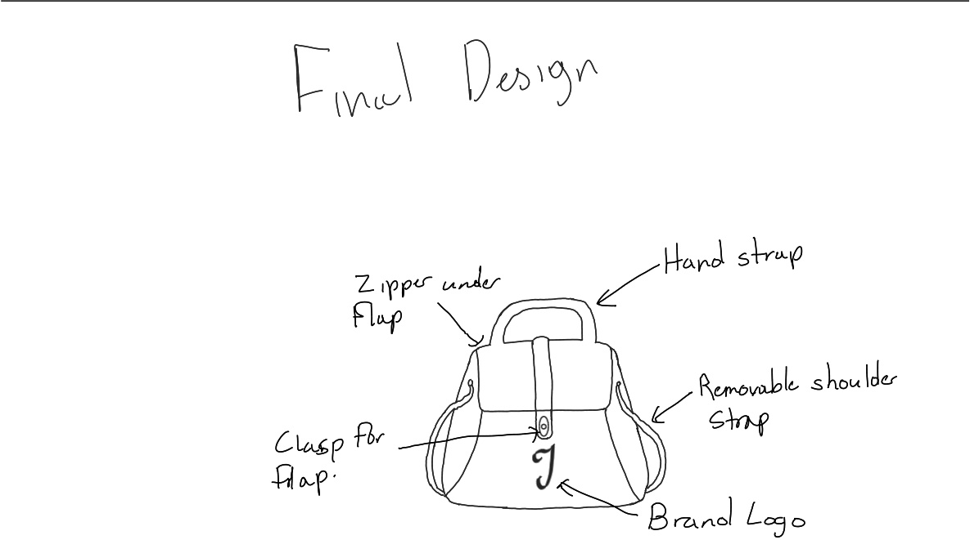New solution sketch.
2. Summary of the user’s reaction.

Likes it, would prefer it to be a bit rounder. Loves the removable straps and the option to have it has a hand carry bag.