***HOSPITAL MANAGEMENT SYSTEM***

BRD

BRD-BUSINESS REQUIREMENT DOCUMENT

***1.INTRODUCTION***

**1.1 Document purposes**

The purpose of this document is to describe business requirements of healthcare portal completely, accurately and unambiguously in technology-independent manner. All attempts have been made in using mostly business terminology and business language while describing the requirements in this document. very minimal and commonly understood technical terminology is used.

Use case/designer approach is used in modelling the business requirements in this document.

**1.2 Intended Audience**

The main intended audience for this document are the business owners of the proposed system. This document should be readable by business owners of the proposed system. They must be able to verify that their business requirements have been documented here completely, accurately and unambiguously. Data Architects, Application Architects and Technical Architects would also find the information in this document useful when they need to design a solution that will address these business requirements. Since the requirements are documented here in Technology-independent manner, the end-users of the system should be able to comprehend the requirements fairly easily from this document.

**1.3 Project Background**

People rush to India for treatment because it is 35 to 40% lesser than the treatment cost in USA. It is not just cost , India has got specialist around the world and world eminent Doctors/Hospitals where there to provide all services to the patient. English and Hindi speaking is another advantage where patients can address/communicate without any difficulties with any area.

 Medical treatment combines with cab and ambulance services that would give an added advantage to the customer.

**1.4 Purpose of business requirements**

* manage the hiring, training and performance of hospital staff.
* serve as a liaison between the staff, management and patients.
* design and implement short, medium and long-term goals for the medical facility.
* frame budgets and operational strategy for each department.
* oversee the finances of the hospital, including setting the rates for various health services, budgeting and revenue monitoring.

**1.5 Business Goals/Objectives to be achieved**

* + 1. **Features**

1. HL-7(Health Level-7) interfaces across all modules that facilitate standards conformance.
2. Flow of the financial data with centralized information to the payer modules.
3. Data for the management reviews displays graphically by executive information system (EIS).
4. The billing, insurance processing modules effectively process clinical data for efficient payout for health encounters.

**1.5.2 Objectives**

Main objectives of a [Hospital Management System](http://www.datamateuae.com/) are:

* Design a system for better patient care.
* Reduce hospital operating costs.
* Provide MIS ([Management Information System](http://www.datamateuae.com/)) report on demand to management for better decision making.
* Better co-ordination among the different departments.
* Provide top management a single point of control.

[Hospital management System](http://www.datamateuae.com/) handles activities of major departments in a hospital like:

1.Front Office/OPD Management

2. Patient management (scheduling, registration and long-term care)

3. Patient care management and departmental modules (radiology, pharmacy and pathology labs)

4. Investigative Labs

5. Billing

6. Medical Stores

7. Financial Accounting (billing, insurance processing, materials management, accounts payable/receivable, payroll and general ledger)

8. Payroll

**1.6 Benefits**

* Improved Processes
* Digital media records
* Staff interaction
* Facility management
* Financial control and tax planning
* Insurance claims processing
* Less time consuming
* Patient self service better costumer experience
* Market Strategy

**1.7 Stakeholders**

•Hospitals/Clinics in India

•Doctors in India

•Medical (Customer)

•Patients in India

•Web-site visitors

•Pharmaceutical Companies

•project sponsors

•Patients in general

•Job seekers

•Employers

**1.8 Assumptions**

* Maintain the medical records of the patient
* Maintain the contact details of the patient
* Keep track of the appointment dates
* Save the insurance information for later reference
* Tracking the bill payments.
* Give best facility and services to patients
* Cabs and Ambulances available for the emergency purposes

**2. Requirements Scope**

This section shows what business functionality is in scope and out of scope for Implementation.

1.Public facing websites (Health Indian portal) should have local city class design templates.

Functionally there are two separate public facing in a website. One is to promote healthcare for people and the other is for transportation for patients.

2.Content of the website would change depending upon the targeted audience and managed through IP .

3.All the contents are to be managed through a password protected admin intranet (to publish formatted text, images, videos, reports, reschedule, appointments)

4.Admin intranet will have various user level to access/not to have access to certain data

5.Publish basic services for people

6.Publish transportation services (cab services, ambulance service etc.)

7.Customer can compare services and pricing on the portal

8.All the communication with the customer should be managed through the admin intranet

9.Extensive search facility (simple and advanced search)

10.Integration with Google Map with address and location.

11.Jobs section (Post jobs, Search jobs related to healthcare services)

12.Branding and advertising by various service providers (Listing of hospitals/clinics, Listing of doctors, Pharmaceutical companies, New product releases, related services like Ambulance, Suppliers etc.)

13.Virtual office for Doctors – Online appointment, sync calendar in smart phones (This may attract some Doctors to be part of this initiative).

14.Clinic management software – SaaS software to manage small clinic/independent doctors

15.Building consumers database which would help in the future to market

16.News feeds

17.Email integration

18.SMS integration

19.Community services/Corporate Social Responsibility (If the customer is poor and could not locate a doctor, we will help them locating right doctor)

20.PMR (Personal Medical Record)

21.Manage data bases of Pharmacists/Drug stores and locate them in Google Map

22.Connect (Consumer, Service providers (Doctors, Drug stores, Diagnostic centers etc..))

**2.1 website**

The website contains a home page describing the purpose and navigational links to other sections. Each navigation link takes the web site visitor . Some pages like (About us, transportation Services, Contact us, Why we) and navigations links described in the respective .

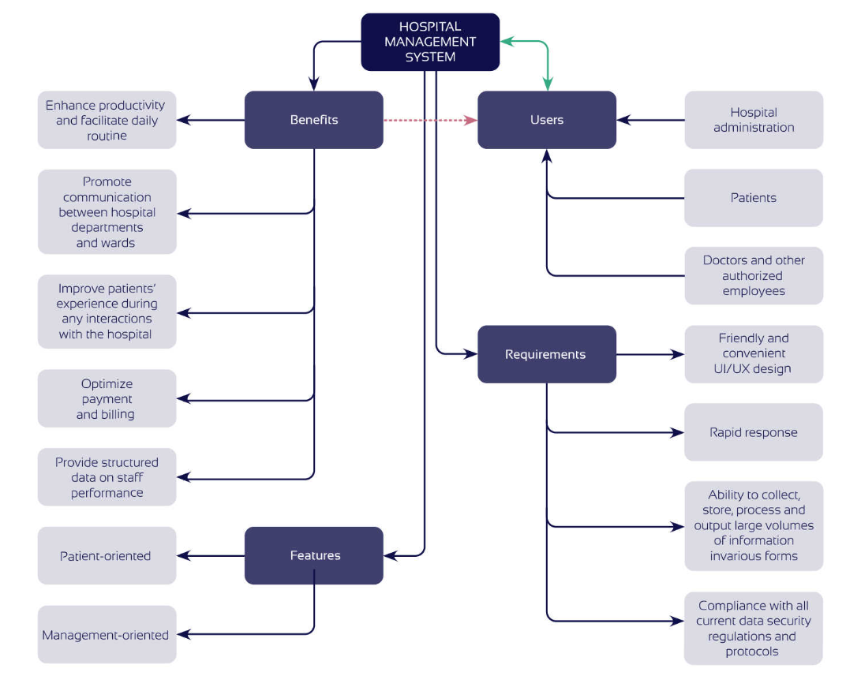

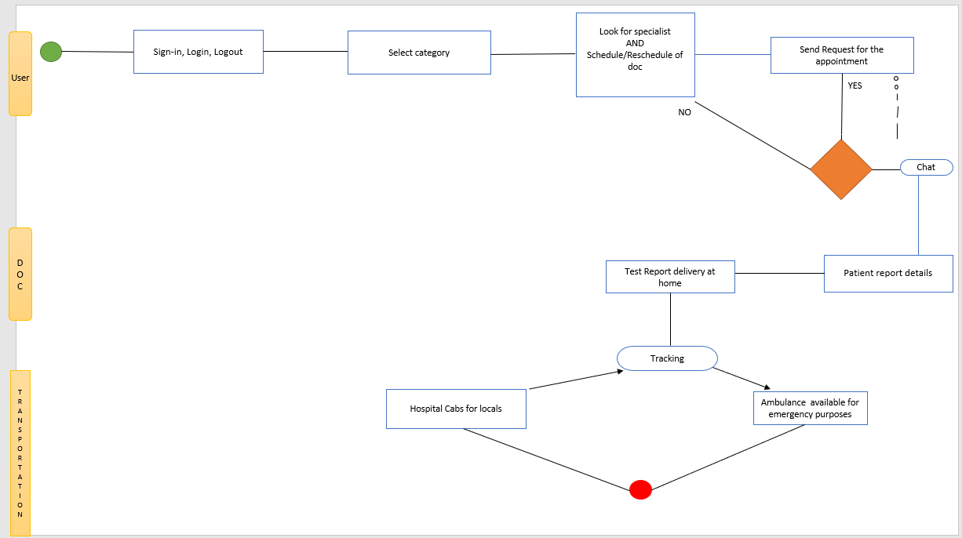

**2.2 Targeted Languages of the current system**

The public facing website of the Healthcare portal contents to be available in the following languages:

* English
* Hindi

is the default language when website is open. There would be an option where user can change the language

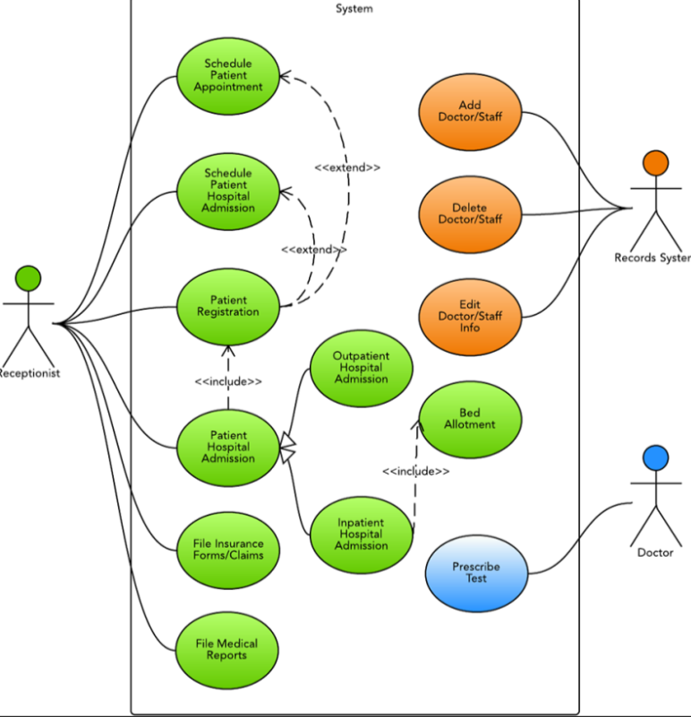

**2.3 Data Requirements**

The content and data required for the portal is collected from various sources and updated through the admin control panel by the authorized users. The content/data published only after it has been verified and approved by the publisher.

1. Core services – Information about various hospitals / clinics, their services, facilities, pricing etc.

2. Other services- Information about cabs and ambulances services

3. Other services – Related news and updates

**2.4 Data Architecture**

1.Information about a Hospital/Clinic

* + - Name and Address
    - Contact Telephones

General

Emergency

Each specialist

* Emails
  + - * Location and direction
      * Photos
      * Specialities / Service catalogue
      * Achievements
      * Testimonials
      * Facilities

Pharmacy

Canteen

Diagnostics

Infrastructure

Make equipments

Photos

Photos

* Doctors

a. Name and contacts

b. Specialization

c. Experienced

d. Achievement

**3.Functional Requirements**

**3.1 User Profiles Specification**

This section describes all the Actors and their profiles within the context of the Business

Requirements being documented. An Actor is a person, organization or an external

system/sub-system/program that has interactions with the Application. Actors, by definition, are external to the system with which they are having interactions. Actors have goals that area achieved by use cases. Typically, Actors have behaviour and are represented by the roles they play in the use case. An Actor stimulates the system by providing input and/or receiving something of measurable value from the system.

**Administrator:**

 Administrator is another user who inherits some controls from the super admin to perform certain activities. Generally admin user has all the rights of “Add/Edit or Delete” a record. There can be multiple admin users.

**Content Developer:**

Content developer is another user who generally create new contents/edit the content but does not have right to delete permission. Content created or edited would not be published until it is has be reviewed or approved by the Publisher.

**Content Publisher:**

Content publisher will review, approve or disapprove any content to be published in the public area.

**Website Visitor:**

 Any website visitor will have access to all the public contents published in the website. Website visitor can search and consume all services which are set as free services.

**Registered User:**

Registered users will have privileges to access certain private data and communicate with the service providers.

**Customer:**

Customer is a user who would have access to paid services.

**3.2 SMS Functionality**

1. Able to send bulk SMS by the website admin/users to the various stakeholders.
2. Able to configure in the Admin internet to send SMS for various activities (Example a new lead is received, confirmation to customer that his enquiry is recorded etc..)
3. Registered users / customers can send SMS after login
4. Able to allocate number of SMSs a customer can avail free and subscribe for more SMSs

**3.3 PMR Functionality**

a. Able to update demographics / personal records

b. Able to update demographics of the family members

c. Able to update Doctors information

d. Able to upload prescriptions (as attachments)

e. Able to update prescriptions as text

f. Able to setup medication

g. Able to setup alerts (Email and SMS) with regard to regular checkup’s, medicine and doses

h. Able to share medical records with the doctor for a particular period with permissions.

**4.4 MAP Functionality**

a. Able to locate Doctors, Hospitals, Clinics, Drug Stores, Diagnostic Labs, Location Tracking on a MAP.

b. Display different icons for each category of information.

c. Icons are updated through Admin intranet for each category of information.

d. Able to display more information through a call-out when user point on a particular icon

e. Able to view more information in a separate page when user opted to know more about selected information.

f. User can able to submit feedbacks to the site owner for any selected information

g. User can able to report any errors to the site owner for any selected information.

h. The feedbacks / errors reported by the users are emailed/sms to the respective site admin/user.

i. The feedback / reported errors are stored in the admin intranet.

 j. The user is reported back when the corrections are done or feedback are acknowledged.

k. Visitors can add a location (Doctor/Hospital/Clinic/Medical store/Diagnostics) if they feel so by filling a small form. The Latitude and Longitude should be picked up automatically.

L . The information submitted are stored separately for the admin to review and approve or disapprove.

**4.5 Clinic Management Application**

a. Application is based on SaaS (Software as a service) model

b. Able to provide a separate area for each customer (Doctor/clinic) andaccessed through a user name and password

c. Each customer can sign-up to avail this facility

d. Customer can opt-out this service by sending an email/calling to a site admin/ support request.

e. Admin can activate / inactivate this service for a customer

f. Following are the facilities included in the Virtual office:

a. Customer (Doctor/Clinic) update their place of availability, timings fora particular period (Day, Time, Not available time etc..)

 b. Visitors (Patients) can view the calendar or schedule an appointment

c. Customer to view the calendar and list of appointments

d. Customer can accept / reject one or all appointments for a day or period

e. Information goes to the patients when Doctor/Clinic accepted or rejected an appointment by email / sms

f. Record/update patient visits

g. Able to generate a bill for the services

h. Able to write a prescription for the patient

i. Able to generate a medical certificate for the patient

 j. Able to recommend/order a diagnostics

**4.6 Advertisement / Branding**

a. Able to define the ad placements in various pages

b. Able to define price for ad placements (ad size / duration / price)

c. Able to update/upload ad content for a location with priority, number of impressions, time period etc.

d. Able to manage the ad banners and content through admin area

**4.7 Job Functionality**

a. Able to search job openings by enter search text, experience/location.

b. Able to respond/send resume for a job directly after login

c. Able to publish list of recent jobs by function and location

d. Able to publish top 10 employers with their logos. Display list of current job openings.

e. Able to register and upload resume by the job seeker

f. Able to login and update resume by the job seekers

g. Employers to register and update job openings

h. Employer login and search resumes

i. Download matching resumes for a particular post

j. Email to job seeker when a new matching job is updated by the employer

k. Email to employer when a new matching resume is updated by a job seeker.

l. Block resumes to be viewed by certain companies (by entering key words of the companies) by the job seeker for managing privacy.

**4.8 Search/Advance Search**

1. Basic search should work like Google search with suggestions
2. User can shift to advance search and search through selecting filters and criteria

* 1. **Communication / Work flows**

a. The visitors to the website should able to communicate with the site admin /service providers by filling pre-defined forms.

 b. A confirmation message should be sent to the person who submitted by email as a copy for him/her record.

c. Apart from saving data in a database table which can be accessed through admin intranet; all information should be sent to respective site user / service provider depending on the kind of service request.

d. Work-flows are defined in the admin intranet ( i.e. mail to whom, access to whom).

* 1. **Community services / Corporate social responsibility**

a. People register as service provider / volunteer to extend their services.

 b. People request to for services (Example: Looking for help to locate a doctor for a particular disease, Looking for help

c. Able to connect between the service providers with service seekers

**Interactive Forms**

|  |  |
| --- | --- |
| **Use case form** | Submitting online form |
| **Description** | Submitting online form in the website |
| **Actors** | Prospective medical tourist (Customer) |
| **Business Rules** | 1. Form can be submitted only after the user complete filling all the required data.  2. User can switch to detailed form/provide more information if he/she willing to provide at that moment by expanding section of the form. |
| **Basic Flows** | **Alternate Flows** |
| 1. On screen thank you message.  2. Email confirmation to the customer’s email address as a copy of the information submitted.  3. Email notification to the business head/concerned executive.  4. Save data in the database for reporting | 1. The service request form can be submitted (after censoring) directly to the affiliate hospitals (Service providers) to submit their quotes.  2. The business head/concerned executive will review and submit the form to Service providers. |

**Contact us**

|  |  |
| --- | --- |
| **Use Case Name** | Submitting online form |
| **Description** | Submitting online form in the website. |
| **Actors** | Prospective medical tourist (Customer)Website visitors Prospective service providers (Wanted to list in the portal) |
| **Business Rules** | 1.Form can be submitted only after the user complete filling all the required data. |
| **Basic Flow** | **Alternate Flow** |
| 1.On screen thank you message.  2.Email confirmation to the email address provided as a copy of the information submitted.  3.Email notification to the business head/concerned executive.  4.  Save data in the database for reporting |  |

**Feedback**

|  |  |
| --- | --- |
| **Use Case Name** | Submitting feedback online |
| **Description** | Submitting online form in the website. |
| **Business Rules** | 2. Form can be submitted only after the user complete filling all the required data. |
| **Basic Flow** | **Alternate Flow** |
| 1. On screen thank you message.  2. Email confirmation to the email address provided as a copy of the information submitted.  3. Email notification to the business head/concerned executive.  4. Save data in the database for reporting |  |
|  |  |

**Data Definition Reports**

**Entity Definition Report**

This section is applicable only to Oracle Designer approach. This section describes Data Architecture / definition (Entity Relationship model) in narrative text form.



|  |  |
| --- | --- |
| **Entity Name** |  |
| **Entity Description** |  |
| **Initial Data Volume** |  |
| **Annual Data growth rate** |  |
| **Attributes (fields) of the entity** | Name:  Description:  Name:  Description:  Name:  Description:  Name:  Description: |

**Data Requirements**

The content and data required for the portal is collected from various sources and updated through the admin control panel by the authorized users. The content/data published only after it has been verified and approved by the publisher.

Initially all the relevant data updated by the portal administrator and progressively an extranet system can be developed which would enable the service provider to update data through secure login.

1. Core services – Information about various Hospitals, Clinics, Doctors, Diagnostic, Facilities, transportation provided by them and pricing etc.

2. Ancillary services Jobs New product releases Advertisement

3. Other services – Related news and updates.

**Data Architecture**

**Availability Requirements**

The system is available over the net. The healthcare portal is targeted to USA and Portal for India is targeted whole of India. The system would re-direct to the user based on IP address. If anybody trying to access the Healthcare portal from India, the system will re-direct to Portal for India and vice-versa. The system uptime should be 99.00%. The similar back to back guarantee needs to be obtained from the hosting company. In case of any breakdown, appropriate message need to be flashed. On-line chat to be adjusted with US and India time. Response to user query within 24 hours.

|  |  |
| --- | --- |
| **Use Case / Business Function Name** | **Availability Requirements**  **-Regular work hours**  **-24x7**  **-Any other (please describe)** |
|  |  |
|  |  |
|  |  |
|  |  |
|  |  |
|  |  |

**Usability Requirements**

This section describes the system usability requirements. A usability requirement specifies how easy the system must be to use. Usability is a non-functional requirement, because in its essence it doesn't specify parts of the system functionality, but specifies only how that functionality is to be perceived by the user, for instance how easy it must be to learn and operate the system.

**System Help Requirements**

This section describes what kind of System Help features are needed to be built into the system

|  |  |
| --- | --- |
| **Use Case / Business Function Name** | **Help Requirements**  **-Field Level (online)**  **-Screen Level (online)**  **-High Printing Options**  **-Operations Manual (office)**  **-Any Other** |
|  |  |
|  |  |
|  |  |
|  |  |
|  |  |
|  |  |

**Performance Requirements**

5.5.1. Stress Requirements

Health tourist portals must be able to support minimum of 200 user accessing records simultaneously. Portal for India must support minimum of 5000 users accessing simultaneously.

5.5.2. Response-Time Requirements

The maximum allowable wait time from the moment the user submits a request until the system comes back with a response should not go beyond 8 seconds with the data volume 300,000+ records.

**Scalability Requirements**

The system should be scalable to accommodate add new services, enhance existing services.

**User Scalability**

**Application Scalability**

**Interface Requirements**

This section describes User and System Interface requirements for the proposed system.

**User Interface Requirements**

**Browser compatibility**

The website should support all major browsers of the current version and one version down.

1.IE

2.Fire Fox

3.Mozilla (Mac)

4.Chrome

**Data display**

The content presented in the portal would be designed professionally like any world class website. The data can be presented in List view/Form view to the stakeholders in the irrespective area.

**Drop-down list**

Data consistency is maintained through selecting choices from drop down list. The application should enable each customer to add their new choices .The master drop down list is managed through the Admin area. When a customer register, set of master data (pre-requisites) are available for them. This would help them to start using the application instantly. Also, each registered customer can manage their own master data (add/edit/delete).

**System Interface Requirements**

**Project Plan and Delivery Schedule**

|  |  |  |  |  |  |
| --- | --- | --- | --- | --- | --- |
| **SL** | **Task** | **Start** | **Finish** | **Duration** |  |
| **1.** | Definition |  |  |  |  |
|  | System Design |  |  |  |  |
|  | Detailed Design |  |  |  |  |
|  | Development |  |  |  |  |
|  | Integration Testing |  |  |  |  |

**Communication Plan**

**8.1Proposed Communication Plans**

•Daily call

•Weekly review meeting would be held on a prescheduled day (______) and time.

•Regular communication would be done through emails, phone and Web Meeting with email would be the most frequent communication medium

•Extranet portal (Basecamp) created for the project would be the platform through which the project related documents, minutes of the meeting are shared. The tasks assigned for the team members are presented and tracked through the portal

•Weekly status report should be shared with Client through email and posted to the extranet portal by end of the week.

**Project Team**

|  |  |  |  |  |  |
| --- | --- | --- | --- | --- | --- |
| **SL** | **Name** | **Role** | **Organisation** | **Contact No.** | **E-mail Address** |
|  |  |  |  |  |  |
|  |  |  |  |  |  |
|  |  |  |  |  |  |

**Revision Log**

|  |  |  |  |
| --- | --- | --- | --- |
| **Date** | **Version** | **Change Reference** | **Reviewed by** |
| **25thoct,2022** |  |  |  |
| **26thoct,2022** |  | List of Functionality included for Indian Portal1. Community /Corporate Social Responsibility2. PHR (Personal Health Record).3. Manage data bases of Pharmacists/Drugstores and locate them in Google Map. |  |
| **6th oct,2022** |  | 1. Scope is explained and expanded  2. SaaS architecture diagram is depicted  3. Connect functionality is included |  |

**Approval**

This document has been approved as the official Business Requirements Document for the HealthCare project. Following approval of this document, changes will be governed by the project’s change management process, including impact analysis, appropriate reviews and approvals, under the general control of the Master Project Plan and according to Project Support Office policy.

|  |  |  |
| --- | --- | --- |
| Prepared by | Signature | Date |
| Author’s Name  [Title]  [Organisation] |  |  |
| Approved by | Signature | Date |
| Client Acceptor’s Name]  [Title]  [Organization] |  |  |