Assignment Kmeans Clustering
3A:
Use your dataset to implement the KMeans clustering.
Task: TODO
- You have to implement K-means clustering algorithm with the data with first 3 dimensions.
- A sample implementation file is provided. Please download it. You can use notebook to complete the TODOs. The implementation file is actually a skeleton or pseudocodes. You need to fill up your code blocks where asked. Numpy array has been used to store the datapoints, centroids, indices in this skeleton.
- At first, data are loaded. You can use the load function or panda function to load numerical data in numpy matrix. Use K = the number of classes present in your dataset
- Use initialize_centroids_simple() to initialize your centroids. This is the simple assignment function you need to implement. Randomly select K points from the sampled data and assign them as initialized centroids.
- Then, in the kmeans function,
  - You have to calculate the cluster_affiliation array based on the distance of each data points from all centroids.
  - you have to write your own code to count the number of points assigned for each cluster based on the cluster_affiliation and store in the defined structure clutser_point_count
  - You have to re-compute the centroids based on the cluster_affiliation and clutser_point_count
  - Then write your own code to terminate the process based on the termination criteria discussed in the class. We evaluate the quality of the clustering using the clustering objective value:

Where N is the total number of sampled points. x_{i} is the i^{th} data point. z_{k} is the centroid for k^{th} cluster. The algorithm is terminated when J is nearly equal in two successive iterations (e.g., we terminate when |J − Jprev| ≤ 10⁻⁵J, where Jprev is the value of J after the previous iteration, flag = False).
  - After the iterations, you will have final cluster affiliation and the final centroids.

- With the cluster affiliation and the final centroids, draw a 3D plot (use plotly) where:
    - Plot the data points using the shapes. Using the given ClassLabel data(ground truth) , determine the shape of the each data point (triangle, square or circle).
    - Determine the shape fill color by the cluster_affiliation for each data point. Such as for cluster 0: use blue fill., for cluster 1: red, cluster 2: yellow, etc.
    - Visually calculate how many data points are wrongly clustered where most of the data points are same in a cluster. That means: same shape with different colors. How many times it happened.

3B: Goal: Performing K Means clustering on image data and text data
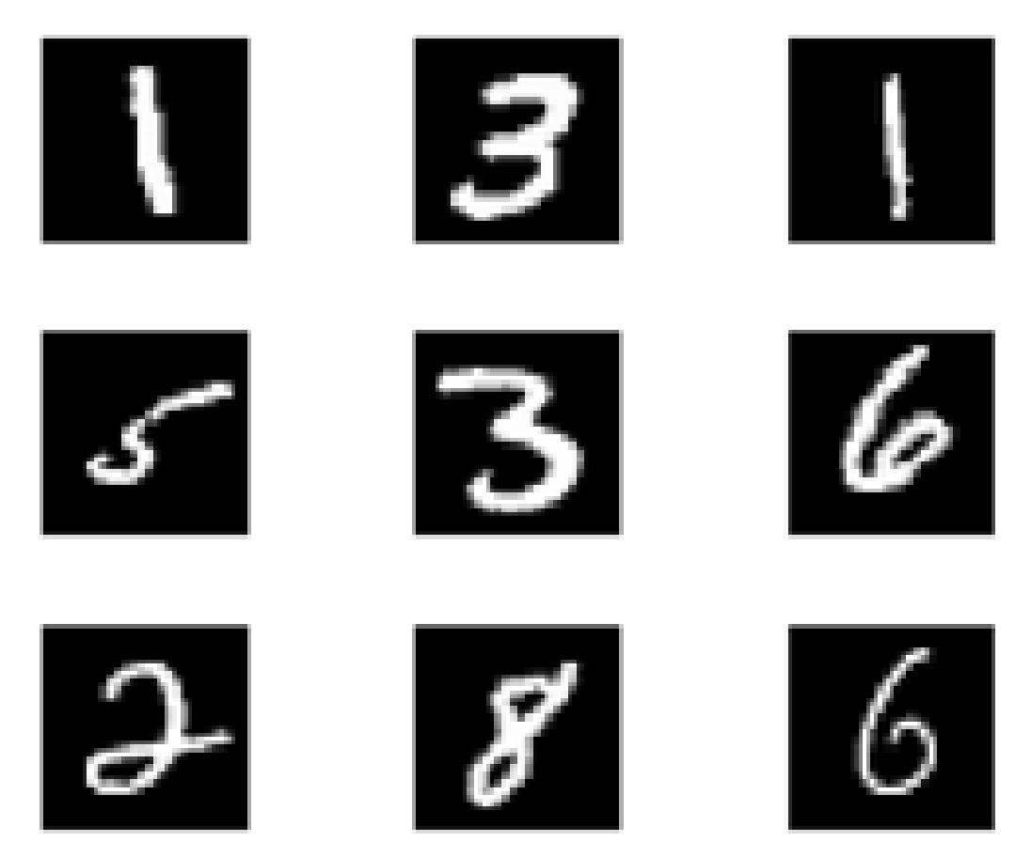
Image data: MNIST data set

- Use google colab. Google colab has GPU so your program will be fast in google golab.
- We will in this assignment cluster images from MNIST (Mixed National Institute of Standards) database of handwritten digits. MNIST train data set containing N = 50000 grayscale images of size 28 × 28 as shown above. We will follow the steps specified below:
- After reading the train dataset, you will get a 784 × 60000 matrix digits and a 1 × 50000 matrix labels.
- We will not need labels for clustering. However, for external validation, we will use them. Each column of digits is a 28 × 28 grayscale image, stored as a vector of length 28² = 784 with elements between 0 and 1
- You are asked to apply the k-means algorithm to this set of N = 50000 vectors, with k = 10 groups, and starting from a random initial group assignment

Visual validation:
- Now take the 10 centroid (784x1) vectors, reshape them into 28x28 and show the images of the centroids. You should see the digits captured in the centroids.
- Plot the 3D plots for the randomly chosen 1000 data from the MNIST using the tsne library (produce 3D points from 784x1 vectors. Use different colors for the points that are assigned to different clusters. Also plot the centroids in bigger markers.
Analytical/Quantitative Validation:
- Calculate the quality of the final clusters using following criteria. you can use library functions here.

    - Davies–Bouldin index
    - Dunn index
  - External validation:
    - Purity
    - Rand index

3C: Text clustering: Clustering Prothom-alo news (BONUS 50)
- Use the dataset described here:
https://github.com/banglanlp/bnlp-resources/tree/main/news_categorization
- Download 1200 different news. 1200 will be from 6 different categories (200 from each category)
- Now use following procedures to calculate feature vectors for the text associated with each editors’ column.
  - Use the tokenizer to extract all words for all sentences
  - Use stemming.
  - Normalize the words
  - Discard stop words.
  - Use Zipf’s law to discard most frequent and least frequent words
  - Build the vocabulary/term list
  - Calculate TF matrix for all comments/documents. (You can’t use library functions)
  - Calculate normalized TF matrix (You can’t use library functions)
  - Calculate IDF for all terms (You can’t use library functions)
  - Calculate final weighted matrix for all documents. (You can’t use library functions)
  - Now use the rows as feature vectors for corresponding documents/columns. We don’t use the category for clustering.
  - We will use this information for external validation
  - Use K-mean clustering with the feature vectors to cluster the 1200 documents into 6 categories.
Visual Validation:
- Plot the 3D plots for the 1200 documents using three-dimension data that you will get from the tsne library. The tsne will take high dimension data and return 3-dimension data for plotting. Use different colors for the points that are assigned to different clusters. Also plot the centroids in bigger markers.
Analytical/Quantitative Validation:
- Calculate the quality of the final clusters using following criteria (You canuse library functions)
  - Internal Validation

    - Davies–Bouldin index
    - Dunn index
  - External validation: Here you will use the ground truth categories (that you have collected during the scrapping)
    - Purity
    - Rand index

