1. Google -> download postman

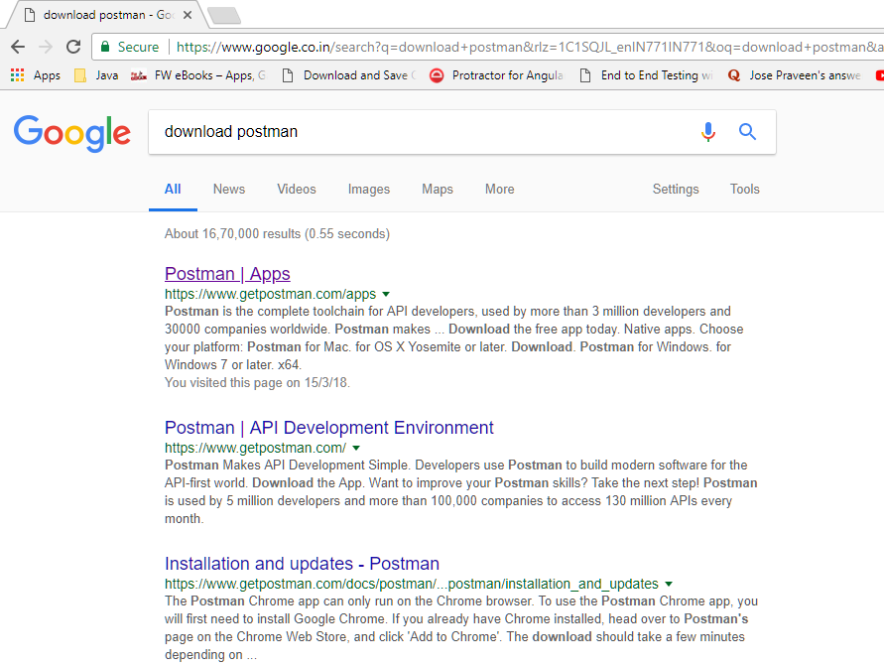

1. Select the 1st result

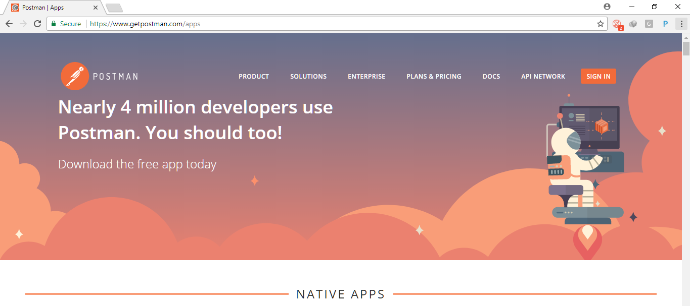

1. Scroll down to select the Windows OS and then select the 64bit (or 32bit) version. Ideally it gets auto selected.

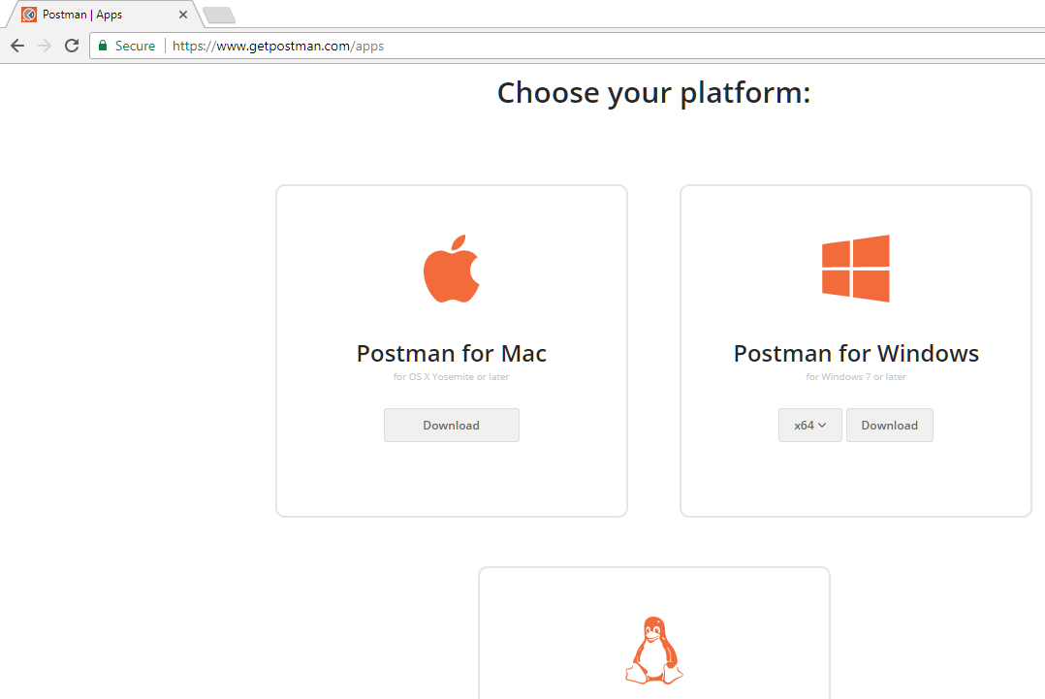

1. Click Sign-In option and at Sign-in page > check out at bottom for text “Take me straight to the app”. You will not need to use login and directly you will be accessing the app.

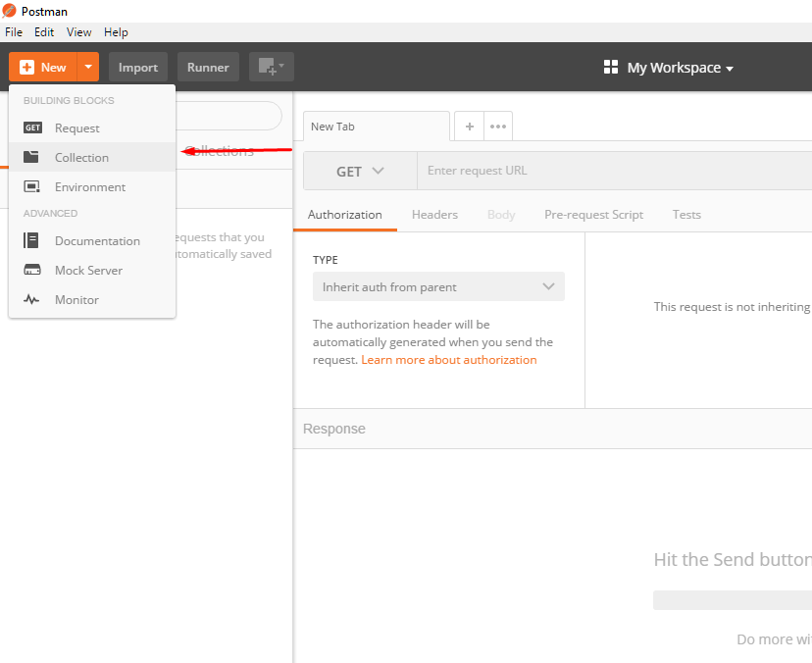

1. Postman allows to create a FOLDER with this you can store all request and response. This folder is knows as “**Collection**” here.

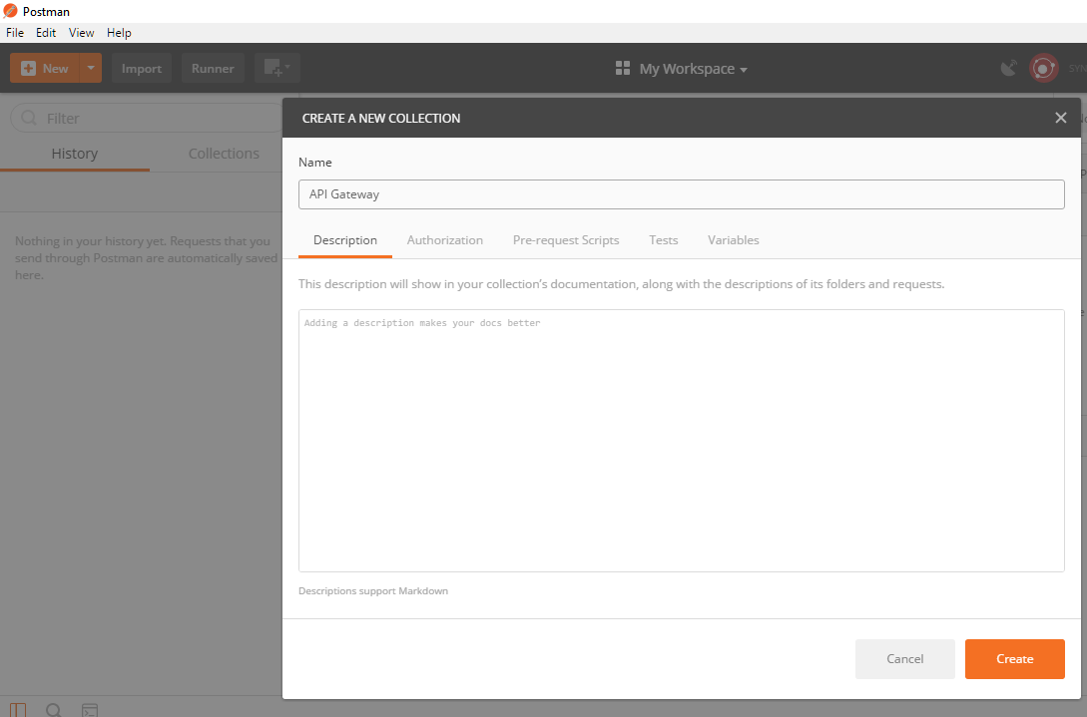

1. Select the API request method > **GET** (from drop down) and type the API endpoint url. Refer below image

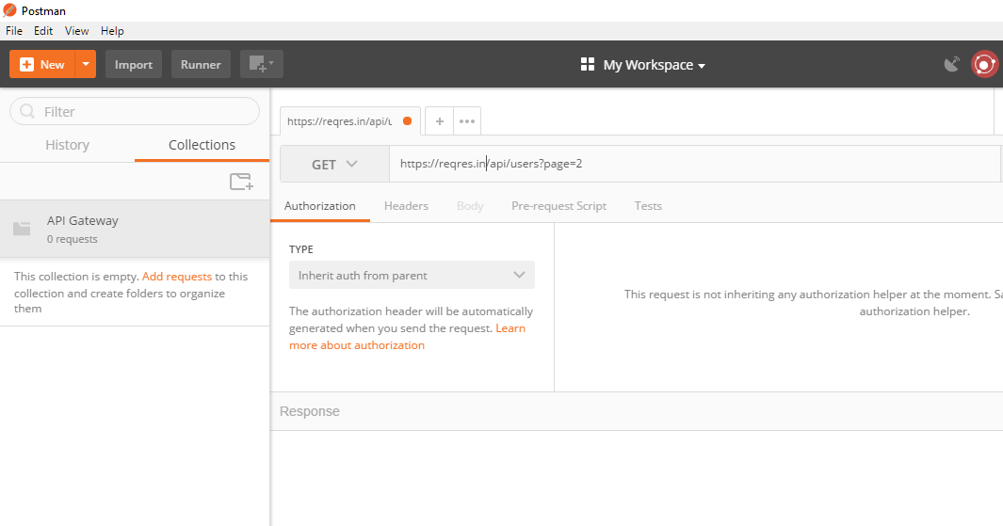

1. Lets add **Header** in this API request, Click at “Header” tab for all header related information.

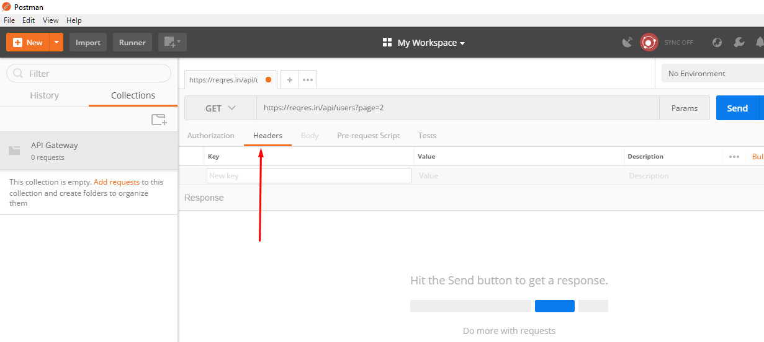

I typed a most common API header “content-type”. POSTMAN tool is intelligent, this will suggest you the similar headers post you start typing. Here I typed “plain” and this tool suggested the value “text/plain

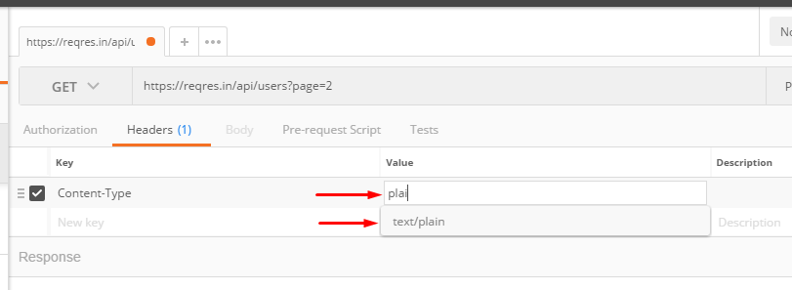

Or when I type “Jso” it suggested me the below

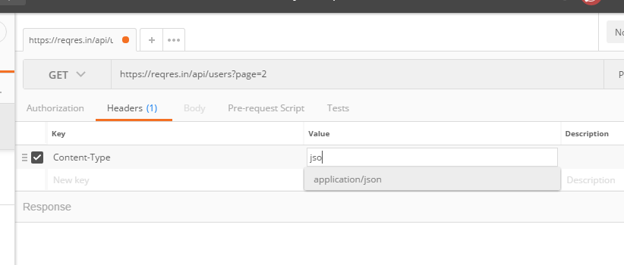

1. Since for the GET request , there is no payload is sent hence “Body” tab is disabled in this case.

Please note that POST method in API sends body (Payload), then body tab will get enabled. When you select **POST** from dropdown, you will notice “Body” tab gets enabled.

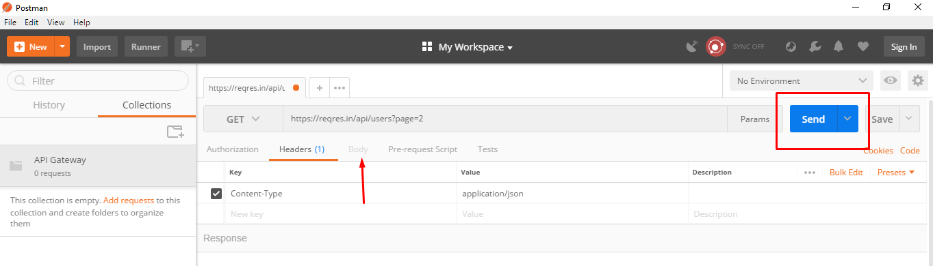

1. When I hit “Send” button below screen displayed (This is response for GET request)

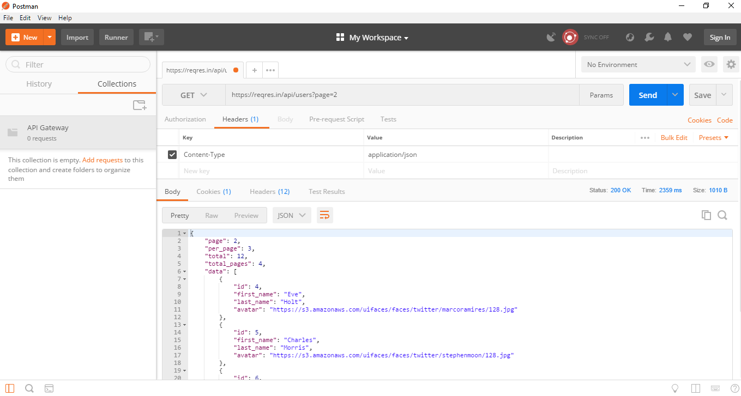

In this Response, please verify that “Cookies” and “Header” are displaying count, which means response has these many number of headers and other information

Click at “Cookies” and cookies will be displayed

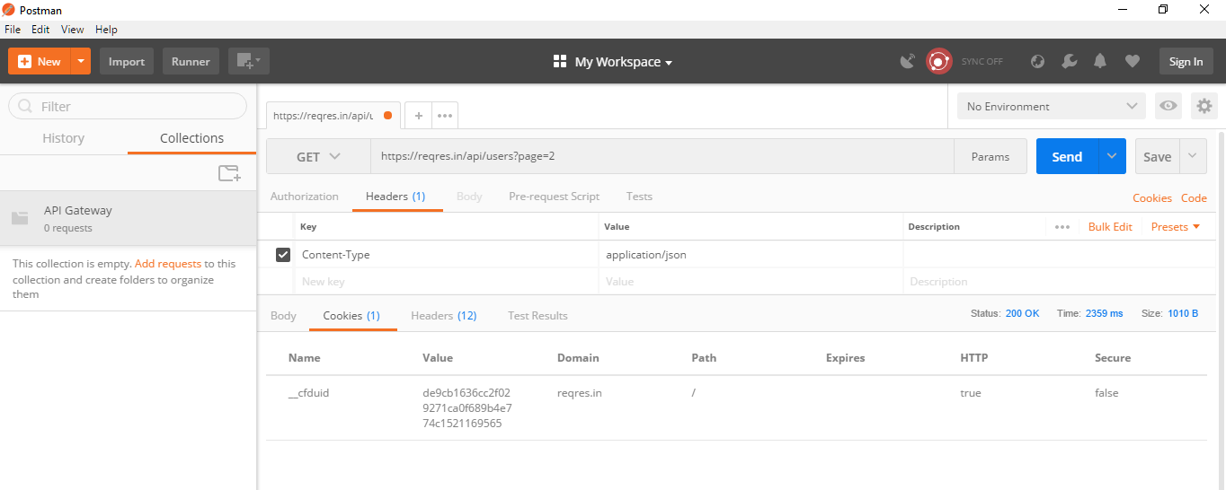

Click at Headers tab and all headers will be displayed

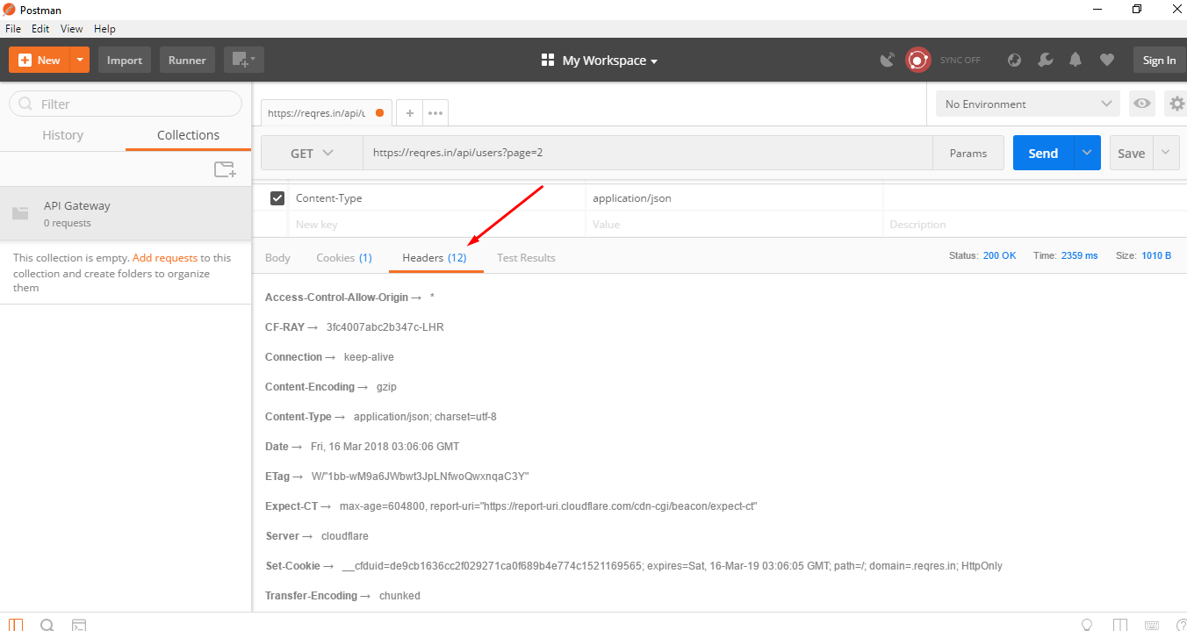

Now let’s save this request and response to our Project

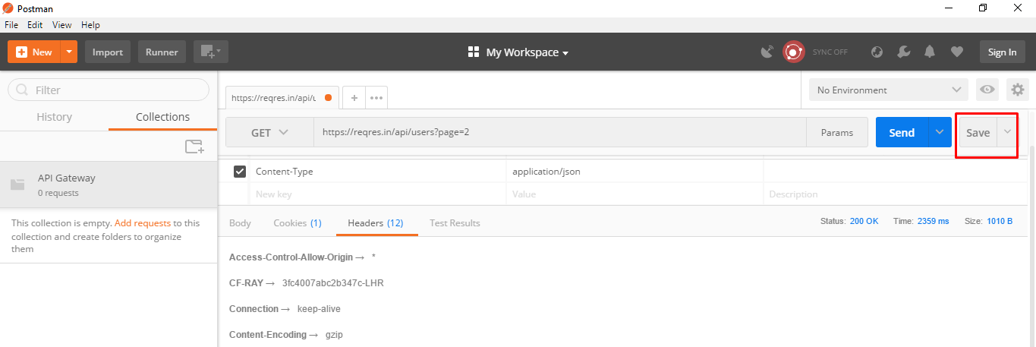

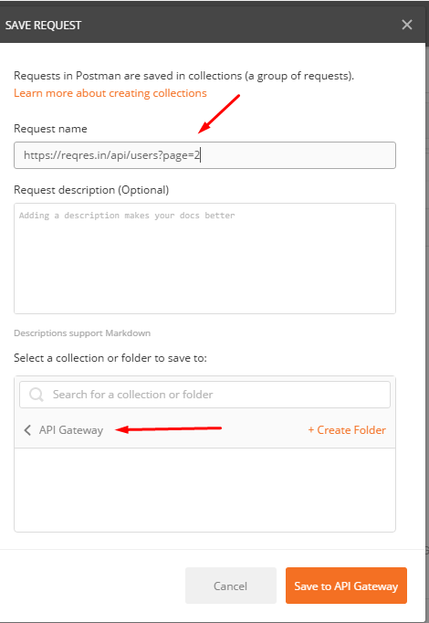

This is our Project

