The chart below shows what Anthropology graduates from one university did after finishing their undergraduate degree course. The table shows the salaries of the anthropologists in work after five years.
Summarize the information by selecting and reporting the main features, and make comparisons where relevant.
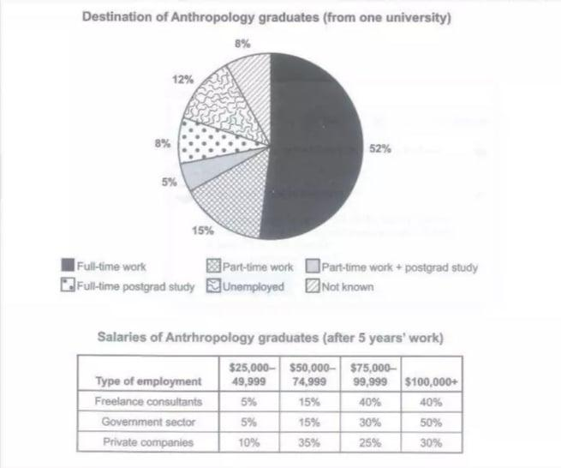
The pie chart shows the destinations of Anthropology graduates from one university, while the table illustrates the salaries earned by graduates after working for five years. Figures in the both pie chart and table are presented in percentages.
Overall, the destination of full-time working graduates marks the highest proportion whereas, the student engaged in both part-time work plus postgrad study remains as the lowest proportion. In terms of earning, salaries accounted by government sector employees illustrates a significant growth through the five years.
Graduates working full time has reached their destination just above the half (52%) whereas, the lowest is recorded by scholars who are working part time and continuing studies, which is (5%).
Regarding incomes, the students who are employed in the government sector reached the highest amount of increment in their salaries (50%) after working for 5 years. Meanwhile, the workers who are stuck up with private companies received the least salary increment (30%).

