LUUM
Cinematics Brief
Opening & Ending 2D Cinematics
Project | Luum — VR narrative adventure
Platform | Meta Quest 3 (standalone)
Deliverables | Two 2D cinematics: opening and ending

* The project and character name were finalized as LUUM. Older documents or files may still show "LOOM" — disregard that spelling.
Visual fidelity: the cinematics can — and should — look more polished than the current demo screenshots. The in-game lighting and atmosphere are not yet final, and it's fine, even desirable, for the cinematics to be more visually striking and refined than what's currently shown in the build.

1. The Game, in Brief
Luum is a VR adventure about guiding a lost creature as she learns to connect with the nature of a world that isn't her own.
Luum is a small, glowing alien creature who crash-lands on an unfamiliar, entirely organic planet. The player helps her recover, move, and bond with a world that communicates through nature rather than language. As she collects glowing runes and connects with her surroundings, her warm yellow-orange body slowly takes on the cool blue of the world around her — and a mysterious blue figure seen in the opening hints at what she may become.
Tone throughout: intimate, not epic. Wonder over action. A quiet two-character story about transformation and connection, not combat or stakes.

2. Structure Overview
- Opening cinematic (2D) — Luum crash-lands; a mysterious blue figure frees her from the wreckage, then vanishes.
- Gameplay (in-engine, three phases) — the player helps Luum stand, navigate her crash site, cross water using a floating log, then enter a cave where she meets an NPC, collects a second rune, and opens a sealed stone door through a synchronized light ritual — turning partially blue in the process.
- Ending cinematic (2D) — Luum steps out of the cave, sees her own change, and looks toward the horizon.
The two cinematics are the visual bookends of the same arc: confusion and crash-landing on one side, quiet transformation and forward motion on the other.

3. Visual Reference
Match the in-game aesthetic: cool blue/purple alien tones, dark rock textures, a bioluminescent quality to anything glowing. The cinematics should feel like a continuation of the same world the player is about to enter, not a separate stylistic universe. The three shots below are the specific locations that must match between video and gameplay.
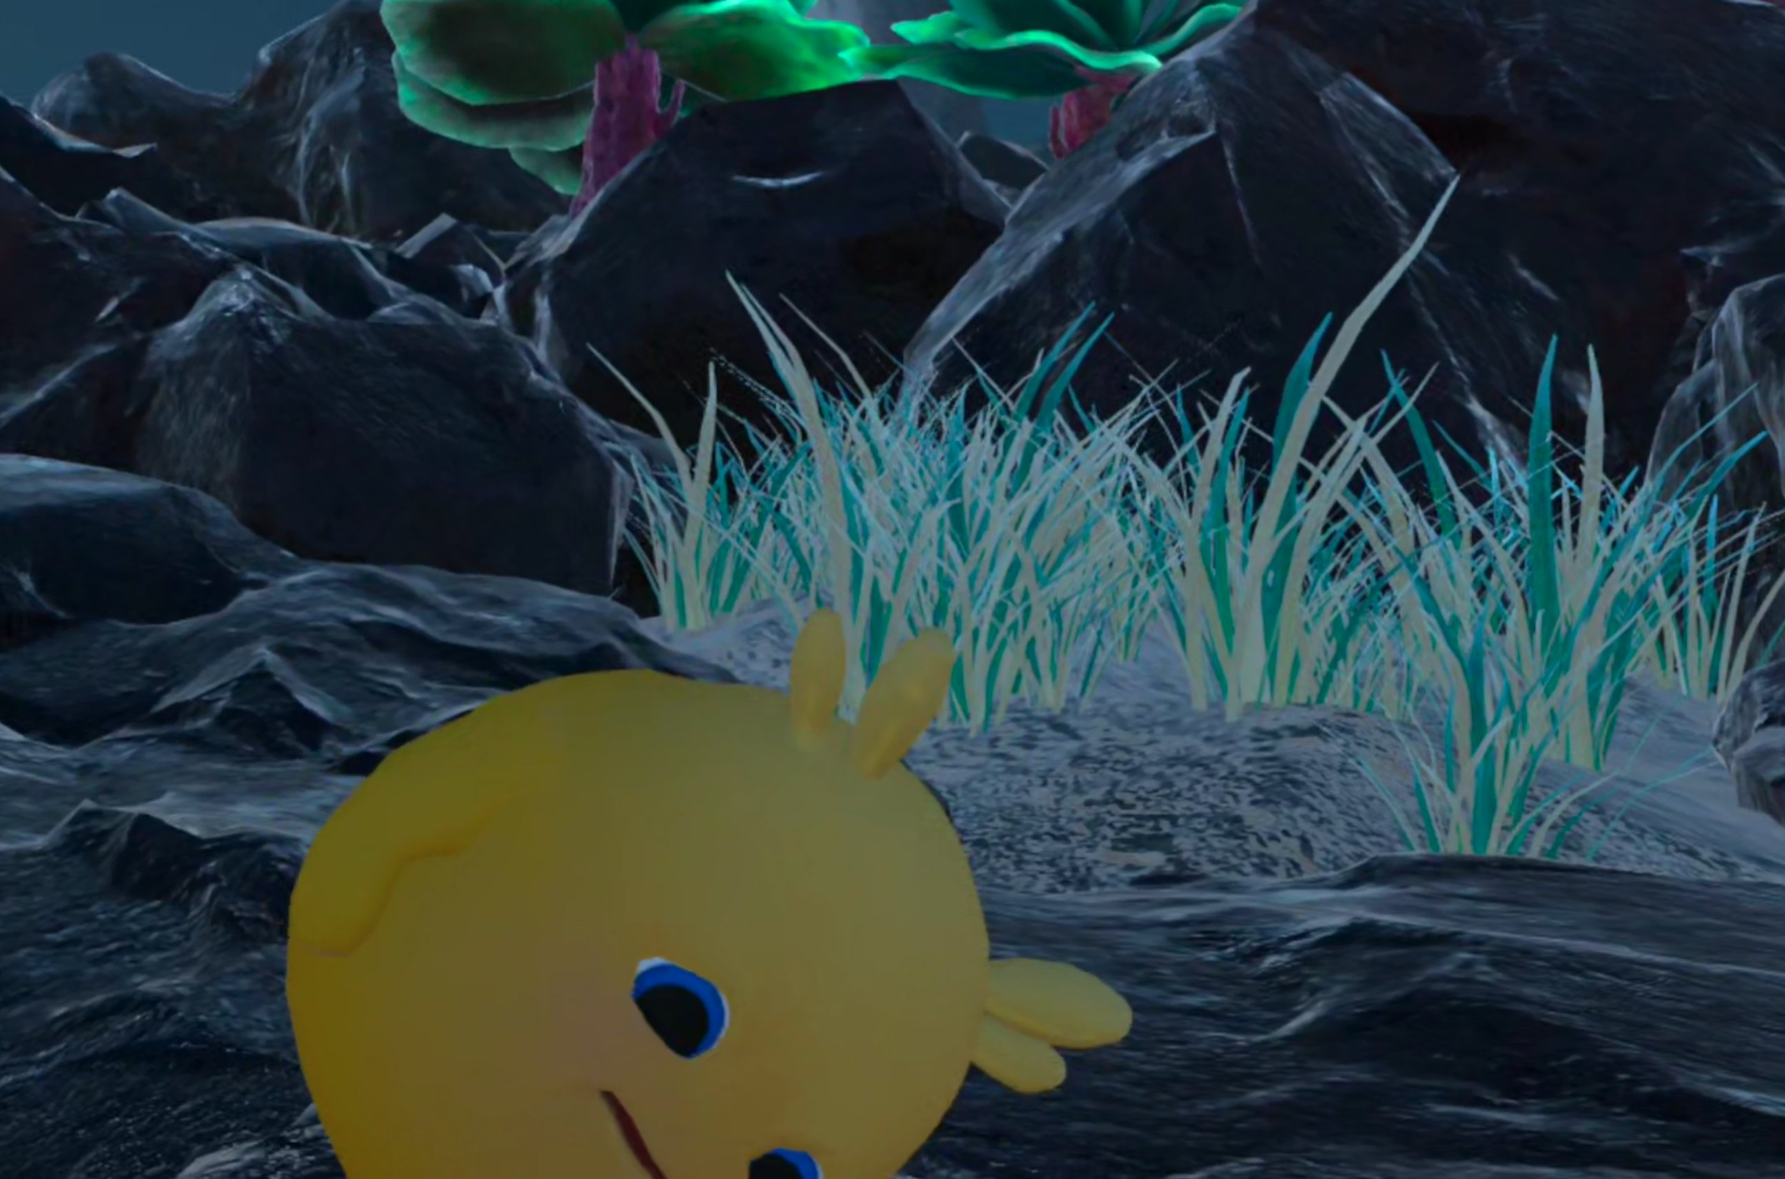
Landing area — opening cinematic: the rocks and bioluminescent plants where Luum ends up after the crash.
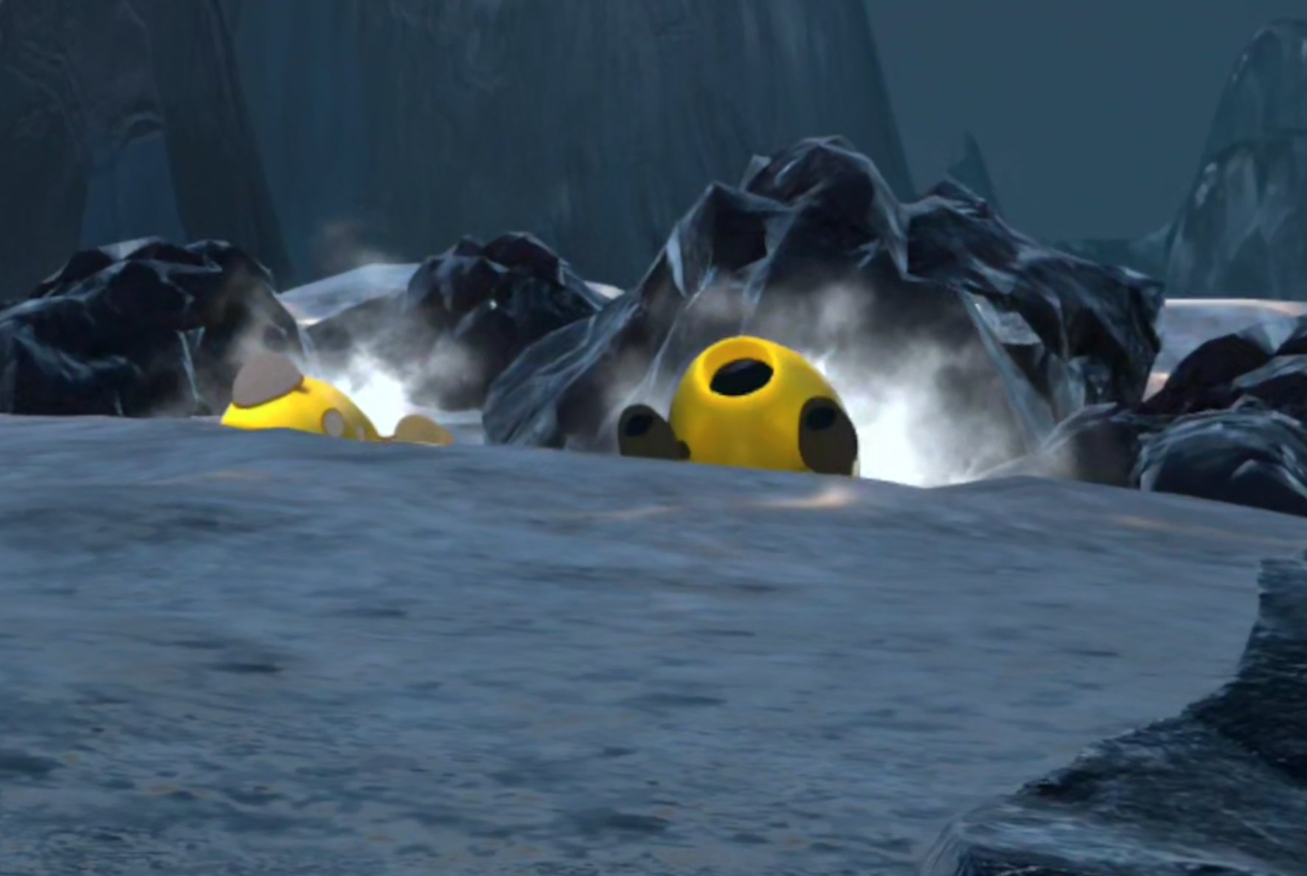
Crash pods — opening cinematic: the capsules embedded in the rock, with smoke/steam rising.
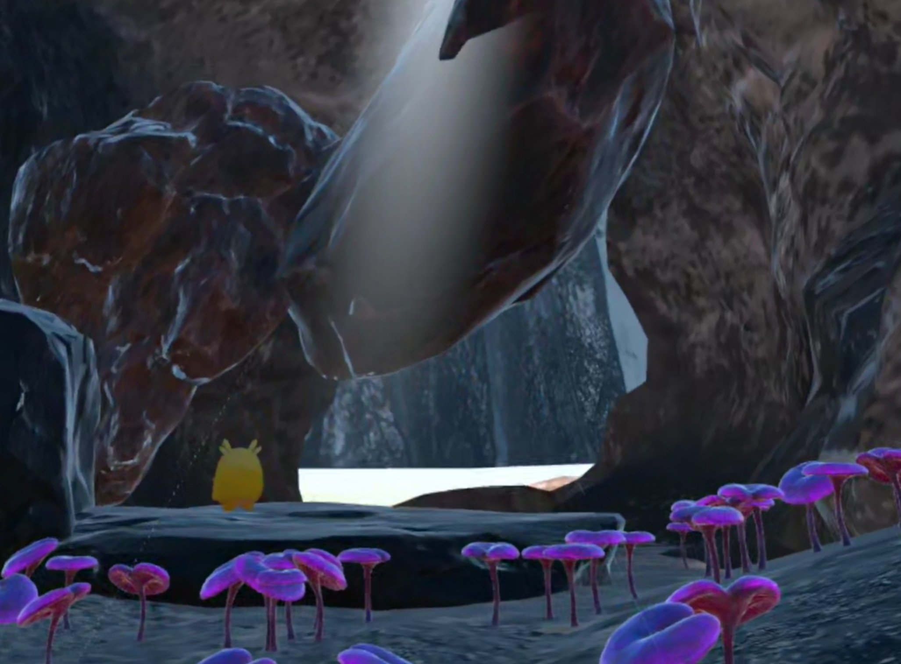
Cave exit — current in-game look (not yet updated). Only the shape/silhouette of the exit opening should be matched, not the surrounding environment design.
Critical continuity note: these three locations — the landing area, the crash pods, and the cave exit — must visually match between the cinematics and the corresponding in-game moments. Same rock formations, same general composition.

3.1 The blue figure's gesture
In the opening cinematic, the blue figure's cosmic gesture should echo the player's own particle effect from the demo — these two reference images are the in-game particles and the player's hand-orb, used as the visual basis for the figure's power.

Player hand reference: glowing translucent blue orb.
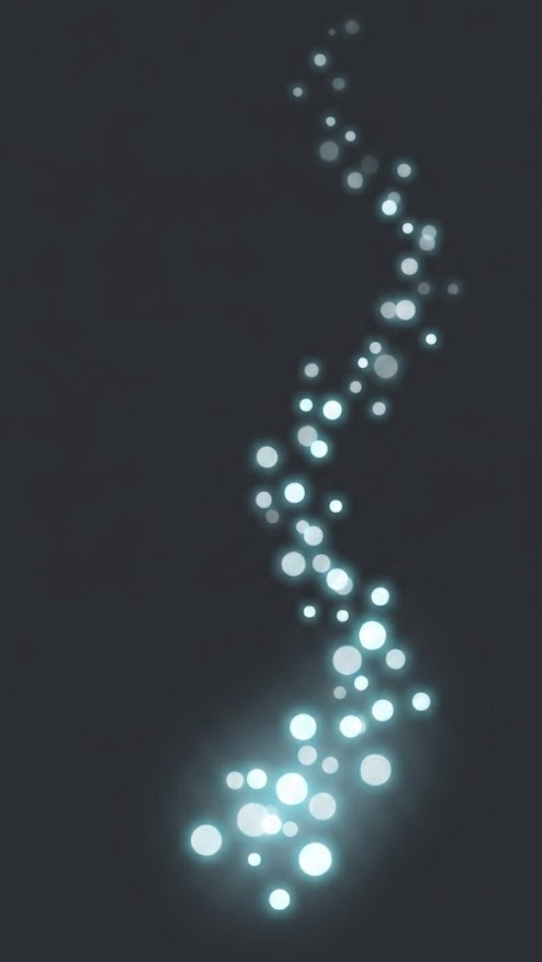
Particle reference: light particles flowing from the hand toward an object.
Using this same particle/orb visual language for the blue figure's gesture is a deliberate hint that the figure and the player are the same kind of being — the player will recognize the rhyme later in the game.

4. Opening Cinematic
Tone: wonder and mystery first, brief shock at the crash, ending on vulnerability — Luum small and alone in an overwhelming world.
- Wide establishing shot of the alien planet — dark rocky terrain, cool palette, genuinely beautiful and untouched. A few seconds to let the world breathe before anything happens.
- Sudden disruption — multiple capsules streak through the sky and crash into the terrain in the distance. One crashes close to camera; dust and smoke rise.
- As the dust settles, a blue figure approaches the wreckage. Keep this figure vague and minimally detailed — it should read as a blue presence that exists and helps, not a fully designed character. If its hands can resemble the player's own glowing blue hand-orb (see Section 3.1), that's ideal.
- The figure performs a cosmic gesture that moves nearby vegetation, using the same particle effect language as the player's own ability (Section 3.1). The gesture's energy wrenches the capsule door open, and Luum tumbles out.
- The blue figure vanishes — no explanation, just gone.
- Luum rolls to a stop on one of the rocks — this exact rock is where Phase 1 of the demo begins, so the landing spot must match (see Section 3).

5. Ending Cinematic
Tone: quiet, earned, hopeful — the opposite emotional register of the opening's confusion and fear.
Unlike the opening, this one is allowed to feel like a new scene rather than a direct continuation — the outdoor world design is flexible and open. What matters is that Luum has exited the cave and is now looking out at a whole, striking world. The current in-game cave exit is not yet updated, so don't treat it as final; what must match is the shape/silhouette of the exit opening itself (see Section 3).
- The camera is outside the cave, looking at the exit from the outside — this is after Luum has already stepped out, not the moment of stepping out itself. The opening's shape should resemble the in-game cave exit (Section 3).
- Luum is now blue — matching the partially-blue state she reaches in the current demo, not fully transformed.
- She looks down at her own body, taking in the change.
- She looks up and out at the wider world in front of her — open, flexible in design, but it should feel whole and impressive, a contrast to the enclosed cave.
- Music shifts to something warmer and deeper than the opening.
- Final text fades in: "Understanding was the key. Connection is the journey…" (temp text – don’t include in the video yet)

6. Mood & Emotional Target
- Wonder over action — curiosity and tenderness, not combat or stakes.
- Small and vulnerable, not heroic.
- Sense of discovery — half-hidden glowing details, soft fog, scale contrast between tiny Luum and big nature.
- Calm, not creepy — even cave/underwater settings stay hushed and magical, not foreboding.

End of brief.

