**C++ Assignment First**

|  |
| --- |
| //Program_1.cpp  // 1. Write a program to find maximum between two numbers.  #include<iostream>  using namespace std;  int main(){      //data type declaration      float num1,num2;      cout<<"Enter Two Number :"<<endl;    //message for display      cin>>num1>>num2;         //taking input from user      if (num1>num2)      //compare value num1 & num2      {          cout<<"Num1 is Greater : "<<num1;      }      else      {          cout<<"Num2 is Greater : "<<num2;      }      } |

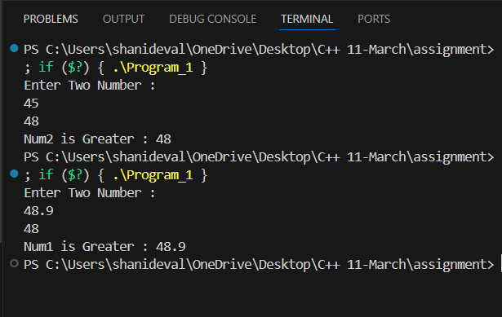

|  |
| --- |
| //Program_2.cpp  // 2. Write a program to find maximum between three numbers.  #include <iostream>  using namespace std;  int main()  {     // data type and variable declaration      float num1, num2, num3;      cout << "Enter Three Number :" << endl;    //Message display      cin >> num1 >> num2 >> num3;             //taking input from user      if (num1 > num2 && num1 > num3)       //Checking condition of the  value form user input num1 greater from,num2,num3      {          cout << "Num1 is Greater : " << num1;      }      else if (num2 > num1 && num2 > num3)   //comparing the value form user input num2 greater,num1,num3      {          cout << "Num2 is Greater : " << num2;      }      else                      //comparing the value form user input num2 greater,num1,num3      {          cout << "Num3 is Greater : " << num3;      }  } |

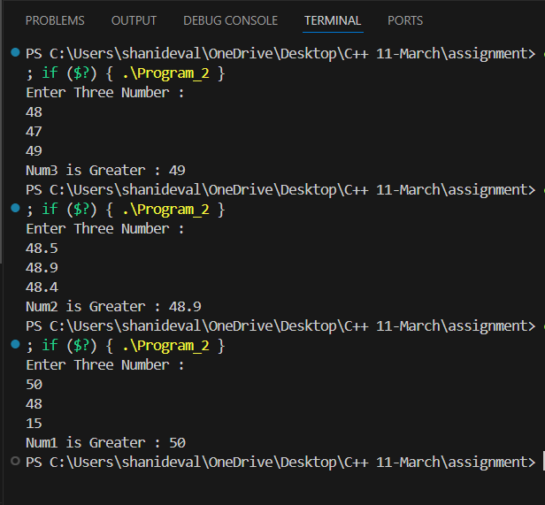

|  |
| --- |
| //Program_3.cpp  // 3. Write a program to check whether a number is negative, positive or zero.  #include <iostream>  using namespace std;  int main()  {      // data type and variable declaration      int number;      cout << "Enter  Number :" << endl; // Message display      cin >> number;                    //taking input from user      // condition for number is negative, positive or zero.      if (number > 0)      {          cout << "Number is Positive : " << number;      }      else if (number < 0)      {          cout << "Number is Negative : " << number;      }      else      {          cout << "Number is Zero : " << number;      }  } |

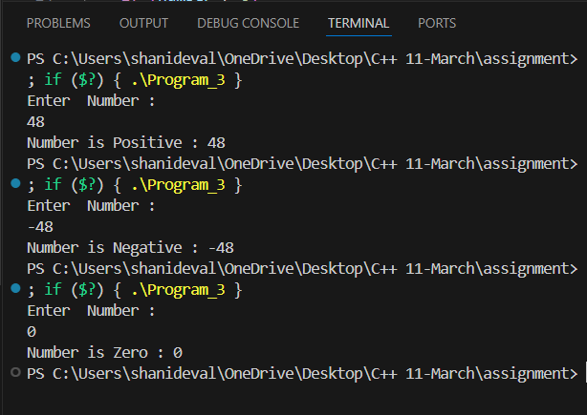

|  |
| --- |
| // Program_4.cpp  // 4. Write a program to check whether a number is divisible by 5 and 11 or not.  #include <iostream>  using namespace std;  int main()  {      // data type and variable declaration      int number;      cout << "Enter  Number :" << endl; // Message display      cin >> number;                    //taking input from user      // condition for number is divisible by 5 and 11 or not.      if (number % 5 == 0 && number % 11 == 0)      {          cout << "Number is divisible by 5 & 11 : " << number;      }      else      {          cout << "Number is not divisible by 5 & 11 : " << number;      }  } |

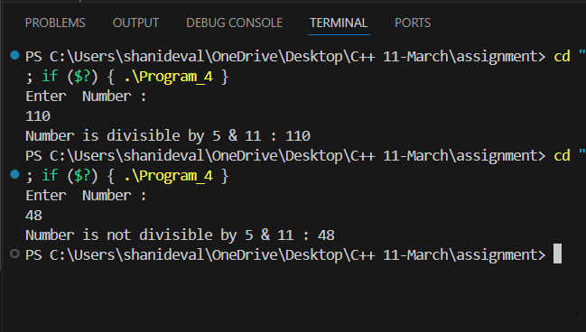

|  |
| --- |
| // Program_5.cpp  //5. Write a program to check whether a number is even or odd.  #include<iostream>  using namespace std;  int main(){      //data type declaration      int number;      cout<<"Enter  Number :"<<endl;    //message for display      cin>>number;         ///taking input from user      if (number%2==0)      //Condition for even and odd number      {          cout<<"Number is Even : "<<number;      }      else      {          cout<<"Number is Odd : "<<number;      }        } |

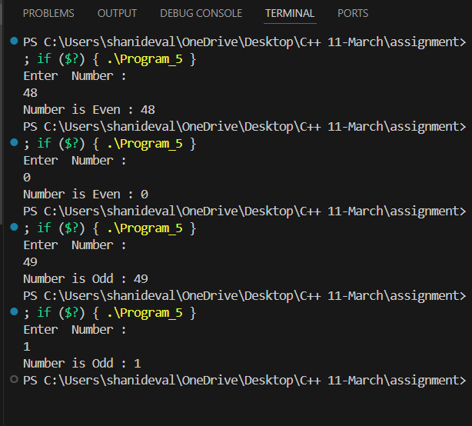

|  |
| --- |
| // Program_6.cpp  //6. Write a program to check whether a year is leap year or not.  #include<iostream>  using namespace std;  int main(){      // data type and variable declaration      int year;      cout<<"Enter  Year :"<<endl;    //message for display      cin>>year;         //taking input from user      if ((year%4==0 && year!=100)|| year%400==0)      //Condition for leap year      {          cout<<"Enter Year is  Leap Year : "<<year;      }      else      {          cout<<"Enter Year is Not Leap Year : "<<year;      }    } |

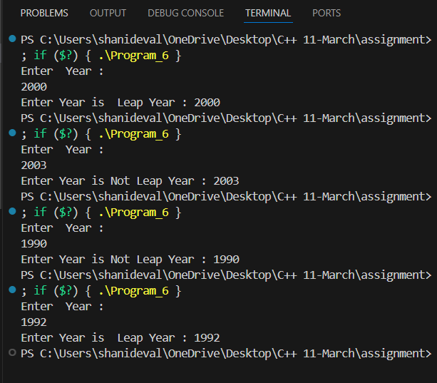

|  |
| --- |
| // Program_7.cpp  // 7. Write a program to check whether a character is alphabet or not.  #include <iostream>  using namespace std;  int main()  {      // data type and variable declaration      char character;      cout << "Enter  Any Character :" << endl; // message for display      cin >> character;                         //taking input from user      // condition for character is alphabet or not.      if (character >= 'a' && character <= 'z' || character >= 'A' && character <= 'Z')      {          cout << "It is Alphabet : " << character;      }      else      {          cout << "It is Not Alphabet : " << character;      }  } |

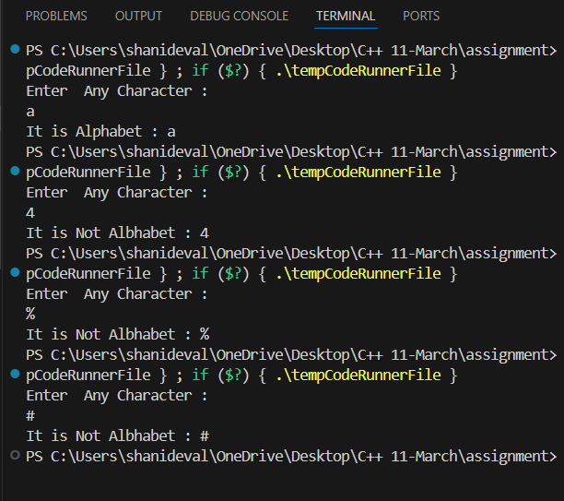

|  |
| --- |
| // Program_8.cpp  // 8. Write a program to input any alphabet and check whether it is vowel or consonant.  #include <iostream>  using namespace std;  int main()  {      // data type and variable declaration      char character;      cout << "Enter  Any Character :" << endl; // message for display      cin >> character;                         //taking input from user      // condition for input any alphabet and check whether it is vowel or consonant.      if (character == 'a' || character == 'A' || character == 'e' || character == 'E' || character == 'i' || character == 'I' || character == 'o' || character == 'O' || character == 'u' || character == 'U') // Condition for check alphabet or not      {          cout << "It is Vowel : " << character;      }      else      {          cout << "It is  Consonant : " << character;      }  } |

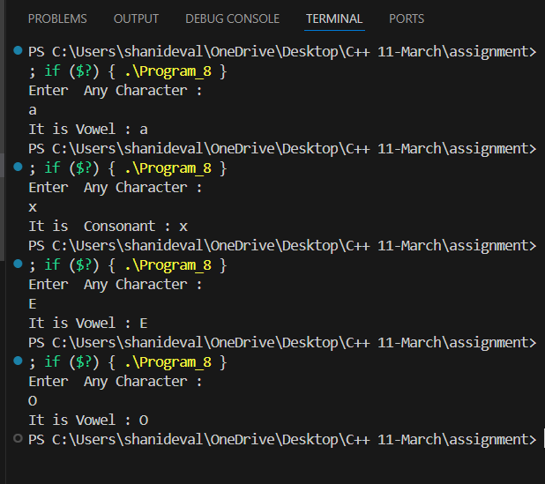

|  |
| --- |
| // Program_9.cpp  // 9. Write a  program to input any character and check whether it is alphabet, digit or special character.  #include <iostream>  using namespace std;  int main()  {     // data type and variable declaration      char character;      cout << "Enter  Any Character :" << endl; // message for display      cin >> character;                         //taking input from user      // condition for input any character and check whether it is alphabet, digit or special character.      if (character >= 'a' && character <= 'z' || character >= 'A' && character <= 'Z') // Condition for check alphabet or not      {          cout << "It is Alphabet : " << character;      }      else if (character == '$' || character == '*' || character == '{' || character == '}' || character == '(' || character == ')' || character == '#' || character == '~' || character == ';' || character == ':' || character == '.' || character == '[' || character == ']')      {          cout << "It is Special Character";      }      else if (character >= '0' || character <= '9')      {          cout << "It is Number : " << character;      }  } |

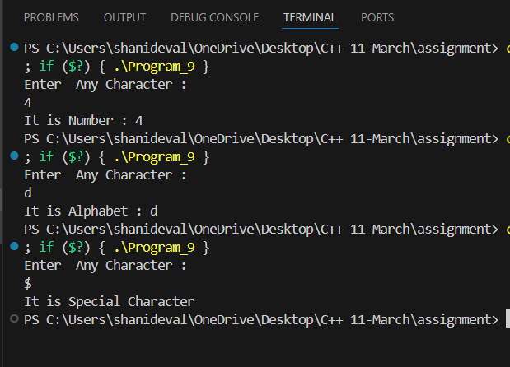

|  |
| --- |
| // Program_10.cpp  //10. Write a program to check whether a character is uppercase or lowercase alphabet.  #include <iostream>  using namespace std;  int main()  {      // data type declaration      char character;      cout << "Enter  Any Character :" << endl; // message for display      cin >> character;                         //taking input from user      if (character >= 'a' && character <= 'z') // Condition for check lowercase alphabet      {          cout << "It is Lowercase alphabet : " << character;      }        else if (character >= 'A' && character <= 'Z')   //// Condition for check uppercase  alphabet      {          cout << "It is Uppercase Alphabet : "<<character;      }      else{          cout<<"Please Enter Valid Input";      }    } |

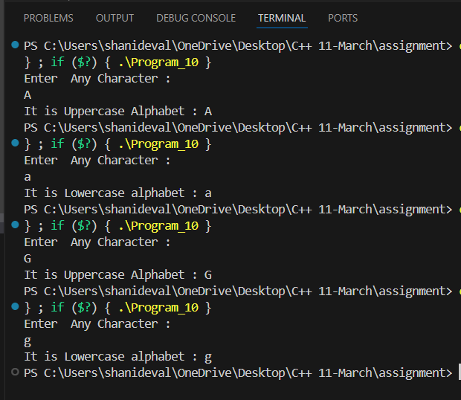

|  |
| --- |
| // Program_11.cpp  // 11. Write a program to input week number and print week day.  #include <iostream>  using namespace std;  int main()  {      int choice;      cout << "Enter Week Number : "; // // message for display      cin >> choice;                  // taking input from user      // case of choosing the Week number      switch (choice)      {      case 1:          cout << "Sunday";          break;      case 2:          cout << "Monday";          break;      case 3:          cout << "Tuesday";          break;      case 4:          cout << "Wednesday";          break;      case 5:          cout << "Thursday";          break;      case 6:          cout << "Friday";          break;      case 7:          cout << "Saturday";          break;      default:          cout << "Please Enter Week month number!";          break;      }  } |

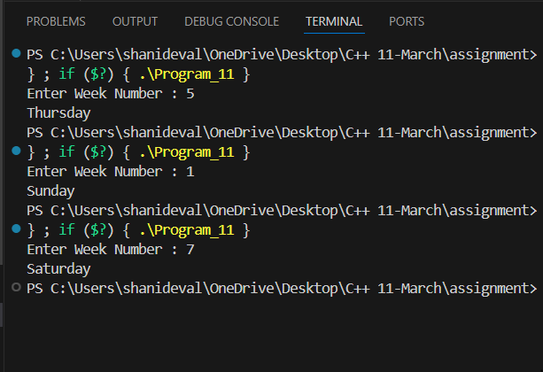

|  |
| --- |
| // Program_12.cpp  // 12. Write a program to input month number and print number of days in that month.  #include<iostream>  using namespace std;  int main(){      int choice;      cout<<"Enter Month Number : ";  // // message for display      cin>>choice;                 //taking input from user      //case of choosing the month number      switch (choice)      {      case 1:          cout<<"January 31 days";          break;      case 2:          cout<<"February 28 or 29 days";          break;      case 3:          cout<<"March 31 days";          break;      case 4:          cout<<"April 30 days";          break;      case 5:          cout<<"May 31 days";          break;      case 6:          cout<<"June 30 days";          break;      case 7:          cout<<"July 31 days";          break;      case 8:          cout<<"August 31 days";          break;      case 9:          cout<<"September 30 days";          break;      case 10:          cout<<"October 31 days";          break;      case 11:          cout<<"November 30 days";          break;      case 12:          cout<<"December 31 days";          break;          default:      cout << "Please Enter Valid month number!";          break;      }  } |

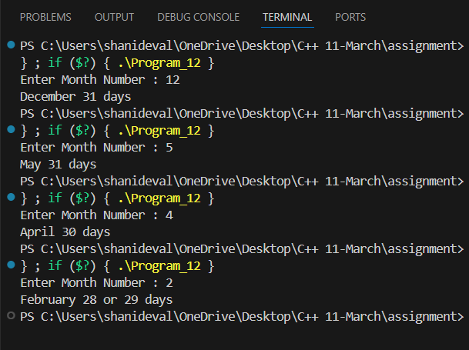

|  |
| --- |
| // Program_13.cpp  // 13. Write a program to count total number of notes in given amount.  #include <iostream>  using namespace std;  int main()  {     // data type and variable declaration      int amount, rm, number;      cout << "Enter  Amount :" << endl; // message for display      cin >> amount;                     // 1388                //taking input from user      number = amount / 100;  //number=13      cout << "Notes of 100 : " << number<<endl;      rm=amount-number*100;   //rm=88  ,rm=remain-number      number=rm/50;           //number=1      cout<<"Notes of 50 : "<<number<<endl;      rm=rm-number*50;        //rm=38      number=rm/20;           //number=1      cout<<"Notes of 20 : "<<number<<endl;      rm=rm-number*20;       //rm=18      number=rm/10;          //number=1      cout<<"Notes of 10 : "<<number<<endl;      rm=rm-number*10;       //rm=8      number=rm/5;          //number=1      cout<<"Notes of 5 : "<<number<<endl;      rm=rm-number*5;      //rm=3      number=rm/2;         //number=1      cout<<"Notes of 2 : "<<number<<endl;      rm=rm-number*2;      //rm=1      number=rm/1;         //number=1      cout<<"Notes of 1 : "<<number<<endl;  } |

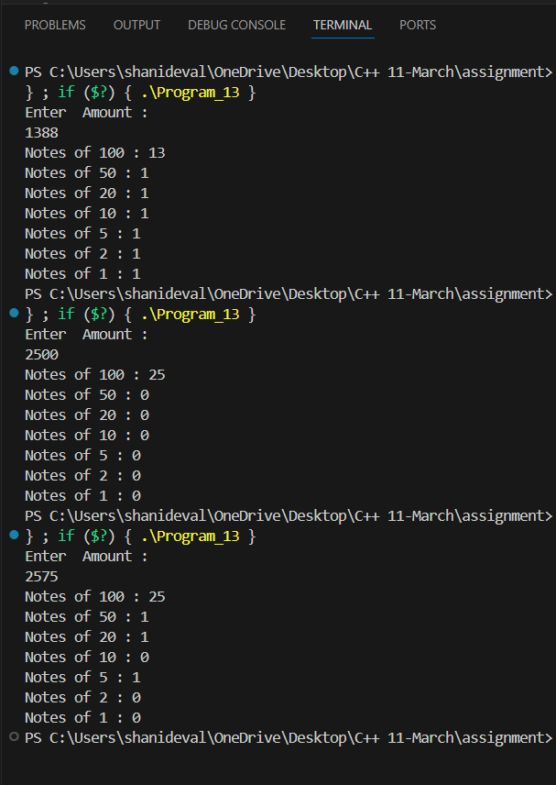

|  |
| --- |
| // Program_14.cpp  // 14. Write a program to input angles of a triangle and check whether triangle is valid or not.  #include <iostream>  using namespace std;  int main()  {      // data type and variable declaration      int a, b, c;      // Input angles of the triangle      cout << "Enter Angles of Triangle : " << endl;      cin >> a >> b >> c;      // condition for angle      if (a + b + c == 180 && a > 0 && b > 0 && c > 0)      {          cout << "Triangle is valid." << endl;      }      else      {          cout << "Triangle is not valid." << endl;      }      return 0;  } |

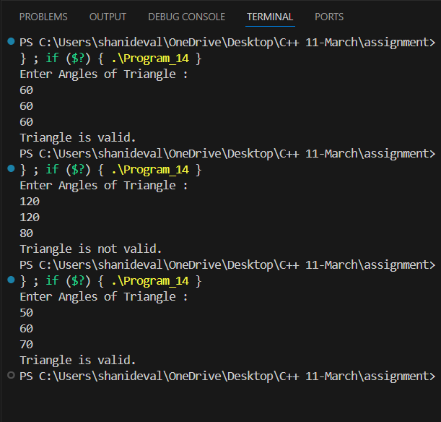

|  |
| --- |
| // Program_15.cpp  // 15. Write a program to input all sides of a triangle and check whether triangle is valid or not.  #include <iostream>  using namespace std;  int main()  {      // data type and variable declaration      int a, b, c;      cout << "Enter Angle of Triangle : " << endl; // message for display      cin >> a >> b >> c;                           // taking input from user      // condition for triangle      if (a + b > c && b + c > a && c + a > b )      {          cout << "It is a Valid triangle ";      }      else      {          cout << "It is not valid input for triangle";      }  } |

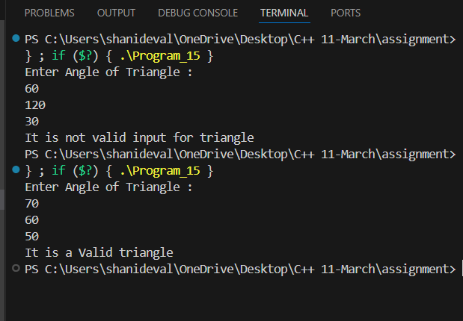

|  |
| --- |
| // Program_16.cpp  // 16. Write a program to check whether the triangle is equilateral, isosceles or scalene triangle.  #include <iostream>  using namespace std;  int main()  {      // data type declaration      int a, b, c;      cout << "Enter Angle of Triangle : " << endl; // message for display      cin >> a >> b >> c;                           // taking input from user      if (a == b && b == c && c==a) // condition for equilateral triangle      {          cout << "It is a equilateral triangle : ";      }      else if ((a == b || a == c || b == c) ) // condition for isosceles triangle      {          cout << "It is a isosceles triangle : ";      }      else             // other these are  scalene triangle      {          cout << "It is a scalene triangle : ";      }    } |

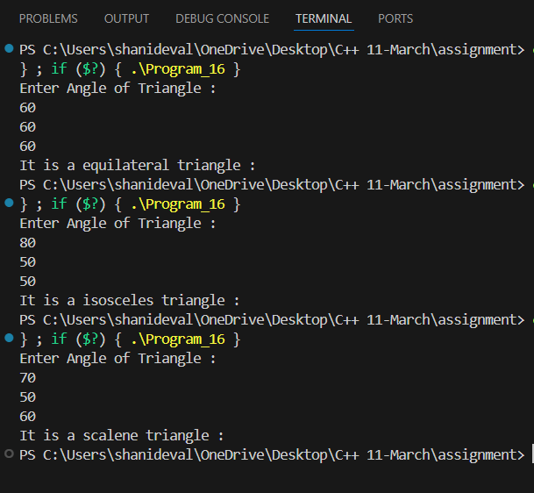

|  |
| --- |
| // Program_17.cpp  // 17. Write a program to calculate profit or loss.  #include <iostream>  using namespace std;  int main()  {      float Selling_Price, Original_Cost, Profit_Or_Loss, q; // q is product quantity      cout << "Enter Per Peace Original Price : " << endl;   // message for display      cin >> Original_Cost;                                  // taking input from user      cout << "Enter Per Peace Selling Price : " << endl;    // message for display      cin >> Selling_Price;      cout << "Enter Product Quantity : " << endl; // message for display      cin >> q;      float t_sel = q * Selling_Price;      float t_Original_Cost = q * Original_Cost;      // Profit and loss calculation      Profit_Or_Loss = t_sel - t_Original_Cost;      if (Profit_Or_Loss > 0)      {          cout << "Your Profit Here :" << Profit_Or_Loss;      }      else if (Profit_Or_Loss < 0)      {          cout << "Your Lose Here :" << Profit_Or_Loss;      }      else      {          cout << "Your Profit or Lose Zero ";      }  } |

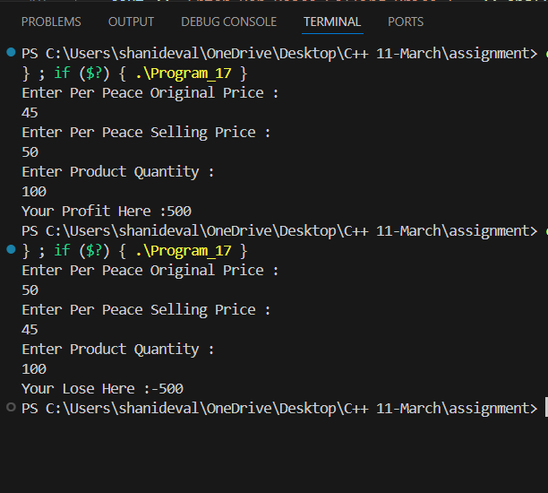

|  |
| --- |
| // Program_18.cpp  /* 18. Write a program to input marks of five subjects Physics, Chemistry, Biology, Mathematics and Computer. Calculate percentage and grade according to following:  Percentage >= 90% : Grade A  Percentage >= 80% : Grade B  Percentage >= 70% : Grade C  Percentage >= 60% : Grade D  Percentage >= 40% : Grade E  Percentage < 40% : Grade F  */  #include <iostream>  using namespace std;  int main()  {      // data type declaration      float p, c, b, m, com, per;      cout << "Enter 5 Subject Marks : " << endl; // message for display      cin >> p >> c >> b >> m >> com;             //taking input from user        per = (p + c + b + m + com) / 5; // Percentage calculated      // According to percentage  grade      if (per>100)      {          cout<<"Please Enter Valid Input for Grade";      }        else if (per >= 90)      {          cout << "Grade A";      }      else if (per >= 80)      {          cout << "Grade B";      }      else if (per >= 70)      {          cout << "Grade C";      }      else if (per >= 60)      {          cout << "Grade D";      }      else if (per >= 40)      {          cout << "Grade E";      }      else if (per < 40)      {          cout << "Fail";      }    } |

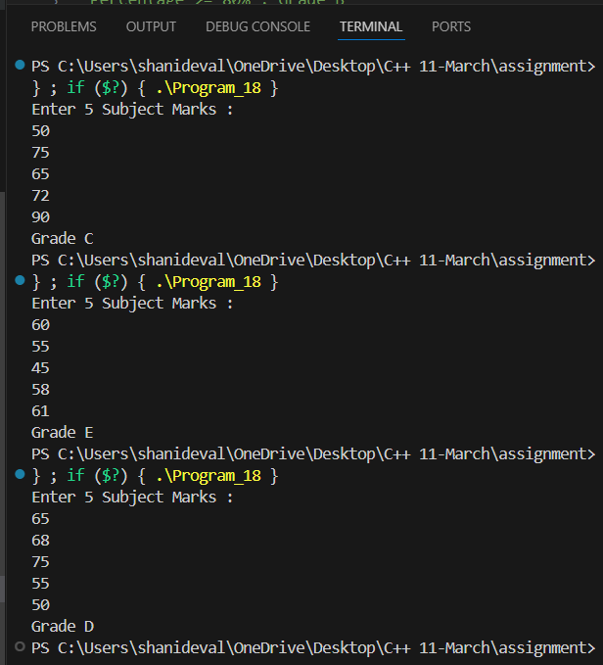

|  |
| --- |
| // program_19.cpp  /* 19. Write a  program to input basic salary of an employee and calculate its Gross salary according to following:  Basic Salary <= 10000 : HRA = 20%, DA = 80%  Basic Salary <= 20000 : HRA = 25%, DA = 90%  Basic Salary > 20000 : HRA = 30%, DA = 95%  */  #include <iostream>  using namespace std;  int main()  {      // data type declaration      float B_salary, hra, da, G_salary;      cout << "Enter  Basic Salary of an Employee: " << endl; // message for display      cin >> B_salary;                                        //taking input from user      // Calculated   according to basic salary      if (B_salary <= 10000)      {          hra = (20.0 / 100) * 10000;          da = (80.0 / 100) * 10000;          // Calculate gross salary          G_salary = B_salary + hra + da;          // Expected output          cout << "Gross Salary: " << G_salary << endl;      }      else if (B_salary <= 20000)      {          hra = (25.0 / 100) * 20000;          da = (90.0 / 100) * 20000;          // Calculate gross salary          G_salary = B_salary + hra + da;          // Expected output          cout << "Gross Salary: " << G_salary << endl;      }      else if (B_salary > 20000)      {          hra = (30.0 / 100) * 20000;          da = (95.0 / 100) * 20000;          // Calculate gross salary          G_salary = B_salary + hra + da;          // Expected output          cout << "Gross Salary: " << G_salary << endl;      }    // this code is can reduce line of code      /*if (B_salary<=10000)       {           hra=(20.0/100)*10000;           da=(80.0/100)*10000;       }       else if (B_salary<=20000)       {           hra=(25.0/100)*20000;           da=(90.0/100)*20000;       }       else if (B_salary>20000)       {           hra=(30.0/100)*20000;           da=(95.0/100)*20000;       }  // Calculate gross salary          G_salary = B_salary + hra + da;          // Expected output          cout << "Gross Salary: " << G_salary << endl;       */  } |

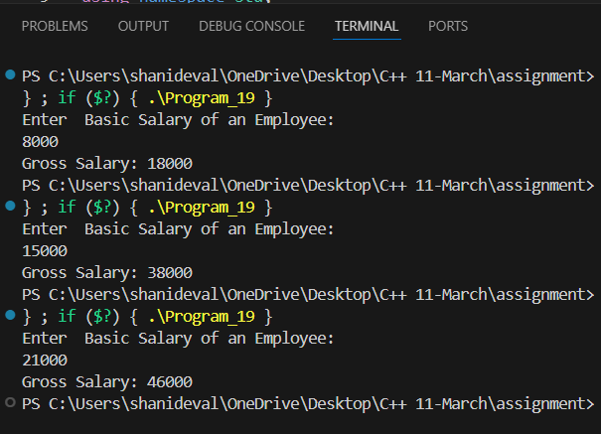

|  |
| --- |
| // Program_20.cpp  /* 20. Write a  program to input electricity unit charges and calculate total electricity bill according to the given condition:  For first 50 units Rs. 0.50/unit  For next 100 units Rs. 0.75/unit  For next 100 units Rs. 1.20/unit  For unit above 250 Rs. 1.50/unit  An additional surcharge of 20% is added to the bill  */  #include <iostream>  using namespace std;  int main()  {      // data type declaration      float unit, unit_price, sur_charge;      cout << "Enter Electricity Unit : " << endl; // message for display      cin >> unit;                                 // taking input from user      // according to unit to excite the condition      if (unit < 0)      {          cout << "Please Enter Valid Input";      }      // Calculated price according to unit + additional charge      else if (unit > 0 && unit < 50)      {          unit_price = unit * .50;          sur_charge = unit_price + (20.0 / 100);          cout << "Total Electricity Bill After Additional Surcharge : " << sur_charge;      }      else if (unit >= 50 && unit < 150)      {          unit_price = unit * .75;          sur_charge = unit_price + (20.0 / 100);          cout << "Total Electricity Bill After Additional Surcharge : " << unit_price;      }      else if (unit >= 150 && unit < 250)      {          unit_price = unit * 1.20;          sur_charge = unit_price + (20.0 / 100);          cout << "Total Electricity Bill After Additional Surcharge : " << unit_price;      }      else if (unit >= 250)      {          unit_price = unit * 1.50;          sur_charge = unit_price + (20.0 / 100);          cout << "Total Electricity Bill After Additional Surcharge: " << unit_price;      }      // this code is can reduce line of code      /* if (unit > 0 && unit <= 50)        {            unit_price = unit * .50;            sur_charge=unit_price+(20.0/100);        }        else if (unit > 50 && unit <= 150)        {            unit_price = unit * .75;            sur_charge=unit_price+(20.0/100);        }        else if (unit > 150 && unit <= 250)        {            unit_price = unit * 1.20;            sur_charge=unit_price+(20.0/100);        }        else if (unit >= 250)        {            unit_price = unit * 1.50;            sur_charge=unit_price+(20.0/100);        }            // Expected output        cout << "Total Electricity Bill After Additional Surcharge : " << sur_charge;        */  } |

