**Q1. Write a Java program to print 'Hello' on screen and your name on a separate line.**

**Expected Output :**

**Hello**

**Ram Lovewanshi**

//Task_1.java

|  |
| --- |
| class Task_1{  public static void main(String args[]){  //expected output  System.out.println("Hello");  System.out.println("Ram Lovewanshi");  }  } |

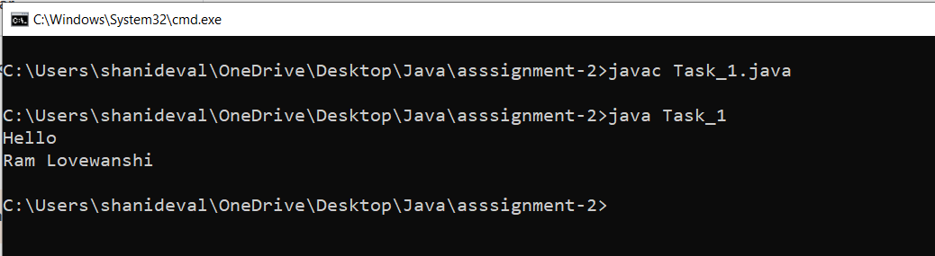

**Q2. Write a Java program to print the sum of two numbers.**

**Test Data:**

**74 + 36**

**Expected Output :**

**110**

//Task_2.java

|  |
| --- |
| import java.util.Scanner;  class Task_2{  public static void main(String args[]){  //data type declaration  int num1=74,num2=36;    System.out.println(num1+ " + " +num2);  System.out.println(num1+num2);  }  } |

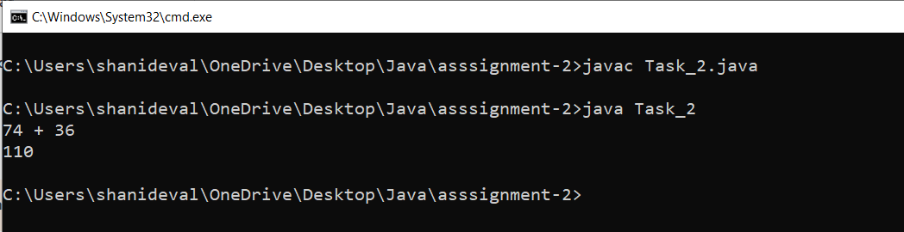

**Q3. Write a Java program to divide two numbers and print them on the screen.**

**Test Data :**

**50/3**

**Expected Output :**

**16**

//Task_3.java

|  |
| --- |
| import java.util.Scanner;  class Task_3{  public static void main(String args[]){  //data type declaration  int a=50,b=3;    System.out.println(a+"/"+b);  System.out.println(a/b);    }  } |

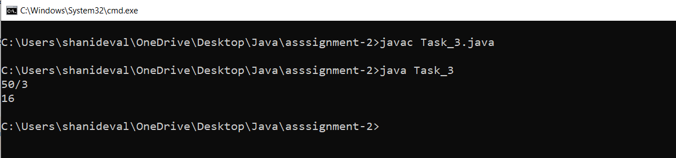

**Q4. Write a Java program to print the results of the following operations.**

**Test Data:**

**a. -5 + 8 * 6**

**b. (55+9) % 9**

**c. 20 + -3*5 / 8**

**d. 5 + 15 / 3 * 2 - 8 % 3**

**Expected Output :**

**43**

**1**

**19**

**13**

//Task_4.java

|  |
| --- |
| import java.util.Scanner;  class Task_4{  public static void main(String args[]){  //data type declaration  int a,b,c,d;  a=-5+8*6;  System.out.println( "a. -5 + 8 * 6");  b=(55+9) % 9;  System.out.println( "b. (55+9) % 9");  c=20 + -3*5 / 8;  System.out.println( "c. 20 + -3*5 / 8");  d=5 + 15 / 3 * 2 - 8 % 3;  System.out.println( "d. 5 + 15 / 3 * 2 - 8 % 3");    System.out.println( );  System.out.println( a);  System.out.println(b);  System.out.println( c);  System.out.println( d);    }  } |

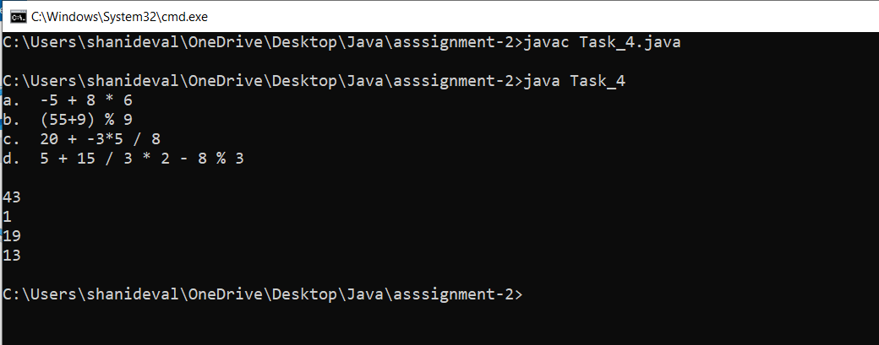

**Q5. Write a Java program that takes two numbers as input and displays the product of two**

**numbers.**

**Test Data:**

**Input first number: 25**

**Input second number: 5**

**Expected Output :**

**25 x 5 = 125**

//Task_5.java

|  |
| --- |
| import java.util.Scanner;  class Task_5{  public static void main (String args[]){    // data type decleration  int a,b;  Scanner obj=new Scanner(System.in); //message for display  System.out.print(" Input first number : ");  a=obj.nextInt(); //25 //taking input from user  System.out.print(" Input second number : "); //message for display  b=obj.nextInt(); //5 //taking input from user  //expected output  System.out.println(a +" x "+b+ " = "+a*b); //25 x 5 =125  }  } |

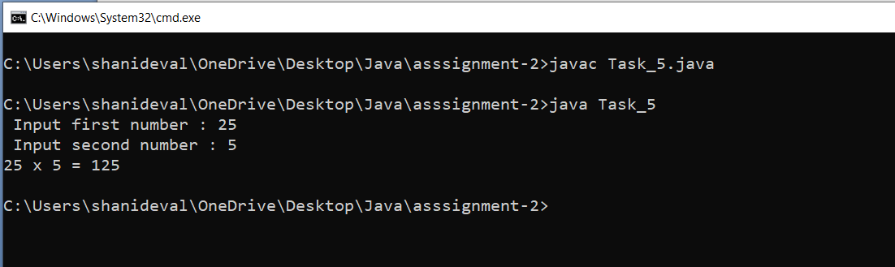

**Q6. Write a Java program to print the sum (addition), multiply, subtract, divide and**

**remainder of two numbers.**

**Test Data:**

**Input first number: 125**

**Input second number: 24**

**Expected Output :**

**125 + 24 = 149**

**125 - 24 = 101**

**125 x 24 = 3000**

**125 / 24 = 5**

**125 mod 24 = 5**

//Task_6.java

|  |
| --- |
| import java.util.Scanner;  class Task_6{  public static void main(String args[]){  //data type declaration  int a,b;  Scanner obj=new Scanner(System.in);  System.out.print("Input first number : "); //message for display  a=obj.nextInt(); //125 //taking input from user  System.out.print("Input second number : "); //message for display  b=obj.nextInt(); //24 //taking input from user    //expected output  System.out.println(a+" + "+b +" = "+(a+b));  System.out.println(a+" - "+b +" = "+(a-b));  System.out.println(a+" X "+b +" = "+(a*b));  System.out.println(a+" / "+b +" = "+(a/b));  System.out.println(a+" mod "+b+ " = "+(a%b));  }  } |

