Q1. Write a java program to implement stack using array?

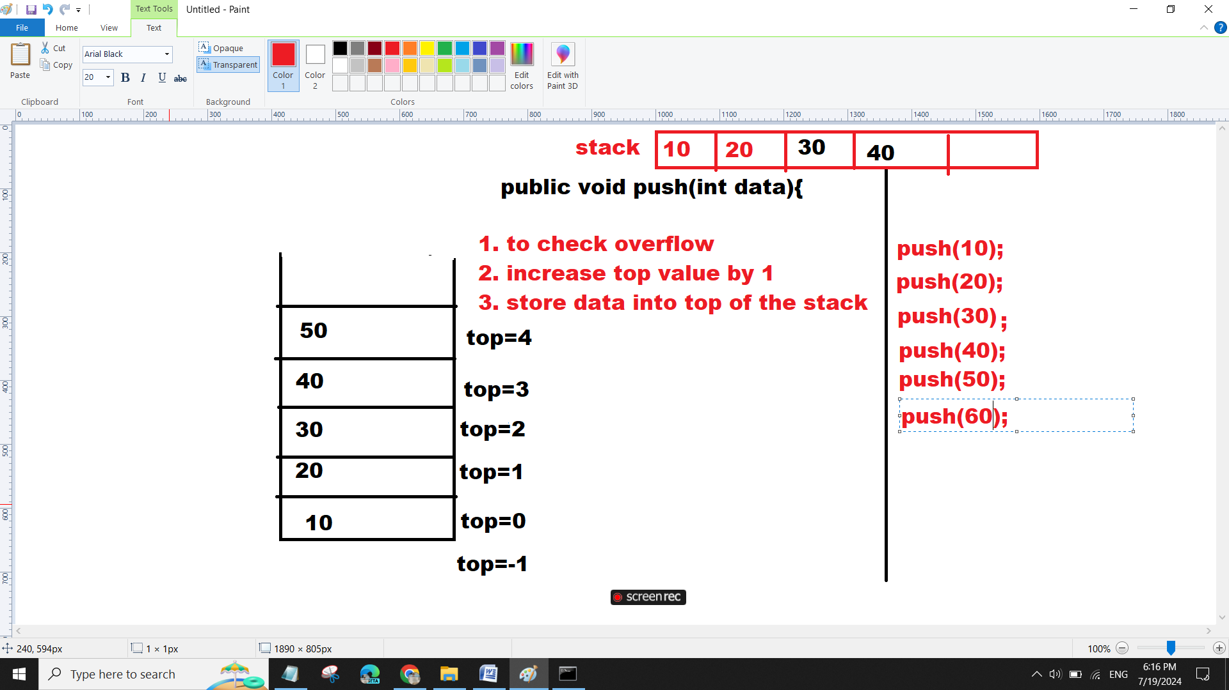

class StackDemo{

int stack[]=new int[5];

int top=-1;

public void push(int data){

if(top==stack.length-1){

System.out.println("over flow condition");

}else{

top++;

stack[top]=data;

}

}

public void display(){

if(top==-1){

System.out.println("stack is empty");

}

else{

System.out.println("Stack Elements Are");

for(int i=top;i>=0;i--){

System.out.println("===>"+stack[i]);

}

}

}

public static void main(String args[]){

StackDemo st=new StackDemo();

st.push(10);

st.push(20);

st.push(30);

st.push(40);

st.push(50);

st.push(60);

st.display();

}

}

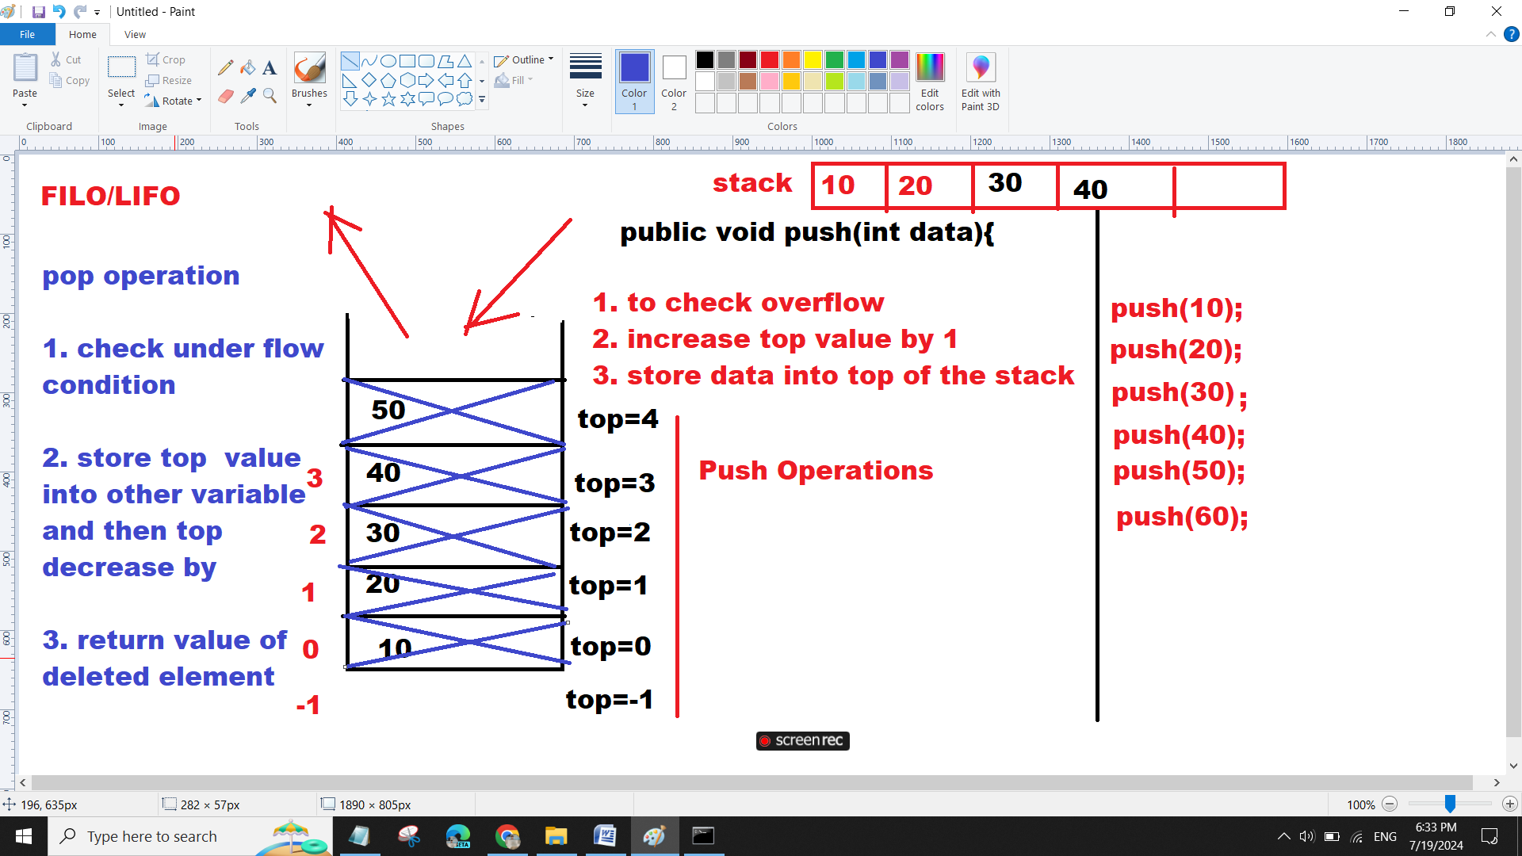

Stack program with all operations



class StackDemo{

int stack[]=new int[5];

int top=-1;

public void push(int data){

if(top==stack.length-1){

System.out.println("over flow condition");

}else{

top++;

stack[top]=data;

}

}

public int peek(){

int r=-1;

if(top==-1){

System.out.println("Stack is Empty");

}

else{

r=stack[top];

}

return r;

}

public void display(){

if(top==-1){

System.out.println("stack is empty");

}

else{

System.out.println("Stack Elements Are");

for(int i=top;i>=0;i--){

System.out.println("===>"+stack[i]);

}

}

}

public int pop(){

int r=-1;

if(top==-1){

System.out.println("Under Flow");

}

else{

r=stack[top];

top--;

}

return r;

}

public boolean isEmpty(){

return top==-1? true : false;

}

public boolean isFull(){

return top==stack.length-1? true : false;

}

public static void main(String args[]){

StackDemo st=new StackDemo();

st.push(10);

st.push(20);

st.push(30);

st.push(40);

st.push(50);

System.out.println("Stack is Full : "+st.isFull());

st.push(60);

st.display();

System.out.println("Deleted Element : "+st.pop());

System.out.println("Deleted Element : "+st.pop());

System.out.println("Deleted Element : "+st.pop());

System.out.println("Top Element : "+st.peek());

System.out.println("Deleted Element : "+st.pop());

System.out.println("Deleted Element : "+st.pop());

System.out.println("Deleted Element : "+st.pop());

System.out.println("Stack is Empty : "+st.isEmpty());

}

}