Q1. How to create a user defined Exception in java programming?

Ans: The process of creating a user defined exception

Involves creating a new class that extends Throwable / Exception

Syntax:

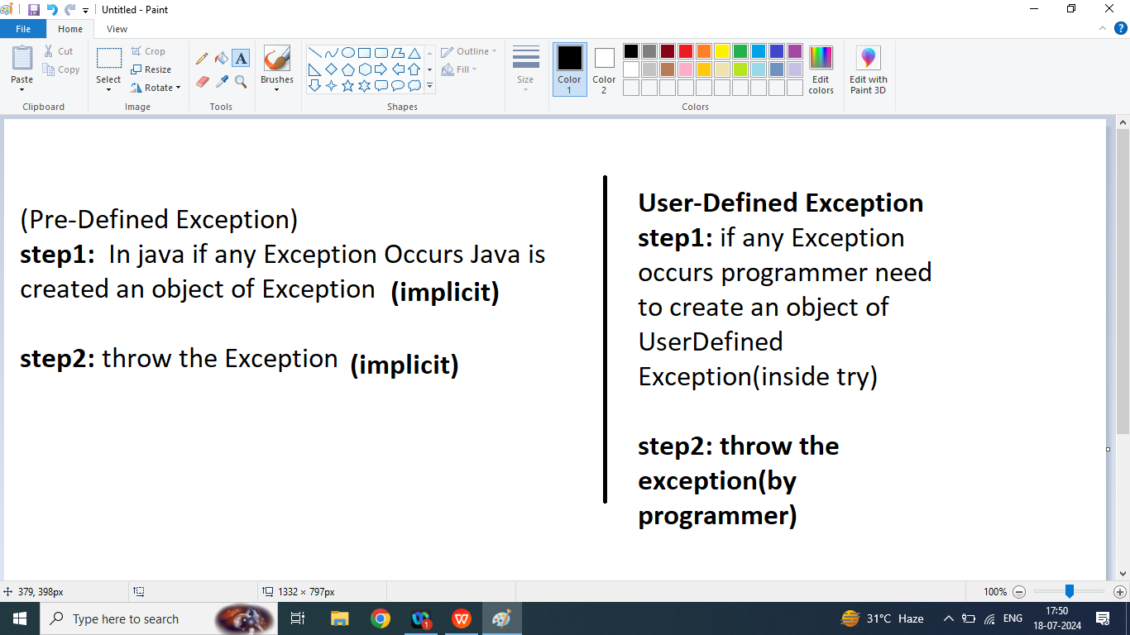

Q1. Write a java program to read age of emloyee from the command line argument and check given age is valid or not using user defined Exception Handling

class AgeException extends Throwable{

String msg;

public AgeException(String msg){

this.msg=msg;

}

public String getMsg(){

return msg;

}

}

class E3{

public static void main(String args[]){

int a=-1;

try{

a=Integer.parseInt(args[0]);

if(a<0 || a>100){

AgeException ae=new AgeException("Invalid Age");

throw ae;

}

System.out.println("Valid Age");

}catch(AgeException x){

System.out.println(x.getMsg());

}

}

}

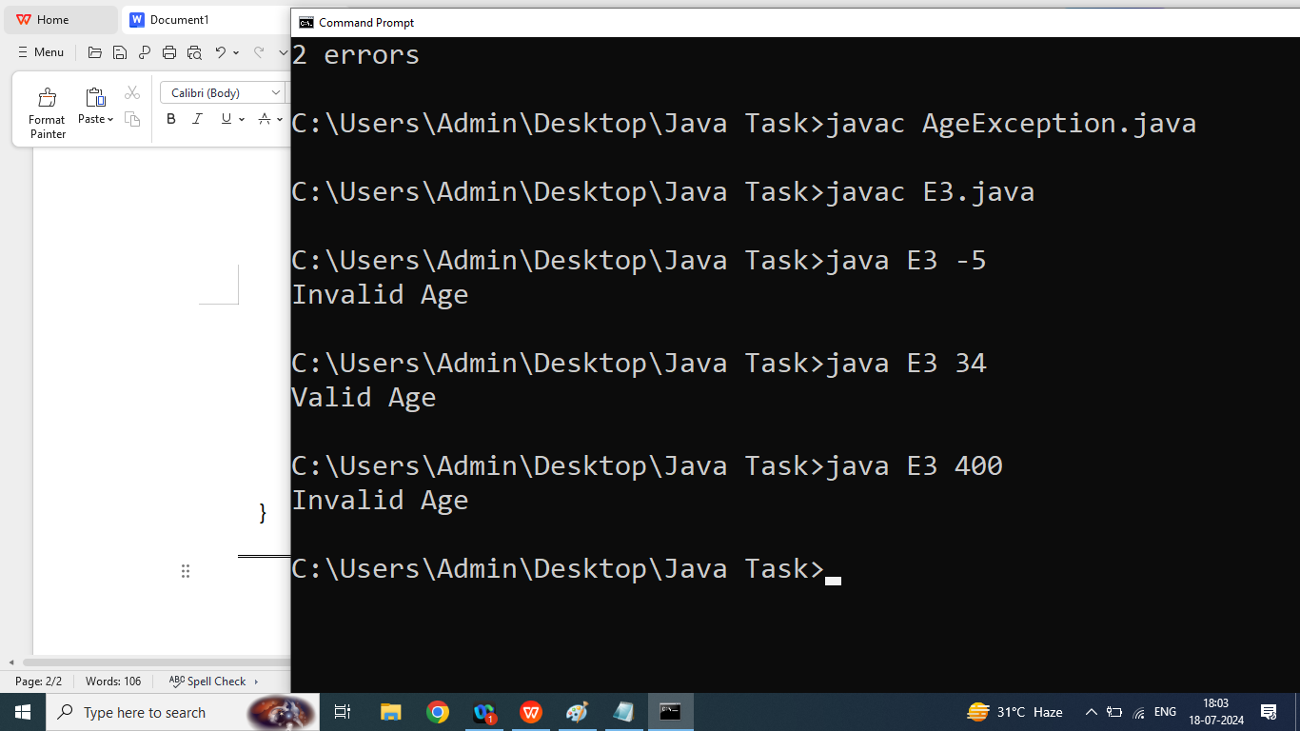

Q2. Types of Exception in java?

1. Pre-Defined
2. User-Defined
3. Checked Exception(Example: SQLException, FileNotFoundException)
4. Un Checked Exception(Example ArithmaticException,NumberFormatException,ArrayIndexOutOfBoundsException)

Q1. Explain Linear Data Structure in java programming?

DBMS: DBMS Deals with Data Storage

DS: Data Structure Deals With How to store and retrieve efficient manner

Linear Data Structure: if we want store data in a particular sequence then we should go for Linear data structure

We discuss following Linear Data Structure

1. Array
2. Stack(FILO/LIFO)
3. QUEUE(FIFO)
4. Linked List

