Q1. Explain Linked List Data Structure?

Ans: A Linked List is a data structure that store a sequence of elements. Each elements of the Linked List Is Node and Node Contains two parts Data and Next.

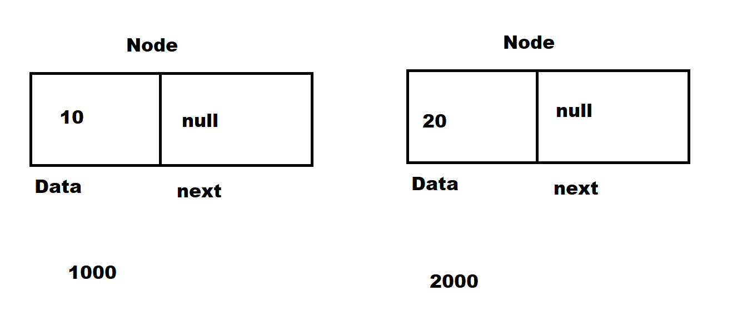

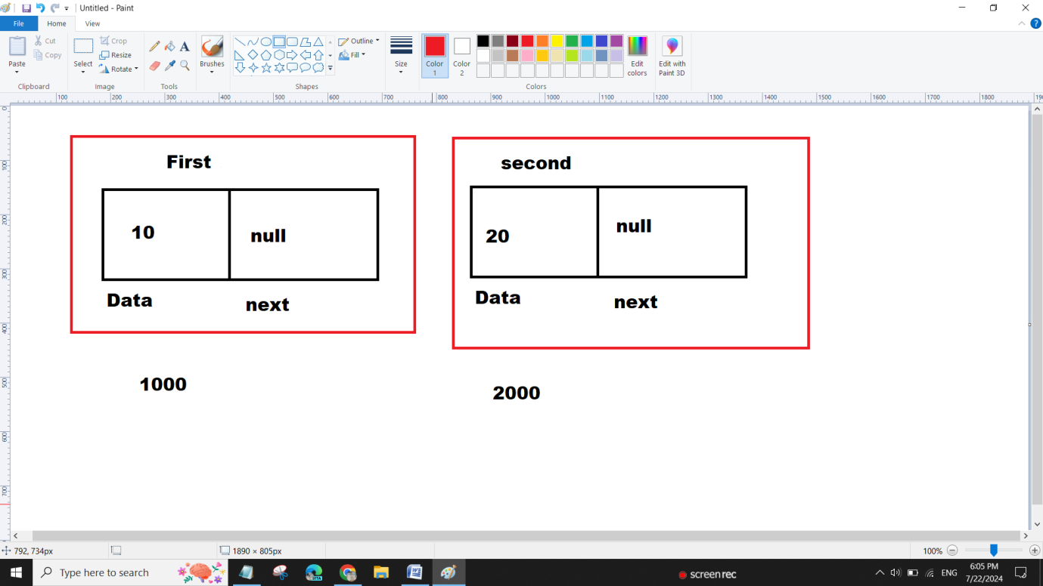

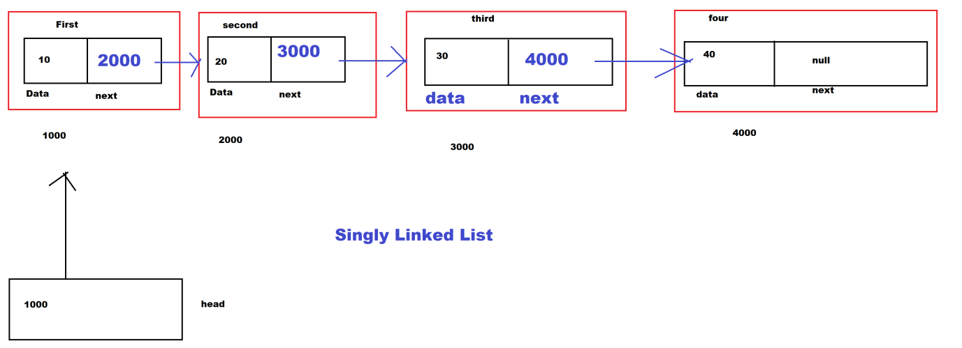

10==🡺20==🡺30==🡺40

class Node{

int data;

Node next;

//Member data

public Node(int data){

this.data=data;

this.next=null;

}

public static void main(String args[]){

Node first=new Node(10);

Node second=new Node(20);

Node third=new Node(30);

Node four=new Node(40);

Node head=first;

head.next=second;

head.next.next=third;

head.next.next.next=four;

System.out.println("Print Data of Singly Linked List : ");

System.out.print("==>"+head.data);

System.out.print("==>"+head.next.data);

System.out.print("==>"+head.next.next.data);

System.out.print("==>"+head.next.next.next.data);

}

}

Q2. Write a java program to print data of Singly Linked List Using methods?

class Node{

int data;

Node next;

//Member data

public Node(int data){

this.data=data;

this.next=null;

}

public void printData(Node head){

if(head==null){

System.out.println("List is Empty");

}else{

Node temp=head;

while(temp!=null){

System.out.print("==>"+temp.data);

temp=temp.next;

}

}

}

public static void main(String args[]){

Node first=new Node(10);

Node second=new Node(20);

Node third=new Node(30);

Node four=new Node(40);

Node head=first;

head.next=second;

head.next.next=third;

head.next.next.next=four;

System.out.println("Print Data of Singly Linked List : ");

head.printData(head);

}

}