1. What is JavaScript?
A high-level, interpreted programming language called JavaScript makes it possible to create interactive web pages and online apps with dynamic functionality. Commonly referred to as the universal language, Javascript is primarily used by developers for front-end and back-end work.

2. What are the different data types in JavaScript?
JavaScript has six primitive data types:
- Number
- String
- Boolean
- Null
- Undefined
- Symbol
It also has two compound data types:
- Object
- Array

3. What is hoisting in JavaScript?
Hoisting is a JavaScript concept that refers to the process of moving declarations to the top of their scope. This means that variables and functions can be used before they are declared, as long as they are declared before they are used in a function.
For example, the following code will print "Hello, world!" even though the greeting variable is not declared until after the console.log() statement.
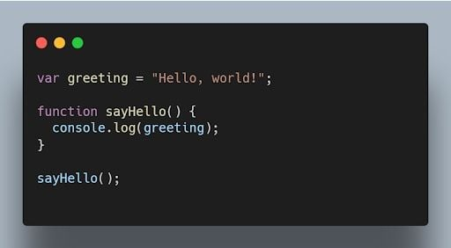
JavaScript code printing "Hello World" using hoisting.

4. What is the difference between null and undefined?
null is an assignment value that represents no value or an empty value, while undefined is a variable that has been declared but not assigned a value.
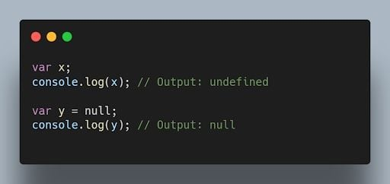JavaScript code outputting null and undefined values. | Image: Akshay Kumar

5. Why do we use the word “debugger” in JavaScript?
The word “debugger” is used in JavaScript to refer to a tool that can be used to step through JavaScript code line by line. This can be helpful for debugging JavaScript code, which is the process of finding and fixing errors in JavaScript code. To use the debugger, you need to open the JavaScript console in your browser. Then, you can use debugger commands to comb through your code line by line.
It's essential to know debugging techniques as well as the more general ideas behind code optimization and speed improvement. In addition to operating smoothly, efficient code significantly enhances the user experience.
For example, the following code will print the value of the x variable at each step of the debugger.
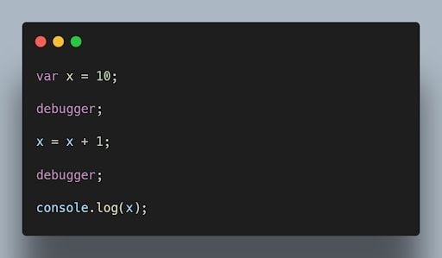JavaScript debugger code printing the value of x at each step. | Image: Akshay Kumar

6. What is the purpose of the “this” keyword in JavaScript?
The this keyword refers to the object that is executing the current function or method. It allows access to object properties and methods within the context of that object.
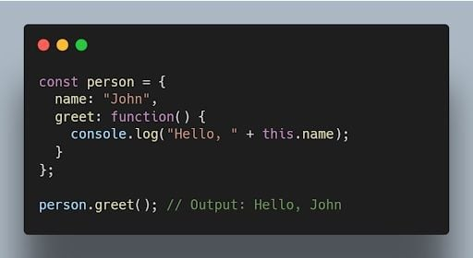JavaScript code using the this keyword to output person name. | Image: Akshay Kumar

7. What is the difference between == and === operators in JavaScript?
The equality == operator is a comparison operator that compares two values and returns true if they are equal. The strict equality === operator is also a comparison operator, but it compares two values and returns true only if they are equal and of the same type.
For example, the following code will return true, because the values of the x and y variables are equal.
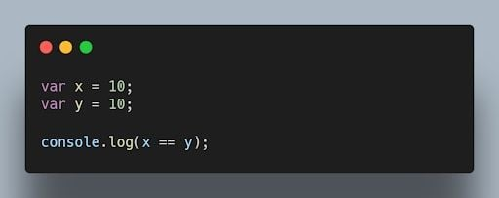JavaScript equality operator code comparing x and y variables. | Image: Akshay Kumar

8. What is the difference between “var” and “let” keywords in JavaScript?
The var and let keywords are both used to declare variables in JavaScript. However, there are some key differences between the two keywords.
The var keyword declares a global variable, which means that the variable can be accessed from anywhere in the code. The let keyword declares a local variable, which means that the variable can only be accessed within the block of code where it is declared.
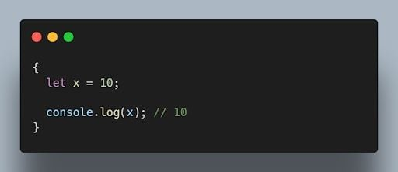JavaScript let keyword example. | Image: Akshay Kumar

9. What are closures in JavaScript?
Closures (closureFn) are functions that have access to variables from an outer function even after the outer function has finished executing. They “remember” the environment in which they were created.
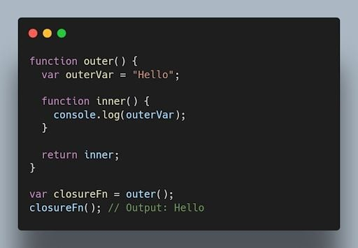JavaScript closure code. | Image: Akshay Kumar

10. What is event delegation in JavaScript?
Event delegation is a technique where you attach a single event listener to a parent element, and that event listener handles events occurring on its child elements. It helps optimize performance and reduce memory consumption.
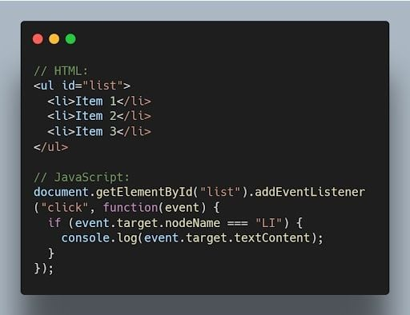JavaScript event delegation code example. | Image: Akshay Kumar

11. What is the difference between “let”, “const”, and “var”?
let and const were introduced in ES6 and have block scope. let is reassignable, and const is non-reassignable. var is function-scoped and can be redeclared and reassigned throughout the function.
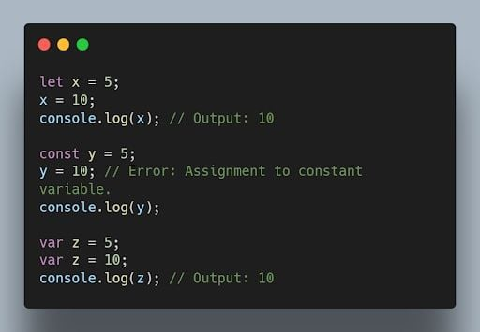JavaScript let, const and var keywords with outputs. | Image: Akshay Kumar

12. What is implicit type coercion in JavaScript?
Implicit type coercion is a JavaScript concept that refers to the automatic conversion of a value from one type to another. In JavaScript, this conversion follows a priority order that typically begins with strings, then numbers, and finally booleans. If you try to add a string to a number, JavaScript will implicitly coerce the number to a string before performing the addition operation because strings have the highest priority in type coercion.
For example, when you combine the number 5 with the string '10' using the addition operator, the result is the string '510'. This occurs because JavaScript will implicitly convert the number 5 to a string following the priority of coercion, and then concatenate it to the string '10'.
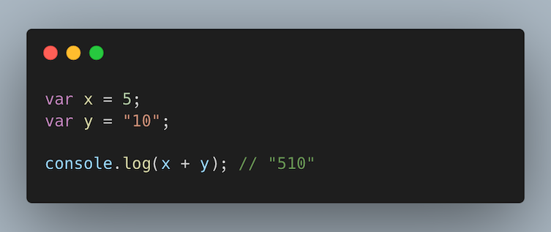Implicit type coercion code example in JavaScript adding x and y variables. | Image: Raymond Van Hoecke

13. Explain the concept of prototypes in JavaScript.
Prototypes are a mechanism used by JavaScript objects for inheritance. Every JavaScript object has a prototype, which provides properties and methods that can be accessed by that object.
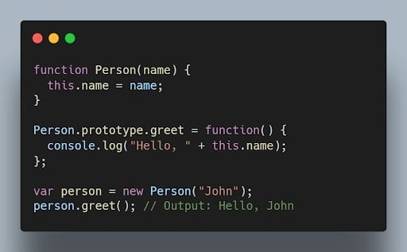JavaScript prototype code example. | Image: Akshay Kumar

14. What is the output of the following code?
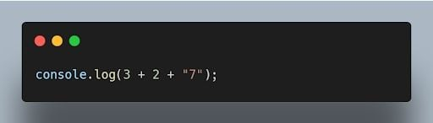JavaScript console.log code. | Image: Akshay Kumar
The output will be "57". The addition operation is performed from left to right, and when a string is encountered, it performs concatenation.

15. How can you clone an object in JavaScript?
There are multiple ways to clone an object in JavaScript. One common method is using the Object.assign() method or the spread operator (...).
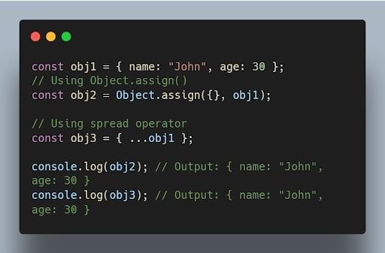JavaScript code for cloning an object using object.assign() and ... operators. | Image: Akshay Kumar
More on JavaScriptJavaScript Question Mark (?) Operator Explained

Intermediate Concepts

16. What are higher-order functions in JavaScript?
Higher order functions are functions that can accept other functions as arguments or return functions as their results. They enable powerful functional programming patterns in JavaScript.
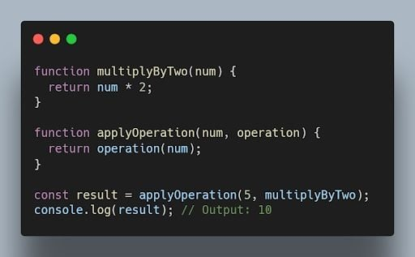JavaScript higher order functions code. | Image: Akshay Kumar

17. What is the purpose of the bind() method in JavaScript?
The bind() method is used to create a new function with a specified this value and an initial set of arguments. It allows you to set the context of a function permanently.
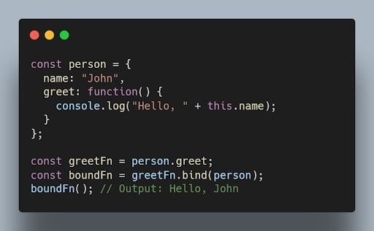JavaScript bound() method code example. | Image: Akshay Kumar

18. What is the difference between function declarations and function expressions?
Function declarations are defined using the function keyword, while function expressions are defined by assigning a function to a variable. Function declarations are hoisted, while function expressions are not.
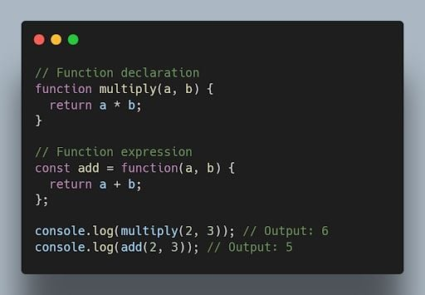JavaScript code showing differences between declaration and expression. | Image: Akshay Kumar

19. What are the different types of errors in JavaScript?
JavaScript can throw a variety of errors, including:
- Syntax errors: These errors occur when the JavaScript code is not syntactically correct.
- Runtime errors: These errors occur when the JavaScript code is executed and there is a problem.
- Logical errors: These errors occur when the JavaScript code does not do what it is supposed to do.

20. What is memoization in JavaScript?
Memoization is a technique that can be used to improve the performance of JavaScript code. Memoization works by storing the results of expensive calculations in a cache. This allows the JavaScript code to avoid re-performing the expensive calculations if the same input is provided again.
For example, the following code calculates the factorial of a number. The factorial of a number is the product of all the positive integers from one to the number.
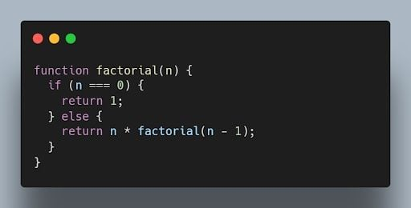JavaScript code to calculate the factorial of all positive integers from one to a number. | Image: Akshay Kumar
This code can be memoized as follows:
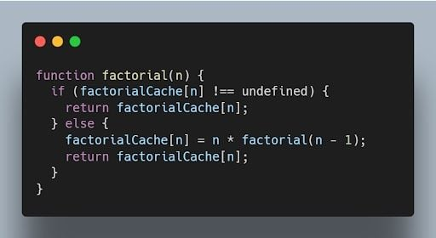Memoized code for JavaScript factorial. | Image: Akshay Kumar

21. What is recursion in JavaScript?
Recursion is a programming technique that allows a function to call itself. Recursion can be used to solve a variety of problems, such as finding the factorial of a number or calculating the Fibonacci sequence.
The following code shows how to use recursion to calculate the factorial of a number:
JavaScript recursion code to solve for factorial of a number. | Image: Akshay Kumar

22. What is the use of a constructor function in JavaScript?
A constructor function is a special type of function that is used to create objects. Constructor functions are used to define the properties and methods of an object.
The following code shows how to create a constructor function:
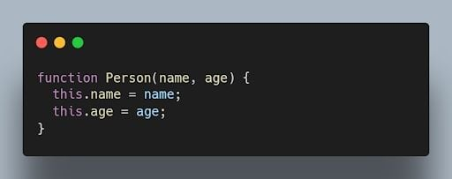Constructor function in JavaScript. | Image: Akshay Kumar

23. What is the difference between a function declaration and a function expression in JavaScript?
A function declaration is a statement that defines a function. A function expression is an expression that evaluates to a function.
The following code shows an example of a function declaration. This code defines a function named factorial. The factorial function calculates the factorial of a number.
JavaScript function declaration code for a factorial function. | Image: Akshay Kumar
The following code shows an example of a function expression:
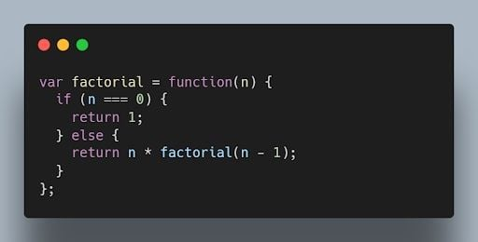JavaScript function expression for factorial code. | Image: Akshay Kumar

24. What is a callback function in JavaScript?
A callback function is a function passed as an argument to another function, which is then invoked inside the outer function. It allows asynchronous or event-driven programming.
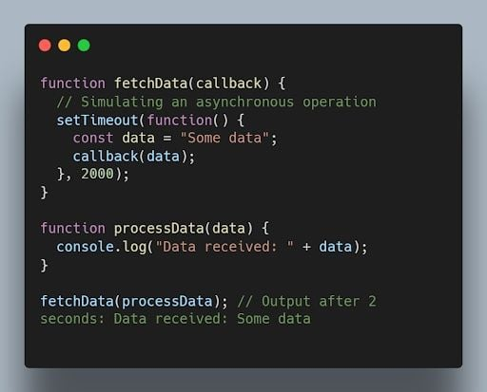JavaScript code for the callback function. | Image: Akshay Kumar

25. What are promises in JavaScript?
Promises are objects used for asynchronous operations. They represent the eventual completion or failure of an asynchronous operation and allow chaining and handling of success or error cases.
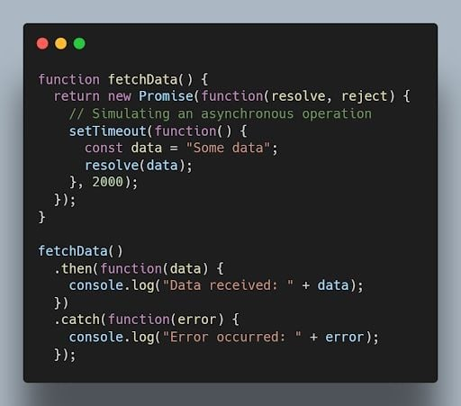JavaScript promises code example. | Image: Akshay Kumar

26. What is the difference between synchronous and asynchronous programming?
In synchronous programming, the program execution occurs sequentially, and each statement blocks the execution until it is completed. In asynchronous programming, multiple tasks can be executed concurrently, and the program doesn’t wait for a task to finish before moving to the next one.
Synchronous coding example:
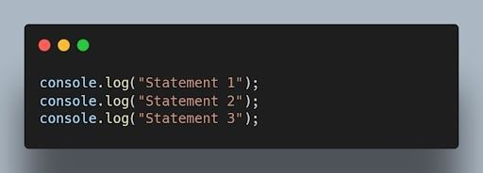JavaScript synchronous code example. | Image: Akshay Kumar
Asynchronous code example:
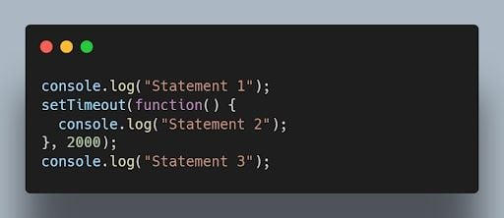Asynchronous JavaScript code example. | Image: Akshay Kumar

27. How do you handle errors in JavaScript?
Errors in JavaScript can be handled using try-catch blocks. The try block contains the code that may throw an error, and the catch block handles the error and provides an alternative execution path.
JavaScript try-catch blocks of code. | Image: Akshay Kumar

28. Explain the concept of event bubbling in JavaScript.
Event bubbling is the process where an event triggers on a nested element, and then the same event is propagated to its parent elements in the document object model (DOM) tree. It starts from the innermost element and goes up to the document root.
Example:
JavaScript code using event bubbling. | Image: Akshay Kumar
When you click on the child element, both the child and parent event handlers will be triggered, and the output will be:
JavaScript code output after clicking on the child element with event bubbling. | Image: Akshay Kumar

29. What are arrow functions in JavaScript?
Arrow functions are a concise syntax for writing JavaScript functions. They have a more compact syntax compared to traditional function expressions and inherit the this value from their surrounding scope.
For example:
JavaScript arrow functions code example. | Image: Akshay Kumar

30. What is the difference between querySelector and getElementById?
querySelector is a more versatile method that allows you to select elements using CSS-like selectors, while getElementById specifically selects an element with the specified ID.
JavaScript code comparing querySelector and getElementByID methods. | Image: Akshay Kumar

31. What is the purpose of the setTimeout() function in JavaScript?
The setTimeout() function is used to delay the execution of a function or the evaluation of an expression after a specified amount of time in milliseconds.
JavaScript setTimeout() function code. | Image: Akshay Kumar
Output after two seconds:
JavaScript setTimeout code output after two seconds. | Image: Akshay Kumar

32. What is event delegation and why is it useful?
Event delegation is a technique where you attach a single event listener to a parent element to handle events occurring on its child elements. It’s useful for dynamically created elements or when you have a large number of elements.
JavaScript event delegation code example. | Image: Akshay Kumar

33. How can you prevent the default behavior of an event in JavaScript?
You can use the preventDefault() method on the event object within an event handler to prevent the default behavior associated with that event.
JavaScript preventDefault() method code example. | Image: Akshay Kumar

34. What is the difference between localStorage and sessionStorage in JavaScript?
Both localStorage and sessionStorage are web storage objects in JavaScript, but they have different scopes and lifetimes.
- localStorage persists data even after the browser window is closed and is accessible across different browser tabs/windows of the same origin.
- sessionStorage stores data for a single browser session and is accessible only within the same tab or window.
JavaScript localStorage and sessionStorage code comparisons. | Image: Akshay Kumar

35. How can you convert a string to lowercase in JavaScript?
You can use the toLowerCase() method to convert a string to lowercase in JavaScript.
JavaScript toLowerCase() code example. | Image: Akshay Kumar

Advanced Concepts

36. What is the purpose of the map() function in JavaScript?
The map() function is used to iterate over an array and apply a transformation or computation on each element. It returns a new array with the results of the transformation.
JavaScript map() function code example. | Image: Akshay Kumar

37. What is the difference between splice() and slice()?
- splice() is used to modify an array by adding, removing, or replacing elements at a specific position.
- slice() is used to create a new array that contains a portion of an existing array, specified by the starting and ending indices.
Example of splice():
JavaScript splice() function code example. | Image: Akshay Kumar
Example of slice():
JavaScript slice() code example. | Image: Akshay Kumar

38. What is the purpose of the reduce() function in JavaScript?
The reduce() function is used to reduce an array to a single value by applying a function to each element and accumulating the result.
JavaScript reduce() function example. | Image: Akshay Kumar

39. How can you check if an array includes a certain value in JavaScript?
You can use the includes() method to check if an array includes a specific value. It returns true if the value is found, and false otherwise.
JavaScript includes() method code on an array. | Image: Akshay Kumar

40. What is the difference between prototype and instance properties in JavaScript?
A prototype property is a property that is defined on the prototype object of a constructor function. Instance properties are properties that are defined on individual objects that are created by a constructor function.
Prototype properties are shared by all objects that are created by a constructor function. Instance properties are not shared by other objects.

41. What is the difference between an array and an object in JavaScript?
An array is a data structure that can store a collection of values. An object is a data structure that can store a collection of properties.
Arrays are indexed by numbers. Objects are indexed by strings. Arrays can only store primitive data types and objects. Objects can store primitive data types, objects and arrays.
JavaScript differences between array and object code example. | Image: Akshay Kumar

42. How can you remove duplicates from an array in JavaScript?
One way to remove duplicates from an array is by using the Set object or by using the filter() method with the indexOf() method.
Example:
JavaScript code example removing duplicates using the filter() method. | Image: Akshay Kumar

43. What is the purpose of the fetch() function in JavaScript?
The fetch() function is used to make asynchronous HTTP requests in JavaScript. It returns a Promise that resolves to the response from the server.
Example:
JavaScript fetch() code function example. | Image: Akshay Kumar

44. What is a generator function in JavaScript?
A generator function is a special type of function that can be paused and resumed during its execution. It allows generating a sequence of values over time, using the yield keyword.
Example:
JavaScript generator function code example. | Image: Akshay Kumar

45. What are the different events in JavaScript?
There are many different events in JavaScript, but some of the most common events include:
- Click: The click event occurs when a user clicks on an HTML element.
- Mouseover: The mouseover event occurs when a user's mouse pointer moves over an HTML element.
- Keydown: The keydown event occurs when a user presses a key on the keyboard.
- Keyup: The keyup event occurs when a user releases a key on the keyboard.
- Change: The change event occurs when a user changes the value of an HTML input element.

46. What are the different ways to access an HTML element in JavaScript?
There are three main ways to access an HTML element in JavaScript:
- Using the getElementById() method: The getElementById() method takes a string as an argument and returns the HTML element with the specified ID.
- Using the getElementsByTagName() method: The getElementsByTagName() method takes a string as an argument and returns an array of all the HTML elements with the specified tag name.
- Using the querySelector() method: The querySelector() method takes a CSS selector as an argument and returns the first HTML element that matches the selector.

47. What is the scope of a variable in JavaScript?
The scope of a variable in JavaScript is the part of the code where the variable can be accessed. Variables declared with the var keyword have a local scope, which means that they can only be accessed within the block of code where they are declared. Variables declared with the let keyword have a block scope, which means that they can only be accessed within the block of code where they are declared and any nested blocks. Variables declared with the const keyword have a global scope, which means that they can be accessed from anywhere in the code.

48. What are the different ways to create objects in JavaScript?
There are multiple ways to create objects in JavaScript, including object literals, constructor functions, the Object.create() method and the class syntax introduced in ECMAScript 2015 (ES6).
Example using object literals:
JavaScript object literals code example. | Image: Akshay Kumar

49. What is the purpose of the window object in JavaScript?
The window object represents the browser window. The window object can be used to access the browser’s features, such as the location bar, the status bar and the bookmarks bar.

50. What is the purpose of the async and await keywords in JavaScript?
The async and await keywords are used for handling asynchronous operations in a more synchronous-like manner. The async keyword is used to define an asynchronous function, and the await keyword is used to pause the execution of an async function until a promise is fulfilled or rejected.
Example:
