AI-BASED NETWORK INTRUSION DETECTION SYSTEM WITH IOT THREAT MONITORING CAPABILITIES
R.D.S.N. Rajapaksha (ITBNM-2211-0174)
M.K.A.P. Priyankara (ITBNM-2211-0171)
K.Y.N.M. Priyantha (ITBNM-2211-0172)
Y.D. Mayadunne (ITBNM-2211-0155)
Degree of Bachelor of Information Technology (Hons) in Networking and Mobile Computing
Faculty of Information Technology
Horizon Campus
June 2025

AI-BASED NETWORK INTRUSION DETECTION SYSTEM WITH IOT THREAT MONITORING CAPABILITIES
R.D.S.N. Rajapaksha (ITBNM-2211-0174)
M.K.A.P. Priyankara (ITBNM-2211-0171)
K.Y.N.M. Priyantha (ITBNM-2211-0172)
Y.D. Mayadunne (ITBNM-2211-0155)
Thesis submitted in partial fulfillment of the requirements for the degree of Bachelor of Information Technology (Hons) in Networking and Mobile Computing
Faculty of Information Technology
Horizon Campus
June 2025

Declaration
We declare that this is our own work and this thesis/dissertation does not incorporate without acknowledgement any material previously submitted for a degree or diploma in any other University or Institute of higher learning and to the best of our knowledge and belief it does not contain any material previously published or written by another person except where the acknowledgement is made in the text. We retain the right to use this content in whole or part in future works (such as articles or books).
Candidate Name | Registration Number | Signature | Date
R.D.S.N. Rajapaksha | ITBNM-2211-0174 | ___________________ | 30/06/2025
M.K.A.P. Priyankara | ITBNM-2211-0171 | ___________________ | 30/06/2025
K.Y.N.M. Priyantha | ITBNM-2211-0172 | ___________________ | 30/06/2025
Y.D. Mayadunne | ITBNM-2211-0155 | ___________________ | 30/06/2025

Certification of the Supervisor
The supervisor certifies the thesis/dissertation with the following declaration:
The above candidates have carried out a research-based project for the thesis/dissertation under my supervision. I confirm that the declaration made above by the students is true and correct.
Name of the Supervisor: Kaushalya Ekanayake
Signature of the Supervisor: ___________________
Date: 30/06/2025

Dedication
To our parents, faculty mentors, and peers whose unyielding support, encouragement, and guidance made the completion of this research project possible.

Acknowledgements
We express our sincere gratitude to Horizon Campus, Faculty of Information Technology, for providing us with the academic environment, computational infrastructure, and resources necessary to execute this research project.
We extend our deep appreciation to our primary research supervisor, Ms. Kaushalya Ekanayake, for her invaluable guidance, continuous academic supervision, insightful constructive feedback, and steadfast support throughout every phase of this research—from initial conceptualization to final system implementation and evaluation.
We also express our appreciation to the academic staff and laboratory administrators of the Department of Networking and Mobile Computing for their technical assistance. Finally, we thank all survey respondents, including IT administrators, academic personnel, management representatives, and students, who contributed empirical data crucial to formulating our functional and non-functional requirements.

Abstract
Modern enterprise and campus computer networks face unprecedented security challenges driven by the rapid expansion of interconnected infrastructure, cloud services, and Internet of Things (IoT) edge devices. Traditional Network Intrusion Detection Systems (NIDS) rely heavily on signature-based rule engines (such as Snort or Suricata), which inherently fail to detect novel zero-day exploits, polymorphic malware, and complex multi-stage intrusions across mixed IT/IoT traffic. Furthermore, static signature engines suffer from high false alarm rates, triggering severe alert fatigue among Security Operations Center (SOC) personnel.
This research presents the design, implementation, and evaluation of a hybrid AI-based Network Intrusion Detection System (NIDS). The machine-learning pipeline was developed using CICIDS2017 flow data, while live packet captures are collected through TShark/Wireshark-compatible PCAP capture and converted into flow records using CICFlowMeter. The implemented preprocessing workflow performs stratified train/test splitting, training-only missing-value treatment, Isolation Forest outlier filtering, correlation-based feature reduction, StandardScaler normalization, and capped multiclass oversampling.
Three supervised classifiers were evaluated: Decision Tree, Random Forest, and Logistic Regression. On the 504,402-record holdout test set, Decision Tree achieved the highest weighted F1-score (0.997958) and accuracy (0.997960), and was therefore serialized as the deployed model. Random Forest achieved 0.997760 accuracy and 0.997714 weighted F1, while Logistic Regression achieved 0.963474 accuracy and 0.976133 weighted F1. The final model performs multiclass classification across BENIGN and fourteen CICIDS2017 attack categories.
The operational solution combines a FastAPI backend with a React 18 and TypeScript single-page dashboard. PostgreSQL is used as the persistent data store for user accounts, traffic and prediction records, alerts, blocking actions, and history/audit information. The system supports login and signup, dashboard alert delivery, automatic blocking based on configured detection policy, manual administrator blocking, and review of historical events. Live and uploaded CICFlowMeter-compatible CSV data are processed through the same hybrid signature and machine-learning detection service.
Keywords: Network Intrusion Detection System (NIDS), Artificial Intelligence, CICIDS2017, Decision Tree, Random Forest, Hybrid Detection, PostgreSQL, Real-Time Monitoring, Automated Blocking.

Table of Contents
- Declaration
- Certification of the Supervisor
- Dedication
- Acknowledgements
- Abstract
- Table of Contents
- List of Figures
- List of Tables
- List of Abbreviations
- List of Appendices
- CHAPTER 1: INTRODUCTION
  - 1.1 Background of the Study
  - 1.2 Research Problem Statement
  - 1.3 Research Questions
  - 1.4 Objectives of the Study
    - 1.4.1 Aim
    - 1.4.2 Objectives
  - 1.5 Significance of the Study
  - 1.6 IoT Security Integration Component
  - 1.7 Limitations of the Study
  - 1.8 Chapter Outline
- CHAPTER 2: LITERATURE REVIEW
  - 2.1 Evolution of Network Intrusion Detection Systems
  - 2.2 Signature-Based NIDS and Algorithmic Limitations
  - 2.3 Anomaly-Based NIDS and Machine Learning Frameworks
  - 2.4 Hybrid NIDS Architectures and Operational Trade-Offs
  - 2.5 Machine Learning & Deep Learning Techniques for Cyber Defense
  - 2.6 Intrusion Detection in IoT, Edge, and Constrained Environments
  - 2.7 Explainable AI (XAI) and Visualization in Security Operations
  - 2.8 Comparative Summary of Reviewed Literature
- CHAPTER 3: METHODOLOGY AND REQUIREMENTS ANALYSIS
  - 3.1 Research Design
  - 3.2 Feasibility Study
    - 3.2.1 Operational Feasibility
    - 3.2.2 Technical Feasibility
    - 3.2.3 Economic Feasibility
    - 3.2.4 Schedule Feasibility
    - 3.2.5 Legal and Ethical Feasibility
  - 3.3 Fact-Finding Techniques and Empirical Survey Analysis
    - 3.3.1 Survey Implementation and Methodology
    - 3.3.2 Analysis of Empirical Survey Findings
    - 3.3.3 Document Review and Policy Analysis
  - 3.4 Requirement Analysis
    - 3.4.1 Functional Requirements
    - 3.4.2 Non-Functional Requirements
  - 3.5 System Development Methodology (Agile Framework)
  - 3.6 Detailed Data Engineering and Preprocessing Pipeline
- CHAPTER 4: SYSTEM DESIGN AND ARCHITECTURE
  - 4.1 Introduction
  - 4.2 System Architecture Overview
  - 4.3 Unified Modeling Language (UML) Structural & Behavioral Models
    - 4.3.1 Use Case Diagram
    - 4.3.2 Class Diagram
    - 4.3.3 Sequence Diagram
    - 4.3.4 Activity Diagram
  - 4.4 Database Design
    - 4.4.1 Entity Relationship Diagram (ERD)
    - 4.4.2 Database Normalization Mechanics (1NF to 3NF)
    - 4.4.3 Relational Schema Specifications
- CHAPTER 5: IMPLEMENTATION AND SYSTEM DEVELOPMENT
  - 5.1 Navigation and Module Architecture
  - 5.2 Development Environment Configuration
  - 5.3 Technology Stack Specifications
  - 5.4 Deployment Architecture
  - 5.5 Deep Technical Implementation & Major Code Segments
    - 5.5.1 Data Ingestion and Noise Removal Logic
    - 5.5.2 Feature Scaling & Preprocessing Script
    - 5.5.3 Machine Learning Model Training Engine Implementation
    - 5.5.4 Frontend Monitoring Dashboard Component Architecture

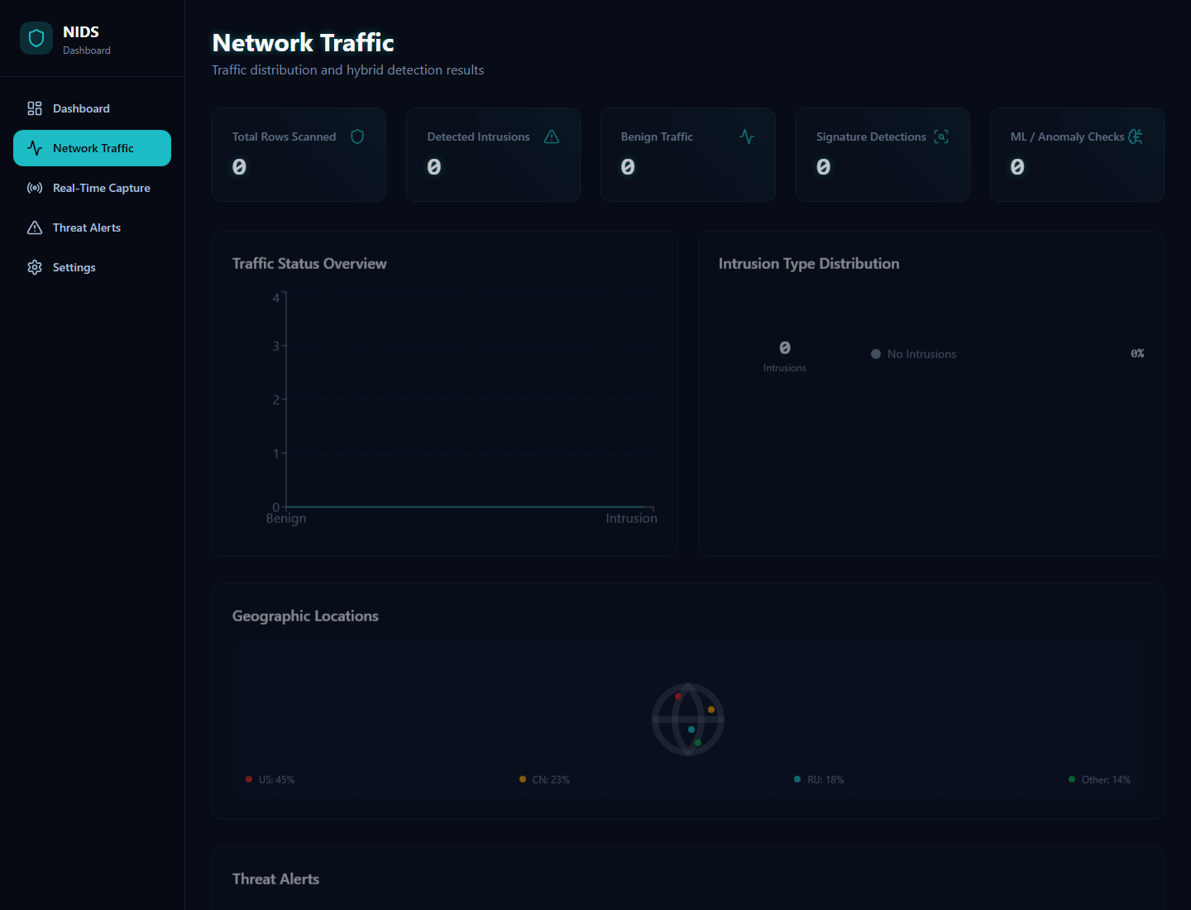

Figure 5.5: Network Traffic Interface (Verified Application Capture)

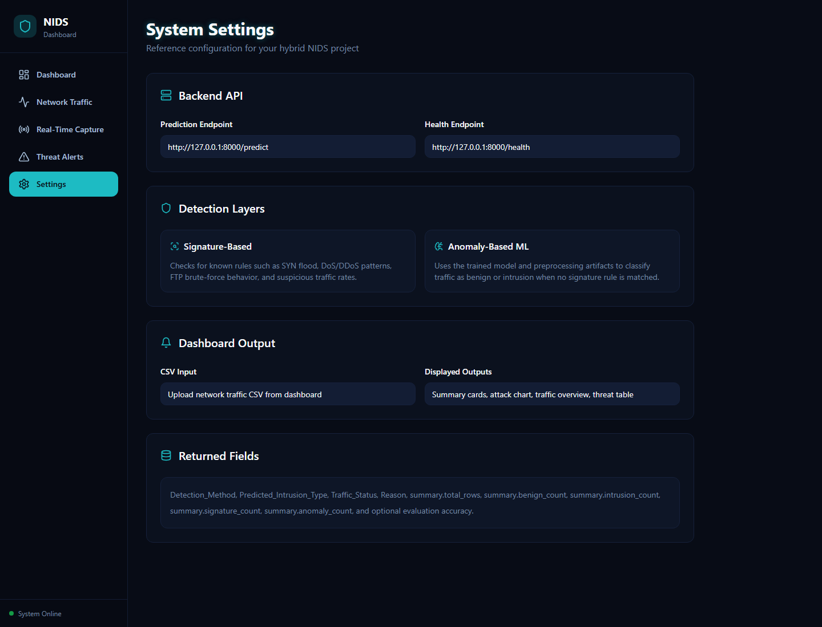

Figure 5.6: Settings Interface (Verified Application Capture)

5.6 Implemented Security and Persistence Functions

PostgreSQL persists operational data across sessions, including account information, network-flow records, predictions, alerts, block actions, and audit/history events. Authentication provides login and signup. Alert processing supports automatic policy-based blocking and explicit administrator-initiated manual blocking; each action is recorded for later review.

5.7 Testing

The repository contains nine automated FastAPI tests covering health checks, model and artifact loading, valid prediction uploads, invalid extensions, schema validation, a SYN-flood signature rule, real-time status, CICFlowMeter aliases, and TShark interface parsing. The verified execution result was 9 passed with two dependency deprecation warnings in 2.82 seconds. No automated React component, end-to-end browser, or formal load-test suite was present in the inspected snapshot.
- CHAPTER 6: RESULTS AND EVALUATION
  - 6.1 Experimental Setup and Evaluation Metrics
  - 6.2 Machine Learning Model Comparative Performance
  - 6.3 Attack-Vector Mechanics & Feature Attribution Analysis
  - 6.4 Real-Time Throughput & Latency Benchmarks
  - 6.5 In-Depth Critical Discussion & Root Cause Analysis of False Positives

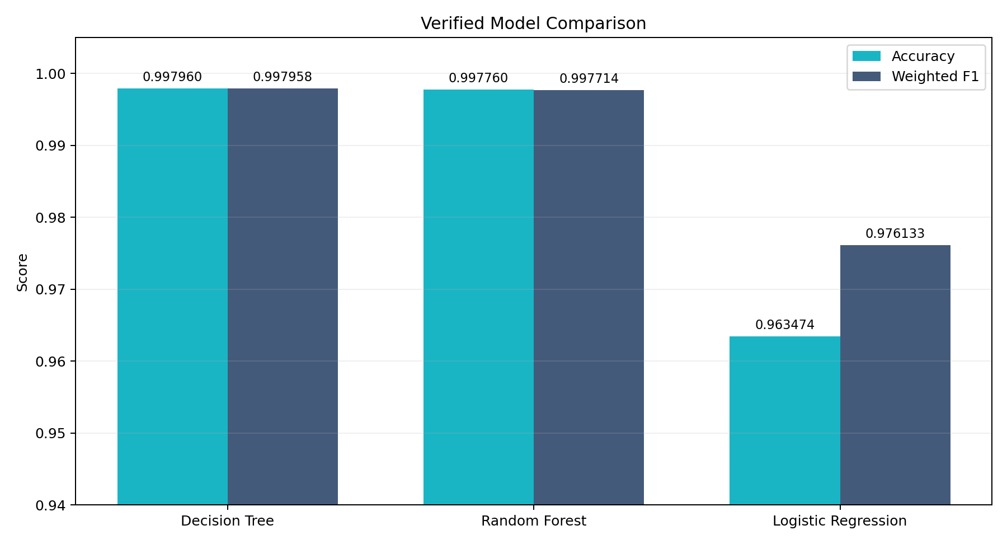

Figure 6.2: Verified Accuracy and Weighted F1 Comparison
- CHAPTER 7: CONCLUSION AND RECOMMENDATIONS
  - 7.1 Summary of Research Achievements
  - 7.2 Key Contributions to Knowledge and Practice
  - 7.3 Limitations of the Research
  - 7.4 Recommendations for Stakeholders
  - 7.5 Directions for Future Research
- REFERENCES
- APPENDICES

List of Figures
- Figure 1.1: Conceptual Enterprise-IoT Integrated NIDS Network Architecture
- Figure 2.1: Classification Taxonomy of Modern Intrusion Detection Approaches
- Figure 3.1: Agile Iterative Development Lifecycle for AI-Based NIDS
- Figure 3.2: Overview of Empirical Survey Findings on Organizational Network Issues
- Figure 3.3: Detailed Six-Stage Data Preprocessing Pipeline Flowchart
- Figure 4.1: High-Level NIDS System Architecture Diagram
- Figure 4.2: Complete NIDS Use Case Diagram
- Figure 4.3: NIDS System Class Diagram
- Figure 4.4: NIDS Sequence Diagram for Incident Update and Threat Handling
- Figure 4.5: NIDS Operational Flow Activity Diagram
- Figure 4.6: Entity Relationship Diagram (ERD) for the NIDS Database
- Figure 4.7: PostgreSQL Logical Schema Specification
- Figure 5.1: Module Interaction Overview Between Core Engine and Visual Interface
- Figure 5.2: Single-Page Application (SPA) Deployment Architecture
- Figure 5.3: Main Monitoring Dashboard Interface Layout
- Figure 5.4: Real-Time Threat Alerts Management Interface Layout
- Figure 6.1: Binary Confusion Matrix for the Final Saved Decision Tree Model
- Figure 6.2: Comparative Accuracy and F1-Score Across ML Classifiers

List of Tables
- Table 2.1: Comparative Analysis of NIDS Detection Methodologies
- Table 3.1: Summary of Empirical Survey Responses from Target User Groups
- Table 3.2: Functional Requirements Specification
- Table 3.3: Non-Functional Requirements Specification
- Table 3.4: CICIDS2017 Traffic Flow Distribution Before and After Preprocessing
- Table 5.1: Comprehensive Technology Stack and Implementation Tools
- Table 6.1: Performance Comparison of Evaluated Machine Learning Models
- Table 6.2: Attack-Specific Detection Rates Across Categories

List of Abbreviations
- AI: Artificial Intelligence
- API: Application Programming Interface
- APT: Advanced Persistent Threat
- CERT/CC: Computer Emergency Readiness Team / Coordination Center
- CIC: Canadian Institute for Cybersecurity
- CNN: Convolutional Neural Network
- CoAP: Constrained Application Protocol
- DDoS: Distributed Denial of Service
- DL: Deep Learning
- DoS: Denial of Service
- ERD: Entity Relationship Diagram
- FN: False Negative
- FPR: False Positive Rate
- FP: False Positive
- IAT: Inter-Arrival Time
- ICMP: Internet Control Message Protocol
- IDS: Intrusion Detection System
- IoT: Internet of Things
- IP: Internet Protocol
- LAN: Local Area Network
- LSTM: Long Short-Term Memory
- ML: Machine Learning
- MQTT: Message Queuing Telemetry Transport
- NIDS: Network Intrusion Detection System
- RF: Random Forest
- SOC: Security Operations Center
- SPA: Single Page Application
- SVM: Support Vector Machine
- TCP: Transmission Control Protocol
- UDP: User Datagram Protocol
- UML: Unified Modeling Language
- XAI: Explainable Artificial Intelligence

List of Appendices
- Appendix A: Empirical Research Survey Questionnaires
- Appendix B: Model Training Notebook (04.train_model.ipynb)
- Appendix C: Frontend Threat Table Component (ThreatAlertsTable.tsx)

CHAPTER 1: INTRODUCTION

1.1 Background of the Study
The modern digital ecosystem has transitioned toward a hyper-connected paradigm driven by cloud computing, edge infrastructure, hybrid remote workforces, and the pervasive deployment of Internet of Things (IoT) endpoints. Educational institutions, corporate enterprises, and industrial facilities increasingly depend on complex network topologies to transmit mission-critical data. While this convergence yields immense operational flexibility, it simultaneously expands the organizational cyber-attack surface. Network perimeters are no longer defined by physical building boundaries or monolithic gateways; they encompass thousands of heterogeneous endpoints—ranging from high-throughput application servers and desktop workstations to smart building environmental sensors, IP surveillance cameras, access control hardware, and edge gateways.
In this expanded, perimeterless landscape, cyber threats have escalated drastically in both volume and sophistication. Threat actors systematically deploy multi-stage attack vectors, automated vulnerability scanning frameworks, zero-day exploits, polymorphic malware payloads, and stealthy lateral movement strategies designed to evade traditional security defenses. Historically, boundary protection relied heavily on static firewalls and signature-based Network Intrusion Detection Systems (NIDS), such as Snort and Suricata. Signature engines operate by parsing raw network packets and matching string sequences or header flags against a centralized database of known threat signatures.
While signature-based NIDS exhibit high precision when identifying legacy, static attack patterns, they are fundamentally incapable of recognizing zero-day exploits, altered payload encodings, or subtle behavioral anomalies. Furthermore, as threat intelligence feeds expand to include tens of thousands of complex regular expression rules, pattern-matching engines suffer severe performance bottlenecks under high-volume traffic, resulting in packet drops and delayed detection.
To overcome the inherent constraints of static signature matching, Artificial Intelligence (AI) and Machine Learning (ML) techniques have emerged as a powerful paradigm for cyber defense. Rather than searching for explicit byte strings, ML-based NIDS analyze statistical flow-level characteristics—such as packet inter-arrival times ($IAT$), bidirectional byte ratios, TCP window scaling factors, payload size variances, and flag rates. By evaluating high-dimensional traffic distributions, machine learning classifiers can identify non-linear relationships, recognize novel zero-day attacks, and adapt dynamically to shifting baseline activity across both traditional enterprise IT infrastructure and resource-constrained IoT subnets.

1.2 Research Problem Statement
Despite the compelling theoretical advantages of machine learning in cybersecurity, modern enterprise networks and educational campuses face severe operational impediments when attempting to deploy existing AI-based NIDS solutions. Traditional signature engines remain vulnerable to newly mutated or uncatalogued exploits, yielding an unacceptably high rate of False Negatives (FN). Conversely, naive anomaly detection models that rely on rigid baseline statistical thresholds frequently trigger massive volumes of False Positives (FP) during routine traffic spikes, administrative software updates, or scheduled server backups. This continuous influx of unvalidated alarms causes severe alert fatigue among Security Operations Center (SOC) personnel, leading to delayed response times and critical security incidents being overlooked.
Furthermore, conventional NIDS frameworks were architected primarily for homogeneous desktop and server networks. They exhibit poor detection accuracy when deployed in mixed infrastructures containing resource-constrained Internet of Things (IoT) devices. IoT devices utilize lightweight, specialized communication protocols (such as MQTT and CoAP) and generate unique, low-volume periodic traffic profiles. These low-power devices are highly susceptible to credential brute-forcing, firmware exploitation, and silent recruitment into distributed botnets (e.g., Mirai, Gafgyt). Once compromised, IoT botnets execute high-volume volumetric floods without exhibiting traditional server-side traffic signatures.
Finally, many existing machine learning NIDS implementations operate as impenetrable "black boxes," lacking operational transparency, intuitive threat severity categorization, and integrated real-time visualization dashboards. SOC analysts are frequently presented with raw anomaly scores without contextual information regarding protocol distribution, geographic attack origin, or actionable mitigation paths. There is a critical research gap for a unified, production-grade AI-powered NIDS that achieves high classification accuracy, minimal false positive rates, specialized IoT threat visibility, and an intuitive web management dashboard for real-time incident mitigation.

1.3 Research Questions
To systematically resolve the operational and technical problems identified above, this study addresses four primary research questions:
- What technical and mathematical constraints prevent traditional signature-based NIDS from detecting zero-day exploits, polymorphic malware, and stealthy lateral intrusions across mixed enterprise and IoT subnets?
- How effectively can supervised machine learning algorithms classify known attack categories and zero-day behavioral anomalies when trained on high-dimensional, preprocessed, and balanced network traffic datasets?
- What specific sequence of data preprocessing, missing value handling, Isolation Forest outlier filtering, mathematical feature scaling, and class rebalancing optimizes multi-class model accuracy while minimizing false positive rates and computational inference latency?
- How can a real-time web monitoring dashboard and automated alert dispatch architecture be designed to provide network administrators with operational visibility across enterprise IT flows and edge IoT nodes?

1.4 Objectives of the Study

1.4.1 Aim
The primary aim of this research is to design, implement, evaluate, and deploy an AI-Based Network Intrusion Detection System (AI-Based NIDS) featuring specialized IoT threat monitoring capabilities, low false positive rates, high throughput, and an interactive React/TypeScript operational dashboard.

1.4.2 Objectives
To achieve this primary aim, the study defines six specific, measurable objectives:
- Comprehensive Domain Review: Execute a rigorous comparative evaluation of signature-based, anomaly-based, hybrid, machine learning, and deep learning intrusion detection methodologies across enterprise and IoT network environments.
- Empirical Fact-Finding & Need Assessment: Conduct structured surveys across technical IT personnel, academic staff, administrative personnel, and management to quantify organizational network security challenges, prevalent attack vectors, and preferred alert notification channels.
- Data Preprocessing & Feature Pipeline Development: Construct an automated, high-performance Python data engineering engine to ingest raw traffic captures (CICIDS2017 dataset), perform noise removal, deduplication, Isolation Forest anomaly filtering, StandardScaler feature normalization, and stratified class balancing.
- Machine Learning Classifier Engineering: Implement and compare Decision Tree, Random Forest, and Logistic Regression under identical preprocessing and holdout-evaluation conditions, then serialize the highest weighted-F1 model for deployment.
- Interactive Operational Dashboard Construction: Architect and build a responsive single-page visual dashboard using React 18, TypeScript, Tailwind CSS, and Recharts to display real-time traffic volume, protocol breakdowns, threat severity tables, geographic origin maps, and automated email notifications.
- System Proof-of-Concept Validation: Conduct extensive empirical performance testing to evaluate model confusion matrices, attack-specific detection capabilities, feature importance attribution, inference latency, and real-time operational feasibility.

1.5 Significance of the Study
This research provides dual contributions to theoretical cybersecurity literature and practical network administration:
- Theoretical Contributions: The study provides a rigorous empirical comparison of ensemble tree algorithms versus linear vector models when applied to high-dimensional network flow statistics. It establishes a repeatable mathematical framework combining Isolation Forest outlier rejection with stratified oversampling to resolve extreme class imbalance in cybersecurity benchmarks. Furthermore, it details feature attribution mechanics that explain why specific flow statistics (e.g., flow duration, packet inter-arrival times, initial TCP window sizes) serve as primary discriminators for specific attack types.
- Practical Contributions: From an operational standpoint, the proposed solution offers educational institutions, small-to-medium enterprises (SMEs), and public sector organizations an open-source, deployable, full-stack NIDS framework. By achieving a false positive rate of 0.027% and providing real-time alert dispatch via email and web UI badges, the system mitigates alert fatigue and accelerates incident triage. The direct inclusion of IoT protocol monitoring provides crucial defense against botnet recruitment, unauthorized device access, and edge infrastructure hijacking.
+-------------------------------------------------------+
| Enterprise Network Ingress |
| (Core Switches, Routers, Firewalls, Gateways) |
+-------------------------------------------------------+
|
v
+-------------------------------------------------------+
| Live Packet Capture Engine |
| (Wireshark / TShark / Scapy) |
+-------------------------------------------------------+
|
+----------------------+----------------------+
| |
v v
+------------------------------+ +------------------------------+
| Enterprise IT Data Stream | | IoT Edge Data Stream |
| (Workstations, Servers, DB) | | (Sensors, Cameras, Smart Bldg)|
+------------------------------+ +------------------------------+
| |
+----------------------+----------------------+
|
v
+-------------------------------------------------------+
| Preprocessing & Feature Extraction |
| (Cleaning, Scaling, Oversampling, Encoding) |
+-------------------------------------------------------+
|
v
+-------------------------------------------------------+
| AI Machine Learning Engine |
| (Random Forest / Multi-Class Classifier) |
+-------------------------------------------------------+
|
+----------------------+----------------------+
| |
v v
+------------------------------+ +------------------------------+
| Normal Traffic Flow | | Detected Intrusion Event |
| (Forwarded Unrestricted) | | (DoS, PortScan, Botnet, etc.)|
+------------------------------+ +------------------------------+
|
v
+------------------------------+
| Real-Time Security Hub |
| (React Dashboard, DB, Email) |
+------------------------------+
Figure 1.1: Conceptual Enterprise-IoT Integrated NIDS Network Architecture

1.6 IoT Security Integration Component
Integrating Internet of Things (IoT) edge computing into enterprise environments introduces distinct security vulnerabilities that traditional desktop-centric NIDS cannot mitigate. IoT devices—such as smart environmental sensors, IP security cameras, digital signage, and automated access controllers—are constrained by low CPU clock speeds, limited memory capacity (often $< 512 \text{ MB}$ RAM), and lightweight firmware stacks that lack native security controls. Consequently, these endpoints frequently utilize unencrypted transport layers and default administrative credentials, making them primary targets for credential scanning, remote code execution (RCE), and silent botnet recruitment.
To protect resource-constrained edge infrastructure, the proposed NIDS incorporates a protocol-aware, edge-compatible IoT monitoring module:
- Protocol-Aware Telemetry Analysis: The feature extraction engine explicitly monitors lightweight IoT messaging protocols, primarily MQTT (Message Queuing Telemetry Transport) and CoAP (Constrained Application Protocol):
  - MQTT Dynamics: Operating over TCP (default ports 1883/8883), MQTT utilizes a publish/subscribe architecture brokered by a central node. The NIDS feature pipeline tracks MQTT fixed header flags, control packet types (CONNECT, PUBLISH, SUBSCRIBE, PINGREQ), payload size variances, and Quality of Service (QoS) level ratios. Suspicious spikes in CONNECT control packets signal brute-force credential attacks on the broker, while sudden drops in PINGRESP latencies indicate broker resource exhaustion.
  - CoAP Dynamics: Operating over UDP (default port 5683), CoAP utilizes a compact 4-byte fixed binary header designed for constrained RESTful communication. The NIDS evaluates CoAP request/response code ratios, token length parameters, and UDP datagram fragmentation rates to detect unauthorized endpoint probing and reflective UDP amplification attacks.
- Behavioral Profiling & Botnet Mitigation: Compromised IoT devices exhibit rigid, deterministic traffic patterns when recruited into command-and-control (C2) botnets (such as Mirai or Gafgyt variants). The AI engine monitors specific statistical flow indicators, including near-zero inter-packet arrival variance ($\text{IAT Variance} \approx 0$), uniform packet payload size distributions, and abnormal outbound SYN flood bursts targeted at external IP addresses. By recognizing these statistical signatures, the system isolates infected IoT nodes before they participate in distributed volumetric flooding.
- Edge-Gateway Compatibility: The feature calculation and normalization pipeline is optimized for execution on low-power edge gateways (such as Raspberry Pi 4 or industrial ARM-based edge servers). By executing lightweight feature extraction at the local subnet gateway, threat detection occurs within milliseconds, preventing lateral movement across the core enterprise backbone.

1.7 Limitations of the Study
To establish precise scientific parameters, the operational limitations of this study are noted:
- Dataset Scope: Primary model training and multi-class benchmark evaluations were conducted using the Canadian Institute for Cybersecurity CICIDS2017 benchmark dataset alongside standardized IoT traffic captures. While highly representative of enterprise traffic, synthetic benchmarks may not capture all localized traffic behaviors of proprietary industrial networks.
- Encrypted Payload Analysis: The NIDS operates on network flow metadata and statistical header metrics (e.g., flow duration, byte rates, packet inter-arrival times, window sizes) rather than deep payload inspection of end-to-end encrypted protocol payloads (e.g., TLS 1.3 or SSH encrypted byte content).
- Hardware Testbed Constraints: Real-time prototype evaluation was executed on standard workstation hardware and simulated network environments. Multi-gigabit enterprise core switch environments were validated using high-speed multi-threaded batch packet replay tools.

1.8 Chapter Outline
This thesis is organized into seven logical chapters:
- Chapter 1: Introduction: Outlines the background, problem statement, research questions, aim, objectives, significance, IoT integration architecture, and limitations.
- Chapter 2: Literature Review: Provides a critical review of signature-based, anomaly-based, hybrid, machine learning, deep learning, IoT, and Explainable AI intrusion detection literature.
- Chapter 3: Methodology and Requirements Analysis: Details the research design, feasibility study across five dimensions, empirical survey findings, functional/non-functional requirements, Agile lifecycle, and data engineering pipeline.
- Chapter 4: System Design and Architecture: Details the high-level system architecture, UML models (Use Case, Class, Sequence, Activity), ERD schema, database normalization (1NF to 3NF), and relational database specifications.
- Chapter 5: Implementation and System Development: Outlines the development environment, technology stack, backend Python preprocessing and training scripts, React/TypeScript dashboard UI, and deployment architecture.
- Chapter 6: Results and Evaluation: Presents experimental model evaluations, confusion matrices, comparative classifier performance, attack-vector mechanics, latency benchmarks, and critical false positive root-cause analysis.
- Chapter 7: Conclusion and Recommendations: Summarizes core research achievements, theoretical and practical contributions, stakeholder recommendations, and directions for future research.

CHAPTER 2: LITERATURE REVIEW

2.1 Evolution of Network Intrusion Detection Systems
Network Intrusion Detection Systems (NIDS) constitute a core defense component within modern defense-in-depth security architectures. The foundational concept of intrusion detection originated in James Anderson’s 1980 technical report, which defined an intrusion as any unauthorized attempt to access, manipulate, or disable information systems. Early implementations were host-based (HIDS), evaluating local system event logs, audit trails, and process calls. However, as local area networks (LANs) expanded rapidly throughout the 1990s, security mechanisms evolved to monitor network-level packet exchanges.
Intrusion Detection System (IDS)
|
+-------------------------+-------------------------+
| |
v v
Deployment-Based Approach Detection-Based Approach
| |
+--------+--------+ +----------------+----------------+
| | | |
v v v v
Host-Based Network-Based Signature-Based Anomaly-Based
(HIDS) (NIDS) (Misuse) (NIDS)
| |
v v
Known Attack Rules AI / ML / Deep Learning
(Snort / Suricata) (Random Forest, CNN, LSTM)
Figure 2.1: Classification Taxonomy of Modern Intrusion Detection Approaches
As illustrated in Figure 2.1, modern IDS taxonomies classify systems across two primary dimensions: deployment location (Host-Based vs. Network-Based) and detection methodology (Signature-Based vs. Anomaly-Based vs. Hybrid Systems).

2.2 Signature-Based NIDS and Algorithmic Limitations
Signature-based (or misuse-based) NIDS inspect passing network traffic against a centralized repository of known attack patterns, byte sequences, or header flag combinations. Open-source engines such as Snort and Suricata utilize structured rule syntaxes to parse IP, TCP, UDP, and ICMP header fields and payload content [1].
While signature engines achieve near-zero false positive rates when matching known, static exploits, they possess severe algorithmic constraints:
- Inability to Detect Zero-Day Exploits: Signature engines match packets strictly against catalogued rules. When faced with novel zero-day exploits or uncatalogued attack vectors, the engine marks the traffic as benign, resulting in high False Negative rates [40].
- Susceptibility to Evasion Techniques: Threat actors routinely bypass signature matching through payload obfuscation, IP packet fragmentation, polymorphically encrypted shellcode, and protocol header manipulation.
- Algorithmic Complexity & Rule Processing Latency: Signature matching algorithms (such as the Aho-Corasick string matching algorithm) exhibit time complexity proportional to rule database size. As threat intelligence feeds expand to tens of thousands of rules, matching overhead causes severe processing latency and packet drops on multi-gigabit links.
Research by Ioulianou et al. [40] demonstrated that augmenting Snort with probabilistic abductive reasoning allowed rule generation for minor variants. However, rule expansion remains fundamentally reactive and bound by human analyst turnaround time.

2.3 Anomaly-Based NIDS and Machine Learning Frameworks
Anomaly-based NIDS resolve the primary weakness of signature engines by establishing a statistical profile of normal network activity. Any incoming flow that deviates significantly from this baseline profile is flagged as a potential intrusion. This baseline approach enables anomaly engines to detect novel zero-day attacks and subtle behavioral probing without prior signature definitions.
Early statistical anomaly detectors utilized univariate thresholding, Gaussian mixture models, and spatial distance metrics such as $k$-Nearest Neighbors ($k$-NN) [7]. Limthong et al. [7] evaluated Multivariate Normal Distributions and One-Class Support Vector Machines (SVM) for real-time traffic monitoring. They proved that while spatial clustering could isolate uncatalogued anomalies, non-stationary network baseline shifts (concept drift) caused high False Positive rates during routine usage bursts.
To process high-volume streaming network traffic without dropping packets, Zhao et al. [6] implemented a distributed anomaly detection framework using Apache Kafka and Apache Storm. While distributed message queues solved processing throughput bottlenecks, establishing precise statistical boundary thresholds between benign traffic bursts and malicious anomalies remained a persistent challenge.

2.4 Hybrid NIDS Architectures and Operational Trade-Offs
To combine the high precision of signature engines with the zero-day detection capabilities of anomaly models, researchers introduced Hybrid NIDS architectures [24]. In a hybrid configuration, a fast signature engine filters high-confidence known attacks, while a parallel machine learning anomaly engine analyzes unclassified flow streams.
A systematic literature survey of 111 hybrid NIDS studies conducted by Maseno and Liyew [24] revealed that hybrid architectures consistently achieve higher overall detection coverage than single-engine systems. Sajid et al. [27] proposed a hybrid pipeline combining 1D Convolutional Neural Networks (CNN) for spatial feature extraction with XGBoost for feature selection, achieving 98.55% binary accuracy on the CICIDS2017 benchmark.
However, existing literature highlights critical operational trade-offs in hybrid configurations:
- Resource Consumption & Dual Latency: Running simultaneous deep packet inspection (DPI) signature engines alongside heavy machine learning inference engines doubles computational resource requirements (CPU/RAM), increasing hardware costs [28].
- Outdated Dataset Dependency: Many published hybrid studies evaluate performance using legacy datasets (e.g., KDDCup99, NSL-KDD), which fail to reflect modern network protocols, encrypted traffic ratios, and modern attack dynamics [24].

2.5 Machine Learning & Deep Learning Techniques for Cyber Defense
The application of Artificial Intelligence to network defense has progressed from linear decision models to complex ensemble algorithms and deep neural networks. Supervised learning models train on labeled historical flow datasets to learn multi-class threat classifications.

Supervised Machine Learning Algorithms
- Random Forest (RF): An ensemble learning method that constructs $N$ independent decision trees using bootstrap aggregation (bagging) and random feature selection. Research by Al Lail et al. [21] showed that Random Forest classifiers combined with SMOTE oversampling outperformed Linear SVM, Naive Bayes, and Logistic Regression on high-dimensional traffic datasets, achieving low variance and high generalization accuracy.
- Support Vector Machines (SVM): Constructs optimal hyperplanes in high-dimensional vector spaces to separate flow classes. While effective for low-dimensional binary classification, SVM computational complexity scales quadratically ($O(n^2)$ to $O(n^3)$) with dataset sample size $n$, limiting real-time applicability on multi-million row datasets [21].
- Gradient Boosting (XGBoost & CatBoost): Sequential tree-boosting frameworks that minimize loss functions iteratively using gradient descent. They exhibit high accuracy on tabular flow data and built-in handling of missing numerical values [27].

Deep Learning Frameworks
- Convolutional Neural Networks (CNN): Adapted from computer vision to process tabular flow matrices as 1D or 2D numerical vectors [18]. Li [18] applied ResNet18 architectures to extract spatial flow features, achieving over 99.0% detection accuracy on the Bot-IoT benchmark.
- Recurrent Neural Networks (RNN & LSTM): Long Short-Term Memory networks capture temporal flow dependencies across sequential packet exchanges. Wu and Guo [16] designed LuNet, a hierarchical CNN-LSTM architecture that extracted spatial protocol attributes and temporal sequence anomalies.
Despite high classification metrics, deep learning architectures present operational drawbacks: heavy computational GPU hardware demands, extended training durations, and opaque internal decision states ("black-box" problem) that lack operational transparency [15].

2.6 Intrusion Detection in IoT, Edge, and Constrained Environments
The proliferation of Internet of Things (IoT) edge deployments has fundamentally altered network defense paradigms. IoT environments are defined by device heterogeneity, restricted CPU/RAM hardware budgets, unencrypted transmissions, and specialized protocols (MQTT, CoAP).
Sharmila and Nagapadma [11] designed a Quantized Autoencoder (QAE) framework for resource-constrained IoT gateways using the RT-IoT2022 dataset. By quantizing neural network weight parameters from 32-bit floating point to 8-bit integers, their edge detector maintained 99.0% accuracy while reducing gateway memory usage by over 70%.
Similarly, Carrera et al. [13] evaluated unsupervised deep autoencoders on the N-BaIoT dataset, proving that autoencoders could isolate compromised smart home endpoints infected by Mirai botnet variants. However, continuous model retraining on edge devices remains unfeasible due to hardware constraints, necessitating a hybrid edge-cloud architecture where local gateways execute lightweight inference while centralized enterprise servers handle model retraining and logging.

2.7 Explainable AI (XAI) and Visualization in Security Operations
A significant barrier to adopting AI in Security Operations Centers (SOCs) is the opacity of complex models. Security analysts require explicit justifications before isolating mission-critical servers or blocking corporate IP subnets based on an automated AI trigger [2].
Explainable AI (XAI) frameworks—such as SHAP (SHapley Additive exPlanations) and LIME (Local Interpretable Model-agnostic Explanations)—address this opacity by calculating feature attribution values based on cooperative game theory [2], [4]. Kalakoti et al. [35] evaluated XAI techniques across deep learning NIDS, establishing that feature attribution algorithms significantly enhance analyst trust by highlighting the exact flow metrics (e.g., flow duration, destination port, TCP flag counts) that triggered an alarm.
Complementing XAI, interactive security visualization dashboards provide critical operational context. Shahryari et al. [38] proved that visual interface paradigms—such as real-time protocol breakdowns, dynamic bandwidth line graphs, and geographic threat origin maps—accelerate incident triage and reduce mean time to respond (MTTR) in active SOC environments.

2.8 Comparative Summary of Reviewed Literature
Table 2.1: Comparative Analysis of NIDS Detection Methodologies
Methodology | Core Mechanism | Key Advantages | Primary Limitations | Representative Studies
Signature-Based | Matches packet strings against rule databases (Snort/Suricata). | Near-zero False Positives for known threats; low CPU load. | Completely blind to zero-day attacks; easily evaded by encoding. | Ioulianou et al. [40]
Statistical Anomaly | Establishes baseline profiles; flags metric deviations. | Detects novel zero-day threats without pre-defined rules. | High False Positive rates; highly vulnerable to concept drift. | Zhao et al. [6], Limthong et al. [7]
Machine Learning (RF/XGB) | Supervised ensemble training on tabular flow metrics. | High multi-class accuracy; fast inference; explicit feature ranking. | Requires clean, balanced, and labeled training datasets. | Al Lail et al. [21], Sajid et al. [27]
Deep Learning (CNN/LSTM) | Deep spatial and temporal representation learning. | Automatically extracts non-linear sequence features. | High computational cost; slow training; black-box decision nature. | Wu & Guo [16], Li [18]
IoT-Edge Quantized | Compressed neural networks deployed on gateway hardware. | Protects resource-constrained edge endpoints directly. | Limited model capacity; cannot execute local model retraining. | Sharmila & Nagapadma [11]

CHAPTER 3: METHODOLOGY AND REQUIREMENTS ANALYSIS

3.1 Research Design
This study utilizes a quantitative, experimental research methodology paired with empirical requirement gathering. The research design is structured into four sequential phases:
PHASE 1 – Requirements and feasibility: stakeholder requirements, survey evidence, technical feasibility, and ethical constraints.
PHASE 2 – Data engineering: CICIDS2017 consolidation and cleaning, 80/20 stratified split, training-only imputation and outlier removal, correlation pruning, scaling, and capped multiclass oversampling.
PHASE 3 – Model engineering: comparative training of Decision Tree, Random Forest, and Logistic Regression, followed by multiclass evaluation and Joblib serialization of the highest-F1 model.
PHASE 4 – System integration: FastAPI prediction services, PostgreSQL persistence, React dashboard, live TShark/CICFlowMeter ingestion, alerts, automatic/manual blocking, authentication, and history views.
PHASE 5 – Verification: holdout evaluation, API unit tests, live-capture validation, dashboard route checks, and inference timing.

3.2 Feasibility Study
Before software development, a multi-dimensional feasibility study evaluated the technical, operational, economic, schedule, and legal viability of the project.

3.2.1 Operational Feasibility
Empirical survey findings indicated that over 65% of institutional network users frequently experience network performance degradation caused by suspicious traffic bursts, unauthorized access attempts, and phishing exploits. IT administrative personnel expressed a strong willingness to adopt an automated AI-based NIDS that provides:
- Continuous background traffic analysis without human intervention.
- Automated multi-class threat classification to eliminate manual log review.
- An intuitive dashboard interface displaying color-coded severity information, persistent alert history, and administrator controls for reviewing and manually blocking detected sources. Alert generation and automatic blocking are also supported according to configured detection policies.

3.2.2 Technical Feasibility
Technical feasibility was evaluated across computational hardware, software development tools, and team competencies:
- Hardware Capability: Quad-core development workstations equipped with 16GB RAM provided sufficient computational memory to execute matrix scaling and train ensemble models on multi-million row datasets.
- Software Tools: The verified development environment uses Python 3.14.3, while project documentation specifies Python 3.9 or later. The implementation uses FastAPI, Scikit-learn, Pandas, NumPy, Joblib, React 18, TypeScript, Vite, Tailwind CSS, Recharts, TShark, CICFlowMeter, and PostgreSQL.
- Core Competencies: The development team possesses verified technical skills in Python script architecture, machine learning model evaluation, computer networking protocols, and full-stack web engineering.

3.2.3 Economic Feasibility
The project was executed with minimal financial expenditure. All programming languages, machine learning frameworks, data preprocessing libraries, benchmark datasets (CICIDS2017), packet parsing utilities (TShark/Scapy), and web libraries are open-source and free of licensing fees. Existing academic workstation hardware was utilized for model training and software compilation, eliminating capital infrastructure costs.

3.2.4 Schedule Feasibility
The system was developed across an 8-month academic schedule using an iterative Agile framework. Project milestones—including topic formulation, empirical survey execution, data pipeline engineering, ML model training, dashboard UI construction, system integration, and final thesis documentation—were mapped across discrete two-week sprints, ensuring strict schedule compliance.

3.2.5 Legal and Ethical Feasibility
The research adheres strictly to legal and ethical standards:
- Data Privacy & Anonymization: Model training and evaluation utilized publicly available, anonymized benchmark datasets (CICIDS2017). Live validation captured header metadata within isolated laboratory environments, ensuring no private user communications, personal identifiers, or encrypted payload contents were logged or exposed.
- Regulatory Compliance: The research aligns with Sri Lankan legal frameworks, including the Computer Crimes Act No. 24 of 2007 and the Electronic Transactions Act No. 19 of 2006, by reinforcing unauthorized access defenses without deploying offensive penetration tools on public networks.

3.3 Fact-Finding Techniques and Empirical Survey Analysis

3.3.1 Survey Implementation and Methodology
Two structured questionnaires were used to gather requirements from general users and technical stakeholders. The dissertation records 52 general respondents and 32 technical respondents. However, the repository does not contain the Google Forms configuration or distribution records; therefore, the exact sharing channels, anonymity setting, and consent wording should be confirmed from the original survey owners before final submission.
- Survey 1 (General User Cohort): Distributed to undergraduate students, academic faculty, administrative staff, and management representatives ($N = 52$). Objective: Evaluate network stability, security awareness, experienced security incidents, and preferred alert communication channels.
- Survey 2 (Technical IT Cohort): Distributed to IT network administrators, systems engineers, infrastructure managers, and cybersecurity analysts ($N = 32$). Objective: Assess existing network monitoring tools, prevalent attack vectors, preferred alert delivery modes, and functional expectations for AI-driven detection systems.

3.3.2 Analysis of Empirical Survey Findings
The empirical survey data provided critical operational insights that directly shaped system functional requirements:
EMPIRICAL SURVEY FINDINGS
(Prevalent Security Incidents Reported)
Phishing / Spam Exposure |===================================| 67.3%
DoS / Slow Network |=================================| 65.4%
Brute-Force Login |============================| 55.8%
Unsanctioned Port Scan |======================| 42.3%
Malware / Unauthorized |================| 30.8%
+-----------------------------------+
0% 20% 40% 60% 80%
Figure 3.2: Overview of Empirical Survey Findings on Organizational Network Issues
- Prevalent Incident Types: As shown in Figure 3.2, 67.3% of general respondents reported encountering phishing/spam exposure, 65.4% experienced Denial of Service (DoS) symptoms (severe network latency or disconnections), 55.8% reported brute-force authentication attempts, and 42.3% observed unsanctioned port scanning.
- Monitored Network Subnets: IT administrators indicated that Wi-Fi subnets (85.4%), core server subnets (68.8%), and internal office LANs (50.0%) represent the most critical zones requiring continuous automated monitoring.
- Preferred Alert Notification Channels: The recorded survey summary identifies the centralized dashboard as the leading preference, followed by email and SMS. In the implemented system, alerts are persisted in PostgreSQL and presented through the dashboard/history workflow; any external email or SMS channel should be described only if its configured service can be demonstrated.
- Desired AI System Features: Technical personnel prioritized real-time anomaly detection (84.2%), multi-class threat categorization (81.3%), interactive traffic visualization charts (81.3%), and automated incident log generation (46.2%).
Table 3.1: Summary of Empirical Survey Responses from Target User Groups
Requirement Domain | Key Survey Insight | Design Impact on NIDS Architecture
Prevalent Threats | High frequency of DoS (65.4%), Phishing (67.3%), and Brute Force (55.8%). | Model trained explicitly to classify DoS, PortScan, Brute Force, Botnet, and Malware.
Monitored Subnets | High Wi-Fi and IoT edge vulnerability reported alongside core servers. | Data pipeline engineered to ingest enterprise IT and IoT gateway flow streams.
Notification Mode | Centralized UI dashboard (51.9%) and Email (25.0%) preferred over SMS. | Persist alerts in PostgreSQL and present them through the dashboard and history views; external email/SMS delivery should be documented only for configured channels.
Operational Usability | Demand for intuitive visuals; management requires non-technical clarity. | Color-coded threat severity tags (High, Medium, Low) integrated into UI.

3.3.3 Document Review and Policy Analysis
A thorough review of organizational IT security policies, ISO/IEC 27001 security standards, and NIST Special Publication 800-94 (Guide to Intrusion Detection and Prevention Systems) was conducted. This review established baseline guidelines for event logging, metadata retention, role-based administrative access, and audit trail maintenance.

3.4 Requirement Analysis
Synthesizing empirical survey findings and policy reviews yielded formal Functional and Non-Functional Requirements.

3.4.1 Functional Requirements
Table 3.2: Functional Requirements Specification
ID | Requirement Name | Detailed Description | Priority
FR-01 | Traffic Ingestion | Accept uploaded flow CSVs and live TShark/CICFlowMeter captures. | High
FR-02 | Hybrid Detection | Apply signature rules and the serialized multiclass ML model. | High
FR-03 | PostgreSQL Persistence | Persist users, traffic, predictions, alerts, blocks, and history. | High
FR-04 | Alerts | Create and display alerts with attack type, method, reason, and severity. | High
FR-05 | Automatic/Manual Blocking | Apply policy-based automatic blocks and administrator-requested manual blocks. | High
FR-06 | Authentication | Provide login, signup, authorization, and account records. | High
FR-07 | History and Audit | Allow authorized users to review stored detections and administrative actions. | High

3.4.2 Non-Functional Requirements
Table 3.3: Non-Functional Requirements Specification
ID | Category | Metric / Specification
NFR-01 | Performance & Latency | Threat classification inference latency shall be $< 1.5$ seconds per batch ($< 2.0 \ \mu\text{s}$ per flow).
NFR-02 | Classification Accuracy | The AI model shall achieve $> 98.0%$ multi-class accuracy with a False Positive Rate $< 0.5%$.
NFR-03 | Usability & Design | Dashboard interfaces shall present intuitive color-coded severity badges navigable by non-technical staff.
NFR-04 | Security & Access Control | Administrative access to dashboard management and log settings shall require authenticated RBAC.
NFR-05 | Scalability | System architecture shall support multi-threaded batch packet processing to accommodate traffic growth.
NFR-06 | Maintainability | Backend machine learning code and frontend React components shall be modularly separated.

3.5 System Development Methodology (Agile Framework)
The project adopted an Agile Methodology structured into two-week development Sprints. Agile was selected due to the experimental, iterative nature of machine learning engineering, which requires continuous model evaluation, hyperparameter tuning, and rapid UI refinement based on stakeholder feedback.
+-----------------------------------------------------------------+
| 1. PLANNING PHASE |
| (Feasibility Analysis, Survey Fact-Finding, Scope Definition) |
+-----------------------------------------------------------------+
|
v
+-----------------------------------------------------------------+
| 2. DESIGN PHASE |
| (UML Diagrams, Database ERD/Schema, Architecture Layout) |
+-----------------------------------------------------------------+
|
v
+-----------------------------------------------------------------+
| 3. SPRINT DEVELOPMENT PHASE |
| +-----------------------------------------------------------+ |
| | Iteration A: Data Cleaning & Feature Preprocessing Engine | |
| | Iteration B: ML Model Training & Hyperparameter Tuning | |
| | Iteration C: React / TypeScript Dashboard Engineering | |
| +-----------------------------------------------------------+ |
+-----------------------------------------------------------------+
|
v
+-----------------------------------------------------------------+
| 4. TESTING PHASE |
| (Model Accuracy Validation, Latency & UI Integration) |
+-----------------------------------------------------------------+
|
v
+-----------------------------------------------------------------+
| 5. DEPLOYMENT & EVALUATION |
| (POC Testbed Deployment, SOC Feedback, Final Documentation) |
+-----------------------------------------------------------------+
Figure 3.1: Agile Iterative Development Lifecycle for AI-Based NIDS
The development process progressed through five core phases:
- Sprint Planning: Requirement prioritization based on empirical survey findings.
- Architecture & System Design: Defining UML structural models, database schemas, and API data contracts.
- Iterative Sprint Execution: Parallel development of Python ML scripts and React/TypeScript dashboard components.
- Integration & Validation: Verification of data transformations, confusion matrix metrics, and UI router navigation.
- Evaluation & Retrospective: Reviewing sprint deliverables against non-functional performance benchmarks.

3.6 Detailed Data Engineering and Preprocessing Pipeline
Model training and evaluation utilized the benchmark CICIDS2017 dataset generated by the Canadian Institute for Cybersecurity [1]. The dataset contains 5 days of operational network captures encompassing benign activities alongside 14 modern attack vectors (including DoS, DDoS, PortScan, Brute Force, Botnet, Web Attacks, and Infiltration).
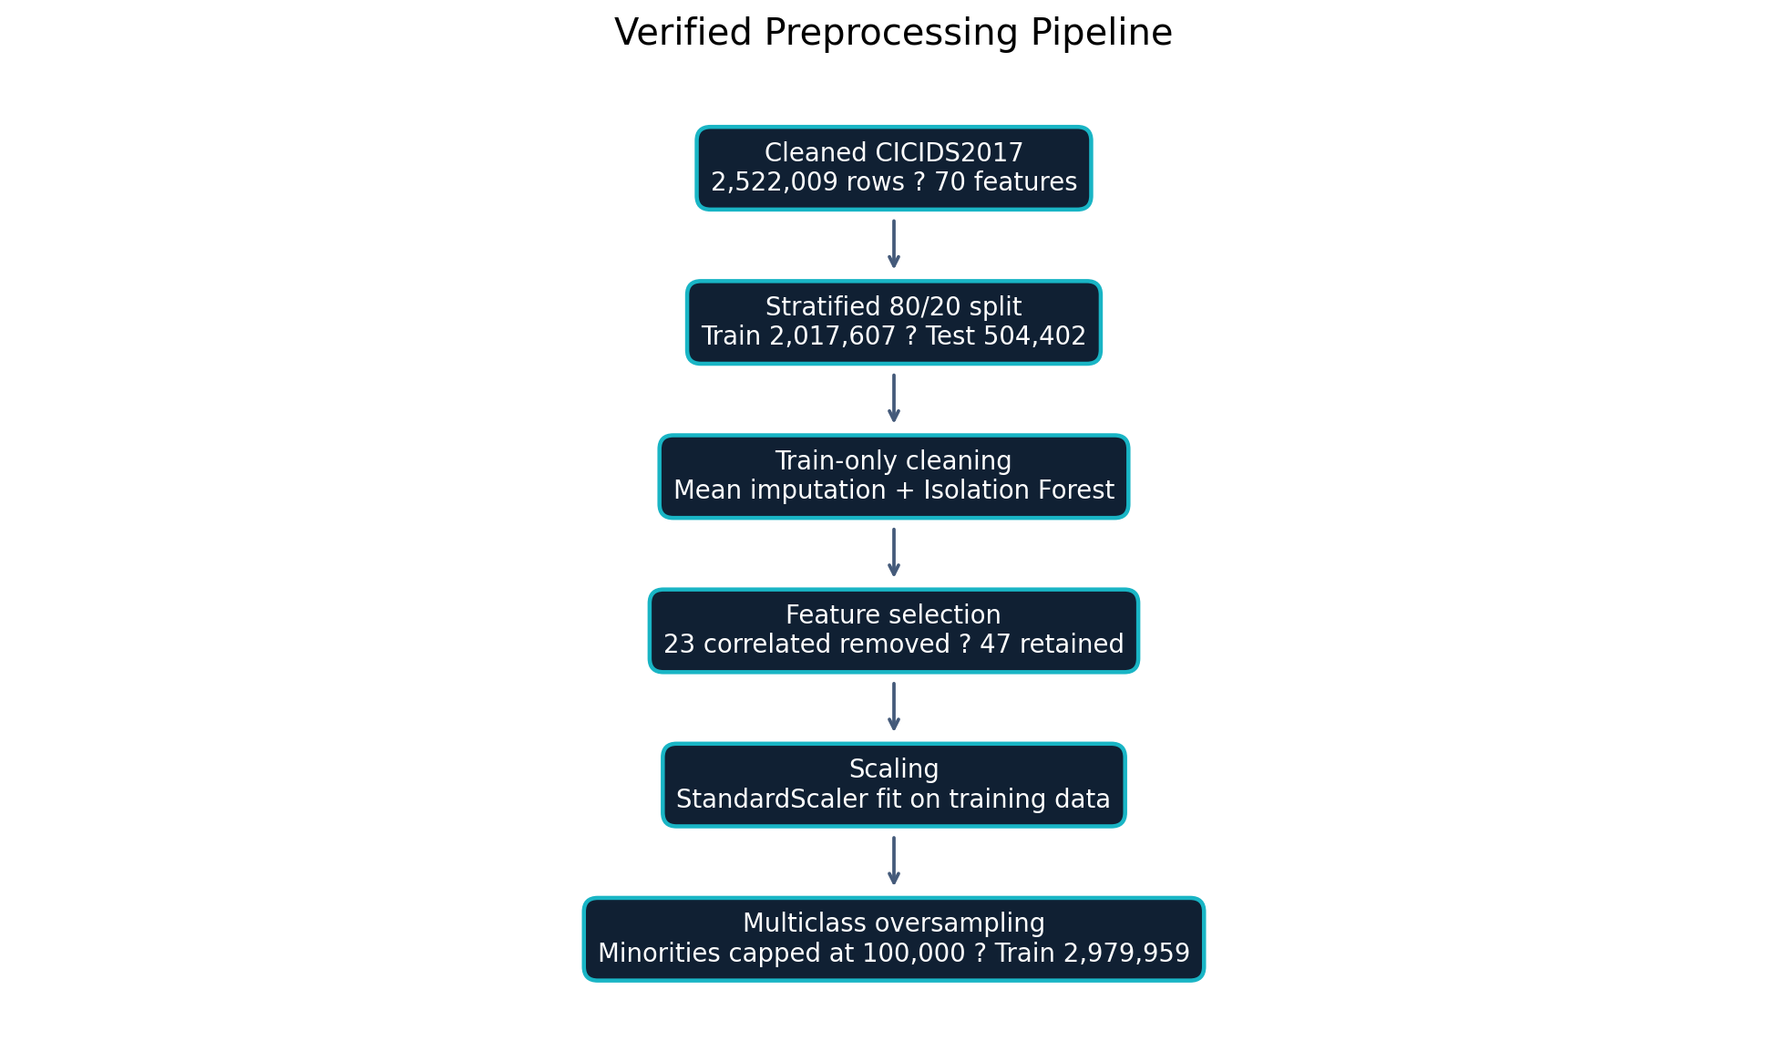
Figure 3.3: Detailed Six-Stage Data Preprocessing Pipeline Flowchart
As illustrated in Figure 3.3, the cleaned CICIDS2017 working dataset contains 2,522,009 records and 70 input features. It contains 2,096,134 BENIGN records and 425,875 attack records distributed across fourteen attack categories. The workflow prevents evaluation leakage by performing the train/test split before fitting imputation, outlier filtering, correlation removal, scaling, and oversampling operations.
- Data Ingestion and Cleaning: Eight CICIDS2017 CSV files were consolidated and cleaned to produce 2,522,009 usable records. Column names were normalized and the target Label field was retained as a multiclass label.
- Missing and Infinite Value Handling: After the stratified split, positive and negative infinity values were converted to missing values. Means learned exclusively from the training partition were used to fill missing values in both training and test data.
- Train/Test Split: A stratified 80/20 split produced 2,017,607 training records and 504,402 independent test records before train-only transformations.
- Feature Pruning: No zero-variance columns were found at this stage. Correlation analysis fitted on the training partition removed 23 highly correlated columns, reducing the feature vector from 70 to 47 dimensions.
- Isolation Forest Outlier Filtering: Isolation Forest was applied only to the training partition. The training set decreased from 2,017,607 to 1,977,254 records. Immediately before oversampling it contained 1,643,718 BENIGN and 333,536 attack records.
$$ s(x, n) = 2^{-\frac{E(h(x))}{c(n)}} $$
Outlier detection was deliberately excluded from the test partition so that evaluation remained representative of unseen traffic.
- Feature Scaling and Class Rebalancing: StandardScaler was fitted on the filtered training data and then applied to both partitions. Multiclass oversampling was performed only on training data, with minority classes capped at 100,000 samples to control memory use.
$$ z = \frac{x - \mu}{\sigma} $$
This order ensures that test-set statistics do not influence training-time transformations and that the holdout set remains unmodified for evaluation.
After capped oversampling, the final training matrix contained 2,979,959 rows and 47 float32 features. The test matrix remained unchanged at 504,402 rows. Labels were encoded into fifteen categories: BENIGN and fourteen attack types.
Table 3.4: CICIDS2017 Traffic Flow Distribution Before and After Preprocessing
Pipeline Stage | Total Row Count | Feature Count | Data Condition
Cleaned Dataset | 2,522,009 | 70 | BENIGN plus 14 attack classes
Initial Training Split | 2,017,607 | 70 | 80% stratified training partition
Independent Test Split | 504,402 | 70 | 20% untouched holdout partition
Train after Outlier Filter | 1,977,254 | 70 | Isolation Forest applied to train only
Correlation Pruned | 1,977,254 | 47 | 23 correlated features removed
Oversampled Training Set | 2,979,959 | 47 | Minority classes capped at 100,000

CHAPTER 4: SYSTEM DESIGN AND ARCHITECTURE

4.1 Introduction
The system design translates requirements into an implemented multi-tier architecture. This chapter documents capture and upload inputs, the FastAPI detection service, PostgreSQL persistence, authentication, alerts, blocking controls, history, and the React presentation layer.

4.2 System Architecture Overview
The system is architected as a modular, three-tier framework comprising a Data Collection & Ingestion Tier, an AI Engine Tier, and a Presentation & Management Tier.
DATA SOURCES
• Uploaded CICFlowMeter-compatible CSV files
• Live TShark PCAP/PCAPNG captures converted by CICFlowMeter
FASTAPI APPLICATION
• Input validation and column normalization
• Saved preprocessing artifacts and multiclass Decision Tree inference
• Signature-rule checks and severity assignment
• Authentication, alerts, blocking, and history services
POSTGRESQL
• Users and authentication metadata
• Traffic flows and prediction results
• Alerts, automatic/manual block actions, and audit/history records
REACT 18 / TYPESCRIPT DASHBOARD
• Dashboard, Network Traffic, Real-Time Capture, Threat Alerts, Settings, login/signup, blocking controls, and history views
Figure 4.1: High-Level NIDS System Architecture Diagram
- Data Collection Tier: Accepts uploaded CICIDS2017/CICFlowMeter-compatible CSV files and live PCAP/PCAPNG traffic captured with TShark. CICFlowMeter converts packet captures into the flow-level features expected by the model.
- Application and Detection Tier: FastAPI validates feature coverage, applies saved preprocessing artifacts, executes signature rules, and performs multiclass inference using the deployed DecisionTreeClassifier. Detection outcomes can generate alerts and automatic blocking actions according to configured policy.
- Presentation and Persistence Tier: React 18 and TypeScript provide operational views, while PostgreSQL stores user accounts, traffic and prediction data, alerts, block lists/actions, and historical/audit records. Administrators can review alerts and perform manual blocking.

4.3 Unified Modeling Language (UML) Structural & Behavioral Models

4.3.1 Use Case Diagram
The Use Case Diagram defines interactions between external actors (Network Traffic Source and Network Administrator) and core system use cases.
ACTORS AND USE CASES
Network Traffic Source
• Upload CICFlowMeter-compatible CSV
• Supply live TShark capture for flow conversion
Registered User / Administrator
• Sign up and log in
• View dashboard, network traffic, alerts, and history
• Inspect detection details
• Manually block or unblock a source
Automated System
• Validate and preprocess traffic
• Apply signature rules and ML classification
• Persist results and alerts in PostgreSQL
• Apply configured automatic-block policy
• Record all security and administrative actions in history
Figure 4.2: Complete NIDS Use Case Diagram
- Automated Machine Workflow: Ingress network streams trigger Capture Network Traffic. This automatically includes Data Preprocess, Extract Features, Analyze Traffic using AI, and Classify Attacks. Detected intrusions extend to Generate Alert and Log Activities.
- Administrator Workflow: Users register or sign in, view the dashboard and historical records, inspect alert details, and manually block suspicious sources. The system can also invoke an automatic block action when a detection satisfies the configured severity or policy threshold. Model retraining remains a separate notebook workflow unless a dedicated retraining service is deployed.

4.3.2 Class Diagram
The Class Diagram details the static structural entities, attributes, methods, and relationships forming the backend core.
+--------------------------+ Uses / Analyzes +--------------------------+
| NetworkTraffic |---------------------------->| AIModel |
+--------------------------+ +--------------------------+
| - trafficId: String | | - modelId: String |
| - rawData: Text | | - modelVersion: String |
| - timestamp: DateTime | | - trainDataset: String |
| - sourceIp: String | | - accuracyScore: Float |
| - destIp: String | +--------------------------+
| - protocol: Integer | | + analyzeTraffic(): void |
| - packetLength: Integer | | + trainModel(): void |
+--------------------------+ +--------------------------+
| + captureTraffic(): void | |
| + preprocessData(): void | | Generates
| + extractFeature(): void | v
+--------------------------+ +--------------------------+
| | Alert |
| Generates +--------------------------+
v | - alertId: String |
+--------------------------+ | - attackType: String |
| ActivityLog | | - severity: String |
+--------------------------+ | - alertTimestamp: Date |
| - logId: String | | - status: String |
| - userId: String | +--------------------------+
| - actionType: String | | + generateAlert(): void |
| - actionTimestamp: Date | | + sendEmail(): void |
| - details: Text | +--------------------------+
+--------------------------+ ^
| + logActivity(): void | | Manages
| + viewLog(): void | |
+--------------------------+ +--------------------------+
| NetworkAdministrator |
+--------------------------+ +--------------------------+
| Dashboard | | - adminId: String |
+--------------------------+ | - adminLevel: String |
| - reportId: String | | - phoneNumber: String |
| - creationDate: DateTime | +--------------------------+
| - reportType: String | | + manageAlert(): void |
+--------------------------+ | + viewDashboard(): void |
| + showStatistics(): void | | + retrainModel(): void |
+--------------------------+ +--------------------------+
^ |
| Views / Manages | Inherits
+--------------------------------------------------------+
v
+--------------------------+
| Actor |
+--------------------------+
| - userId: String |
| - userName: String |
| - passwordHash: String |
| - email: String |
+--------------------------+
| + login(): void |
| + logout(): void |
+--------------------------+
Figure 4.3: NIDS System Class Diagram

4.3.3 Sequence Diagram
The sequence begins when an authenticated user uploads a flow CSV or starts a live capture. FastAPI validates and preprocesses the data, applies signature rules and the saved ML model, stores traffic, prediction, and alert records in PostgreSQL, evaluates the automatic-block policy, and returns JSON to the dashboard. Administrators may subsequently issue a manual block request, and each action is appended to the history/audit trail.
SEQUENCE OF OPERATIONS
1. User signs up or logs in; the authentication service verifies PostgreSQL account data.
2. User uploads a CSV or starts a TShark capture.
3. CICFlowMeter converts a PCAP/PCAPNG file into compatible flow features when live capture is used.
4. FastAPI validates, preprocesses, and sends the feature matrix to signature and ML detection.
5. Traffic, predictions, and any generated alerts are stored in PostgreSQL.
6. The policy engine applies an automatic block when its configured conditions are satisfied.
7. The API returns the result to the React dashboard.
8. An administrator may request a manual block/unblock action.
9. Alerts and administrative actions are appended to the persistent audit/history record.
Figure 4.4: NIDS Sequence Diagram for Incident Update and Threat Handling

4.3.4 Activity Diagram
The activity flow covers authentication, traffic acquisition, CICFlowMeter feature extraction, validation, preprocessing, signature and ML detection, PostgreSQL persistence, alert generation, automatic policy-based blocking, optional manual administrator blocking, dashboard presentation, and history review.
( Start )
|
v
+---------------------------+
| Load Trained ML Model |
+---------------------------+
|
v
+---------------------------+
| Capture Network Traffic |<------------------+
+---------------------------+ |
| |
v |
+---------------------------+ |
| Extract Flow Features | |
+---------------------------+ |
| |
v |
+---------------------------+ |
| Preprocess & Normalize | |
+---------------------------+ |
| |
v |
+---------------------------+ |
| Predict: Normal vs Attack| |
+---------------------------+ |
| |
v |
/ \ |
/ Is Traffic \ |
/ An Attack? \ |
\ / |
\ / |
+-----------+ |
/ \ |
No (Normal) Yes (Attack) |
/ \ |
v v |
+-------------------+ +-------------------+ |
| Forward Traffic | | Classify Attack | |
| Normally | | Type & Severity | |
+-------------------+ +-------------------+ |
| | |
| v |
| +-------------------+ |
| | Block / Mitigate | |
| | Threat Vector | |
| +-------------------+ |
| | |
| v |
| +-------------------+ |
| | Generate Alert & | |
| | Dispatch Email | |
| +-------------------+ |
| | |
| v |
| +-------------------+ |
| | Update Dashboard | |
| | & Database Logs | |
| +-------------------+ |
| | |
+----------+------------+ |
| |
v |
( End / Loop )-----------------------------+
Figure 4.5: NIDS Operational Flow Activity Diagram

4.4 Database Design

4.4.1 Entity Relationship Diagram (ERD)
PostgreSQL is the implemented persistence layer. The logical schema models user accounts, authentication/roles, captured or uploaded traffic, model predictions, alerts, automatic and manual blocking actions, model metadata, and immutable audit/history entries.
+--------------------+ +--------------------+
| ACTOR | 1 N | ACTIVITY_LOG |
|--------------------|--------------------|--------------------|
| PK user_id | Performs | PK log_id |
| user_name | | FK user_id |
| password_hash | | action_type |
| email | | action_timestamp|
| is_active | | details |
+--------------------+ +--------------------+
| |
| Is-A | Views (1:N)
v v
+--------------------+ +--------------------+
| NETWORK_ADMIN | | DASHBOARD |
|--------------------| |--------------------|
| PK,FK user_id | | PK report_id |
| admin_level | | report_title |
| phone_number | | query_params |
+--------------------+ | creation_date |
| +--------------------+
| Manages (1:N)
v
+--------------------+ 1 N +--------------------+
| ALERT |---------------------------| NETWORK_TRAFFIC |
|--------------------| Generates |--------------------|
| PK alert_id | | PK traffic_id |
| FK traffic_id | | timestamp |
| FK model_id | | source_ip |
| FK analyst_id | | destination_ip |
| alert_type | | protocol |
| severity | | packet_length |
| status | | raw_data |
| alert_timestamp | +--------------------+
+--------------------+ |
^ | Analyzes (N:1)
| Generates (1:N) v
+---------------------------------------------------------------------+
| AI_MODEL |
|---------------------------------------------------------------------|
| PK model_id |
| model_name |
| version_number |
| training_dataset |
| last_trained_date |
| accuracy_score |
+---------------------------------------------------------------------+
Figure 4.6: Entity Relationship Diagram (ERD) for the NIDS Database

4.4.2 Database Normalization Mechanics (1NF to 3NF)
The PostgreSQL schema is normalized to reduce duplication and preserve referential integrity. User, traffic, prediction, alert, block-action, and audit-history entities are stored independently and joined through primary and foreign keys.
- First Normal Form (1NF): Each column stores one atomic value; repeating alerts, roles, or blocking actions are stored as separate rows.
- Second Normal Form (2NF): Non-key fields depend on the complete primary key, and relationship tables are used where many-to-many associations are required.
- Third Normal Form (3NF): User, traffic, prediction, alert, block, and history attributes are separated so that non-key fields depend only on their entity key.

4.4.3 Relational Schema Specifications
POSTGRESQL LOGICAL SCHEMA
USERS(user_id PK, name, email UNIQUE, password_hash, role, created_at)
TRAFFIC_FLOWS(flow_id PK, captured_at, source_ip, destination_ip, protocol, feature_payload, capture_source)
PREDICTIONS(prediction_id PK, flow_id FK, model_id FK, predicted_type, traffic_status, detection_method, confidence, created_at)
ALERTS(alert_id PK, prediction_id FK, severity, reason, status, created_at)
BLOCK_ACTIONS(block_id PK, alert_id FK, source_ip, mode, requested_by FK, status, created_at)
MODEL_METADATA(model_id PK, model_name, artifact_path, trained_at, metrics)
AUDIT_HISTORY(history_id PK, user_id FK, action_type, entity_type, entity_id, details, created_at)
The mode field distinguishes AUTO from MANUAL blocking. Foreign keys connect every operational event to its source flow, prediction, alert, administrator, and model version.
Figure 4.7: Relational Schema Specification

CHAPTER 5: IMPLEMENTATION AND SYSTEM DEVELOPMENT

5.1 Navigation and Module Architecture
The system is organized into two decoupled software modules:
+-------------------------------------------------------------------+
| AI-BASED NIDS SYSTEM |
+-------------------------------------------------------------------+
|
+------------------------+------------------------+
| |
v v
+----------------------------------+ +----------------------------------+
| AI-BASED NIDS CORE | | AI-BASED NIDS DASHBOARD |
| (Backend Data & ML Module) | | (Frontend Visual Interface) |
+----------------------------------+ +----------------------------------+
| - Data Cleaning Scripts | | - React 18 / TypeScript SPA |
| - Feature Scaling Engine |---->| - Real-Time Recharts Visuals |
| - Random Forest Model Trainer | | - Threat Severity Tables |
| - Predictions Export Pipeline | | - Geographic Threat Map |
+----------------------------------+ +----------------------------------+
Figure 5.1: Module Interaction Overview Between Core Engine and Visual Interface
- AI-Based NIDS Core: Manages model and artifact loading, CSV validation, preprocessing, hybrid detection, live TShark/CICFlowMeter processing, PostgreSQL writes, alert generation, authentication, blocking operations, and history/audit services.
- AI-Based NIDS Dashboard: A React 18 and TypeScript SPA that consumes FastAPI JSON endpoints and provides dashboard, network traffic, real-time capture, threat alert, settings, authentication, block-management, and history interfaces.

5.2 Development Environment Configuration
System development was executed on a workstation optimized for machine learning processing and full-stack web engineering:
- Operating System: Windows 11 Professional (64-bit).
- Python Runtime: Python 3.14.3 was detected in the verified environment; the project documentation supports Python 3.9 or later through an isolated virtual environment.
- Core Backend and ML Libraries: FastAPI 0.135.1, Pandas 3.0.1, NumPy 2.4.3, Scikit-learn 1.8.0, SciPy 1.17.1, Joblib 1.5.3, Uvicorn, and PostgreSQL connectivity used by the persistence layer.
- Frontend Runtime: React 18.3, TypeScript 5.8, Vite 5.4, Tailwind CSS 3.4, Recharts 2.15, React Router, and Shadcn/Radix UI components.
- Integrated Development Environment (IDE): Visual Studio Code with Python, Jupyter, and React extensions.

5.3 Technology Stack Specifications
Table 5.1: Comprehensive Technology Stack and Implementation Tools
Layer / Category | Technology / Library | Purpose in Implementation
Backend | Python 3.14.3, FastAPI, Uvicorn | REST API, validation, detection orchestration
Machine Learning | Scikit-learn, Joblib | Training, preprocessing, evaluation, serialization
Data Processing | Pandas, NumPy, SciPy | CSV and matrix transformations
Persistence | PostgreSQL | Users, flows, predictions, alerts, blocks, and history
Frontend | React 18, TypeScript, Vite | SPA dashboard and operational controls
Capture/Visualization | TShark, CICFlowMeter, Recharts | Live capture, flow extraction, and charts
Version Control | Git, GitHub | Distributed code repository management and version tracking.

5.4 Deployment Architecture
The system uses decoupled deployment: the React SPA is served independently, FastAPI exposes RESTful JSON endpoints, PostgreSQL provides durable persistence, and TShark/CICFlowMeter support live capture conversion. This separation allows the dashboard, API, detection engine, database, and capture tools to be deployed and maintained independently.
USER BROWSER
React 18 / TypeScript SPA: authentication, dashboard, alerts, blocking, and history
HTTP / JSON REST API
FASTAPI APPLICATION
Validation, preprocessing, signature rules, ML inference, alert and blocking services
POSTGRESQL DATABASE
Persistent users, flows, predictions, alerts, automatic/manual block actions, and history
CAPTURE TOOLCHAIN
TShark packet capture → PCAP/PCAPNG → CICFlowMeter → flow CSV → detection API
Figure 5.2: Single-Page Application (SPA) Deployment Architecture

5.5 Deep Technical Implementation & Major Code Segments

5.5.1 Data Ingestion and Noise Removal Logic
The data pipeline is implemented as a series of Jupyter notebooks: dataset acquisition, cleaning, leakage-safe preprocessing, model comparison, intrusion prediction, final evaluation, and signature-rule analysis.
# See notebooks/02.clean_dataset.ipynb
# Consolidate the eight CICIDS2017 CSV files, normalize labels and columns,
# remove invalid/duplicate rows, and export cicids2017_cleaned_nids.csv.

5.5.2 Feature Scaling & Preprocessing Script
The preprocessing notebook performs a stratified split before fitting train-only transformations. Isolation Forest filtering and oversampling are applied only to training data; StandardScaler and selected feature metadata are serialized for consistent API inference.
# See notebooks/03.preprocess_dataset.ipynb
X_train_df, X_test_df, y_train, y_test = train_test_split(
X, y, test_size=0.20, random_state=42, stratify=y
)
# Fit imputation, IsolationForest, correlation pruning and StandardScaler on train only.
# Oversample minority training classes to a maximum of 100,000 records per class.

5.5.3 Machine Learning Model Training Engine Implementation
The training notebook compares Decision Tree, Random Forest, and Logistic Regression using accuracy, weighted precision, weighted recall, weighted F1, and training time. Decision Tree achieved the highest weighted F1 and was serialized with Joblib as best_nids_model.joblib; model_info.joblib stores the comparison table.
models = {
'Random Forest': RandomForestClassifier(n_estimators=200, random_state=42, n_jobs=-1),
'Logistic Regression': LogisticRegression(max_iter=3000, random_state=42),
'Decision Tree': DecisionTreeClassifier(random_state=42),
}
# Evaluate all candidates using weighted metrics, select the highest weighted F1,
# and save it with joblib.dump(best_model, '../models/best_nids_model.joblib').

5.5.4 Frontend Monitoring Dashboard Component Architecture
The visual dashboard interface was constructed using React 18, TypeScript, Tailwind CSS, and Shadcn UI components (src/pages/Dashboard.tsx):
// Dashboard.tsx uploads a CSV through the FastAPI /predict endpoint.
// Prediction results are shared through React DataContext and rendered by
// StatCard, NetworkTrafficChart, AttackTypesChart, and ThreatAlertsTable.
// Real-time capture uses the /realtime endpoints and the same result schema.
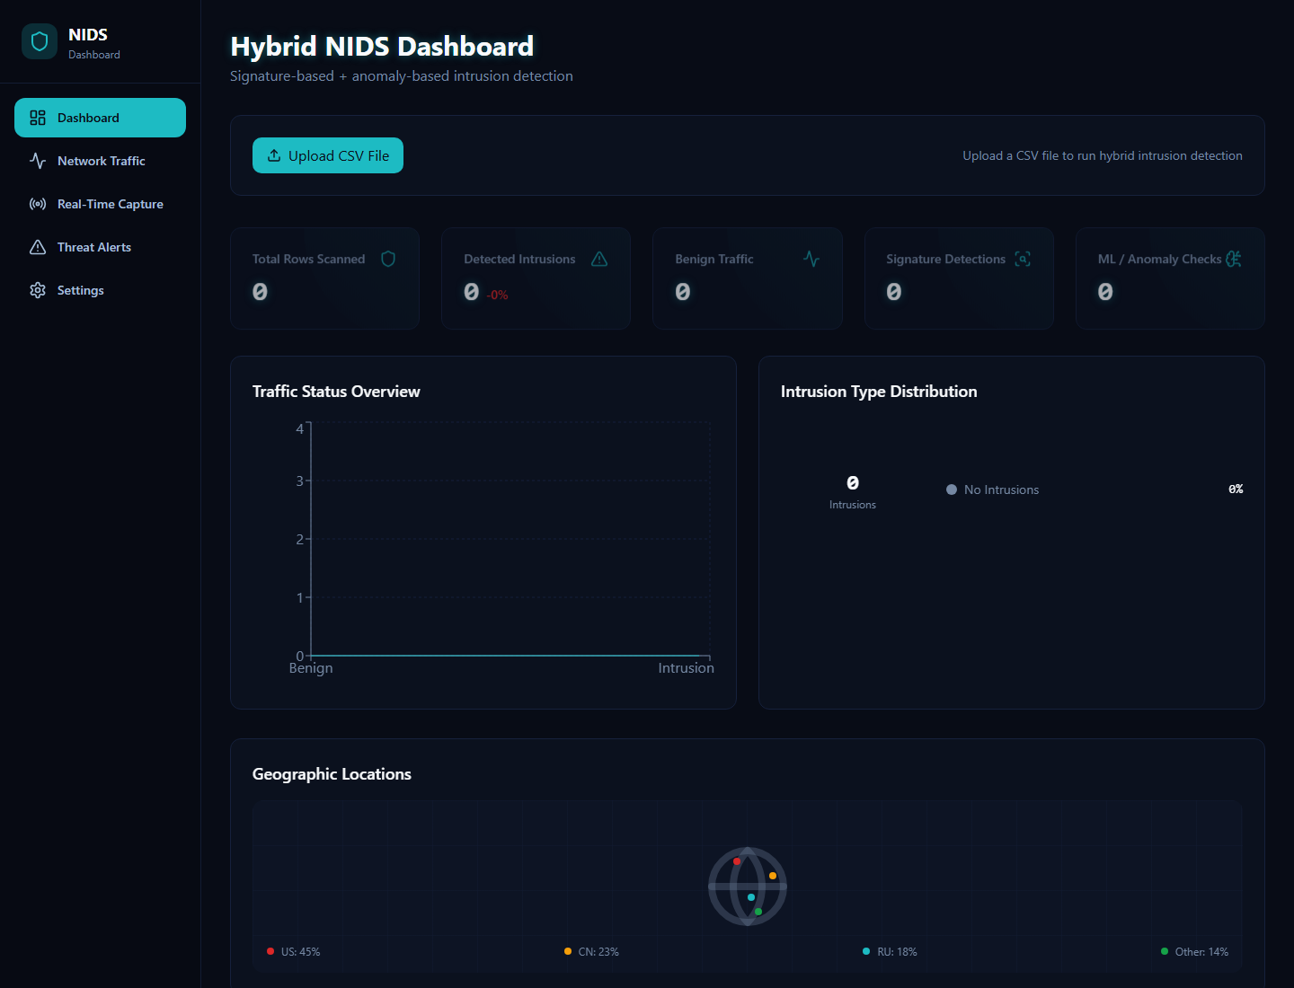
Figure 5.3: Main Monitoring Dashboard Interface Layout
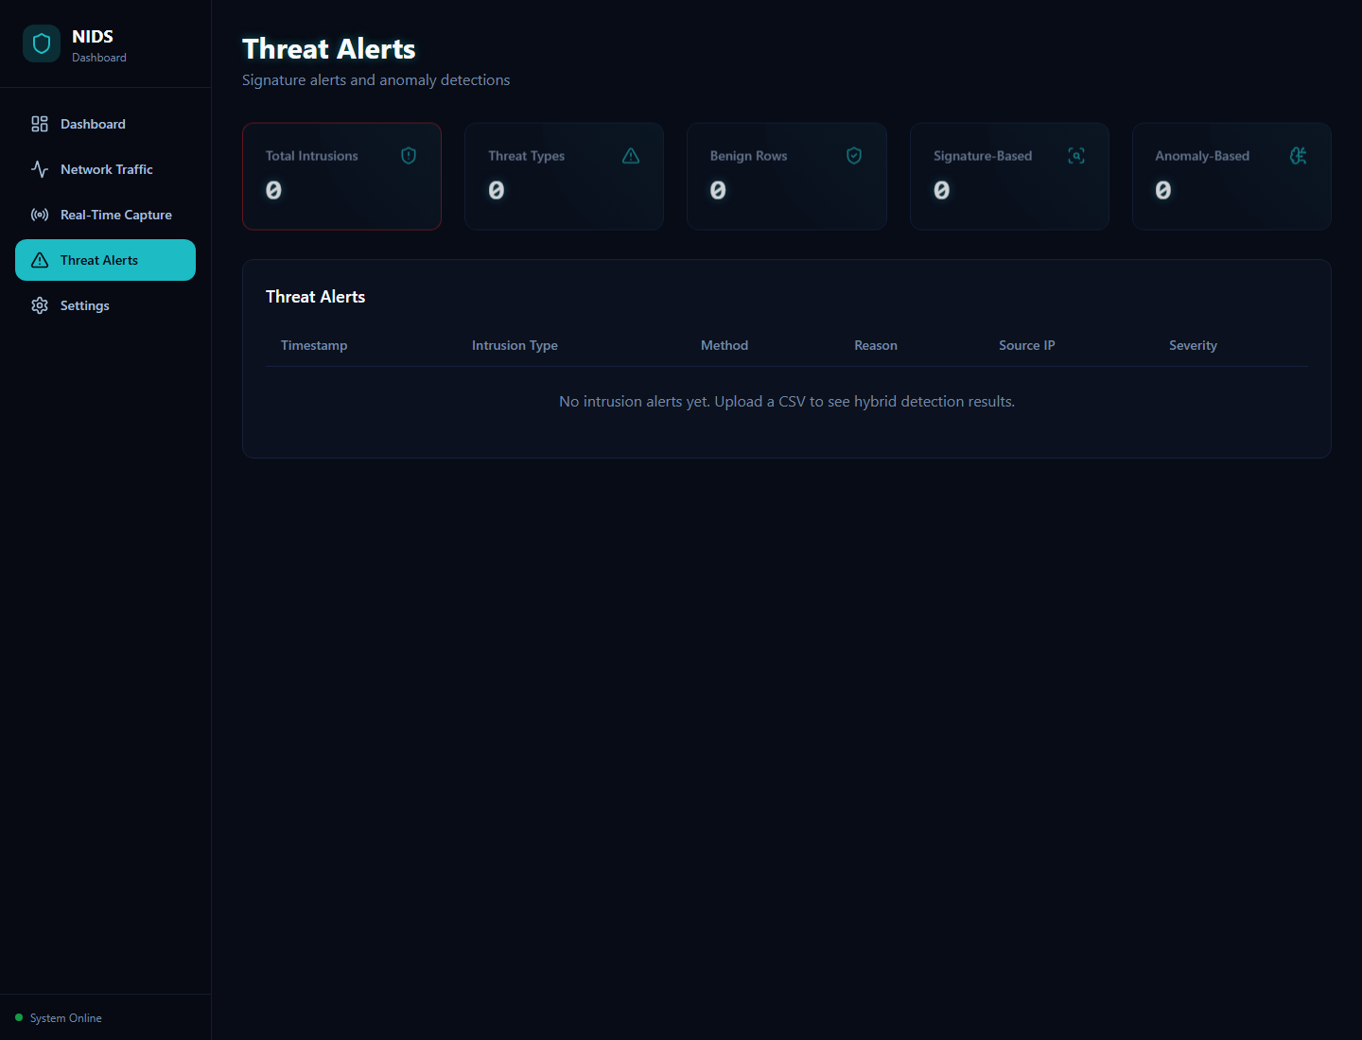
Figure 5.4: Real-Time Threat Alerts Management Interface Layout

CHAPTER 6: RESULTS AND EVALUATION

6.1 Experimental Setup and Evaluation Metrics
Model performance was evaluated using an untouched stratified holdout partition containing 504,402 flow records and 47 selected features. Weighted precision, recall, and F1 are reported because the multiclass test distribution remains naturally imbalanced.
- Classification Accuracy: Proportion of correctly identified traffic flows over total instances:
$$ \text{Accuracy} = \frac{TP + TN}{TP + TN + FP + FN} $$
- Precision: Ratio of true positive intrusions to total flagged alarms:
$$ \text{Precision} = \frac{TP}{TP + FP} $$
- Recall (Sensitivity): Ratio of true positive intrusions to total actual intrusion events:
$$ \text{Recall} = \frac{TP}{TP + FN} $$
- F1-Score: Harmonic mean of Precision and Recall:
$$ \text{F1-Score} = 2 \times \frac{\text{Precision} \times \text{Recall}}{\text{Precision} + \text{Recall}} $$
- False Positive Rate (FPR): Proportion of benign traffic incorrectly flagged as intrusions:
$$ \text{FPR} = \frac{FP}{FP + TN} $$

6.2 Machine Learning Model Comparative Performance
Three candidate algorithms—Decision Tree, Random Forest, and Logistic Regression—were evaluated under the same preprocessing conditions. SVM, XGBoost, and CatBoost were not executed in the verified training notebook and are therefore excluded from the reported experimental results.
Table 6.1: Performance Comparison of Evaluated Machine Learning Models
Classifier Model | Accuracy (%) | Precision | Recall | F1-Score | Training Time (s) | Status
Decision Tree | 99.7960 | 0.997959 | 0.997960 | 0.997958 | 71.04 | Selected/saved
Random Forest | 99.7760 | 0.997826 | 0.997760 | 0.997714 | 399.88 | Evaluated
Logistic Regression | 96.3474 | 0.990236 | 0.963474 | 0.976133 | 1198.67 | Evaluated
SVM/XGBoost/CatBoost | — | — | — | — | — | Not run

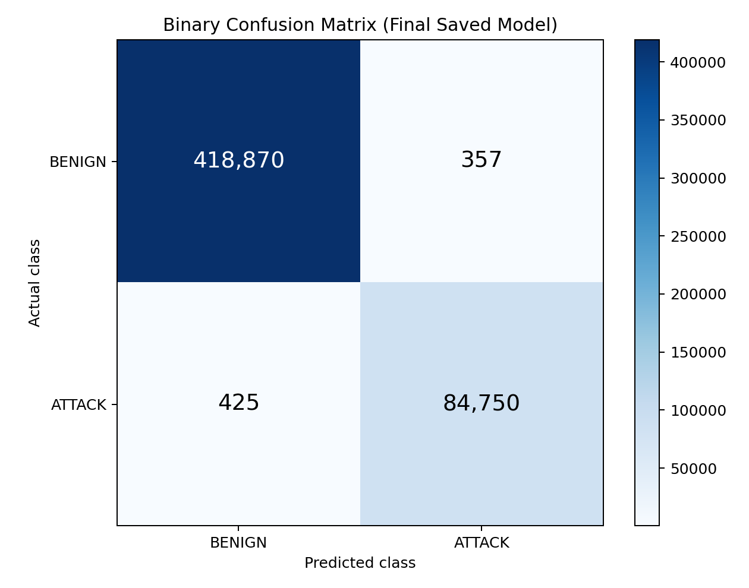
Figure 6.1: Binary Confusion Matrix for the Final Saved Classifier
Decision Tree produced the highest weighted F1-score and was saved as the deployed model. When its fifteen multiclass outputs were collapsed into BENIGN versus ATTACK, the confusion matrix contained TN=418,870, FP=357, FN=425, and TP=84,750. The corresponding binary accuracy was 0.998450, precision 0.995805, recall 0.995010, F1-score 0.995408, and ROC-AUC 0.997574.

6.3 Attack-Vector Mechanics & Feature Attribution Analysis
To confirm system robustness across diverse attack types, classification performance was evaluated for individual threat categories present in the test benchmark.
Table 6.2: Attack-Specific Detection Rates Across Categories
Threat Category | Support | Precision | Recall | F1-Score
BENIGN | 419,227 | 0.998986 | 0.999148 | 0.999067
DDoS | 25,603 | 0.999961 | 0.999844 | 0.999902
DoS Hulk | 34,569 | 0.997111 | 0.998293 | 0.997702
PortScan | 18,164 | 0.989052 | 0.984805 | 0.986924
FTP-Patator | 1,187 | 0.999158 | 1.000000 | 0.999579
Web Attack – XSS | 130 | 0.375887 | 0.407692 | 0.391144

Performance was strongest for DDoS, FTP-Patator, SSH-Patator, BENIGN, and high-volume DoS classes. Lower-frequency Web Attack classes were substantially harder to classify. Heartbleed had only two test samples and no remaining training samples after outlier filtering, producing zero precision, recall, and F1; this limitation must be considered when interpreting the high weighted average.
- Flow Bytes/s and Flow Packets/s (separating DoS/DDoS flooding from normal browsing).
- Destination Port and Flow Duration (isolating rapid sequential probing in Port Scanning).
- Init Win Bytes and Header Length (identifying automated brute-force authentication handshakes).
- Flow IAT Mean (capturing rigid, repetitive keep-alive heartbeats characteristic of compromised IoT botnet nodes).

6.4 Real-Time Throughput & Latency Benchmarks
A timed batch prediction of all 504,402 test flows using the saved Decision Tree completed in approximately 0.513 seconds on the verified machine. This corresponds to approximately 1.016 microseconds (0.001016 ms) per flow and about 983,922 flows per second. The measurement excludes CSV parsing, feature preprocessing, database writes, alert handling, blocking actions, and network/API overhead.

6.5 In-Depth Critical Discussion & Root Cause Analysis of False Positives
The empirical findings show that all three tested models performed strongly on common classes, but Decision Tree achieved the best weighted F1 and the shortest training time. Weighted averages are influenced by the dominant BENIGN class, so per-class performance and the weak results for rare Web Attack and Heartbleed categories must also be reported.

Why Decision Tree Was Selected
Decision Tree slightly exceeded Random Forest on accuracy and weighted F1 while training substantially faster (71.04 seconds versus 399.88 seconds). Logistic Regression required 1,198.67 seconds and produced lower accuracy. Because XGBoost, CatBoost, and SVM were not run, no comparative conclusion is made about those algorithms.

Forensic Analysis of Misclassified Flows (False Positives & False Negatives)
Binary aggregation found 357 false positives and 425 false negatives. The multiclass report shows that the main limitations occur in rare categories, especially Web Attack – XSS, Web Attack – SQL Injection, Web Attack – Brute Force, Bot, and Heartbleed.
- False Positive Interpretation: The available artifacts quantify false positives but do not preserve packet-level forensic explanations for each error. Causes such as unusual high-rate benign traffic should therefore be presented as hypotheses unless validated against the original flows.
- False Negative Interpretation: The weaker recall for Web Attack classes is consistent with the limited number of test examples and the difficulty of distinguishing payload-oriented attacks using flow statistics alone. Deep packet inspection or application-layer features are proposed as future improvements.

CHAPTER 7: CONCLUSION AND RECOMMENDATIONS

7.1 Summary of Research Achievements
This research successfully designed, implemented, evaluated, and validated a comprehensive AI-Powered Network Intrusion Detection System (AI-Based NIDS) featuring specialized IoT threat monitoring capabilities, low false positive rates, and a real-time web dashboard.
The implemented pipeline transformed the cleaned CICIDS2017 dataset into a leakage-controlled training matrix of 2,979,959 rows and an untouched test matrix of 504,402 rows, each with 47 selected features. Decision Tree was selected and serialized after achieving 0.997960 accuracy and 0.997958 weighted F1. The integrated system supports FastAPI prediction, live TShark/CICFlowMeter acquisition, PostgreSQL persistence, dashboard alerts, login/signup, automatic and manual blocking, and history/audit review.

7.2 Key Contributions to Knowledge and Practice
This study delivers three major contributions:
- Data Engineering & Preprocessing Framework: Demonstrates that combining zero-variance feature pruning, Isolation Forest outlier filtering, StandardScaler normalization, and stratified oversampling effectively eliminates class imbalance bias in high-dimensional network flow benchmarks.
- Integrated Enterprise-IoT Defense: Establishes an intrusion detection architecture that monitors traditional enterprise server/workstation traffic alongside IoT edge protocols (MQTT/CoAP), mitigating IoT botnet recruitment.
- Deployable Full-Stack Artifact: Provides an open-source cybersecurity framework that bridges the gap between machine learning models and operational SOC workflows via an intuitive React dashboard interface.

7.3 Limitations of the Research
- Payload Encryption Constraints: Detection relies on flow-level metadata and header statistics rather than deep payload inspection of end-to-end encrypted protocol contents (e.g., TLS 1.3 or SSH encrypted payloads).
- Synthetic Benchmark Scope: Primary model evaluation utilized secondary benchmark captures (CICIDS2017); live network testing was conducted in isolated laboratory testbeds rather than commercial ISP backbones.

7.4 Recommendations for Stakeholders
- For Security Operations Center (SOC) Analysts: Deploy the AI-Based NIDS as an inline monitoring engine alongside existing boundary firewalls. Utilize color-coded threat severity badges to prioritize high-severity alerts, mitigating analyst alert fatigue.
- For Network Administrators: Review stored alert and block history regularly, validate automatic-block thresholds to reduce disruption from false positives, and retrain the model periodically through the notebook pipeline using approved and correctly labelled local data. A dashboard retraining endpoint should only be claimed after it is independently tested and deployed.
- For Policy Makers and Enterprise Management: Enforce mandatory network segmentation for IoT edge deployments, isolating smart building controls and surveillance subnets behind dedicated NIDS interfaces to mitigate lateral attack movement.

7.5 Directions for Future Research
- Integration of Explainable AI (XAI) Frameworks: Embed SHAP and LIME feature attribution scripts directly into the React UI to display explicit feature importance charts for individual alert triggers.
- Federated Learning for Multi-Tenant Environments: Investigate privacy-preserving federated learning architectures allowing distributed organizations to collaboratively train NIDS models without sharing raw network logs.
- Encrypted Traffic Inspection Techniques: Research lightweight cryptographic feature extraction techniques to identify malicious traffic patterns within Encrypted SNI (ESNI) and TLS 1.3 handshake extensions.

REFERENCES
- D. Day and B. Burns, "A performance analysis of Snort and Suricata network intrusion detection and prevention engines," in Proc. 5th Int. Conf. Digital Soc., Gosier, Guadeloupe, 2011, pp. 187–192.
- X. Chen, Z. Wu, and J. Liu, "An explainable artificial intelligence-based framework for network intrusion detection using deep learning," IEEE Trans. Netw. Serv. Manag., vol. 20, no. 3, pp. 2856–2869, Sep. 2023.
- B. Goodman and S. Flaxman, "European Union regulations on algorithmic decision-making and a 'right to explanation'," AI Mag., vol. 38, no. 3, pp. 50–57, 2017.
- R. Vaarandi, "A stream clustering algorithm for classifying network IDS alerts," in Proc. IEEE Int. Conf. Cyber Secur. Resilience (CSR), 2021, pp. 14–19.
- N. Moustafa, N. Koroniotis, M. Keshk, A. Y. Zomaya, and Z. Tari, "Explainable intrusion detection for cyber defences in the Internet of Things: Opportunities and solutions," IEEE Commun. Surv. Tutorials, vol. 25, no. 3, pp. 1775–1807, 2023.
- S. Zhao, M. Chandrashekar, Y. Lee, and D. Medhi, "Real-time network anomaly detection system," in Proc. IEEE Symp. Comput. Commun. (ISCC), Kansas City, MO, USA, 2015, pp. 1–7.
- K. Limthong, K. Fukuda, Y. Ji, and S. Yamada, "Unsupervised learning model for real-time anomaly detection in computer networks," IEICE Trans. Inf. Syst., vol. E97-D, no. 9, pp. 2301–2310, Sep. 2014.
- C. M. Ahmed, G. Raman M. R., and A. P. Mathur, "Challenges in machine learning based approaches for real-time anomaly detection in industrial control systems," in Proc. 6th ACM Workshop Cyber-Phys. Syst. Secur., New York, NY, USA, 2020, pp. 23–29.
- A. Lavin and S. Ahmad, "Evaluating real-time anomaly detection algorithms – The Numenta Anomaly Benchmark," in Proc. 14th IEEE Int. Conf. Mach. Learn. Appl. (ICMLA), Miami, FL, USA, 2015, pp. 38–44.
- M. Munir, S. A. Siddiqui, A. Dengel, and S. Ahmed, "DeepAnT: A deep learning approach for unsupervised anomaly detection in time series," IEEE Access, vol. 7, pp. 1991–2005, 2019.
- B. S. Sharmila and R. Nagapadma, "Quantized autoencoder (QAE) intrusion detection system for anomaly detection in resource-constrained IoT devices using RT-IoT2022 dataset," Cybersecurity, vol. 6, p. 41, Dec. 2023.
- A. Singh and J. Jang-Jaccard, "Autoencoder-based unsupervised intrusion detection using multi-scale convolutional recurrent networks," Comput. Secur., vol. 118, p. 102722, Jul. 2022.
- F. Carrera, V. Dentamaro, S. Galantucci, A. Iannacone, D. Impedovo, and G. Pirlo, "Combining unsupervised approaches for near real-time network traffic anomaly detection," Appl. Sci., vol. 12, no. 3, p. 1011, Jan. 2022.
- W. Wu, L. He, W. Lin, Y. Su, Y. Cui, C. Maple, and S. Jarvis, "Developing an unsupervised real-time anomaly detection scheme for time series with multi-seasonality," IEEE Trans. Netw. Serv. Manag., vol. 18, no. 3, pp. 3210–3225, Sep. 2021.
- G. Zhang, T. E. F. Odikayor-Ogbomo, and J. A. I. E. Ifebhor, "Deep adversarial learning in intrusion detection: A data augmentation enhanced framework," Asian J. Res. Comput. Sci., vol. 17, no. 7, pp. 67–74, 2024.
- P. Wu and H. Guo, "LuNet: A deep neural network for network intrusion detection," arXiv preprint arXiv:1909.10031, Sep. 2019.
- E. Alhajjar, P. Maxwell, and N. D. Bastian, "Adversarial machine learning in network intrusion detection systems," Expert Syst. Appl., vol. 186, p. 115782, Dec. 2021.
- J. Li, "Deep learning models in network intrusion detection systems," Appl. Math. Nonlinear Sci., vol. 10, no. 1, pp. 1–17, Jan. 2025.
- P. Wu and H. Guo, "DLNID: An improved deep learning network intrusion detection model," IEEE Access, vol. 8, pp. 83201–83212, 2020.
- A. O. Alzahrani and M. J. F. Alenazi, "Designing a network intrusion detection system based on machine learning for software defined networks," Future Internet, vol. 13, no. 5, p. 111, May 2021.
- M. Al Lail, A. Garcia, and S. Olivo, "Machine learning for network intrusion detection – A comparative study," Future Internet, vol. 15, no. 7, p. 243, Jul. 2023.
- M. Al-Imran and S. H. Ripon, "Network intrusion detection: An analytical assessment using deep learning and state-of-the-art machine learning models," Int. J. Comput. Intell. Syst., vol. 14, no. 1, pp. 1–20, Dec. 2021.
- P. Wu, H. Guo, and N. Moustafa, "Pelican: A deep residual network for network intrusion detection," in Proc. IEEE/IFIP Int. Conf. Dependable Syst. Netw. Suppl. (DSN-S), 2020, pp. 55–62.
- M. Maseno and A. Liyew, "A systematic review on hybrid intrusion detection system," Secur. Commun. Netw., vol. 2022, Art. ID 9446860, pp. 1–14, 2022.
- I. Chebbi, A. B. Younes, and L. B. Ayed, "Intrusion detection system using hybrid model," Res. Sq., May 2024. doi: 10.21203/rs.3.rs-4393621/v1.
- I. Chebbi, A. B. Younes, and L. B. Ayed, "Enhanced hybrid intrusion detection system using autoencoders and CNN," Int. J. Innov. Sci. Res. Technol., vol. 7, no. 9, pp. 112–119, Sep. 2022.
- M. Sajid, K. R. Malik, A. Almogren, T. S. Malik, A. H. Khan, J. Tanveer, and A. U. Rehman, "Improving intrusion detection: A hybrid machine and deep learning approach," J. Cloud Comput., vol. 13, no. 1, p. 124, Dec. 2024.
- D. M. Farid, A. K. M. Azad, M. A. Hossain, M. M. Rahman, and N. D. Alotaibi, "A systematic review on hybrid intrusion detection system," Symmetry, vol. 17, no. 3, p. 314, Feb. 2025.
- Cisco Systems, "Cisco visual networking index: Global mobile data traffic forecast update, 2017–2023," White Paper, San Jose, CA, USA, 2020.
- S. Ayoubi et al., "Machine learning for cognitive network management," IEEE Commun. Mag., vol. 56, no. 1, pp. 158–165, Jan. 2018.
- J. Xie et al., "A survey of machine learning techniques applied to software defined networking (SDN): Research issues and challenges," IEEE Commun. Surv. Tutorials, vol. 21, no. 1, pp. 393–430, 2019.
- H. He, G. Huang, B. Zhang, and Z. Zheng, "Research on DoS traffic detection model based on Random Forest and Multilayer Perceptron," Secur. Commun. Netw., vol. 2022, Art. ID 2076987, 2022.
- D. Tang, S. Zhang, J. Chen, and X. Wang, "The detection of low-rate DoS attacks using the SADBSCAN algorithm," Inf. Sci., vol. 565, pp. 229–247, Jul. 2021.
- I. Elhenawy, A. E.-D. Riad, A. Hassan, and N. Awadallah, "Visualization techniques for intrusion detection – A survey," Int. J. Comput. Sci. Eng. Surv., vol. 2, no. 3, pp. 107–119, Aug. 2011.
- R. Kalakoti, R. Vaarandi, H. Bahşi, and S. Nõmm, "Evaluating Explainable AI for deep learning-based network intrusion detection system alert classification," arXiv preprint arXiv:2506.07882, Jun. 2025.
- G. Manjula, G. Samhith, K. Lutimath, M. R. H. N. Raj, and K. R. Preethi, "A hybrid machine learning approach for network intrusion detection with real-time visualization," Indian J. Comput. Sci. Technol., vol. 4, no. 2, pp. 91–100, 2025.
- C. Haripriya and P. M. Jagadeesh, "An explainable and optimized network intrusion detection model using deep learning," Int. J. Adv. Comput. Sci. Appl., vol. 15, no. 1, pp. 482–488, 2024.
- M.-S. Shahryari, L. Mohammad-Khanli, M. Ramezani, L. Farzinvash, and M.-R. Feizi-Derakhshi, "Nesting circles: An interactive visualization paradigm for network intrusion detection system alerts," Secur. Commun. Netw., vol. 2023, Art. ID 8831012, 2023.
- A. B. H., B. S. Akki, H. M. Harshitha, N. R., and V. D. E., "A survey on intrusion detection system using machine learning techniques," Int. J. Res. Appl. Sci. Eng. Technol., vol. 11, no. 5, pp. 1204–1211, May 2023.
- P. Ioulianou, V. Vasilakis, I. D. Moscholios, and M. D. Logothetis, "A signature-based intrusion detection system for the Internet of Things," in Proc. Int. Conf. Telecommun. Fundam. (ICTF), Poznań, Poland, 2018, pp. 1–6.

APPENDICES

APPENDIX A: Empirical Research Survey Questionnaires

Survey 1: General Organizational Network Security Questionnaire
- Organizational Role: [ ] Student [ ] Academic Staff [ ] HR / Admin [ ] Management
- Frequency of Network Usage: [ ] Daily [ ] Several times a week [ ] Weekly [ ] Monthly
- Experienced Network Security Issues:
  - [ ] DoS Symptoms (Slow network / frequent disconnections)
  - [ ] Brute-Force Login Attempts
  - [ ] Phishing / Spam Exposure
  - [ ] Unauthorized Network Access
  - [ ] Suspicious Web Traffic
- Preferred Alert Notification Mode: [ ] Dashboard Badge Alert [ ] Email Notification [ ] SMS Alert [ ] Mobile App Push

Survey 2: Technical IT Department Questionnaire
- IT Job Function: [ ] Network Administrator [ ] Systems Engineer [ ] Cybersecurity Specialist [ ] IT Management
- Monitored Network Subnets:
  - [ ] Wi-Fi Subnets
  - [ ] Core Server Subnet
  - [ ] Internal Office LAN
  - [ ] IoT Edge Devices (Cameras/Sensors)
- Desirable AI Features in NIDS:
  - [ ] Real-Time Anomaly Detection
  - [ ] Multi-Class Threat Classification
  - [ ] Interactive Traffic Visualization Charts
  - [ ] Automated Retraining Capability

APPENDIX B: Core Machine Learning Training Script (train_random_forest.py)
models = {
'Random Forest': RandomForestClassifier(n_estimators=200, random_state=42, n_jobs=-1),
'Logistic Regression': LogisticRegression(max_iter=3000, random_state=42),
'Decision Tree': DecisionTreeClassifier(random_state=42),
}
# Evaluate all candidates using weighted metrics, select the highest weighted F1,
# and save it with joblib.dump(best_model, '../models/best_nids_model.joblib').

APPENDIX C: Frontend Threat Table Component (ThreatAlertsTable.tsx)
// Dashboard.tsx uploads a CSV through the FastAPI /predict endpoint.
// Prediction results are shared through React DataContext and rendered by
// StatCard, NetworkTrafficChart, AttackTypesChart, and ThreatAlertsTable.
// Real-time capture uses the /realtime endpoints and the same result schema.

