Sales & Revenue Analysis Dashboard
Internship Task 1 - Final Report - Data Science / Business Analytics Domain
Item | Details
Student | Shynav
Program | B.Tech, Artificial Intelligence & Data Science
Task | Sales & Revenue Analysis Dashboard
Dataset | Synthetic order-level sales data (1,200 orders, FY 2025)
Tools | Python, Pandas, Matplotlib, Seaborn, Chart.js

1. Objective
Import sales data, clean it, visualize key performance indicators (total sales, revenue trends, top-performing products), and build an interactive dashboard with charts and filters for business analysis.

2. Dataset Overview
Order-level sales data for an online and retail business, covering 1,200 orders across 5 product categories (Electronics, Apparel, Home & Kitchen, Sports, Beauty), 4 regions, 3 sales channels (Online, Retail Store, Marketplace), and 6 sales reps, over calendar year 2025. Each row records order date, product, unit price, quantity, discount percentage, and revenue.

3. Data Cleaning
- Removed 10 exact duplicate order rows.
- Filled missing SalesRep values with 'Unassigned' and missing Region values with 'Unknown', to preserve order records without introducing bias.
- Derived Month and Weekday fields from OrderDate for time-based analysis.
Final cleaned dataset: 1,200 unique orders with no missing values.

4. Key Performance Indicators (KPIs)
KPI | Value
Total Revenue | Rs 12,083,335
Total Orders | 1,200
Total Units Sold | 4,788
Average Order Value | Rs 10,069

5. Revenue Trend Over Time
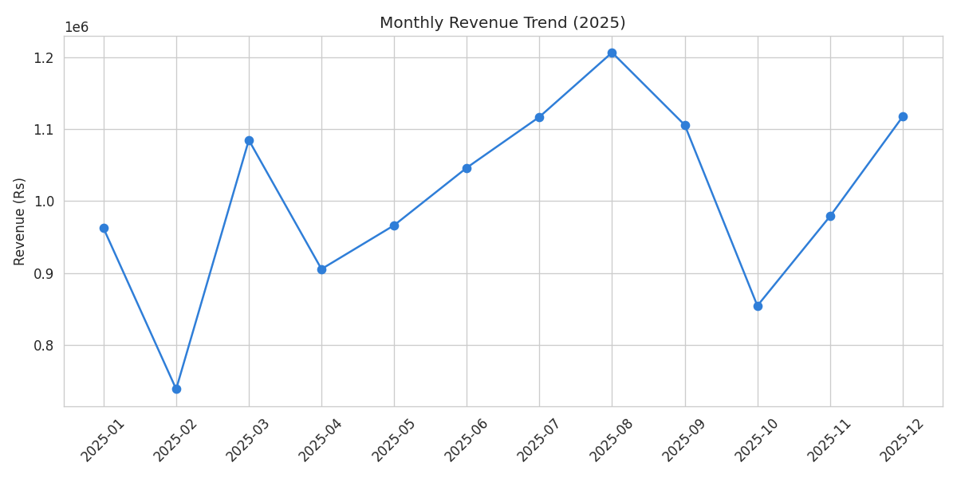
Figure 1: Monthly revenue trend across 2025
Revenue fluctuates month to month across the year rather than following a single dominant season, worth tracking against marketing campaigns or stock availability for each month.

6. Top-Performing Products
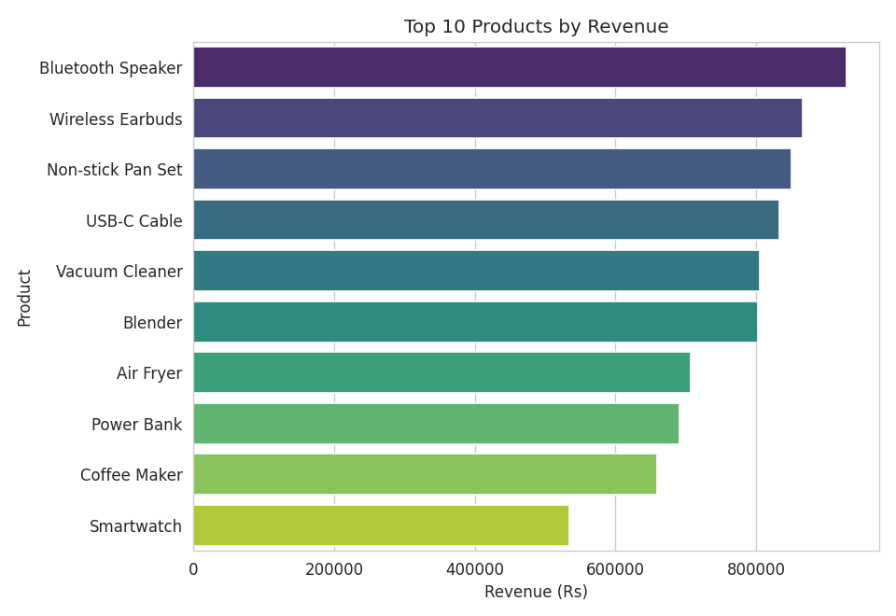
Figure 2: Top 10 products by revenue
The top 5 products by revenue are Bluetooth Speaker (Rs 9.29L), Wireless Earbuds (Rs 8.66L), Non-stick Pan Set (Rs 8.51L), USB-C Cable (Rs 8.33L), and Vacuum Cleaner (Rs 8.05L) - a small set of products driving a disproportionate share of revenue, a classic 80/20 pattern.

7. Revenue by Category and Region
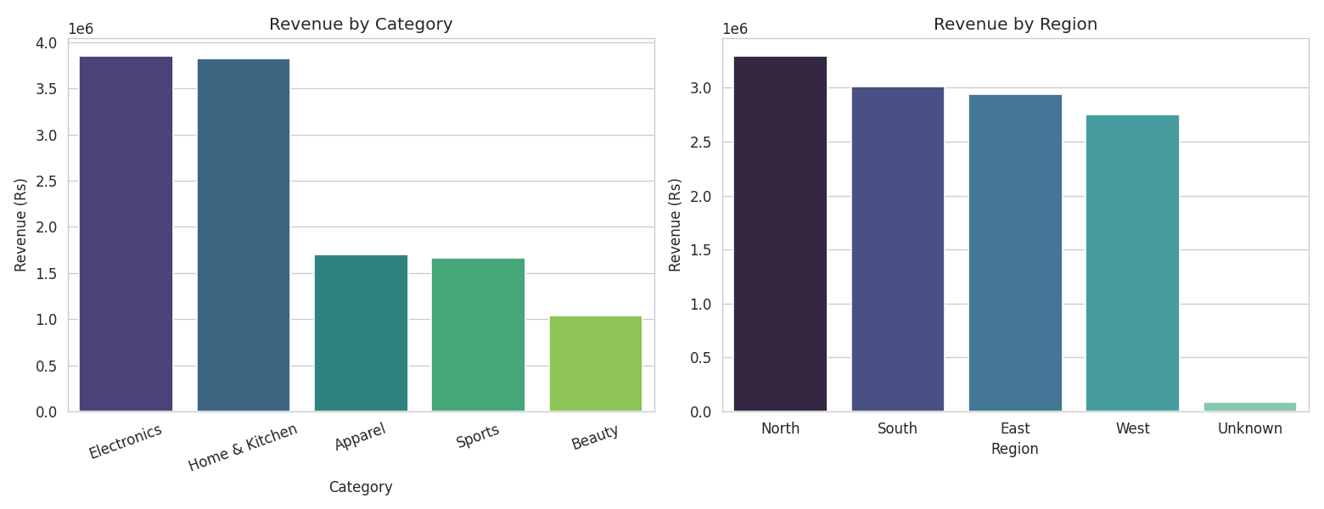
Figure 3: Revenue by category (left) and region (right)
Electronics (Rs 38.5L) and Home & Kitchen (Rs 38.2L) lead category revenue, followed by Apparel, Sports, and Beauty. North region leads at Rs 32.97L, with South, East, and West close behind.

8. Sales Channel Mix
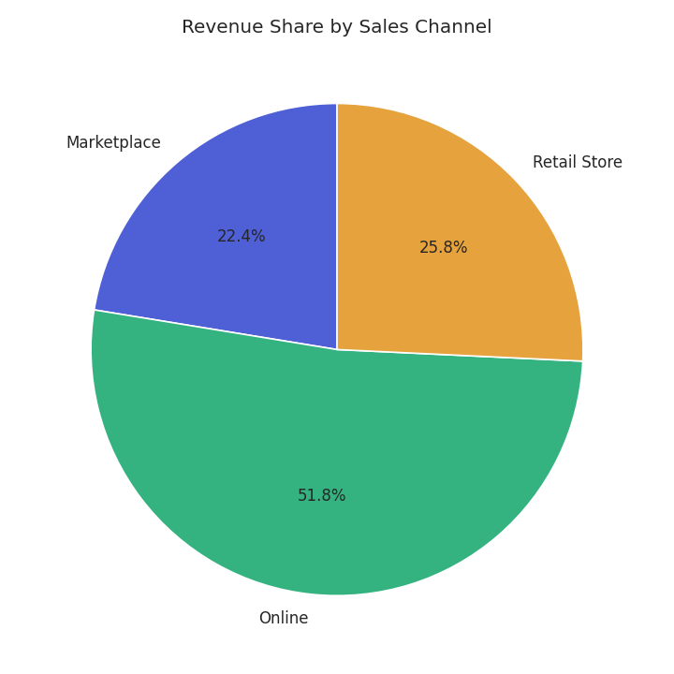
Figure 4: Revenue share by sales channel
Online is the largest channel at 51.8% of revenue, followed by Retail Store (25.8%) and Marketplace (22.4%).

9. Sales Rep Performance
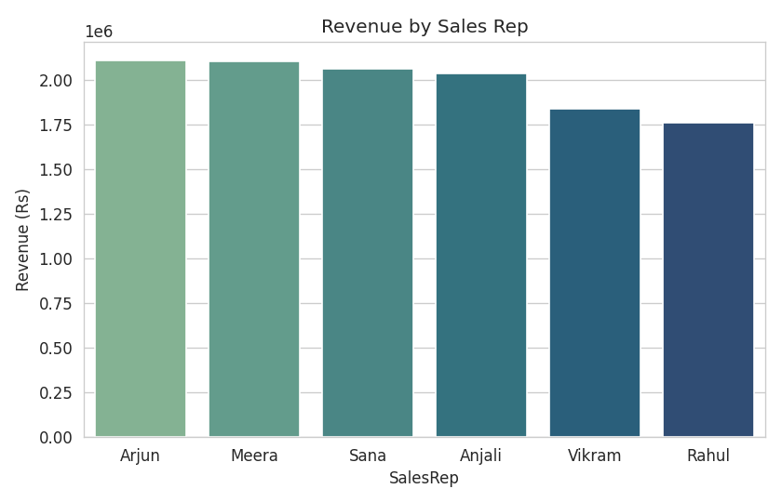
Figure 5: Revenue by sales rep

10. Discount Impact on Revenue
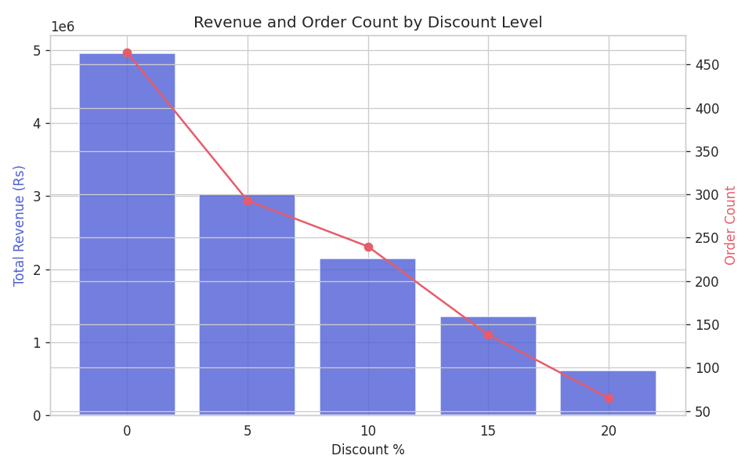
Figure 6: Revenue and order count by discount level
Heavier discounts do not proportionally increase order volume in this dataset - order counts don't scale up enough at high discount levels to offset the lower margin, suggesting the discounting strategy is worth re-examining.

11. Interactive Dashboard
An interactive web dashboard was built (using HTML, JavaScript, and Chart.js) to present the cleaned dataset visually, with live filters for Category, Region, and Sales Channel, KPI summary cards, and five interactive charts (revenue trend, top products, category revenue, channel mix, region revenue).
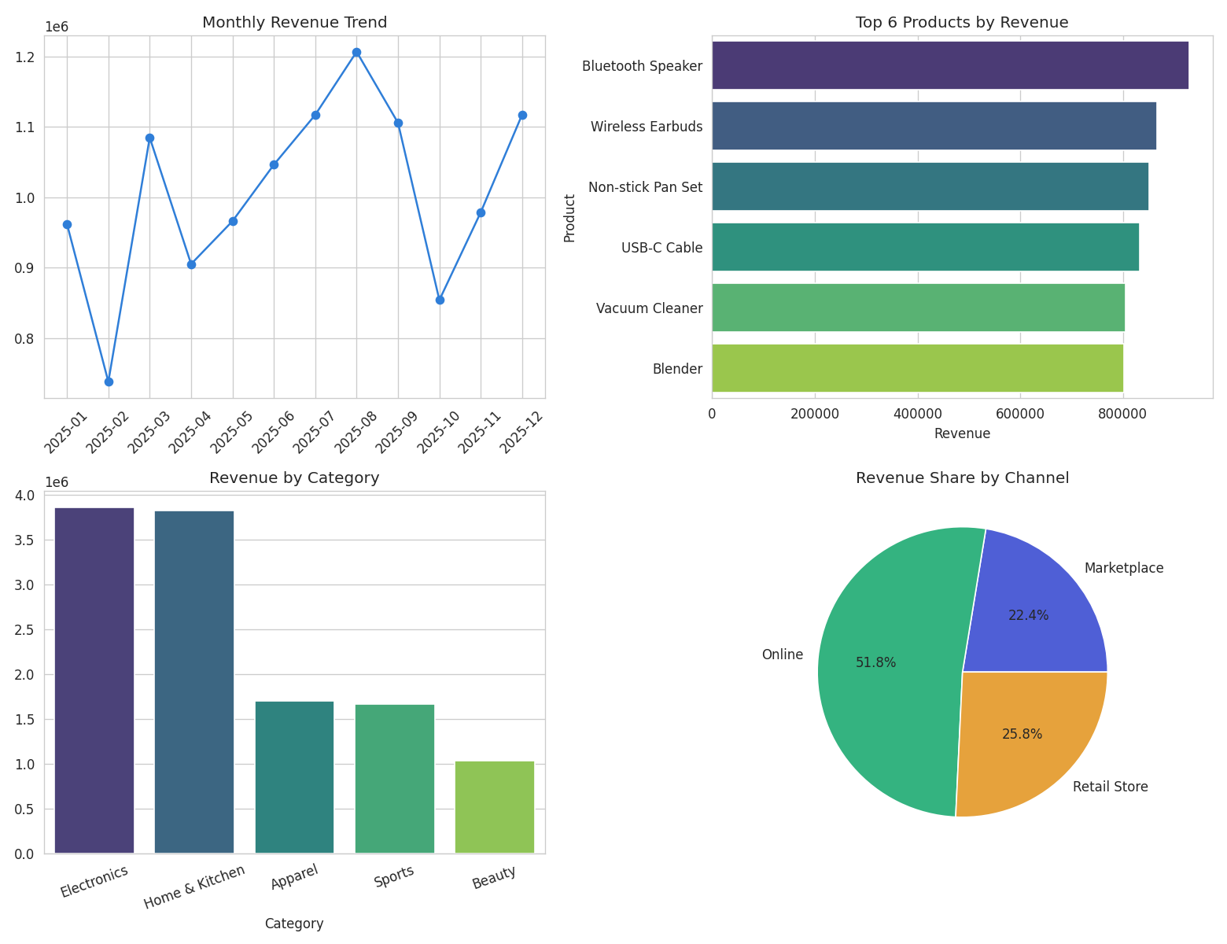
Figure 7: Static preview of the dashboard view (interactive version included separately as sales_dashboard.html)

12. Key Business Insights
- A small set of products drives a disproportionate share of revenue - prioritize these in inventory and marketing.
- Online is the largest sales channel by revenue, useful for channel investment decisions.
- Category and region performance is uneven, which should inform where sales effort is focused.
- Heavier discounts do not proportionally increase order volume - discounting strategy is worth re-examining.
- Revenue fluctuates through the year rather than following one clear season, worth tracking against campaigns and stock.

13. Conclusion
This project demonstrated a complete sales analytics workflow: importing and cleaning order-level data, computing core KPIs, identifying revenue drivers and trends, and presenting findings through both static visualizations and an interactive filterable dashboard - the kind of business-facing deliverable used to support real inventory, marketing, and channel decisions.

14. Deliverables
- sales_raw_dataset.csv - raw dataset
- sales_cleaned_dataset.csv - cleaned dataset
- Sales_Revenue_Analysis.ipynb - full analysis notebook
- Sales_Revenue_Report.html - static report export
- sales_dashboard.html - interactive dashboard
- Final_Report_Sales.docx - this report

