TryHackMe Networking Rooms: CTF Challenge Walkthrough
Name: GK Shanjeev Kumar
Date: September 24, 2026
TryHackMe profile: https://tryhackme.com/p/progamerazerz
Rooms covered: What is Networking? and Intro to Networking

Both rooms show "Room completed: 100%" with every task ticked. For each room below, the first section walks through what I did, task by task, and the second covers what I learned.

Room 1: What is Networking?

What I did
- Task 1 – What is Networking? I opened the room and started with the introductory video, "What is Networking? - Networking Basics" from TryHackMe, which gives the big picture of what a network is before the later tasks go into detail (Figure 1.1).
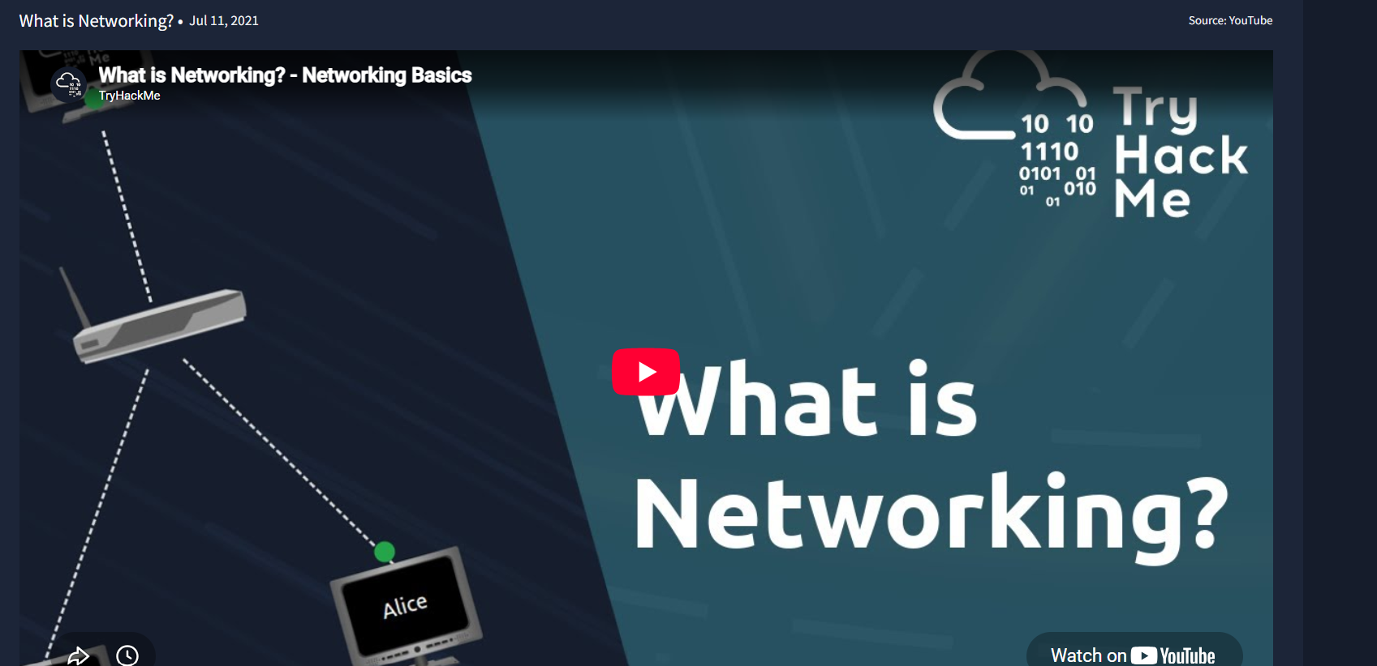
Figure 1.1 – Task 1: the introductory video, "What is Networking? - Networking Basics".
- Task 2 – What is the Internet? I read that the Internet is made up of many small private networks joined together, and that the networks connecting them are the public networks, which is the Internet itself. The diagram (Network #1 and Network #3 linked through "The Internet") made this easy to picture. I then answered the question "Who invented the World Wide Web?" with Tim Berners-Lee (Figure 1.2).
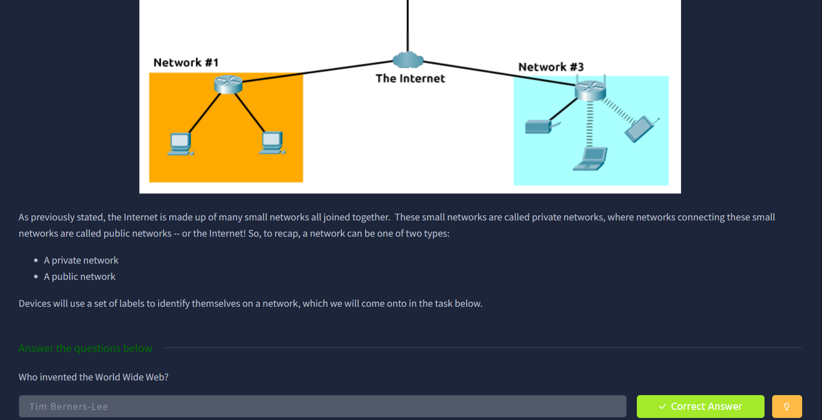
Figure 1.2 – Task 2: the private/public network diagram and the "Who invented the World Wide Web?" question marked Correct Answer.
- Task 3 – Identifying Devices on a Network This task introduces the labels a device uses to identify itself on a network, namely its IP address and its MAC address. I read through the explanation and answered the questions at the end of the task.
- Task 4 – Ping (ICMP) I read that ping is used to test whether a connection to another device is possible. I answered that ping uses ICMP, and that the syntax to ping 10.10.10.10 is "ping 10.10.10.10" (the command followed by the target). Then I used the deployable website in the task to ping 8.8.8.8, which revealed the flag THM{I_PINGED_THE_SERVER}. The example output in the task shows how to read a result: how many packets were sent and received, the percentage lost, and the average round-trip time (Figure 1.3).
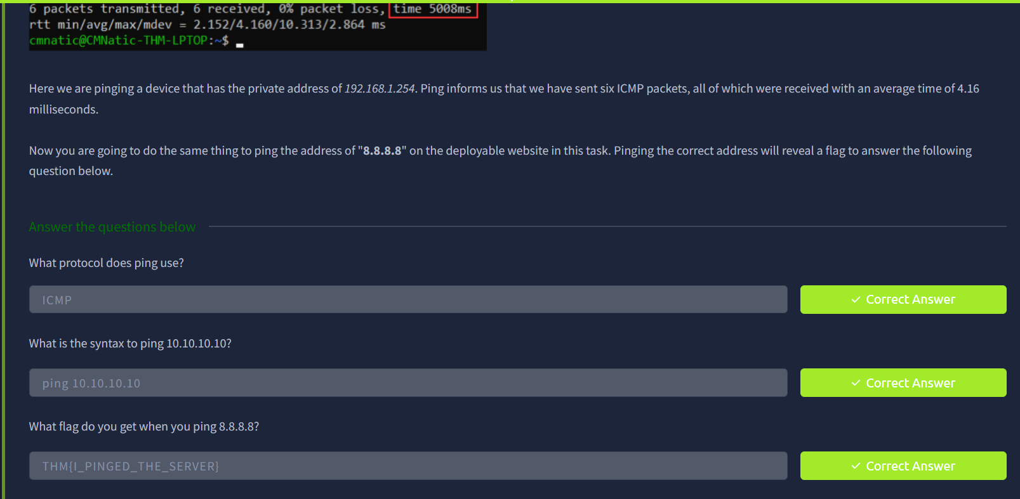
Figure 1.3 – Task 4: the three ping questions, all marked Correct Answer, including the flag from pinging 8.8.8.8.
- Task 5 – Continue Your Learning: Intro to LAN This task has no questions. It points to the next room in the path, so I marked it complete and confirmed the whole room read 100% (Figure 1.4).
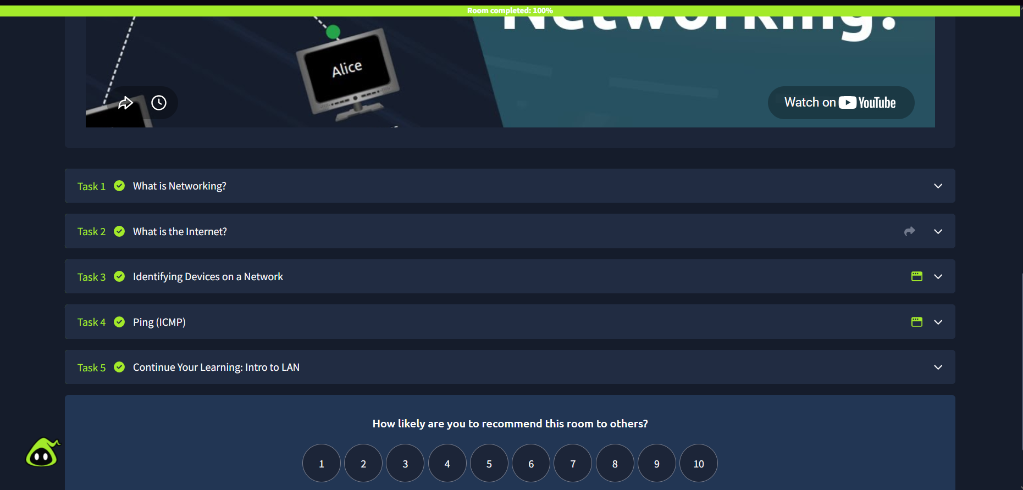
Figure 1.4 – Completion screen: all five tasks ticked and "Room completed: 100%".

What I learned
- The Internet is not one giant network. It is many small private networks (like a home or office LAN) connected together through public networks.
- Devices identify themselves with two labels. An IP address says where a device sits on a network, while a MAC address is tied to the device's network hardware.
- Ping tests reachability using ICMP. Its output tells you whether packets got through, how many were lost, and how long the round trip took, so it is a quick first check when a connection seems broken.
- Reading ping output properly matters as much as running the command. Zero packet loss and a low round-trip time mean a healthy path to that device.
- The World Wide Web (invented by Tim Berners-Lee) is a service that runs on top of the Internet, not the same thing as the Internet.

Room 2: Intro to Networking

What I did
- Task 1 – Introduction I read the overview, which explains that the room covers the models behind computer networking first and then the command-line tools used in practice.
- Task 2 – The OSI Model: An Overview I worked through the seven layers of the OSI model (Application, Presentation, Session, Transport, Network, Data Link and Physical) and what each one is responsible for, then answered the questions.
- Task 3 – Encapsulation I learned that as data moves down the layers on the sending device it gets wrapped with extra information (headers) at each layer, and that the receiving device unwraps it in the opposite order.
- Task 4 – The TCP/IP Model I compared the four-layer TCP/IP model with the seven-layer OSI model and how the layers line up. I also read how TCP sets up a connection with its three-way handshake (SYN, SYN/ACK, ACK). The questions checked the mapping between the two models: TCP/IP was introduced first, the OSI Transport layer maps to the TCP/IP Transport layer, the OSI Session layer is covered by the TCP/IP Application layer, the Network Interface layer covers Data Link and Physical, and the OSI Network layer is handled by the Internet layer (Figure 2.1).
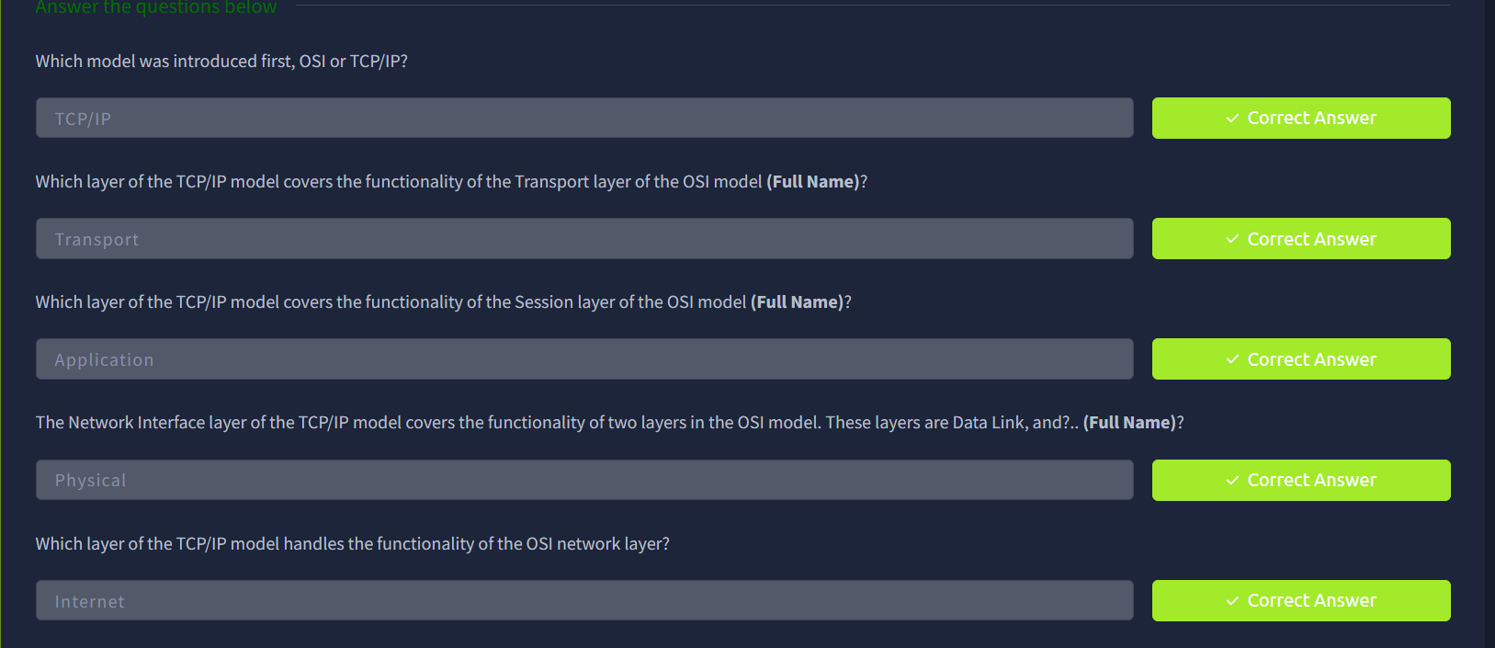
Figure 2.1 – Task 4: the TCP/IP versus OSI layer questions, all marked Correct Answer.
- Task 5 – Ping The room switches from theory to practical tools here, assuming a Linux machine. Ping tests whether a connection to a remote resource is possible using ICMP, which works at the Network layer of the OSI model (the Internet layer of TCP/IP). I also noted that ping shows the IP address of the server behind a domain name, and that "man ping" explains any syntax questions (Figure 2.2).
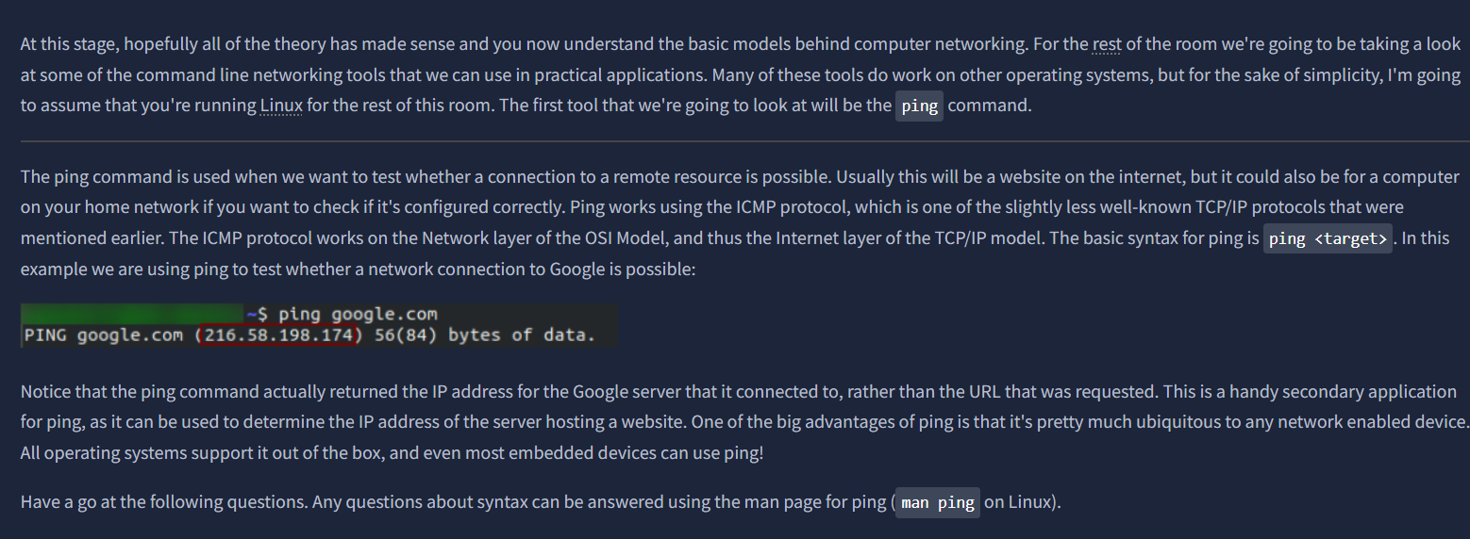
Figure 2.2 – Task 5: the room text explaining ping, ICMP and the man page.
- Task 6 – Traceroute I learned that traceroute shows the path a packet takes to a destination, one router (hop) at a time, which helps locate where a connection slows down or fails. The task example showed a route of 13 hops. I ran traceroute against tryhackme.com to see the path my request took (that question needs no answer). I then used the man page to find the switch that specifies an interface (-i) and the switch that uses TCP SYN requests (-T). The lateral-thinking question asked which TCP/IP layer traceroute runs on by default on Windows, and the answer is the Internet layer, because it works with ICMP messages (Figure 2.3).
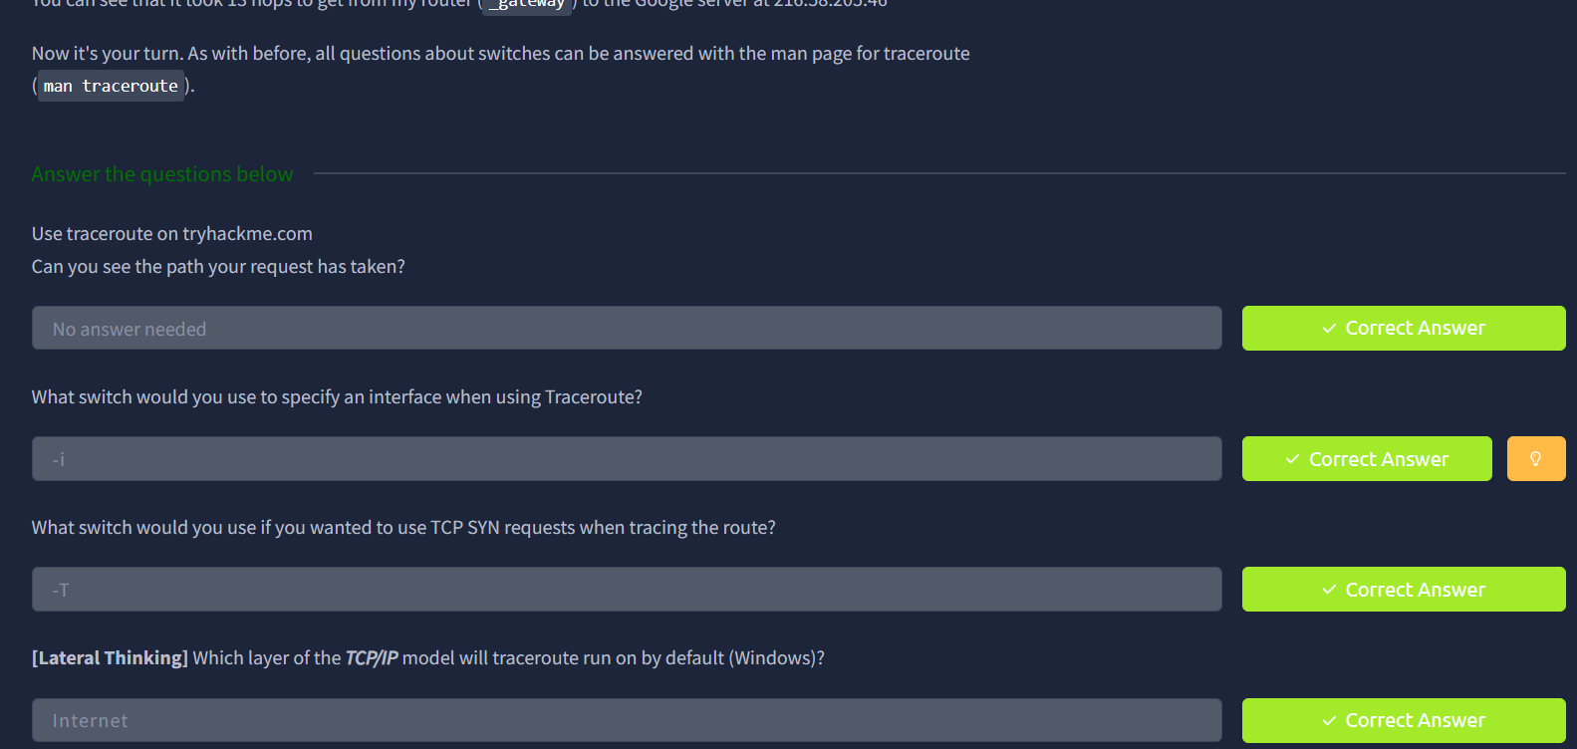
Figure 2.3 – Task 6: the traceroute questions, all marked Correct Answer.
- Task 7 – WHOIS WHOIS looks up who a domain is registered to and related registration details such as the registrar, dates and name servers.
- Task 8 – Dig This task covers DNS and the dig tool. The questions asked what DNS stands for (Domain Name System), which type of DNS server a computer asks first (a recursive server), which type holds records for domain extensions like .com and .co.uk (Top-Level Domain servers), and where the computer looks first before asking any server (its own local records). A research question asked for the second Google public DNS address alongside 8.8.8.8, which is 8.8.4.4. The last question asked what number dig shows for a TTL of 24 hours. dig reports TTL in seconds, so 24 × 60 × 60 = 86400 (Figure 2.4).
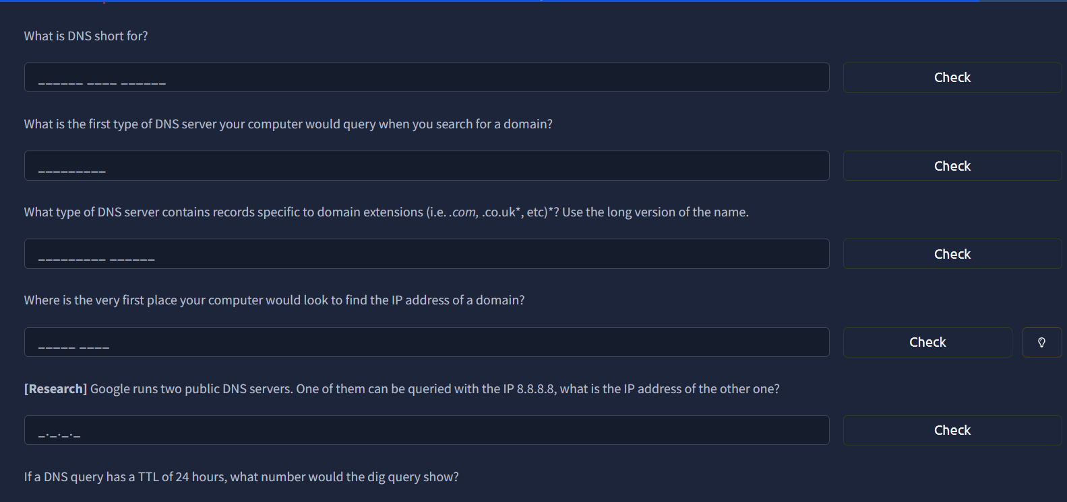
Figure 2.4 – Task 8: the DNS and dig questions.
- Task 9 – Further Reading This task lists extra resources and has no questions. With it marked, the room showed "Room completed: 100%" (Figure 2.5).
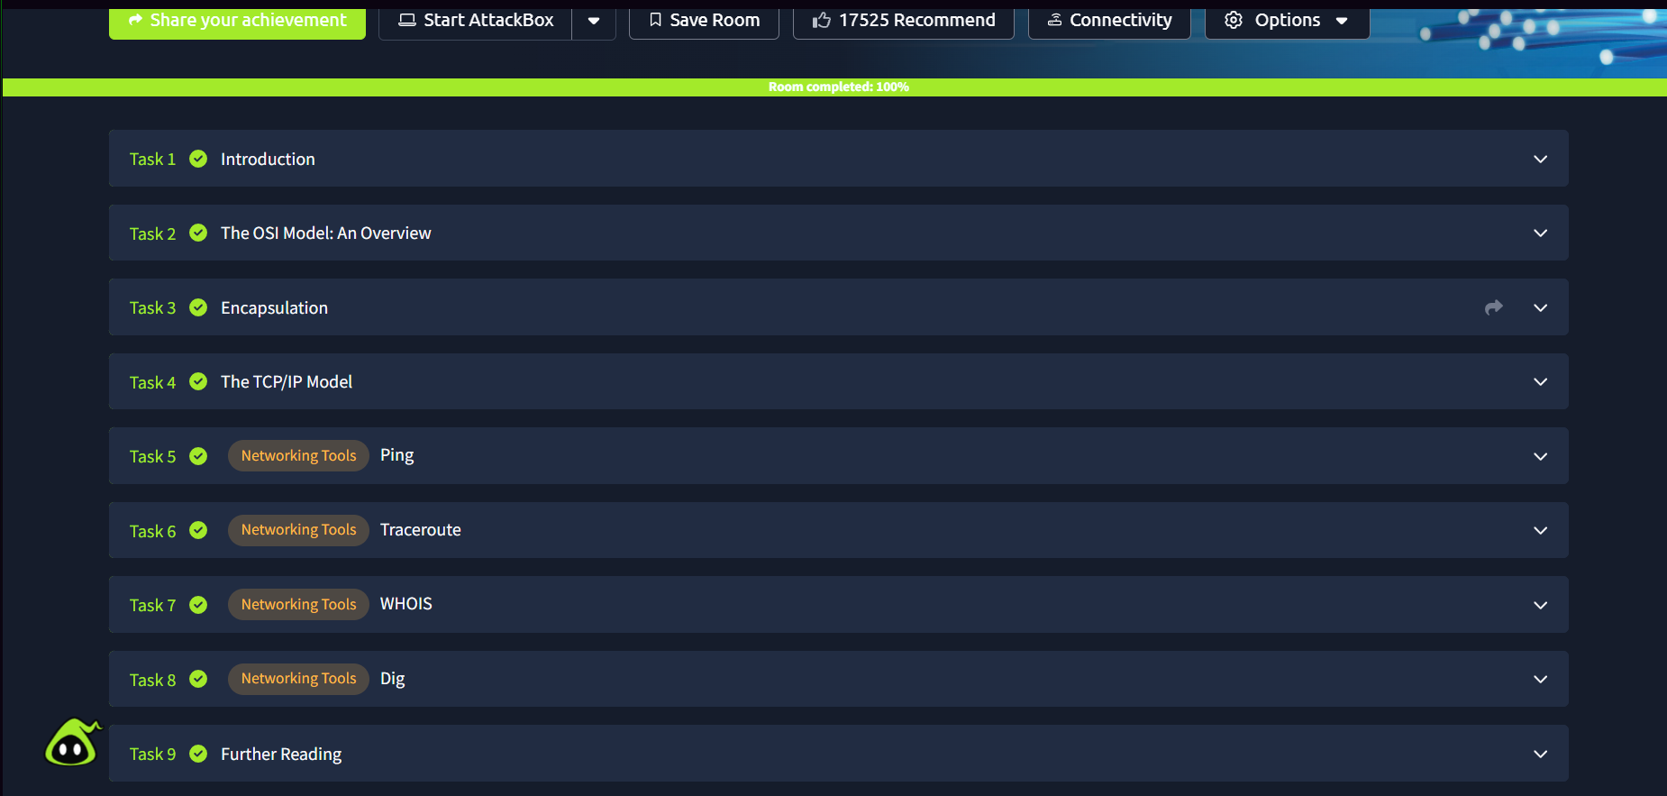
Figure 2.5 – Completion screen: tasks 1 to 9 ticked and "Room completed: 100%".

What I learned
- The OSI model splits networking into seven layers and the TCP/IP model into four. Both describe the same job, moving data from one device to another, at different levels of detail.
- Encapsulation is how data travels. Each layer adds its own header on the way down, and the receiver strips them off on the way up.
- TCP builds a reliable connection using a three-way handshake before any data is sent.
- Each tool answers a different question. Ping asks whether a device is reachable, traceroute asks what route the traffic takes, WHOIS asks who owns a domain, and dig asks what DNS says about a domain.
- DNS resolution is a chain: the computer checks its own records first, then a recursive server, which in turn asks root, Top-Level Domain and authoritative servers as needed.
- The TTL in a DNS answer is the number of seconds a record may be cached before it must be looked up again, which is why 24 hours shows up as 86400.

