Preparation of papers for Elektrotehniski vestnik (use style EV_Title)

Aleksander Kovač (EV_Auth)

Fakulteta za računalništvo in informatiko (EV_Kontakt)

Mentor: prof. dr. Denis Trček

E-mail: ak78348@student.uni-lj.si

Received  
Accepted

**Abstract.** These instructions give you guidelines for preparing papers for the journal Elektrotehniski vestnik. The document can be used as a Word template for writing papers, *LaTeX* template is also available online. The short abstract of the paper shoud have no more than 200 words. Do not use equations and references to the figures or likterature in the abstract. (EV_Abstract)

**Keywords:** provide up to 5 keywords

**Title of the paper in Slovenian language**

Provide short abstract in Slovenian language if one of the authors is native speaker. If you are unable to provide translation, the Editor will prepare the abstract translation.

(EV_Slovene)

# Introduction (Heading 1)

The *Elektrotehniški vestnik* strives to publish well-written papers in all areas of electrical engineering and computer science that present important research results, successful applications or development, and well-focused surveys which put recent progress into a broader perspective. The journal publishes papers in English and Slovenian language. The preferred length of the paper is 6 pages.

# Paper Submission

Paper submission procedure for Elektrotehniski vestnik:

* Send electronic version of the manuscript in **pdf** or **docx** format to the Editor according to the instructions from the EV home page: *http://ev.fe.uni-lj.si/*
* The Editor will take care of the review process and return to the contact author the reviewers notes and copyediting notes.
* If the paper gets accepted, the contact author will be asked to amend the manuscript. The Editor will check the manuscript and send it to the appropriate lector.
* Apply the received lector corrections and send the final version of the manuscript in source format (**docx** or **LaTeX**, including graphic files) to the Editor. Please mark the parts where you disagree with lector.
* During the typesetting process the Editor will correspond with the author directly advising him/her of necessary steps to be taken for the processing of his/her manuscript.

## Manuscript styles (Heading 2)

Use manuscript styles as defined in this template. Do not change the size of characters or margins. Use style Normal for paragraph text. The first paragraph after the heading or figure is without identation, other paragraphs are indented using tabulator.

The header and footer on the title page will be set by the editor during final preparation of the manuscript for printing.

### Subchapters (Heading 3)

Divide the manuscript into chapters and subchapters up to the third level using the predefined styles.

### References

Use consecutively numbered citations within brackets. The sentence punctuation follows the bracket [1]. All citations should be listed in the chapter References.

### Equations

Equations should be written in italics and numbered:

 (1)

### Figures and Tables

Provide high-quality figures and consider that the printed edition of Elektrotehniski vestnik is in black-and-white. In the electronic online version we can print color figures. The figures can span one column or entire page width. Use captions for the figures and references in the text (see Fig. 1).

## Table 1. Table labels should be above the table.

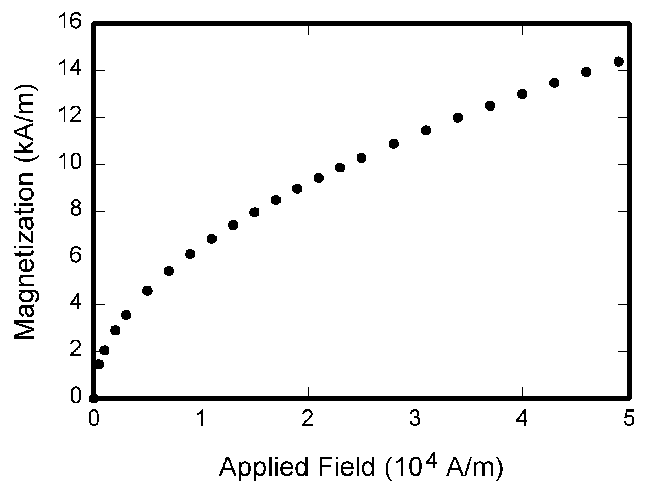

Figure 1. A short caption describing the figure. (Caption)

|  |  |  |  |  |
| --- | --- | --- | --- | --- |
| **L1+L2+L3** | **BP-in** | **BP-out** | **VK-in** | **VK-out** |
| S ' [VA] | 9937,3 | 9647,2 | 12297,6 | 10282,2 |
| P [W] | 9483,0 | 9397,7 | 10593,1 | 10077,8 |
| Q ' [VAr] | 2301,4 | 2068,9 | 5847,4 | 1763,2 |
| SH1 [VA] | 9922,2 | 9640,9 | 12265,1 | 10228,0 |
| PH1 [W] | 9480,3 | 9395,2 | 10619,8 | 10042,1 |
| QH1 [VAr] | 2140,2 | 2042,0 | 5702,1 | 1712,5 |
| SH1-40 [VA] | 9926,4 | 9643,6 | 12274,6 | 10274,7 |
| PH1-40 [W] | 9480,5 | 9396,6 | 10620,5 | 10087,2 |
| QH1-40 [VAr] | 2143,1 | 2043,6 | 5708,4 | 1720,8 |

# Conclusion

Provide short conclusion where you review the main points of the paper, do not replicate the abstract as the conclusion. A conclusion might elaborate on the importance of the work or suggest applications and extensions.

# Acknowledgement

You can include an acknowledgement section, which should appear before references.

# References

1. Elektrotehniški vestnik online, http://ev.fe.uni‑lj.si (1.1.2014).
2. Miklavčič Damijan “Objavljanje rezultatov raziskav - pisanje člankov”, *Elektrotehniški vestnik*, 77(1), str. 75-84, 2010.

**First Author** and the other authors should include short author biographies in the text at the end of regular papers.