Github link: https://github.com/shankar-01/MAD_Lab2

Task 1:

Answer:

1: onCreate, onStart, onResume

2: onPause, onStop

3: onRestart, onStart, onResume

4: onPause, onStop, onDestory, onCreate, onStart, onResume

Task2:

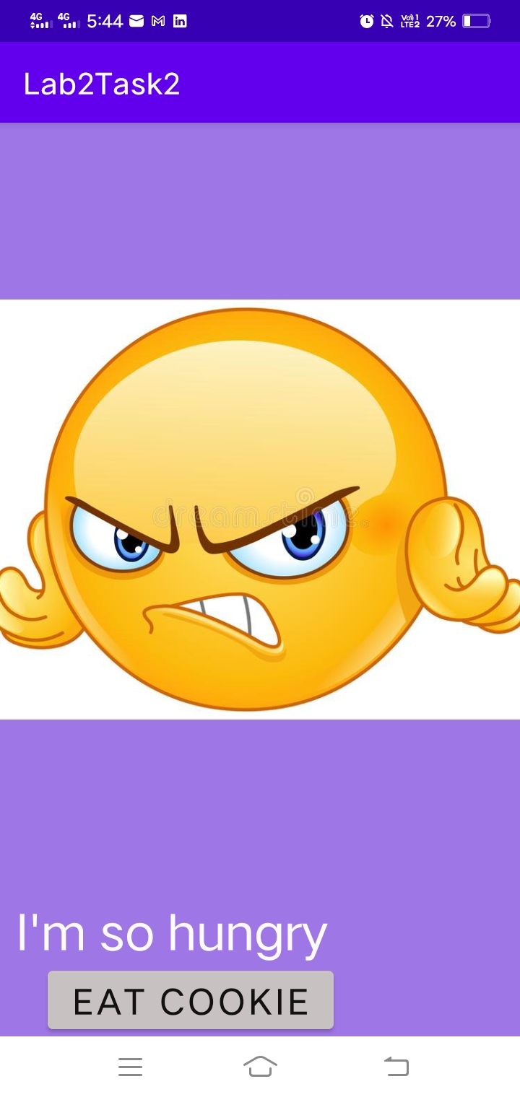

Task 3:

