DEVOPS ASSIGNMENT
Flask & MongoDB
Submitted by: Shankar Anand
Date: 29 September 2026
GitHub repository: https://github.com/shankar-anand1/Flask_and_MongoDB_ShankarAnand
I made a small Flask app. /api reads a JSON file and returns it. The home page has a form. If MongoDB insert works, it goes to a success page. If something fails, the error stays on the same form page.

How I ran it
pip install -r requirements.txt
python3 app.py
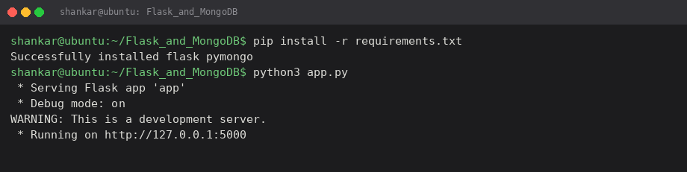

Task 1: JSON API Route
The list is stored in data.json (not hardcoded in the route). /api opens that file, loads it, and returns jsonify(data).
@app.route("/api")
def api():
with open("data.json", "r") as f:
data = json.load(f)
return jsonify(data)
Browser at http://127.0.0.1:5000/api :
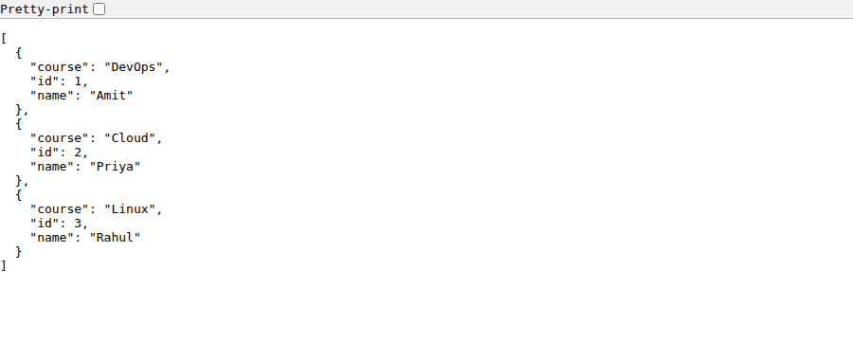
Same thing with curl:
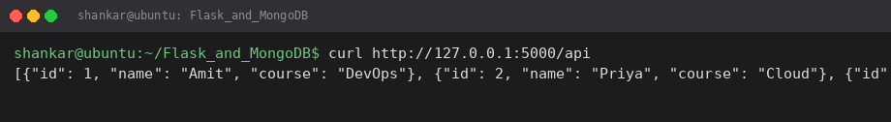

Task 2: Form + MongoDB Atlas
index.html is a normal POST form (name, email, message) to /submit. Home page:
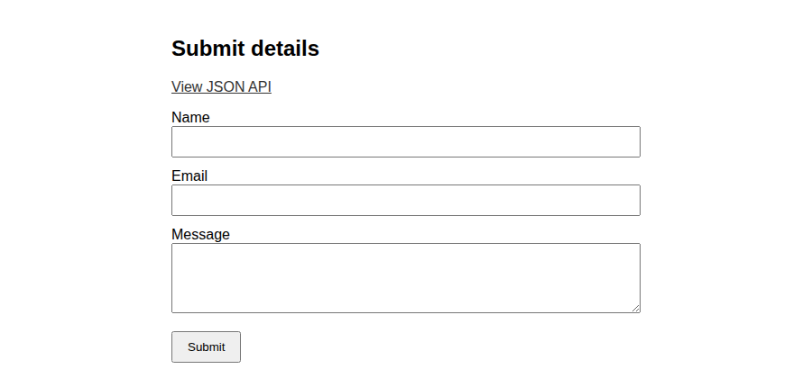
In app.py I connect with MongoClient using MONGO_URI. You have to replace USERNAME, PASSWORD and the cluster host, or export MONGO_URI. Also add your IP in Atlas Network Access.
client = MongoClient(MONGO_URI, serverSelectionTimeoutMS=8000)
client.admin.command("ping")
col.insert_one(doc)
On success it redirects to /success which shows the exact line: Data submitted successfully.
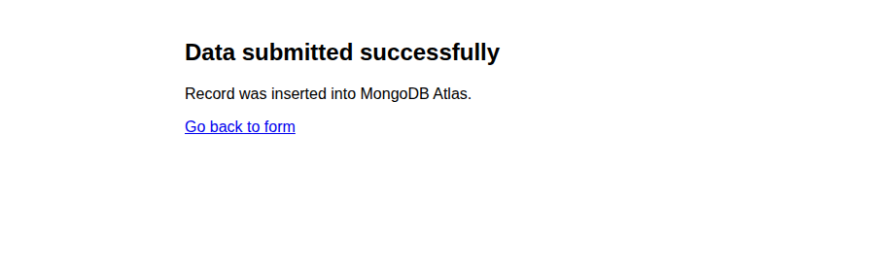
If name or email is empty I do not redirect. Error is printed on the same page.
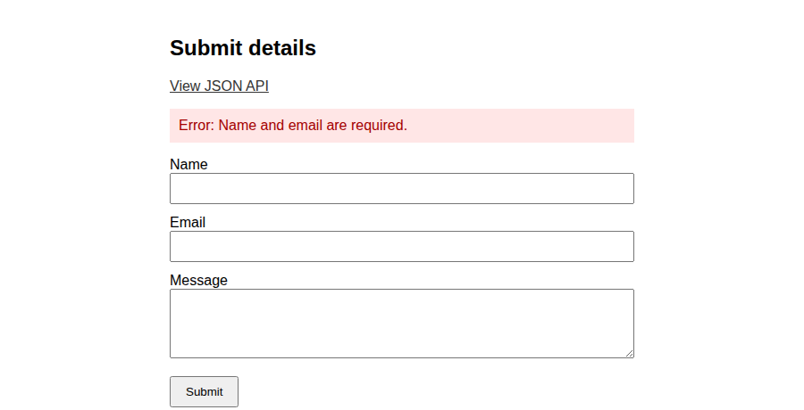
If Atlas is not set up (wrong URI / no network access) insert_one fails. I catch the exception and render index.html again with the error text. No redirect.
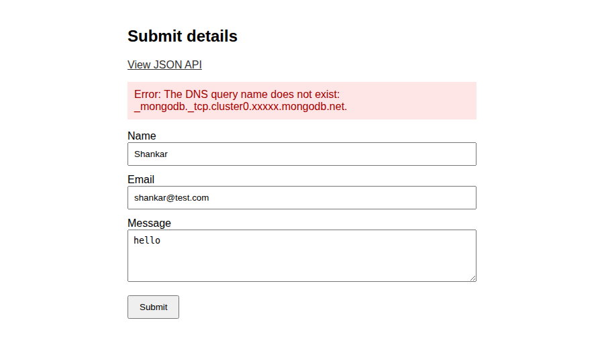

Files
app.py – routes
data.json – backend list for /api
templates/index.html – form
templates/success.html – success message
requirements.txt – flask, pymongo

Note
I did not put a real Atlas password in the code. After you create the cluster, paste the connection string in app.py and run the form again. Then take a new success screenshot if the teacher wants Atlas proof from your account.

