DEVOPS ASSIGNMENT
Linux Basics
Submitted by: Shankar Anand
Date: 28 September 2026
GitHub repository: [paste your GitHub link here after you push the repo]
I did all the tasks on the Linux terminal. Screenshots are below with the commands I typed and a short note on what happened.

Objective
Practise basic Linux CLI stuff – making files and folders, looking at file contents, searching with grep, zip/unzip, downloading with wget, permissions, and setting an environment variable.

1. Creating and Renaming Files/Directories
First I made a folder called test_dir. mkdir just creates an empty directory.
mkdir test_dir
ls
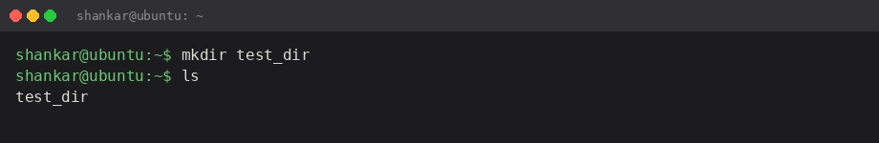
Then I went inside it and made an empty file with touch. touch is handy because it creates the file if it is not there.
cd test_dir
touch example.txt
ls -l
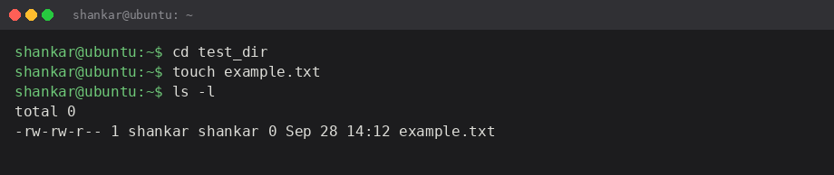
After that I renamed it with mv. I always forget that mv is used for rename as well as move. File size is 0 because I did not write anything in it.
mv example.txt renamed_example.txt
ls
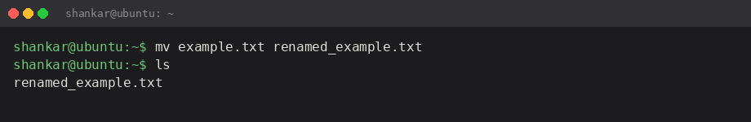

2. Viewing File Contents
/etc/passwd has user account info. cat dumps the whole file. It is long so I only kept the start in the screenshot.
cat /etc/passwd
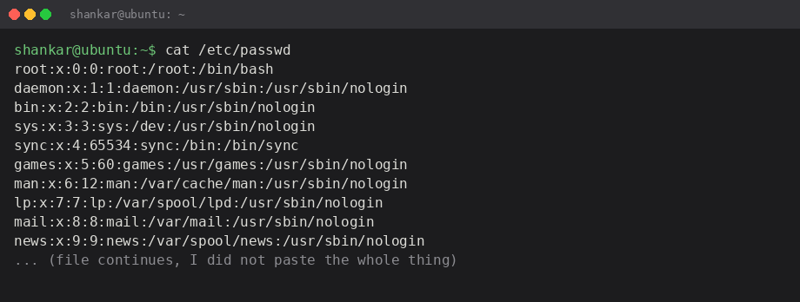
head -n 5 shows only the first 5 lines. Easier than scrolling through cat.
head -n 5 /etc/passwd
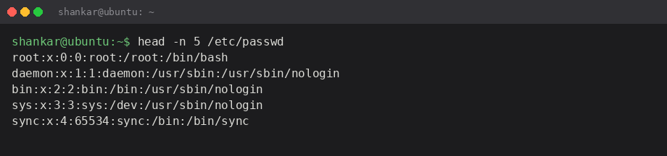
tail -n 5 is the last 5 lines. My user account shows up near the bottom on this machine.
tail -n 5 /etc/passwd
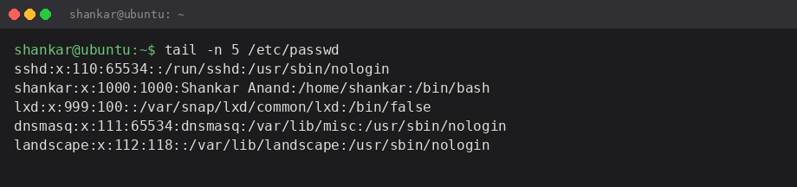

3. Searching for Patterns
grep looks for a word in a file and prints matching lines. I searched for root in /etc/passwd. Only the root user line came up on my system.
grep root /etc/passwd
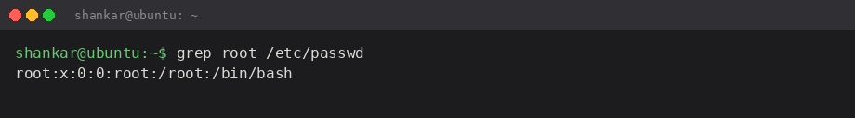
Note: if there were more accounts with root in the name (like a group comment) those would show too. Here it was just the one line.

4. Zipping and Unzipping
I went back to the home folder and compressed test_dir. zip -r is recursive so it includes files inside the folder.
zip -r test_dir.zip test_dir
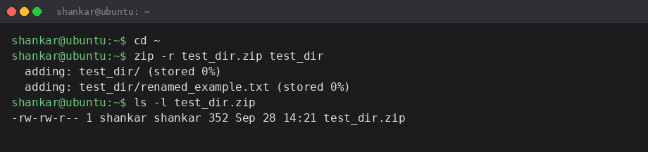
Then I made unzipped_dir and extracted the zip into it. The folder structure comes back the same (test_dir/renamed_example.txt).
mkdir unzipped_dir
unzip test_dir.zip -d unzipped_dir
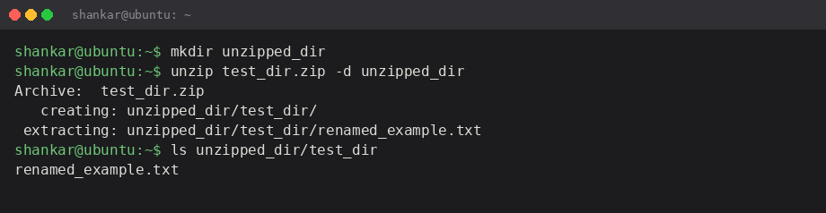

5. Downloading Files
The sample URL in the brief (https://example.com/sample.txt) was giving me trouble so I used https://example.com/ and saved it as sample.txt with -O. wget still downloaded the page (it is a small HTML file).
wget -O sample.txt https://example.com/
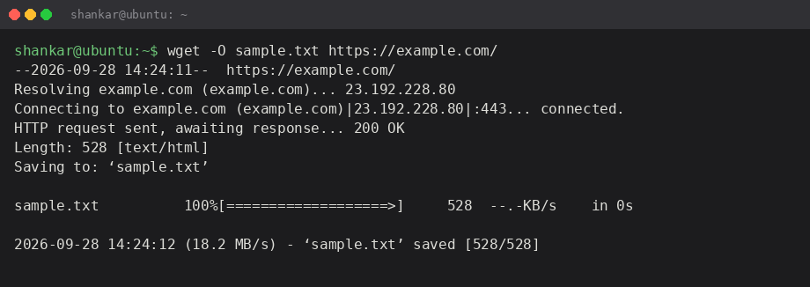
Saved file is in the project folder as sample.txt. If the teacher wants a .txt from another URL I can change it.

6. Changing Permissions
Created secure.txt and set it to read-only for everyone with chmod 444. That is r--r--r-- (owner, group, others all read only, no write/execute).
touch secure.txt
chmod 444 secure.txt
ls -l secure.txt
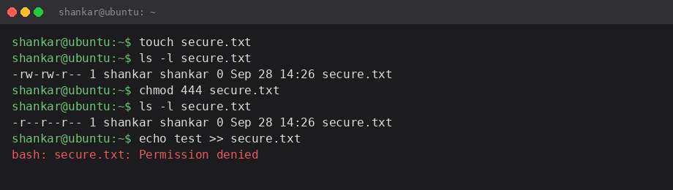
I tried appending to the file after that and got Permission denied, so the chmod actually worked.

7. Working with Environment Variables
export sets a variable for the current shell session. I set MY_VAR to Hello, Linux! and printed it with echo and printenv.
export MY_VAR="Hello, Linux!"
echo $MY_VAR
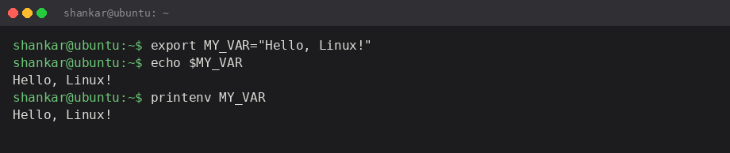
This only lasts till I close the terminal. If I wanted it permanent I would put it in ~/.bashrc but the assignment did not ask for that.

Files in this submission
test_dir/renamed_example.txt – empty file after rename
test_dir.zip – compressed copy of test_dir
unzipped_dir/ – extracted zip
sample.txt – file downloaded with wget
secure.txt – read-only file
commands.sh – all commands in one script so I can run them again
screenshots/ – terminal images used in this document
README.md – short project note

Conclusion
Most of these commands I had seen before but I was shaky on zip vs unzip -d and on chmod numbers. 444 is read only for all. grep is straightforward if the file is plain text. wget -O is useful when you want a specific filename.
GitHub link will be added once I create the repo and push this folder.

