DEVOPS ASSIGNMENT
Python & Bash
Submitted by: Shankar Anand
Date: 28 September 2026
GitHub repository: https://github.com/shankar-anand1/Python_and_Bash_ShankarAnand
The brief is mostly Python (if/else, dictionary, file write and read). I wrote four small programs and ran them with python3.

Objective
Practise core Python – conditionals, dictionaries, and reading/writing files.

Files
grade_checker.py – task 1
student_grades.py – task 2
write_file.py – task 3
read_file.py – task 4
notes.txt – file created by write_file.py
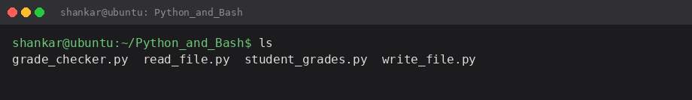

1. Grade Checker
Program takes a score from the user and prints A, B, C, D or F. I used if / elif / else because the ranges are simple.
score = int(input("Enter the score: "))
if score >= 90:
grade = "A"
elif score >= 80:
grade = "B"
Same pattern for C (70), D (60) and else F. Full code is in grade_checker.py.
I ran it three times to check the boundaries.
python3 grade_checker.py
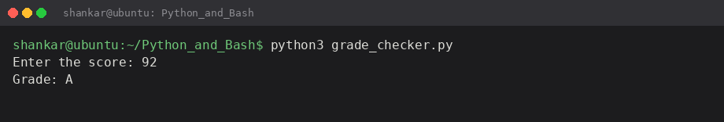
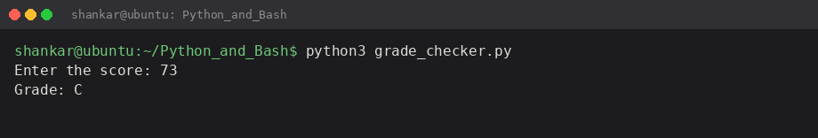
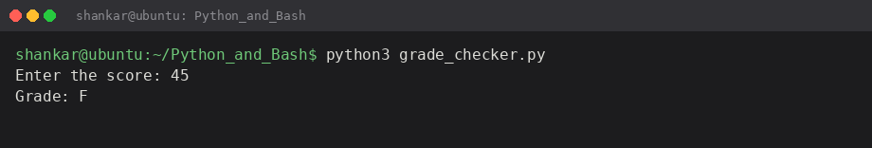
92 gave A, 73 gave C, 45 gave F. Looks correct.

2. Student Grades
I made a dictionary with 3 students already in it so I could test update and print without adding first.
students = {"Amit": "B", "Priya": "A", "Rahul": "C"}
Menu has 3 options: add, update, show all. For update I check if the name is in the dictionary first, otherwise it would just add a new key by mistake.
Show all:
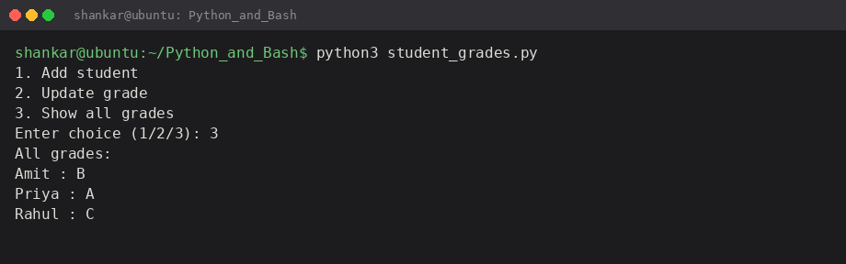
Add a student:
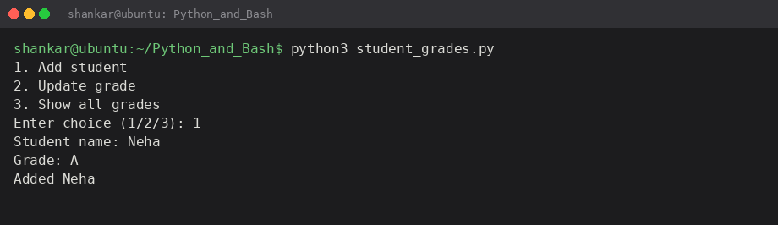
Update Rahul from C to B:
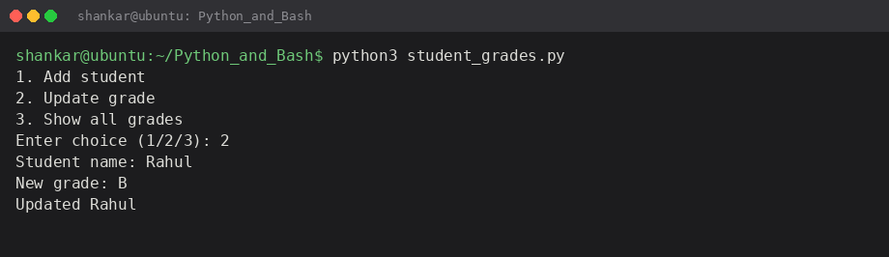
Note: because the dictionary is created fresh every time I run the script, the add/update does not stay after the program ends. That is normal unless I save it to a file, which this task did not ask.

3. Write to a File
open() in write mode creates notes.txt (or overwrites it). I wrote 3 lines then close().
f = open("notes.txt", "w")
f.write("DevOps assignment - file handling\n")
f.close()
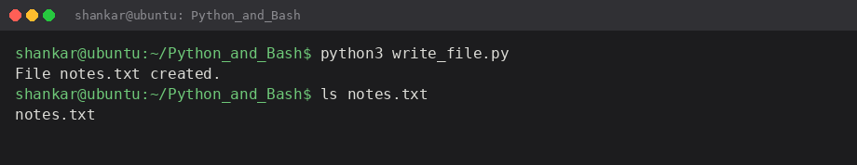

4. Read from a File
Same file, opened in read mode. file.read() gives the whole content as one string and I printed it.
f = open("notes.txt", "r")
content = f.read()
print(content)
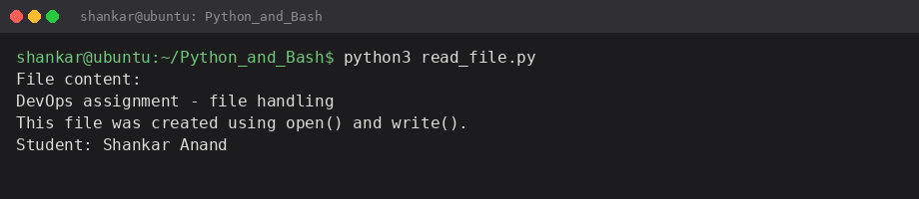
Output matches what I wrote in task 3.

How to run
From the project folder:
python3 grade_checker.py
python3 student_grades.py
python3 write_file.py
python3 read_file.py

Conclusion
If/elif is enough for the grade bands. Dictionary add and update is just students[name] = grade. File write and read is straightforward if I remember to close the file. Title says Python & Bash but all four tasks were Python so I did not add extra bash scripts.

