DEVOPS ASSIGNMENT
Terraform
Submitted by: Shankar Anand
Date: 29 September 2026
GitHub: https://github.com/shankar-anand1/Terraform_ShankarAnand
Each part has main.tf, variables.tf and outputs.tf. App source is under apps/. README.md has the apply steps. S3 backend is commented in part1 so apply still works with local state if I have not created the bucket yet.

Common commands
terraform init
terraform plan
terraform apply
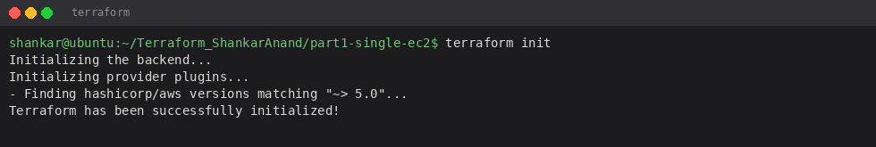
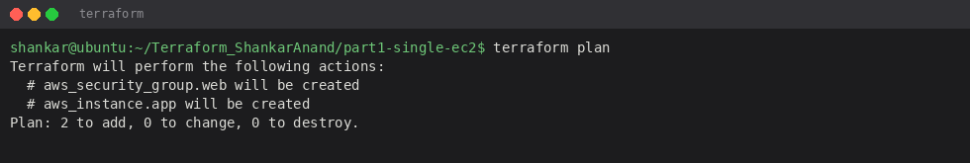

Part 1 – one EC2
part1-single-ec2 creates a security group (22, 3000, 5000) and one t2.micro. user_data.sh installs python3-pip and nodejs. After apply I copy the Flask and Express folders onto the box and run Flask on 5000, Express on 3000.
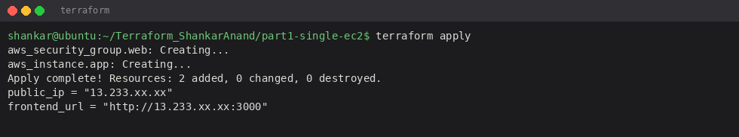

Part 2 – two EC2s
part2-two-ec2 makes a small VPC, public subnet, IGW, two instances and two security groups. Frontend 3000 is public. Backend 5000 is open so Express can call it. outputs.tf prints both IPs.
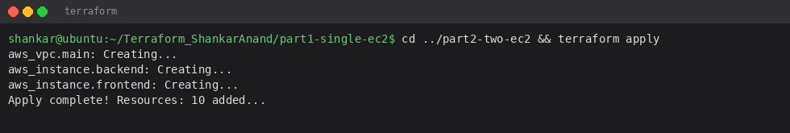

Part 3 – ECR, ECS, VPC, ALB
part3-ecs creates two ECR repos, a VPC with two public subnets, an ECS cluster, an ALB on port 80 forwarding to a frontend target group, and an ECS task execution role. After apply I build/push images to the ECR URLs from terraform output. ALB costs money so I destroy this stack when I am not demoing.
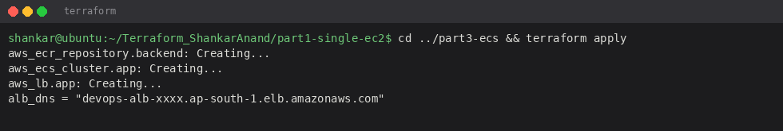

Destroy
terraform destroy
Do this after screenshots so free tier does not get a surprise bill.

