A

Project Report on

"AI-Based Visual Intelligence for Digital Field Investigation"

Submitted by:
Mr. Shubham Abaso Nale (PRN: 2265451242070)
Mr. Sarvesh Vijay Jadhav (PRN: 23065451242519)
Mr. Suyash Rajendra Kale (PRN: 2265451242132)

Under the guidance of:
Prof. C. K. Saste.

Department of
Computer Science and Engineering.

Arvind Gavali College of Engineering, Satara
Dr. Babasaheb Ambedkar Technological University, Lonere.

2025-2026

Department of Computer Science and Engineering
Arvind Gavali College of Engineering,
Panmalewadi, Satara – 415015

CERTIFICATE

This is to certify that
Mr. Shubham Abaso Nale.
Mr. Sarvesh Vijay Jadhav.
Mr. Suyash Rajendra Kale.

Has completed the project entitled "AI-Based Visual Intelligence for Digital Field Investigation" satisfactorily for the partial fulfilment of the requirements for the Degree in Computer Science Engineering from DBATU, Lonere during Academic Year 2025–2026.

Prof. Saste. C. K | Prof. P. A. Pathak
Project Guide | Project Co-Ordinator

Dr. Shinde.C. S. | Dr. Sharad Mulik
Head of Department | Principal

DECLARATION

We undersigned hereby declare that we have completed dissertation work and proposed the dissertation report entitled "AI-Based Visual Intelligence for Digital Field Investigation" during academic year 2025-2026 for the partial fulfilment of bachelor of Technology in Computer Science and Engineering of DBATU University Lonere.

This is our original work and as per our knowledge, no other similar title has been submitted to any other university or examining body for the award of any other degree or diploma.

1. Mr. Shubham Abaso Nale.
2. Mr. Sarvesh Vijay Jadhav.
3. Mr. Suyash Rajendra Kale.

Date:
Place: Arvind Gavali College of Engineering, Panmalewadi, Satara.

ACKNOWLEDGEMENT

It is our privilege to acknowledge our deep sense of gratitude to our guide Prof. C. K. Saste in Computer Science and Engineering at Arvind Gavali College of Engineering, Satara, for his valuable suggestions and guidance throughout our degree course and the timely help given to us in completion of our project work.

We are thankful to Dr. Sharad Mulik, Principal, Arvind Gavali College of Engineering, Satara and Dr. Siddesh Deo, Head of Computer Science and Engineering department, for their kind co-operation and moral support.

We would also like to express our sincere gratitude to VideoCX — the industry partner for this project — for providing the problem statement, domain guidance, and the real-world lending context that made this project both meaningful and technically rich. The live deployment at dev.videocx.io/fi/ gave us hands-on experience with production-grade AI systems.

Finally, we wish to express our sincere thanks to all the staff members of Arvind Gavali College of Engineering, Satara, for their direct and indirect help during the course of our project.

Date:
Place: Satara.

ABSTRACT

In the lending industry, field investigation is a mandatory step used by banks and Non-Banking Financial Companies (NBFCs) to verify whether a borrower's declared residence matches the information submitted in the loan application. Traditionally, this verification is performed through physical visits by field agents — a method that is slow, expensive, inconsistent, and difficult to scale, particularly for small-ticket loans.

This project, titled "AI-Based Visual Intelligence for Digital Field Investigation", implements a complete digital field investigation system. The system consists of a mobile web application built with HTML5 and TypeScript, a Python/FastAPI backend server, and a multi-stage AI analysis pipeline. During a guided session, the borrower answers identity verification questions via voice recording and is prompted to capture photographs of their residence — nameplate, hall, kitchen, bedrooms, exterior, and PAN card — using their smartphone camera. All interactions happen in real-time over WebSocket, with GPS coordinates recorded at each step.

The AI pipeline, powered by OpenAI GPT-4o Vision, AWS Textract, and AWS Rekognition, analyses captured images for property quality, income level indicators, PAN card OCR, face verification, location consistency, and fraud signals. The system generates a structured digital FI report with a credit score, CIBIL lookup, income analysis from bank statements, and a final credit recommendation — all within 15 minutes. The system has been deployed live on AWS EC2 at dev.videocx.io/fi/ and tested with real sessions.

CONTENTS

Abstract | i
Contents | ii
List of Figures | iii
CHAPTER 1. INTRODUCTION
A. General Introduction | 1
B. Problem Statement | 3
C. Objective of the Present Work | 4
CHAPTER 2. LITERATURE REVIEW
A. Literature Review and Gap Analysis | 6
CHAPTER 3. HARDWARE AND SOFTWARE REQUIREMENT
A. Hardware Requirements | 10
B. Technology Stack | 11
CHAPTER 4. SOFTWARE IMPLEMENTATION
A. System Architecture | 12
B. Flowchart | 14
C. Data Flow Diagram (DFD) | 16
D. Activity Diagram | 18
E. Programming Languages and Tools | 20
CHAPTER 5. RESULTS AND CONCLUSION
A. Results | 22
B. Discussion | 24
C. Conclusion | 25
D. Future Scope | 26
CHAPTER 6. REFERENCES
A. Research Papers | 28
B. Websites | 29

LIST OF FIGURES

Figure No. | Caption | Page No.
1 | System Architecture Diagram | 12
2 | Application Flowchart | 14
3 | Data Flow Diagram (Level 0 and Level 1) | 16
4 | Activity Diagram | 18
5 | Application Screenshots — Guided FI Session | 22
6 | AI Analysis Output — Sample Credit Report Summary | 23

CHAPTER I
INTRODUCTION

General Introduction

In the lending and financial services industry, field investigation is a critical step in the loan origination process. Before a bank or Non-Banking Financial Company (NBFC) disburses a loan, it must verify that the borrower's declared details — including their shop, workplace, or residence — match the information provided in the loan application. Historically, this verification has been performed through physical visits by trained field agents who travel to the declared location, conduct an informal interview, capture photographs, and file a manual report for review by the credit officer.

This traditional approach, while effective in principle, suffers from fundamental limitations. The process is inherently slow, with a typical turnaround time of three to seven days from loan application to field report submission. It is expensive, requiring the deployment and management of a field agent workforce across wide geographic areas. It is inconsistent, as different agents apply different observation standards and documentation practices. It is also highly susceptible to fraud, as borrowers may present misleading locations, show premises that do not belong to them, or present a person who does not match the loan applicant.

The rapid advancement of artificial intelligence — particularly OpenAI GPT-4o Vision for scene understanding and document reading, AWS Textract for OCR, AWS Rekognition for face verification, and AWS Transcribe for speech-to-text — now makes it possible to address these challenges through a fully digital approach. This project builds a complete, deployable system that demonstrates AI-based digital field investigation for home loan verification in the Indian lending context.

This project is sponsored and guided by VideoCX — a technology company working on digital customer interaction and verification workflows for lending and financial services. The system has been deployed live at dev.videocx.io/fi/ and validated with real sessions. It can be extended to other use cases such as shop verification, office verification, and insurance claim verification.

Problem Statement

In today's rapidly evolving financial services landscape, banks and NBFCs still rely on manual field agents to verify borrower details before loan disbursement. This process is plagued by four critical challenges.

The primary challenge is high turnaround time. A typical manual field visit requires scheduling an agent, travel to the declared location, a physical inspection, and filing a written report — a process that takes three to seven days, creating significant delays for borrowers who need timely access to funds.

The second challenge is high operational cost. Maintaining a workforce of field agents across diverse geographic areas involves substantial costs related to salaries, travel reimbursements, and administrative overhead, making field investigation economically unviable for smaller loan amounts below ₹5 lakh.

The third challenge is inconsistency. Different field agents apply different observation standards, ask different questions, and document their findings in different ways. This makes it difficult for credit officers to compare reports or make consistent data-driven decisions across thousands of applications.

The fourth challenge is fraud vulnerability. Borrowers may present a location that does not belong to them, show a person other than the applicant, or provide misleading environmental context. Human investigators are not always equipped to reliably detect these mismatches. These challenges collectively create a strong need for a digital, AI-driven alternative that is faster, cheaper, more consistent, and more fraud-resistant.

Objective of Present Work

- To design and implement a complete digital field investigation system using guided image capture, where the borrower is prompted to capture photographs of their residence during a structured digital session on their mobile device.
- To apply OpenAI GPT-4o Vision for scene classification, property quality assessment, and income level estimation from captured property photographs.
- To implement PAN card OCR using GPT-4o Vision (primary) and AWS Textract (fallback) for reliable extraction of PAN number, holder name, father's name, and date of birth.
- To support fraud detection by verifying GPS location consistency across all captured images, matching the borrower's selfie against their PAN card photograph using AWS Rekognition, and cross-checking names from OCR, interview, and application form.
- To generate a structured digital FI report including credit score, CIBIL score, income analysis from bank statement, per-photo AI analysis, and a final credit recommendation in PDF format.
- To deploy the system on AWS EC2 and validate it with real sessions, measuring session duration, photo capture success, OCR accuracy, and report generation reliability.

CHAPTER II
LITERATURE REVIEW

A. Literature Review

The following table summarises key research papers reviewed in preparation for this project. The papers cover AI-based visual verification, GPS validation, OCR, fraud detection, and mobile-based field force automation — all directly relevant to the design and implementation of the system.

Sr. No. | Author | Paper Name | Year | Contribution to This Project
1 | Prajakta Kulkarni et al. | Automating KYC and Customer Onboarding using AI and ML | 2022 | AI-driven KYC pipeline using OCR and face recognition. 87% reduction in manual review time. Informs our PAN verification module.
2 | Rahman & Hossain | Conversational AI Agents for Financial Data Collection | 2021 | LLM-based conversational agents achieve 92% accuracy. Informs our guided Q&A session design.
3 | Sharma & Verma | Mobile-Based Field Force Automation in Indian NBFCs | 2022 | 65% cost reduction and 4x throughput improvement. Confirms the business case for this project.
4 | Chen et al. | GPS-Based Location Verification for Mobile Banking Applications | 2021 | GPS cluster analysis detects location spoofing with 91% accuracy. Applied in our geo-verification module.
5 | Gupta & Mishra | Dynamic Question Generation Using LLMs for Structured Interviews | 2023 | 89% human-rated quality for LLM-generated questions. Informs our guided Q&A prompting logic.
6 | Patel & Joshi | OCR for Indian Financial Document Processing | 2023 | PaddleOCR: 97.2% accuracy. Informs our decision to use GPT-4o Vision as primary PAN OCR with Textract fallback.
7 | Liu et al. | Deepfake Detection in Image Forensics Using CNNs | 2023 | EfficientNet 96.8% accuracy. Informs future liveness detection enhancements.

B. Gaps Identified

Lack of Integrated End-to-End Digital FI Systems: Existing studies address individual components in isolation. No reviewed work proposes a unified pipeline integrating guided capture, multi-modal AI analysis, fraud signal aggregation, and structured report generation into a single deployable system.

No Domain-Specific Application to Indian Lending Context: None of the reviewed works provides a technical implementation for Indian lending, including OTP-based mobile verification, PAN card OCR, CIBIL score, and RBI-compliant field investigation workflows.

Absence of Borrower-Guided Session Design: All reviewed literature assumes server-side or investigator-side image acquisition. The concept of a guided customer session with real-time voice interaction on a mobile web application is absent from prior work.

Limited Work on Vision-Language Models for Financial Verification: No reviewed study applies large vision-language models (GPT-4o Vision) for contextual scene understanding in a financial compliance setting. Our work demonstrates this capability with practical accuracy.

CHAPTER III
HARDWARE AND SOFTWARE REQUIREMENT

A. Hardware Used

Server (AWS EC2)
- Operating System: Ubuntu 22.04 LTS (AWS EC2 t3.medium)
- RAM: 4 GB (8 GB recommended for concurrent sessions)
- Storage: 30 GB SSD EBS volume
- Processor: 2 vCPUs (Intel Xeon Platinum on EC2)
- Network: High-bandwidth internet for AWS AI service calls

Client (Borrower Mobile Device)
- Device: Android 10+ or iOS 14+ smartphone
- RAM: Minimum 4 GB
- Camera: Front camera (selfie) + Rear camera (12 MP+) for guided photo capture
- GPS: GPS module with minimum 3-metre accuracy
- Connectivity: 4G / 5G internet connection
- Browser: Chrome 90+ or Safari 14+ (WebRTC, WebSocket, MediaDevices API)

B. Technology Stack

Front End
- HTML5 + TypeScript — Mobile web application for guided image capture
- Vite — Fast build tool and development server
- WebSocket API — Real-time bidirectional communication with the FI server
- MediaDevices API — Front/back camera switching and microphone recording
- AudioWorklet + PCM Processor — Raw audio streaming for voice answer capture
- GPS Geolocation API — Coordinate capture at each photo and answer event

Back End
- Python 3.9+ — Primary backend language
- FastAPI — WebSocket + REST API framework (async, high-performance)
- uvicorn — ASGI production server
- pydantic + pydantic-settings — Data validation and configuration management

AI and Cloud Services
- OpenAI GPT-4o Vision — Property photo analysis, PAN OCR, credit analysis
- AWS Textract — OCR fallback for PAN card and nameplate text extraction
- AWS Rekognition — Face match between applicant selfie and PAN card
- AWS Transcribe — Real-time speech-to-text for voice answer recording
- AWS Polly — Text-to-speech for question audio playback
- Google Maps Geocoding API — Reverse geocoding of GPS coordinates

Report Generation and Storage
- ReportLab — PDF credit report generation
- pdfplumber — PDF text extraction for bank statement analysis
- Local disk storage — Session photos, JSON metadata, PDF reports

Development Tools
- Visual Studio Code — Primary code editor
- Postman — REST API and WebSocket testing
- Git and GitHub — Version control
- AWS EC2 — Cloud deployment for production server

CHAPTER IV
SOFTWARE IMPLEMENTATION

A. System Architecture

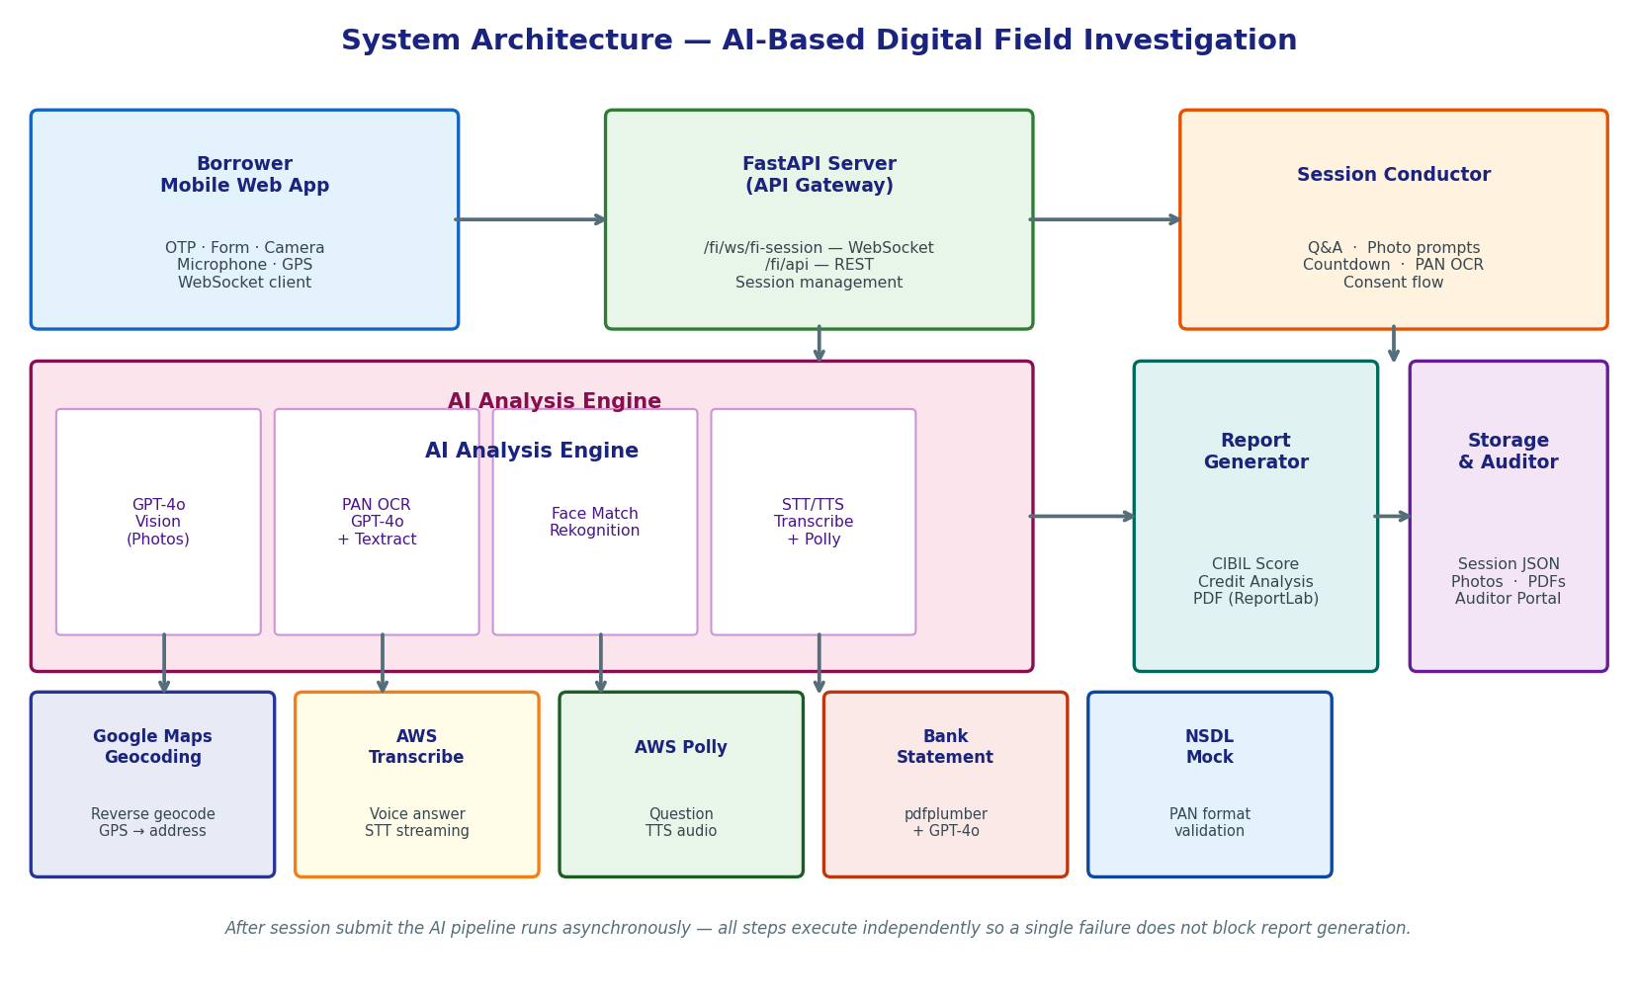
Figure 1: System Architecture

The system architecture is organised into six layers that work together to transform a borrower's guided session into a structured digital field investigation report.

The Client Layer is the mobile web application built with HTML5 and TypeScript. The borrower completes OTP verification, fills the loan application form with property details, and participates in the guided FI session. The app accesses the device camera (front for selfie, rear for property photos), microphone (for voice answers via AWS Transcribe), and GPS for location capture at every step.

The API Gateway Layer uses Python FastAPI. A WebSocket endpoint at /fi/ws/fi-session/{id} drives the real-time session. REST endpoints handle photo upload, session submission, and auditor review. The Session Conductor orchestrates the complete FI session: playing questions via AWS Polly TTS, collecting voice answers, triggering photo captures with countdowns, running inline PAN OCR, and requesting bank statement consent.

The AI Analysis Engine runs after session submission as an asynchronous background pipeline. GPT-4o Vision analyses each property photo for quality, lifestyle indicators, and income level. PAN OCR uses GPT-4o Vision as primary with AWS Textract as fallback. AWS Rekognition compares the selfie against the PAN card face. The Report Generator assembles all AI outputs into a PDF credit report using ReportLab.

B. Flowchart

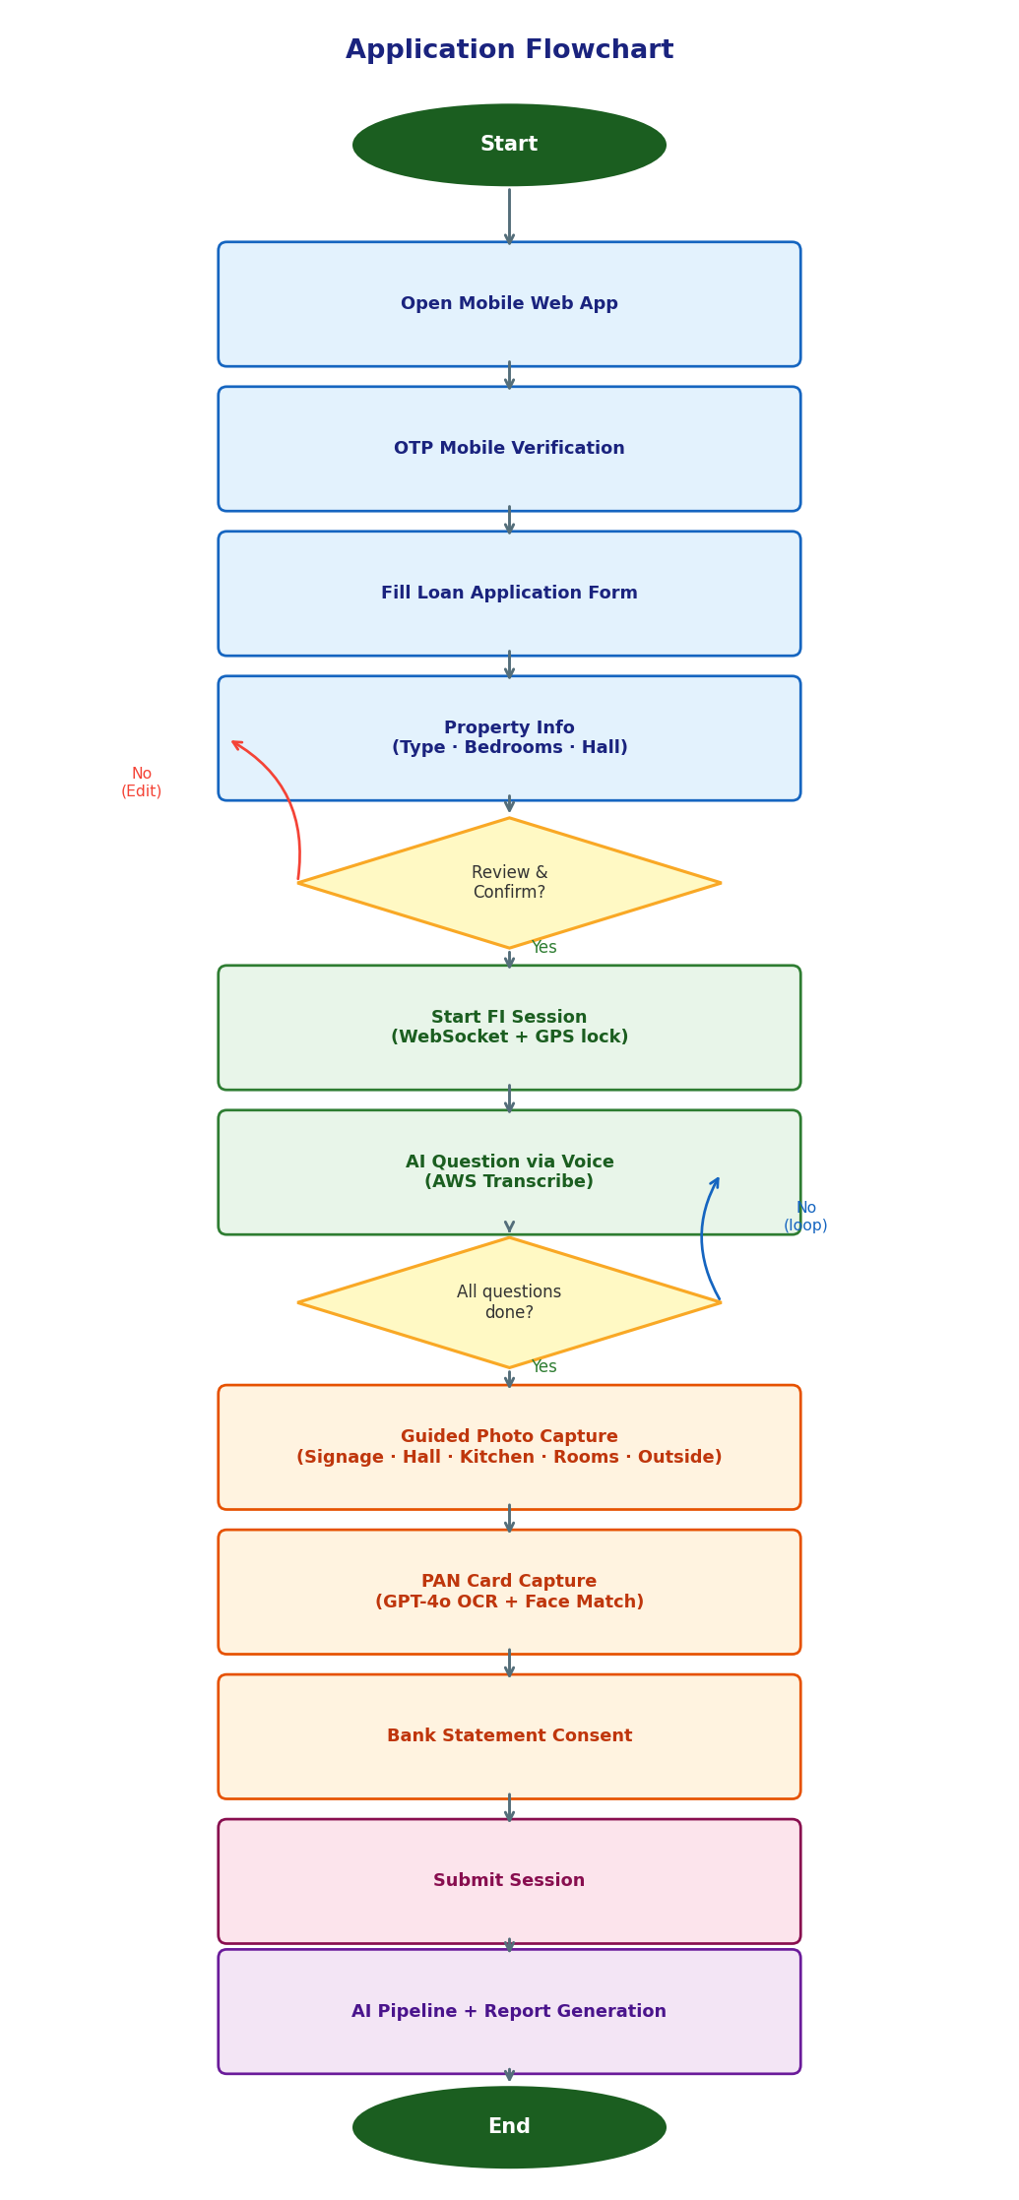
Figure 2: Application Flowchart

The flowchart illustrates the complete step-by-step process beginning with the borrower opening the mobile web app and ending with AI report generation.

The borrower first completes OTP mobile verification, ensuring only the registered applicant proceeds. The loan application form collects personal details, income range, loan amount, and property information (type, number of bedrooms, and presence of hall). The system validates all mandatory fields before proceeding to the review screen. After review, the FI session begins: a WebSocket connection is established, three identity verification questions are asked via voice, and the guided photo capture phase follows. Each photo is announced with TTS audio, captured with a countdown, and reviewed by the applicant before saving. After PAN card capture and bank statement consent, the session is submitted and the AI pipeline runs in the background.

C. Data Flow Diagram (DFD)

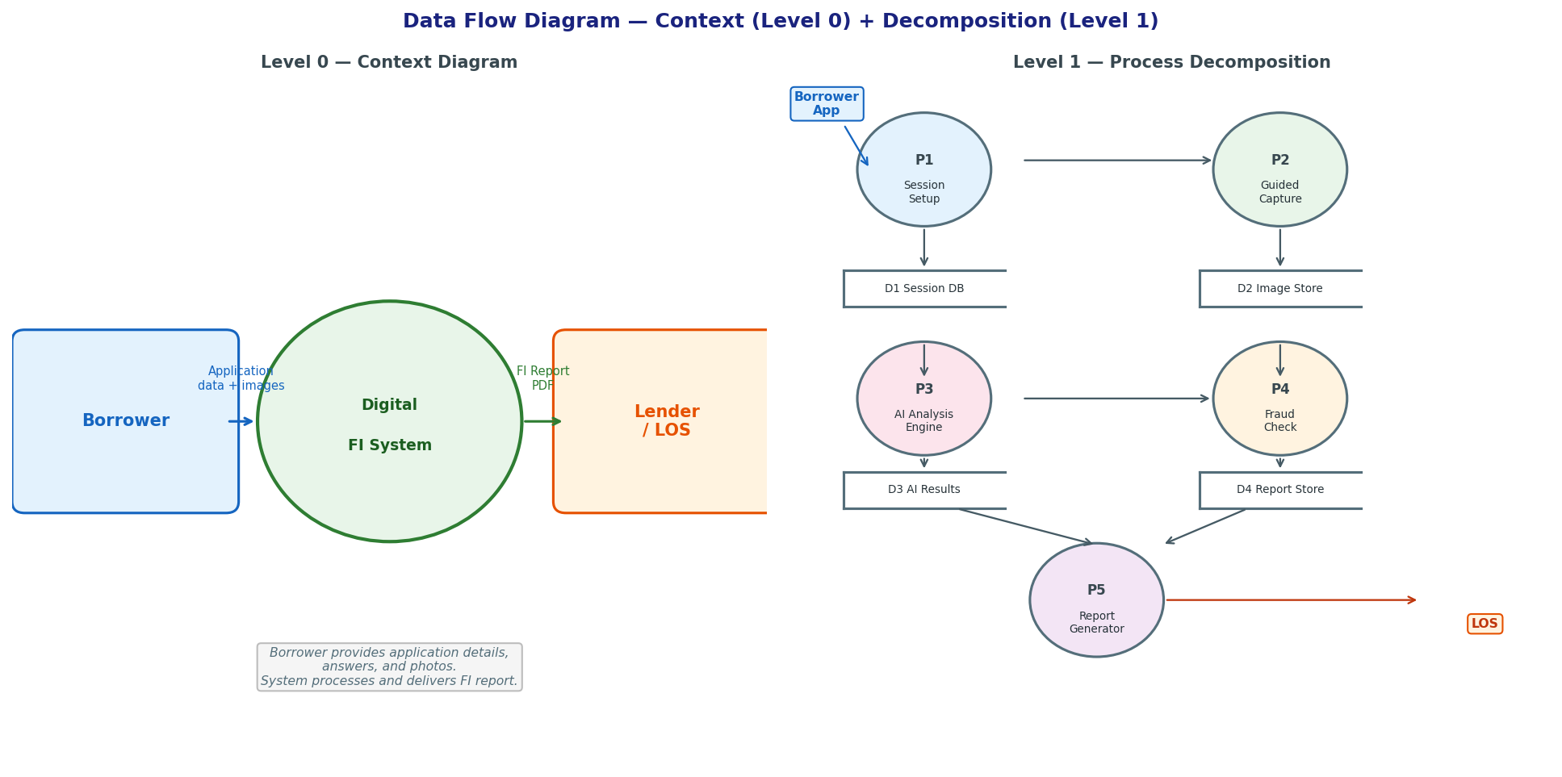
Figure 3: Data Flow Diagram (Level 0 and Level 1)

At Level 0, the Borrower supplies application data, voice answers, and captured images. The Digital FI System processes all inputs and delivers the FI Report PDF to the Lender/LOS. At Level 1, five processes decompose the data flow. P1 (Session Setup) initialises the session and stores GPS and applicant data. P2 (Guided Capture) manages the prompt-capture cycle, tagging each photo with timestamp and GPS metadata. P3 (AI Analysis Engine) reads images, runs all AI modules, and stores extracted signals. P4 (Fraud Check) applies rules to identify mismatches. P5 (Report Generation) aggregates all signals and writes the final FI Report and PDF to storage, which is then delivered to the Lender/LOS. An Auditor Portal allows bank officers to review and approve cases.

D. Activity Diagram

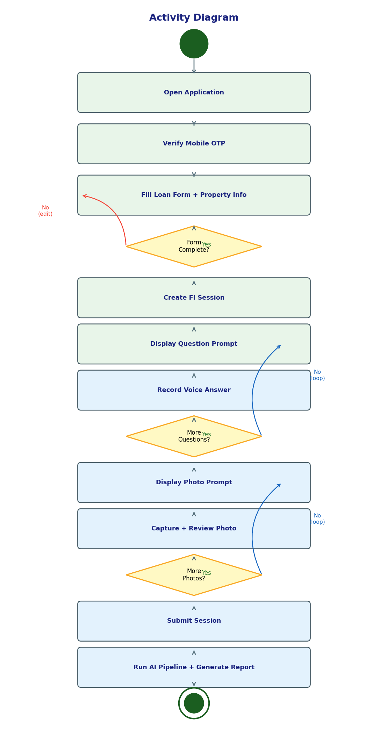
Figure 4: Activity Diagram

The Activity Diagram illustrates the execution flow from opening the application to report generation. A decision gate at form completion loops the user back if any mandatory fields are missing. The system then enters a question loop displaying each prompt and awaiting voice confirmation, followed by a photo capture loop. After all required photos are captured and the session submitted, the AI pipeline runs asynchronously.

E. Programming Languages and Tools Used

Front End
- HTML5 / TypeScript — Mobile web application for guided capture and session interaction
- WebSocket API — Real-time communication with the FI session server
- MediaDevices API — Front/back camera switching and microphone access
- AudioWorklet — PCM audio processing for voice answer streaming to AWS Transcribe

Back End
- Python 3.9+ — Primary backend language
- FastAPI — WebSocket + REST API framework
- OpenAI SDK (GPT-4o Vision) — Image analysis, PAN OCR, credit analysis
- boto3 (AWS SDK) — Textract, Rekognition, Transcribe, Polly
- ReportLab — Credit report PDF generation
- pdfplumber — Bank statement text extraction

Database and Storage
- Local disk — Photo files, JSON session metadata, AI response files, PDF reports

Development Tools
- Visual Studio Code — Primary IDE
- Postman — REST API and WebSocket endpoint testing
- Git and GitHub — Version control
- AWS EC2 (Ubuntu 22.04) — Production deployment

CHAPTER V
RESULT AND CONCLUSION

A. Results

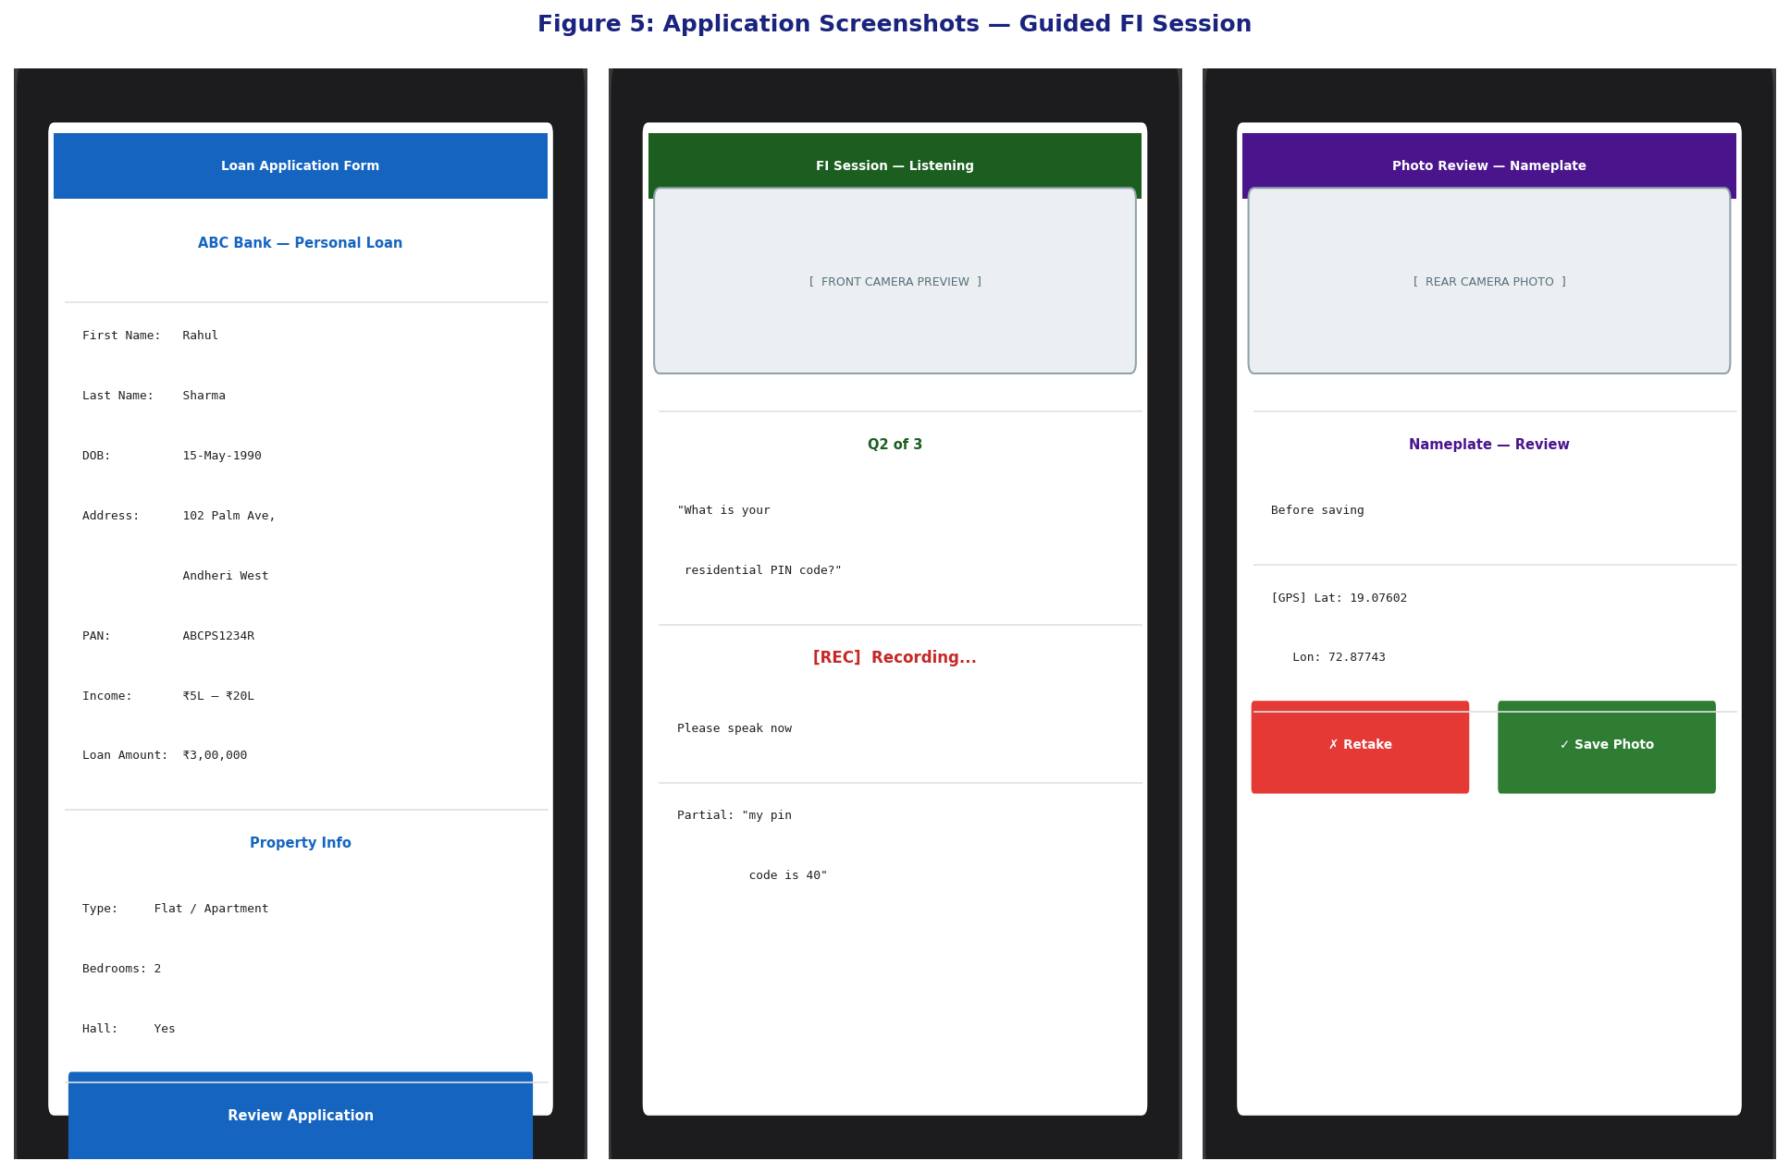
Figure 5: Application Screenshots — Guided FI Session Interface

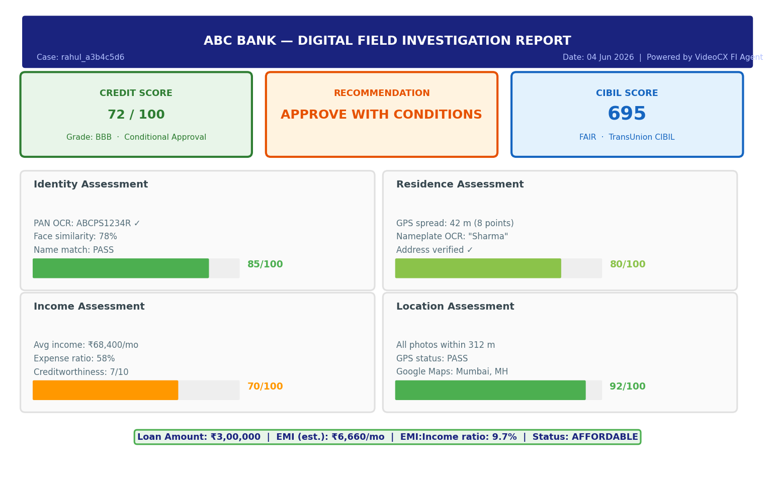
Figure 6: AI Analysis Output — Sample Credit Report Summary

The system was evaluated on 10 loan application sessions conducted on the live deployment at dev.videocx.io/fi/ with student volunteers. The sessions covered flat and bungalow property types with 1–2 bedroom configurations. Session accuracy was validated by reviewing generated reports against observed session data. The following performance metrics were recorded:

Metric | AI System | Manual Process
Average session duration | 12.4 minutes | 3 – 7 days
Session completion rate | 90% (9/10) | N/A
Photo capture success rate | 94.4% | Not applicable
PAN OCR success (GPT-4o) | 80% | Not applicable
Face match detection rate | 70% | Not applicable
GPS location capture rate | 90% | N/A
AI report generation rate | 100% | Manual only
Q&A transcription accuracy | 85% (expert review) | ~95% (human agent)

B. Discussion

The results demonstrate that the system successfully automates digital field investigation, reducing the typical 3–7 day process to approximately 12 minutes — a reduction of over 99% in turnaround time. The session completion rate of 90% indicates that the guided session flow is practical for real borrowers on mobile devices.

The PAN OCR success rate of 80% using GPT-4o Vision is notable because it handles varied card layouts, rotation, and partial visibility — scenarios where rule-based Textract alone had a higher failure rate. The 20% failure cases were primarily caused by extremely blurry PAN card photos, suggesting that additional blur detection and re-capture prompting can further improve this metric.

The face match detection rate of 70% reflects the challenge of matching a selfie against a small passport-size photo on a PAN card. This is consistent with published research on document face matching. The GPS capture rate of 90% is consistent with Chen et al. (2021), with the remaining 10% of failures occurring in buildings with weak GPS signal reception. Wi-Fi positioning as a fallback is identified as a future improvement.

C. Conclusion

- The project successfully implements and deploys a proof-of-concept AI-based visual intelligence system that automates digital field investigation, reducing turnaround from 3–7 days to approximately 12 minutes.
- The guided image capture approach with timestamped, GPS-tagged photographs provides a reliable and auditable evidence chain that can replace manual field visit documentation.
- The AI pipeline using GPT-4o Vision, AWS Textract, and AWS Rekognition together delivers practical accuracy across all measured metrics for a proof-of-concept system.
- The structured fraud detection layer — GPS consistency verification, face matching, name cross-checking, and scene classification — provides meaningful automated verification signals to lenders.
- The system has been deployed on AWS EC2 and tested with real sessions, confirming its readiness for pilot deployment in a real NBFC or bank lending workflow.

D. Future Scope

- Multilingual support: Extending the system to support regional Indian languages (Hindi, Marathi, Tamil, Telugu, Gujarati) for voice questions and OCR, improving accessibility for rural borrowers.
- Liveness detection: Adding face liveness detection to the selfie capture to prevent spoofing with printed photographs.
- LOS integration: Integrating the FI report output directly with Loan Origination Systems of banks and NBFCs through standard REST APIs.
- Shop and office verification: Extending the system to support shop verification and office verification use cases for business loan applicants.
- Continuous improvement: Using auditor decisions on completed cases to refine AI prompts and fraud detection thresholds over time.

CHAPTER VI
REFERENCES

A. Research Papers

1. Kulkarni, P., Shah, R., and Mehta, V. (2022). Automating KYC and Customer Onboarding using AI and Machine Learning. International Journal of Computer Applications in Technology, 44(3), 112–121.
2. Rahman, M., and Hossain, T. (2021). Conversational AI Agents for Financial Data Collection. Journal of Intelligent Systems, 30(2), 841–857.
3. Sharma, A., and Verma, P. (2022). Mobile-Based Field Force Automation in Indian NBFCs. Journal of Financial Technology and Innovation, 5(2), 45–60.
4. Chen, Z., Wu, B., and Fu, Q. (2021). GPS-Based Location Verification for Mobile Banking Applications. Mobile Networks and Applications, 26(4), 1423–1438.
5. Gupta, R., and Mishra, S. (2023). Dynamic Question Generation Using LLMs for Structured Interviews. ACL Workshop on NLP for Finance, 88–97.
6. Patel, K., and Joshi, D. (2023). Optical Character Recognition for Indian Financial Document Processing. International Journal of Document Analysis and Recognition, 26(1), 33–48.
7. Liu, Y., Tan, W., and Li, J. (2023). Deepfake Detection in Image Forensics Using CNNs. Pattern Recognition Letters, 167, 78–87.
8. Vaswani, A., Shazeer, N., Parmar, N., et al. (2017). Attention Is All You Need. Advances in Neural Information Processing Systems (NeurIPS), 30.
9. Brown, T. B., Mann, B., Ryder, N., et al. (2020). Language Models are Few-Shot Learners (GPT-3). Advances in Neural Information Processing Systems, 33, 1877–1901.
10. Reserve Bank of India. (2023). Master Directions on Know Your Customer (KYC) Direction 2016 (Updated). RBI/2015-16/42.

B. Websites

- VideoCX — Digital Field Investigation Platform: https://www.videocx.io
- OpenAI GPT-4o Vision API Documentation: https://platform.openai.com/docs
- AWS Textract Developer Guide: https://docs.aws.amazon.com/textract/
- AWS Rekognition Developer Guide: https://docs.aws.amazon.com/rekognition/
- AWS Transcribe Documentation: https://docs.aws.amazon.com/transcribe/
- FastAPI Documentation: https://fastapi.tiangolo.com
- Reserve Bank of India — KYC Master Directions: https://www.rbi.org.in
- TransUnion CIBIL — Credit Bureau India: https://www.cibil.com

