ALFIDO TECH INTERNSHIP

Task 1: Java Basics & OOP Fundamentals
Domain: Java Developer | Language: Java | IDE: Visual Studio Code

1. Objective
The objective of this task is to practise basic Java programming and understand fundamental Object-Oriented Programming (OOP) concepts. The task includes an arithmetic calculator and a student-details program that demonstrates classes, objects, constructors, methods, encapsulation, the this keyword, and conditional statements.

2. Software and Tools
- Java Development Kit (JDK)
- Visual Studio Code
- PowerShell terminal

3. Program 1 — Arithmetic Calculator
Description: This console-based program accepts two numbers and performs addition, subtraction, multiplication, and division. It checks whether the second number is zero before dividing.

Source Code
import java.util.Scanner;
public class ArithmeticCalculator {
public static void main(String[] args) {
Scanner sc = new Scanner(System.in);
System.out.println("=== Java Arithmetic Calculator ===");
System.out.print("Enter first number: ");
double a = sc.nextDouble();
System.out.print("Enter second number: ");
double b = sc.nextDouble();
System.out.println("\n--- Results ---");
System.out.println("Addition: " + (a + b));
System.out.println("Subtraction: " + (a - b));
System.out.println("Multiplication: " + (a * b));
if (b != 0) {
System.out.println("Division: " + (a / b));
} else {
System.out.println("Division: Cannot divide by zero.");
}
sc.close();
}
}

Sample Output
=== Java Arithmetic Calculator ===
Enter first number: 99
Enter second number: 99
--- Results ---
Addition: 198.0
Subtraction: 0.0
Multiplication: 9801.0
Division: 1.0

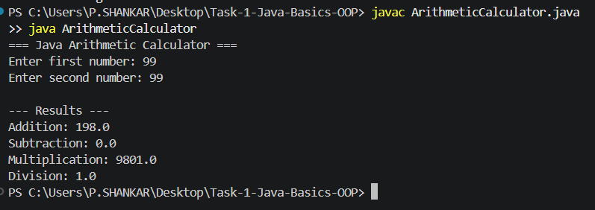
4. Program 2 — Student Details Using OOP
Description: This program defines a Student class with private data fields, a constructor to initialize student information, and methods to display details and check age status. The StudentDemo class creates two Student objects and calls their methods.

Source Code
class Student {
private String name;
private int age;
private String course;
public Student(String name, int age, String course) {
this.name = name;
this.age = age;
this.course = course;
}
public void displayDetails() {
System.out.println("Student Details");
System.out.println("--------------------");
System.out.println("Name : " + name);
System.out.println("Age : " + age);
System.out.println("Course : " + course);
}
public void checkAge() {
if (age >= 18) {
System.out.println("Status : Adult student");
} else {
System.out.println("Status : Young student");
}
}
}
public class StudentDemo {
public static void main(String[] args) {
Student s1 = new Student("Rahul", 20, "Java");
Student s2 = new Student("Priya", 17, "Computer Science");
s1.displayDetails();
s1.checkAge();
System.out.println();
s2.displayDetails();
s2.checkAge();
}
}

Sample Output
Student Details
--------------------
Name : Rahul
Age : 20
Course : Java
Status : Adult student
Student Details
--------------------
Name : Priya
Age : 17
Course : Computer Science
Status : Young student
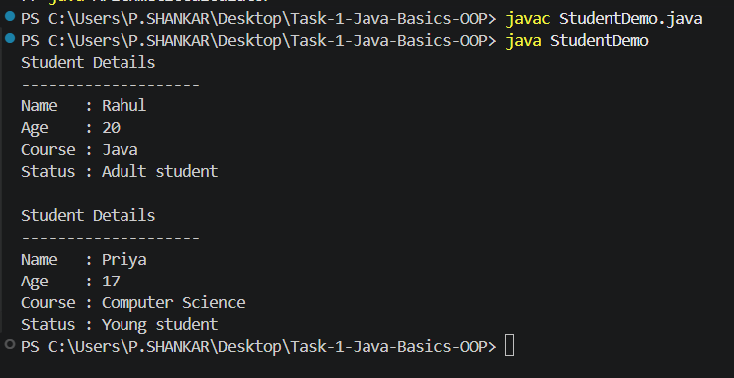

5. OOP Concepts Demonstrated
Concept | Explanation
Class | Student is a blueprint that defines student data and behaviour.
Object | s1 and s2 are separate instances of the Student class.
Constructor | The Student constructor initializes each object's fields.
Methods | displayDetails() and checkAge() define behaviours.
Encapsulation | The private fields restrict direct access from outside the class.
this keyword | this.name, this.age, and this.course refer to the current object's fields.
Conditional statement | if/else checks whether a student's age is at least 18.

6. How to Compile and Run
Calculator:
javac ArithmeticCalculator.java
java ArithmeticCalculator
Student OOP program:
javac StudentDemo.java
java StudentDemo

7. Learning Outcomes
Through this task, basic Java input/output, arithmetic operators, conditional logic, class and object creation, constructors, methods, encapsulation, and compiling/running Java programs from the terminal were practised.

8. Evidence and Repository Links
GitHub repository URL: https://github.com/shankar-uxcloud/java-programming-projects/

9. Conclusion
Both Java programs were compiled and executed successfully in Visual Studio Code. The calculator demonstrated basic arithmetic and division-by-zero handling, while the student-details program demonstrated key OOP concepts. The code and evidence should be reviewed and the repository links completed before submitting this report to Alfido Tech.

