JAVA PROJECT REPORT

Student Management System
Console-Based Java Application
Prepared by: P SHANKAR
Language: Java
Development Environment: Visual Studio Code
Before publishing: insert your own screenshots in the evidence placeholders and ensure the source code matches the final tested version.

1. Introduction
The Student Management System is a console-based Java application for managing basic student records. It allows users to add, view, search, update, and delete student details through a menu-driven interface. The project demonstrates core Java, object-oriented design, collections, and input validation.

2. Objectives
- Practise classes, objects, constructors, methods, and encapsulation.
- Use ArrayList to maintain a collection of student records.
- Implement Create, Read, Update, and Delete (CRUD) operations.
- Validate numeric input and prevent duplicate student IDs.
- Build and test a menu-driven console application.

3. Technologies Used
- Java Development Kit (JDK)
- Visual Studio Code
- Scanner for console input
- ArrayList for in-memory storage
- PowerShell terminal

4. Features
Feature | Description
Add Student | Collects ID, name, age, and course and adds a new record.
View All Students | Displays records in a formatted table.
Search Student | Finds a student by ID.
Update Student | Updates a student's name, age, and course.
Delete Student | Removes a student by ID.
Input Validation | Retries invalid whole-number input and rejects invalid student details.
Duplicate ID Prevention | Prevents adding a student with an ID already in use.

5. Program Design
StudentRecord represents one student and stores ID, name, age, and course in private fields. StudentManagementSystem provides the main menu and operations. An ArrayList<StudentRecord> stores records during the current program session.

6. Source Code:-

import java.util.ArrayList;
import java.util.Scanner;

class StudentRecord {
private int id;
private String name;
private int age;
private String course;

public StudentRecord(int id, String name, int age, String course) {
this.id = id;
this.name = name;
this.age = age;
this.course = course;
}

public int getId() {
return id;
}

public void setName(String name) {
this.name = name;
}

public void setAge(int age) {
this.age = age;
}

public void setCourse(String course) {
this.course = course;
}

public void display() {
System.out.printf("%-8d %-20s %-8d %-20s%n",
id, name, age, course);
}
}

public class StudentManagementSystem {
private static final Scanner sc = new Scanner(System.in);
private static final ArrayList<StudentRecord> students =
new ArrayList<>();

public static void main(String[] args) {
int choice;

do {
System.out.println("\n================================");
System.out.println(" STUDENT MANAGEMENT SYSTEM");
System.out.println("================================");
System.out.println("1. Add Student");
System.out.println("2. View All Students");
System.out.println("3. Search Student");
System.out.println("4. Update Student");
System.out.println("5. Delete Student");
System.out.println("6. Exit");
System.out.print("Enter your choice: ");

choice = readInt();

switch (choice) {
case 1:
addStudent();
break;
case 2:
viewStudents();
break;
case 3:
searchStudent();
break;
case 4:
updateStudent();
break;
case 5:
deleteStudent();
break;
case 6:
System.out.println("Thank you for using the system!");
break;
default:
System.out.println("Invalid choice. Try again.");
}
} while (choice != 6);

sc.close();
}

private static void addStudent() {
System.out.print("Enter student ID: ");
int id = readInt();

if (findStudent(id) != null) {
System.out.println("A student with this ID already exists.");
return;
}

System.out.print("Enter student name: ");
String name = sc.nextLine().trim();

System.out.print("Enter age: ");
int age = readInt();

System.out.print("Enter course: ");
String course = sc.nextLine().trim();

if (name.isEmpty() || course.isEmpty() || age <= 0) {
System.out.println("Invalid details. Student not added.");
return;
}

students.add(new StudentRecord(id, name, age, course));
System.out.println("Student added successfully!");
}

private static void viewStudents() {
if (students.isEmpty()) {
System.out.println("No student records found.");
return;
}

System.out.println("\n--- Student Records ---");
System.out.printf("%-8s %-20s %-8s %-20s%n",
"ID", "Name", "Age", "Course");
System.out.println("----------------------------------------------------------");

for (StudentRecord student : students) {
student.display();
}
}

private static void searchStudent() {
System.out.print("Enter student ID to search: ");
int id = readInt();

StudentRecord student = findStudent(id);

if (student == null) {
System.out.println("Student not found.");
} else {
System.out.println("\nStudent found:");
System.out.printf("%-8s %-20s %-8s %-20s%n",
"ID", "Name", "Age", "Course");
student.display();
}
}

private static void updateStudent() {
System.out.print("Enter student ID to update: ");
int id = readInt();

StudentRecord student = findStudent(id);

if (student == null) {
System.out.println("Student not found.");
return;
}

System.out.print("Enter new name: ");
String name = sc.nextLine().trim();

System.out.print("Enter new age: ");
int age = readInt();

System.out.print("Enter new course: ");
String course = sc.nextLine().trim();

if (name.isEmpty() || course.isEmpty() || age <= 0) {
System.out.println("Invalid details. Update cancelled.");
return;
}

student.setName(name);
student.setAge(age);
student.setCourse(course);

System.out.println("Student updated successfully!");
}

private static void deleteStudent() {
System.out.print("Enter student ID to delete: ");
int id = readInt();

StudentRecord student = findStudent(id);

if (student == null) {
System.out.println("Student not found.");
return;
}

students.remove(student);
System.out.println("Student deleted successfully!");
}

private static StudentRecord findStudent(int id) {
for (StudentRecord student : students) {
if (student.getId() == id) {
return student;
}
}
return null;
}

private static int readInt() {
while (true) {
String input = sc.nextLine().trim();

try {
return Integer.parseInt(input);
} catch (NumberFormatException e) {
System.out.print("Enter a valid whole number: ");
}
}
}
}

7. How to Compile and Run
javac StudentManagementSystem.java
java StudentManagementSystem

8. Testing and Results
Test | Observed result
View with no records | Displayed a message that no student records were found.
Add student | Added student ID 101 successfully.
View records | Displayed student details in a table.
Add second student | Added student ID 102 successfully.
Search | Found student ID 102.
Update | Updated student ID 101; a subsequent search showed the new details.
Delete | Deleted student ID 101 successfully.
View after deletion | Displayed the remaining student ID 102.

9. Evidence Screenshots

Screenshot 1: Application menu at startup.

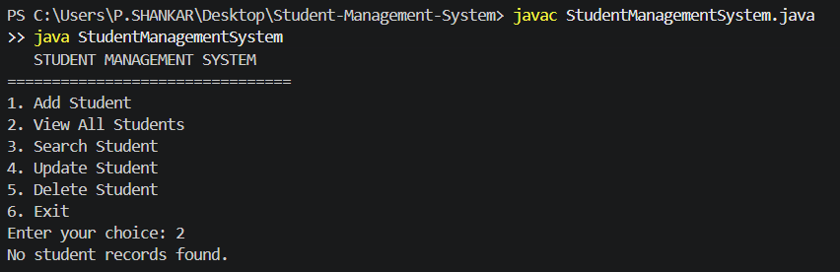

Screenshot 2: Adding a student successfully.

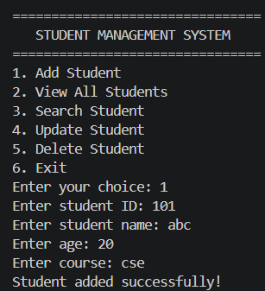
Screenshot 3: Viewing multiple student records.
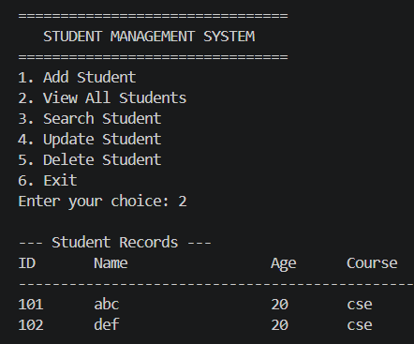

Screenshot 4: Searching and updating a student.

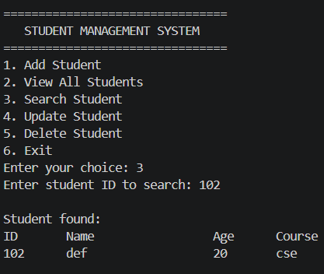 | 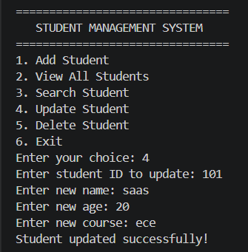

Screenshot 5: Deleting a student and viewing the remaining record.

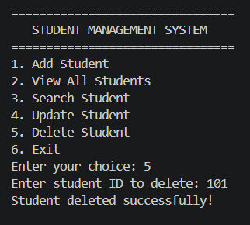

10. Limitations and Future Improvements
- Records are stored in memory and are lost when the program exits.
- Save records to a text file or database in a future version.
- Add stronger validation for names and course values.
- Separate classes into packages and add automated unit tests.

11. Repository

GitHub repository:- https://github.com/shankar-uxcloud/java-programming-projects

12. Conclusion
The Student Management System demonstrates a menu-driven Java program with add, view, search, update, and delete operations. Testing confirmed that the operations worked for the sample records. The project can be enhanced with persistent storage, database connectivity, and unit testing.

