WEEK 2: ANTENNA STUDY
Antenna Parameters and Preliminary Downlink Calculation
Intern | P. Shankar
Internship | Spacecraft Communications Intern — YuvaIntern
Project continuity | Week 1 notional LEO spacecraft-to-ground telemetry downlink
Document status | Educational analytical study. Assumed inputs and idealized equations; no physical antenna measurements or EM simulation are claimed.

1. Executive Summary
This report carries out the antenna-study stage of the project planned in Week 1. A notional 8.2 GHz spacecraft-to-Earth telemetry downlink is used to calculate the first-order performance of a 0.30 m parabolic spacecraft antenna and a 3.0 m parabolic ground-station antenna. Using explicitly stated aperture-efficiency assumptions, the calculated spacecraft antenna gain is 25.63 dBi with an approximate half-power beamwidth of 8.53 degrees; the ground antenna gain is 46.01 dBi with an approximate half-power beamwidth of 0.853 degrees. The report also calculates effective apertures and illustrates how antenna diameter affects gain and beamwidth. A sample RF power ledger is included to connect antenna results to the larger link budget. These are reproducible theoretical calculations using assumed values, not measured antenna data, a full electromagnetic model, or proof that an actual mission link closes. Receiver noise, modulation/coding threshold, and final link margin are left for Week 3 validation.

2. Study Objective and Configuration
Objective: apply the Week 1 plan by selecting a parabolic reflector antenna concept, documenting its input parameters, calculating gain, wavelength, effective aperture and approximate beamwidth, and recording a preliminary downlink calculation. A parabolic reflector is selected as a conceptual high-gain antenna because its aperture can concentrate RF energy into a narrower beam. NASA's small-spacecraft communications overview describes the trade between antenna gain, antenna size, beamwidth, pointing accuracy, and frequency. The particular sizes and frequency below are educational assumptions, not a recommendation or mission specification.
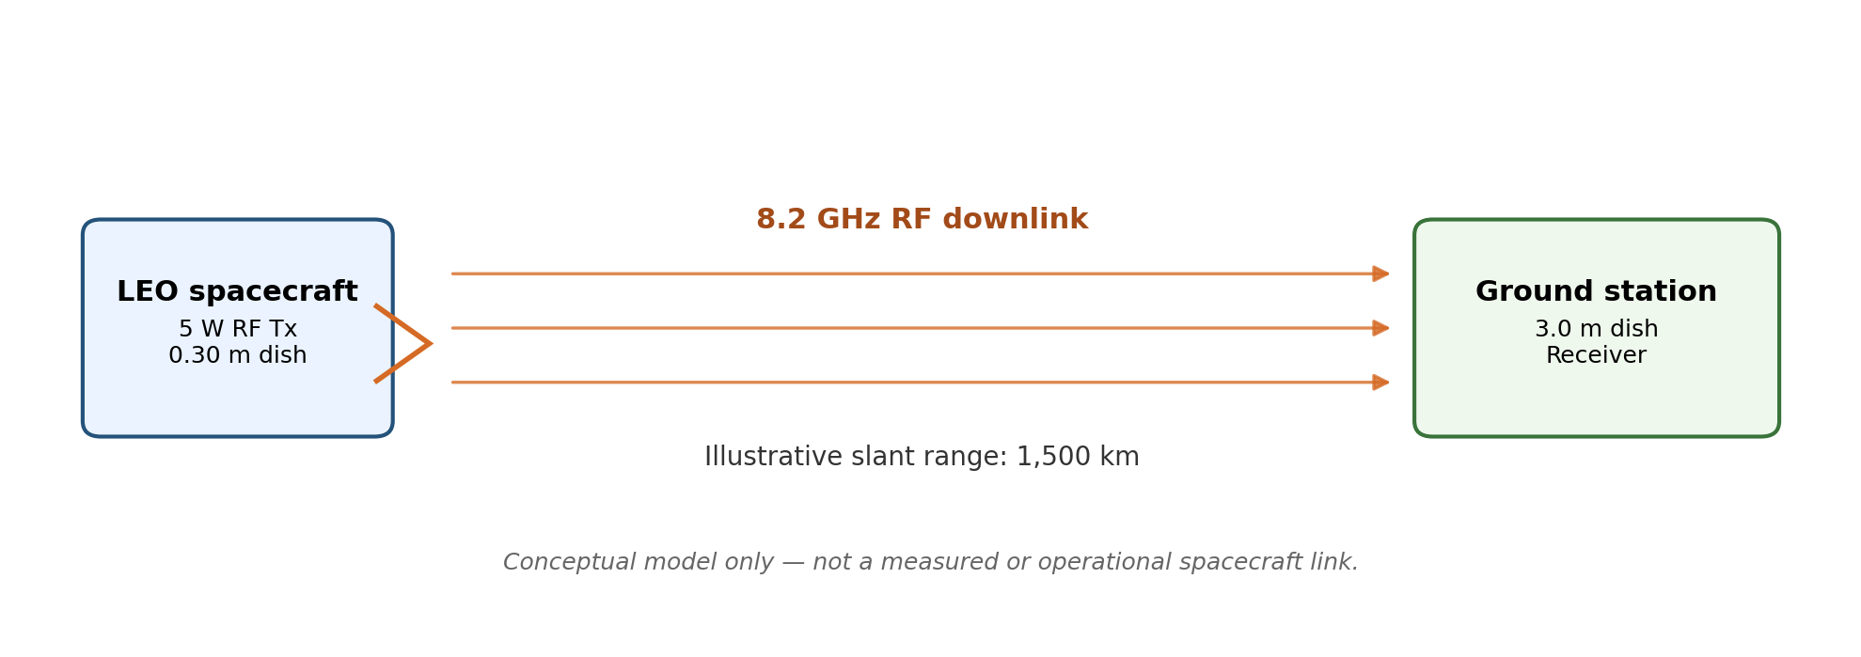
Figure 1. Conceptual 8.2 GHz spacecraft-to-ground RF downlink (author-created).

3. Inputs, Sources, and Assumptions
Input | Value | Basis / status
Carrier frequency, f | 8.2 GHz | Illustrative X-band study frequency; not a frequency authorization or assigned channel.
Spacecraft reflector diameter, Dtx | 0.30 m | Assumed conceptual deployable or fixed reflector size.
Spacecraft aperture efficiency, ηtx | 0.55 | Assumed efficiency factor; accounts approximately for illumination taper, spillover, blockage and aperture-related losses.
Ground reflector diameter, Drx | 3.0 m | Assumed ground terminal aperture for the example.
Ground aperture efficiency, ηrx | 0.60 | Assumed efficiency factor.
Representative slant range, R | 1,500 km | Illustrative LEO slant range for a calculation case; actual range varies with orbit and pass geometry.
Spacecraft RF output power | 5 W (6.99 dBW) | Illustrative conducted RF power before the stated transmit feeder loss.
Transmit feeder loss | 1.0 dB | Assumed lumped loss between transmitter output reference plane and antenna input.
Other propagation losses | 2.0 dB | Illustrative aggregate allowance for losses not included in free-space path loss; not a site-specific atmospheric prediction.
Receive feeder loss | 0.5 dB | Assumed loss between receive antenna and receiver reference plane.

4. Equations and Step-by-Step Calculations

4.1 Wavelength
λ = c / f
Using c = 299,792,458 m/s and f = 8.2 × 10⁹ Hz:
λ = 299,792,458 / 8,200,000,000 = 0.036560 m = 3.656 cm.

4.2 Parabolic antenna gain
Idealized aperture relation: Glinear = η (πD/λ)²; gain in dBi = 10 log₁₀(Glinear).
Spacecraft antenna:
Gtx = 10 log₁₀[0.55 × (π × 0.30 / 0.036560)²] = 25.63 dBi.
Ground-station antenna:
Grx = 10 log₁₀[0.60 × (π × 3.0 / 0.036560)²] = 46.01 dBi.

4.3 Effective aperture
Physical area A = πD²/4; effective aperture Ae = ηA.
Spacecraft physical aperture = π(0.30)²/4 = 0.07069 m²; effective aperture = 0.55 × 0.07069 = 0.03888 m².
Ground physical aperture = π(3.0)²/4 = 7.06858 m²; effective aperture = 0.60 × 7.06858 = 4.24115 m².

4.4 Approximate half-power beamwidth
For a typical parabolic reflector illumination, use the approximate relation θHPBW ≈ 70 λ/D degrees. This is an engineering approximation; actual beamwidth depends on feed illumination and antenna design.
Spacecraft: θtx ≈ 70 × 0.036560/0.30 = 8.53°.
Ground station: θrx ≈ 70 × 0.036560/3.0 = 0.853°.
The narrower ground-station beam indicates that accurate tracking is important. The half-power beamwidth is the full angular width between the approximate −3 dB points, so the corresponding half-angle is about ±4.27° for the spacecraft dish and ±0.427° for the ground dish. This is not a guaranteed pointing tolerance; real pointing budgets require antenna pattern and mission dynamics data.

5. Antenna Results Summary
Calculated quantity | Result
Wavelength | 0.036560 m
Spacecraft dish gain | 25.63 dBi
Spacecraft dish HPBW | 8.53°
Spacecraft effective aperture | 0.03888 m²
Ground dish gain | 46.01 dBi
Ground dish HPBW | 0.853°
Ground effective aperture | 4.24115 m²

6. Gain Versus Diameter and Pattern Illustration
Figure 2 uses the aperture-gain equation to plot theoretical boresight gain at 8.2 GHz over a range of reflector diameters. It is a calculation plot, not an antenna measurement.
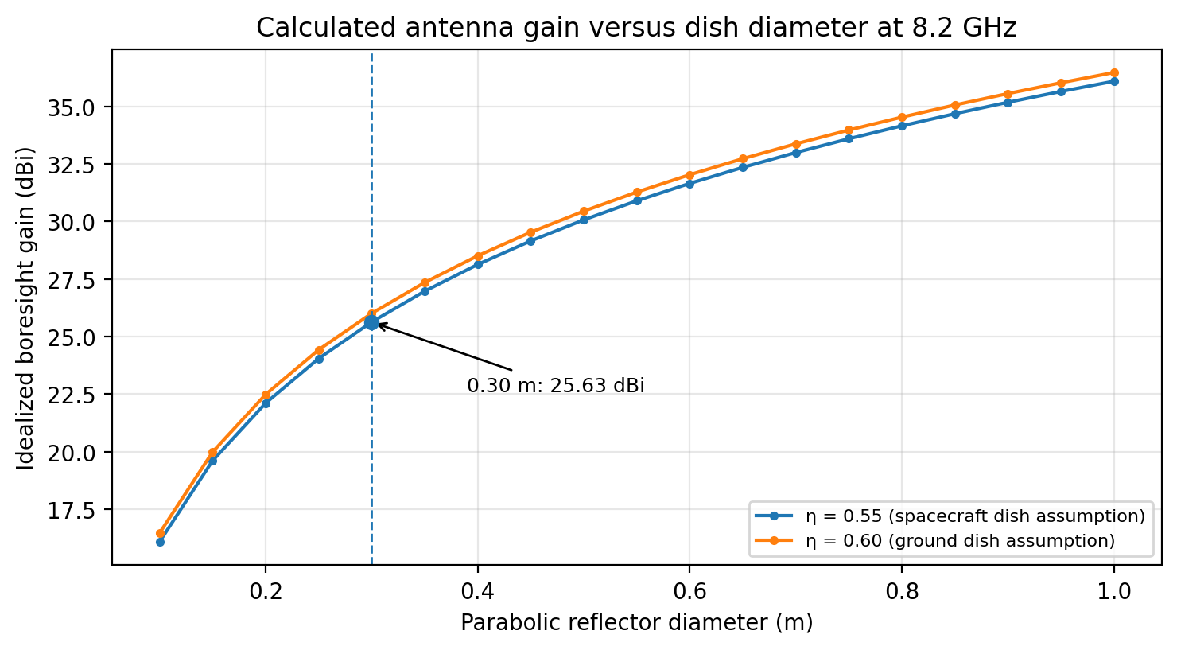
Figure 2. Calculated gain versus reflector diameter at 8.2 GHz.
Figure 3 shows a smooth illustrative main-lobe envelope whose −3 dB width is set to the calculated spacecraft HPBW. It is included to visualize beamwidth only. It is not a full electromagnetic radiation pattern: sidelobes, cross-polarization, feed effects, reflector surface errors and measured pattern data are not modeled.
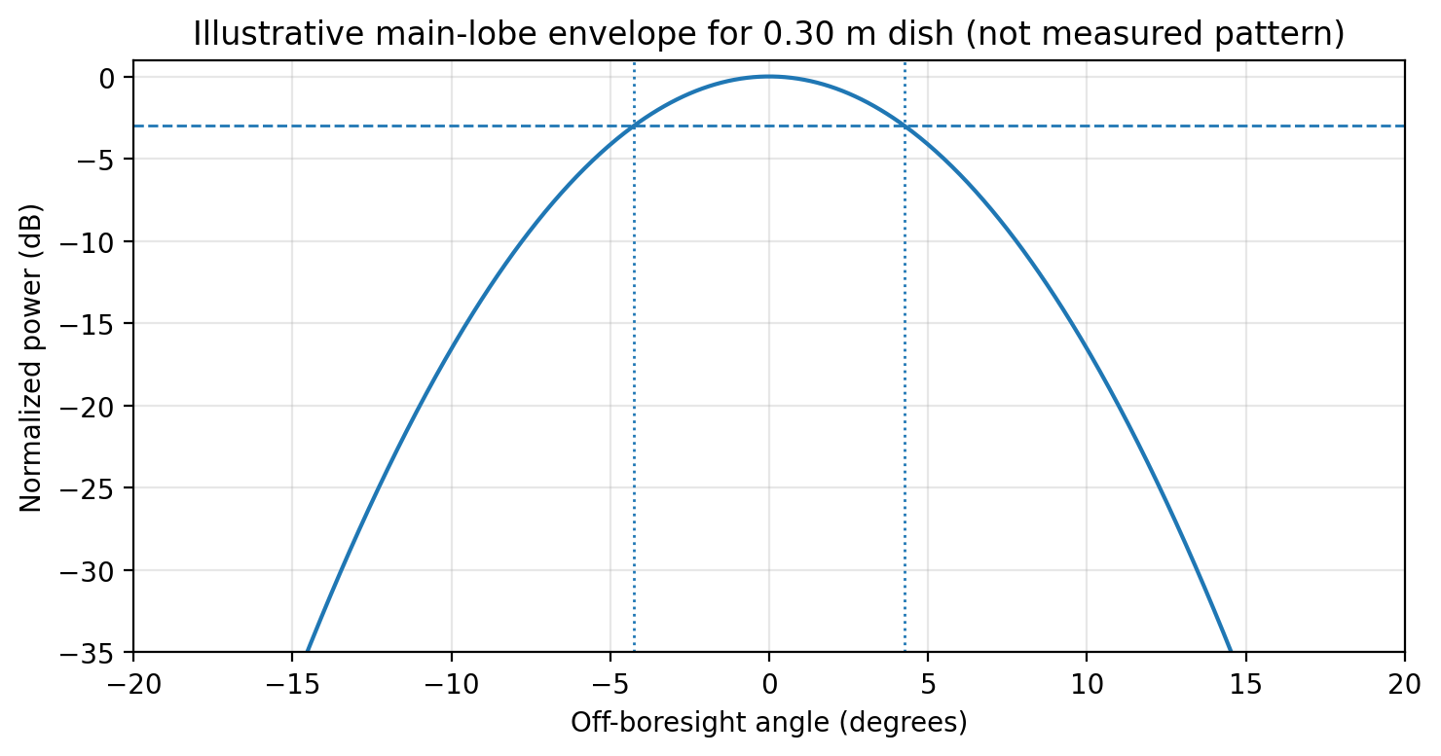
Figure 3. Illustrative normalized main-lobe envelope; not measured or EM-simulated.

7. Preliminary Link-Budget Interface Calculation
This subsection demonstrates how the antenna results enter the full link budget. It is not a complete link closure because receiver system noise temperature/G/T, modulation, coding, data rate, required Eb/N0, and validated pointing/atmospheric losses have not yet been selected and checked.
Transmitter power: Ptx(dBW) = 10 log₁₀(5 W / 1 W) = 6.99 dBW.
EIRP = Ptx(dBW) + Gtx − transmit feeder loss = 6.99 + 25.63 − 1.0 = 31.62 dBW.
Free-space path loss: FSPL = 20 log₁₀(4πR/λ) = 20 log₁₀[4π × 1,500,000 / 0.036560] = 174.25 dB.
Received carrier power at the receiver reference plane = EIRP + Grx − FSPL − other propagation losses − receive feeder loss.
Pr = 31.62 + 46.01 − 174.25 − 2.0 − 0.5 = -99.12 dBW (approximately -69.12 dBm).
This received-power result is conditional on the assumed inputs. It must not be interpreted as a guaranteed received signal level for an actual satellite pass.

8. Interpretation and Engineering Trade-offs
- Gain and aperture: increasing dish diameter increases gain approximately with the square of diameter for fixed frequency and efficiency. A larger aperture can improve the link budget but adds volume, mass, deployment, and structural constraints.
- Gain and beamwidth: increasing gain narrows the main beam. The 3 m ground dish has a much narrower beam than the 0.30 m spacecraft dish, which makes tracking and pointing accuracy important.
- Frequency: for fixed physical diameter, higher frequency means shorter wavelength and greater idealized aperture gain, but propagation, atmospheric attenuation, licensing, hardware, and pointing constraints also change.
- Efficiency: aperture efficiency is not a universal constant. The selected 0.55 and 0.60 values are explicit assumptions. A final design should use a manufacturer's datasheet, validated electromagnetic model, or measured antenna data.
- Spacecraft feasibility: a 0.30 m reflector is treated as a conceptual antenna for this study. Its suitability depends on spacecraft volume, deployment, attitude knowledge/control, thermal and structural constraints, and link requirements.

9. Limitations and Assumptions
- No physical antenna was fabricated, measured, or tested for this report.
- No full-wave electromagnetic simulation or validated antenna-pattern model was run. The gain, aperture and beamwidth equations are idealized first-order estimates.
- All mission-specific values (frequency, dish sizes, efficiency, RF power, range, and lumped losses) are assumed for an educational example. They are not provided by YuvaIntern or a real spacecraft operator.
- Free-space path loss is calculated for a single representative slant range. Actual slant range changes during a pass.
- Atmospheric attenuation, rain, polarization mismatch, antenna pointing loss, receiver noise, interference, coding, data rate, and demodulator threshold require additional sourced inputs and will be examined in Week 3.
- The selected frequency is not an authorization to transmit. Any real system must comply with the applicable national regulator and ITU frequency allocation/coordination requirements.

10. Reproducibility: Calculation Procedure
- Record frequency in Hz, antenna diameters in metres, aperture efficiencies as dimensionless fractions, range in metres, and power in watts or dBW.
- Calculate wavelength using λ = c/f.
- Calculate linear gain using η(πD/λ)², then convert to dBi with 10 log₁₀.
- Calculate effective aperture from Ae = ηπD²/4.
- Estimate HPBW from 70λ/D in degrees and label it as approximate.
- Compute EIRP, FSPL, and received carrier power using a single, documented reference plane and count each loss only once.
- Retain all input values, formulas, units, intermediate values, and output values so a reviewer can reproduce the calculation.

11. Conclusion and Handoff to Week 3
The antenna study has produced a reproducible first-order comparison for an assumed 8.2 GHz downlink. Under the stated assumptions, the 0.30 m spacecraft reflector yields 25.63 dBi idealized gain and 8.53° approximate HPBW; the 3.0 m ground reflector yields 46.01 dBi and 0.853° respectively. The illustrative link interface calculation estimates received carrier power of -99.12 dBW at the stated reference plane. These values are conditional calculations, not measured performance or a completed link-margin assessment. Week 3 will select a defensible protocol/modulation/coding case, identify receiver noise and required performance thresholds from authoritative sources, compare independent calculations, and assess uncertainty and sensitivity.

12. References
- NASA Small Spacecraft Technology State of the Art, Chapter 9: Communications (updated May 18, 2026). Background on small-spacecraft RF bands, antenna types, gain/beamwidth trade-offs, and communication system considerations. https://www.nasa.gov/smallsat-institute/sst-soa/soa-communications/
- NASA Small Spacecraft Technology State of the Art, Chapter 11: Ground Data Systems and Mission Operations. Background on link-budget accounting and link margin. https://www.nasa.gov/smallsat-institute/sst-soa/ground-data-systems-and-mission-operations/
- ITU-R Report F.2323-0 (2014), Fixed wireless systems in the fixed service. Includes parabolic antenna aperture efficiency and approximate beamwidth relation; use as general antenna reference, not as a mission-specific space standard. https://www.itu.int/dms_pub/itu-r/opb/rep/R-REP-F.2323-2014-PDF-E.pdf
- Electronics Notes, Parabolic Reflector Antenna Gain and Directivity. General explanation of reflector gain and beamwidth approximations. https://www.electronics-notes.com/articles/antennas-propagation/parabolic-reflector-antenna/antenna-gain-directivity.php
- NASA Science, Chapter 10: Telecom. Background on spacecraft high-gain reflectors and antenna directivity. https://science.nasa.gov/learn/basics-of-space-flight/chapter10-1/
Access date: 29 September 2026. Confirm publication applicability and current editions before using any reference for an actual engineering design.

Appendix A — Portal Submission Description (200+ words)
This Week 2 Antenna Study report carries out a preliminary analytical study for the notional spacecraft-to-Earth telemetry downlink defined in Week 1. The report selects a parabolic reflector antenna concept and documents the assumed inputs, equations, calculations, intermediate results, and limitations so that another reader can reproduce the work. The illustrative case uses an 8.2 GHz carrier, a 0.30 m spacecraft reflector with an assumed aperture efficiency of 0.55, and a 3.0 m ground-station reflector with an assumed aperture efficiency of 0.60. The wavelength is calculated from the speed of light and carrier frequency. Antenna boresight gain is estimated using the aperture relation, effective aperture is calculated from physical area and efficiency, and approximate half-power beamwidth is estimated using a common reflector approximation. The report includes an author-created conceptual downlink diagram, a gain-versus-diameter plot, and an illustrative normalized main-lobe envelope. These graphics are analytical illustrations and are not presented as measured antenna patterns or full electromagnetic simulation results. A preliminary link-budget interface calculation is also included to show how transmit power, antenna gain, free-space path loss, and stated losses combine to estimate received carrier power. All mission-specific parameters and lumped losses are explicitly marked as assumptions. The report explains the trade-off between antenna gain, beamwidth, pointing, physical size, and system constraints. It also identifies the remaining work for Week 3, including protocol and coding selection, receiver noise and performance thresholds, independent checks, and uncertainty analysis. The study is educational and does not claim hardware testing, operational satellite communications, frequency authorization, or flight-qualified design performance.

