DATA SCIENCE PROJECT COORDINATOR INTERNSHIP
Week 2 Data Acquisition & Management Planning
Case Study: Student Performance Prediction and Early Intervention System
  - Data sourcing • Data governance • Cleaning • Transformation • Pipeline design
Project Type | Python-based Data Science Case Study
Role | Data Science Project Coordinator
Primary Data | Publicly available / approved educational dataset
Planned Tools | Python, Pandas, NumPy, Matplotlib, Seaborn, Scikit-learn, Jupyter
Week 2 Focus | Acquisition strategy and reproducible data management

1. Executive Summary
This Week 2 plan defines how data will be identified, acquired, validated, cleaned, transformed and stored for the hypothetical Student Performance Prediction and Early Intervention System. The project is treated as a Data Science case study rather than a website or production application. The purpose is to establish a reliable and ethical data pipeline that can later support exploratory analysis and machine-learning modelling.
The preferred approach is to use a publicly available educational dataset, such as the UCI Student Performance dataset, or another dataset with a compatible structure and clearly documented usage conditions. Before using any dataset, the coordinator will record its source, usage terms, variables, collection context and limitations. The plan prioritizes data minimization, reproducibility and protection of personal information.
Python will be used throughout the workflow. Pandas will handle tabular data operations, NumPy numerical processing, Matplotlib and Seaborn quality checks and visualization, and Scikit-learn preprocessing that may be required before later modelling. Raw data will remain separate from processed data so transformations are traceable.
2. Data Requirements and Case Study Context
The case study requires data that can support analysis of factors associated with student academic performance. Potential variables include attendance-related indicators, assessment results, study time, previous grades, course-related information and other non-sensitive educational attributes where permitted.
Minimum data requirements
- A clearly defined target outcome or performance indicator.
- Enough observations to support meaningful exploratory analysis.
- Documented variable names, data types and definitions.
- A known source and acquisition date.
- Permission or a public usage basis appropriate for the intended educational analysis.
- No unnecessary personally identifying information.
3. Potential Public Data Sources
Source | Example Dataset Type | Why It May Fit | Planned Use
UCI Machine Learning Repository | Student Performance dataset | Educational records with academic and related attributes; suitable for a student-performance case study. | Primary candidate
Kaggle | Public education/student datasets | Useful for discovering alternatives; each dataset's usage terms should be checked before use. | Secondary option
Government / Open Data Portals | Education-related open datasets | May provide official aggregate or anonymized datasets where reuse is permitted. | Alternative option
Source-selection rule: the dataset will not be selected solely because it is easy to download. It must have clear provenance, usable documentation, appropriate access conditions and variables relevant to the case study.
4. Step-by-Step Data Acquisition Strategy
- Define the analytical question and minimum variables required before searching for data.
- Identify candidate public datasets and compare provenance, documentation, usage terms, completeness and relevance.
- Select the dataset that best satisfies project requirements and record its source/reference, version/date and acquisition date.
- Review dataset documentation and the data dictionary before loading it into Python.
- Check that the dataset does not contain unnecessary personal identifiers or restricted information.
- Download the original dataset into a read-only raw-data location and calculate a file hash if practical.
- Create a metadata record describing source, acquisition date, variables, formats, assumptions and limitations.
- Load a working copy into Pandas and perform initial structural inspection before transformation.
5. Ethical, Legal and Responsible Data Handling
- Use only datasets whose access and reuse conditions permit the planned educational analysis.
- Do not attempt to identify individuals from anonymized or aggregated datasets.
- Collect or retain only variables necessary for the stated analytical objective.
- Keep raw data separate from processed data and restrict access when data is not intended to be public.
- Do not publish private records, credentials, personal identifiers or restricted datasets to GitHub.
- Document the source and applicable usage terms in the project README and report.
- Do not present model outputs as definitive judgments about individual students.
- For real institutional data, obtain required authorization and follow applicable privacy/data-protection requirements.
6. Data Management Plan
Area | Management Rule
Raw data | Preserve an unchanged copy; never overwrite the source file.
Processed data | Store cleaned/transformed copies separately and document major transformations.
Metadata | Record source, acquisition date, variable definitions, units, missing-value conventions and limitations.
Version control | Track code and documentation with Git; do not commit sensitive or restricted data.
File formats | Use CSV for simple tabular exchange and Parquet where efficient analytical storage is useful.
Naming convention | Use descriptive consistent names such as raw_student_data.csv and processed_student_data.csv.
Backup | Maintain a separate backup of important project files and documentation.
7. Python Data Cleaning and Preprocessing Workflow
Step | Python Approach | Justification
1. Load | Use Pandas to load the raw file and inspect shape, columns and sample records. | Confirms the file was read correctly.
2. Schema check | Use dtypes, info(), and documented expectations to verify column types and names. | Prevents silent type errors.
3. Duplicate check | Identify duplicate rows and decide whether removal is justified. | Avoids double-counting.
4. Missing-value analysis | Measure missingness by column and investigate why values are missing. | Supports evidence-based treatment.
5. Data-type correction | Convert numeric, categorical and date-like fields to appropriate types. | Makes later analysis reliable.
6. Range/logic checks | Check impossible values such as negative scores or invalid percentages. | Improves data validity.
7. Outlier review | Use summary statistics and plots to flag unusual values; do not delete automatically. | Prevents loss of legitimate observations.
8. Encoding | Encode categorical variables when required for machine learning. | Creates model-compatible inputs.
9. Scaling | Apply feature scaling when required by the chosen algorithm. | Supports scale-sensitive models.
10. Final validation | Re-check shape, missingness, ranges and consistency after transformation. | Ensures the processed dataset is analysis-ready.
8. Data Pipeline Flowchart
The diagram below summarizes the proposed pipeline from public data acquisition to an analysis-ready dataset. Separating raw, processed and quality-control stages improves traceability and reproducibility.
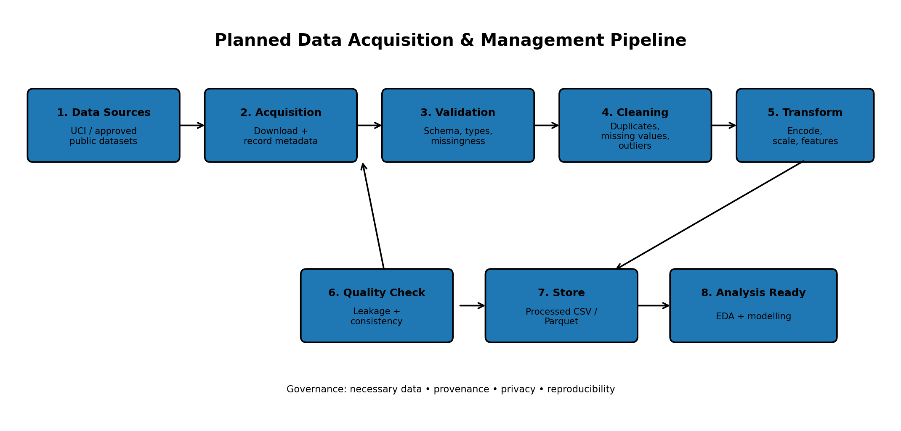
9. Example Data Dictionary / Annotation Plan
Variable | Type | Meaning | Management Note
student_id | Identifier | Identifier if supplied; should be anonymized/non-identifying for the case study. | Exclude from modelling if it has no analytical meaning.
attendance_pct | Numeric | Attendance percentage. | Validate range; document missing values.
study_time | Ordinal/Numeric | Approximate study-time category or measure. | Check category definitions.
previous_grade | Numeric | Previous academic performance measure. | Check scale and valid range.
assessment_score | Numeric | Assessment or test score. | Validate range and missingness.
performance_class | Categorical | Defined target class for the case study. | Define target rule before modelling.
These fields are illustrative planning examples, not a claim that every listed variable exists in the selected dataset. The final data dictionary must be based on the actual dataset documentation.
10. Data Quality Checklist
- Source and acquisition date recorded.
- Usage terms/license reviewed.
- File opens successfully and expected columns are present.
- Duplicate records assessed.
- Missing-value patterns documented.
- Data types validated.
- Numeric ranges and categorical values checked.
- Potential leakage variables identified before modelling.
- Raw data preserved unchanged.
- Processed data generated through documented/reproducible steps.
- No sensitive/private data committed to the public GitHub repository.
11. Week 2 Deliverables
- Finalized Data Acquisition and Management Plan.
- Annotated source-selection and acquisition strategy.
- Data cleaning and preprocessing workflow.
- Embedded data-pipeline flowchart.
- Example data dictionary and quality checklist.
- Python library integration plan.
- Ethical, legal and responsible data-handling considerations.
12. Week 2 Execution Timeline
Day | Activity | Expected Output
Day 1 | Define data requirements and target variables | Approved data requirements
Day 2 | Identify and compare public datasets | Source comparison
Day 3 | Review documentation and usage conditions | Selected source + metadata
Day 4 | Design acquisition and storage structure | Data management plan
Day 5 | Design cleaning/preprocessing workflow | Annotated preprocessing plan
Day 6 | Create and review pipeline flowchart | Embedded diagram
Day 7 | Quality review and finalize DOC | Week 2 submission
13. Conclusion
A reliable data science project begins with a reliable data-management strategy. This Week 2 plan establishes a controlled process for identifying suitable public data, reviewing provenance and usage conditions, acquiring it responsibly, preserving the raw source, documenting metadata, and producing a validated analysis-ready dataset. The proposed Python workflow provides a repeatable sequence for inspection, cleaning, transformation and quality control.
The plan also recognizes that educational data can affect real people and therefore should not be treated as ordinary unrestricted data. Data minimization, appropriate access, transparent documentation and human oversight are included as core planning requirements. The resulting pipeline is designed to support the next stages of the case study—exploratory analysis and modelling—without overstating what the data or a future model can prove.
Appendix – Submission Description (200+ Words)
This Week 2 task develops a detailed Data Acquisition and Management Plan for the hypothetical Student Performance Prediction and Early Intervention System. The work is designed as a Python-based Data Science case study and focuses on how suitable data would be identified, acquired, validated, cleaned, transformed and stored before analysis. Potential sources include the UCI Machine Learning Repository, public Kaggle datasets and suitable government or open data portals. The selected dataset must have clear provenance, relevant variables, appropriate usage conditions and adequate documentation. The acquisition strategy includes recording the source, acquisition date, metadata and usage conditions while keeping original data separate from processed data. Ethical and legal considerations are included through data minimization, privacy protection, responsible reuse and a rule against publishing private or restricted records to a public GitHub repository. The planned Python workflow uses Pandas for loading and cleaning, NumPy for numerical processing, Matplotlib and Seaborn for quality checks and visualization, and Scikit-learn for preprocessing steps that may be required before later machine-learning work. The workflow covers schema validation, duplicate detection, missing-value analysis, data-type correction, range checks, outlier review, categorical encoding, scaling where appropriate and final quality validation. A data-pipeline flowchart is embedded in the document to show the complete process from acquisition to analysis-ready data. An annotated data dictionary and quality checklist are also included. The plan emphasizes reproducibility by preserving raw data, documenting transformations and using version control for code and documentation. The final deliverable is a professionally organized Week 2 report that provides a practical foundation for subsequent data science phases.

