DATA SCIENCE PROJECT COORDINATOR INTERNSHIP
Week 3 Execution & Implementation Plan
Case Study: Student Performance Prediction and Early Intervention System
  - Model development • Agile coordination • Programming practices • QA • Ethics
Project Type | Python-based Data Science Case Study
Role | Data Science Project Coordinator
Implementation Focus | Model selection, training, validation and coordination
Planned Tools | Python, Pandas, NumPy, Scikit-learn, Jupyter, Git/GitHub
Week 3 Focus | Execution strategy and implementation governance

1. Executive Summary
Week 3 moves the Student Performance Prediction and Early Intervention System from planning into the execution stage. The goal is to define how a small data science team would implement the analytical solution in a controlled, reproducible and ethical manner. The work remains a Data Science case study; it is not a website-development task.
The implementation strategy begins with the validated dataset and preprocessing plan from Week 2. The team then creates a baseline, prepares candidate features, trains suitable classification models, validates them using appropriate metrics and documents errors and limitations. Scikit-learn is proposed for model development, while Pandas and NumPy support data handling. Jupyter Notebook is used for exploratory and experimental work, while modular Python scripts can contain reusable preprocessing and modelling logic.
Coordination follows an Agile-inspired weekly cycle with clearly assigned responsibilities, short review points, version control and quality gates. Code review, unit checks, data validation, reproducibility checks and ethical review are treated as part of implementation rather than activities postponed until the end.
2. Implementation Objectives
- Convert the approved data-preparation plan into a reproducible modelling workflow.
- Establish a baseline model before comparing more complex candidates.
- Train and validate appropriate classification models using Python and Scikit-learn.
- Compare models using metrics that reflect the project's target and potential class imbalance.
- Coordinate data-science, analysis and engineering responsibilities through an Agile workflow.
- Apply version control, code review, testing and documentation practices throughout implementation.
- Maintain ethical safeguards and avoid presenting predictions as automatic decisions about students.
3. Team Coordination Strategy
The case study assumes a small cross-functional team. If the internship work is completed individually, the same roles can be treated as responsibility areas performed sequentially.
Role | Primary Responsibilities | Coordination Points
Project Coordinator | Scope, schedule, priorities, risks, reviews and final documentation. | Daily task status; weekly milestone review.
Data Scientist | Feature engineering, model selection, training, tuning and evaluation. | Model experiments; validation results; technical decisions.
Data Analyst | Data quality, EDA, data summaries and interpretation of patterns. | Data-quality findings; feature assumptions.
Engineer / ML Engineer | Reusable code structure, pipeline packaging, environment and handoff planning. | Code review; reproducibility; packaging.
Reviewer / Stakeholder | Reviews requirements, assumptions, outputs and limitations. | Milestone approvals and feedback.
4. Agile Coordination Methodology
An Agile-inspired workflow will be used rather than a rigid sequential handoff. Work will be divided into small tasks with visible status, clear ownership and short review cycles.
Agile Practice | Application in This Case Study
Backlog | Maintain tasks for data checks, features, experiments, documentation and QA.
Sprint planning | Select a small set of implementation tasks for the current cycle.
Daily/regular check-in | Review completed work, next action and blockers.
Experiment tracking | Record model, features, parameters, metrics and observations.
Review | Inspect code, results and documentation before merging major changes.
Retrospective | Record what worked, what caused delays and what should change in the next cycle.
5. Model Development, Training and Validation Process
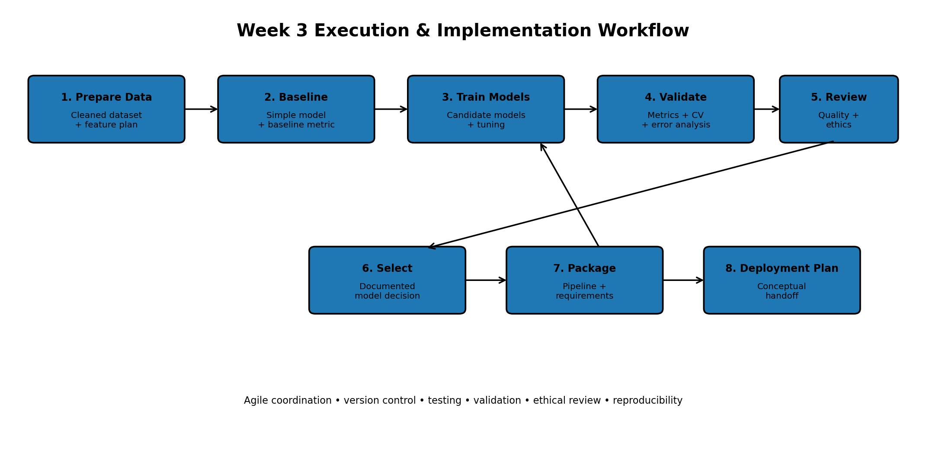
- Confirm the target variable and modelling objective using the approved Week 2 data dictionary.
- Separate predictors and target; remove identifiers or variables that create leakage.
- Split the data into training and test sets using a reproducible random state and stratification where appropriate.
- Create a simple baseline model to establish a reference performance level.
- Train candidate classification models such as Logistic Regression, Decision Tree and Random Forest when suitable for the dataset.
- Use a validation strategy such as cross-validation on the training data for model comparison and parameter tuning.
- Evaluate the selected model on held-out test data using appropriate metrics.
- Inspect the confusion matrix and error patterns rather than relying on a single score.
- Document assumptions, limitations and reasons for the final model choice.
- Package the preprocessing and model steps into a reproducible pipeline for a conceptual handoff.
6. Model Selection Strategy
Candidate | Purpose | Strength | Key Consideration
Logistic Regression | Baseline / interpretable classification | Simple, fast and relatively interpretable. | Assumes a suitable relationship between features and log-odds.
Decision Tree | Non-linear baseline | Easy to explain and handles mixed feature relationships. | Can overfit without controls.
Random Forest | Robust candidate model | Combines multiple trees and can capture non-linear patterns. | Less simple to explain than a single tree; requires tuning.
The final model should not be selected simply because it produces the highest accuracy. The selection should consider the target definition, class distribution, precision/recall trade-offs, interpretability, validation stability, reproducibility and the consequences of errors.
7. Conceptual Python Code References
The task requests relevant Python code snippet references described conceptually. The following examples show what implementation modules would contain; they are reference patterns rather than a claim that the complete production system has already been built.
Stage | Library | Conceptual Reference | Purpose
Data loading | Pandas | pd.read_csv(...) | Load the approved processed dataset and inspect columns.
Train/test split | Scikit-learn | train_test_split(...) | Create reproducible training and test partitions.
Preprocessing | Scikit-learn | Pipeline / ColumnTransformer | Apply transformations consistently without leakage.
Baseline model | Scikit-learn | LogisticRegression(...) | Create an interpretable reference model.
Candidate model | Scikit-learn | DecisionTreeClassifier(...) / RandomForestClassifier(...) | Train alternative classifiers.
Validation | Scikit-learn | cross_val_score(...) / cross_validate(...) | Estimate validation performance across folds.
Metrics | Scikit-learn | classification_report(...) / confusion_matrix(...) | Inspect multiple evaluation measures.
Persistence | Joblib / Scikit-learn | joblib.dump(...) | Conceptually save a validated pipeline for later handoff.
8. Programming, Version Control and Code Review Practices
- Use Git for source-code and documentation version control, with meaningful commit messages.
- Keep experimental notebooks separate from reusable Python modules where practical.
- Use descriptive functions and variable names and avoid duplicated logic.
- Keep configuration and random seeds explicit to improve reproducibility.
- Review code before merging significant changes into the main branch.
- Do not commit passwords, API keys, private datasets or other sensitive information.
- Use a requirements.txt or equivalent environment specification to record important dependencies.
- Document assumptions and preprocessing decisions in the README or project report.
Suggested branch workflow
main → feature/data-validation → code review → merge → tagged milestone
9. Quality Assurance and Testing Strategy
QA Area | Check | Acceptance Condition
Data validation | Schema, nulls, ranges, duplicates | Dataset passes documented validation checks.
Unit testing | Test reusable preprocessing/model helper functions | Expected inputs produce expected outputs.
Pipeline testing | Run preprocessing and model pipeline end-to-end | Pipeline completes without data leakage or unexpected errors.
Model validation | Cross-validation + held-out test evaluation | Results are documented and reproducible.
Regression check | Compare new model/code against prior baseline | No unexplained degradation or behavior change.
Reproducibility | Re-run notebook/script from clean environment | Results can be regenerated from documented inputs.
Documentation review | Check assumptions, metrics and limitations | Report accurately describes what was performed.
10. Ethical and Responsible Implementation
- Use only authorized/public data and preserve the source and usage conditions.
- Minimize use of personal information and exclude unnecessary identifiers from modelling.
- Check for data leakage and inappropriate proxy variables before training.
- Review whether class imbalance or sampling patterns could affect results.
- Report limitations and uncertainty instead of presenting predictions as facts.
- Keep human review in the decision process; the model is an analytical support tool, not an automatic decision-maker.
- Avoid publishing private datasets or sensitive records in the public repository.
- Document significant model assumptions, known failure modes and intended use.
11. Conceptual Deployment and Handoff Process
Deployment is described conceptually because this internship task is an implementation-plan exercise, not a requirement to build a live website or production application. If a validated model were later approved for use, the handoff would follow these stages:
- Freeze the approved preprocessing and model pipeline.
- Record model version, training data version, metrics and known limitations.
- Package the Python environment and dependencies.
- Run a final security, privacy and quality review.
- Deploy only to an authorized environment after stakeholder approval.
- Monitor data quality and model performance after deployment.
- Define a rollback/retraining process if data distribution or performance changes.
12. Week 3 Implementation Milestones
Phase | Planned Activity | Deliverable
Phase 1 | Confirm data and target; create baseline | Baseline notebook/results
Phase 2 | Feature preparation and candidate models | Model experiment records
Phase 3 | Cross-validation and tuning | Validation comparison
Phase 4 | Test evaluation and error analysis | Evaluation report
Phase 5 | Code review, QA and documentation | Reviewed implementation package
Phase 6 | Conceptual deployment/handoff review | Implementation handoff plan
13. Execution Risks and Mitigation
Risk | Potential Impact | Mitigation
Overfitting | Poor performance on unseen data | Cross-validation, baseline comparison and held-out testing.
Data leakage | Artificially high evaluation results | Review feature timing and use pipelines for preprocessing.
Class imbalance | Poor detection of minority class | Use suitable metrics, stratification and carefully justified techniques.
Unreproducible experiments | Difficult to verify results | Fix random states, track parameters and version code.
Schedule delays | Missed milestone | Prioritize critical tasks and review blockers frequently.
Misuse of predictions | Incorrect decisions about students | Human oversight, limitations and responsible-use rules.
14. Week 3 Deliverables
- Implementation and execution plan.
- Model-development and validation workflow.
- Team coordination and Agile strategy.
- Conceptual Python code-reference table.
- Programming and version-control practices.
- Quality-assurance and testing strategy.
- Ethical implementation and conceptual deployment plan.
- Milestone and risk-management tables.
15. Conclusion
The Week 3 execution plan converts the earlier case-study planning work into a controlled implementation strategy. It defines how the team would move from validated data to baseline modelling, candidate model training, validation, error analysis and a documented model-selection decision. Agile coordination, Git-based version control, code review and testing are included so that implementation quality is managed continuously rather than checked only at the end.
The plan also treats ethical and quality considerations as implementation requirements. The model should support human analysis rather than replace human judgment, and the project should document data limitations, potential errors and intended use. Deployment is presented as a conceptual future handoff, keeping the project aligned with the internship's Data Science case-study nature.
Appendix – Submission Description (200+ Words)
This Week 3 task presents an execution and implementation plan for the hypothetical Student Performance Prediction and Early Intervention System. The project is treated as a Python-based Data Science case study and focuses on how a coordinated team would implement a predictive solution after the data acquisition and management stage. The plan starts with a validated dataset, a clearly defined target and a reproducible preprocessing workflow. A simple baseline model is proposed before comparing candidate classification algorithms such as Logistic Regression, Decision Tree and Random Forest. Training and validation are planned using Scikit-learn, with cross-validation for model comparison and a held-out test set for final evaluation. Accuracy alone will not be treated as sufficient; precision, recall, F1-score, confusion matrix results and error patterns will be considered according to the target and class distribution. The document also explains conceptual Python references including Pandas data loading, train_test_split, Pipeline and ColumnTransformer, model classes, cross-validation, classification_report and confusion_matrix. Team coordination follows an Agile-inspired workflow with backlog management, short planning cycles, regular status checks, experiment tracking, code review and retrospectives. Git and GitHub are used for version control, while testing and reproducibility checks provide quality assurance. Ethical safeguards include data minimization, leakage checks, privacy protection, transparent limitations and human oversight. Deployment is described only as a conceptual future handoff because this is a planning and implementation case study rather than a requirement to build a live website or production application. The final deliverables provide a structured and professional roadmap for implementing, validating and documenting the data science solution.

