DATA SCIENCE PROJECT COORDINATOR INTERNSHIP
Week 4 Monitoring, Reporting & Process Improvement Plan
Case Study: Student Performance Prediction and Early Intervention System
  - Performance tracking • KPIs • Reporting • Corrective action • Continuous improvement
Project Type | Python-based Data Science Case Study
Role | Data Science Project Coordinator
Monitoring Focus | Data quality, model performance, delivery and risk indicators
Planned Tools | Python, Pandas, NumPy, Matplotlib, Seaborn, Scikit-learn, Jupyter
Week 4 Focus | Continuous monitoring, reporting and process improvement

1. Executive Summary
Week 4 establishes a monitoring and reporting framework for the Student Performance Prediction and Early Intervention System. The purpose is to continuously check whether the planned data-science workflow is meeting its technical, data-quality, project and documentation targets. The framework converts measurements into regular reports and defines a corrective-action loop when performance deviates from agreed thresholds.
Python is used as the analytical foundation for calculating and visualizing metrics. Pandas and NumPy support metric preparation, Matplotlib and Seaborn support trend charts and diagnostic plots, and Scikit-learn provides model evaluation metrics such as precision, recall, F1-score and confusion matrices. The dashboard design in this document is illustrative: example values are placeholders and are not presented as actual project results.
Monitoring is divided into data quality, model performance, project delivery and process-quality indicators. Reports are produced at defined intervals for the Project Coordinator, Data Scientist, Data Analyst, Engineer and reviewer/stakeholder. When a KPI falls outside its acceptable range, the team records the deviation, investigates the root cause, proposes an action, assigns an owner and verifies the result after implementation.
2. Key Performance Indicators (KPIs)
KPI | Category | Measurement | Target / Trigger | Frequency
F1-score | Model | Harmonic mean of precision and recall | Example target ≥ 0.75; define before final evaluation | Per experiment / milestone
Recall | Model | Correctly identified positive cases / actual positives | Example target ≥ 0.75; depends on project objective | Per experiment / milestone
Precision | Model | Correctly identified positives / predicted positives | Track alongside recall | Per experiment / milestone
Data completeness | Data quality | 1 − missing required values / total required values | Example ≥ 95% | Weekly
Duplicate rate | Data quality | Duplicate rows / total rows | Near zero after approved cleaning | Weekly
Invalid-value rate | Data quality | Invalid records / records checked | Below agreed threshold | Weekly
Pipeline success rate | Engineering | Successful runs / scheduled runs | Example ≥ 95% | Weekly
Task completion | Project | Completed planned tasks / planned tasks | Example ≥ 90% per cycle | Weekly
Open critical risks | Project | Count of unresolved critical risks | No overdue critical risks | Weekly
Documentation completeness | Process | Required sections/artifacts completed | 100% at milestone | Milestone
Thresholds shown as examples must be confirmed against the actual dataset, project objective and evaluation criteria before they are treated as acceptance criteria.
3. Python Tools for Performance Tracking
Tool / Library | Monitoring Use | Example Output
Pandas | Aggregate KPI tables, calculate missingness, duplicates and task/report summaries. | Data-quality summary table
NumPy | Numerical calculations and threshold comparisons. | Metric calculations
Matplotlib | Create trend charts, KPI plots and comparison charts. | Line/bar charts
Seaborn | Statistical plots and model/error diagnostics. | Heatmaps, distributions
Scikit-learn | Calculate classification metrics and confusion matrices. | Precision, recall, F1, confusion matrix
Jupyter Notebook | Combine metric calculations, charts and explanations. | Reproducible monitoring report
Git/GitHub | Track changes to analysis code and reporting artifacts. | Version history / reviewed changes
4. Monitoring Dashboard Layout
The dashboard is a planning design rather than a claim that a live dashboard has already been implemented. It organizes the most important indicators into KPI cards, trends, error analysis and corrective-action status.
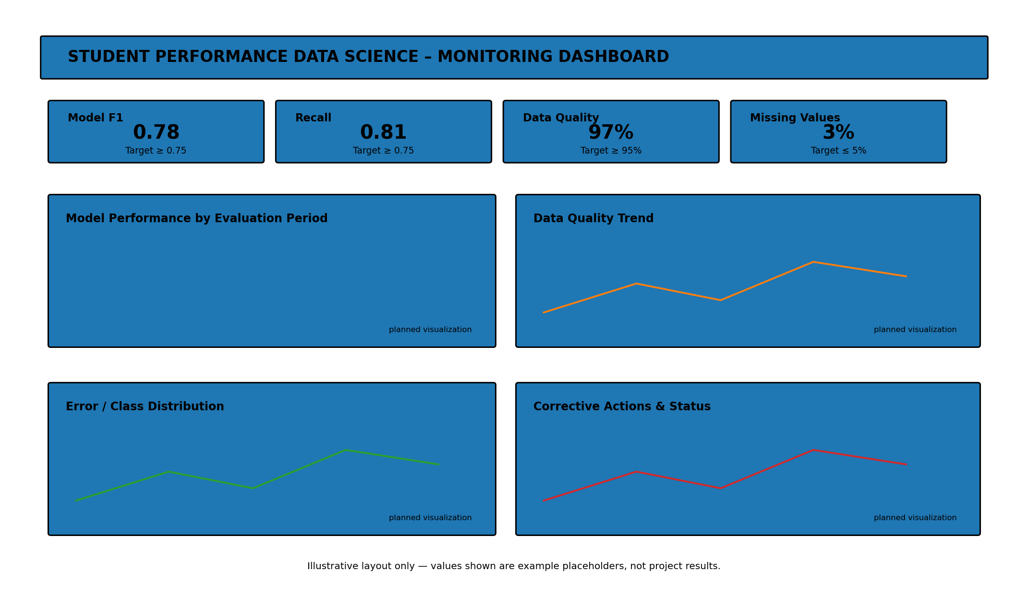
Dashboard sections
- KPI cards: current metric, target and status.
- Model-performance trend: F1, recall and precision across evaluation periods.
- Data-quality trend: missingness, duplicate rate and invalid-value rate.
- Error/class distribution: confusion matrix or class-level diagnostic view.
- Corrective-action panel: issue, owner, due date, action and verification status.
5. Reporting Mechanism and Stakeholders
Report | Frequency | Audience | Contents
Progress update | Weekly | Project Coordinator, team | Tasks, blockers, risks, data quality and model progress
Technical model report | Per major experiment / milestone | Data Scientist, Analyst, Reviewer | Metrics, validation results, error analysis and assumptions
Data-quality report | Weekly / after major data change | Analyst, Data Scientist, Coordinator | Missingness, duplicates, invalid values and data drift indicators where applicable
Management summary | At major milestone | Coordinator, stakeholder | KPI status, deviations, actions and decisions needed
Final monitoring report | End of project phase | All relevant stakeholders | KPI trends, corrective actions, lessons learned and improvement proposals
6. Performance Evaluation Process
- Collect the latest KPI and project-status data from the approved analysis workflow.
- Validate the metric inputs before reporting so that a reporting error is not mistaken for a project problem.
- Compare each KPI with its predefined target, tolerance or previous-period baseline.
- Classify deviations by severity: informational, moderate or critical, based on agreed project rules.
- Investigate the likely root cause using data-quality checks, model diagnostics, code changes and task history.
- Record the deviation and proposed corrective action in an issue/action log.
- Assign an owner and target date for the corrective action.
- Re-run the relevant analysis or process after the action is implemented.
- Verify whether the KPI returned to the acceptable range and document the outcome.
- Escalate unresolved critical issues to the appropriate reviewer/stakeholder.
7. Monitoring and Corrective-Action Flowchart
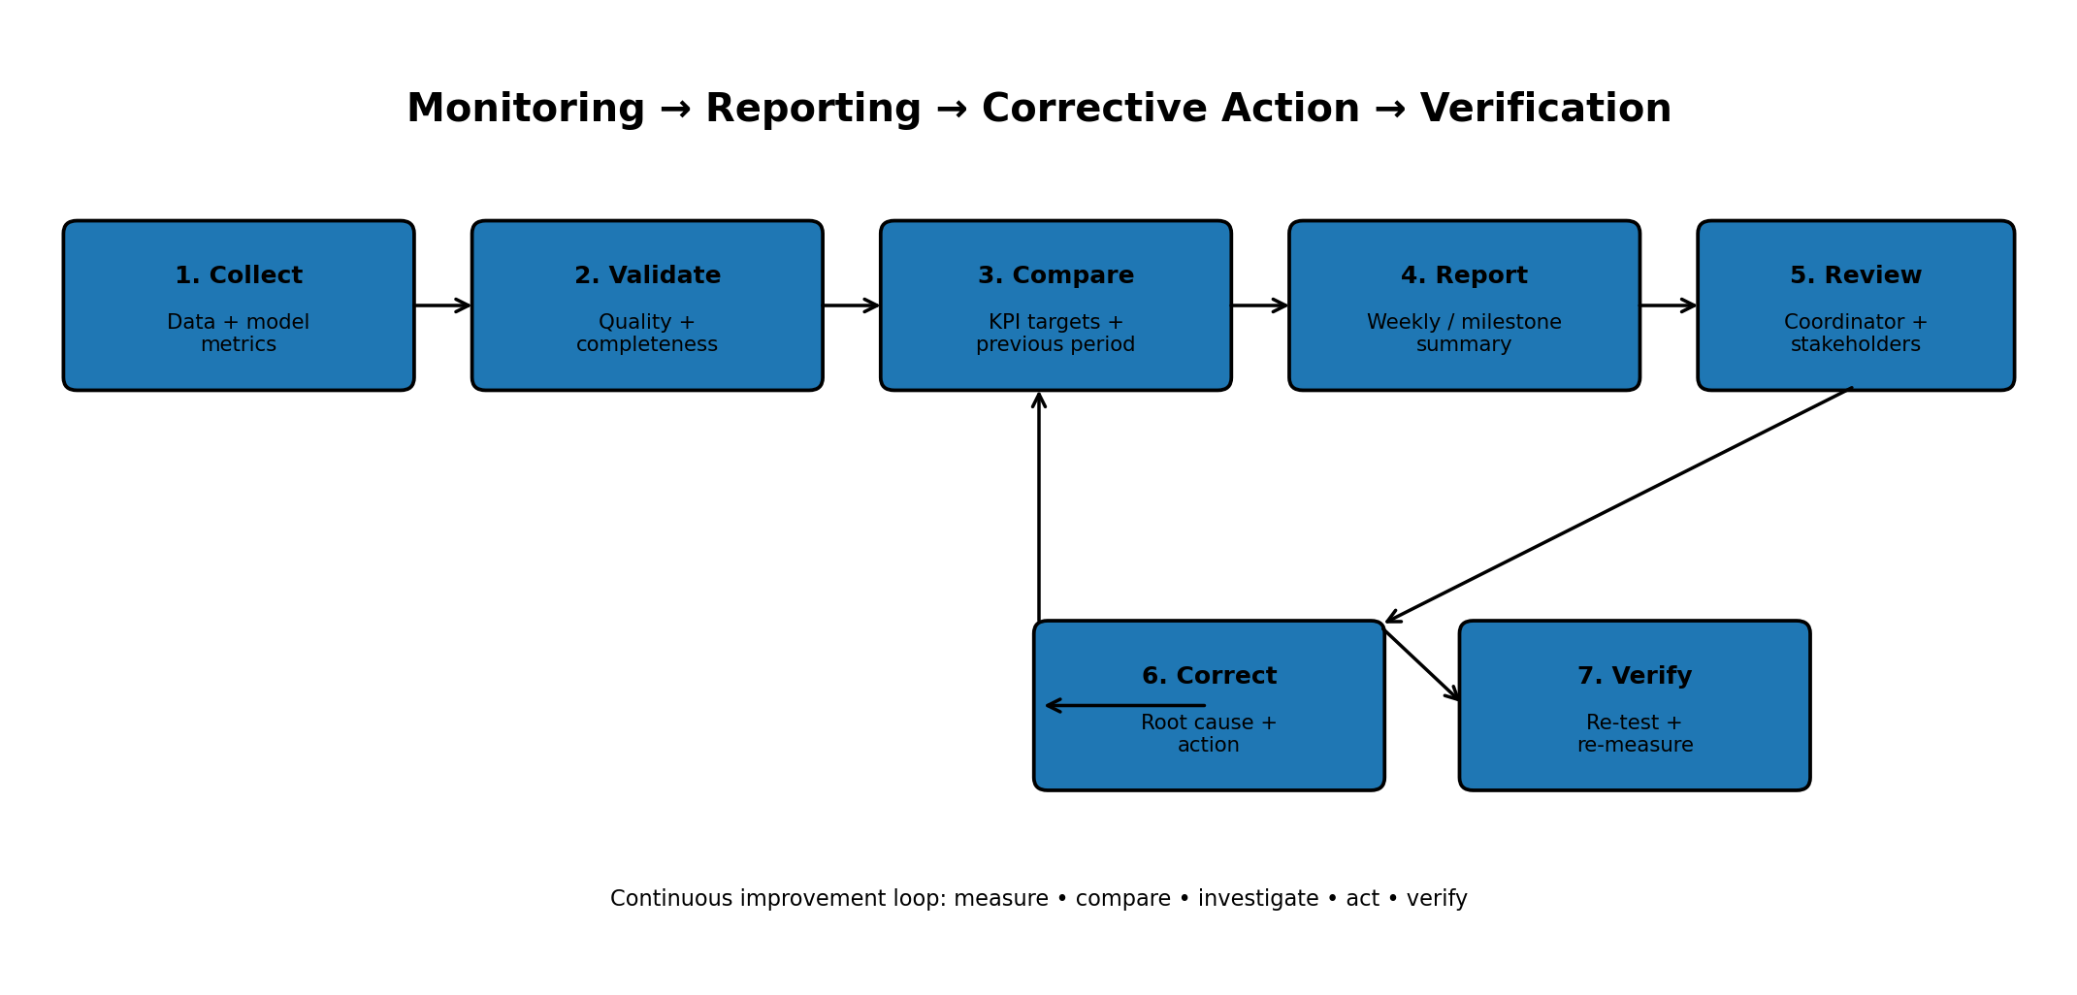
This loop prevents monitoring from becoming passive reporting: every significant deviation should lead to an investigation, an assigned action and a verification step.
8. Corrective Action and Strategy Adjustment Protocol
Step | Action | Owner | Evidence
1. Detect | Record KPI deviation and affected component. | Coordinator | KPI snapshot
2. Diagnose | Identify root cause through data/code/model checks. | Relevant technical owner | Diagnostic notes
3. Propose | Define one or more corrective options and expected effect. | Coordinator + technical owner | Action proposal
4. Approve | Review impact, risk and feasibility before significant changes. | Coordinator / stakeholder | Decision record
5. Implement | Apply change in a controlled branch/workflow. | Assigned owner | Commit / change record
6. Re-test | Re-run quality checks and relevant model evaluation. | Analyst / Data Scientist | Test results
7. Verify | Compare KPI against target and prior state. | Coordinator | Verification record
8. Learn | Update process documentation and backlog if needed. | Coordinator | Lessons learned
9. Process Improvement Strategy
- Use trend analysis rather than reacting to one isolated measurement when the metric is not safety- or compliance-critical.
- Review recurring root causes and convert them into process-improvement backlog items.
- Automate repetitive KPI calculations with reusable Python functions or notebooks.
- Standardize report templates so each reporting period contains comparable measurements.
- Track whether corrective actions actually improve the KPI instead of assuming that implementation equals success.
- Update thresholds only through documented review; do not change targets merely to make results appear better.
- Capture lessons learned at each milestone and use them to improve subsequent project cycles.
10. Monitoring Quality and Governance
- Verify the source and calculation method for each KPI.
- Keep the definition of each metric consistent across reporting periods.
- Record data and model versions associated with reported results.
- Separate illustrative dashboard values from real project measurements.
- Maintain an audit-friendly record of corrections, decisions and approvals.
- Protect any restricted data used to calculate internal metrics.
- Report limitations and uncertainty rather than overstating performance.
11. Example Periodic Report Structure
Section | Content
1. Executive summary | Overall status, key changes and decisions needed.
2. KPI snapshot | Current value, target, previous period and status.
3. Data quality | Missingness, duplicates, invalid values and notable changes.
4. Model performance | Precision, recall, F1, confusion matrix and error analysis.
5. Project delivery | Completed tasks, blockers and milestone status.
6. Risks | Open risks, severity and mitigation progress.
7. Corrective actions | Open/closed actions, owners and verification.
8. Improvement proposals | Evidence-based changes proposed for the next cycle.
12. Week 4 Deliverables
- Detailed monitoring and reporting plan.
- KPI definitions, targets and reporting frequencies.
- Python tool and library integration plan.
- Illustrative monitoring dashboard layout.
- Periodic reporting mechanism and stakeholder matrix.
- Performance-evaluation and corrective-action protocol.
- Embedded monitoring/corrective-action flowchart.
- Process-improvement and governance strategy.
13. Conclusion
The Week 4 monitoring plan turns the project from a one-time modelling exercise into a measurable and continuously reviewed data science process. By defining KPIs for model performance, data quality, delivery and process quality, the coordinator can compare actual progress with agreed expectations. Python tools provide a reproducible way to calculate metrics and generate visual reports, while the dashboard design gives stakeholders a concise view of status.
The most important feature of the plan is the corrective-action loop. A deviation is not simply reported; it is validated, investigated, assigned, corrected and re-measured. This makes process improvement evidence-based and prevents target changes from being used to hide weak performance. The approach also maintains responsible data handling and transparent reporting throughout the project lifecycle.
Appendix – Submission Description (200+ Words)
This Week 4 task develops a monitoring, reporting and process-improvement plan for the hypothetical Student Performance Prediction and Early Intervention System. The purpose is to establish a continuous evaluation framework that tracks whether the data science project is meeting agreed technical, data-quality and delivery benchmarks. The plan defines KPIs covering model performance, data quality, engineering reliability, project delivery and documentation. Model indicators include precision, recall and F1-score, while data-quality indicators include completeness, duplicate rate and invalid-value rate. Project indicators include task completion, open critical risks and documentation completeness. Python is integrated into the monitoring workflow through Pandas and NumPy for metric calculations, Matplotlib and Seaborn for trend charts and diagnostic visualizations, and Scikit-learn for model evaluation metrics and confusion matrices. An illustrative dashboard layout is included with KPI cards, model-performance trends, data-quality trends, error analysis and corrective-action status. The reporting mechanism specifies weekly progress reporting, milestone-based technical reports and periodic management summaries for the Project Coordinator, Data Scientist, Data Analyst, Engineer and reviewer/stakeholder. A corrective-action protocol is also defined: detect the deviation, validate the measurement, investigate the root cause, propose an action, assign ownership, implement the change, re-test and verify the result. The plan emphasizes that targets should not be changed simply to improve reported performance. Instead, strategy adjustments should be supported by evidence and documented decisions. The embedded flowchart illustrates the complete monitoring-to-correction loop. Overall, the Week 4 document provides a structured approach for turning project measurements into transparent reports and continuous process improvements while maintaining reproducibility, responsible data use and clear governance.

