DATA SCIENCE PROJECT COORDINATOR INTERNSHIP
Week 5 Final Evaluation, Review & Presentation Plan
Case Study: Student Performance Prediction and Early Intervention System
  - Final review • success metrics • lessons learned • recommendations • stakeholder presentation
Project Type | Python-based Data Science Case Study
Role | Data Science Project Coordinator
Final Focus | Evaluate planning, data, execution, monitoring and improvement
Planned Tools | Python, Pandas, NumPy, Matplotlib, Seaborn, Scikit-learn, Jupyter
Week 5 Focus | Final evaluation and communication strategy

1. Executive Summary
Week 5 brings together the complete Student Performance Prediction and Early Intervention System case study. The final review examines the work completed across planning, data acquisition and management, execution, monitoring and process improvement. The objective is not simply to describe activities, but to determine whether the planned process met its defined goals, what evidence supports the conclusions, what challenges were encountered and what should happen next.
Python-based analytics provide the evidence base for the final review. Pandas and NumPy can summarize project measurements, while Matplotlib and Seaborn can visualize trends and comparisons. Scikit-learn provides model evaluation metrics where modelling results are available. Because this internship work is a case-study planning exercise, example metrics in this document are clearly labelled as placeholders. Final numerical values should be filled from actual analysis outputs if the implementation is executed.
The final stakeholder presentation will communicate the problem, methodology, data-management decisions, model evaluation, monitoring results, lessons learned and recommendations in a concise sequence. The presentation is designed to support data-driven decision-making without overstating what a model can prove.
2. Integrated Final Review Framework
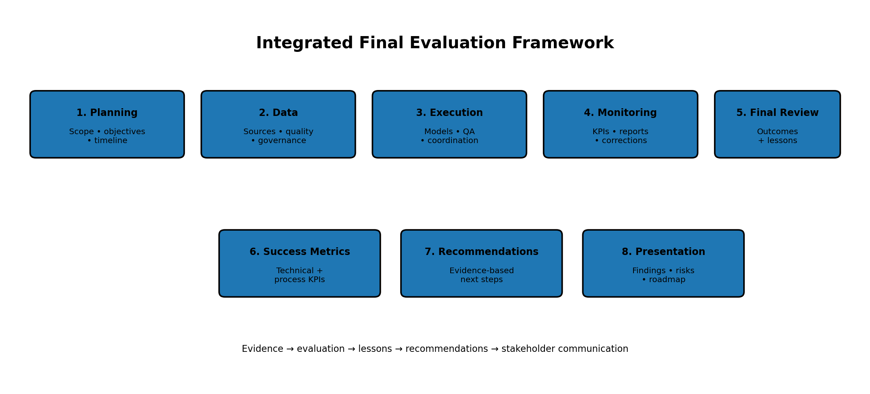
The final review follows the same lifecycle used throughout the internship: planning → data → execution → monitoring → final evaluation. Each phase contributes evidence, lessons and recommendations to the final review.
3. Review of All Project Phases
Phase | What Was Planned | Evidence to Review | Final Review Questions
Week 1 – Planning | Scope, objectives, timeline, resources and risks. | Project plan, Gantt chart, risk register. | Were objectives clear? Were milestones realistic?
Week 2 – Data Management | Source selection, acquisition, cleaning, governance and pipeline. | Data source record, data dictionary, quality checks, pipeline diagram. | Was data appropriate, documented and sufficiently clean?
Week 3 – Execution | Model development, Agile coordination, coding, validation and QA. | Experiment records, code/review history, validation results. | Was implementation reproducible and properly validated?
Week 4 – Monitoring | KPIs, dashboard, reporting and corrective-action process. | KPI snapshots, reports, action log, trend charts. | Were deviations identified and addressed systematically?
Week 5 – Final Review | Evaluate outcomes, lessons, recommendations and communication. | Final report, presentation and improvement roadmap. | What was achieved and what should happen next?
4. Success Metrics and Outcome Evaluation
Success should be assessed using a balanced set of technical, data-quality, process and project-management measures. No single metric should be used as the sole basis for declaring the project successful.
Metric | Category | How to Evaluate | Example Success Criterion | Evidence
F1-score | Model | Calculate using Scikit-learn on held-out evaluation data. | Example ≥ 0.75; define before final test. | classification_report
Recall | Model | Measure correctly identified positive cases. | Target depends on intervention objective. | Recall metric
Data completeness | Data | Measure required fields with valid values. | Example ≥ 95%. | Pandas quality report
Pipeline reproducibility | Technical | Re-run documented workflow from recorded inputs. | Results reproduce within expected tolerance. | Notebook/script run
Milestone completion | Project | Compare completed milestones with plan. | All critical milestones completed or explained. | Gantt/status log
Risk closure | Governance | Review critical risks and mitigation status. | No unexplained overdue critical risks. | Risk register
Documentation completeness | Process | Check required report/artifact sections. | 100% at final review. | Final checklist
Stakeholder communication | Process | Review whether findings, limits and recommendations are clear. | All key findings communicated. | Presentation/Q&A
The numerical examples above are planning thresholds, not actual results. If the case study is implemented, the final report should replace them with measured values and state the dataset, evaluation population and evaluation period.
5. Python-Based Analytics for the Final Review
Tool | Final Review Use | Expected Insight
Pandas | Combine KPI tables, summarize results and compare periods. | Structured final metrics table.
NumPy | Perform numerical comparisons and aggregations. | Calculated indicators and deltas.
Matplotlib | Create final trend and comparison charts. | Readable performance trends.
Seaborn | Visualize distributions, correlations and model diagnostics. | Patterns and error distributions.
Scikit-learn | Generate classification metrics and confusion matrix. | Model outcome evidence.
Jupyter Notebook | Create reproducible final analysis narrative. | Code + metrics + charts + interpretation.
Suggested final analytics checks
- Compare baseline and candidate-model metrics.
- Review precision, recall, F1-score and confusion matrix rather than relying on one score.
- Compare data-quality measurements before and after preprocessing.
- Review KPI trends across monitoring periods.
- Summarize unresolved risks and corrective actions.
- Record the exact data/model version used for every final metric.
6. Outcome Review: Achievements, Challenges and Gaps
Area | Possible Outcome / Evidence | Review Interpretation
Planning | Scope, timeline and risk plan established. | Assess whether the plan was realistic and traceable.
Data management | Source, cleaning rules and metadata documented. | Assess data suitability and reproducibility.
Execution | Models and validation process documented. | Assess technical completeness and quality.
Monitoring | KPIs and corrective-action process defined. | Assess whether progress was measurable.
Communication | Final report and presentation structure prepared. | Assess clarity for technical and non-technical stakeholders.
7. Lessons Learned
Successes / practices to retain
- Defining scope and deliverables before technical work reduces ambiguity.
- Separating raw and processed data improves traceability.
- Using a baseline before more complex models provides a useful reference.
- Combining code review, testing and documentation improves reproducibility.
- Monitoring KPIs creates an evidence-based mechanism for detecting deviations.
- Embedding ethics and data governance throughout the lifecycle is stronger than treating them as a final checklist.
Areas for improvement
- Automate repetitive data-quality and KPI calculations where practical.
- Improve experiment tracking so model comparisons are easier to reproduce.
- Define acceptance thresholds before final evaluation to avoid changing standards after seeing results.
- Increase stakeholder feedback earlier in the project rather than waiting for final presentation.
- Document assumptions and limitations immediately when they arise.
- If real deployment is considered, add formal monitoring for data drift, model drift, access control and incident response.
8. Future Recommendations and Roadmap
Priority Area | Recommendation | Expected Benefit | Next Step
Data | Improve source documentation and automate validation. | Higher data reliability. | Create reusable validation module.
Modelling | Compare additional suitable models and calibration methods. | Better evidence for model selection. | Run controlled experiments.
Explainability | Add feature-importance or explainability analysis where appropriate. | Clearer stakeholder interpretation. | Evaluate suitable explainability method.
Monitoring | Automate KPI reports and maintain historical trends. | Earlier detection of deviations. | Schedule repeatable report generation.
Governance | Formalize privacy, access and model-use guidelines. | More responsible future use. | Create governance checklist.
Deployment | Conduct a controlled pilot only after approval. | Evidence from real operational conditions. | Define pilot, rollback and monitoring plan.
9. Final Stakeholder Presentation Plan
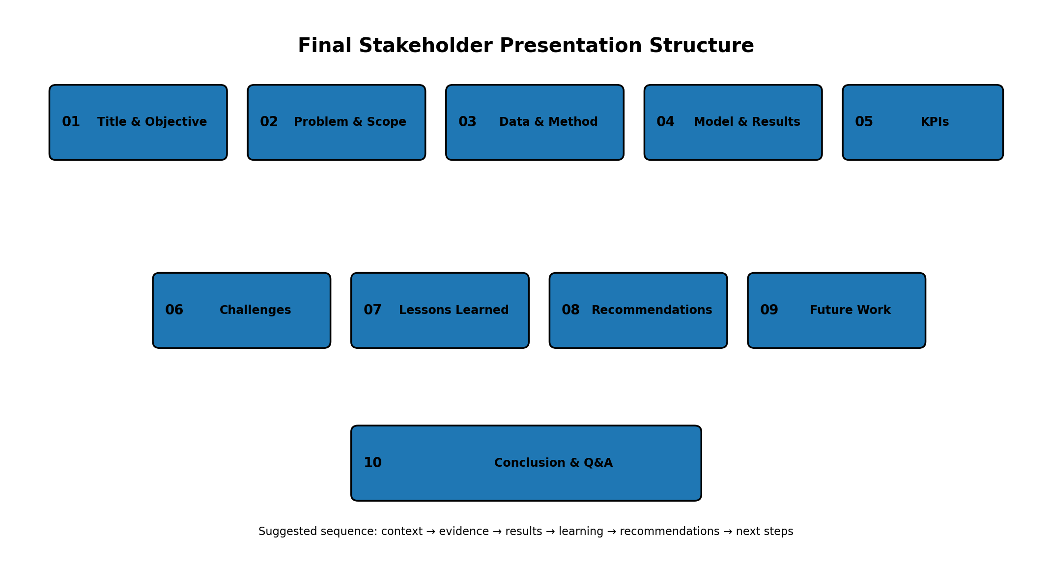
The presentation should prioritize a clear story: why the project was needed, what data and methods were used, what the evidence shows, what was learned and what should happen next.
Slide | Topic | Key Content | Communication Goal
1 | Title & Objective | Project title, objective, role and scope. | Establish context.
2 | Problem & Scope | Case-study problem, in/out of scope. | Define the question.
3 | Data & Method | Data source, pipeline and Python tools. | Explain methodology.
4 | Model & Results | Models, validation and key metrics. | Present evidence.
5 | Monitoring KPIs | Dashboard-style KPI summary and trends. | Show project control.
6 | Challenges | Major technical/data/process challenges. | Be transparent.
7 | Lessons Learned | Successes and areas for improvement. | Show reflection.
8 | Recommendations | Evidence-based improvements. | Support next decisions.
9 | Future Work | Roadmap, pilot/deployment considerations. | Define next steps.
10 | Conclusion & Q&A | Summary and stakeholder questions. | Close and invite discussion.
10. Communication Strategy
- Lead with the problem and evidence, not technical jargon.
- Use charts and concise tables for metrics; explain what each metric means before interpreting it.
- Clearly distinguish measured results from planned targets and illustrative examples.
- State limitations next to the relevant result rather than hiding them in a final slide.
- Tailor detail to the stakeholder: technical reviewers need methodology; management stakeholders need outcomes, risks and next steps.
- Reserve time for questions and document unresolved questions for follow-up.
11. Final Evaluation Checklist
- All five project phases are reviewed.
- Final metrics are linked to defined objectives.
- Data and model results are traceable to versions and evaluation data.
- Challenges and limitations are documented.
- Lessons learned include both strengths and improvement areas.
- Recommendations are supported by project evidence.
- Presentation communicates findings clearly to technical and non-technical stakeholders.
- Future steps include ownership and a practical next action where appropriate.
- No illustrative or placeholder value is presented as an actual project result.
12. Week 5 Deliverables
- Final evaluation and review document.
- Integrated review of planning, data management, execution and monitoring.
- Success metrics and Python analytics evaluation strategy.
- Lessons learned and process-improvement section.
- Future recommendations and roadmap.
- Stakeholder presentation plan with sample slide structure.
- Final evaluation checklist.
13. Conclusion
The Week 5 plan completes the project-management lifecycle by connecting the original objectives to evidence, lessons and future actions. A strong final review should show not only what the project produced, but also how reliably the work was performed, where uncertainty remains and what improvements are justified by the evidence.
The final presentation will communicate the case study in a concise stakeholder-friendly format. Python-based analytics provide the measurement foundation, while transparent documentation ensures that results, limitations and recommendations can be understood and reviewed. Because this is a Data Science case study, the final plan focuses on evaluation and communication rather than claiming a live production deployment.
Appendix – Submission Description (200+ Words)
This Week 5 task provides a comprehensive final evaluation, review and presentation plan for the hypothetical Student Performance Prediction and Early Intervention System. It synthesizes the work from all previous phases: project planning, data acquisition and management, execution, model validation, monitoring, reporting and process improvement. The final review uses a balanced set of success measures covering model performance, data quality, pipeline reliability, milestone completion, risk closure and documentation quality. Python-based analytics are integrated into the evaluation through Pandas and NumPy for metric summaries, Matplotlib and Seaborn for trends and diagnostic visualizations, and Scikit-learn for classification metrics and confusion matrices. The document clearly distinguishes example planning thresholds from actual measured results so that illustrative values are not mistaken for project outcomes. A structured phase-review table identifies the evidence and questions to examine for each stage of the project. The lessons-learned section records both practices to retain and areas that could be improved, including automation, experiment tracking, stakeholder feedback and stronger governance. Future recommendations cover data validation, model experimentation, explainability, monitoring, governance and a controlled future pilot if the project is ever taken beyond the case-study stage. The stakeholder presentation plan contains a ten-slide structure covering the problem, scope, data, methodology, results, KPIs, challenges, lessons, recommendations and future work. Communication guidance emphasizes evidence, clarity, limitations and audience-appropriate technical detail. Overall, the final document provides a professional framework for closing the data science project, communicating its findings and identifying practical next steps without overstating what the available evidence can demonstrate.

