Name : B.Shankar Reddy
ID : 11610372
Email : shankarbhumireddy@outlook.com
Section : K1616
Roll no : A22
Questions :20 and 21

Question 20:
Consider that a system has P resources of same type. These resources are shared by Q
processes time to time. All processes request and release the resources one at a time. Generate a
solution to demonstrate that, the system is in safe state when following conditions are satisfied.
Conditions:
1. Maximum resource need of each process is between 1 and P.
2. Summation of all maximum needs is less than P+Q
Description:
The question can be solved by using BANKAER’S ALGORITHM.
In the given question we want to satisfy two conditions.
1. Maximum resource need of each process is between 1 and P.
2. Summation of all maximum needs is less than P+Q
Where P is the number of resources and
Q is the number of process.
Banker’s Algorithm:
The banker’s algorithm is a resource allocation and deadlock avoidance algorithm that tests for safety by simulating the allocation for predetermined maximum possible amounts of all resources, then makes an “s-state” check to test for possible activities, before deciding whether allocation should be allowed to continue.
Following Data structures are used to implement the Banker’s Algorithm:
Let ‘Q’ be the number of processes in the system and ‘P’ be the number of resources types.
Available :
- It is a 1-d array of size ‘P’ indicating the number of available resources of each type.
- Available[ j ] = k means there are ‘k’ instances of resource type R_{j}
Max :

- It is a 2-d array of size ‘Q*P’ that defines the maximum demand of each process in a system.
- Max[ i, j ] = k means process P_{i} may request at most ‘k’ instances of resource type R_{j.}
Allocation :
- It is a 2-d array of size ‘Q*P’ that defines the number of resources of each type currently allocated to each process.
- Allocation[ i, j ] = k means process P_{i} is currently allocated ‘k’ instances of resource type R_{j}
Need :
- It is a 2-d array of size ‘Q*P’ that indicates the remaining resource need of each process.
- Need [ i, j ] = k means process P_{i} currently allocated ‘k’ instances of resource type R_{j}
- Need [ i, j ] = Max [ i, j ] – Allocation [ i, j ]
Allocation_{i} specifies the resources currently allocated to process P_{i} and Need_{i} specifies the additional resources that process P_{i} may still request to complete its task.
Banker’s algorithm consist of Safety algorithm and Resource request algorithm
Safety Algorithm
The algorithm for finding out whether or not a system is in a safe state can be described as follows:
Let Work and Finish be vectors of length m and n, respectively. Initialize:
Work = Available
Finish [i] = false for i = 0, 1, …, n- 1
2.Find an i such that both:
(a) Finish [i] = false
(b) Need_{i} ≤ Work
If no such i exists, go to step 4
3.Work=Work+Allocation_{i}
Finish[i]=true
go to step 2
4.If Finish [i] == true for all i, then the system is in a safe state
Request Algorithm
Request_{i} = request vector for process P_{i}. If Request_{i} [j] = k then process P_{i} wants k instances of resource type R_{j}
1. If Request_{i} ≤ Need_{i} go to step 2. Otherwise, raise error condition, since process has exceeded its maximum claim
2. If Request_{i} ≤ Available, go to step 3. Otherwise P_{i} must wait, since resources are not available
3. Pretend to allocate requested resources to P_{i} by modifying the state as follows:
Available = Available – Request_{i};
Allocation_{i} = Allocation_{i} + Request_{i};
Need_{i} = Need_{i} – Request_{i};
If safe ⇒ the resources are allocated to P_{i}
If unsafe ⇒ P_{i} must wait, and the old resource-allocation state is restored
Complexity: O( m*n ² ).

Code snippet:
#include<stdio.h>
#include<unistd.h>
#include<stdlib.h>
#include<conio.h>
int p;
int q;
int i,j;
int n,r;
int instance[10];
int finish[10];
int max[50][50];
int allo[50][50];
int needmatrix[50][50];
int requestmatrix[50][50];
int safe[20];
int avail[20];
int calling()
{
printf("if you want to continue press 1 otherwise 0 :");
scanf("%d",&n);
if(n==1)
{
main();
}
else
{
exit(0);
}
}
int instances()
{
for(i=0;i<p;i++)
{
printf("enter the no of instances for resource R%d :",i);
scanf("%d",&instance[i]);
}
for(i=0;i<p;i++)
{
printf("no of instances for resource R%d is %d\n",i,instance[i]);

}
}
int maxresource()
{
for(i=0;i<q;i++)
{
printf("enter the maximum resources need for process p%d ");
for(j=0;j<p;j++)
{
int sum=0;
printf("for resource R%d :");
scanf("%d",&max[i][j]);
sum=sum+max[i][j];
if(max[i][j]<1||max[i][j]>p||sum>p+q)
{
printf("you have entered incorrect values\n");
printf("values must be between or equal to 1 and %d \n",p);
printf("required conditions not satisfed\n");
calling();
}
}

}
}
int allocated()
{
for(i=0;i<q;i++)
{
printf("enter the allocated resources for process p%d ");
for(j=0;j<p;j++)
{
printf("for resource R%d :");
scanf("%d",&allo[i][j]);
}
}

}
int need()
{
printf("\n\nneed matrix :\n ");
for(i=0;i<q;i++){
printf(" R%d",i);
}
for(i=0;i<p;i++){
printf("\nP%d ",i);
for(j=0;j<q;j++){
needmatrix[i][j]=max[i][j]-allo[i][j];
printf(" %d",needmatrix[i][j]);
}
}
}
int request()
{
int j,k;
for(j=0;j<3;j++)
{
printf("\nFor resource %c :",j+65);
scanf("%d",&requestmatrix[i][j]);
k=requestmatrix[i][j];
if(requestmatrix[i][j]>needmatrix[i][j])
{
printf("\nProcess has exceeded its maximum claim for instances. Request cannot be granted.");
return;
}
if(requestmatrix[i][j]>avail[j])
{
printf("\nResources are not yet available , You have to wait for request grant.");
}
else
{
avail[j] = avail[j] - requestmatrix[i][j];
needmatrix[i][j] = needmatrix[i][j] - requestmatrix[i][j];
}
}
int c=safety();
if(c==0)
{
printf("\nProcess P%d is granted the Requested instances ",i);
return;
}
else
{
printf("\nProcess P%d cannot be granted the requested instances because of unsafe state,\nProcess has to wait for the safe environment.",i);
needmatrix[i][j] = needmatrix[i][j] + requestmatrix[i][j];
avail[j] = avail[j] + requestmatrix[i][j];
}
}
int safety()
{
int k=0;
int ssnum=0;
int l=0;
while(1){
for(i=0;i<q;i++)
{
if(finish[i]==0)
{
for(j=0;j<p;j++)
{
if(avail[j] >= needmatrix[i][j]){

}
else{
break;
}
}
if(j==p)
{
for(j=0;j<p;j++)
{
avail[j]=avail[j]+allo[i][j];
}
finish[i]=1;
safe[ssnum]=i;
ssnum++;
l++;
}
}
}

if(k==r)
{
if(l == r)
{
printf("\nSystem is in safe state with safe sequence : <");
for(i=0;i<r;i++)
{
printf(" P%d",safe[i]);
}
printf(" >");
calling();
}
else
{
printf("\nSystem is in unsafe state\n");
calling();
}
}
k++;
}
}

int main()
{
printf("enter no of resources :");
scanf("%d",&p);
printf("enter no of process :");
scanf("%d",&q);
instances();
maxresource();
allocated();
need();
request();
safety();
}

Boundary Conditions :
1. Maximum resource need of each process is between 1 and P.
2. Summation of all maximum needs is less than P+Q.
If we enter beyond this conditions the program will show error
Test Cases :
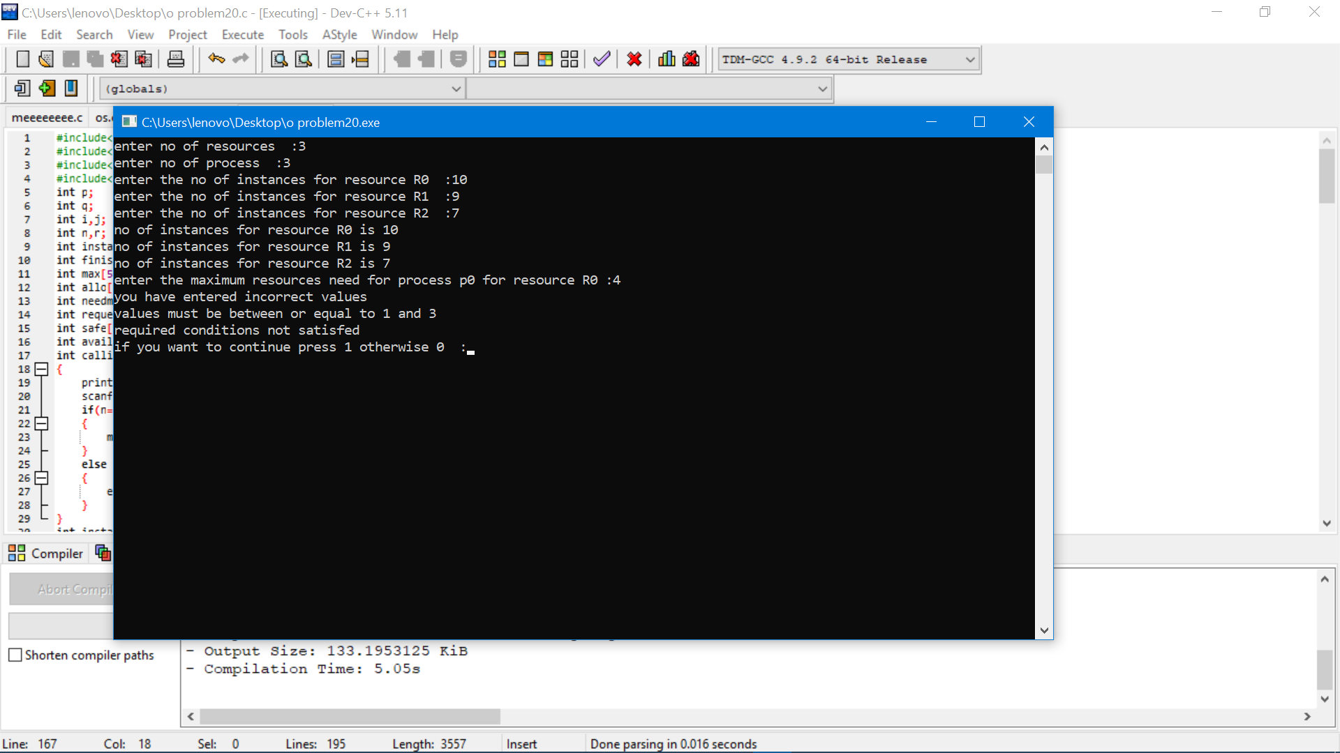
Showing error when the maximum resources values are beyond the required condition .
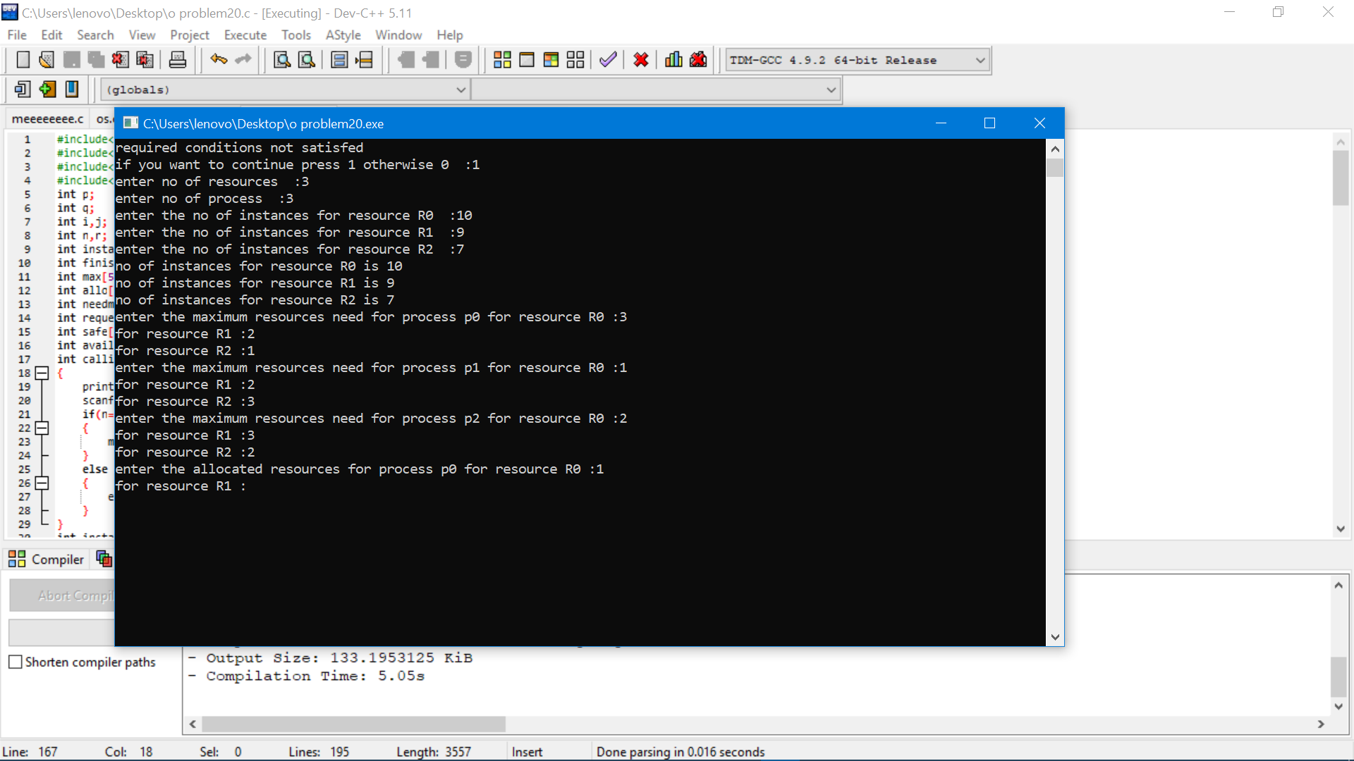
Accepting the maximum resources values if they are entered correct
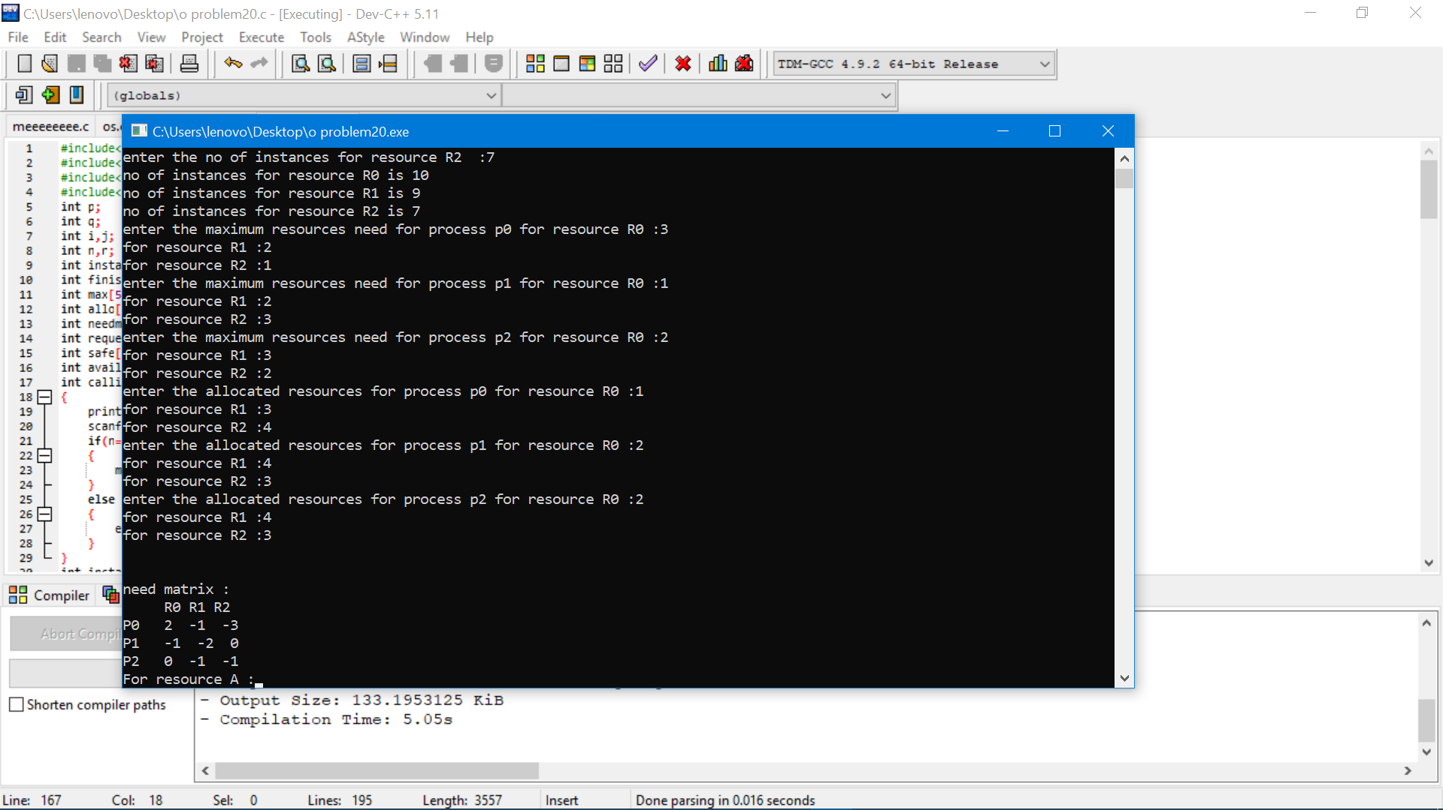
Initializing the values of the allocated resources and showing the need matrix
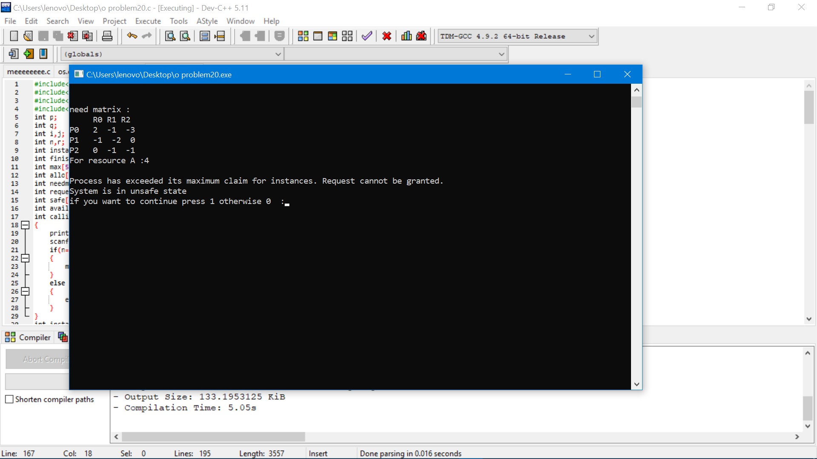
Asking for the further allocation and showing the errors if we enter the wrong value
And showing it is in unsafe state

Question 21:
Consider a scenario of demand paged memory. Page table is held in registers. It takes
8 milliseconds to service a page fault if an empty page is available or the replaced page is not
modified and 20 milliseconds if the replaced page is modified. Memory access time is 100
nanoseconds. Assume that the page to be replaced is modified 70 percent of the time. Generate a
solution to find maximum acceptable page-fault rate for access time that is not more than 200
nanoseconds.
Description:
In the above question we will use demand paged memory. where page table is held in registers
time to service a page fault
time to modify a replaced page
memory access time
percentage of time taken to modify a replaced page
maximum acceptable page-fault rate
effective access time
are all given and here we want to find maximum acceptable page-fault rate
Code Snippet:
#include<stdio.h>
#include<unistd.h>
#include<stdlib.h>
#include<conio.h>
int main()
{
float spf; //time to service a page fault
float rpm; //time to modify a replaced page
float mat; //memory access time
float mp; //percentage of time taken to modify a replaced page
float mapfr; //maximum acceptable page-fault rate
float ea; //effective access time
printf("Enter the time takes to service a page fault in milliseconds\n");
scanf("%f",&spf);
printf("Enter the time takes to modify a replaced page in milliseconds \n");
scanf("%f",&rpm);
printf("Enter the memory access time in nano seconds \n");
scanf("%f",&mat);
printf("Enter percentage of time taken to modify a replaced page\n");
scanf("%f",&mp);
printf("Enter maximum access time in milliseconds\n");
scanf("%f",&ea);
mapfr=((rpm/1000)-(mat/1000))/(-(mat/1000)+(0.3*spf)+((mp/100)*rpm));
printf("%f",mapfr);
}
In the above code we want give all the required attributes
And by the formula
mapfr=((rpm/1000)-(mat/1000))/(-(mat/1000)+(0.3*spf)+((mp/100)*rpm))
we can get the out put
Test cases:
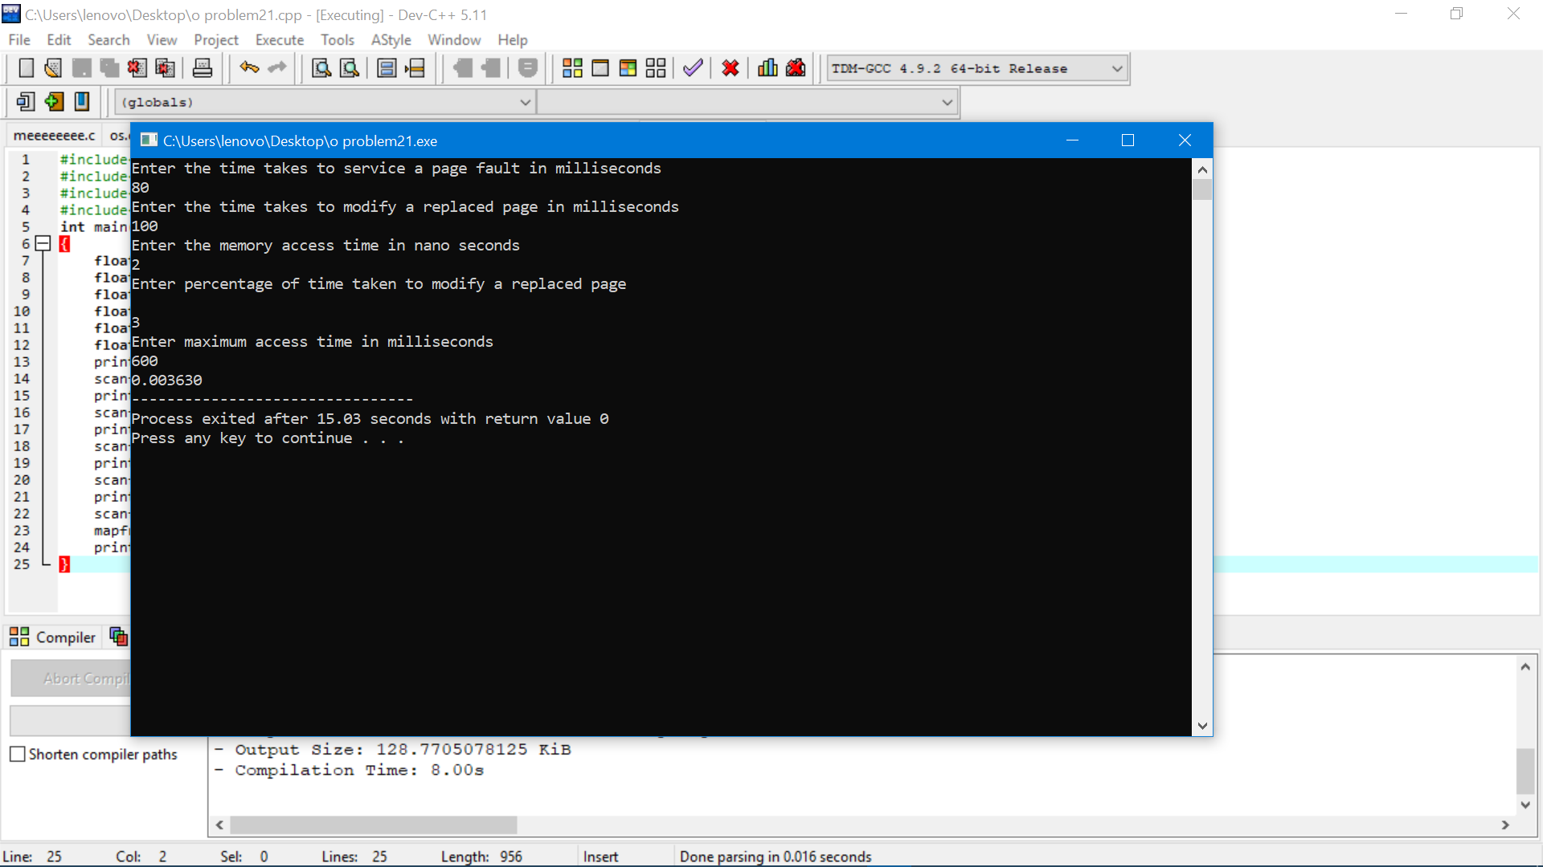
In the above figure there we have given required attributes
And the output is displayed

