**Performance of Airlines**

**Natarajan Shankar - W209 – 5 (Thursday 6:30PM session)**

**Please Note: I tried to use many forms of charts but bar charts and line charts worked best in representing the data and to support the interpretations.**

**Hypothesis 1:** **In 2001, Southwest Airlines (Code: WN) was deemed the best US based airline. This must mean that Southwest Airlines had the best on-time performance that year.**

**Data 1:** Start by looking at on-time performance of all airlines, i.e. at a plot of count of delayed flights for the top 12 airlines. Chart the total number of delayed flights per airline in 2001 for the top 12 airlines.

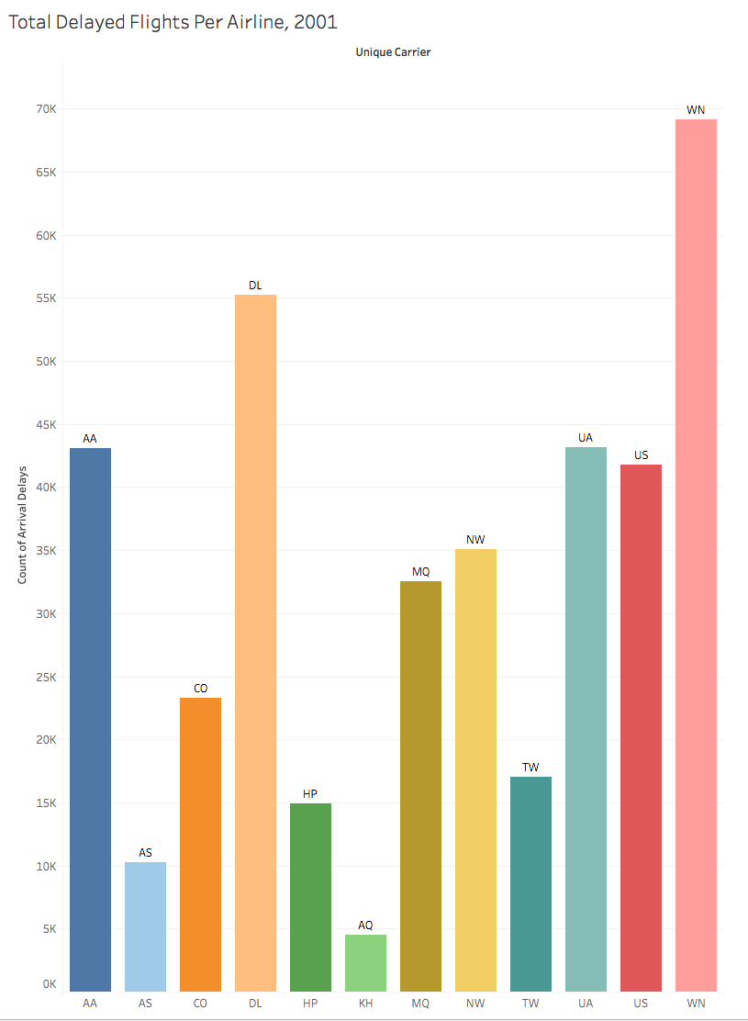

**Chart Interpretation:** In 2001, Southwest Airlines (69116) had the most number of delayed flights. Delta Airlines (55246) had the second worst performance followed closely by United (43162), American (43102) and US Airways.

**The above finding is a negative attribute towards the hypothesis. Being tops in delayed flight count is not a positive attribute for Southwest but there is likely more to the data.**

**Data 2:** Examine the total delayed minutes per Airline by plotting cumulative total delay against airline name.**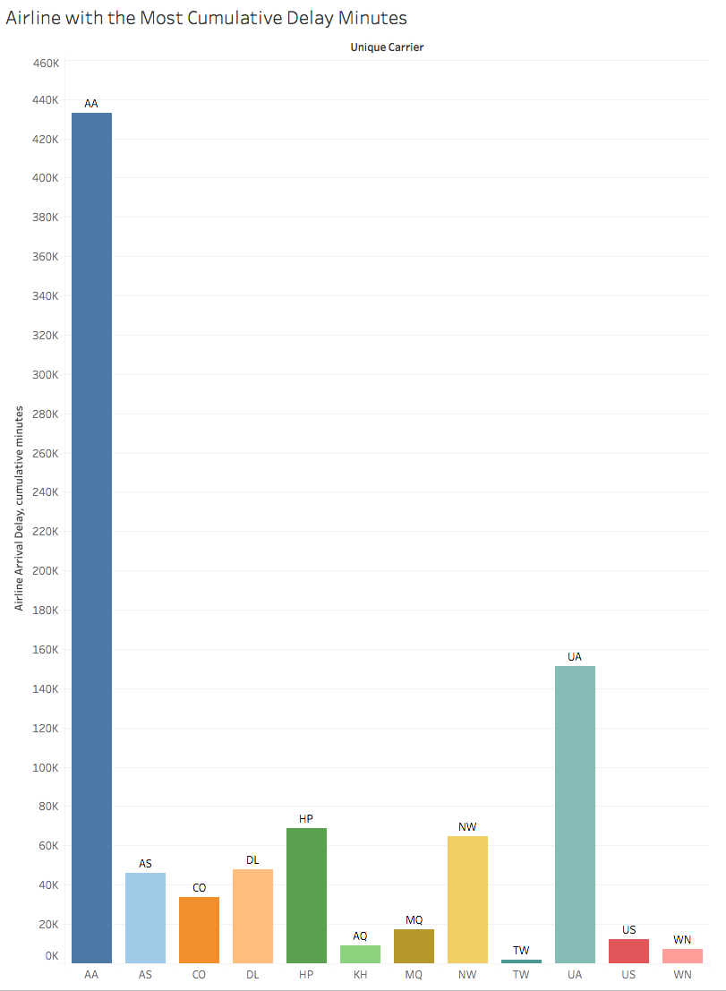Chart**

**Interpretation:** American Airlines (432820 minutes) has by far the most cumulative delay minutes. United was a far second at 151131 minutes followed by America West (HP: 68878 minutes).

**Southwest had only 7348 delay minutes in 2001, much lower that that of other airlines. This is a positive attribute for the hypothesis.**

**Data 3:** Examine the number of flights per airline in 2001 by plotting the annual total number of flights per airline for the top 12 airlines

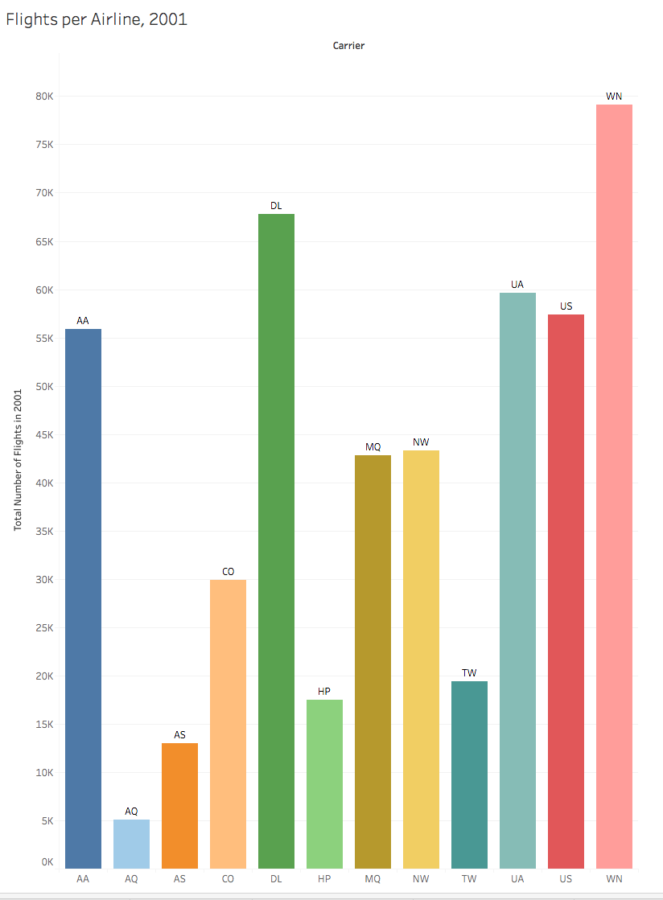

**Chart Interpretation:** Southwest Airlines had the most flights, 79079. Followed by Delta (67821), United (59590), US Airways (57377) and American (55846)

**Data 4:** Examine the flight delay times normalized by number of flights. This is done by computing a new calculated field: SUM([Arr Delay]) / Sum([Flights]). Plot this new calculated field against airline name.

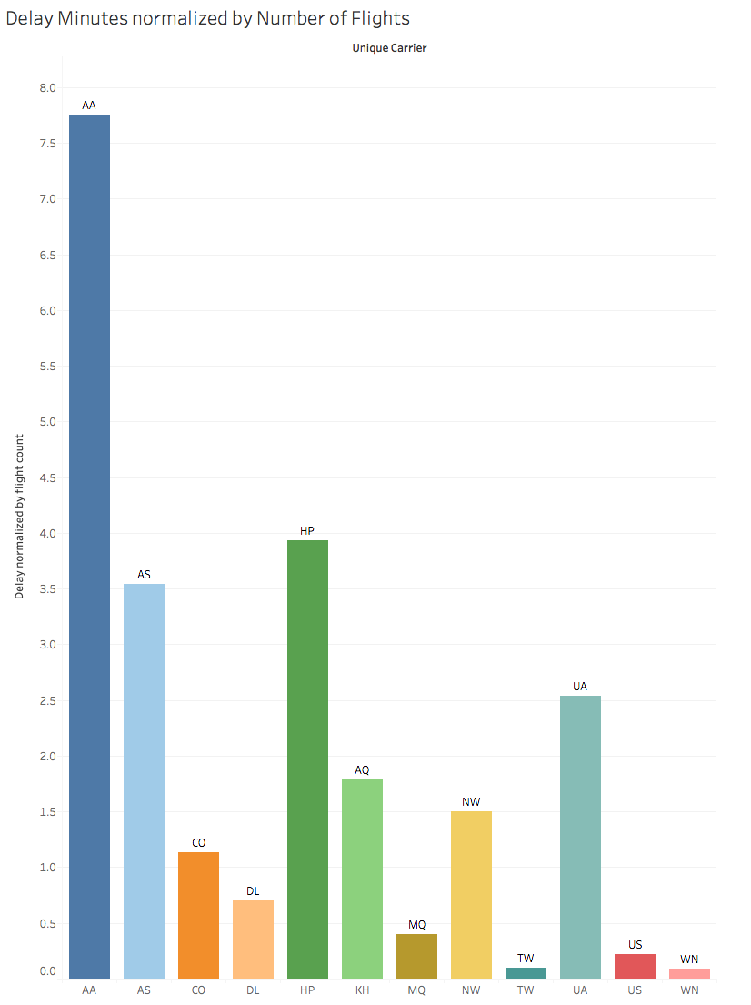

**Chart Interpretation:** American Airlines had the worst per flight delay (7.75 minutes). Followed by America West (3.937 minutes) and Alaska (3.544).

**Southwest was lowest at 0.093 minutes. This fact is a very positive attribute towards the hypothesis.**

**Conclusion: Even though Southwest airlines had the most number of delayed flights in 2001, its average delay per flight was the lowest amongst the 12 airlines with comparable data.**

**Consumer perception of Airline performance is very sensitive to delays. Even though Southwest airlines had the most number of delays in 2001, the very low measure of the delay per flight was likely not a significant factor in the vote for “Best US Airline” even though delayed-flight-count data pointed towards a lack of performance.**

**Hypothesis 2:**

**Part a:** **The worst day for flight on-time performance is Monday or Friday when most business travelers schedule their travel and return days.**

**Part b: To support this work related travel, airlines will show peak number of flights on Mondays and Fridays.**

This chart shows that flight count remains unchanged and does not peak on Mondays and Fridays. For select airlines, there is a surge in flight count between Friday and Sunday but no such surge on workdays.

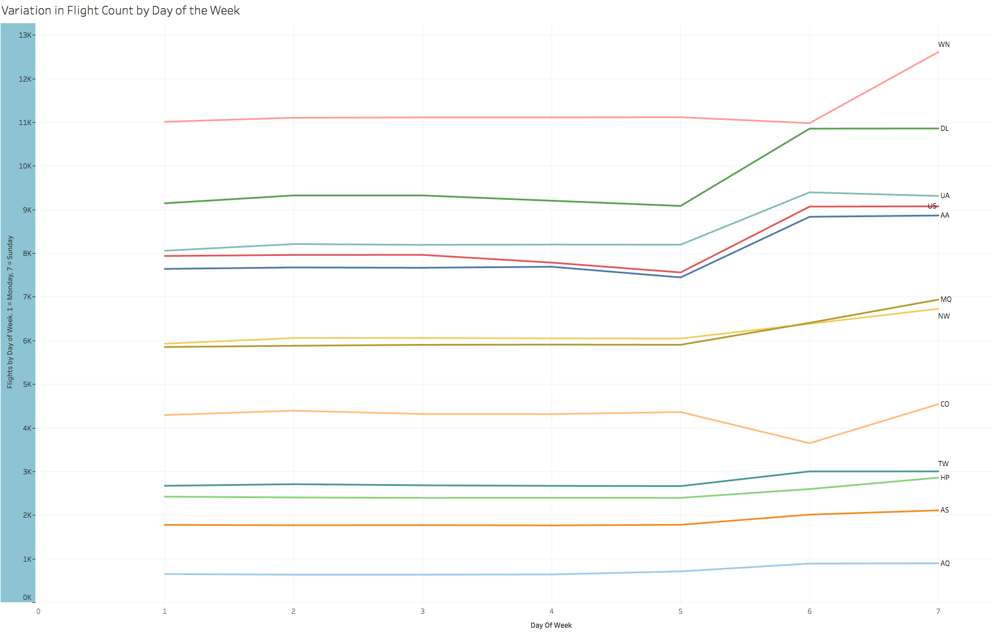

**The above chart indicates that there was no peaking of flights on Mondays and Fridays in 2001. And thus, Part b of the hypothesis is not supported.**

**The following chart shows the arrival and departure delays by day of the week.**

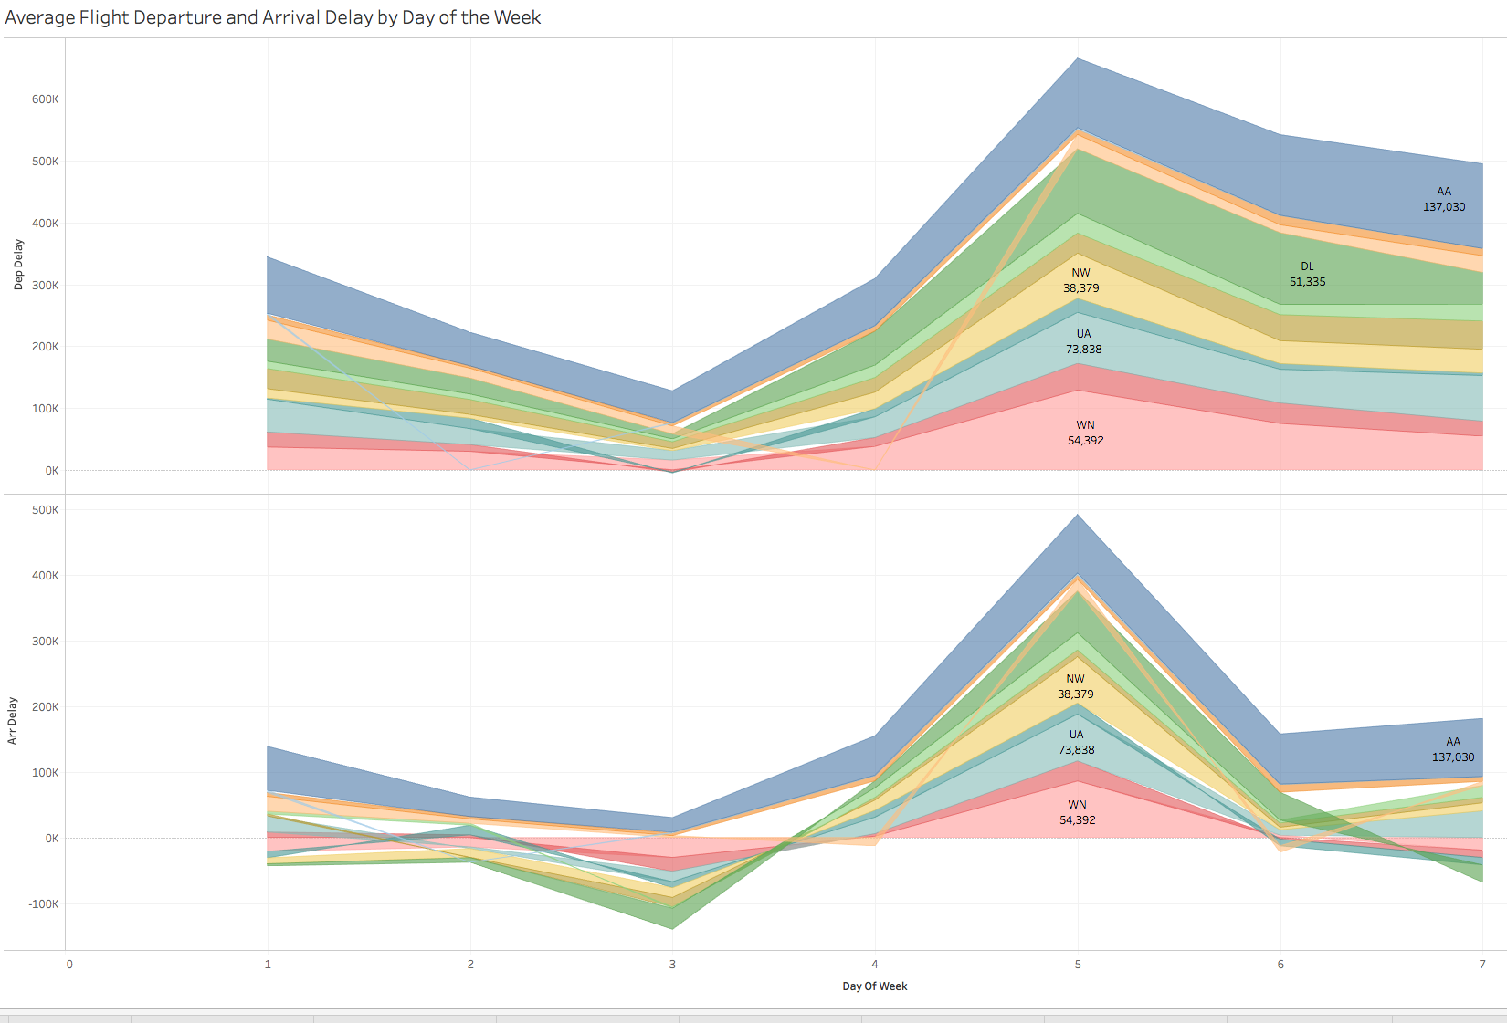

The data shows that for each of the major airlines, there is a widened delay band on Thursdays capturing a very noticeable delay in arrivals and departures.

The delay bands on Mondays and Fridays are significant for only a couple of airlines and largely normal for most others.

**The charts show that Thursdays are the worst days for travel delay. Not Friday or Monday.**

**Hypothesis 3:** **September 11, 2001 was a chaotic day for flights. The hypothesis is that many flights were cancelled for many days and there was a peak in flight redirection for multiple days after September 11th.**

**This chart shows the cumulative number of flight cancellations per airline peaking on September 13 but that the airline system recovered almost to normalcy within 15 days.**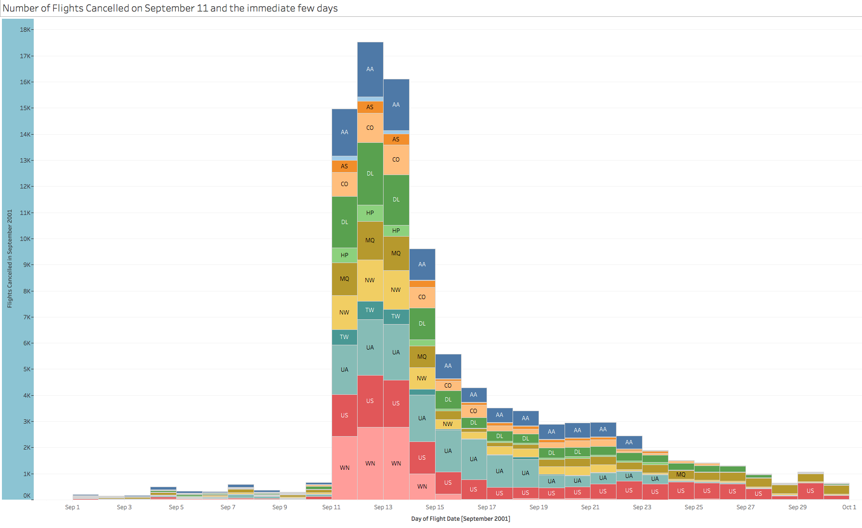

**This chart shows the cumulative number of flight redirects per airline at a peak on September 11 but remaining at normal count over the subsequent few days meaning that not many flights were getting redirected away from the busy NY and Boston areas. This immediate recovery was unexpected.**

