IEEE Computational Intelligence Society (CIS) Kolkata Chapter

Summer Internship Report 2025

Submitted by: Adarsh Rounak, Abantika Ghosal Chowdhury, Shailja Jha, students at Dept. of CSE (AI & ML), Heritage Institute of Technology, Kolkata
Internship Title: AI-powered database schema generation system
Mentor(s): Dr. Ramen Pal, University of Limerick, Ireland
Mode of Internship: Online
Internship Duration: 1st June 2025 – 31st July 2025
Date of Submission: 02/08/2025

Declaration by the Student
We hereby declare that the Internship Report titled:
"AI-powered database schema generation system"
submitted in partial fulfillment of the Summer Internship 2025 under IEEE Computational Intelligence Society (CIS), Kolkata Chapter, is a record of original work done by us during the internship period from 1st June, 2025 to 31st July, 2025 under the mentorship of Dr. Ramen Pal, University of Limerick, Ireland.
This report has not been submitted previously to any other organization or institution for any purpose. All information and data provided in this report are true to the best of our knowledge and belief.
We understand that any form of plagiarism or misrepresentation of information will lead to disqualification of the report.

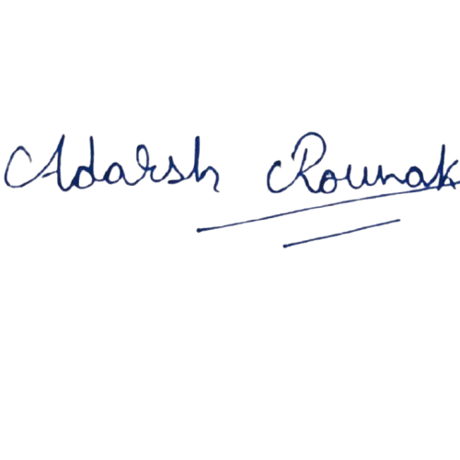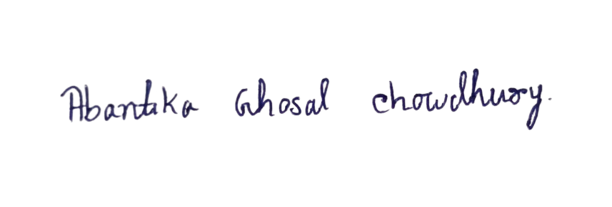
______________________
Signature of the Student(s)

Certificate from Mentor(s) [In Official Letterhead of Mentor]
This is to certify that the following students have successfully completed the Summer Internship 2025 under the IEEE Computational Intelligence Society (CIS), Kolkata Chapter from 1st June, 2025 to 31st July, 2025:

Sl. No. | Name of the Student | Affiliation
1 | Adarsh Rounak | Dept. of CSE (AI & ML), Heritage Institute of Technology, Kolkata
2 | Abantika Ghosal Chowdhury | Dept. of CSE (AI & ML), Heritage Institute of Technology, Kolkata
3 | Shailja Jha | Dept. of CSE (AI & ML), Heritage Institute of Technology, Kolkata
The students worked on the project titled:
"AI-powered database schema generation system"
under my mentorship. Their performance was found to be [excellent/very good/satisfactory].
I/We wish them success in all their future endeavors.

_____________________
Signature of the Mentor

Acknowledgment
We would like to express our sincere gratitude to the IEEE CIS Kolkata Chapter for offering us this opportunity to participate in the Summer Internship Program 2025. We are grateful to our mentor, Dr. Ramen Pal, for his continuous guidance, support, and encouragement throughout this internship. Our heartfelt thanks also extend to all the team members for their collaboration and contribution.

Abstract of the Internship/Project Work
During our internship with the IEEE CIS Kolkata Chapter, we developed an AI-powered database schema generation system to help non-technical users, especially small business owners, convert natural language descriptions into structured database schemas. This tool aimed to simplify the database creation process by integrating advanced NLP techniques and offering a user-friendly interface. We explored various technologies, including Streamlit, Flask, LangChain, and Ollama, and leveraged large language models (LLMs) like Gemma3 and Mistral-7B. Over the span of several weeks, we implemented modules for ER diagram generation and Bengali-English code-mixed translation. We also prepared a code-mixed dataset, for fine-tuning the Gemma3 model, using rule-based, ML-based, and LLM-based methods. The project concluded with an exploration into auto dubbing feature using LLMs to support multilingual content creation, to further increase the model performance using multi-lingual or code-mixed input.

Detailed Project Report [GITHUB]

1. Introduction/Background
Small businesses and developers often struggle to design efficient database schemas due to a lack of technical knowledge or the complex nature of schema creation. Our project proposes a solution where natural language inputs are translated into SQL-compatible schemas, thus simplifying the process.
2. Motivation
Manual database design is tedious, error-prone, and time-consuming. By automating this task using AI, we aimed to reduce human effort, increase accuracy, and make data handling accessible to a wider audience.
3. Problem Statement
Developers and small businesses lack tools to easily convert their ideas or business models into structured databases. This results in delays, technical bottlenecks, or improper data management. Our goal was to bridge this gap using AI and natural language understanding.
4. Proposed Method
The proposed AI tool converts plain text inputs like "I run a chai shop" into complete database schemas with tables, attributes, and relationships. Our system included:
- Natural Language Processing (NLP) for schema and SQL generation.
- Frontend using HTML/CSS/JS and Streamlit for user interaction.
- Backend using Flask and LangChain.
- Database compatibility with MySQL and PostgreSQL.
- Visual ER diagram generation using Mermaid.js.
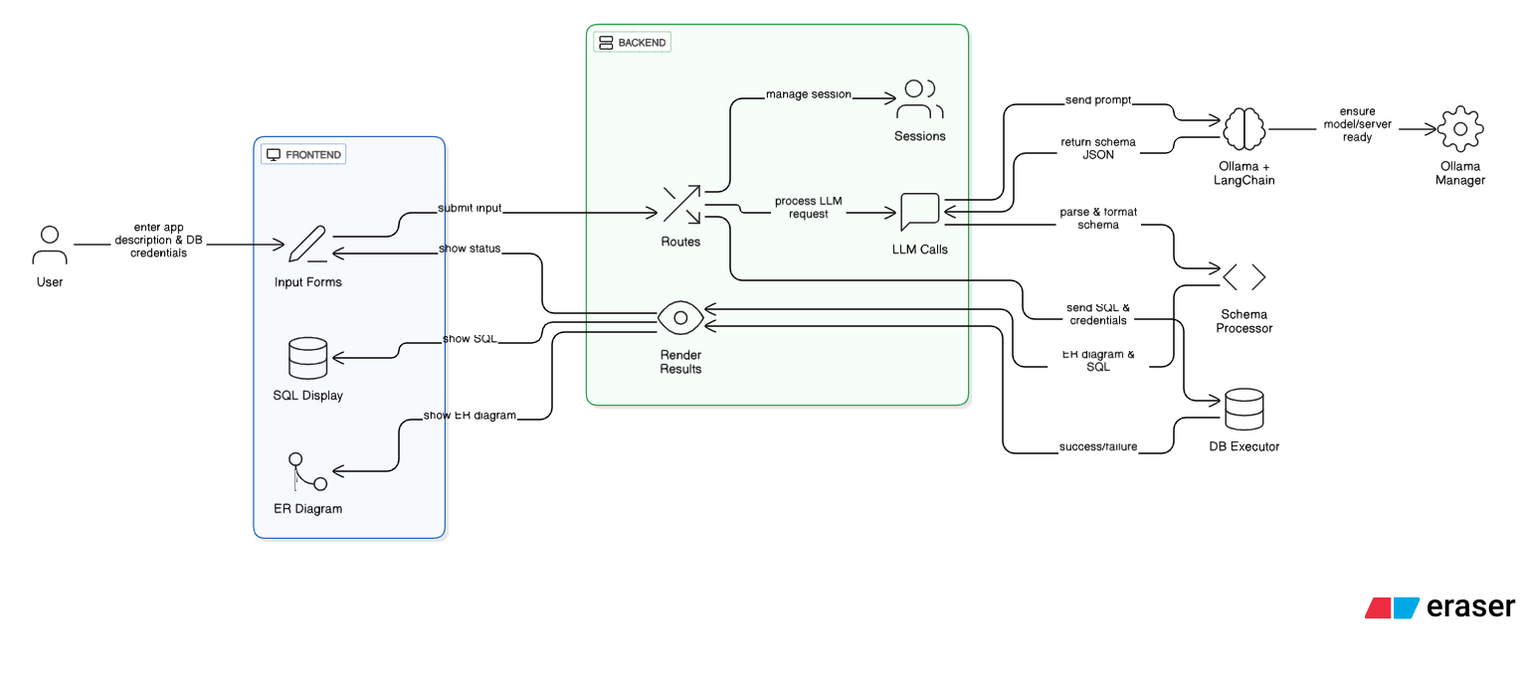
5. Experimental Results
- Successfully generated SQL schemas and ER diagrams from natural language.
- Developed code-mixed dataset, for fine-tuning the Gemma3 model, using rule-based, ML-based, and LLM-based methods.
- Integrated Gemma3 model for efficient schema generation.
- Researched on auto-dubbing feature using Deepgram API and Google Translate for further increasing the model performance using multi-lingual input.

Technology Stack:
Layer | Component | Technology / Tool | Purpose
Frontend | UI Rendering | HTML5, Bootstrap 5, JavaScript | User interface and form design
 | Diagram Visualization | Mermaid.js | Render ER diagrams from Mermaid code
Backend | Web Framework | Flask | Server-side logic, routing, session handling
 | Session Storage | Flask Session | Store DB credentials and schema temporarily
 | LLM Prompting | LangChain (PromptTemplate) | Structured prompt to LLM for schema generation
LLM & AI | Language Model Runtime | Ollama | Local LLM runtime for inference
 | Model | gemma3:4B / Mistral-7B | Generate structured schema from user input
Database Layer | MySQL Connectivity | mysql-connector-python | Connect and execute queries on MySQL
 | PostgreSQL Connectivity | psycopg2 | Connect and execute queries on PostgreSQL
Utilities | HTTP Requests | requests | Check Ollama server status
 | Process Management | subprocess, os, time | Start and manage Ollama process
 | JSON Parsing & Cleaning | json, re | Parse and clean LLM response
Visualization Output | Code & Diagram Display | <pre>, <code>, Mermaid.js | Present schema and ER diagrams on results page

6. Conclusion
This internship enabled us to develop a scalable, AI-powered tool that simplifies database schema creation for non-experts. It combines NLP and multilingual support and incorporates visual ER diagrams. The project also expanded into code-mixed NLP and video dubbing, opening possibilities for future enhancements in multilingual AI tools.
7. Future Improvements
- Add voice input functionality using Whisper.
- Enhance code-mixed NLP pipeline for broader language support.
- Fine-tune Gemma3 on Bengali-English code-mixed data for improved performance.
8. References
- Hugging Face Datasets (Sangraha, Pralekha)
- LangChain documentation
- OpenAI Whisper
- Deepgram API
- mT5, MBART, Falcon models
- Gemma3 and Mistral-7B model documentation
- Google Translate API
- Flask, Streamlit, HTML/CSS/JS frameworks

