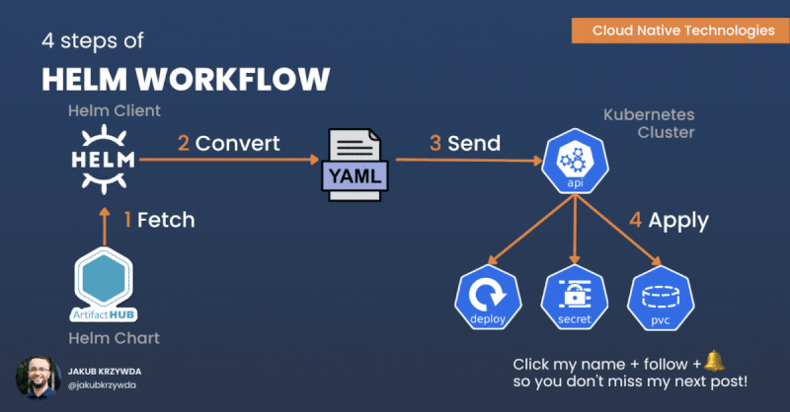
Managing applications in Kubernetes can get complex. Helm, a package manager for Kubernetes, simplifies deployment by using Helm Charts—reusable and configurable deployment units.
1️⃣ Fetch the Helm Chart:
The Helm client pulls a Chart package and its dependencies from a remote repository, such as Artifact Hub.
Command: 𝘩𝘦𝘭𝘮 𝘱𝘶𝘭𝘭 [𝘙𝘌𝘗𝘖𝘚𝘐𝘛𝘖𝘙𝘠]/[𝘊𝘏𝘈𝘙𝘛]
2️⃣ Convert the Chart into Kubernetes YAML:
The Helm client renders and validates the Chart into a valid Kubernetes YAML manifest, by applying the values.yaml file.
Command: 𝘩𝘦𝘭𝘮 𝘵𝘦𝘮𝘱𝘭𝘢𝘵𝘦 [𝘙𝘌𝘓𝘌𝘈𝘚𝘌] [𝘊𝘏𝘈𝘙𝘛]
3️⃣ Deploy the Application:
Helm sends the raw YAML to the Kubernetes API server over HTTPS.
Command: 𝘩𝘦𝘭𝘮 𝘪𝘯𝘴𝘵𝘢𝘭𝘭 [𝘙𝘌𝘓𝘌𝘈𝘚𝘌] [𝘊𝘏𝘈𝘙𝘛]
4️⃣ Kubernetes Applies the Resources:
The Kubernetes API server creates the necessary resources—Deployments, Secrets, Persistent Volume Claims, and more.

