**Python Basic Assignment 4 - Submitted by Shankar Eaga / Full Stack Data Science course**

**Answers captured in red color**

1. What exactly is []?

Answer : The above square brackets are used in Python “list”, which is one of the collection of data types. The list are used to store multiple items in a single variable , see below example

My_list_variable = [“first_name”, “Second_name”, age, “address”]

Some of the important points of List

1. list items are ordered, changeable and all duplicate values.
2. List items are indexed , starting with index[0], index[1] etc.
3. List items can be different data types like string, numeric, boolen

There are four collection data types in Python,

**List** is a collection which is ordered and changeable. Allows duplicate members.

**Tuple** is a collection which is ordered and unchangeable. Allows duplicate members.

**Set** is a collection which is unordered and unindexed. No duplicate members.

**Dictionary** is a collection which is unordered and changeable. No duplicate members.

2. In a list of values stored in a variable called spam, how would you assign the value 'hello' as the third value? (Assume [2, 4, 6, 8, 10] are in spam.)

Answer : spam = [2,4,6,8,10]

Spam[2] = “hello”

Output : [2,4,”hello”,8,10]

Let's pretend the spam includes the list ['a', 'b', 'c', 'd'] for the next three queries.

3. What is the value of spam[int(int('3' * 2) / 11)]?

Answer : 8

4. What is the value of spam[-1]?

Answer : ‘d’

5. What is the value of spam[:2]?

Answer : [2, 4]

Let's pretend bacon has the list [3.14, 'cat,' 11, 'cat,' True] for the next three questions.

6. What is the value of bacon.index('cat')?

Answer : 1

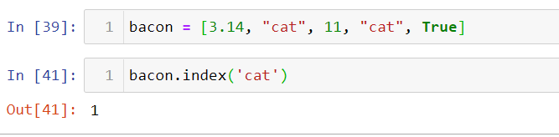

7. How does bacon.append(99) change the look of the list value in bacon?

Answer : bacon = [3.14, 'cat', 11, 'cat', True, 99]

8. How does bacon.remove('cat') change the look of the list meaning in bacon?

Answer : See below for output, it removes only first instance at index 1.

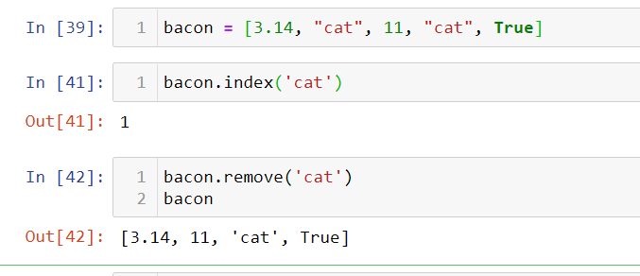

9. What are the list concatenation and list replication operators?

Answer : List concatenation operations : Add (+), Multiply (*), see below for examples.

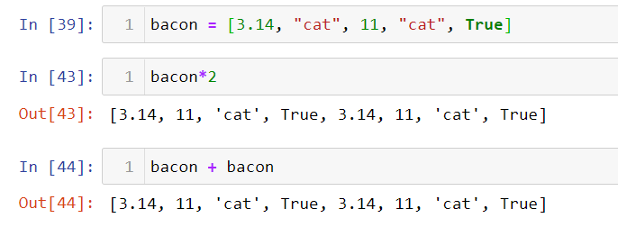

10. What is difference between the list methods append() and insert()?

Answer : The main difference between append and insert for list is that append will add the values at the end of the list where as insert will add value based on index , see below examples.

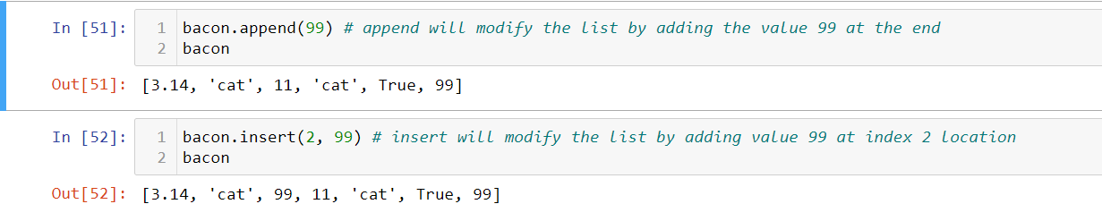

11. What are the two methods for removing items from a list?

Answer : The following operations will be performed on the list

List slicing and list.pop will allow to select range of values in the list and at index level. See below screen shot for examples.

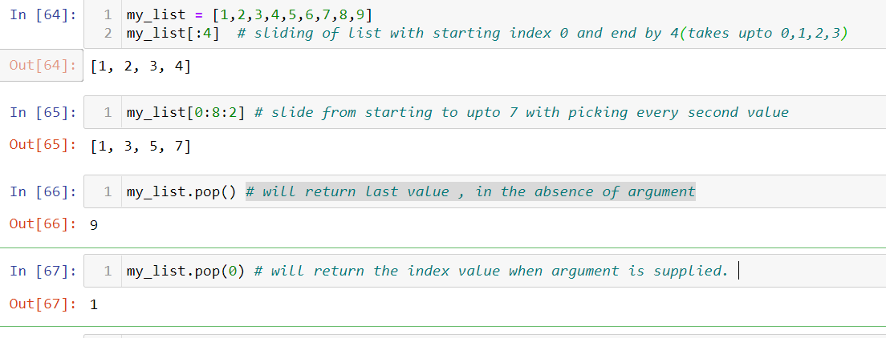

12. Describe how list values and string values are identical.

Answer : The main identical features between list and string are

1. Values are indexed and can be assessed. by index number.

My_string = “shankar” ; to assess first letter ‘s’ : My_string[0] = ‘s’

My_list = [“shankar”, 1, 100, “python”] ; to assess first value which is indexed at ‘0’ : My_list[0] = ‘shankar’

1. Values in string are not mutable where as values in list are mutable.
2. String can sort character where as list can store all data types.

What's the difference between tuples and lists?

Answer : The fundamental difference between list and tuple is that 1. values are mutable in list and immutable in tuples, 2. List uses [] square bracket where as tuple uses () round brackets. 3. Both can store heterogenous and non-heterogenous data types. 4. List and tuple can be mutually converted, list 🡪 tuple and tuple 🡪 list.

14. How do you type a tuple value that only contains the integer 42?

Answer : In Python , tuple can accept one value but comma has to be added at the end of the value, otherwise Python will not recognise it is a tuple. In case of integer value, it recognises as integer without comma at the end.

Example : my_tuple_with_onevalue = (42,)

15. How do you get a list value's tuple form? How do you get a tuple value's list form?

Answer : In the list , with append function, additional values can be added to list including tuples, see below with list.append, tuple(4,5) are added to end of the list.

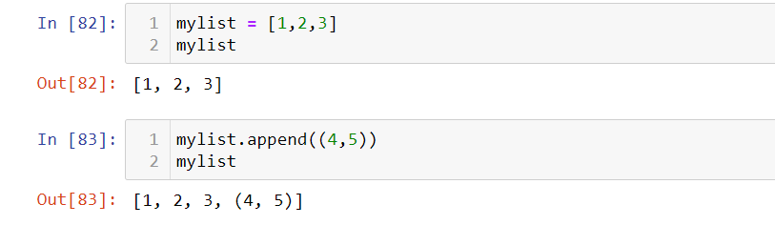

In tuples, once tuples created, can not be changed. You can add data by changing to list and then append with additional data and change back to tuple, see below example.

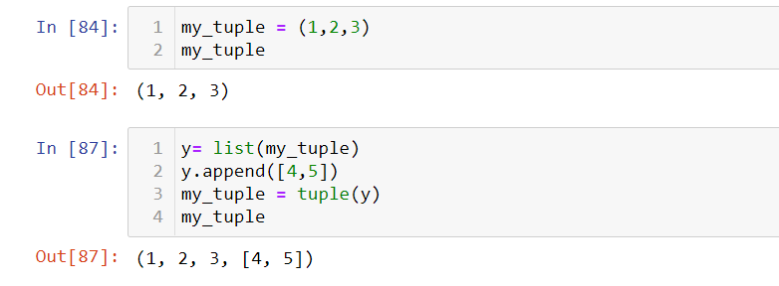

16. Variables that "contain" list values are not necessarily lists themselves. Instead, what do they contain?

Answer: if you have a variable with collection of list or tuples etc, Python will allow them to extract as variables , which is called unpacking of collection, see below for example,

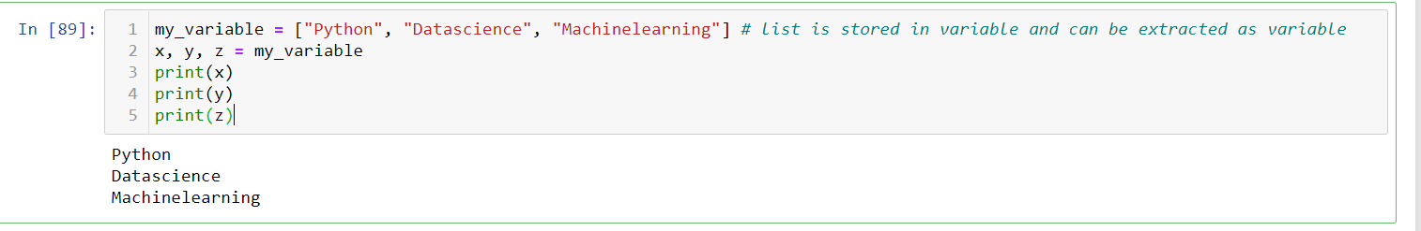

17. How do you distinguish between copy.copy() and copy.deepcopy()?

Answer : Copy.copy() , sometimes also called shallow copy, constructs a new compound object and then (to the extent possible) inserts references into it to the objects found in the original.

Deep copy is a process in which the copying process occurs recursively. In case of deep copy, a copy of object is copied in other object. It means that any changes made to a copy of object do not reflect in the original object. In python, this is implemented using “deepcopy()” function.