MLOps Assignment 01
End-to-End ML Model Development, CI/CD and Production Deployment
Course: Machine Learning Operations (MLOps) AIMLCZG523, BITS Pilani
Student: Siva Sankar K (s2025ae05092)
Code repository: https://github.com/shankarece/mlops-heart-disease

1. Problem statement and approach
For this assignment I built a classifier that predicts whether a patient has heart disease from routine clinical measurements, and deployed it as a monitored API on Kubernetes. I tried to treat it like a small production project rather than a notebook exercise: the pipeline is scripted from end to end, every training run is tracked, the code is tested and linted automatically, and the service runs in a container.
- Data: the UCI Heart Disease (Cleveland) dataset, fetched by a download script.
- Models: logistic regression and random forest, tuned with grid search and 5-fold stratified cross-validation, tracked in MLflow.
- Serving: FastAPI with /predict, /health and /metrics, packaged in Docker.
- Delivery: GitHub Actions (lint, tests, training, Docker build) and a Kubernetes Deployment with a LoadBalancer Service on Minikube.
- Observability: request logging, Prometheus metrics and a Grafana dashboard.

2. Setup and installation
Everything can be run from a fresh clone. I worked in the BITS Prayogshala virtual lab (Docker available, Python 3.12). Because the lab session resets when it is idle, I wrapped each stage in a script that checks its prerequisites first, so the whole setup can be rebuilt with a few commands:
git clone https://github.com/shankarece/mlops-heart-disease.git
cd mlops-heart-disease
bash scripts/run_all.sh # install, data, EDA, train, lint, tests, docker build/run, API smoke test
bash scripts/monitoring_up.sh # Prometheus + Grafana
bash scripts/k8s_deploy.sh # Minikube deployment
Each script stops with a clear ERROR message if something is wrong and writes a log file to logs/. The manual equivalents are:
pip install -r requirements.txt
python -m src.download_data
python -m src.eda
python -m src.train
mlflow ui
python -m pytest -v
docker build -t heart-api:latest .
docker run -d -p 8000:8000 --name heart-api heart-api:latest

3. Data acquisition and exploratory data analysis
The dataset has 303 patients, 13 features and a target column. src/download_data.py downloads processed.cleveland.data from the UCI repository so nobody has to fetch it by hand. In src/data.py I turn the original 0-4 target into a binary label (0 = no disease, 1-4 = disease), drop duplicate rows and save the cleaned table as data/heart_clean.csv.
Missing values: ca (4), thal (2). I left them in the data and impute inside the model pipeline (median for numeric columns, most frequent for categorical ones). That way the imputation values are learned from the training folds only, and the same rule is applied when the API receives a request.
After cleaning there are 139 disease and 164 no-disease cases (45.9% positive), so the classes are close to balanced and accuracy is a fair metric. I still report precision, recall and ROC-AUC, because missing a sick patient is the costly mistake here.
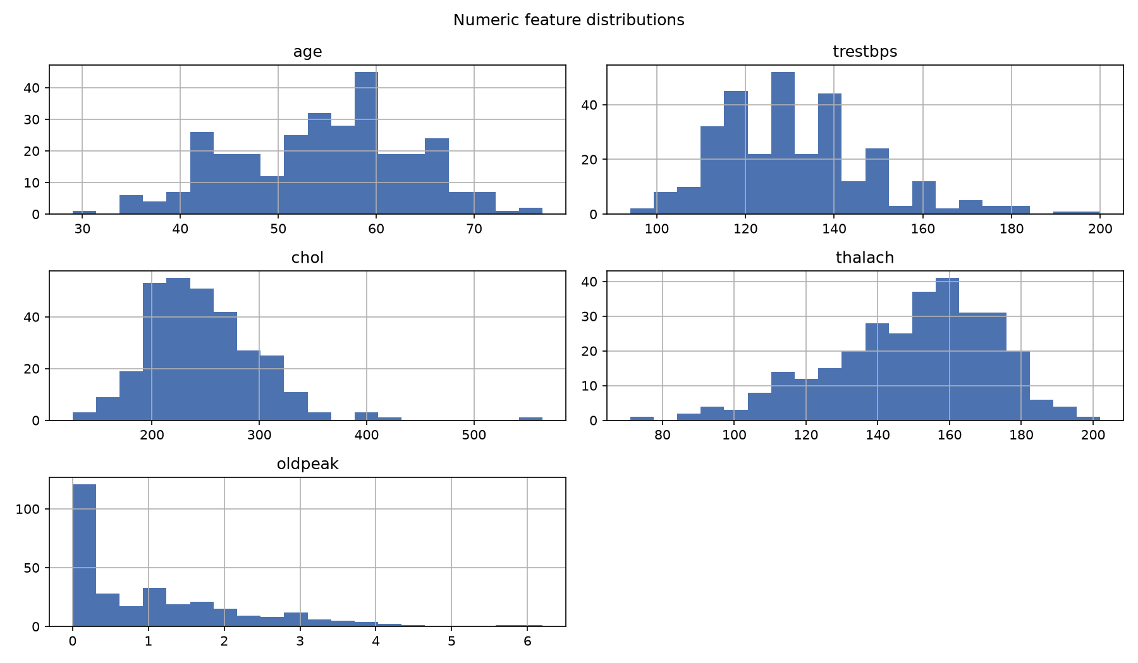
Figure 1: Distributions of numeric features
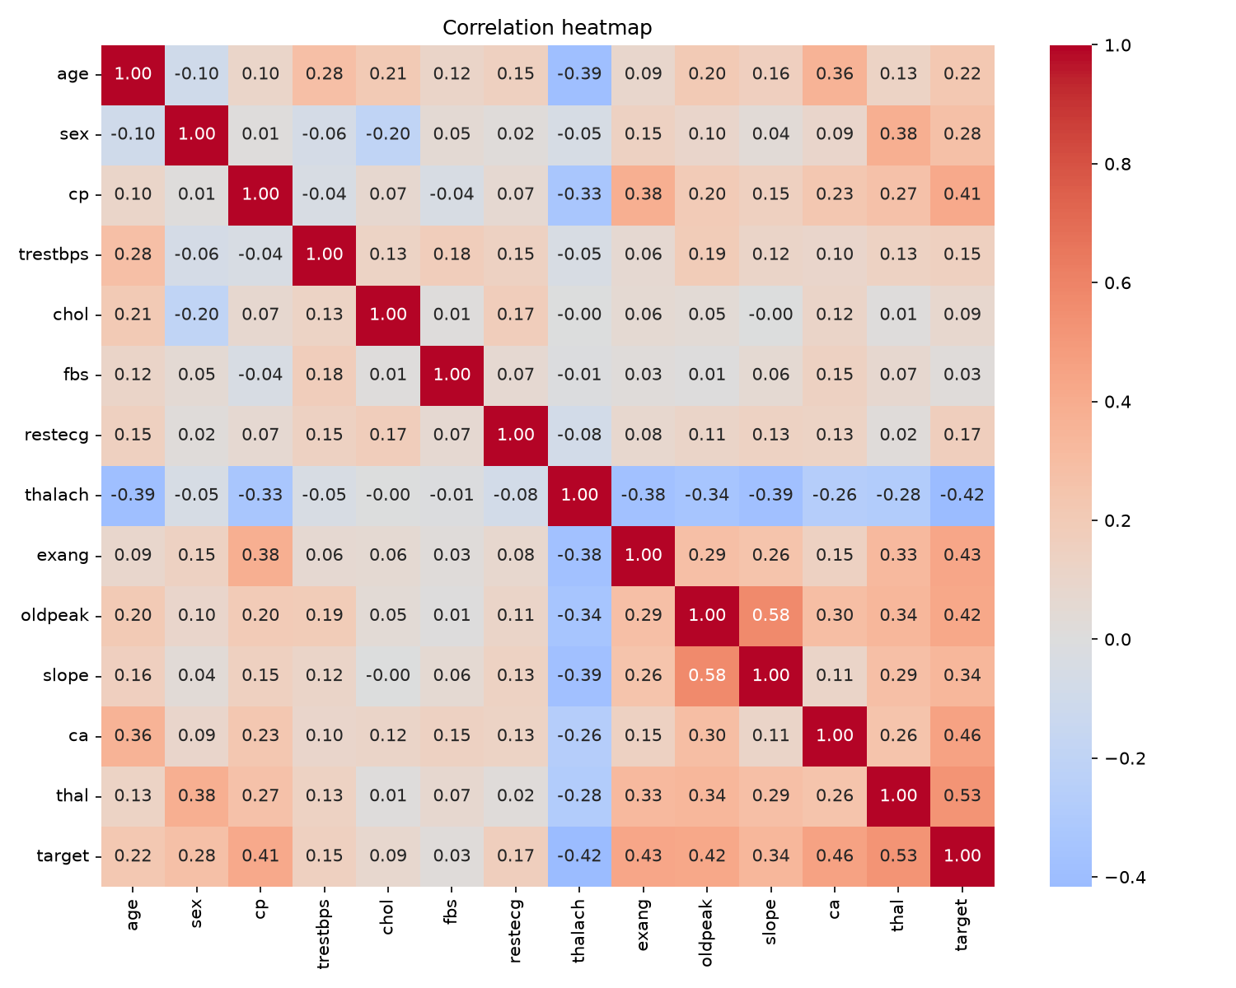
Figure 2: Correlation heatmap
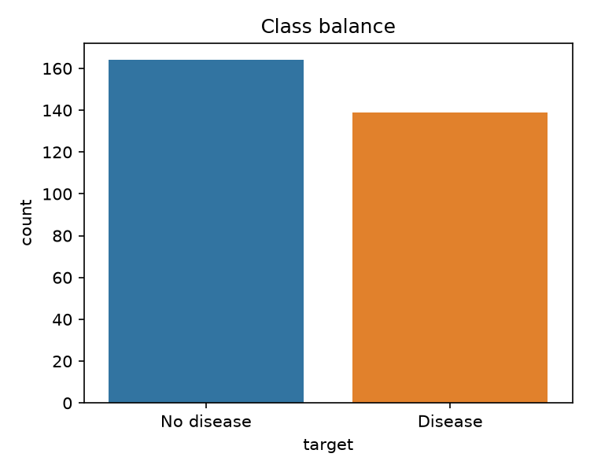
Figure 3: Class balance
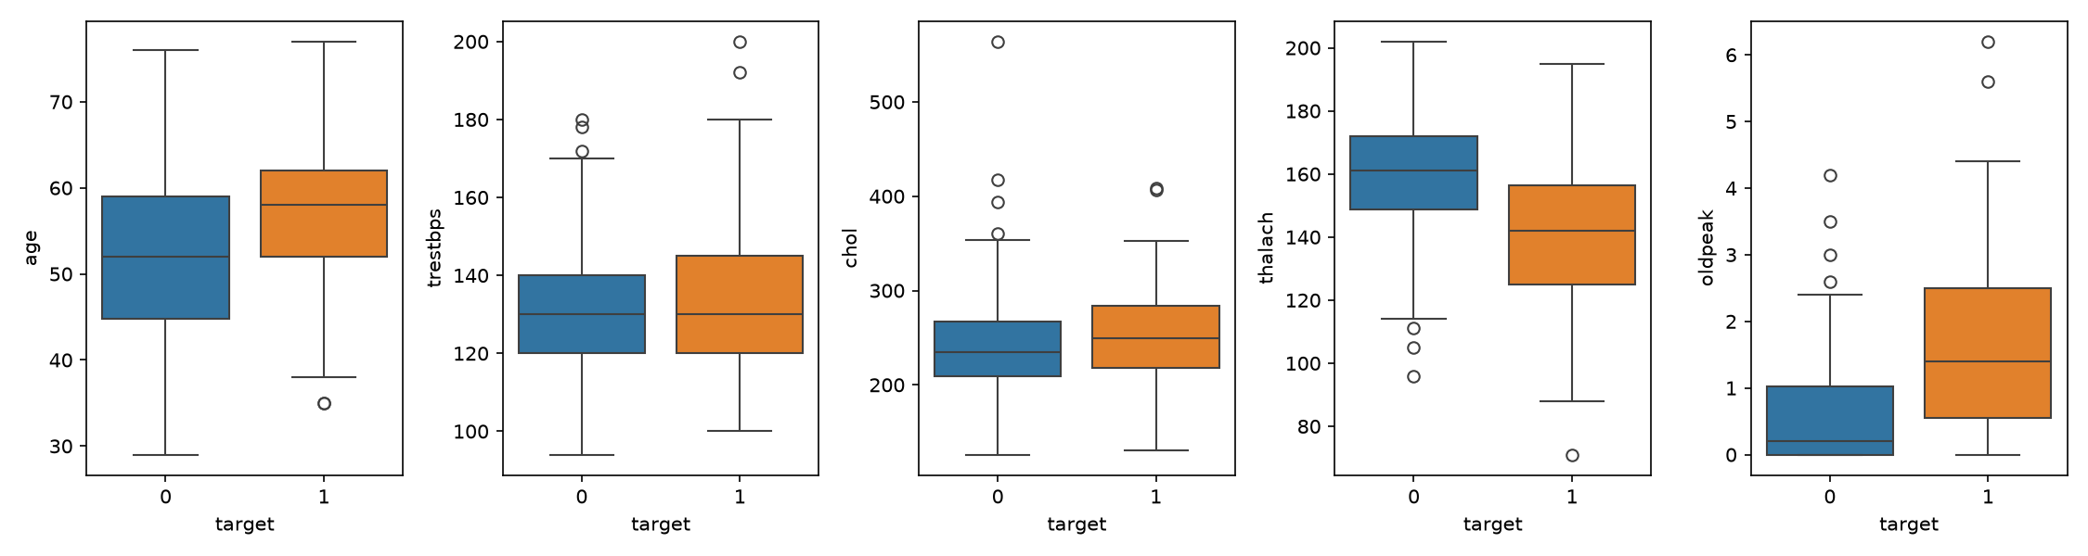
Figure 4: Numeric features by target
Features most correlated with the target: thal (+0.53), ca (+0.46), exang (+0.43), oldpeak (+0.42), thalach (-0.42).

4. Feature engineering and model development
Preprocessing is a scikit-learn ColumnTransformer. The numeric features (age, trestbps, chol, thalach, oldpeak) are median-imputed and standardised; the categorical features are imputed with the most frequent value and one-hot encoded, ignoring unseen categories at inference time. I fit the transformer and the classifier together as a single Pipeline, so the API applies exactly the same preprocessing as training.
I used an 80/20 stratified train/test split with seed 42. For each model I ran GridSearchCV with 5-fold stratified cross-validation on the training part, scored on ROC-AUC, then cross-validated the best setting for the full set of metrics and scored it once on the held-out test set. I chose the model to deploy using cross-validation AUC only, so the test set stayed an unbiased final check.
Model | Search space
Logistic Regression | C in {0.01, 0.1, 1, 10}
Random Forest | n_estimators in {100, 300}; max_depth in {3, 5, None}

Model | CV accuracy | CV precision | CV recall | CV ROC-AUC | Test ROC-AUC
Random Forest | 0.818 | 0.817 | 0.783 | 0.897 | 0.943
Logistic Regression | 0.847 | 0.877 | 0.783 | 0.902 | 0.966

I selected logistic regression (CV ROC-AUC 0.902, held-out test ROC-AUC 0.966). It is ahead of random forest by 0.005 CV ROC-AUC, which is within noise, so I preferred the simpler and more interpretable linear model.
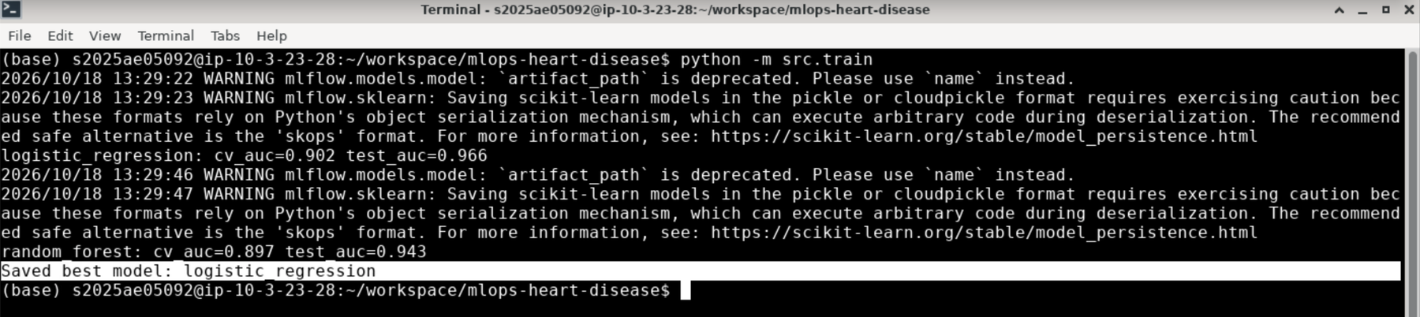
Figure 5: Training output

5. Experiment tracking (MLflow)
Every run of the training script is logged to MLflow under the experiment 'heart-disease': the best hyper-parameters, the cross-validated metrics, the test ROC-AUC, the ROC curve and confusion matrix plots, and the fitted model. I ran the script several times while developing, so the MLflow UI shows more than two runs; the tables in this report use the latest run of each model.
Run | Best parameters
Random Forest | clf__n_estimators=100
Logistic Regression | clf__C=1

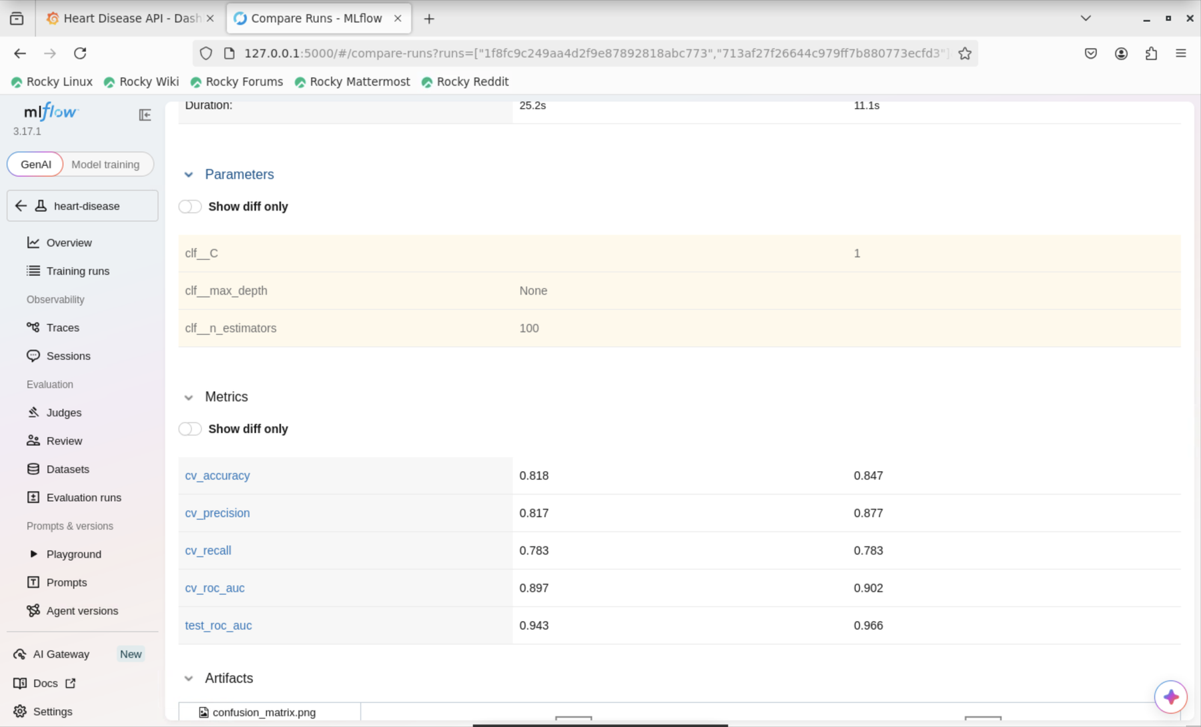
Figure 6: MLflow comparison of the two models (left column: random forest, right column: logistic regression)
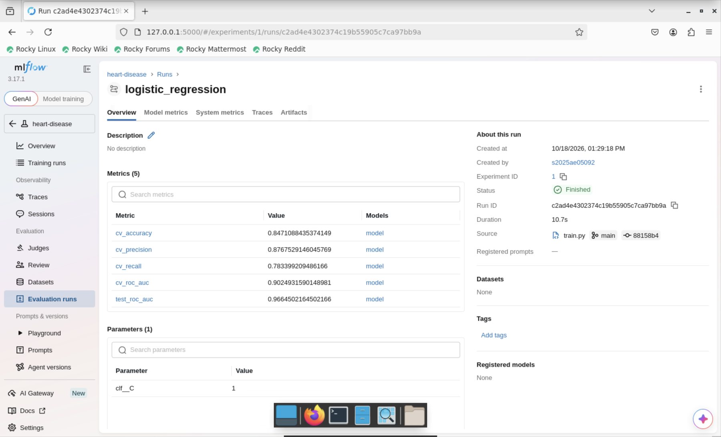
Figure 7: MLflow run with parameters, metrics and plots

6. Model packaging and reproducibility
- I saved the final model as the complete Pipeline (preprocessing plus classifier) with joblib in models/model.joblib, and also logged it to MLflow.
- All dependencies are listed in requirements.txt and every script installs from it.
- I fixed the random seed (42) for the split, the cross-validation and the forest.
- The Docker image downloads the data and trains the model while it is being built, so training and serving always use the same library versions (see section 8 for why).

7. CI/CD pipeline and automated testing
I wrote 6 pytest tests. They cover the data cleaning (target binarisation), the preprocessing pipeline (missing values and output shape), model training and probability output, and the API (health, metrics, prediction and input validation).
The GitHub Actions workflow (.github/workflows/ci.yml) runs on every push and pull request. It installs the dependencies, runs flake8, downloads the data, trains the model, runs pytest, builds the Docker image and uploads the test report, the model and the cleaned data as artifacts. It fails on any lint, test or training error, and the logs of every run are kept.
The very first run failed: the newer MLflow version I had installed would not save the scikit-learn pipeline in its default format. I reproduced the error locally, switched the model logging to the cloudpickle format, and the next run passed. That is the kind of problem I wanted the pipeline to catch.
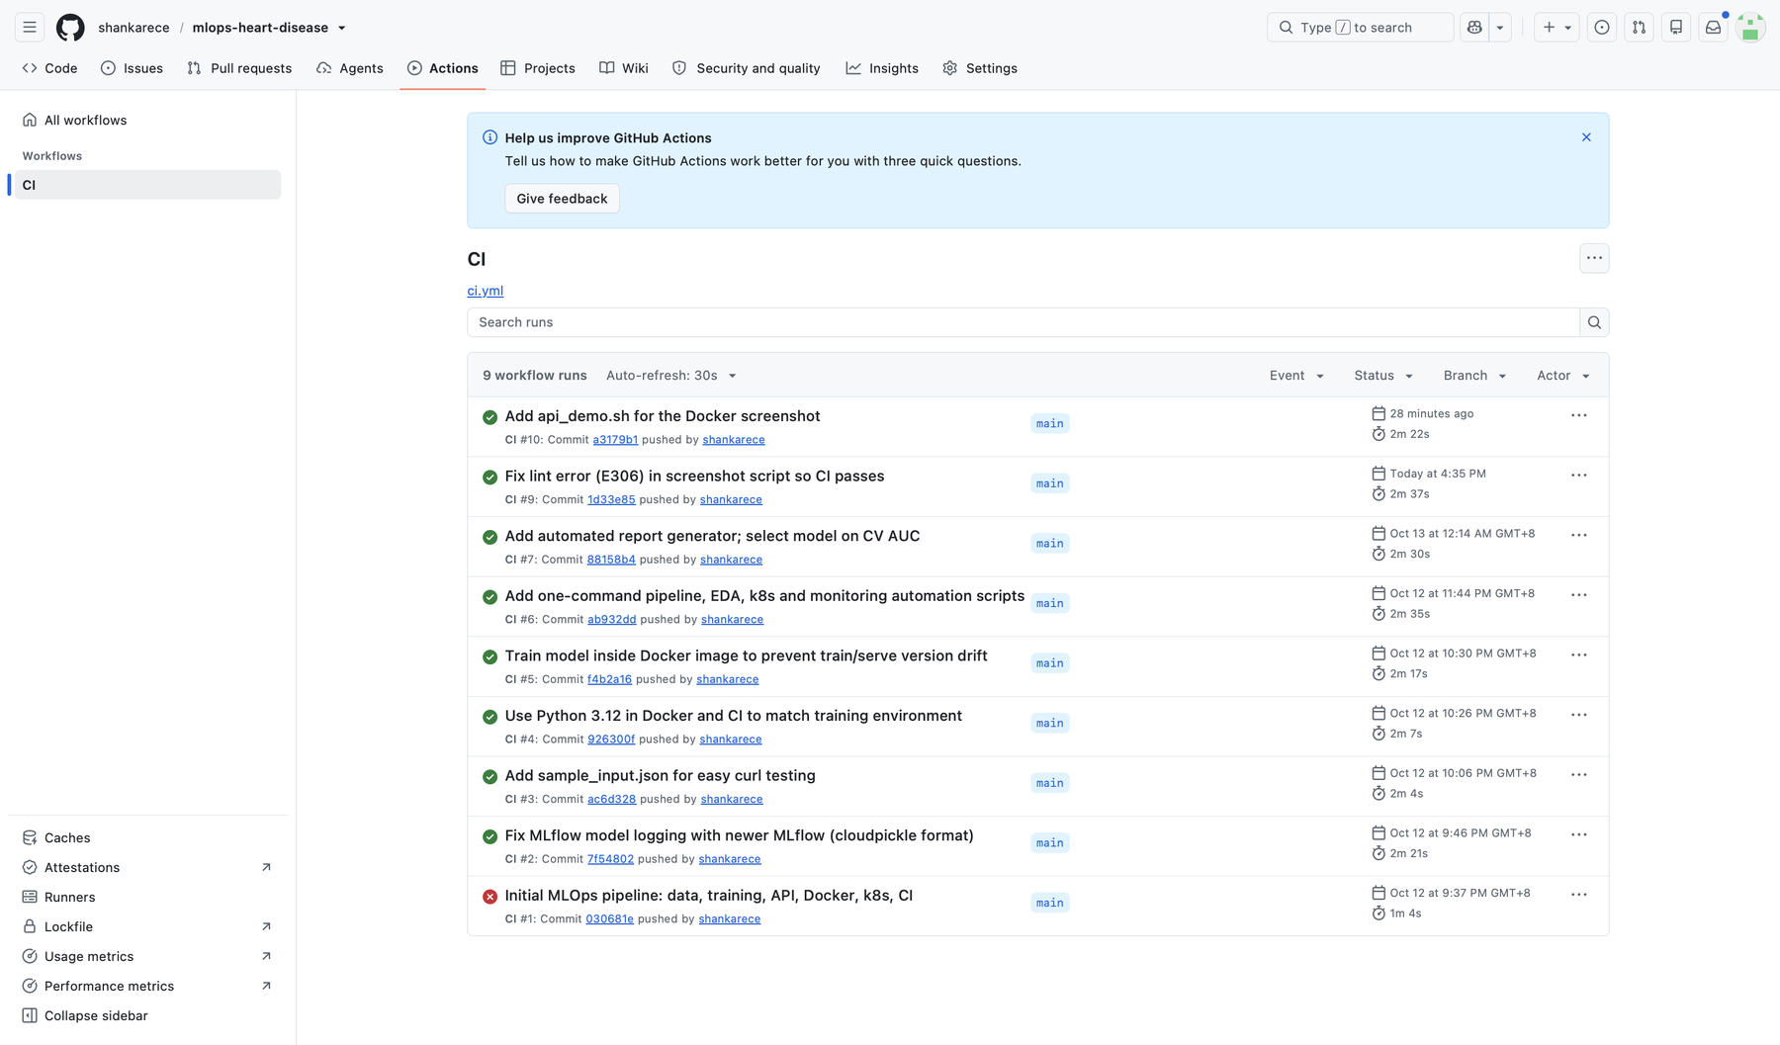
Figure 8: GitHub Actions run history (the latest runs pass; the first run failed and was fixed in run 2)

8. Containerisation
The Dockerfile is based on python:3.12-slim. It installs the requirements, copies the source, trains the model inside the image and starts uvicorn on port 8000. POST /predict takes the 13 patient features as JSON and returns the predicted class and a confidence value (the probability of disease); invalid input returns HTTP 422. Example request:
curl -X POST localhost:8000/predict -H "Content-Type: application/json" -d @sample_input.json
-> {"prediction": ..., "confidence": ...}
I ran into one problem here. My first image used Python 3.10, but the model had been trained with Python 3.12 and a newer scikit-learn, and /predict returned HTTP 500 inside the container. Training the model during the image build removed that mismatch.
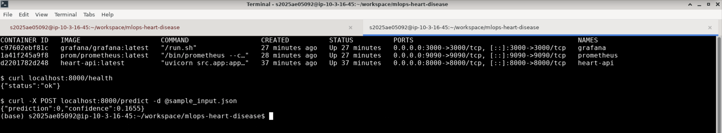
Figure 9: Running containers with /health and /predict responses

9. Production deployment (Kubernetes)
I deployed the API on a local Minikube cluster (Docker driver). k8s/deployment.yaml runs 2 replicas with readiness and liveness probes on /health plus resource requests and limits, and k8s/service.yaml exposes them through a Service of type LoadBalancer (port 80 to container port 8000). scripts/k8s_deploy.sh starts the cluster, loads the image, applies the manifests, waits for the rollout and checks /health and /predict through the Service. On Minikube the EXTERNAL-IP stays 'pending' until 'minikube tunnel' is running, which is expected.
Access: the API is not on a public URL. To try it locally, run scripts/run_all.sh (the container listens on http://localhost:8000 and the interactive docs are at /docs) or scripts/k8s_deploy.sh (Kubernetes, then 'minikube service heart-api --url'). The same model can also be scored from the command line with 'python -m src.predict sample_input.json'.
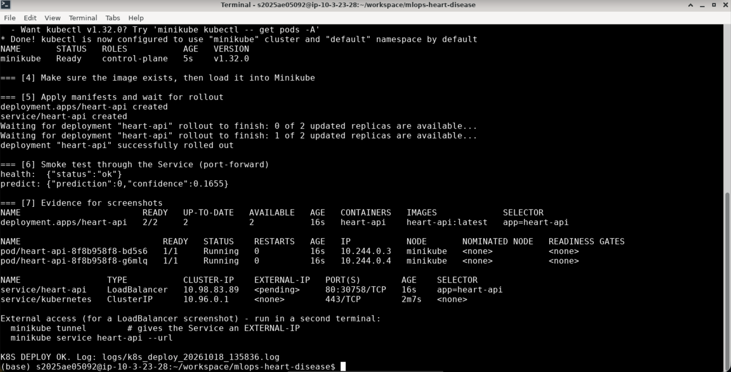
Figure 10: Kubernetes rollout and resources

10. Monitoring and logging
Every request to the API is logged (input and result), and failures are logged with a stack trace. The /metrics endpoint exposes Prometheus metrics: predict_requests_total, labelled by status, and a latency histogram, predict_latency_seconds. The docker-compose file in monitoring/ starts Prometheus, which scrapes the API every 10 seconds, and Grafana with a provisioned datasource and a 'Heart Disease API' dashboard (total predictions, errors, request rate and p95 latency). scripts/monitoring_up.sh sends test traffic and checks that Prometheus received it.
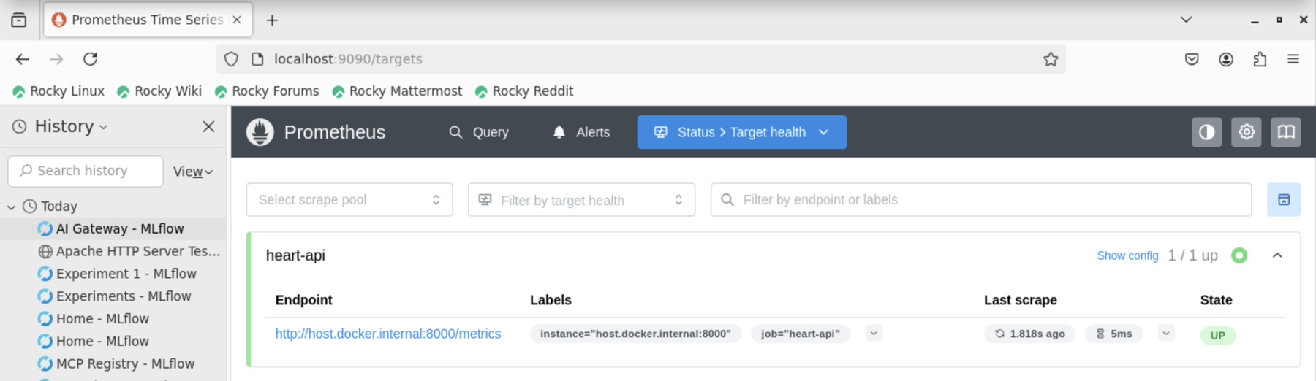
Figure 11: Prometheus target UP
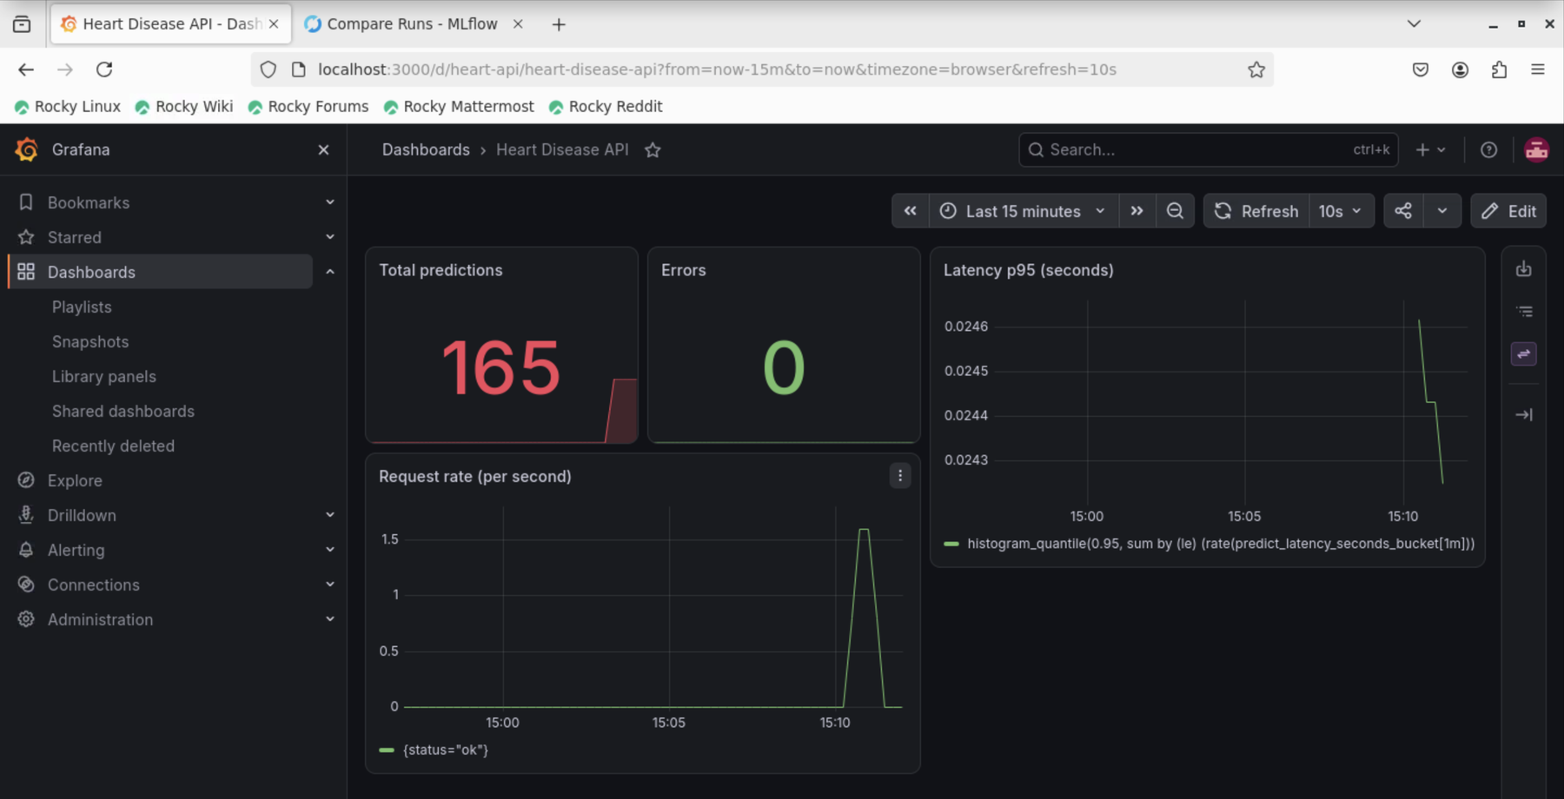
Figure 12: Grafana dashboard

11. Architecture
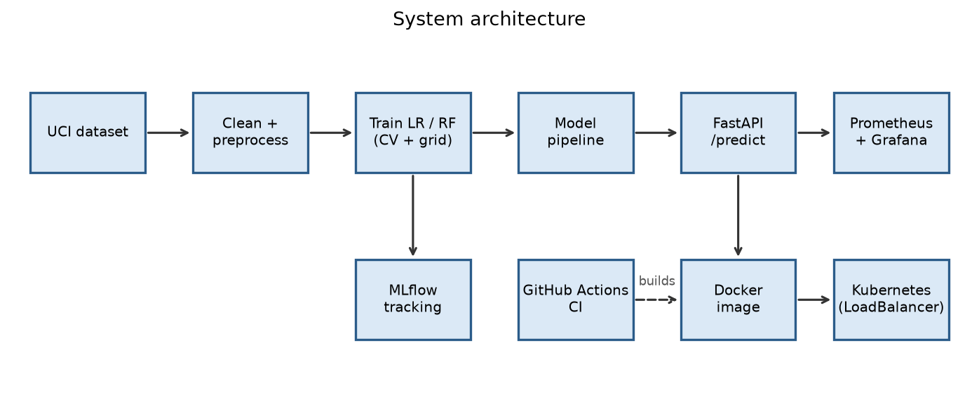
Figure 13: System architecture

12. Conclusion and links
The result is a reproducible path from raw data to a monitored model service on Kubernetes, with lint, tests and training checked automatically on every push. If I carried on with this project, I would add a model registry with promotion rules, data-drift monitoring and automated retraining.
Code repository: https://github.com/shankarece/mlops-heart-disease

